Evaluating the use of GIS software as a modelling tool for environmental analysis

Jake Davies (P151889)

Table of
Contents
Table of figures. iii
1.0 Introduction. 1
2.0 Literature Review. 1
2.1 What is GIS? 1
2.1.1 Vector data. 1
2.1.2 Raster Data 2
2.2 History of GIS. 2
2.3 The role of GIS in environmental monitioring. 2
2.3.1 Case studies of GIS within the environment. 3
3.0 Methodology. 3
3.1 Study area. 4
4.0 Results and Analysis. 4
4.1 Task one: 4
4.2 Task two 12
5.0 Conclusion. 18
7.0 Works Cited 19

Table of figures.
(all figures created by author)
Figure 1: Townsend index dispalyed within Microsoft excel. 5
Figure 2: Swansea Output area boundary data table. 6
Figure 3: Swansea output area map 6
Figure 4: Stage 1 creating a thematic map. 7
Figure 5: Stage 2 creating thematic map. 7
Figure 6: Stage 3 creating thematic map. 8
Figure 7: Swansea Output area Townsend map. 8
Figure 8: Swansea middle super output area Townsend map. 9
Figure 9: Selection of the SA1 and SA3 postal boundaries. 10
Figure 10: The selection has to be saved as a new layer. 10
Figure 11: Adding the new SA1 and SA3 layer to the map. 11
Figure 12: Style override to then define the SA1 and SA3 boundaries. 11
Figure 13: Swansea middle super output area Townsend map with SA1 and SA3 defined. 12
Figure 14: Creating postcode points on swansea deprevation map. 13
Figure 15:Deprivation map with all of Swansea's postcode points. 13
Figure 16: Example of cleansed REAP data. 14
Figure 17: Geocoding primary data onto the deprivation map. 14
Figure 18: Geocoded primary data points in red against all postcode points. 15
Figure 19: SQL select, querying the above average carbon footprints. 15
Figure 20: Pin points of carbon footprints over 15.51 tCO2e. 16
Figure 21: Style override, for over average carbon footprints. 16
Figure 22: Creating graded unemployment points. 17
Figure 23: Graded unemployment map. 17

Introduction.
Geographical Information Systems, have become a fundamental resource within the environmental sector. Within this area GIS is intended encompass and present all type of physical, biological, environmental and social data (Gharehbaghi & Scott-Young, 2018). This report aims to evaluate the use of GIS as a modelling tool for environmental purposes, this will encompass two tasks:
- Investigating coloration and characteristics between two sets of deprivation data, within Microsoft Excel and a GIS package.
- Demonstrate, describe and discuss the construction of an environmental GIS map, including deprivation and household carbon footprints.

Literature Review.

2.1 What is GIS?
A Geographical Information System (GIS) is a system used to capture, collect, manipulate, examine, manage and present spatial or geographic data (Clark, 1986) (Maliene, Grigonis, Palevičius, & Griffiths, 2011). Esri defines GIS as “A geographic information system (GIS) is a computer-based tool for mapping and analysing things that exist and events that happen on earth. GIS technology integrates common database operations such as query and statistical analysis with the unique visualization and geographic analysis benefits offered by maps” (Esri, n.d.). GIS data can be separated into two categories, vector and raster.

2.1.1 Vector data.
Vector data can be split into three further categories, polygon, line and point data. Polygons represent a two-dimensional area for example, a lake, woodland or city area. These features are usually displayed using thematic mapping, colour graduation or pattern schemes. Line data represents linear features such as rivers and roads. Line features have only one dimension therefore, can be utilized to measure length. Symbology is commonly used to vary features such as line type, thickness and colour. Point data is utilised to represent nonadjacent features and desecrate data points. Examples of these zero dimensional points include, museums, train stations and city locations (Dempsey, 2017).

2.1.2 Raster Data
Raster data represents surfaces, this data type is cell based and includes aerial and satellite imagery. Raster data incorporates continuous and discrete data. Continuous data examples include temperature and elevation measurements. Whereas a discrete data example would be population density. Raster data is further split into thematic, spectral and imagery data types (Dempsey 2017).

2.2 History of GIS.
The first GIS, was created in Canada in the mid 1960s and designed as a computerised map-measuring system. Many early GIS developers recognised that the same needs were present in many different applications from land management to the census. Many developments in GIS come from progressions by the military, especially during the cold war. With the creation of the Global Positioning System (GPS), driven by the need for accurate targeting for intercontinental ballistic missiles. GIS become more relevant in the early 1980s when the price of computers fell allowing the creation significant software industry and cost-effective applications (Longley, et al., 2011).

2.3 The role of GIS in environmental monitioring.
In multiple instances GIS is underutilised, mainly used for the presentation of data and creation of ‘pretty maps’ (Larsen, 1999). The use of GIS within the environmental sector will allow any environmental organisation to (ESRI, 2005):
- Ensure accurate reporting and improved data collection.
- Improve decision making.
- Increased productivity.
- Improved data analysis and presentation.
- Model environmental phenomena.
- Create predictive scenarios for impact studies.
- Automate regulatory compliance processes.
Due to the above qualities of GIS programs, it is vital in countless areas of environmental management. GIS can be used to understand the important process and procedures within environmental management. It plays a sizeable role in areas such as: (GrindGIS, 2018)
- Environmental Impact Assessments (EIA).
- Disaster management.
- Land zoning.
- Soil and wetland mapping.
- Flood and irrigation mapping.
- Natural resource mapping.

2.3.1 Case studies of GIS within the environment.
- Creating a digital representation of the water table in a sandstone aquifer:
Groundwater is a significant resource within the UK providing 33% of drinking water. Beginning in the mid 1960s groundwater assessments began to be conducted using GIS software. It was found by Posen, et al that GIS software generates a more reliable representation of the water to any region with adequate coverage of groundwater monitoring (Posen et al., 2008).
- GIS and predictive modelling: A comparison of methods for forest management and decision making:
GIS has become a vital tool in special planning. The research by Felicisimo and Gomez-Munoz developed a set of likelihood and suitability models for the presence of tree species over a study area of 41,000 km². Suitability maps symbolise a vital tool in environmental management, as they incorporate a range of knowledge which is difficult to integrate in any other way (Felicisimo & Gomez-Munoz, 2008).

3.0 Methodology.
As stated within the introduction two tasks will be completed within this report. The GIS software package used within this report is MapInfo Pro V16, this program combines a user-friendly experience with state-of-the-art software.
- Data for both task 1 and 2 is retrieved from the UK data service website, provided by the UK government.
- The Townsend deprivation index will be used to map deprivation in the city and county of Swansea, the index will be calculated on Microsoft Excel and displayed thematically through the GIS package.
- Household analysis will then be added to the map, displaying variables such as unemployment and cars per home this data will also be retrieved through the UK data service.
- Carbon footprint analysis was calculated for two postal areas of Swansea, SA1 and SA3. These areas were chosen for comparison as they have differentiating levels of affluence. The program used for carbon footprint analysis was REAP petite. The carbon footprint data will then be imported into the GIS software, to display the largest footprints within the areas.

3.1 Study area.
The study took place within the city and county of Swansea, South Wales. The population estimate for this area in 2017 was 244,500 (Swansea Council, 2017), within an area of 420km² (Centre For Cities, 2012).

4.0 Results and Analysis.

4.1 Task one:
The Townsend index is used to map deprivation in an area, it was developed by Townsend et al in 1988. Deprivation is measured from the following census data (Holland, 2018):
- Percentage of households without car access.
- Percentage of households with more than one person per room.
- Percentage of households that are not owner occupied.
- Percentage of unemployed residents.
The score is calculated with the four above variables, firstly the percentages for each are computed. The second stage variable scores (VAR) are created, this in turn allows a Zscore to be calculated for each variable for example:
Zscore1(Homes without car access) = (VAR1-Mean(VAR1))/S.D(VAR1).

Once the Zscores for each category has been calculated this allows the Townsend score to be created for each data point. The calculation is as follows:
Townsend index = Sum (Zscore1:Zscore4)

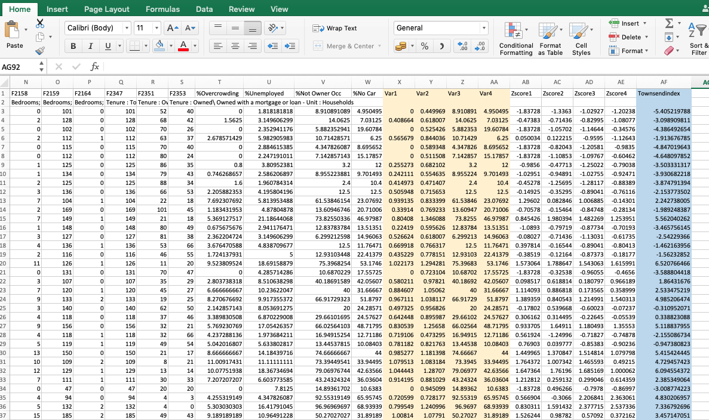
Presentation of the Townsend index on Microsoft excel is limited, as of an area there is a large amount of data present. For the Swansea area, there are 792 data points leaving analysis of this data extremely challenging.
Figure 1: Townsend index dispalyed within Microsoft excel.
As can be seen within figure 1 the data in the blue column represents the Townsend score, the data presented this way makes for difficult reading. The cities areas are represented by geographical codes rather than place names, this along with the amount of raw data would make analysing deprivation between areas particularly problematic.
The task of comparing deprivation in two areas is made simple by using spatial thematic mapping on a GIS package. Spatial mapping can easily simplify data presentation and allow sophisticated analysis (Sheffield University, 2010). Once the boundary data for the study area has been downloaded, from the UK data service it can be imported into the GIS package. In this case MapInfo Pro v16 and the Swansea output area, figures 2 and 3 show the table of the boundary data and the representative map respectively.

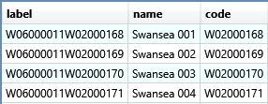

Figure 2: Swansea Output area boundary data table.

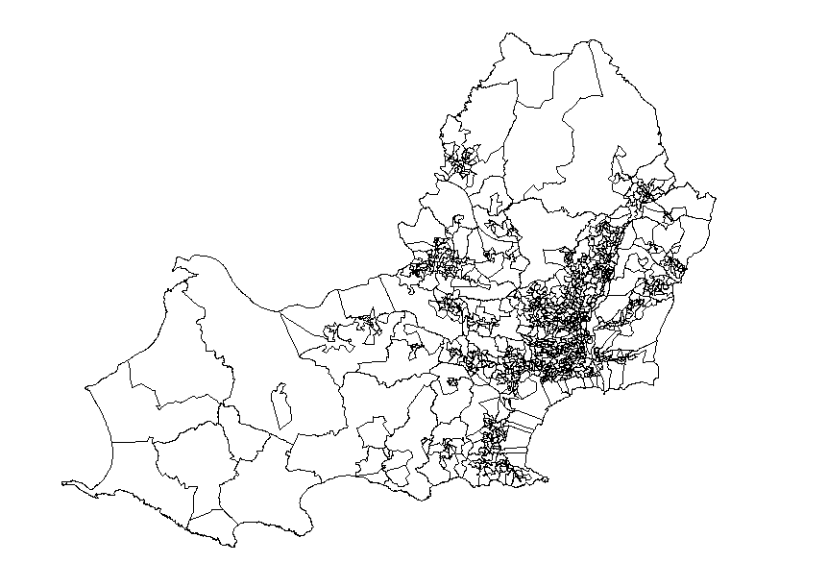

Figure 3: Swansea output area map

Creating a thematic map within MapInfo is a relatively simple task, there are three steps shown between figures 4,5 and 6. Firstly the Townsend data excel workbook has to be opened within the GIS program. As both boundary data and Townsend data have the same geographical area code, (seen in figure 2) this then enables the Townsend score to be added directly to the boundary map.
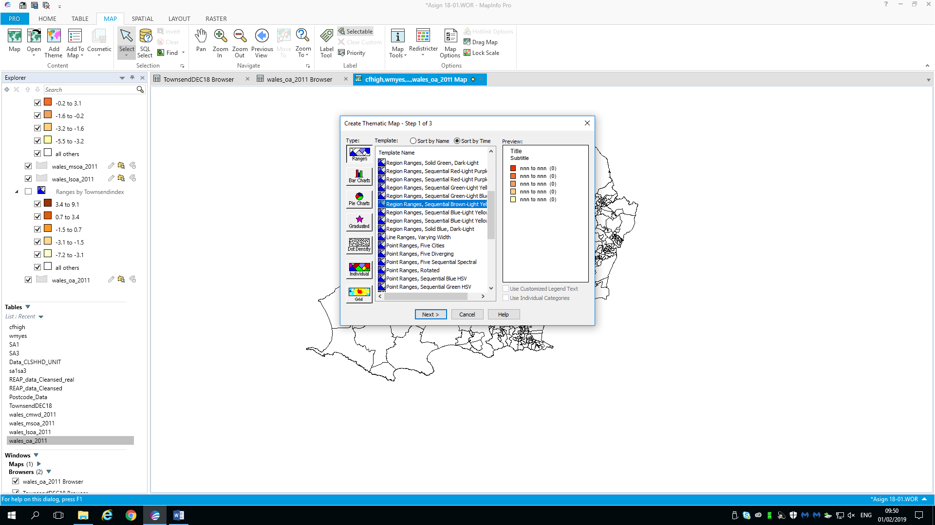
Figure 4: Stage 1 creating a thematic map.
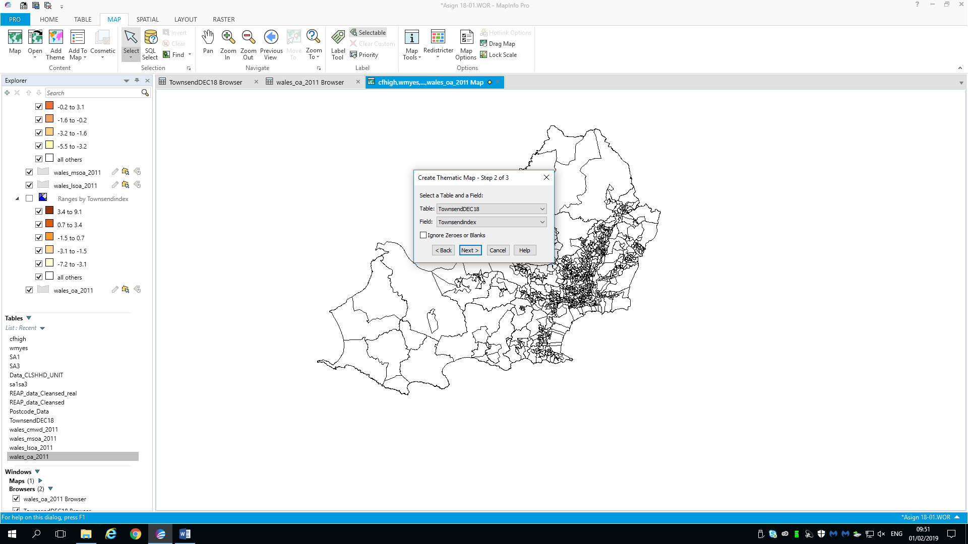
Figure 5: Stage 2 creating thematic map.
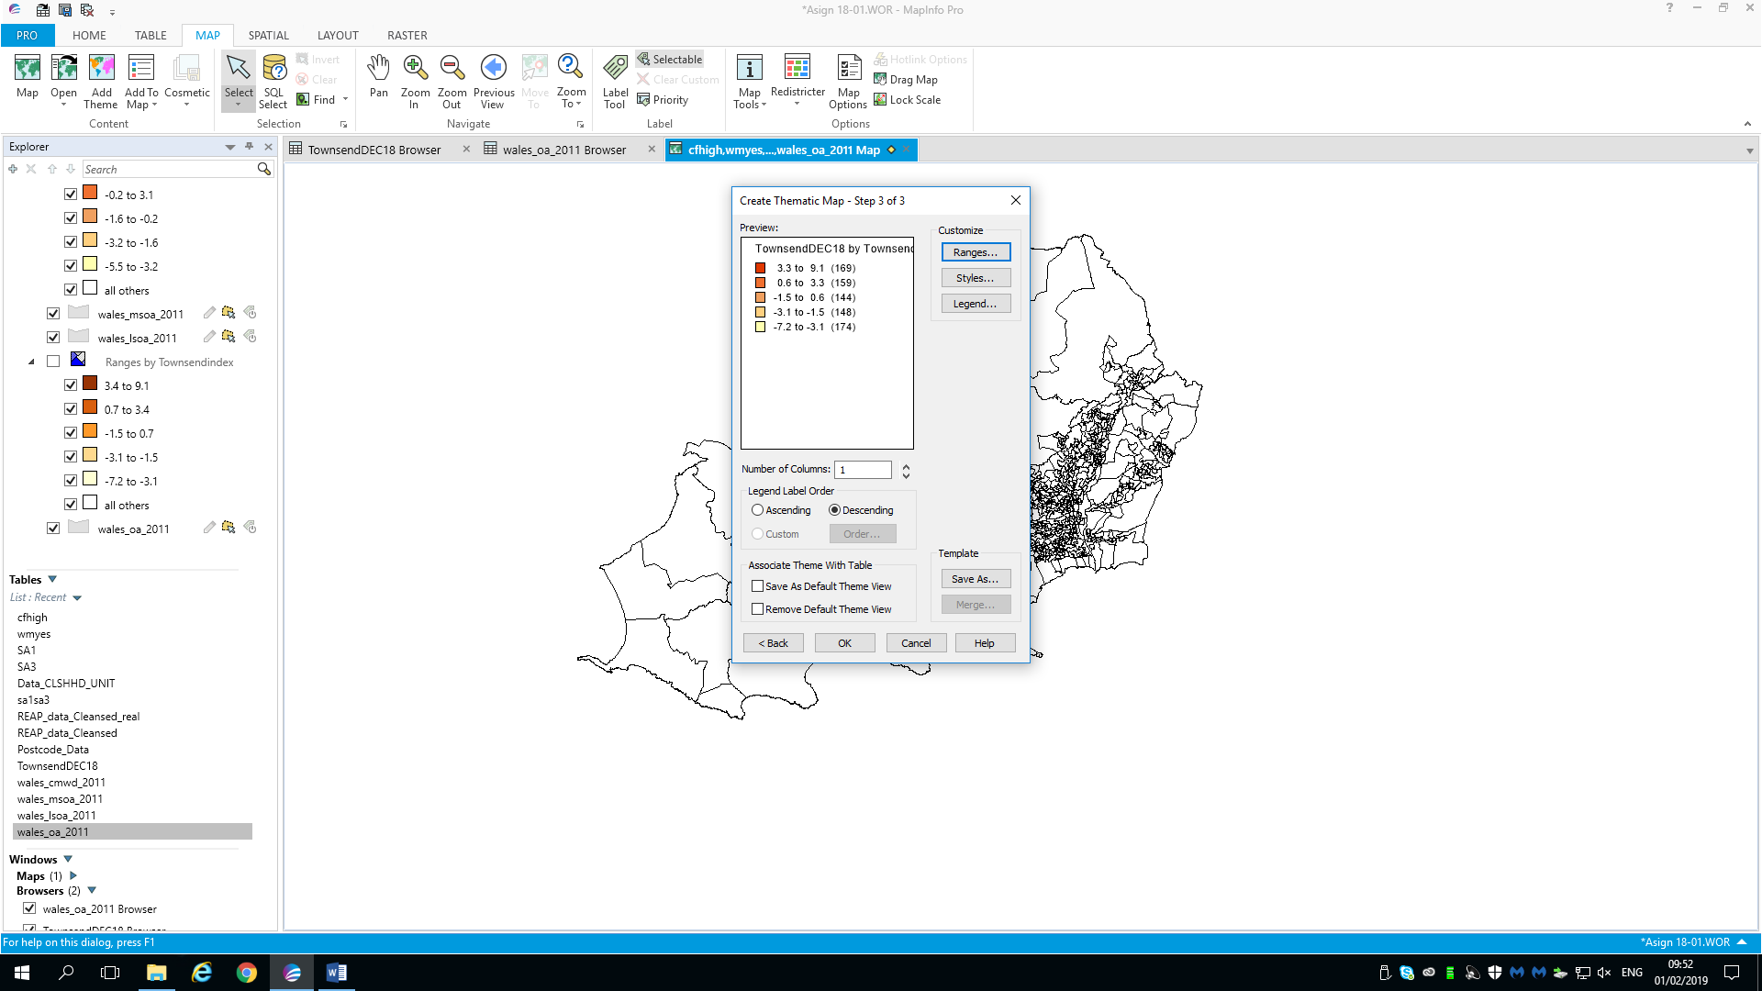
Figure 6: Stage 3 creating thematic map.
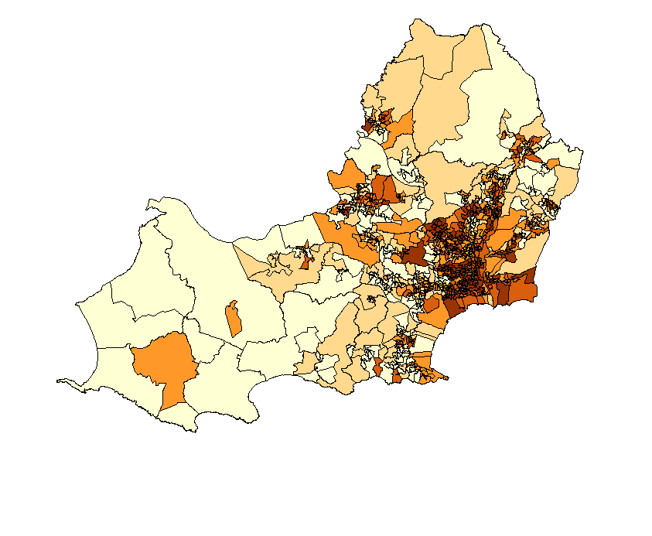
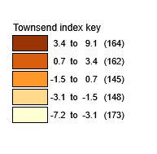
Figure 7: Swansea Output area Townsend map.

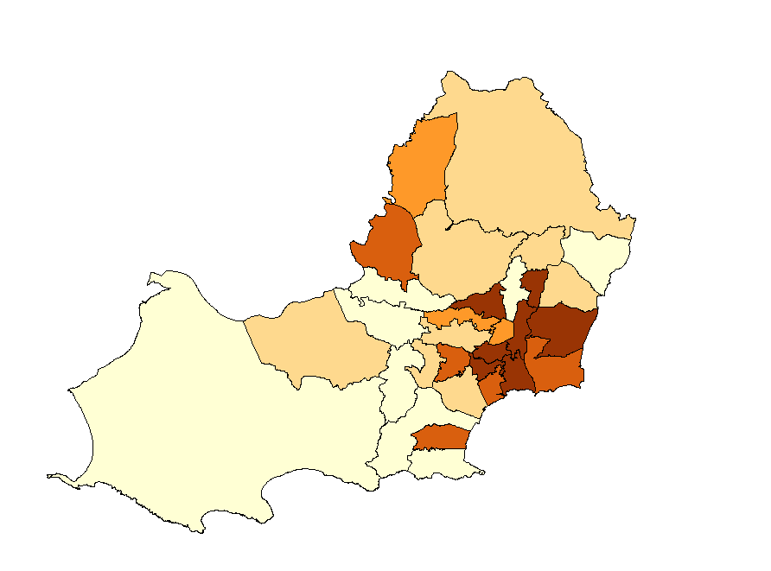
The above figure shows the Townsend thematic map, the higher the Townsend score the more deprived the area. These areas are also represented by the darker colours. Thematic mapping allows simple summarisation of large data sets and can produce qualitative analysis to inform policy development (Ramirez, 2006). The above process was the repeated for the Swansea Middle super output area, which groups the 792 areas into 28 larger areas, this allows analysis of larger community’s overall deprivation.
Figure 8: Swansea middle super output area Townsend map.
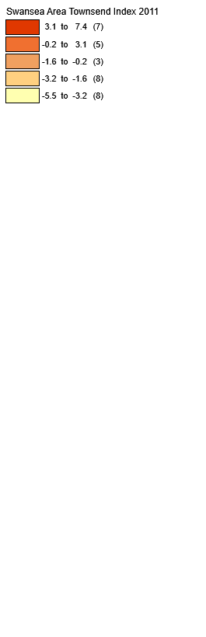

The two areas compared within this report are SA1 and SA3, these are defined within the below figures.
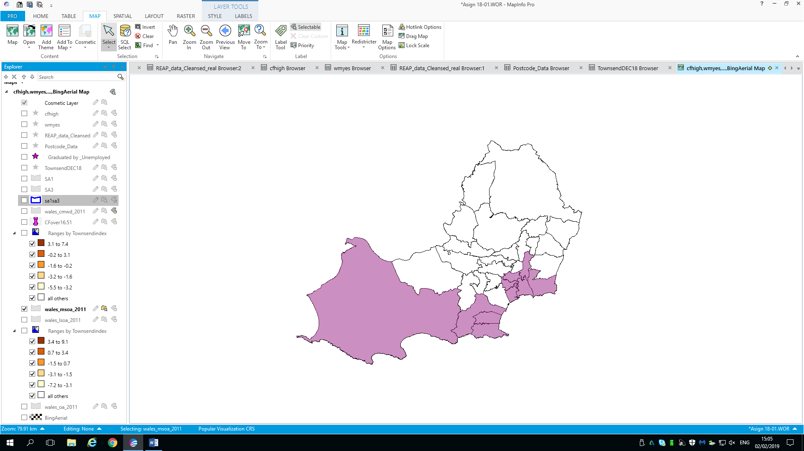
Figure 9: Selection of the SA1 and SA3 postal boundaries.
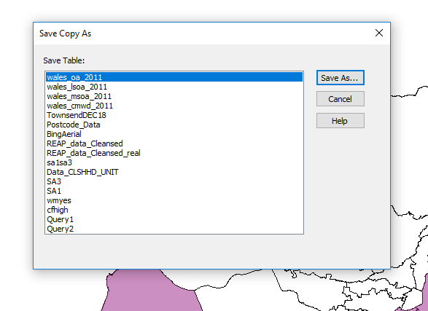
Figure 10: The selection has to be saved as a new layer.
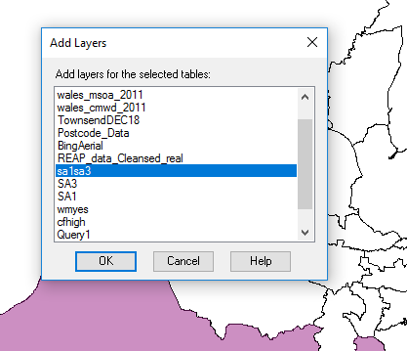
Figure 11: Adding the new SA1 and SA3 layer to the map.
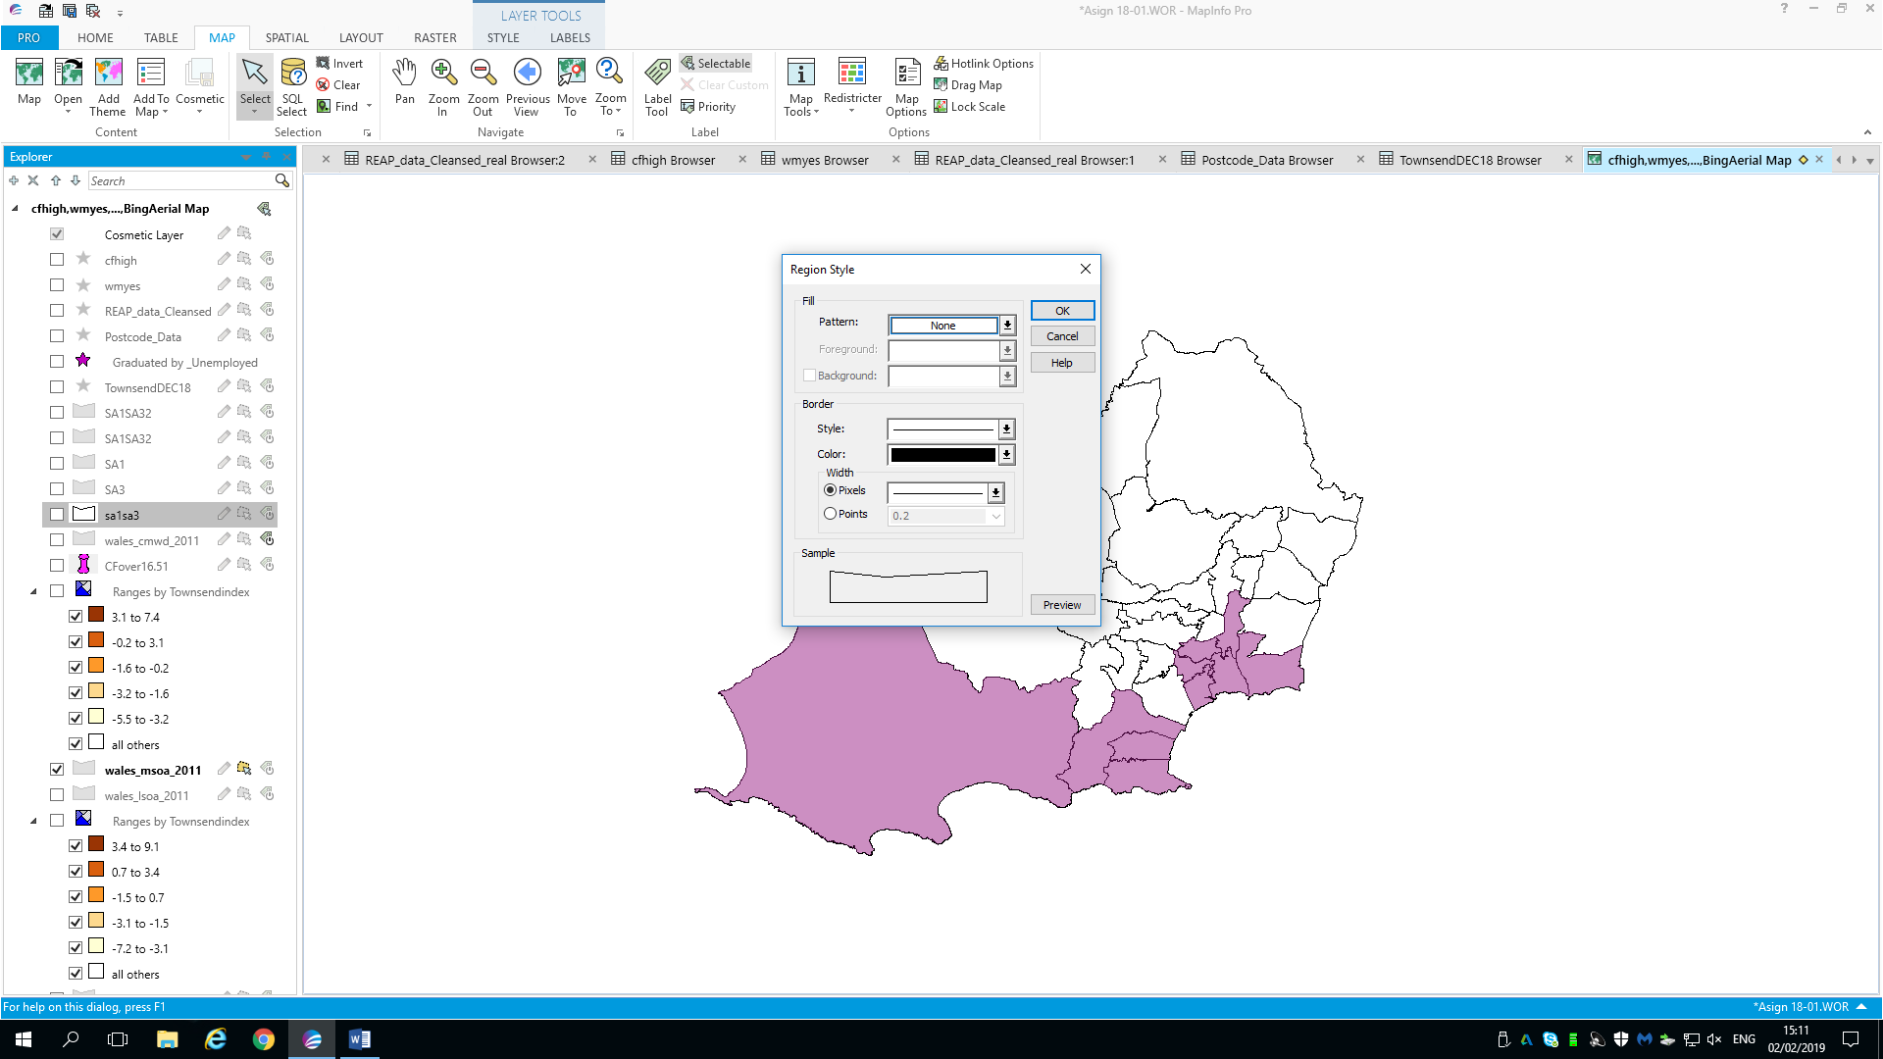
Figure 12: Style override to then define the SA1 and SA3 boundaries.
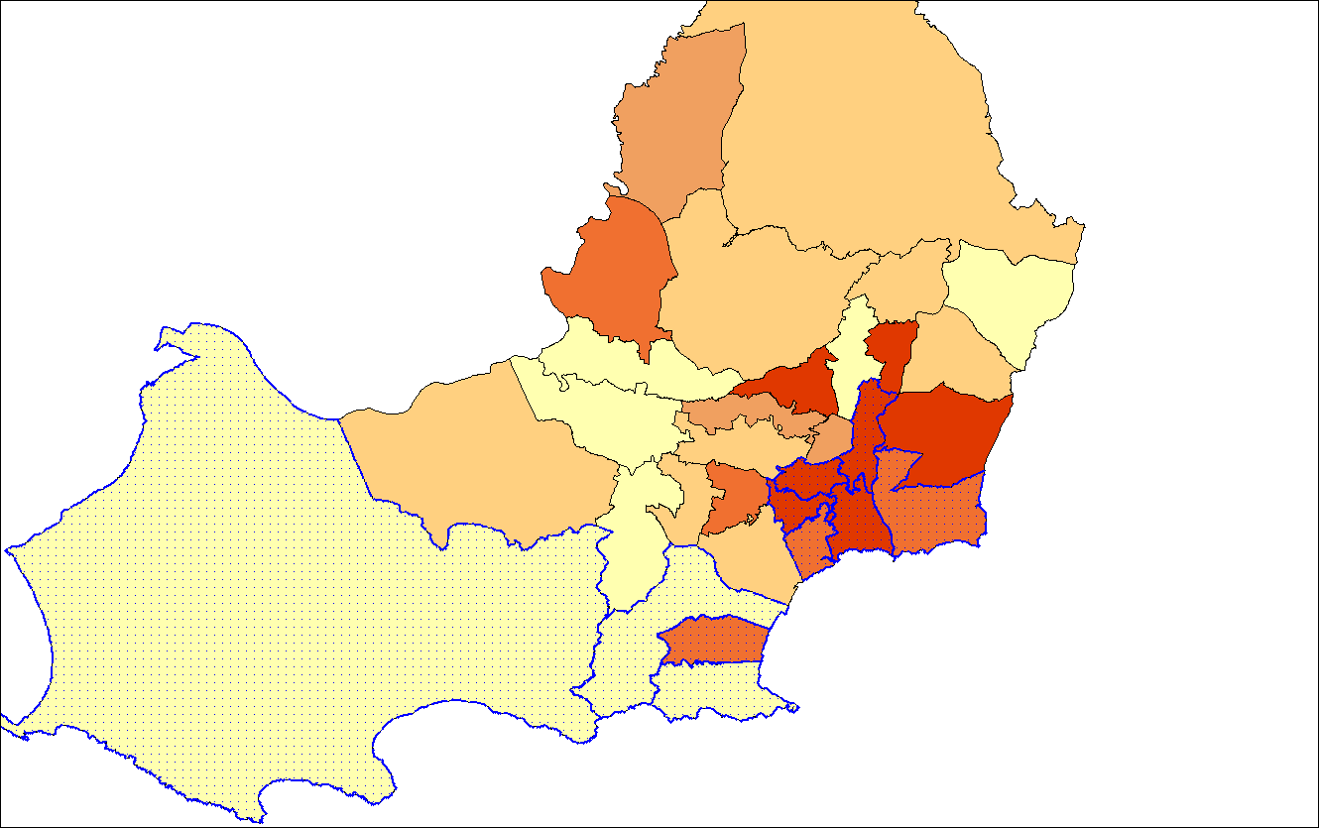
Figure 13: Swansea middle super output area Townsend map with SA1 and SA3 defined.
SA3
SA1
The above figures 8-13 display the method of defining the postal boundaries. As displayed in figure 13 SA1 is by far the more deprived area within the Townsend index’s parameters. The MapInfo software allows this to be displayed in a simple and effective manner. SA1 encompasses many of Swansea’s inner-city areas, which are historically more deprived and less affluent then rural or sub urban areas (Irfany & Klasen, 2017). As can be seen from the above data, there is no correlation between deprivation in SA1 and SA3. Figure 13 displays SA3 as a prosperous affluent area, through the Townsends index’s parameters.

4.2 Task two
Environmental mapping has been made accessible to everyone though the introduction of widely available GIS software and data sets. Within this task primary carbon footprint data for two postal area of Swansea defined above will be added to the deprivation map, allowing easy analysis of the two areas. To allow postcode analysis, postcode data was downloaded for the UK data service web site, points were created on the deprivation map using the British coordinate system (figure 14).
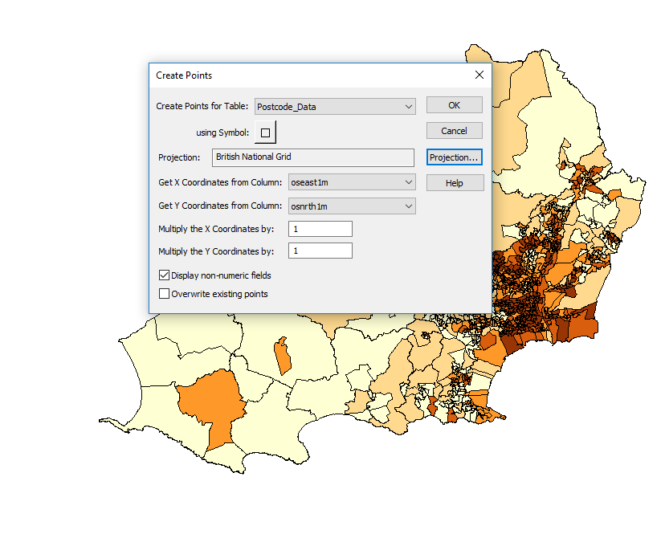
Figure 14: Creating postcode points on swansea deprevation map.
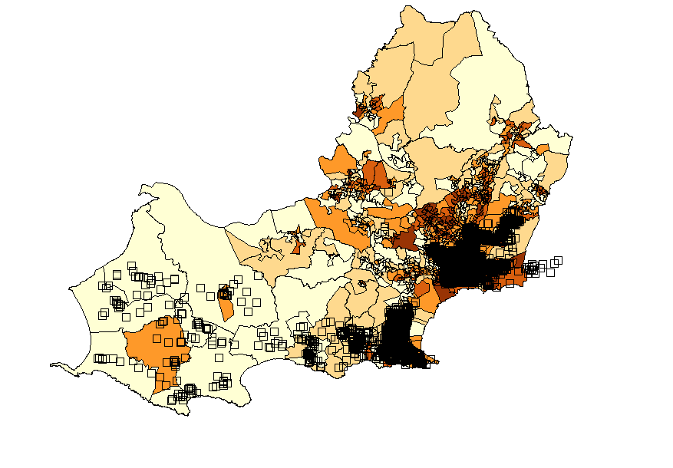
Figure 15:Deprivation map with all of Swansea's postcode points.
The primary REAP petite data was then cleansed to ensure all provided postcodes could be geocoded onto the deprivation map. The cleansing took place within Microsoft excel and displayed in figure 16. The data required cleansing as some participants of the surveys provided limited postcode data.
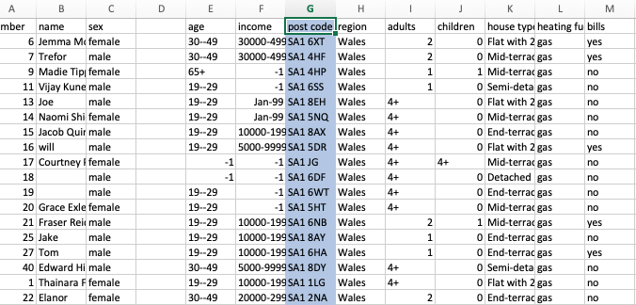
Figure 16: Example of cleansed REAP data.
This primary data table was opened within MapInfo, the postcodes were then geocoded against the codes from the postcode points in figure 15. This was achieved through the geocode tab as seen in figure 17.
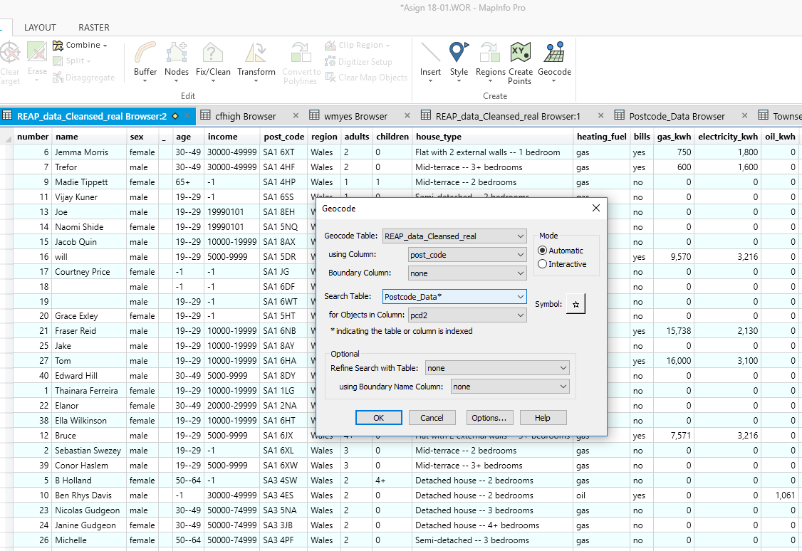
Figure 17: Geocoding primary data onto the deprivation map.
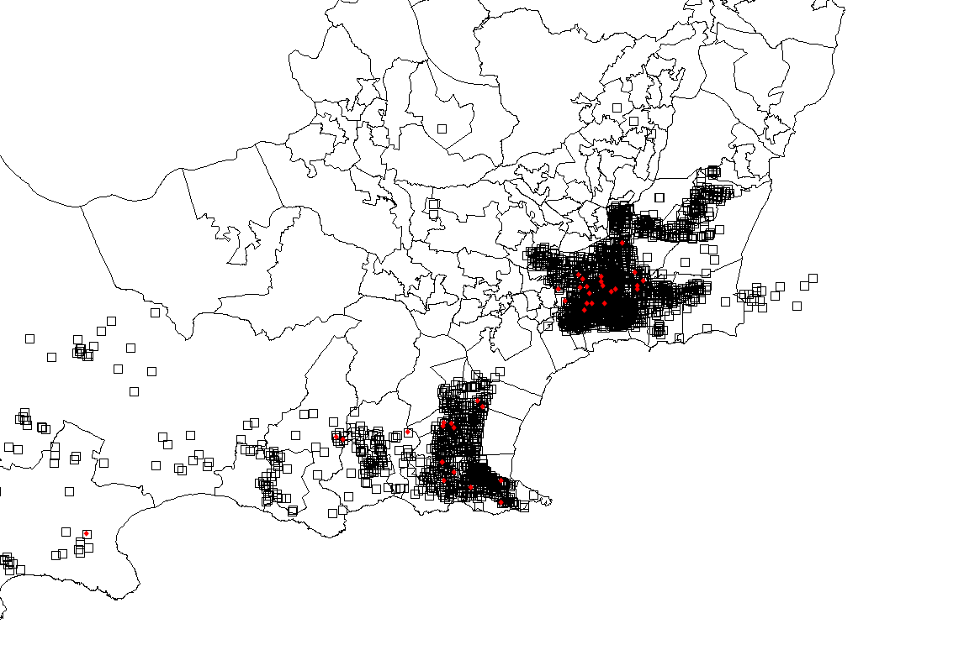
Figure 18: Geocoded primary data points in red against all postcode points.
The above figure shows the locations of all primary data points in red, the deprivation layer has been removed to make the points easily recognisable. The ability to incorporate the primary data points allows environmental management issues to be pinpointed to an exact location, elements such as unemployment and carbon footprint information can be visually represented.
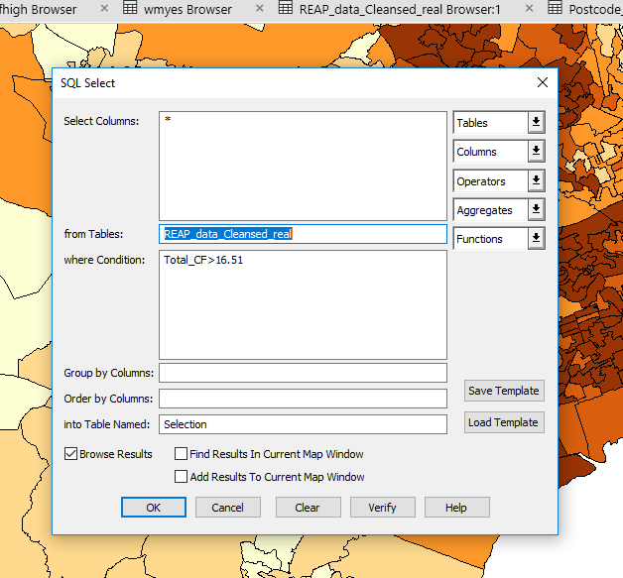
It was found that the overall average carbon footprint in Swansea is 15.51 tCO₂e per month. To plot these points the SQL (Structured Query Language) select function was used, this allows the user to query any of the data tables added.

Figure 19: SQL select, querying the above average carbon footprints.

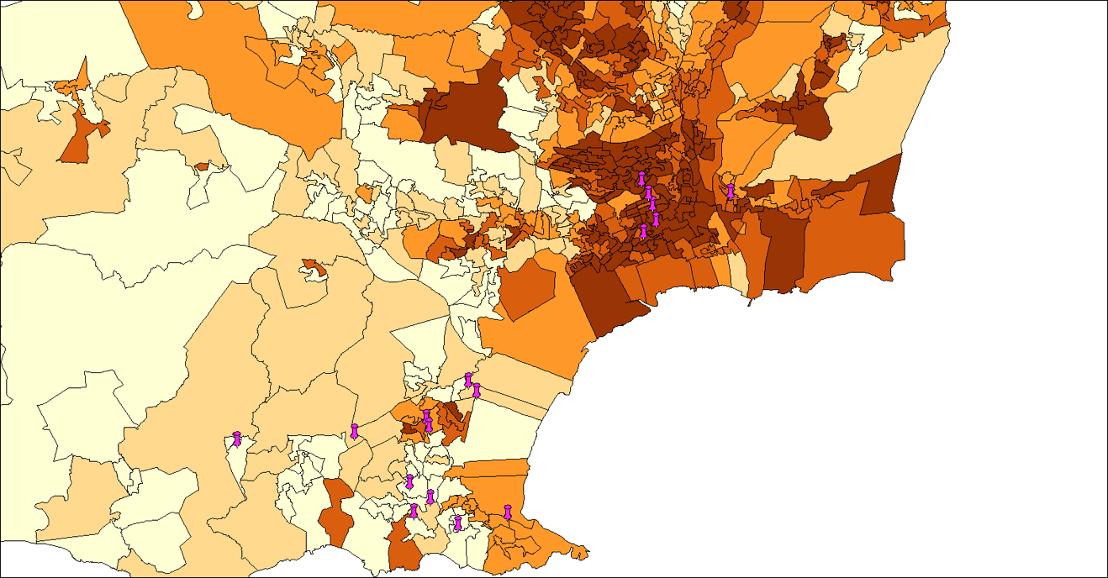
Figure 20: Pin points of carbon footprints over 15.51 tCO2e.
As portrayed within figure 20, there are a higher amount of pin points within the SA3 region (11) to 6 within SA1. Therefore, there this indicates a higher number of households with an above average carbon footprint. The points were style overridden into the pink pin points to allow a clear visual representation of the data, the process is shown in figure 21.
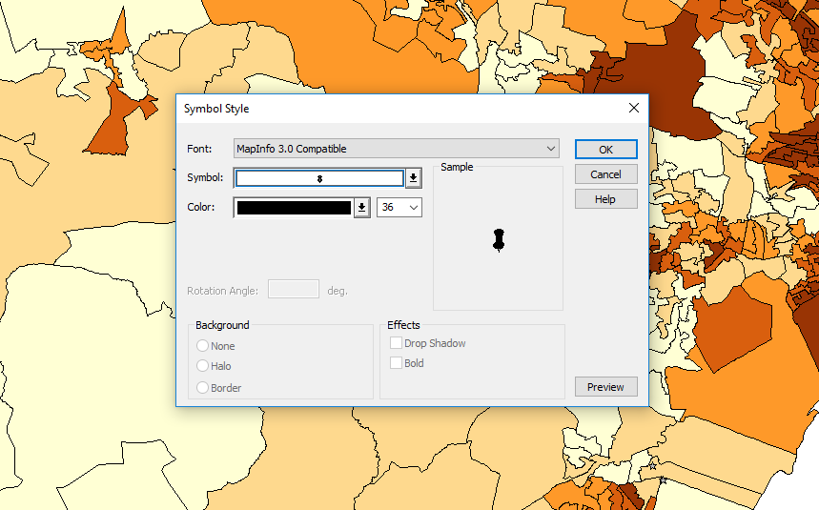
Figure 21: Style override, for over average carbon footprints.
Along with thematic mapping and pin points, graded data can be added to the deprivation map. In this case unemployment was added as it’s a major factor in deprivation (Timmins, 1995).
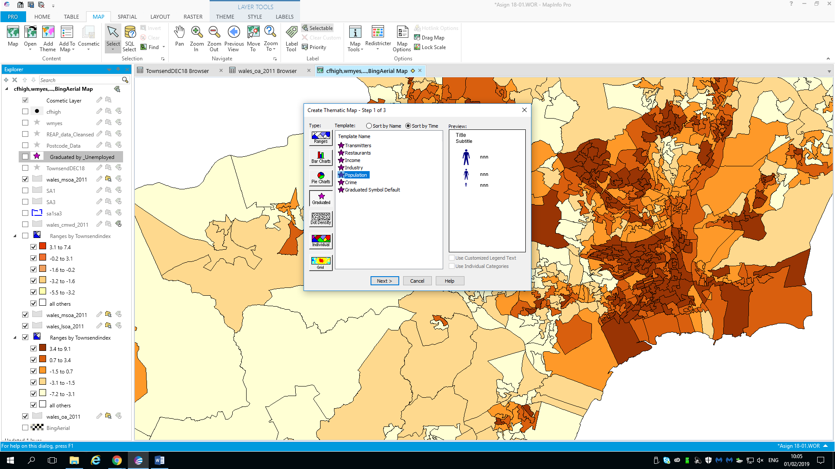
Figure 22: Creating graded unemployment points.
These points were created from the Townsend data table from the number of unemployed column.
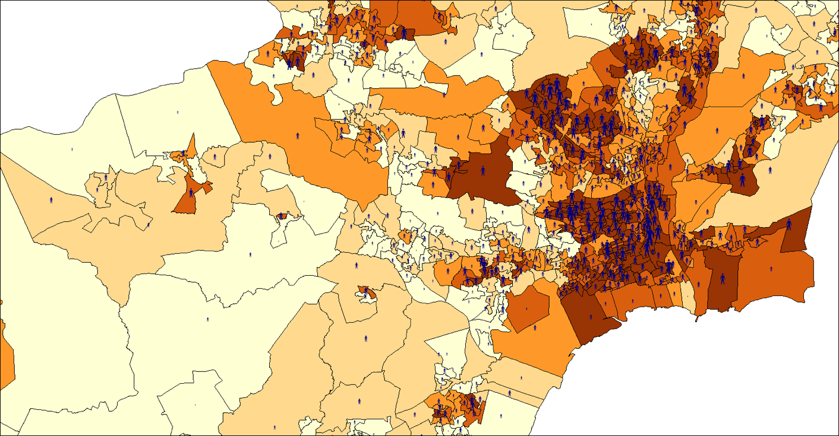
Figure 23: Graded unemployment map.
The size of the icons represents the amount of unemployed people in the area. With the largest icons representing 25 people and the smallest 5. As can be seen in figure 23 the more deprived areas have far more unemployed inhabitants, further enhancing their deprivation status.
Elements of the use of GIS within the environmental sector has been examined within this report, displaying how data can be presented and ultimately analysed. The environmental sector is a multidisciplinary field that encompasses biological, social and physical sciences. Thematic mapping is a vital application of GIS in resource and population management areas of the environmental sector (Wright, et al., 2009) (Ahamad & Laituri, 2017).
MapInfo as a GIS package is extremely user friendly, accurate and allows a fantastic base for analysis of data. Creation of polygons and thematic maps, permits the user to overlay basic data with graphic styles to display information on a more sophisticated level (Pitney Bowes, 2016).
To create an accurate representation of the output area, further deprivation indices can be integrated into the current Townsend map. The Welsh Index of Multiple Deprivation (WIMD) is the welsh governments preferred method of assessing deprivation, this index takes 8 variables into account when calculating deprivation. Therefore, creating a more rounded and potentially accurate view of the population compared with the Townsend index (Welsh Government, 2018).

5.0 Conclusion.
In conclusion, it was found the SA3 area was the least deprived, with the least unemployed occupants and had more residents with a carbon footprint over the Swansea average. The GIS package enabled concise analysis of a medium sized regional data set. Emerging technological advances such as open source GIS allow larger data sets to be to be addressed, such as climate change and citizen science (Sui, 2014). Combining GIS with carbon footprint analysis can help the managers of an area for example: City and County of Swansea council to visualise the impacts of their population on the environment. Furthermore, enabling policy development and mitigation programs against presented environmental issues. GIS software does have its issues within the environmental sector, not all environmental data is suitable to be implemented into a GIS map. Additionally, presenting qualitative data within MapInfo can encounter potential problems. Finally, GIS software is an outstanding tool within an environmental managers arsenal, and if implemented in the correct way provides great reward.

7.0 Works Cited
Ahamad, K., & Laituri, M. (2017, September 27). Use of GIS in Environmental Science. Retrieved Febuary 04, 2019, from Oxford Bibliographies: http://www.oxfordbibliographies.com/view/document/obo-9780199363445/obo-9780199363445-0081.xml
Centre For Cities. (2012). Local Authorities in PUA. Retrieved January 12, 2019, from https://www.centreforcities.org/wp-content/uploads/2014/09/Swansea.pdf
Clark, C. (1986). Advances in geographic information systems, computers, environment and urban systems,. Computers, Environment and Urban , 10(3 - 4), 175 - 184.
Dempsey, C. (2017, May 01). Types of GIS Data Explored: Vector and Raster. Retrieved January 24, 2019, from GIS Lounge: https://www.gislounge.com/geodatabases-explored-vector-and-raster-data/
ESRI. (2005). GIS Solutions for environmental Management. New York: ESRI.
Esri. (n.d.). What is GIS? Retrieved Jaunuary 24, 2019, from https://www.esri.com/en-us/what-is-gis/overview
Felicisimo, A., & Gomez-Munoz, A. (2008). GIS and predictive modeling: A comparison of methods for forest management and decision-making. In A. Lovett, & K. Applrton, GIS for Environmental Decision-Making (pp. 117-129). BocaRaton: Taylor & Francis Group.
Gharehbaghi, K., & Scott-Young, C. (2018). GIS as a vital tool for Environmental Impact Assessment and Mitigation. Earth and Environmental Science, 127.
GrindGIS. (2018, April 10). 10 Importance of GIS. Retrieved January 29, 2019, from https://grindgis.com/blog/10-importance-of-gis-in-environment
Holland, B. (2018). Calculating a Townsend Score Using Infuse Data 2011. Retrieved January 30, 2019, from Moodle : https://moodle.uwtsd.ac.uk/course/view.php?id=2603
Irfany, M. I., & Klasen, S. (2017, October). Affluence and emission tradeoffs: evidence from Indonesian households’ carbon footprint. Environment and development economics, 22(5), 446-570.
Larsen, L. (1999). GIS in environmental monitoring and assessment. Geographical information systems 2, 999- 1007.
Longley, P., Goodchild, M., Maguire, D., & Rhind, D. (2011). Geographical Information Systems & Science (Third ed.). New York: Wiley.
Maliene, V., Grigonis, V., Palevičius, V., & Griffiths, S. (2011). Geographic information system: Old principles with new capabilities. Urban Design International, 16(1), 1-6.
Pitney Bowes. (2016). Product Documentation: MapInfo Pro. Retrieved Febuary 04, 2019, from Pintney Bowes: https://www.pitneybowes.com/us/support/products/software/mapinfo-pro-support.html
Posen, P., Lovett, A., Hiscock, K., Evers, R., & Ward, R. (2008). Creating a digital representation og the water table in a sandstone aquifer. In A. Lovett, & K. Appleton (Eds.), GIS for Environmental Decision-Making (pp. 101-114). Boca Raton: Taylor & Francis Group.
Ramirez, R. (2006). Advantages and disadvantages of thermatic analysis. San Carlos: University of San Carlos.
Sheffield University. (2010). Life Expectancy in Sheffield, UK. Retrieved Febuary 2, 2019, from Public Health GIS Unit: http://gis.sheffield.ac.uk/phgis/GIS-Example.html
Sui, D. (2014). Opportunities and impediments for open GIS. In Transactions in GIS 18.1 (pp. 1-24). Columbus: Ohio state University.
Swansea Council. (2017). Mid year estimates of population, 2017. Swansea: Swansea Council.
Timmins, N. (1995, July 24). Education 'the key to breaking cycle of deprivation'. Retrieved from The Independent: https://www.independent.co.uk/news/education-the-key-to-breaking-cycle-of-deprivation-1592977.html
Welsh Government. (2018, October 22). Welsh Index of Multiple Deprivation. Retrieved Febuary 04, 2019, from Welsh Government: Statistics: https://gov.wales/statistics-and-research/welsh-index-multiple-deprivation/?lang=en
Wright, D. J., Duncan, S. L., & Lach, D. (2009). Social power and GIS technology: A review and assessment of approaches for natural resource management. Annals of the Association of American Geographers , 99(2), 252-274.

