Alex Griffiths
1700819
Abstract
In this report, the author attempts to analyse a variety of different computer forensics tools and categorise those tools into a readable format. The author will also attempt to analyse an evidence disk supplied to them by the lecturer and document to process. The author will also attempt to answer questions asked as part of the investigation, and finally, the author will create and an invoice in order to specify fees paid for the service.

Synthesize a solution to a potential REAL-LIFE scenario

Computer Forensics
LECTURER: DR CARLENE CAMPBELL
Contents
1. Introduction 2
2. Background 2
3. Forensics Software Tools 2
3.1. FTK Imager 2
3.2. Autopsy 2
3.3. X-Ways Forensics 2
3.4. ProDiscover Forensics 2
3.5. SIFT-SANS Investigative Forensic Toolkit 2
4. Forensics Case Study 2
5. Terrorist Attack Case Study Questions 3
5.1. What are the other processes or forensic methods John would have taken/used before he prepared a chain-of-custody document and stored the original hard disk in a secure location? 3
5.2. How would John go about retrieving these files? 3
5.3. would john make a detailed list of the videos and prepare a document explaining each of the videos in brief? 3
5.4. What software would John use to get the contact list of the terrorist’s MS Outlook? 3
6. Invoice 3
7. Conclusion 4
8. References 4
9. Appendix 5

Introduction
In this report the author will analyse computer forensics tools and categorise them into a table-based format. The author will also analyse an evidence disc drive taken from a suspected terrorist [1], document the process steps they take and use their findings to create an investigation report. As part of this process, the author will answer various questions asked as part of the investigation. At the end of the process, the author will submit an invoice for payment of their work.

Background
A terrorist was shot down at Heathrow International airport. He was planning to bomb the Mason International airport at Fiji. His face matched with the terrorist list. He tried to escape when the police confronted him; eventually they shot him. He was carrying a laptop briefcase when he was shot down.

Mr. Mark Wales, the Chief Investigator at The Heathrow Police Department made a phone call to John, a detective in a professional investigation service, and asked him to investigate the items in the brief case.

Forensics Software Tools

FTK Imager
FTK Imager is a commercial disk imaging software written by Access Data [2], and therefore has the ability to create a perfect copy of a hard disk saved as one file or split into multiple segments that can later be combined.

Autopsy
Autopsy [3] is an open source computer software originally written by Brian Carrier [4] and now continually developed by Basis Technology Corp [5] as well as others from the open source community. It is used as a platform to make many of the other free, open source utilities in the Sleuth Kit [6] easier to use.

X-Ways Forensics
X-Ways Forensics [7] is a fast, commercial closed-source forensics program that operates on all versions of windows. It is able to image disks and view all files, including those that have previously been deleted.

ProDiscover Forensics
ProDiscover Forensics is disk imaging and report creating computer forensic tool which allows the user to view all files on the system, including files that have been hidden or have been deleted through the use of accessing Windows’ Alternate Data Streams.

SIFT-SANS Investigative Forensic Toolkit
SIFT [8] is an ubuntu-based open source disk imaging software created by Rob Lee et Al, with the ability to examine data from raw hard disks to evidence formats and numerous types of file systems. Supported file systems include Advanced Forensic Format (AFF) and RAW (dd).

Forensics Case Study
Due to author carelessness and bad time management, they were unable to complete this section of the report.

Terrorist Attack Case Study Questions

What are the other processes or forensic methods John would have taken/used before he prepared a chain-of-custody document and stored the original hard disk in a secure location?
John would have:
- Made two bit-for-bit copies of the suspects hard disk
- Saved the original materials
- Taken photographic proof of the physical evidence
- Screenshotted the content of the evidence
- Documented the time, date and other useful information
- Authenticated the working clone using a hash test

How would John go about retrieving these files?
John would do a bit-for-bit copy of files from the working copy of the evidence and store them in preparation of the upcoming court case.

would john make a detailed list of the videos and prepare a document explaining each of the videos in brief?
Yes.

What software would John use to get the contact list of the terrorist’s MS Outlook?
John would use a piece of software such as Data Extraction Kit for Outlook [9] to retrieve the contact list from Microsoft outlook.

Invoice
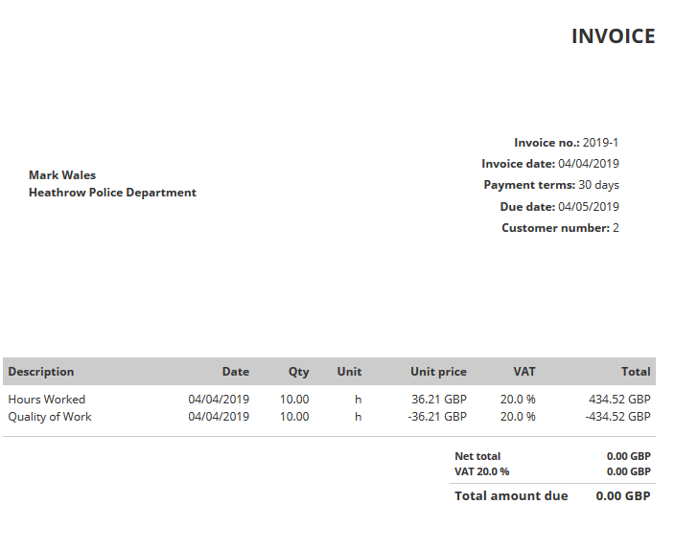
Average salary £36.21 per hour ($47.34) [10].

Conclusion
In conclusion, the author knows that they were unable to complete the task at hand and there were a number of reasons for this, all of which were the fault of the author. The most important reasons for this failure were both the author’s terrible time management and the author suffering from a complete lack of motivation towards the due date of the report. The author also badly handled the evidence data given to them which lend to the data being overwritten multiple times and when coupled with the above, led the author to being unable to complete the second half of the task. After the outcome of this, the author has charged £0.00 for their work and thinks they need to change career.

References

[1] | C. Campbell, “Computer Forensics Assignment,” 5 December 2018. [Online]. Available: https://moodle.uwtsd.ac.uk/pluginfile.php/197738/mod_folder/content/0/ACCA5000_CF_Sem2_assignment_2018-2019%20%281%29.docx?forcedownload=1. [Accessed 13 Feburary 2019].
[2] | Access Data, “Access Data Forensic Toolkit,” Access Data, 16 June 2018. [Online]. Available: https://www.accessdata.com/products-services/forensic-toolkit-ftk. [Accessed 1 April 2019].
[3] | Basis Technology, “Autopsy | Open Source Digital Forensics,” 15 October 2018. [Online]. Available: https://www.autopsy.com/. [Accessed 4 April 2019].
[4] | C. Brian, “Brian's Digital Investigation / Forensics Tools,” Brian's Digital Investigation, 06 January 2009. [Online]. Available: http://www.digital-evidence.org/tools/index.html. [Accessed 02 April 2019].
[5] | Basis Technology, “Basis Technology,” Basis Technology, 12 September 2017. [Online]. Available: https://www.basistech.com/. [Accessed 4 April 2019].
[6] | Basis Technology, “The Sleuth Kit,” Basis Technology, 18 October 2018. [Online]. Available: https://www.sleuthkit.org/sleuthkit/. [Accessed 4 April 209].
[7] | X-Ways Forensics, “X-Ways Forensics: Integrated Computer Forensics Software,” 17 September 2018. [Online]. Available: http://www.x-ways.net/forensics/. [Accessed 4 April 2019].
[8] | SANS Digital Forensics, “SIFT Workstation Download,” 3 March 2018. [Online]. Available: https://digital-forensics.sans.org/community/downloads. [Accessed 4 April 2019].
[9] | “E-mail Forensics and Outlook Data Analysis,” Outlook Transfer, 4 June 2018. [Online]. Available: https://www.outlooktransfer.com/email-forensics-and-advanced-outlook-analysis/. [Accessed 4 April 2019].
[10] | Computer Careers, “Computer Forensics Salary - Computer Careers,” ComputerCareers.org, 5 January 2019. [Online]. Available: https://www.computercareers.org/computer-forensics-salary/. [Accessed 4 April 2019].

Appendix
Name of Software | Open Source? | Free? | Disk Imager | Auto Creates Reports?
FTK Imager | No | No | Yes | Yes
Autopsy | Yes | Yes | No | No
X-Ways | No | No | Yes | No
Pro Discover | No | Yes | Yes | Yes
SIFT-SANS | Yes | Yes | Yes | Yes

