


Ethical Hacking (EH)

Lab 4

Wales Institute of Science and Art
Applied Computing
I.Q Building, Room 205
Swansea
SA1 8EW

Lecturer: Assoc. Professor Carlene Campbell
Email: carlene.campbell@uwtsd.ac.uk
Website: https://www.knowledgewithprofit.com

Vulnerability assessment is an examination of the ability of a system or application, including current security procedures and controls, to withstand an assault. Vulnerability research is the process of discovering vulnerabilities and design flaws that leave an OS and its applications open to attack or misuse.
As a professional ethical hacker or pen tester, your first step is to search for vulnerabilities in the target system or network using vulnerability scoring systems and databases. Vulnerability research provides awareness of advanced techniques to identify flaws or loopholes in the software that could be exploited. Using this information, you can use various tricks and techniques to launch attacks on the target system.

Task 1: Perform Vulnerability Research in Common Weakness Enumeration (CWE)
Lab Objectives
- Perform vulnerability research in Common Weakness Enumeration (CWE)
Lab Environment
To carry out this lab, you need:
- Windows 11 virtual machine
- Web browsers with an Internet connection
- Administrator privileges to run the tools
Overview of Vulnerabilities in Vulnerability Scoring Systems and Databases
Vulnerability databases collect and maintain information about various vulnerabilities present in the information systems

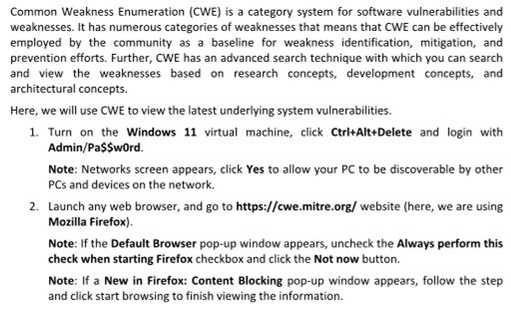

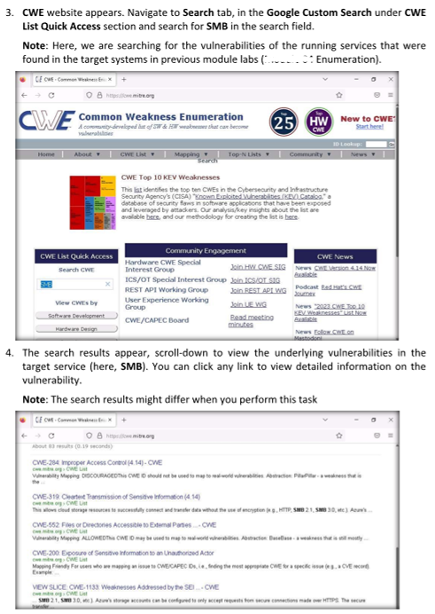

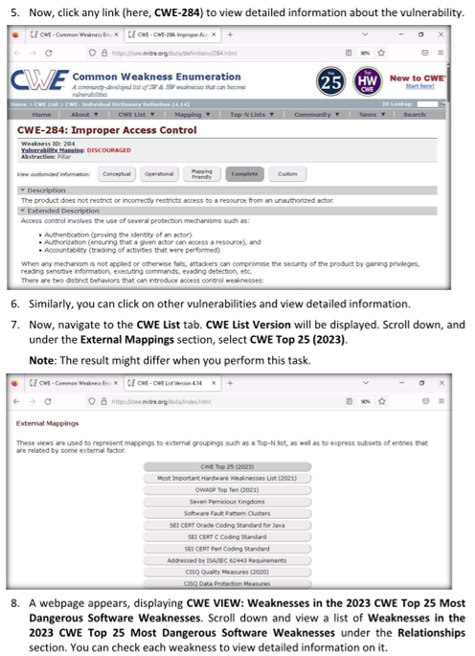
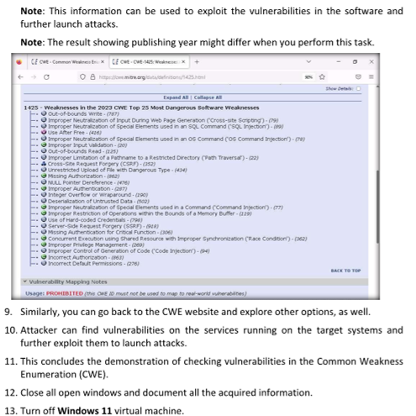

Lab Analysis
Analyze and document the results of this lab exercise.

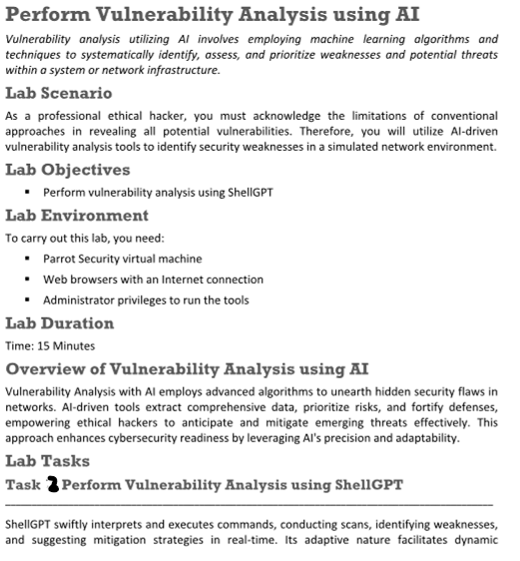
navigation through complex systems, enhancing efficiency and precision in vulnerability analysis. By integrating ShellGPT, you can gain a powerful ally in their quest to safeguard digital ecosystems, leveraging AI's capabilities to uncover and address security risks with unparalleled speed and accuracy.
Here, we will use ShellGPT to discover potential vulnerabilities in the target. The commands generated by ShellGPT may vary depending on the prompt used and the tools available on the machine. Due to these variables, the output generated by ShellGPT might differ from what is shown in the screenshots. These differences arise from the dynamic nature of the AI's processing and the diverse environments in which it operates. As a result, you may observe differences in command syntax, execution, and results while performing this lab task.
1. Turn on Windows Server 2019 virtual machine.
2. Turn on the Parrot Security virtual machine and login using attacker/toor.
3. Before starting this lab, follow the steps to integrate ShellGPT provided in previous labs, Setup → Integrate ShellGPT in Parrot Security Machine.
4. After incorporating the ShellGPT API in Parrot Security machine, in the terminal window, run sgpt --chat nikto --shell “Launch nikto to execute a scan against the URL www.certifiedhacker.com to identify potential vulnerabilities.” to launch Nikto scan on the target website.
Note: In the prompt, type E and press Enter to execute the command.
5. Scan result appears displaying the discovered vulnerabilities in the target website (here, www.certifiedhacker.com), as shown in the screenshot.
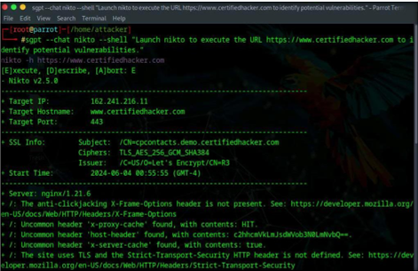
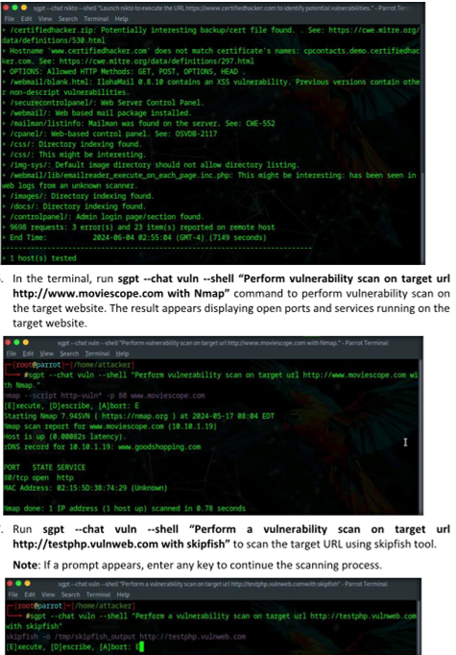
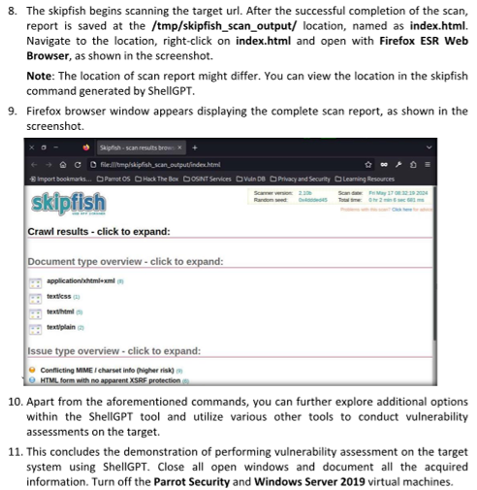

Lab Analysis
Analyze and document the results of this lab exercise.

