Data Analysis and Visualisation

REPORT

Donka Ivanova
2023511

University of Wales Trinity Saint David
London

BSc Cloud Computing

ACCB4002

Suneth Fernando

Table of Contents

Message 3
Colour 3
Text 4
Graphs 4
Graphics 5
Cognition 5
Improvements 6
References 7

- What message is the poster trying to provide?

The infographic tries to provide people with collected information on the impact COVID-19 has had on business. It does not specify in what part of the world so the observers might assume it is based on the country they are reading it in or might interpret it as an international analysis on the impact the COVID-19 pandemic has had on companies and their business. It also tries to inform the people on opportunities of going digital as opposed to print and physical devices. It also gives statistics on the demand of different services in the 6 major sectors.

- Colour – Do the colours fit the subject?

The colours on the infographic result difficult to see with the increase of distance and for certain figures, people will need to be very close to the poster or screen to be able to easily distinguish and read the shown text. Using two different shades of green makes it difficult to focus on one single thing as the main content of the infographics gets lost in the lighter background, of the same colour.
Though the colour combination might look nice and appealing, it might turn out to be impractical, and it is important to have colour-blind people in consideration, as the same colour of a different shade might look all the same to them.
The colours fit the subject of medicine, but they do not look industrial, which is what businesses essentially are, so it could be accepted, but might not be the best combination of colours.

- Text – Can you read everything? Is the text too large or too small?
Are there too many fonts or styles of text?

Most text is easy to read thanks to the high contrast it has with the light background of the poster. The smaller font size might be difficult to read at further distances which could cause misunderstanding amongst readers. On top of that the green numbers and green text used on the green background can look very bad depending on the lighting and the vision capabilities of the person reading the poster.
Some of the chart keys used are barely legible, and as shown on the ‘Impact of COVID-19 on business’ chart, the description of the keys can be read only looking it from very close up.
An easier font on the eyes could have been used as there are too many ‘bold’ [1] fonts which does not guide the person reading the poster on what to focus on.

- Graphs – Are the graphs easy to read?

The graphs clearly indicate the percentages and statistics the person reading the poster should focus on. The colours on the charts allow to easily differentiate every different type of percentage matched to the keys of the charts. The graphs seem to be suitable for the used data though the chart regarding ‘Channel partners expect more support from their suppliers’ seems to be lacking information key for the understanding of the graph, it could be improving by either using a more descriptive heading for the section or more elaborated keys for each percentage.

5. Graphics – Are there graphics that don’t provide information? Is the overall design good or bad?

As mentioned in the above section the graphic regarding ‘Channel partners expect more support from their suppliers’, there seems to be a lack of information, as it is not completely clear what the percentages intend to show to the person reading the poster.
In the graphic under ‘Office print volumes are in free fall’, the font colour next to 68% makes the text very hard to read.
The graphics do not raise any ethical issues as it does not seem the discussed content in the poster is biased in any kind, though sources and references have not been included, which might impact the credibility on the information shown.

- Cognition – Does it put any unnecessary demands on the viewer in terms of memory load, perception, or mental modelling?

The poster puts unnecessary demands as it might make the viewer confused where to look at. Some of the colours make it hard to differentiate, and the green colour might have been overused. At first glance it seems like 70% of the poster is green which can only confuse anyone that is looking at it.

- Improvements – How would you improve the infographic?

I consider the improvements that could be made would come from the colours used [2], and I would make a couple of changes to the different types of fonts used. This could make great improvements on how information is seen by the viewer.
I would use higher contrast colours to emphasise the most important information, such as percentages and main outtakes from each section of the poster.
I would also use larger but thinner fonts for the keys of the charts, which could make a good improvement in terms of legibility.
A sketch on potential improvements is provided below with an example taken from the ‘Office print volumes are in free fall section’

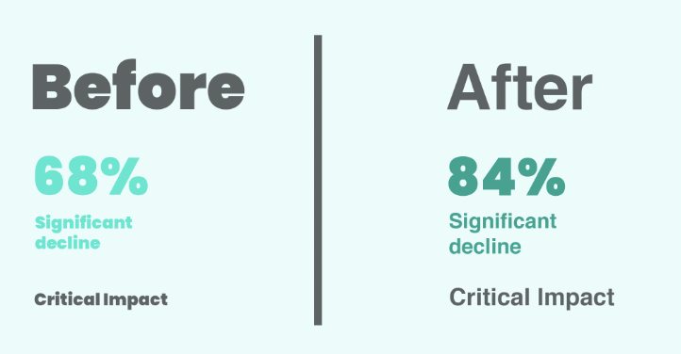

References
[1] L. Graham, Basics of design. Clifton Park, N.Y.: Thomson/Delmar Learning, 2005, p. 271.
[2] E. Lupton and J. Phillips, Graphic design the new basics. New York, NY: Princeton Architectural Press, 2014. p.71.

