Introduction to Database concepts (ACCA4023)
Assignment 1
Adam Smith (2317631)
Digital Degree Apprenticeship

Contents
Section A 2
Task 1 – Types of users who might access the database 2
Task 2 - Departments which might require access 2
Task 3 – Entity Relationship Diagram 4
Task 4 – Relational database schema 5
Task 5 – Database 6
Task 6 - Reports 6
Task 7 - Forms 7
Task 8 -– Menus 8
Section B 9
Task 9 – Importance of developing a database 9
Task 10 - Challenges and benefits of transitioning to database 10
Bibliography 10

Section A

Task 1 – Types of users who might access the database
Database administrator
A Database Administrator would be the role responsible for delivering the project for Costal Getaways. The Database Administrator is responsible for the physical database and its design and implementation. The Database Administrator will review and investigate requirements for building the database, utilising the data receive to then design an appropriate system to meet the specified requirements. The Database Administrator is also responsible for the ongoing development, security and the maintenance of the system, ensuring its continued availability and performance.
Costal Getaways staff
Support staff working for Costal Getaways will require access to amend and delete bookings, review data. Review, amend and or delete reviews, review reports for payments which are due.
Local Businesses
As per the design specification, local businesses can provide services via the DBMS. Local businesses will require access to the database to add and be able to quote for their services and provide detailed information of these services, along with pricing and availability for when tourists can book. Businesses are responsible for ensuring the availability they provide is accurate, they can meet the bookings and the pricing detailed is accurate and reflects the services they offer.
Within the local businesses different departments will require access to the databases, such as a sales department to add or correct bookings, a support department to help with any queries customers may have etc and follow up with any feedback which has been provided. A billing or invoicing department to ensure all bookings are recorded correctly, payments have been received and to chase payments for those which are outstanding.
Tourists / Customers
Tourists will require access to the database to allow them to search for services, check pricing, locations of stays, businesses and activities etc, along with availability and an ability to reserve or book and pay for services. Tourists will also have an ability to provide feedback for the services they have used, to help continual development of the service.
Local council / government tourism board / ONS
It is possible the local council or government tourism or Office for National Statistics (ONS) may request a form of access to be able to view and download data on sales / tourism numbers. The role of these users would be to analyse data gathered by the database in preparation for local government or tourism board use.

Task 2 - Departments which might require access
Accounts
Accounting is responsible for all incoming and outgoing expenditure. The accounting department will require access to the database to see all bookings, with the relevant fees and balances. Accounting will require access to account holder details, banking information, including addresses etc, for customers. They will also require the same from service providers. Will require access to invoicing and an ability to create invoices for customers. Will require access or ability to confirm which invoices have been paid, when they are due and an ability to highlight passed due invoices, to chase debtors for payment.
Sales
Responsible for supporting use of the services and increasing use of the system. Sales will be responsible for answering queries from customers, both tourists and businesses registered within the system to provide services. Sales will require access to see user data – such as the account details of the person they are responding to, along with any bookings they have made and associated prices. Whilst they will not need access to bank information, they will likely need the ability to see if a booking has been paid or not. They will also need the ability to make, cancel and adjust bookings to help with customers who are less computer literate.
Support / HR
Responsible for administration of staff, deal with hiring, training and discipline of employees. Will require access to sections of the database regarding staffing. Will require access to confidential information such as full employee files, including salary along with company records of transactions and detailed lists of employee accreditation, qualifications and specific training received whilst employed in this business. Will not require access to third party businesses etc.
IT / Database Administrator
The task confirms the company is hiring someone else to build the DBMS as such they would not be involved in the building or implementation of the DBMS. The IT department and Database administrator will be responsible for the ongoing security, development and maintenance of the database. They will require full access to the database to be able to deal with requests made by other departments and the ability to change records etc to ensure the accuracy of data. They will be responsible for the data integrity and the continual development of the system and integrity with new services which the business may wish to provide in the future.

Task 3 – Entity Relationship Diagram
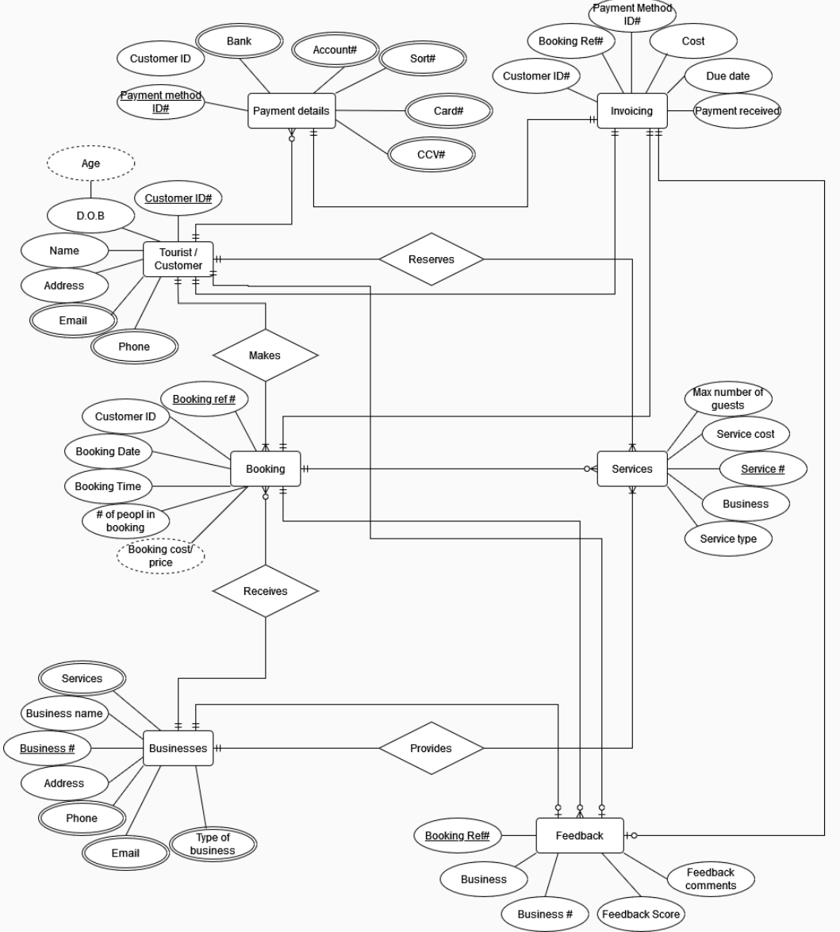 The file can be accessed HERE

Task 4 – Relational database schema
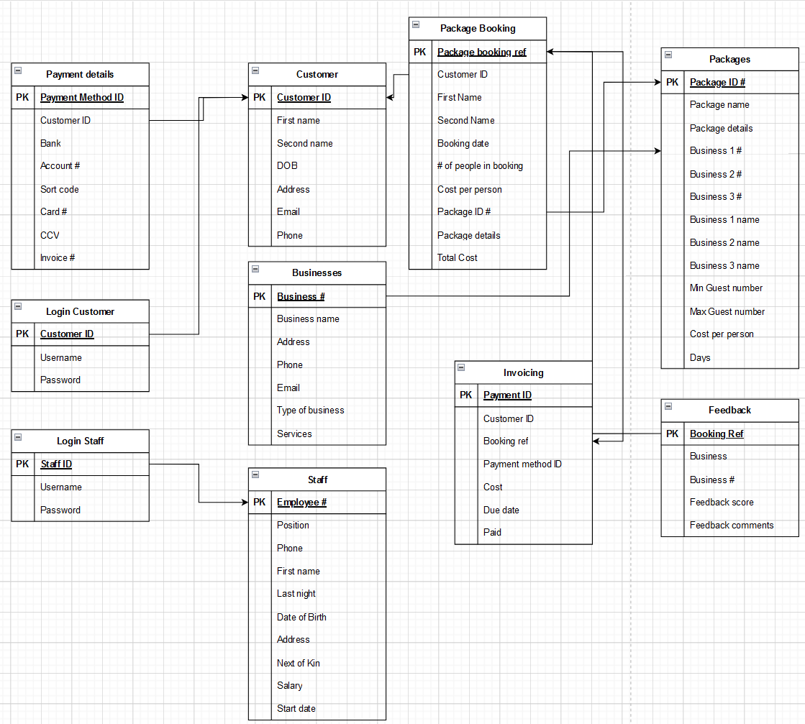
Tourist / Customer
Customer ID (PK), D.O.B, Name, Address, Email, Phone.
Booking
Booking Ref # (PK), Customer ID(FK), Booking date, booking time, # People booked, Service, Booking Cost (calculated field)
Services
Service ref # (PK), Max # of guests, service cost, Business, Service [details].
Payment Details
Payment method ID#(PK), Customer ID(FK), Bank, Account #, Sort #, Card #, CCV #, Invoice # (FK)
Invoicing
Payment (PK), Customer ID, Booking ref, Payment method ID, Cost, Due date, Paid
Businesses
Business # (PK), Business Name, Address, Phone, Email, Type of business, Services
Staff
Employee #(PK), Position, Phone, First name, Last name, Date of birth, Address, Next of Kin, Salary, Start date.
Feedback
Booking ref(PK), Business, Business #(FK), Feedback score, Feedback Comments.
Package booking
Package booking ref(PK), Customer ID, First name, Last name, Booking date, # of people in booking, cost per person, package ID#, Package details, total cost
Packages
Package ID # (PK), Package name, Package details, business 1 #, Business 2 #, Business 3 #, Business 1 name, business 2 name, business 3 name, Min guest number, Max guest number, cost per person, days,
Login Staff
Staff #(PK), Username, Password
Login Customer
Customer ID(PK), Username, Password

Task 5 – Database
Database file uploaded separately.

Task 6 - Reports
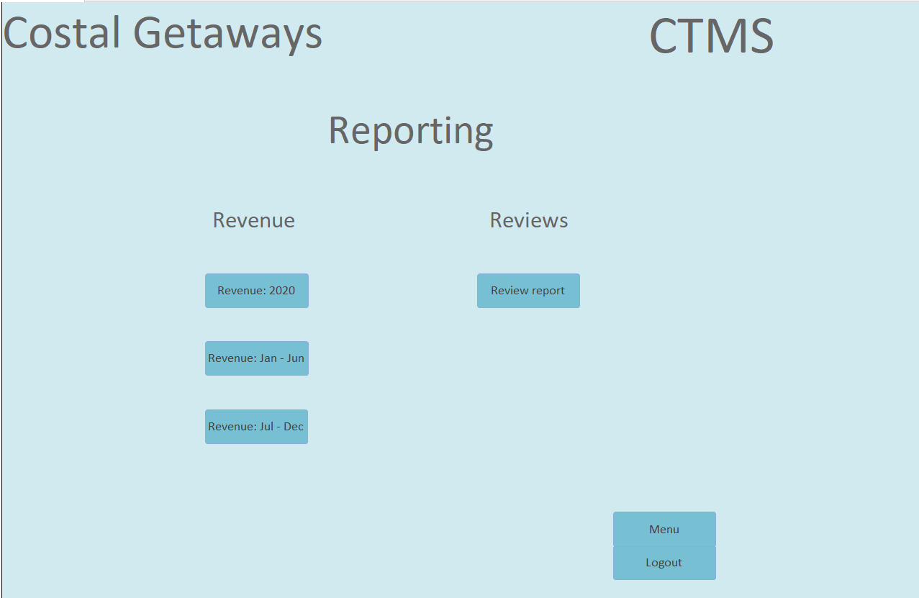
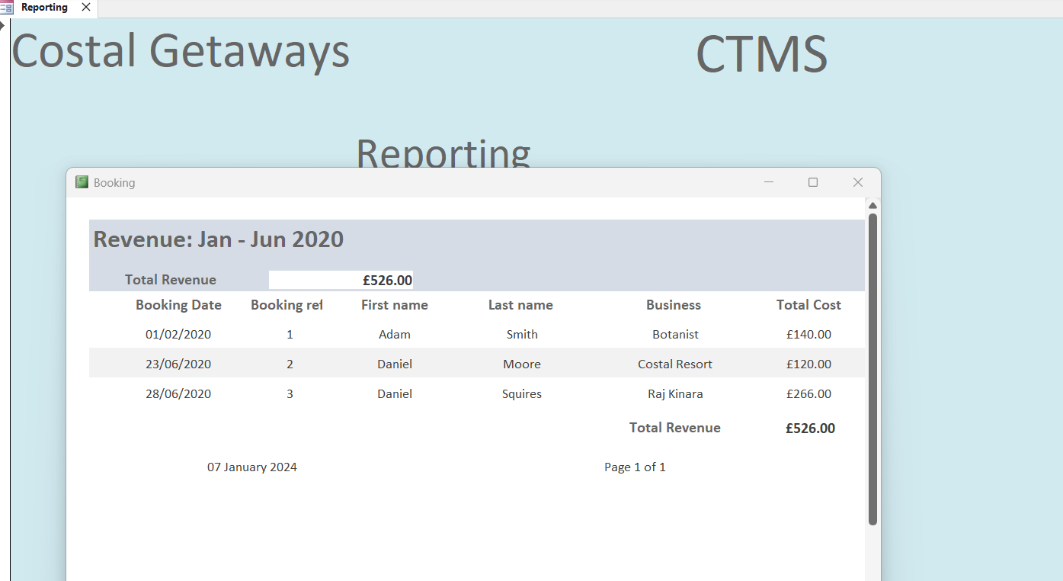
Reports are located on a form which is accessed from the staff menu. Reports open in a separate pop-up tab when selected in the relevant form.

Reports named: Revenue
Rprt – Revenue: Jan – June 2020
Rprt – Revenue: July – December 2020
Rprt – Revenue: 2020
Feedback
Rprt - Feedback

Task 7 - Forms
Forms named: Customer Customer Booking
Package booking
Package change

Forms are split into those intended for use by staff and those intended to be completed directly by customers.
Both forms use a customer ID – the staff form will autofill the customers name so they can confirm they have selected the right customer. Selection is restricted to a drop down to ensure they select a valid customer number.
Booking date is restricted by a validation rule to ensure that all bookings are made for a future date, and cannot be made in the past.
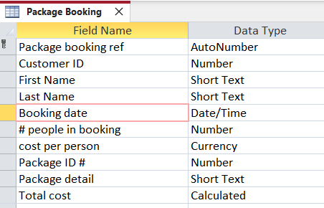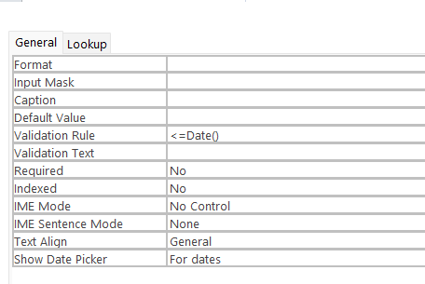

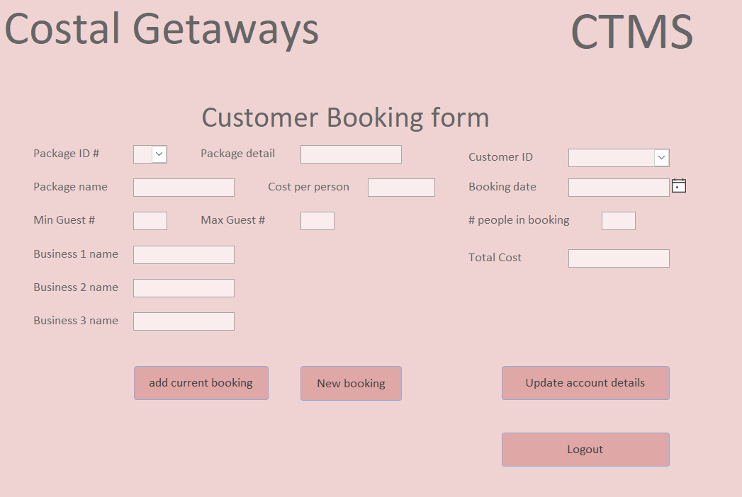
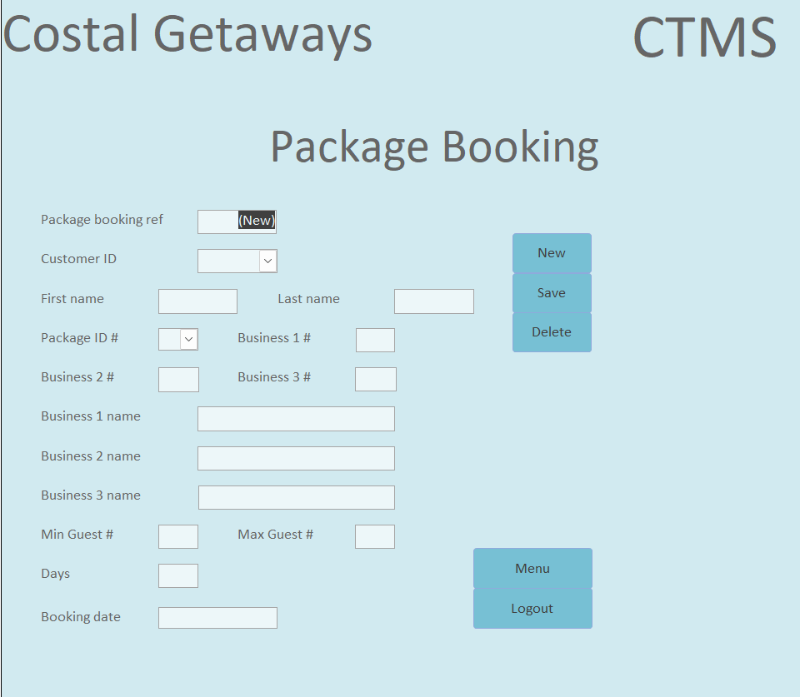

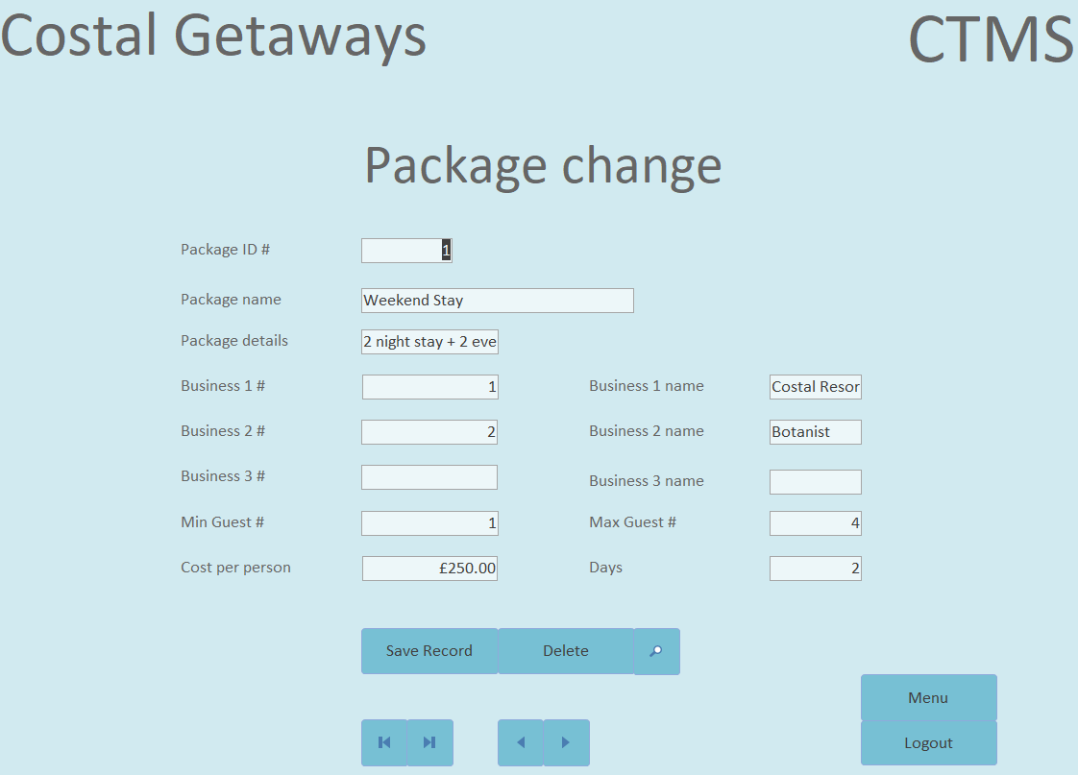

Task 8 -– Menus
Database file uploaded separately.
Menu opens immediately when database opened.
Menu allows users to navigate to reports, forms
Database opens immediately into a login screen.
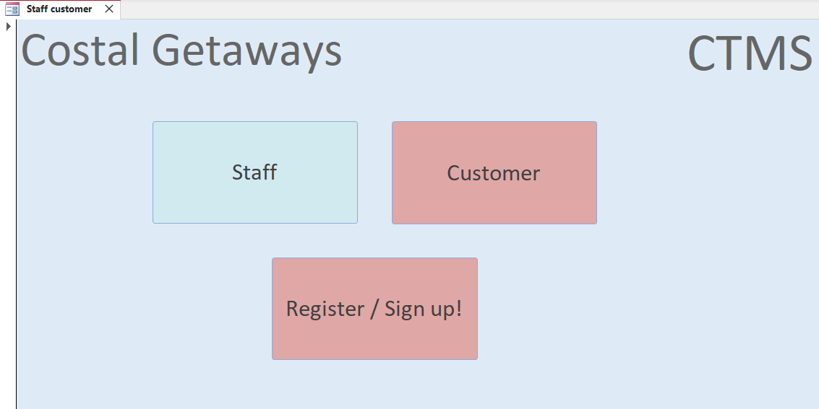

Navigation of database via customer or staff login, and then separate user menu’s
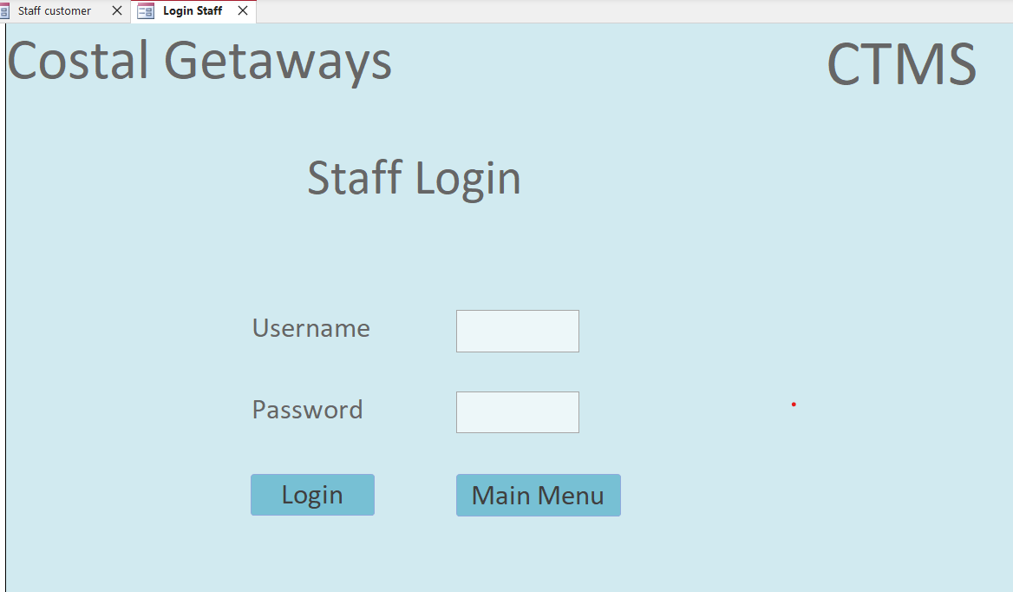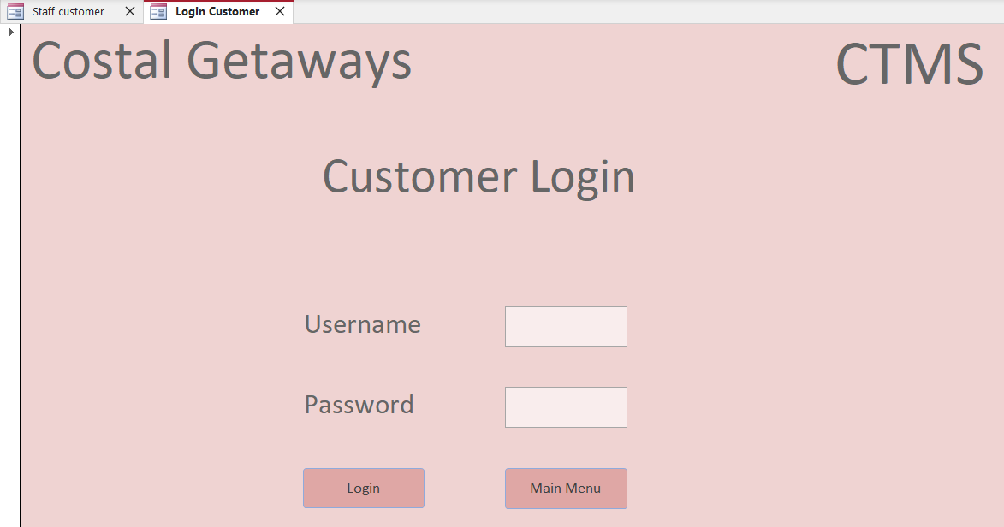

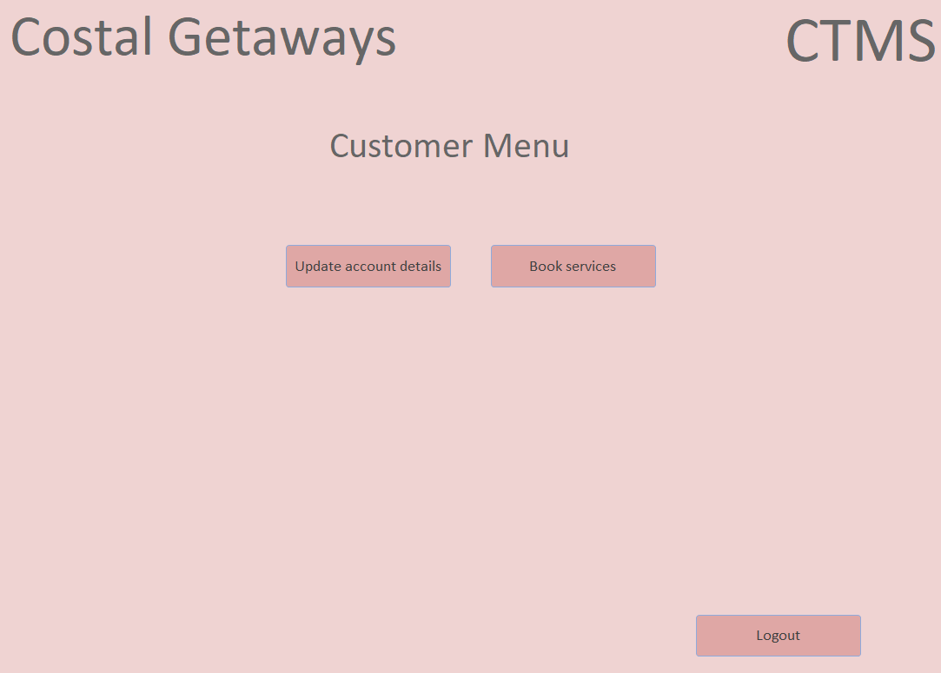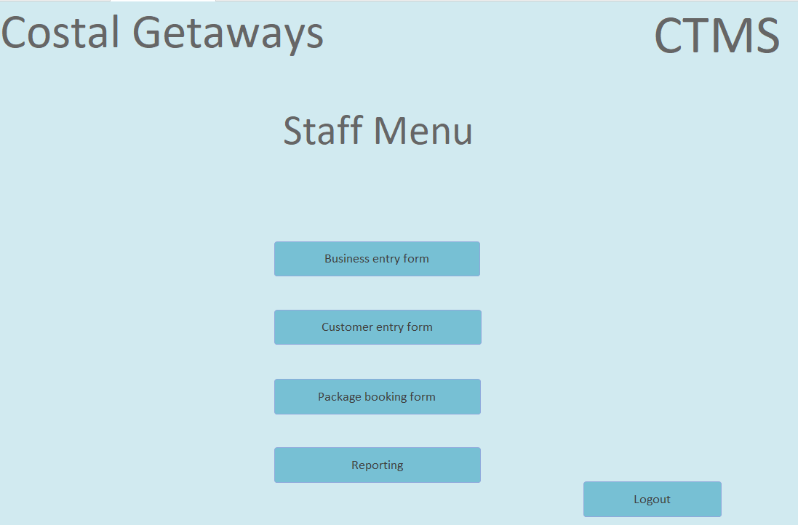

Section B

Task 9 – Importance of developing a database
Implementing a database over a file-based system has several benefits and efficiencies. A file-based system is ‘A collection of application programs that perform services for the end users, such as the production of reports. Each program defines and manages its own data’ [1]. 3 main advantages of a database are Data availability and cross-referencing, Data security and data integration.
Implementing a database over a file-based system of either physical or electronic records would allow for better cross referencing between businesses and instant access to data. For instance, were a customer to register with the costal management database their details would be stored correctly for all businesses across the platform, allowing for a better user experience, better tracking for the businesses and improved data for analytics. It would also mean that whereas previously a customer may have updated their details with a single section or business, this information would now be stored centrally to ensure data integration and mean all records would update to reflect the new information. The ability to cross-reference data instantly is a huge increase in efficiency over manually searching separate platform/applications for records, or paper files allowing for fewer staff required to input and manage the accounts.
Data security can be improved by the implementation of specific user accounts protected by secure passwords, allowing for customers to enter payment details securely and these be protected from other users and still be used when required. This can improve efficiency for businesses as they can utilise this database instead of maintaining their own individual systems – avoiding individual maintenance costs and allowing for businesses to spend more time on other elements such as marketing.
The size of the database would be improved over a file-based system. An electronic record or database would take drastically less room than a secure physical filing system, and with correct data integrity and minimising data duplication a database should require less memory than a separated electronic file-based system.
One a database has been built data access and reporting will be significantly quicker and more efficient. There should not be any issue with incompatible file formats. Changing and adding data for reporting should be a simple matter, and not require a developer to write software to convert files or writing new parameters to create required queries or reporting.
A database will also help with redundancy, allowing for easy creation of backups of data and ease of reinstatement if there is an issue.

Task 10 - Challenges and benefits of transitioning to database
A large part of the challenge of moving from manual data management to a computerised system is the initial required data input and the time this will require. All manual paper records will require an electronic equivalent – along with the time invested to design an appropriate system which will record the required data in a fashion which will allow it both to be accessible, can be cross-referenced and also avoid data duplication.
A potential challenge of utilising a DBMS system is the required data protection and limitation laws and ensuring compliance with these restrictions. A DBMS can help address these by ensuring protected data is restricted to required personnel, providing an audit trail of who has access and when along with categorising all records in one place – meaning compliance can easily be documented and demonstrated where needed.
A benefit of moving to a DBMS is that once completed, paper records will no longer be required, meaning less requirement of space and potentially less cost.
Data integrity and cross referencing is greatly improved with the use of a DBMS. Instead of the cost in both time and staffing to have records manually collected and reviewed, a DBMS will allow for instant comparison and integration between departments and linked businesses.
With all details being stored in one DBMS there should be no issues with data format. Meaning queries and reporting should be easily available when requested and not require one off software to be written to get the required results.
Redundancy is a benefit of a DBMS. A computerised system allows for easy creation of back up’s, and the ability to easily roll back to a previous version or mirror and reinstate data.
Both a challenge and benefit when transitioning from manual data management to computerised is the element of Human error when in-putting raw data. Mistakes can be made by the person entering or creating the records. The benefit is that once the records have been created, human error is limited, once digitised, a large portion of human process is removed, which should equate to less errors.
Scalability and associated costs of implementation are a potential benefit of utilising a DBMS. An initial system can be purchased for the current scale and needs of the associated use and businesses, with the ability to increase as required with the addition of businesses and data volumes in the future. This also ties in with ongoing maintenance costs, the initial requirements will be appraised, with server and storage space provided to match required needs – meaning maintenance is only being paid for what is required, which will then increase with demand.
Complexity is both a challenge and a benefit. The initial installation, migration and implementation of a computerised system is complex and requires third party involvement, but once implemented, the system should be easy to use and require less staff and time to operate.

Bibliography
[1] T Connolly & C Begg, Database systems, A Practical Approach to Design, Implementation and Management, 6th Edition, Global Edition, Pearson 2015, ch1, p55

