Manufacturing Design & Technology

William Taylor Durban – 2218327
ACMA5002
Task 1 – Case Study - Applying Design for Additive Manufacturing Principles to an Existing Component

Contents
Introduction 3
Initial Design Assessment 4
Addition Manufacturing 7
Solidworks Analysis Tools 11
Stress Analysis 11
Topology 14
Design for Addition Manufacturing 17
Designed for 3D Printing 17
Stress Analysis on New Design 18
Topology on New Design 19
Prototype 20
Conclusion 22
References 23

Introduction

This report outlines the design for manufacture (DFM) of a component that is used in one of the automation machines that are designed, machined, and built by Sony UK Technology Centre. For this project the focus was on the gripper finger component of the autoloader system that attaches onto the auto tester machines – the component can be seen in the engineering drawing in figure 1.
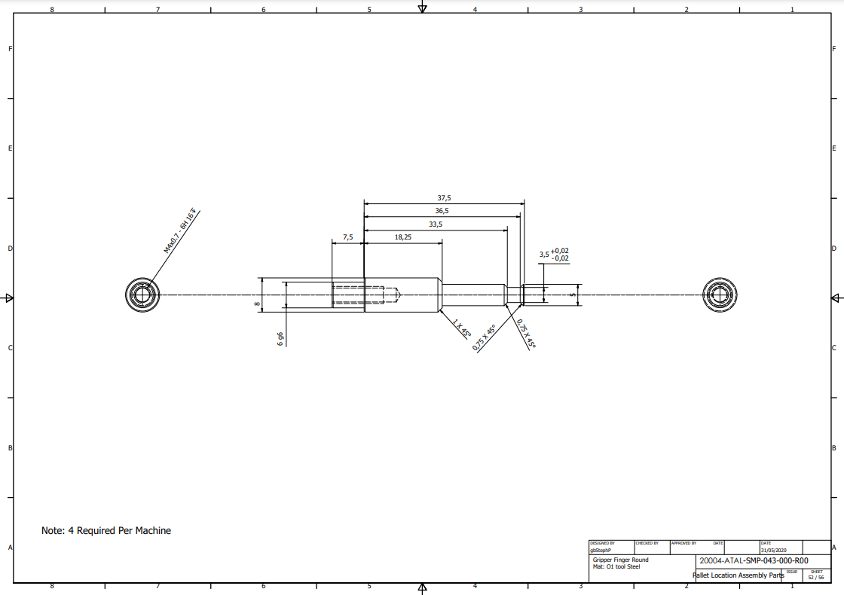
Figure 1 – Autoloader Gripper Finger Component Engineering Drawing.

As seen in the drawing the current material choice is 01 tool steel, however, the goal of this project is to research, analyse and produce additive manufacturing methods and materials that offer savings in both time and cost of the manufacture of the component without reduction in strength or fatigue.

Initial Design Assessment

Looking at the engineering drawing provided by the lead designer (figure 2), it can be quickly recognised that this component is a simple part to manufacture using a manual or CNC lathe. In Sony UK Tec this part has always been turned by the same workshop engineer, due to the high tolerance on the 6mm G6 diameter and the +/- 0.02mm tolerance on the narrowest diameter on the opposite end.
Figure 2 – Engineering Drawing Up Close

These tolerances add a great deal of time to the manufacture of the part as not only does the part need to be dimensionally accurate but also have a high-quality surface finish and be concentric – the concentricity tolerance is not specified, but concentricity still needs to be achieved for accuracy.
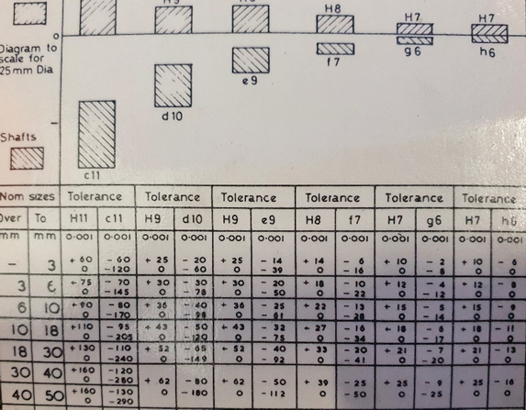
Figure 3 - Zeus Book Tolerance Page

As shown in figure 3 the Zeus book denotes the G6 tolerance on a 6mm shaft to be 0.005 to 0.014mm under sized – 5.986 to 5.995. For this type of measurement and quality control a micrometre is required, as well as this a much more accurate 6 tooth, self-centring, collet lathe chuck is used to increase the ease of achieving concentricity. All these factors combined make the process of machining this component quite complex, time consuming, costly (in terms of labour) and restrictive as there is only one member of the team who can achieve these tolerances.

After discussion with the design team, it was found that the choice to use 01 tool steel was because of the requirement of having a material that has good durability properties and excellent wear resistance. Although this material choice far exceeds the requirements of the component as its job is simply to pick up, transport and place a Raspberry Pi computer (as can be seen in figures 4 and 5), the product only weighs around 46g, and very little force, only around 19N, is produced by the (SMC MHF2 – 8D1R – X83B1) low profile air gripper (gripper can be seen in figures 4 and 5) (SMC.eu, 2023).
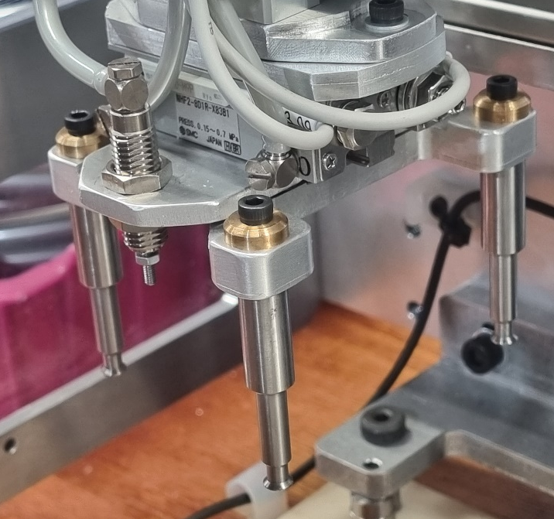
Figure 4 - Gripper Seen without a Raspberry Pi Board
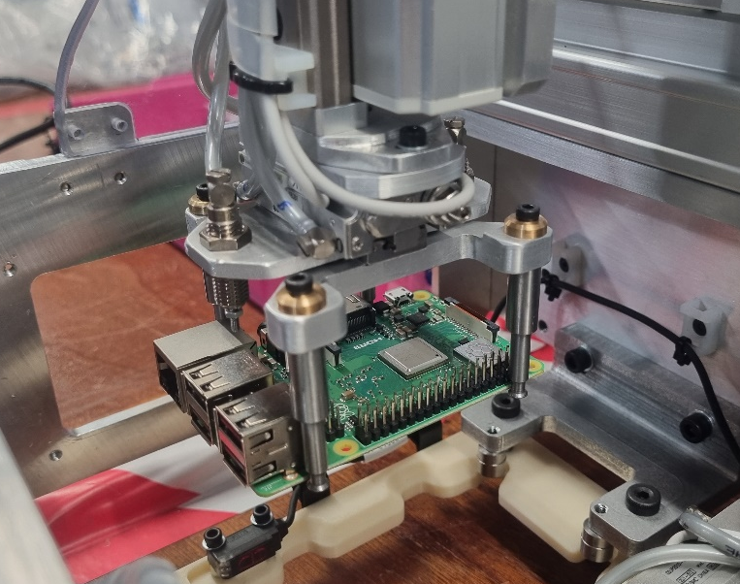
Figure 5 – Gipper System Seen Holding a Raspberry Pi Board

Despite the large volume of use, at this force, fatigue of 01 tool steel would not be an issue as the fatigue strength is 40 KSI (onlinemetals.com, 2023), much higher than alternatives that would have likely been suitable – for example 6061 aluminium, with fatigue strength of around 14 KSI (asm.matweb.com, 2023), would still be enough for this application.

Addition Manufacturing

Using the opposite approach to reduction manufacturing, addition manufacturing (AM) uses the principle of adding material, and building a part, rather than cutting or machining a part out of the stock material. This addition method often means much less waste, and less restriction during manufacturing as over hangs and negative space can often be included without too much hassle.

The most recognised AM process is 3D printing, gaining huge development over the past 15 years it has now become a common use engineering tool, initially just for prototypes but now for small batch manufacturing and sometimes small mass production tasks. As the technology has progressed the range of options has grown tremendously with options ranging from the cheaper, simple printing of plastics such as PLA and ABS through to more complex titanium 3D printing – as well as all the composite material printing in between. Drawbacks to more complex printing tasks usually arise around the cost, accessibility to equipment and material property quality, for example 3D printed titanium is less dense than machined titanium and therefore will not have the same properties (Daley, 2022).

To decide which 3D print type to use the capabilities of each style needed to be analysed, in Sony this decision was between the two brands of FDM (fused deposition modelling) printers – Ultimaker S5 and Stratasys F170. There is also a Formlabs, Form 3 SLA (stereolithography) printer and the newest printer, a Markforged Mark Two desktop series continuous fiber printer.

Generally, the Ultimaker printer is used for prototyping and less critical prints, with the Stratasys being used for higher finish qualities and better dimensional accuracy. Meanwhile the Markforged printer is often run with a carbon fiber constant filament, this is used to hugely increase the strength of components and can be used to print parts that in some cases rival the strength of reduction manufactured parts. Typically, the Markforged is used when the component needs to be strong and have a low Youngs Modulus (low amount of flex). The Formlabs Form 3, being a resin-based printer, delivers the best dimensional accuracy, and the best surface finish – something that will be important for the component being designed for printing, as it needs to achieve high accuracy on the shaft where it connects to the gripper plate (as can be identified in figure 6).

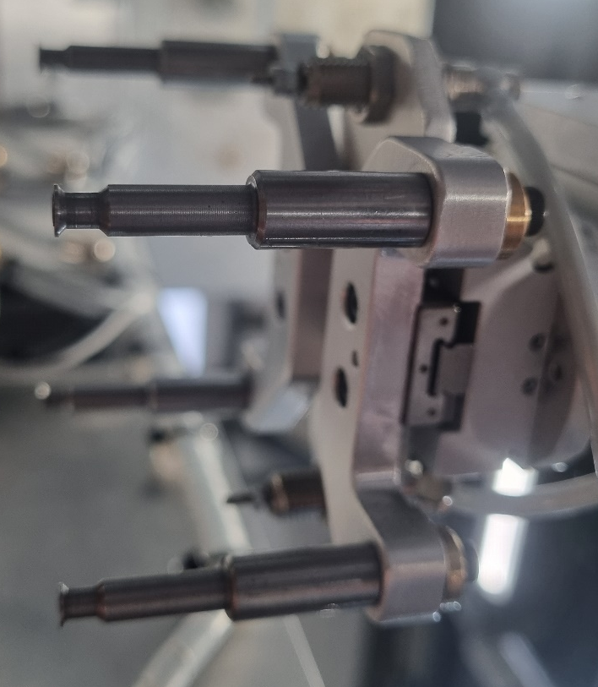
Figure 6 – Showing how the Gipper Fits into the Gripper Plate

As specified, this is a tolerance clearance fit and needs to be accurate to keep the gripper perpendicular to the gripper plate and parallel with each of the other grippers. The end of the gripper finger, where it contacts the Raspberry Pi also needs to be within a 0.2mm tolerance, the surface finish also needs to be good in this area as a poor surface finish has the potential to allow for the Pi board to slip/move in the gripper. Since the grippers need to be strong enough not to flex and withstand a large volume of load cycles then the strength and fatigue of the resins available will need to be evaluated before deciding to use this printer over the Markforged composite printer, which undoubtably produce a stronger component, but with a less accurate surface finish.

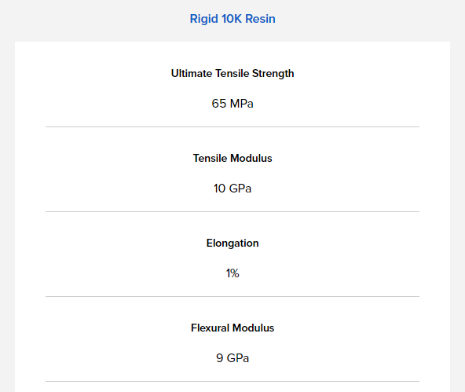
Figure 7 - FormLabs Rigid 10K Resin Material Properties
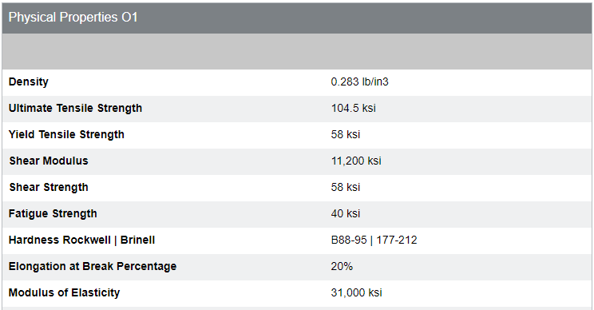
Figure 8 - OnlineMetals.com 01 Tool Steel Material Properties
Comparing the Formlabs Rigid 10k resin to the properties of the tool steel that was initially used for the part it is easy to see that the resin has a much lower flex/elasticity to the tool steel, 1305KSI (Formlabs.com, 2023) compared to 31000KSI (as 1GPa = 145KSI). It is difficult to compare this to the flex of composite materials as the print can be adjusted and set up to have strength in different areas, depending on where it is required. Just considering the properties of the base material and continuous carbon fiber support printed in a standard profile, and not including any extra carbon fiber support that may be added to specific areas the data sheet seen below in figure 9, suggests an elastic modulus of 3GPa, or 435KSI for the base material and 51GPa or 7395KSI for the carbon fiber support (Markforged.com, 2023). This suggests the blend used in a composite print would be higher than the resin, but still lower than the tool steel.

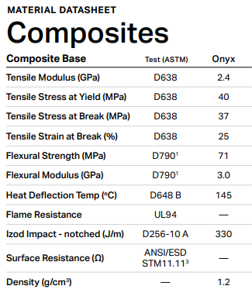
Figure 9 – Markforged Datasheet

For the requirements of this component, it was decided that the resin printer would be the best choice, although the elastic modulus was a little lower (suggesting that the component would flex more under load) the increase in dimensional accuracy and surface finish was more desirable.

Solidworks Analysis Tools

Stress Analysis

After using the Solidworks CAD package to create the CAD model from the engineering drawing provided the model was loaded into the analysis side of the software, this allows for a stress analysis to be completed, setting the material to the different options to evaluate how the different materials behave under the stress and adding scientific fact to the material and printer choice.

Figures 10 and 11 show the component in the stress analysis tool, with the data inputted, the material set to tool steel and the force set to 19N; this is the maximum the gripper can output, during normal use this is shared between the 4 grippers, but if set up in correctly, theoretically all the force could be pushed through one gripper.

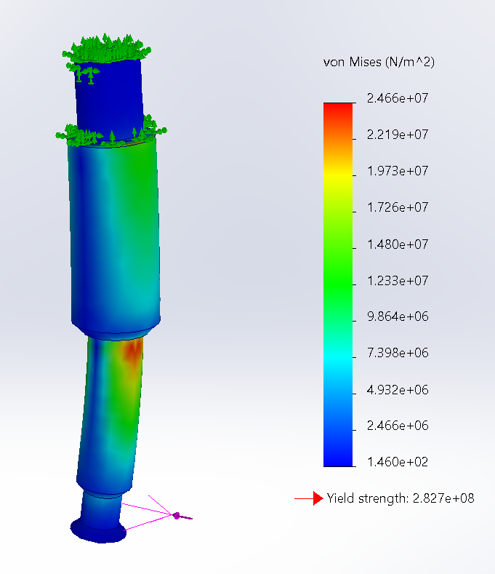
Figure 10 – The Model in the Stress Analysis Tool
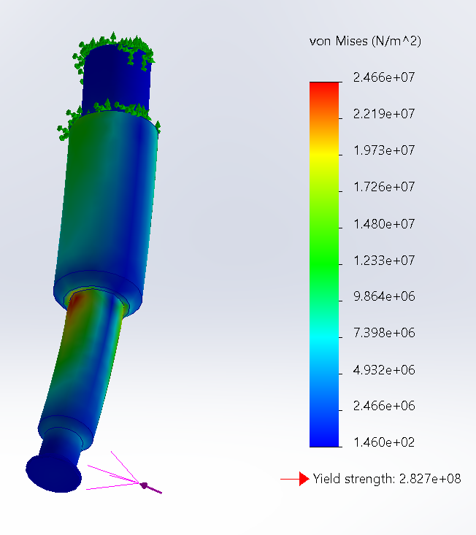
Figure 11 – Second View of Model in the Stress Analysis Tool

As can be identified using the colour scale for strength, where there is blue on the model the stress is below 0.000004932 N/m^2, whereas above this figure (as shown by the green, yellow, and red areas) is where there is greater stress and suggests that this is where the weakest points of the design are. If the design was to be changed it would be advisable to add more support in these areas.

A second stress analysis was run, this time with the material choice set to the specifications of the resin material, this allowed for there to be a fair comparison between the materials and to ensure that there would not be any vital information missing when modifying the design for additive manufacturing.

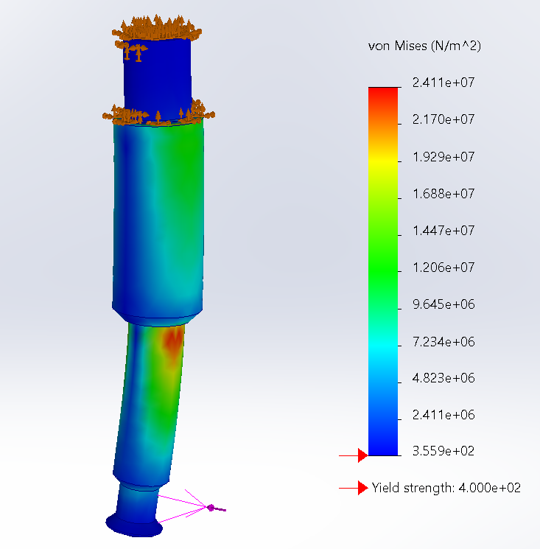
Figure 12 – Stress Analysis with the Material Set to Resin

Figure 12 above shows no visible change compared to the analysis with the material set to tool steel, this suggests that with such a low force, the gripper finger will operate as required no matter which material is used.

Topology

A topology analysis is the evaluation of what can be modified to make the component smaller/lighter/less dense whilst still maintaining the same structural integrity and engineering properties. In this circumstance the topology study was completed by importing the model, setting the fixed positions (where the component attaches to the gripper assembly, and then applying a force. For this analysis the force was set to 19N and the material was set to tool steel, the software then ran through the data and produced the model as seen in figures 13 and 14.

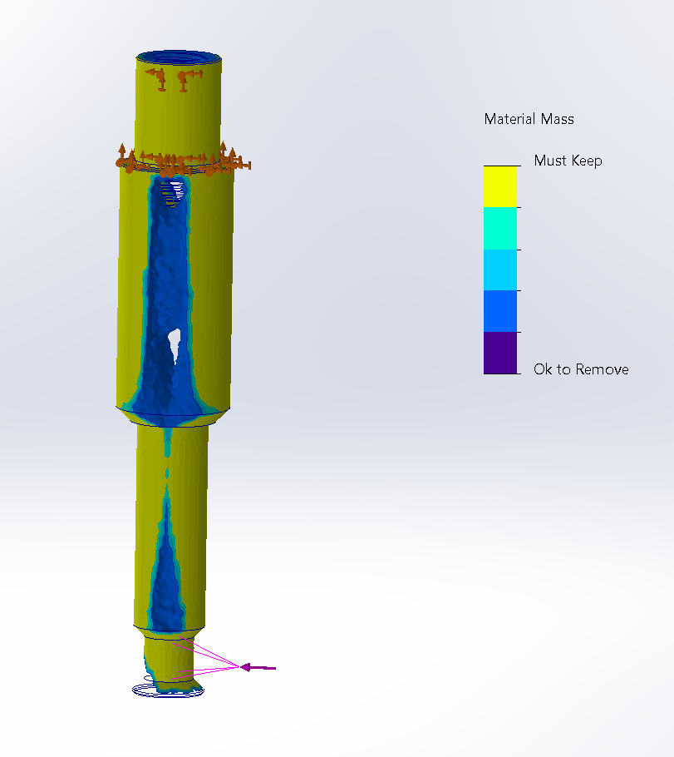
Figure 13 - Component in the Topology Analysis
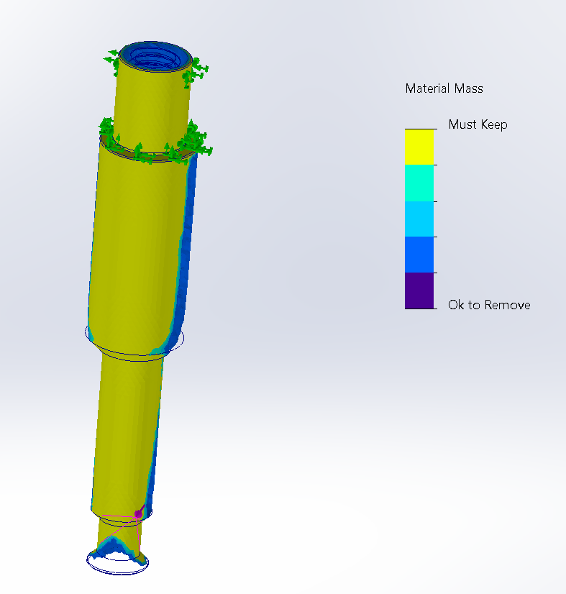
Figure 14 - Component Shown from Rear

As can be seen from figures 13 and 14, the yellow areas are the critical mass, without these areas the component could not complete the task it is designed to do so. There are no large areas of dark purple, which suggests that the part is not massively oversized, the darker blue areas suggest that the part could be modified, to make it lighter and smaller. This even suggests that it would be possible to put a space through the middle of the part and it still be completely operational – in this circumstance this would not result in any real benefit and so is unnecessary, however, on a component that needs a wire running through it this could be very useful information.

Similarly, to the stress analysis, a second test was run, this time with the material set to the 3D print resin.

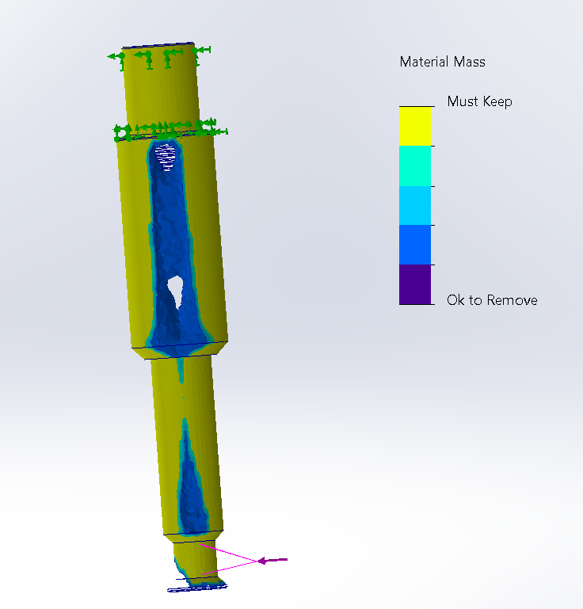
Figure 15 - Topology of Component with Material Set to Resin

As shown in figure 15, with the material set to resin there is no real difference between what is suggested, this information can be used to reinforce that due to the minimal force the gripper finger is put under the material chance from tool steel to 3D print 10K resin will not make a difference to the performance.

Design for Addition Manufacturing

Taking into consideration of all the information from the original design, the component requirements as well as the data from the analysis tests the following design modifications have been made to ensure that there is minimal loss of strength and rigidity whilst also making the component as easy to manufacture as possible.

Designed for 3D Printing

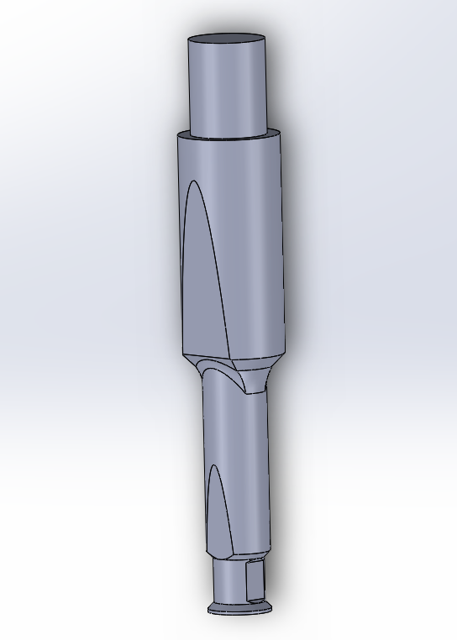
Figure 16 – Redesigned Part

As can be seen in figure 16, the part has been redesigned whilst keeping the previous findings in mind. Material has been taken off the sides of the gripper, to reduce weight, reduce the amount of resin used on each print, to make the gripper slimmer and as it gives a good flat space for the gripper to be printed from.

Stress Analysis on New Design

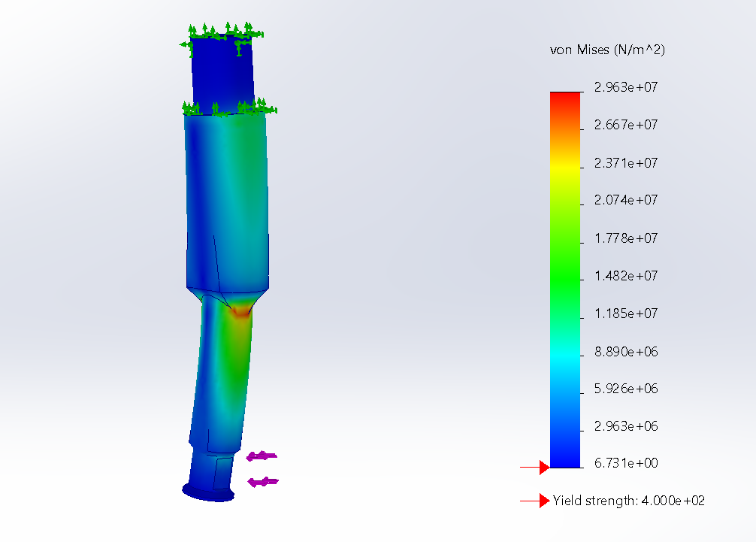
Figure 17 - Stress Analysis on Redesigned Part

Figure 17 shows that the stress points are the new design are much smaller than the previous design, this suggests that there is a smaller stress raiser between the stepped shafts. If possible, it would be good to remove this step all together and instead have a smooth taper from one diameter to the other, this would likely remove the stress locator on the step and instead share the stress throughout the length of the part. However, in this circumstance the space where the gripper drops off the Raspberry Pi board is small and so the stepped shaft is required for there to be clearance. Overall, the reduction in the red area suggests that the new design has better stress distribution across the part and would likely be stronger than the previous design (if both are 3D printed in the same way). This also builds confidence as the 3D print is recognised to be weaker than the tool steel, however, the new design reduces the gap in strength between the two materials.

Topology on New Design

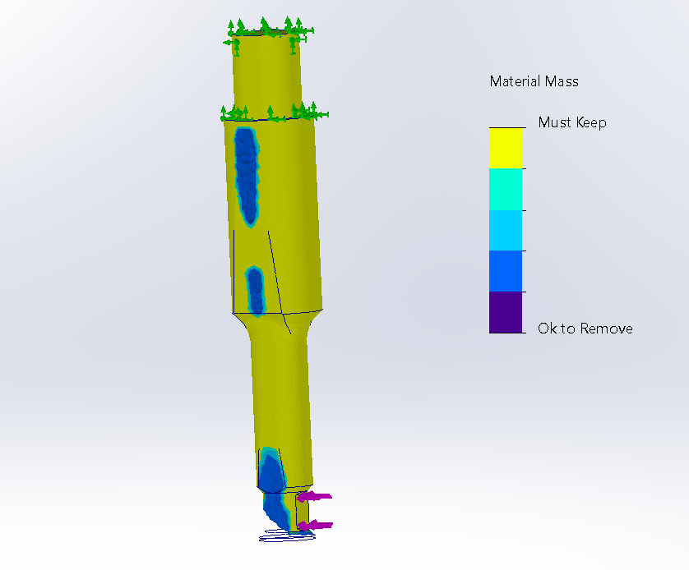
Figure 18 – Topology of the New Design

Finally, another topology analysis was completed on the new design, again this showed improvements over the previous design. There is less blue/purple areas, suggesting there is less unnecessary material – most of the blue/purple areas that remain are still there for aesthetic purposes, to remove all of these areas would leave the part looking unfinished and unprofessional. As the parts job does not particularly depend upon weight, and reducing the size of the component was more important it is good to see that the new design has been able to remove some material and increase the clearance the grippers have when placing the Raspberry Pi boards in the carrying pallet.

Prototype

To further test the theory that has been analysed using the Solidworks design tools a resin 3D printed model was produced on the Formlabs 3 printer out of the grey 10k resin (as discussed). This model can be seen in each stage of manufacture in the images below:

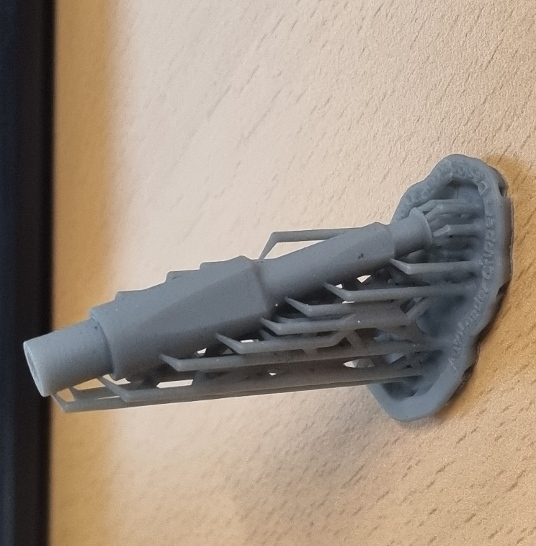
Figure 19 – 3D Printed Part After Curing

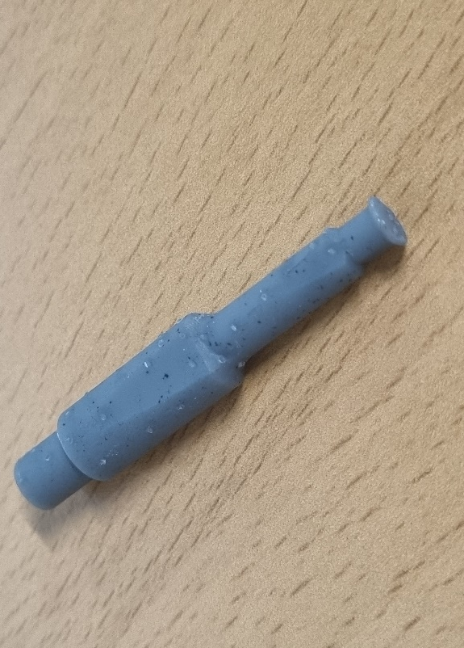
Figure 20 – 3D Printed Part Before Finishing
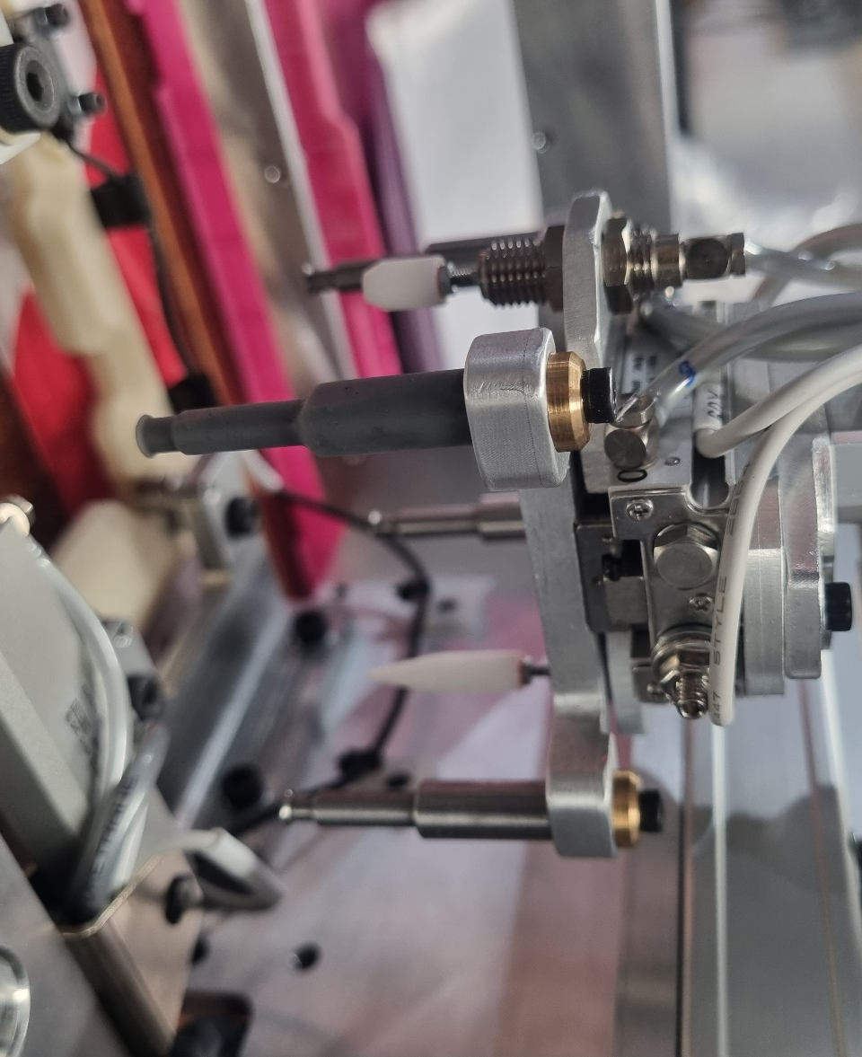
Figure 21 – 3D Printed Prototype Fitted to the Offline Autoloader for Testing.

From these images it can be seen that as expected the surface finish and accuracy is good, with a tight tolerance fit into the gripper mounting plate. Visually the component looks almost identical, just with slightly better clearance in the drop off pocket. The next step is for a trial run to take place to evaluate the real-life performance of the redesigned gripper.

Conclusion

To conclude this mini project, it would be fair to say that successful changes have been suggested to make the design more suitable to print, as well as these changes have been made with a recommended printing type in mind and even a specific material (Formlabs Form 3 printer, with their 10k resin).

Using stress analysis and topology tools has allowed for thorough investigation into the original design, these tools have also been used to support decision making when making suggestions for the new design and have helped to support the changes that have been made to make the part more accurate and stronger than if the original design had been printed without any changes.

Once the remaining 3 grippers have been printed and a trial run has taken place, a final decision can be made on whether this change to a 3D printed gripper should be made for all the autoloader units.

References

asm.matweb.com. (2023), ‘Aluminum 6061-T6; 6061-T651’, [online]. Available: https://asm.matweb.com/search/SpecificMaterial.asp?bassnum=ma6061t6 [Accessed 2023 June 14].

Daley, S. (2022), ‘3D Printing’, [online]. Available: https://builtin.com/3d-printing [Accessed 2023 June 27].

Formlabs.com. (2023), ‘Rigid 10K Resin 1 L’, [online]. Available: https://formlabs.com/eu/store/materials/rigid-10k-resin/ [Accessed 2023 June 27].

Markforged.com. (2023), ‘Mark Two’, [online]. Available: https://markforged.com/3d-printers/mark-two [Accessed 2023 June 25].

onlinemetals.com. (2023), ‘O1 Product Guide’, [online]. Available: https://www.onlinemetals.com/en/product-guide/alloy/O1 [Accessed 2023 June 11].

SMC.eu. (2023), ‘2 Finger Gripper, Parrallel Style, Standard - MHF2’, [online]. Available: https://www.smc.eu/en-gb/products/standard-mhf2~17437~cfg?partNumber=MHF2-8D1R [Accessed – 2023 June 11].

Zeus Engineering Book [Accessed 2023 June 10].

Manufacturing Design & Technology

William Taylor Durban – 2218327
ACMA5002
Task 2 – High Volume Production – Portable Wind Turbine Redesign

Contents

Introduction 26
Concept Design Appraisal 27
Design Specification 28
Manufacturing Process Proposal 29
Design and Development Work Undertaken 32
DFMEA – Design Failure, Modes, Effect Analysis 32
Design/Assembly Efficiency 33
Purchased Components 34
Injection Moulding 35
CNC Machining 37
Conclusion 40
Appendix 42

Introduction

The decision to start the mass production of any product requires a lot of time, money and effort, in this case the mass production of a portable wind turbine that has been designed for 3D printing. The report will outline some business suggestions in terms of areas to be reviewed before production starts as well as key stages once mass production has started that need to be reviewed and monitored. Thorough analysis of the component’s designs will outline what changes are required for the suggested manufacturing process and supporting evaluation tools will support these suggestions to ensure that the process that is recommended is fit for purpose and the best solution based upon the information that has been shared.

Concept Design Appraisal

A portable wind turbine with estimated production volumes of 1000 to 2000 units per week would likely be aimed at the people who are looking for means of charging power banks/small devices when taking part in outdoor activities such as camping or fishing. There may also be demand for people looking for something small to charge up power packs that run small CCTV/lighting systems.

Typically, the market for anything that is portable will require the product to be study, tough and able to be dismantled and reassembled easily, there will also be a large focus on the ability to replace parts that may break. Not only will these factors determine any customer opinion on the product and determine future sales, but as it is the companies first mass production product the organisations reputation will follow on from the public perception of the product – this will be based on the whole product and service, not just quality. When building reputation, it is key to remember that quality and cost are not the only battle, it is advisable that the organisation build strong relationships with retailers, advertisers and potential influencers who can impact their target market in a predictable and in-control way. This method should start the release of the product strongly and ensure that customers have only heard positive things regarding the business as a whole and the product in question.

To help identify key goals and objectives for the product to achieve these things a design specification has been written. A design specification is usually written at the beginning of project and then referred to throughout the project to ensure that the work is still progressing in the right direction and that nothing is being missed out. This tool is also an excellent baseline to compare the final product to at the end of the project, it allows the review to be fair and non-bias as it compares what the initial goals were to what the product currently is.

Design Specification

- The product must be lightweight and easy to transport.
- The product must be high quality and function reliably.
- The product should be tough enough to be transported without requiring a special protective bag or case.
- The components should be easy to remove/replace for new components if something breaks.
- The product must be able to withstand harsh weather conditions – such as strong winds, heavy rain, and long periods of strong sunlight (without discolouration).
- The product must be able to be cleaned down and freshened up easily – likely to be used in environments where it will be muddy and have many contaminants.
- The product should be simple and easy to explain, good documentation is also necessary to help ensure that high quality customer service can be delivered over the phone.
- The product should look unique/have unique features so that it can easily be visually identified by other potential customers.

Manufacturing Process Proposal

The manufacturing process is very often the most important factor in outlining whether a product is profitable on a unit-by-unit rate. On many occasions poor production methods have resulted in huge profit losses and sometimes for products to be discontinued before they truly get underway. The component design, material choice, manufacturing process, packaging and shipping are almost always the keyways to cut costs and increase profitability, other external factors, such as market perception, competition and product reviews are also hugely important, but often much more difficult to keep close control over.

In this circumstance the key decision is regarding what production method should be picked to manufacture the components required to achieve the production of 1000 to 2000 units per week. Currently the parts are designed to be 3D printed, and although 3D printing is ideal for prototypes and small batch production it is not the best choice for mass production (Vogel, 2020). With some design evaluation and correct considerations, it will be possible to adjust some of the part designs to allow for different, more suitable, production methods, such as injection moulding.

Injection moulding offers many benefits, not only is the cost per part cheaper (when mass producing parts) but there are benefits in having 100% density components, unlike most 3D prints where they have a honeycomb style internal structure. Although the honeycomb structure is obviously lighter weight, solid objects usually have better strength and durability properties, and injection moulded parts typically have better surface finishes and more regulated processed (Goehrke, 2022) – in this situation these benefits outweigh those of 3D printing.

Through proper injection mould tool design, it may be possible to assemble the required parts into one array and therefore all into one tool, where all the parts for one unit could be injection moulded in one shot. This would mean only one tool being made and reduces the requirement for multiple injection mould tools/frequent machine tool changes. Alternatively, an injection mould tool could be made that has an array of the same component, this would allow for batch manufacture of one part at a time and could be the ideal solution if wanting to use various materials/additives/colours for different parts. There are other factors to consider, such as flow paths, potential cold spots where material may cool quicker and issues regarding releasing the parts from the tool after injection, software such as Moldex3D is available to help assist tool designers avoid these issues and find solutions to make high quality tooling.

Not only should the designs for this product be altered to be better suited for injection moulding, but the material choice must also be strongly considered. With modern advancements in material research and development there are now many additives available on the market that can simply be added to polymers during the pelletising phase. These additives are designed to specifically alter and improve certain properties, for example strength, fatigue, UV light degradation to mention a few. It is recommended that considerations be made to take advantage of this technology, although there will be an inevitable increase in material and production costs the benefits for advertisement, gaining the edge on competitors and the increased customer reviews from making a stronger product will no doubt return their investment and make the product much more unique. To better utilise these opportunities discussions with material development experts would be advised.

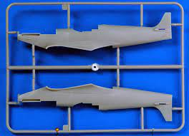
Figure 1 - Injection Moulded Airfix Components
As can be seen in figure 1, the parts are injection moulded and then broken out and assembled. Good tool design and high-quality manufacturing processes can help ensure that the breakaway surface finish remains good and does not need much further finishing.

Comparing this wind turbine design with the Airfix kit it could be suggested that if the design can be easily simplified that there is potential to be able to offer a version of this product as a ‘build it yourself’ kit. Typically, the type of person interested in purchasing a miniature, portable wind turbine is likely to be interested in the assembly and workings of the product, therefore they are also likely to be interested in assembling it themselves. Although this would require extra work in terms of developing well thought out instructions, packaging and customer support networks, the long-term opportunity could mean that an assembly facility is no longer needed, this has the potential to drastically reduce the number of employees required, waste materials, transport, time, and the size of facility that is needed. There is also no reason that both a ‘build it yourself’ and a pre-assembled version cannot be sold, but at an inflated price – increasing the profitability whilst also increasing the desire for the product that costs less money and time to produce.

Design and Development Work Undertaken

DFMEA – Design Failure, Modes, Effect Analysis

Before undertaking any design changes the overall product design and assembly need to be assessed, to do this a DFMEA (design failure, modes, effects analysis was competed. As suggested by Eisner (2022) an FMEA of any kind is an excellent tool for identifying product risks before organisations spend time, effort, and money into potentially ineffective ideas. The DFMEA that was completed can be seen in figure 2 below:

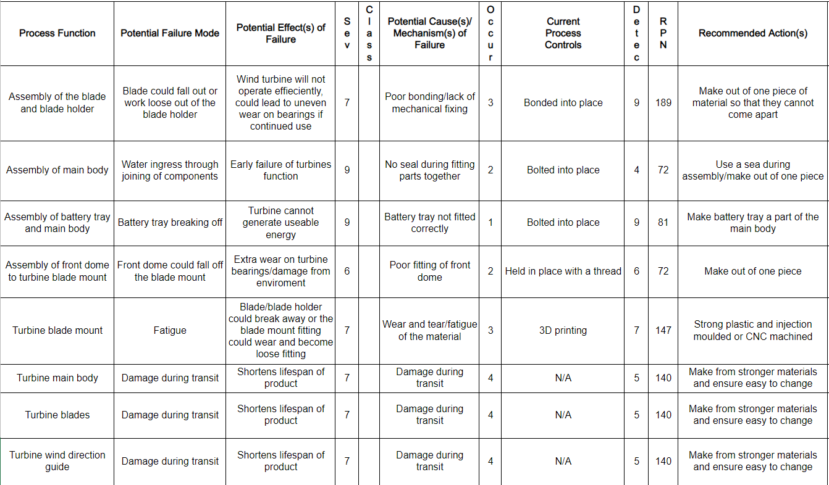
Figure 2 - DFMEA of the Wind Turbine

As can be seen in the DFMEA there are some key points surrounding the assembly and material choice for the components. Using this as a guide meaningful changes can be made to the design and suggestions made for using various manufacturing methods to ensure longevity of the product. (See appendix 1, 2 and 3 for DFMEA score rankings).

Design/Assembly Efficiency

To further evaluate the design and efficiency of the assembly, analysis tools such as the Boothroyd & Dewhurst, and Lucas methodologies have been considered. These tools use the principle of assessing each individual component to decide whether it is essential or non-essential, with the non-essential components being selected to be designed out of the overall design, this is usually done by combining them with another component.

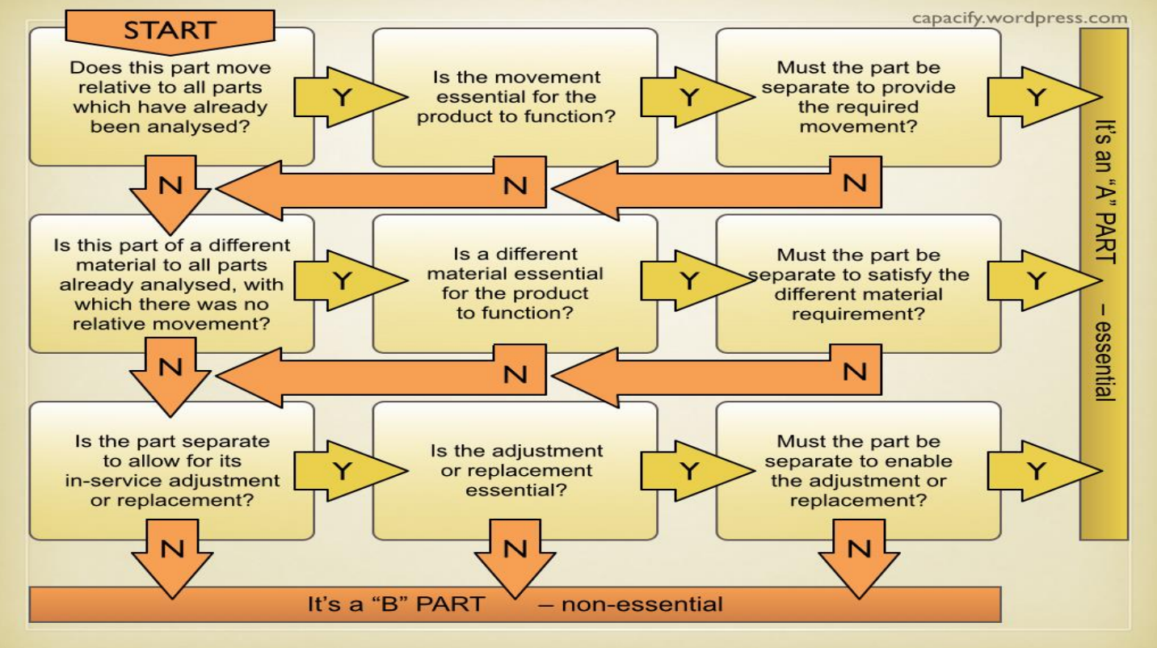
Figure 3 – DFA Component Appraisal Chart

As the assembly for this product is already quite simple it was found that there were minimal components that could be designed out, the main parts that were highlighted to be ideal for combining were:
- Turbines blades and blade fittings
- Turbine blade mount and front cover
- Main body and body spacer
- Main body and battery tray

Purchased Components

Many of the components that make up the product will not need to change when the switch is made to mass production as they are externally purchased items, however, consideration should be taken to ensure that suppliers can keep up with this demand and that if they cannot alternative suppliers are on standby with suitable replacement items.

It was found that the following parts are simply bought as standard for the product:
- 3 phase motor
- 6203 ball bearing
- external retaining ring
- internal retaining ring
- hex nut
- prevailing torque hex nut
- socket head cap screw
- 4mm sphere
- Tube

Injection Moulding

To improve the strength and cost per part, and due to the production volume of 1000-2000 products per week injection moulding is the preferred manufacturing method. The goal was injection mould as many of the parts as possible and so some of the parts required some redesign work.

The wind turbine blades were completed first as they not only needed to be modified for injection moulding but were also flagged up in the DFMEA and assembly efficiency chart. These need to be strong, lightweight and have good fatigue properties due to their constant stress loading and unloading. The current design is very simple, has no negative areas and should be perfect for injection mounding as it is – see figure 4. However, it was recognised that there was a requirement for this part to fit into the mounting adapter, there are no fittings to hold this in place and so it is assumed they are to be bonded. For this reason, it made sense to merge these components into one so that they can just be moulded together.

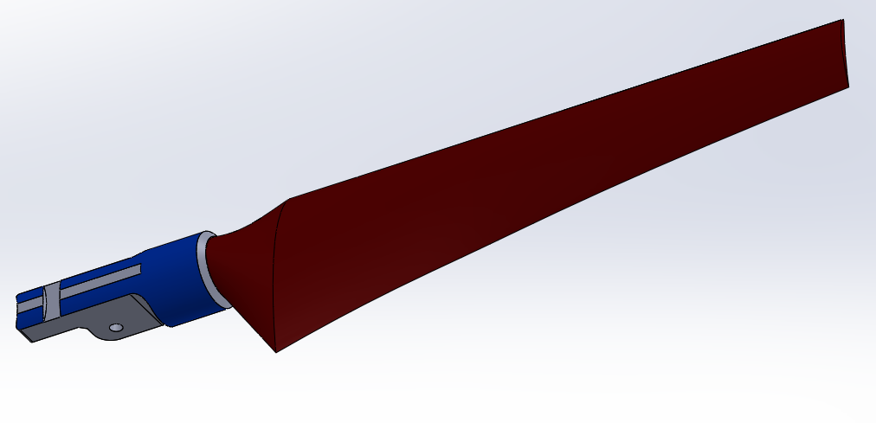
Figure 4 - Wind Turbine Blades

The remained of the components were checked over for negative spaces, areas that may cause difficulty when trying to injection mould and any possible scenarios where parts could be merged/standard components used instead. The components below are already suitable to be injection moulded, although some will need some extra manufacturing processes, such as adding thread inserts.

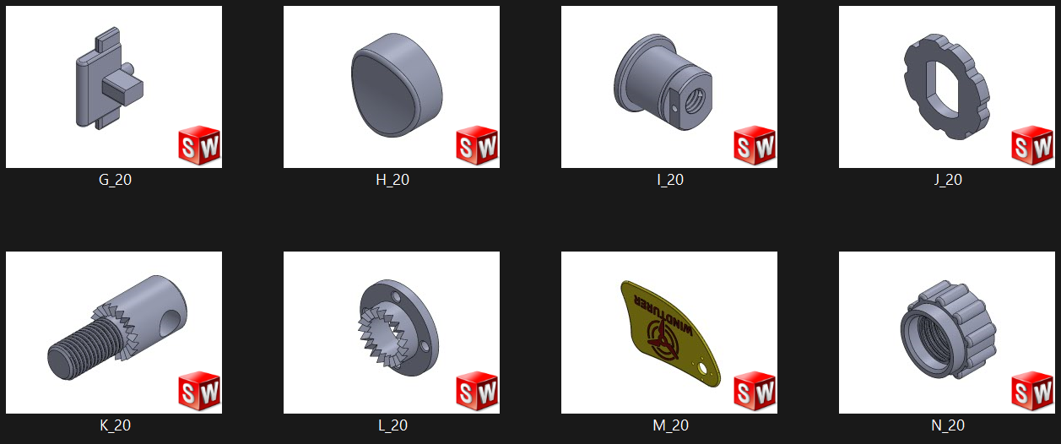
Figure 5 - Image Showing the Components that can be Injection Moulded.

CNC Machining

The complexity of these components meant that it was decided that injection moulding would not be possible and that 3D printing was a method that would not produce components that have the required strength to cost target. Therefore, it was decided that for the following components: the blade mount, nose cover, main body, main body spacer and battery shelf (F20) would be CNC machined from aluminium, this decision was also made by considering the suggestions that were made in the DFMEA.

For simplicity the components were modified and merged in a method to reduce the number of parts and create a simpler order list. Figure 6 shows the blade mount with added nose cover. Figure 7 shows the new main body, with spacer and battery tray as a part of the new design.

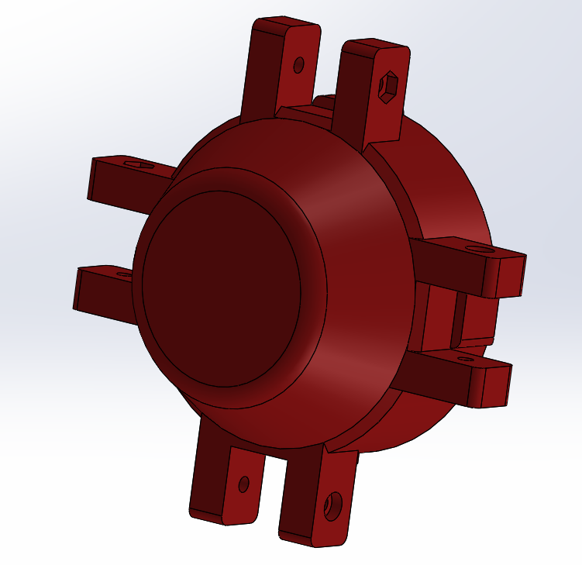
Figure 6 - Blade Mound with Nose Cover

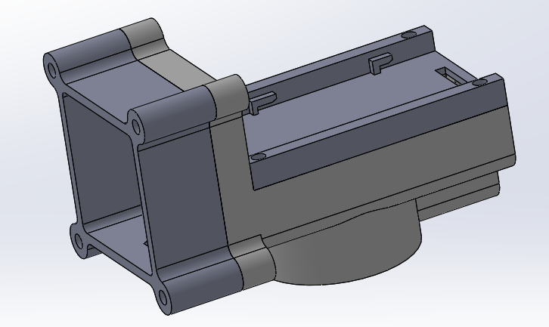
Figure 7 - New Main Body Housing with Spacer and Battery Tray

Although more expensive, time consuming and heavier that the other methods, by CNC machining these components out of aluminium the final process can be much stronger, stiffer, tougher and withstand the elements better – all parts of the objectives set out in the initial design specification.

DFMEA – Action Results
With these changes and suggestions in mind the action results section of the DFMEA was filled out so that a fair comparison could be made to evaluate the suggestions. This can be seen in figure 8 below.
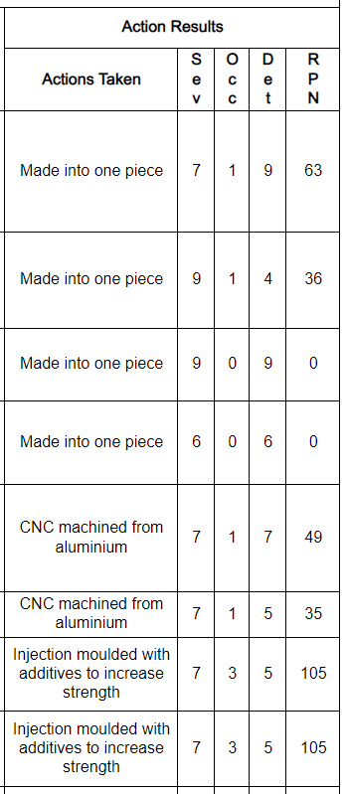
Figure 8 - DFMEA Action Results

These results clearly show that the suggested modifications and manufacturing methods should contribute a great deal to ensuring that the mass production of the portable wind turbine is successful, and a high-quality, long-lasting product is delivered as requested in the design specification. (See appendix 1, 2 and 3 for DFMEA score rankings).

Conclusion

Many of the components required for the product are bought items that will not change during the process of moving to mass production, however, as identified in the DFMEA some of the specifically designed parts such as the blades and blade mounts will need to be modified and set up for injection moulded manufacture. For the volume of units required (1000 – 2000 per week) injection moulding the certainly the better method compared to 3D printing, not only will the unit cost per part be lower and the material cost be lower but the material range and option to use additives to achieve specific properties adds a range of benefits and will help to set this product apart from any competitors. There are also options for the development of a ‘build it yourself’ style kit that could create the opportunity to lower the manufacturing/assembly costs and set this product into a more specialist category.

Overall, the design of the product is well thought through and with further considerations to the suggestions made in this report and the input from injection mould tool design experts the mass production of the product should not cause any major issues, this is supported by the data presented in figure 8 - the action results section of the DFMEA.

References

DFA Component Appraisal Chart. (2023), ‘Design for X’, [online]. Available: Manufacturing Design and Technology Moodle [Accessed 2023 June 27].

Eisner, C. (2022), ‘DFMEA: The Beginner’s Guide to Design Failure Mode and Effects Analysis’, [online]. Available: https://www.getmaintainx.com/blog/beginners-guide-to-dfmea/ [Accessed - 2023 June 26].

Goehrke, S. (2022), ‘Point of Pivot: 3D Printing vs. Injection Molding’, [online]. Available: https://www.plasticstoday.com/3d-printing/point-pivot-3d-printing-vs-injection-molding [Accessed - 2023 June 27].

Vogel, J. (2020), ‘3D Printing vs Injection Molding – Which is Better?’, [online]. Available: https://www.kaysun.com/blog/plastic-injection-molding-vs-3d-printing [Accessed - 2023 June 27].

Appendix

Appendix 1 – DFMEA Severity Rankings
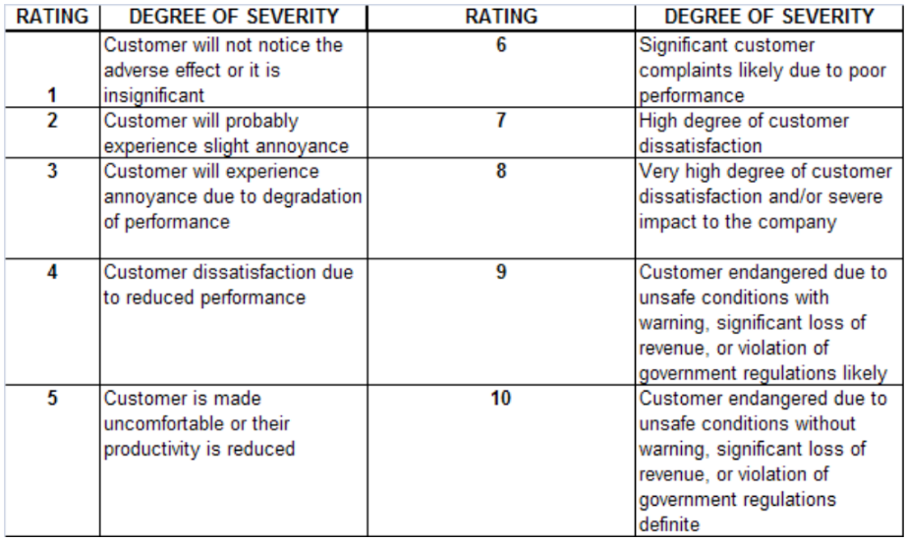

Appendix 2 – DFMEA Occurrence Rankings
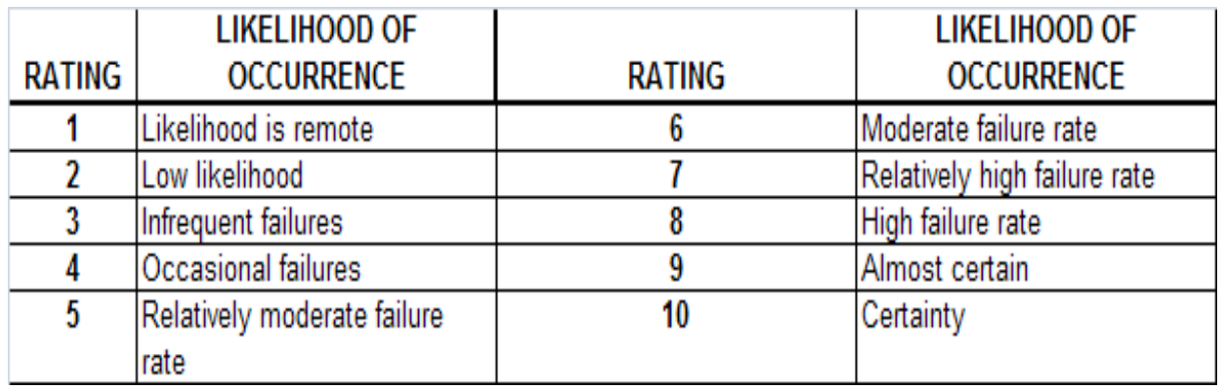

Appendix 3 – DFMEA Detectability Rankings


