Name of the Team: Team NOS
Team Members
Student Name | Student ID
1 Alexander Tzafos | 2104846
2 James FREW | 2108660
3 Josh naylor | 2114259
4 daniels zelinskis | 2104718

Team Evaluation (Self Evaluate your Team)
 | Student 1 | Student 2 |  | Student 3 |  | Student 4
Student 1 | 4 |  | 5 |  | 3 |  | 3
Student 2 | 5 |  | 5 |  | 3 |  | 3
Student 3 | 5 |  | 5 |  | 3 |  | 3
Student 4 | 5 |  | 5 |  | 3 |  | 3
Rate your Teams Contribution with a scale of 1 to 5 (1 No Contribution and 5 Excellent Contribution)
Add your comments on Team Evaluation: (Justify your evaluation)
Student 3: I think I could have been involved in the screenshot more.
Student 4: I think he could have given more screenshots and turner up to class more.
Student 2: I think he did most of the work on his computer.
Student 1: I think he did a good amount of work, and he gave a lot of screenshots.

Introduction
This assignment is about setting up a VM which has 2 servers and 2 clients so in total we will have to set up 4 VMs as part of the assignment. Then we will have to do an individual task which will involve a set of question we will have to answer.

Task 1
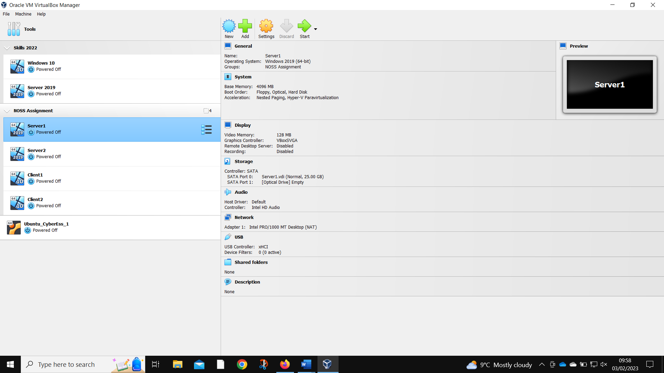
Server 1 created
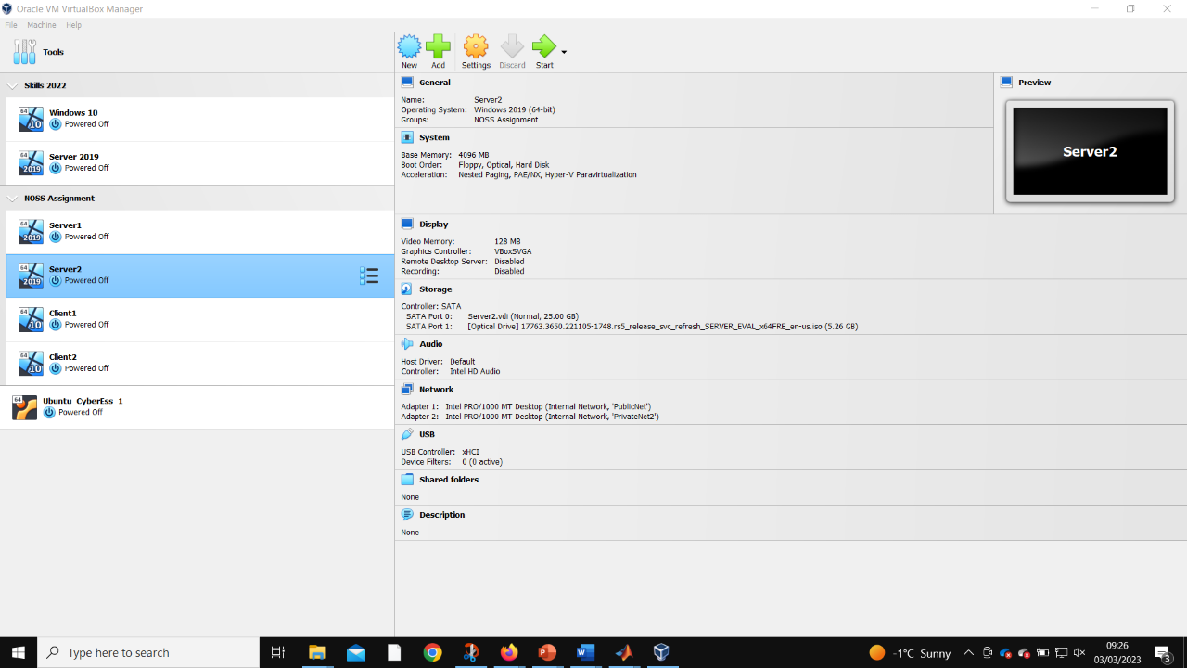
Server 2 created
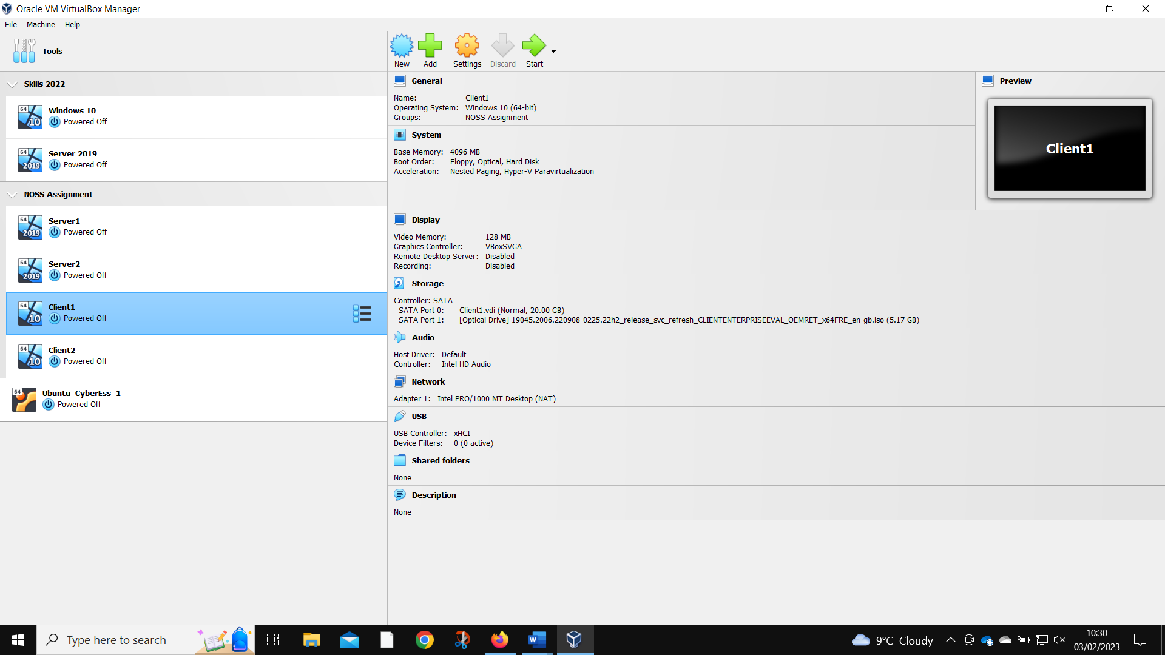
Client 1 created
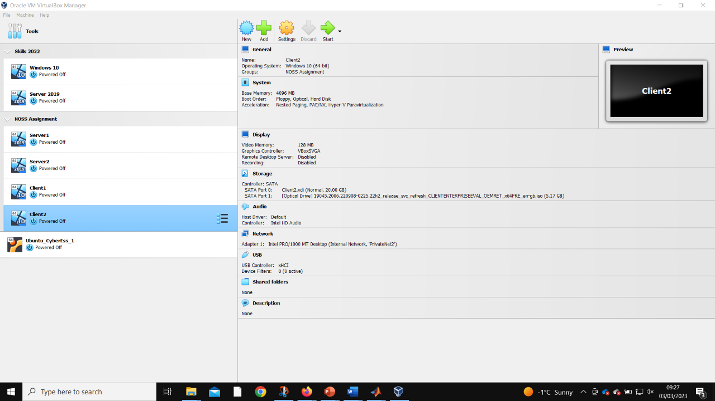
Client 2 created
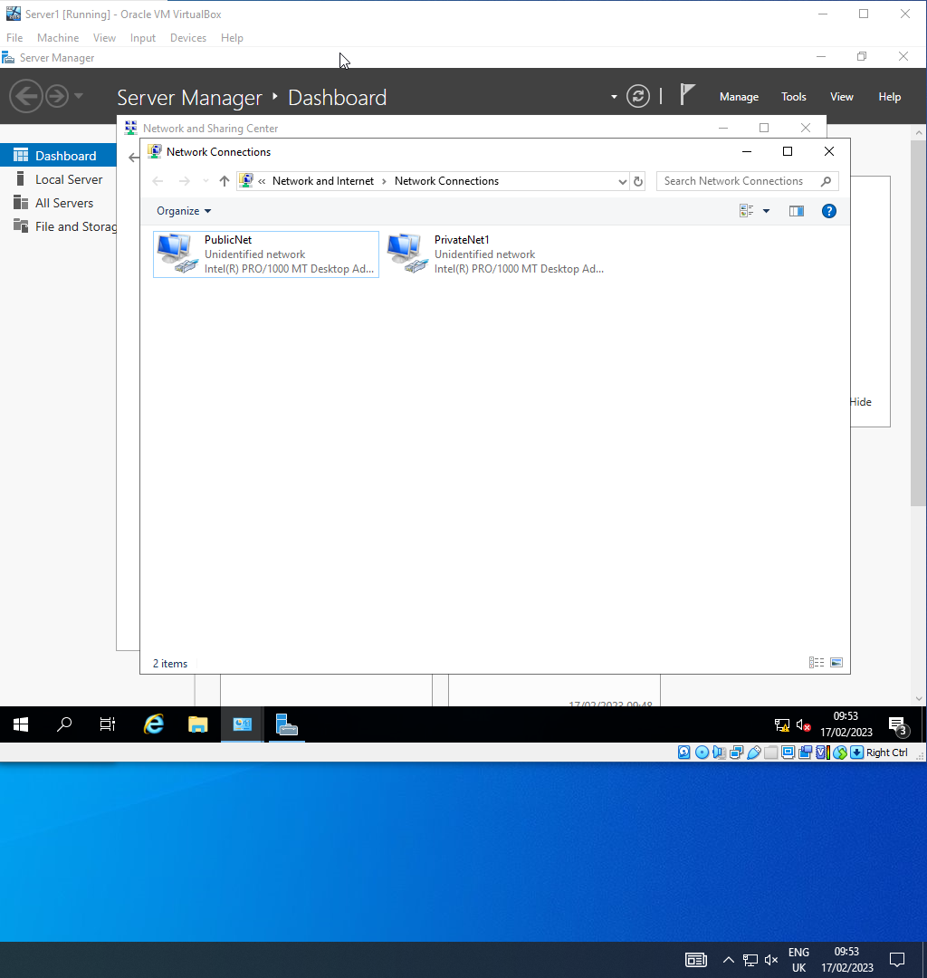
Server 1 networks named
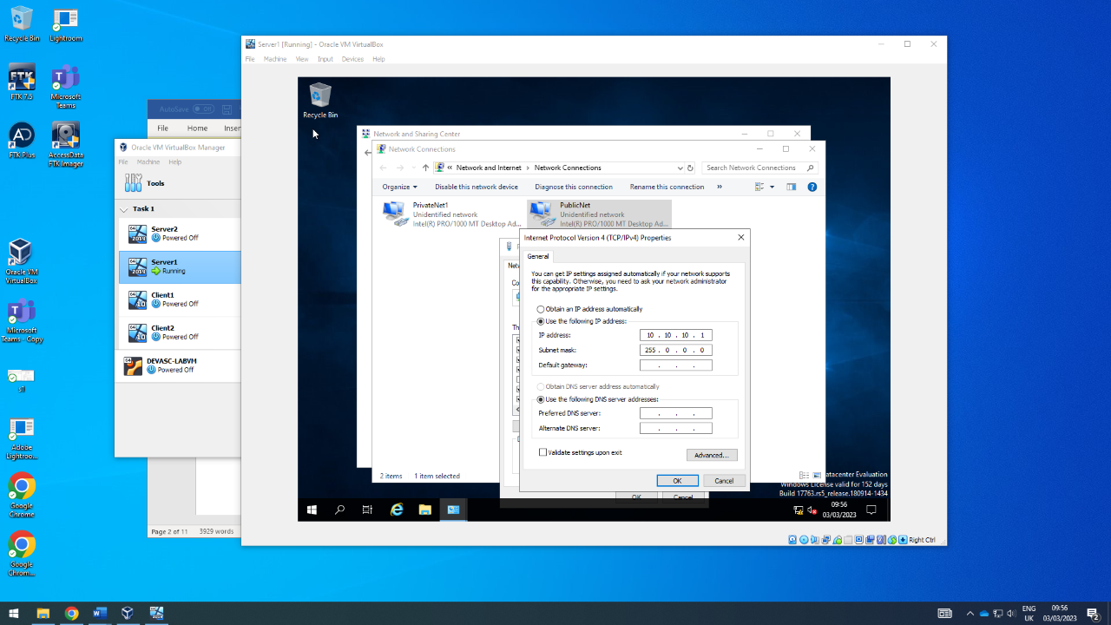
Server 1 Public Net IP set
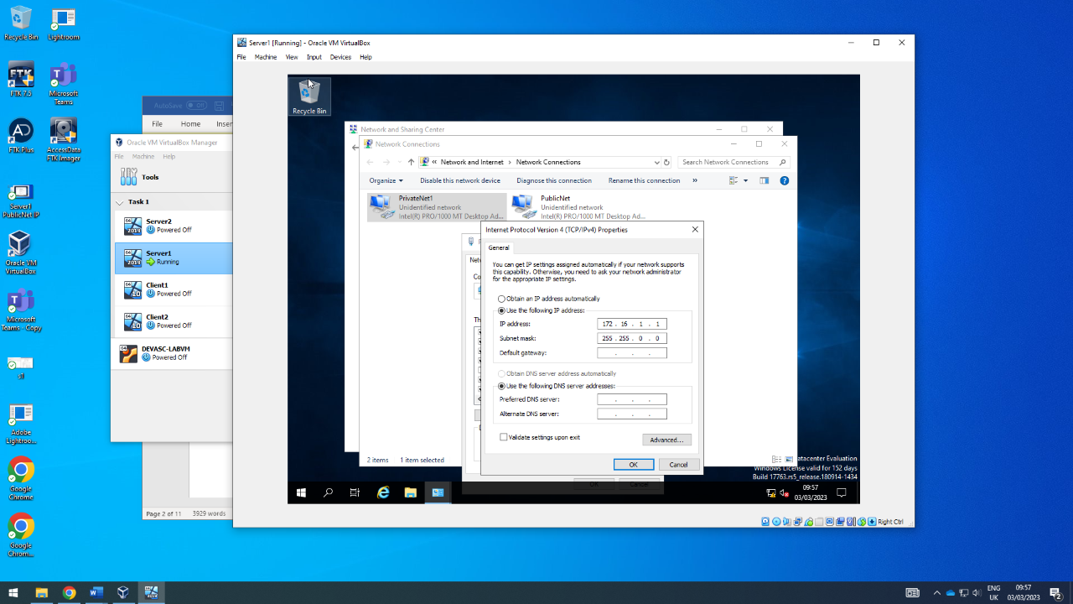
Server 1 PrivateNet1 IP set
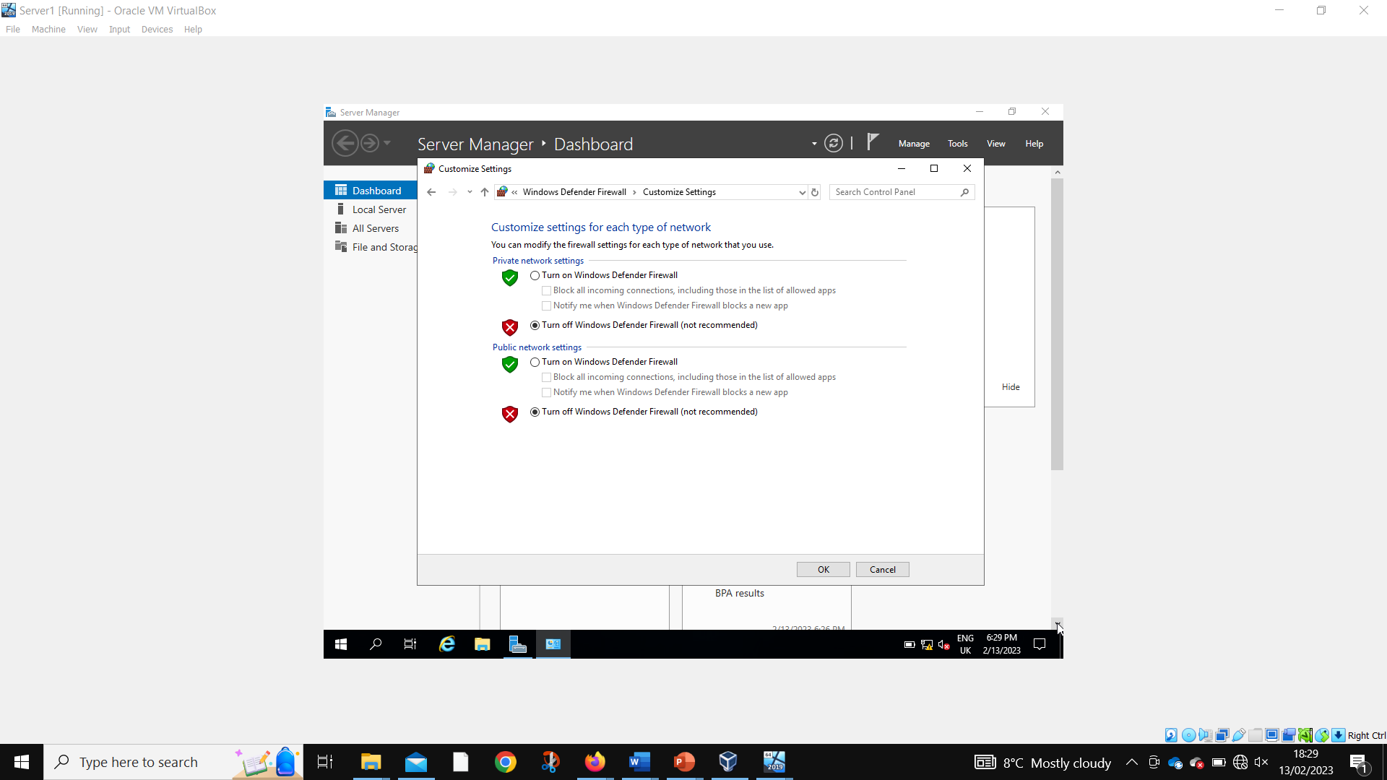
Disabling fire walls Server 1

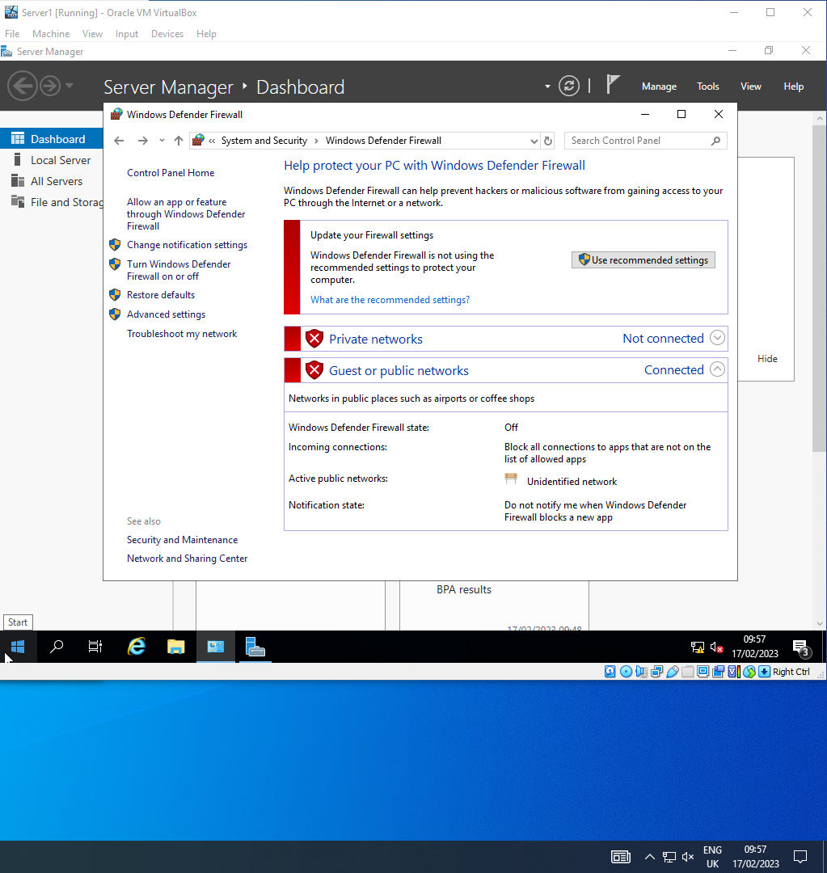
Fire walls disabled Server 1

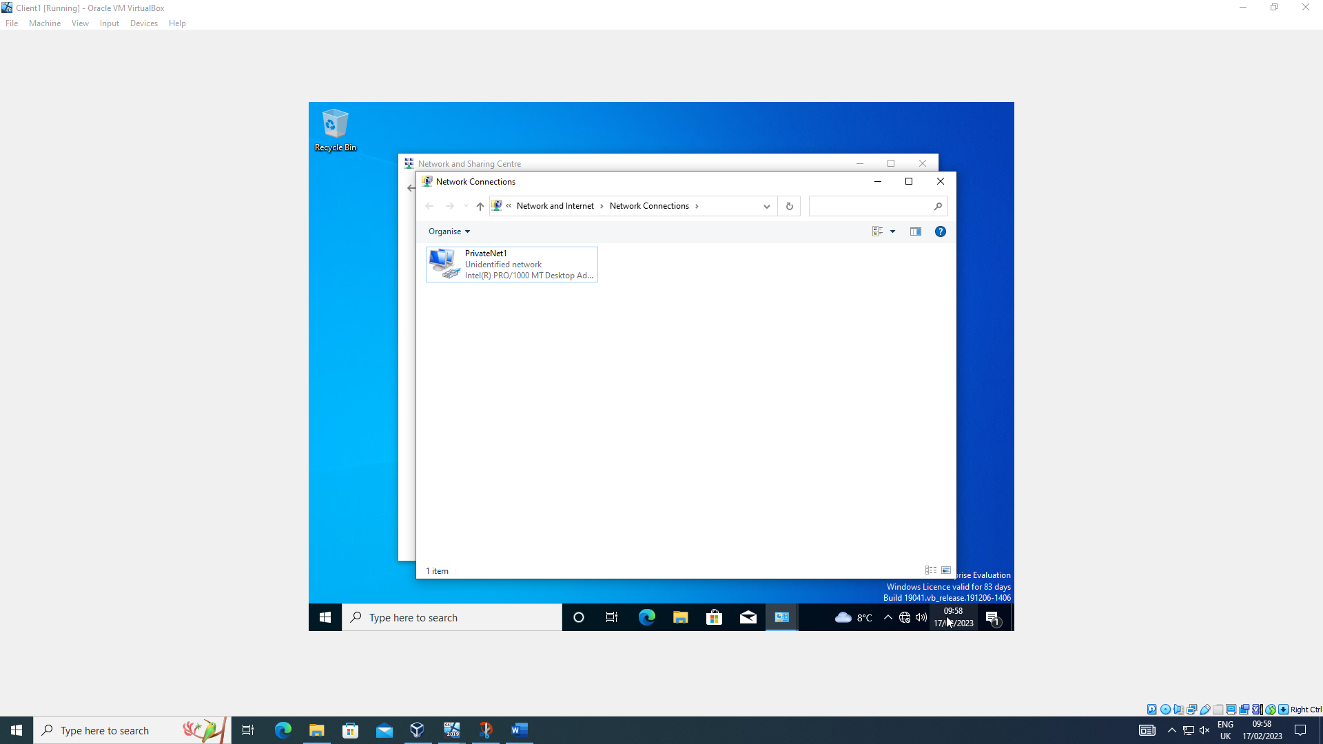
Client 1 network named
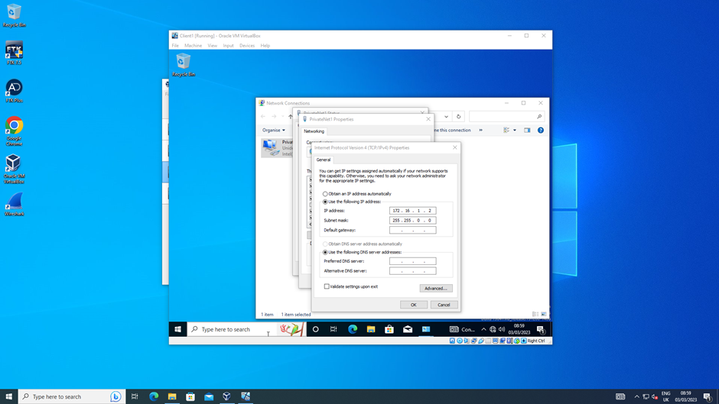
Client 1 PrivateNet1 IP set
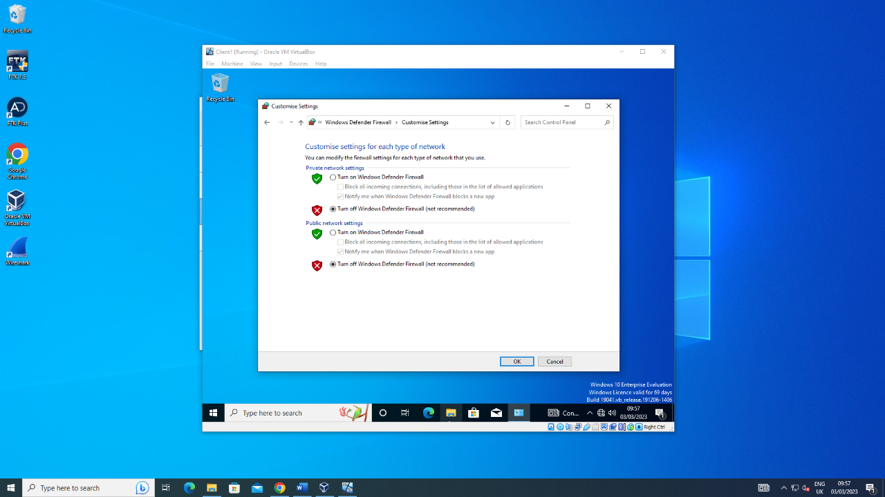
Client 1 firewalls being disabled
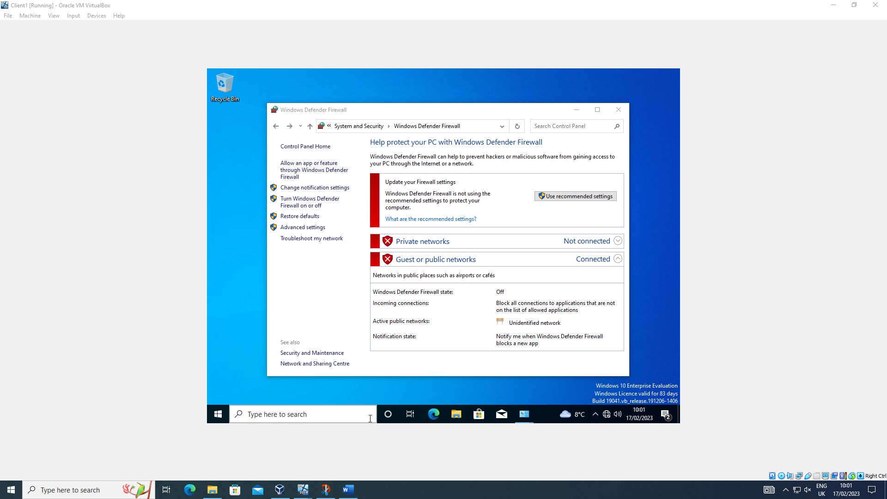
Client 1 firewalls disabled
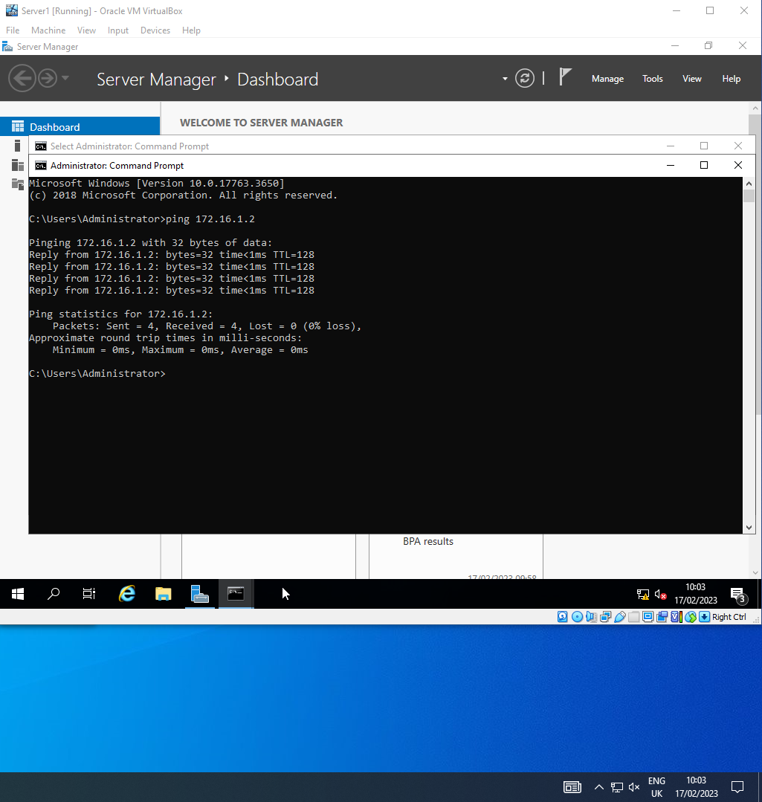
Server 1 successfully pinging client 1
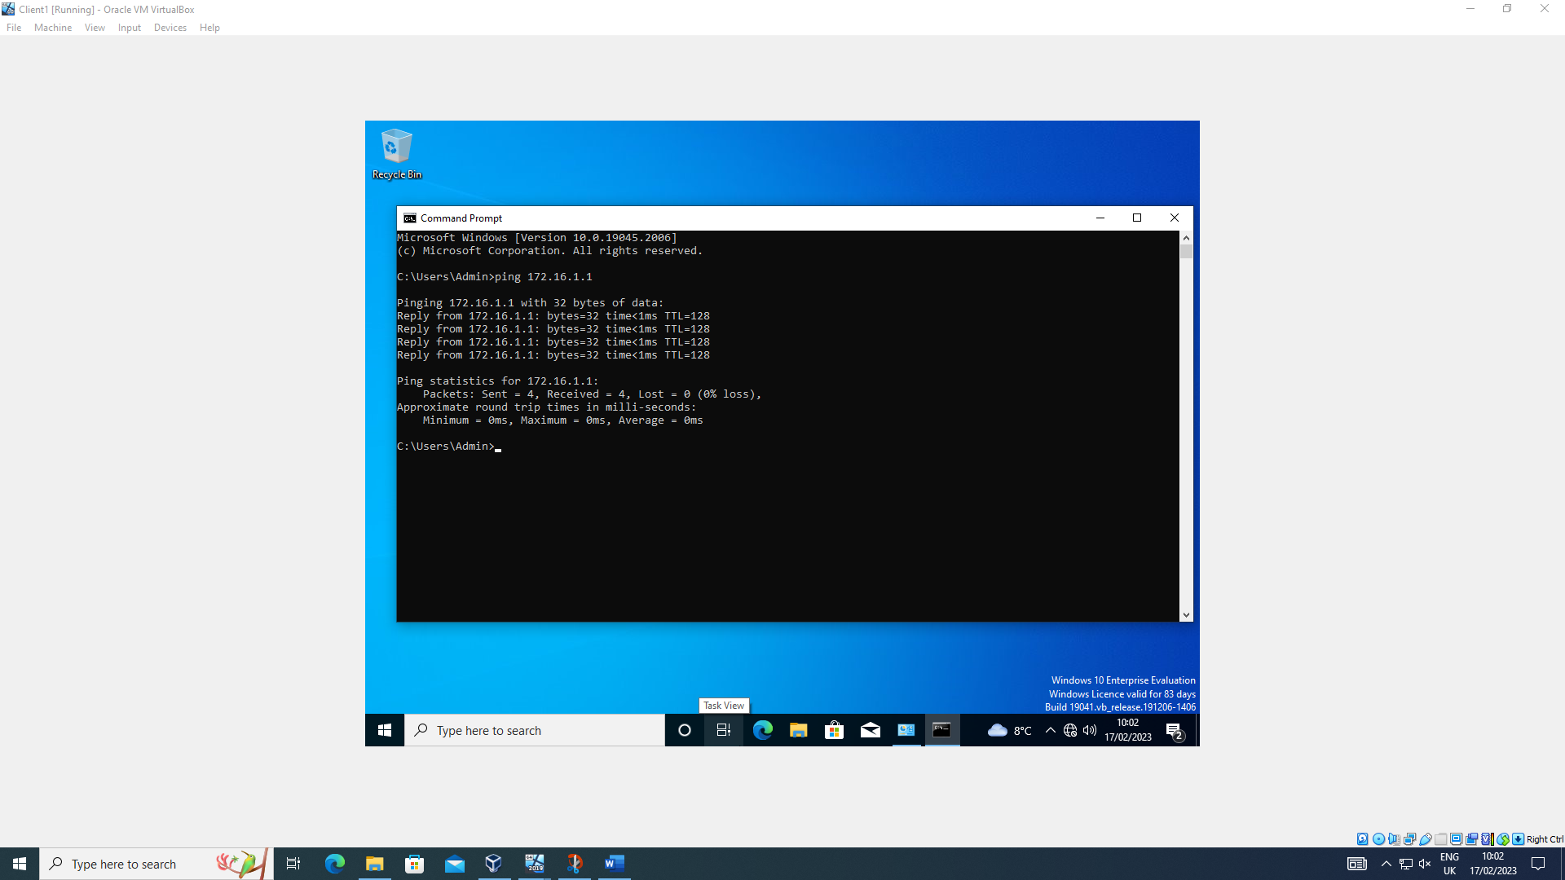
Client 1 successfully pinging server 1
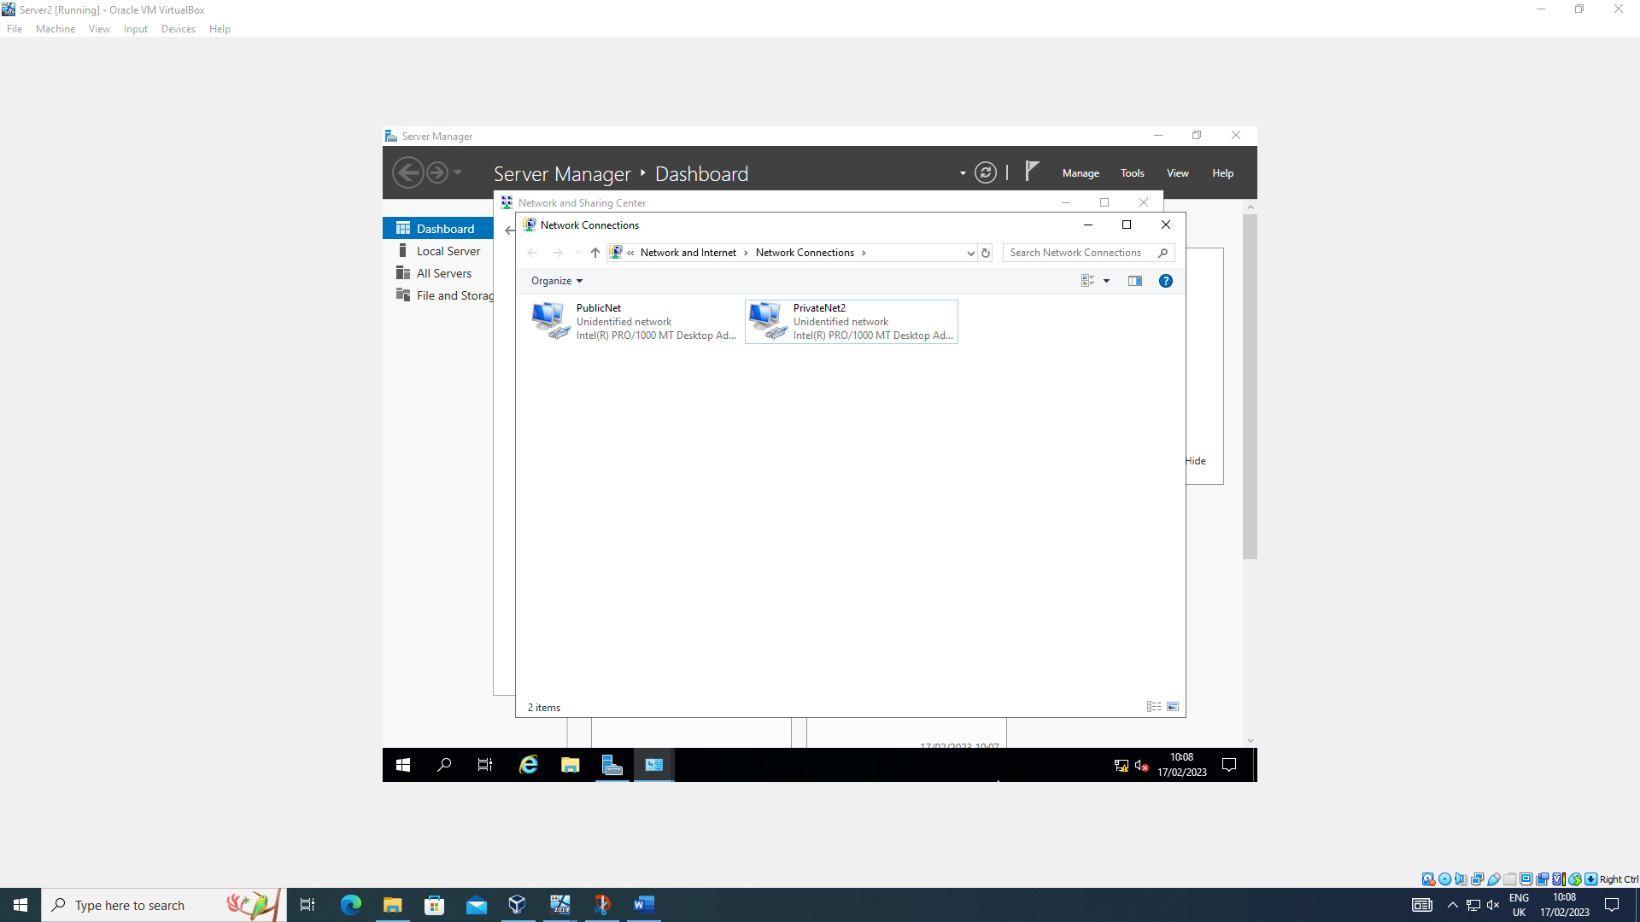
Server 2 networks named
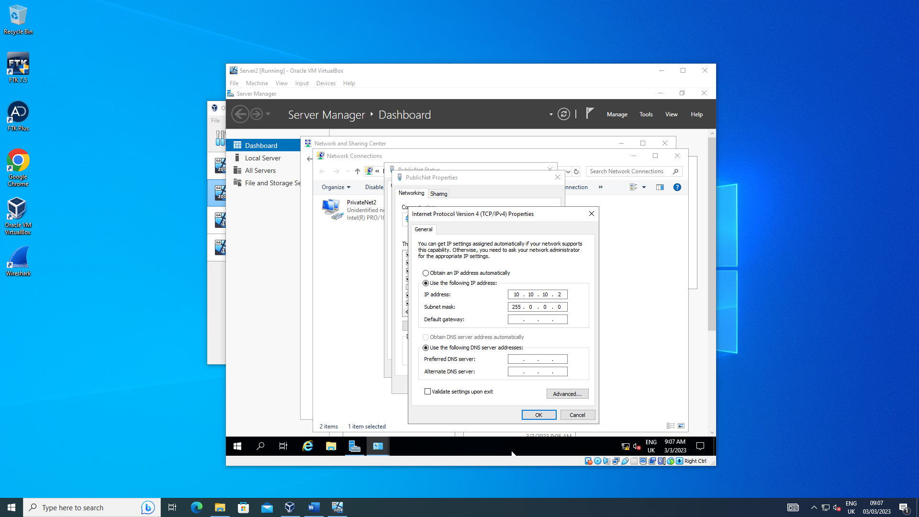
Server 2 Public Net IP set
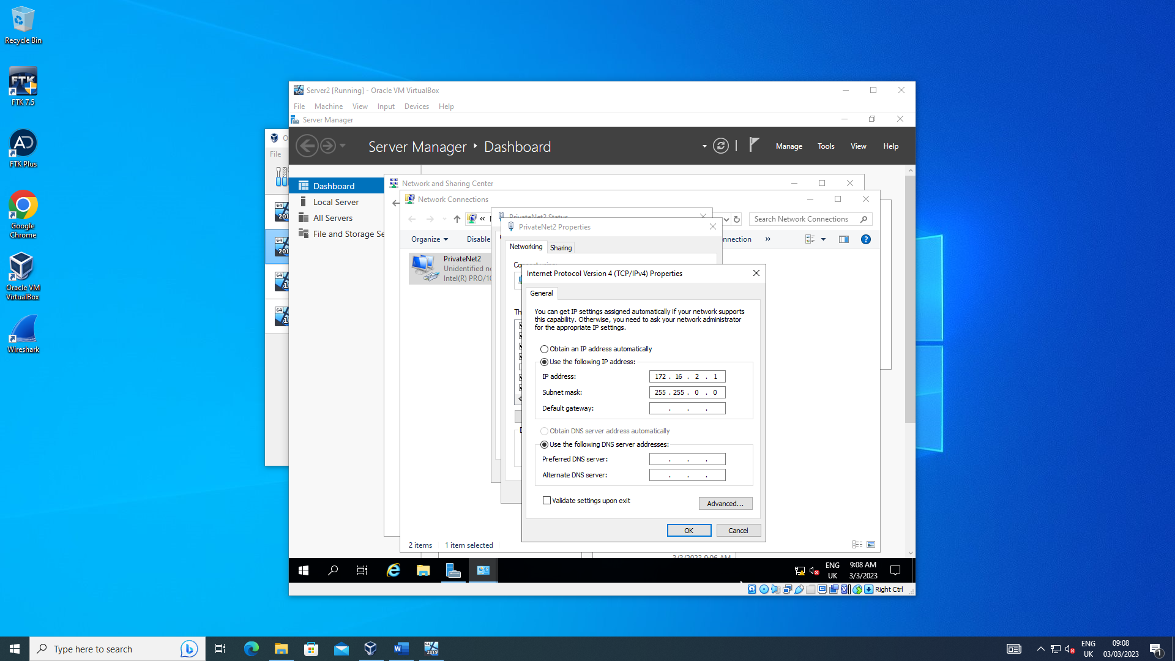
Server 2 PrivateNet2 IP set
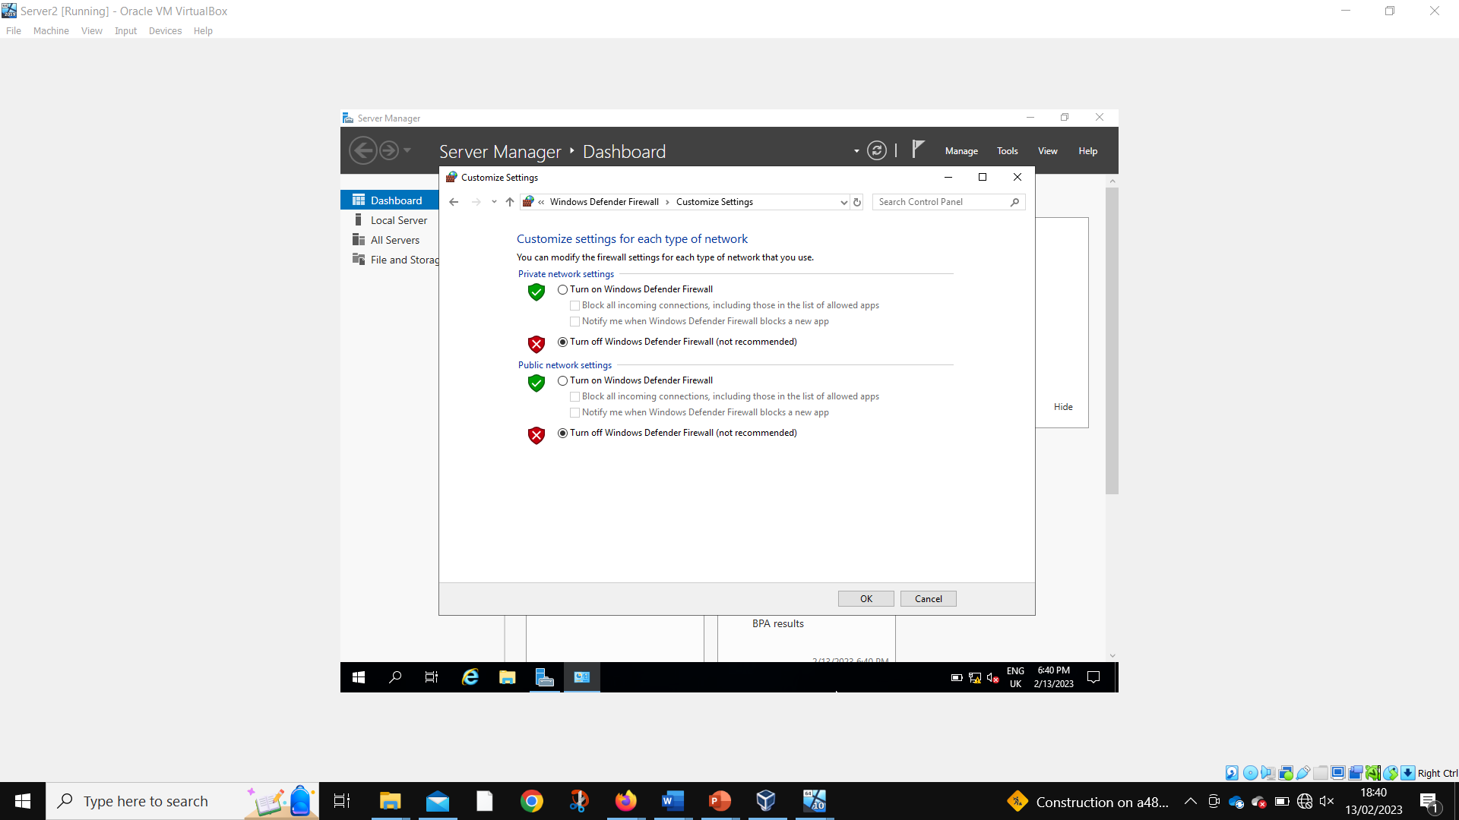
Server 2 disabling firewalls
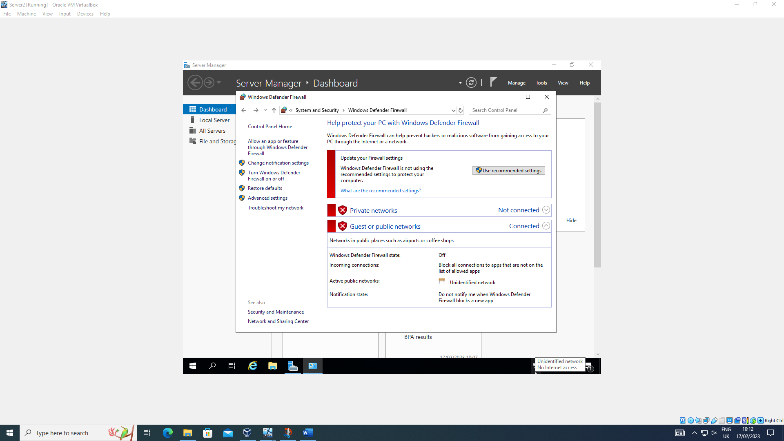
Server 2 firewalls disabled
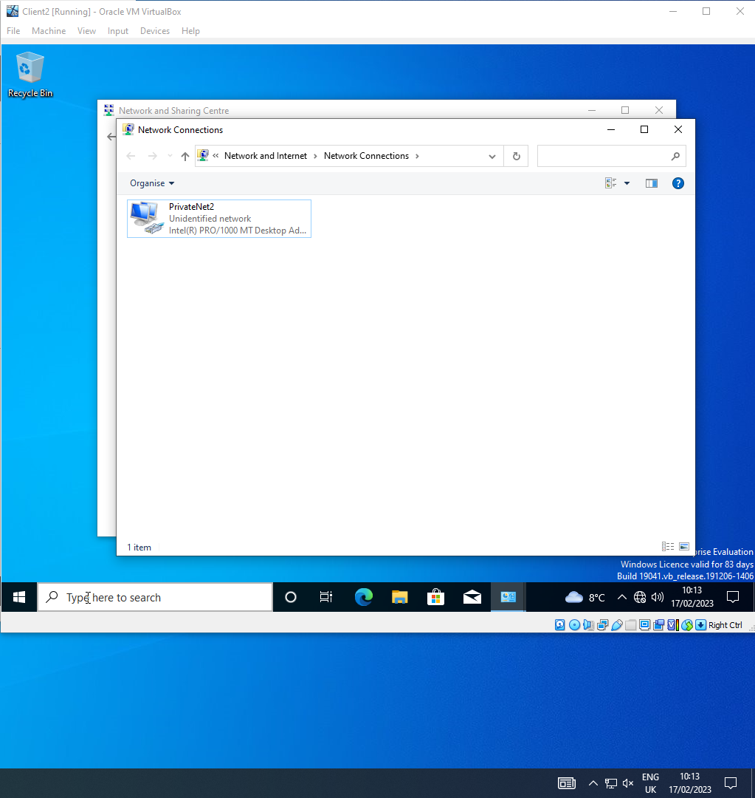
Client 2 network named
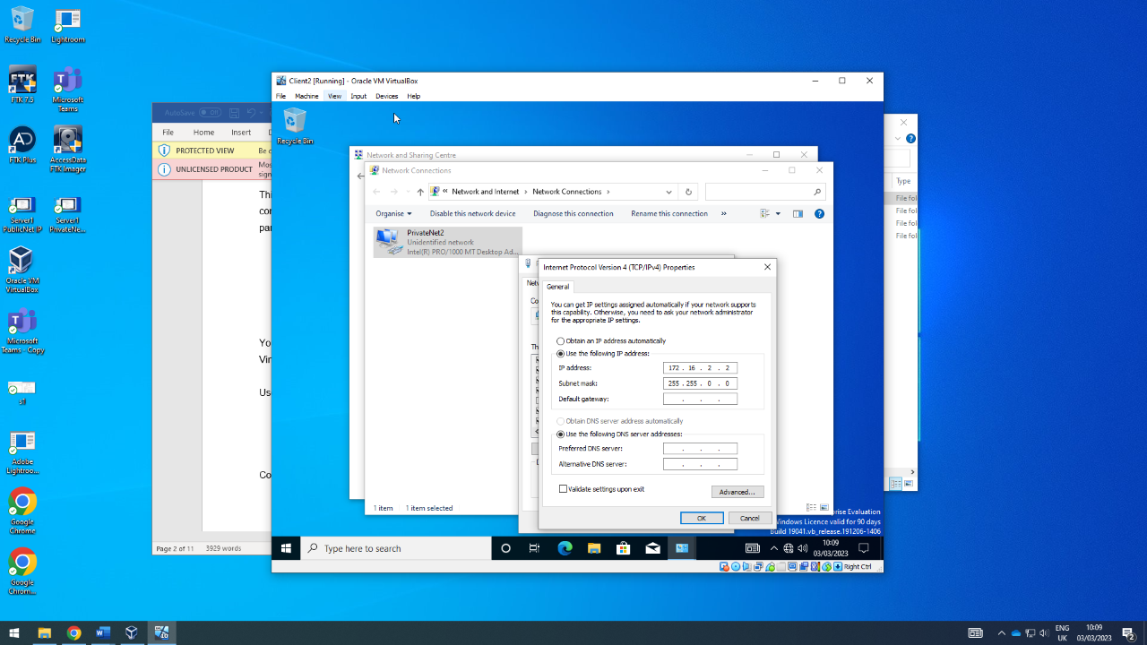
Client 2 PrivateNet2 IP set
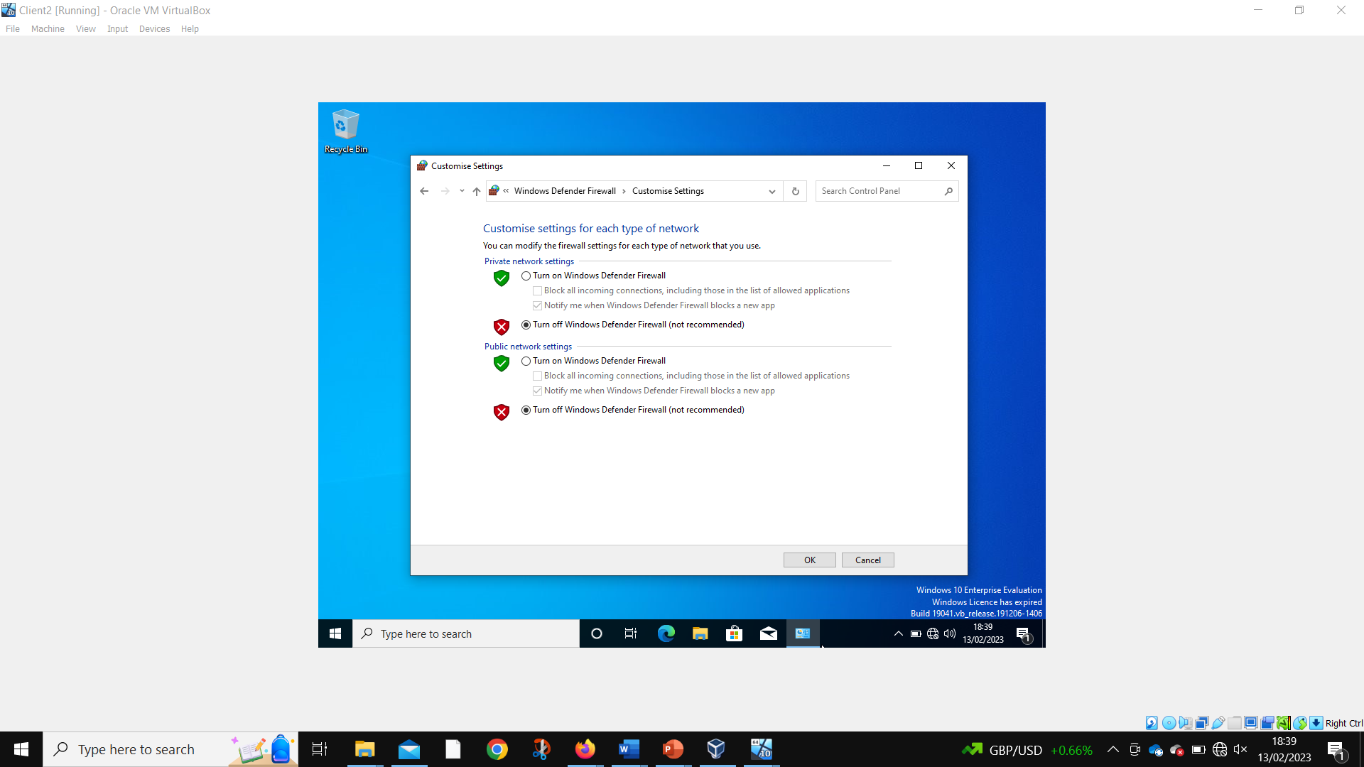
Client 2 disabling firewalls
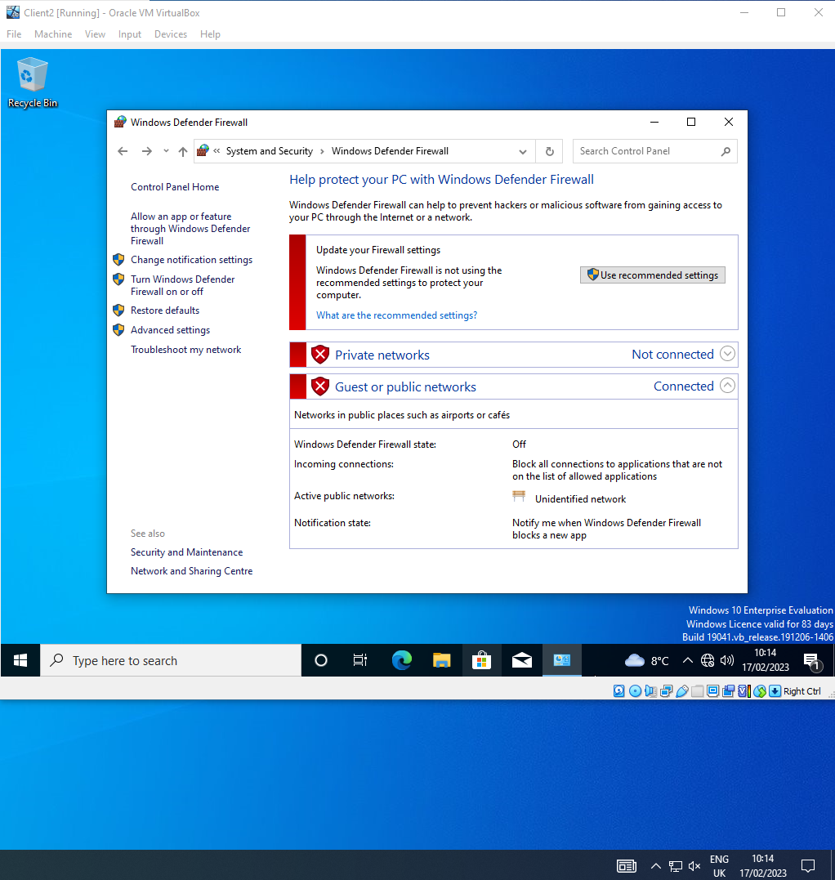
Client 2 firewalls disabled
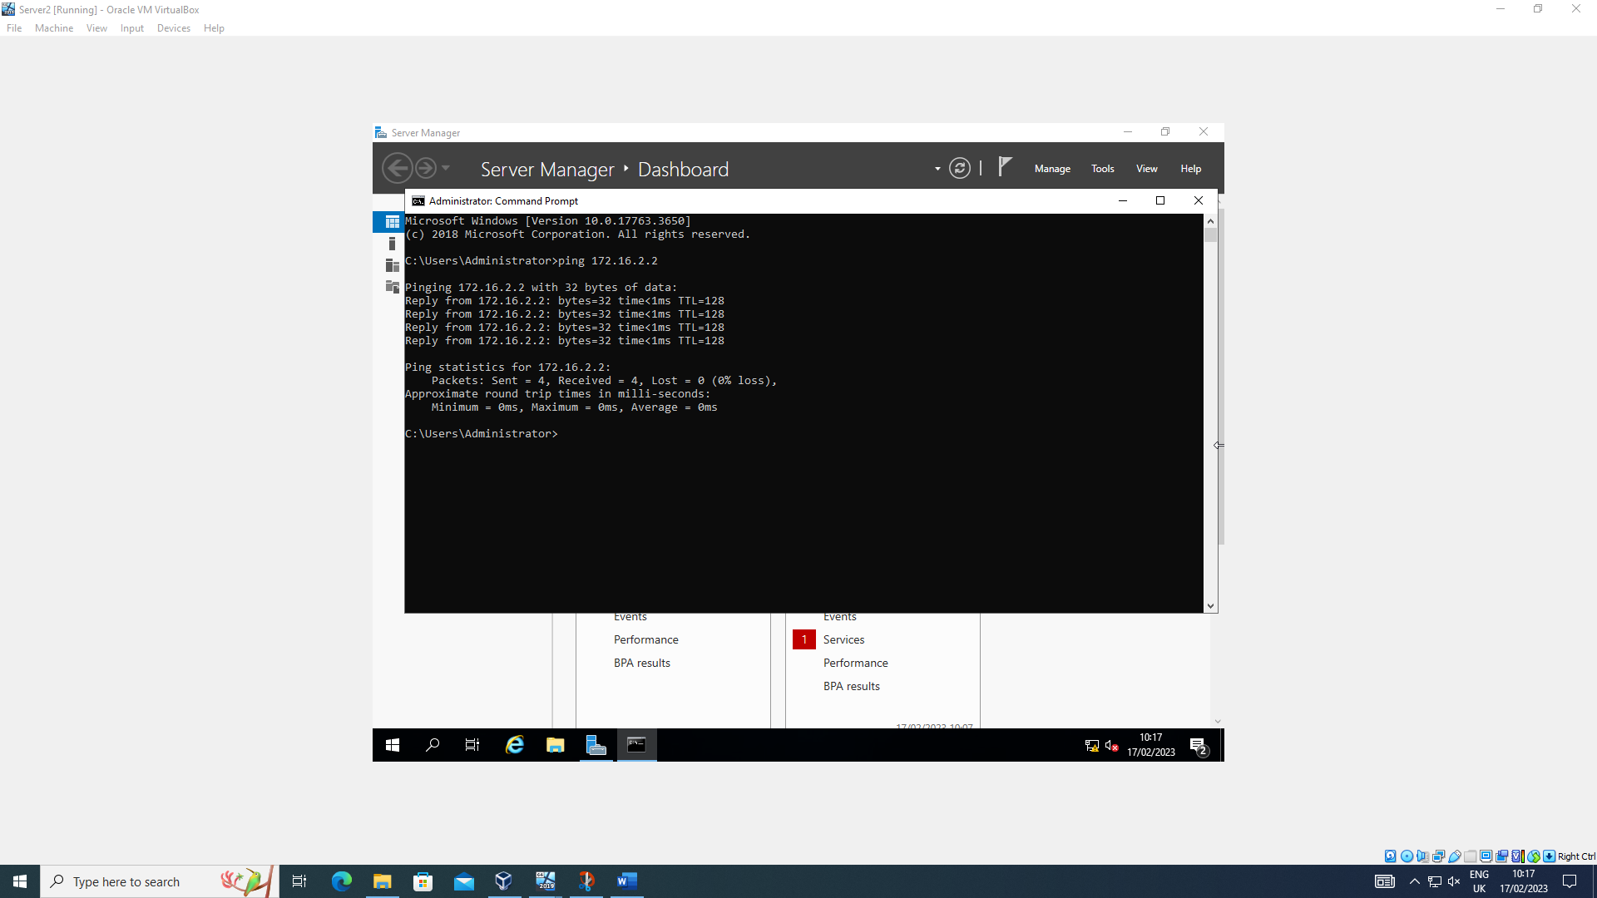
Server 2 successfully pinging Client 2
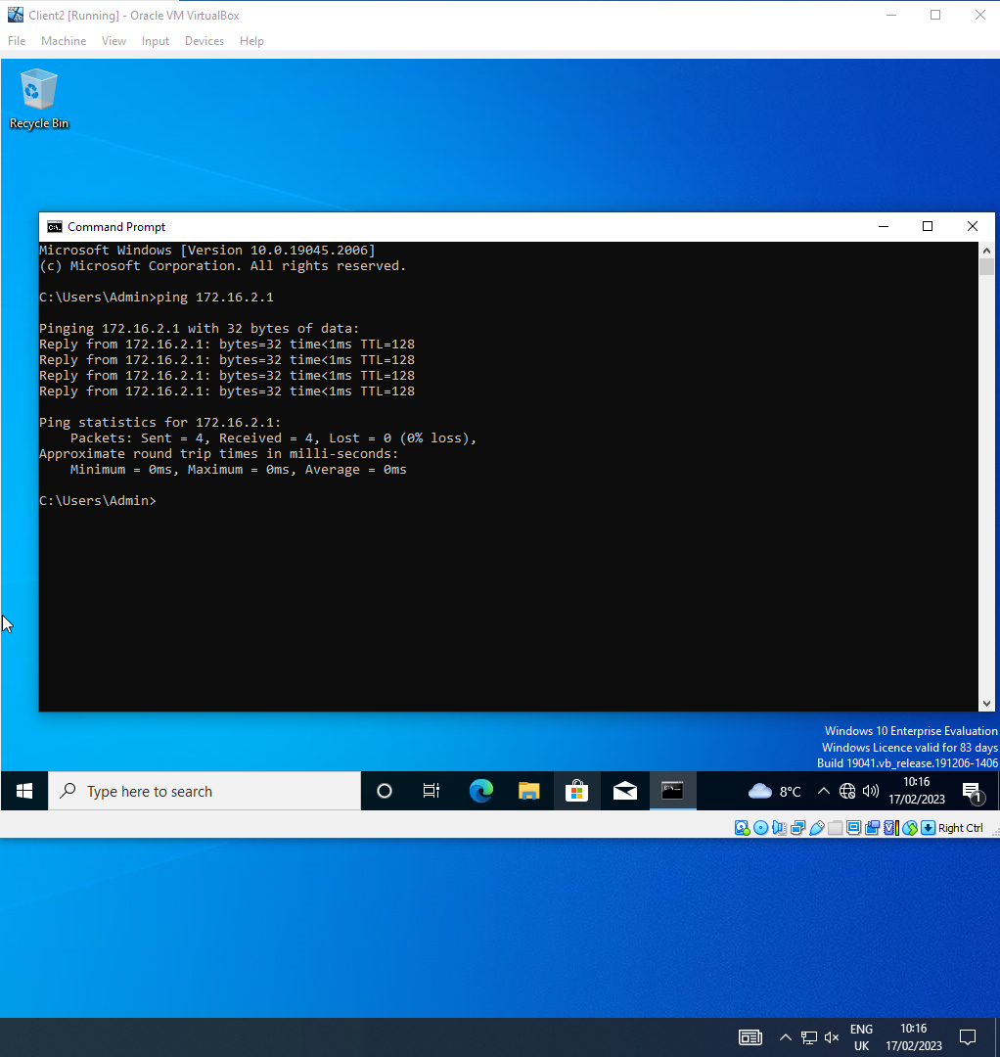
Client 2 successfully pinging server 2

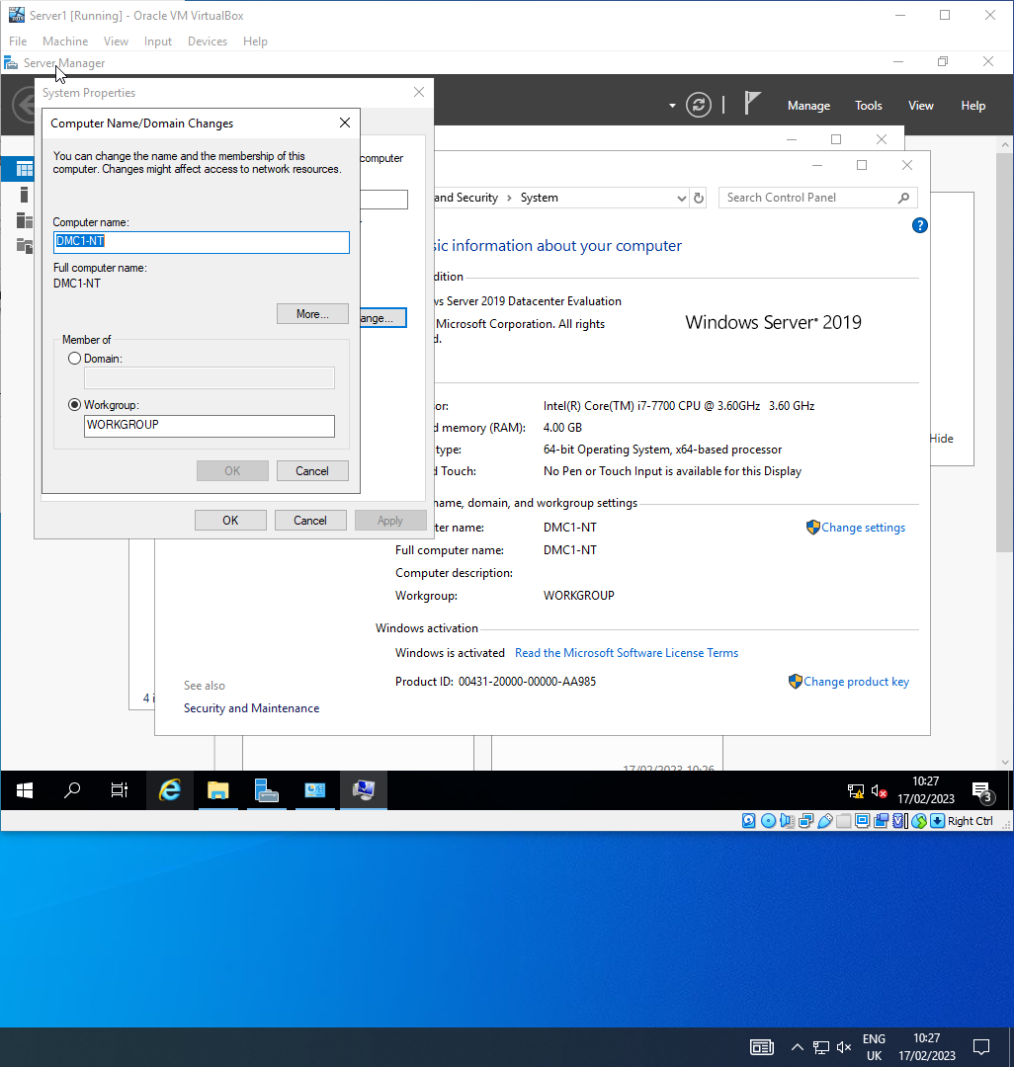
Changing Server1 computer name
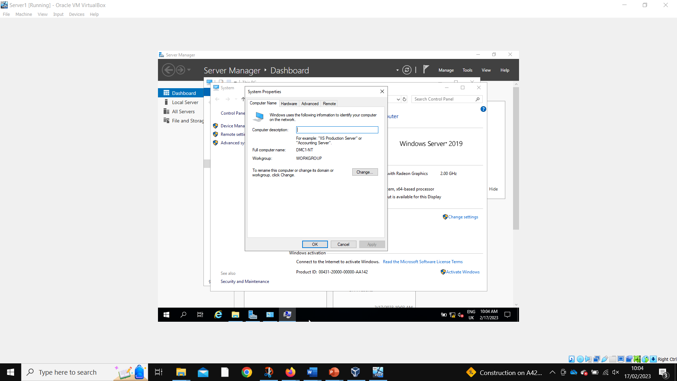
Server 1 computer name successfully changed
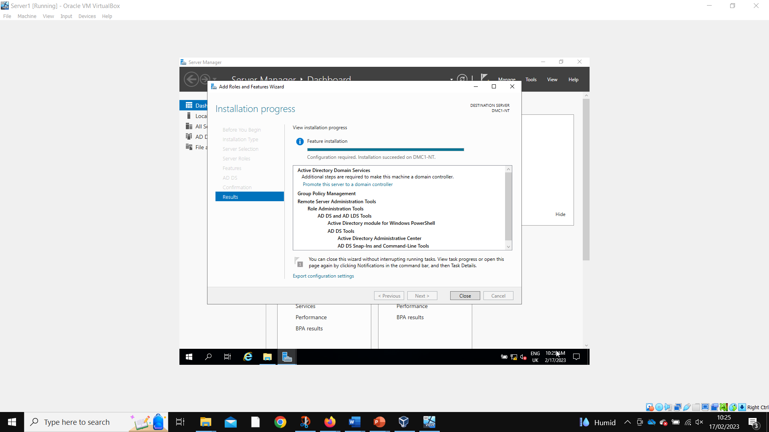
Server 1 adding active directory domain services
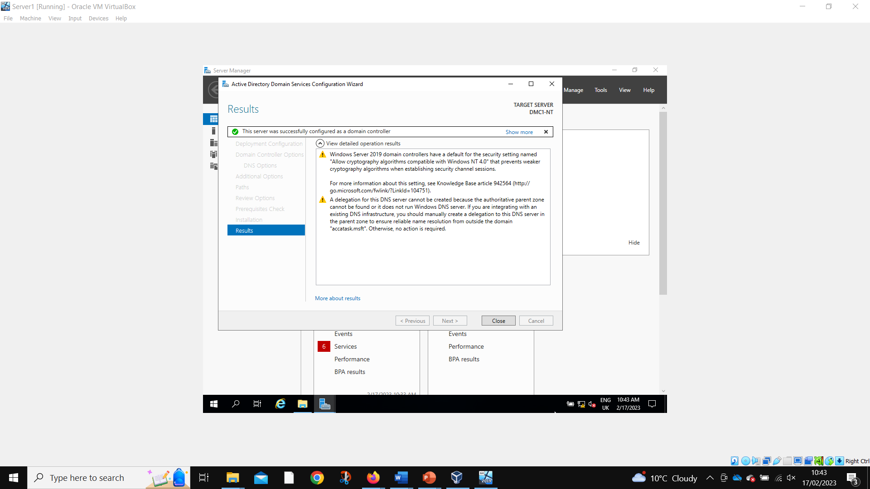
Server 1 active directory domain services successfully installed
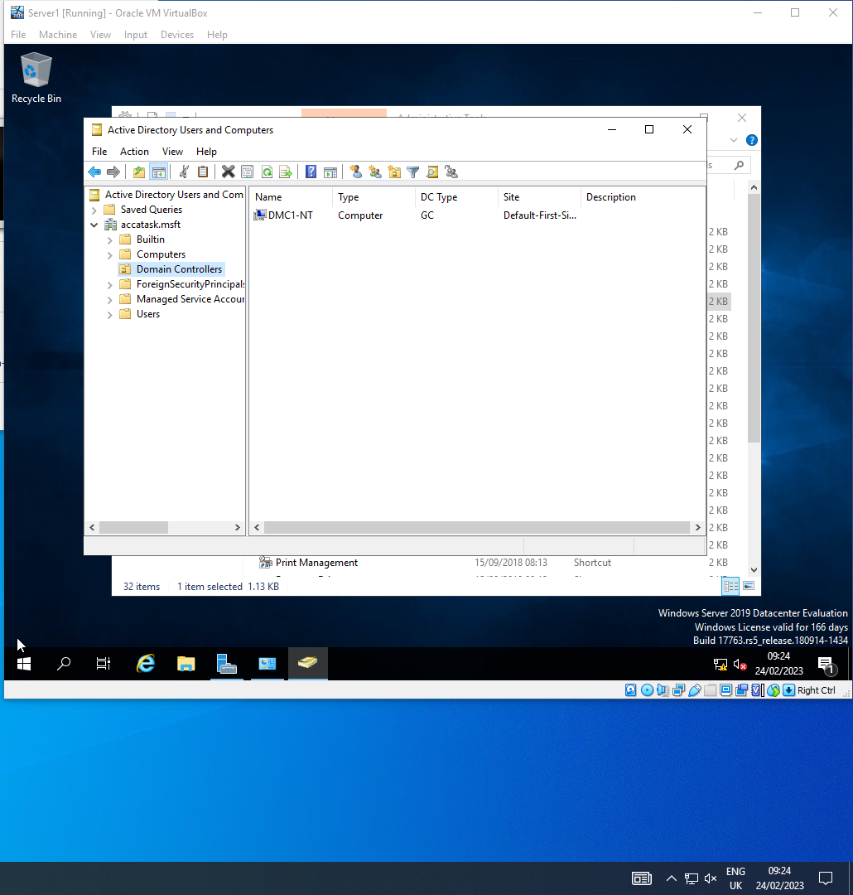
Server 1 DMC1-NT present in domain controllers
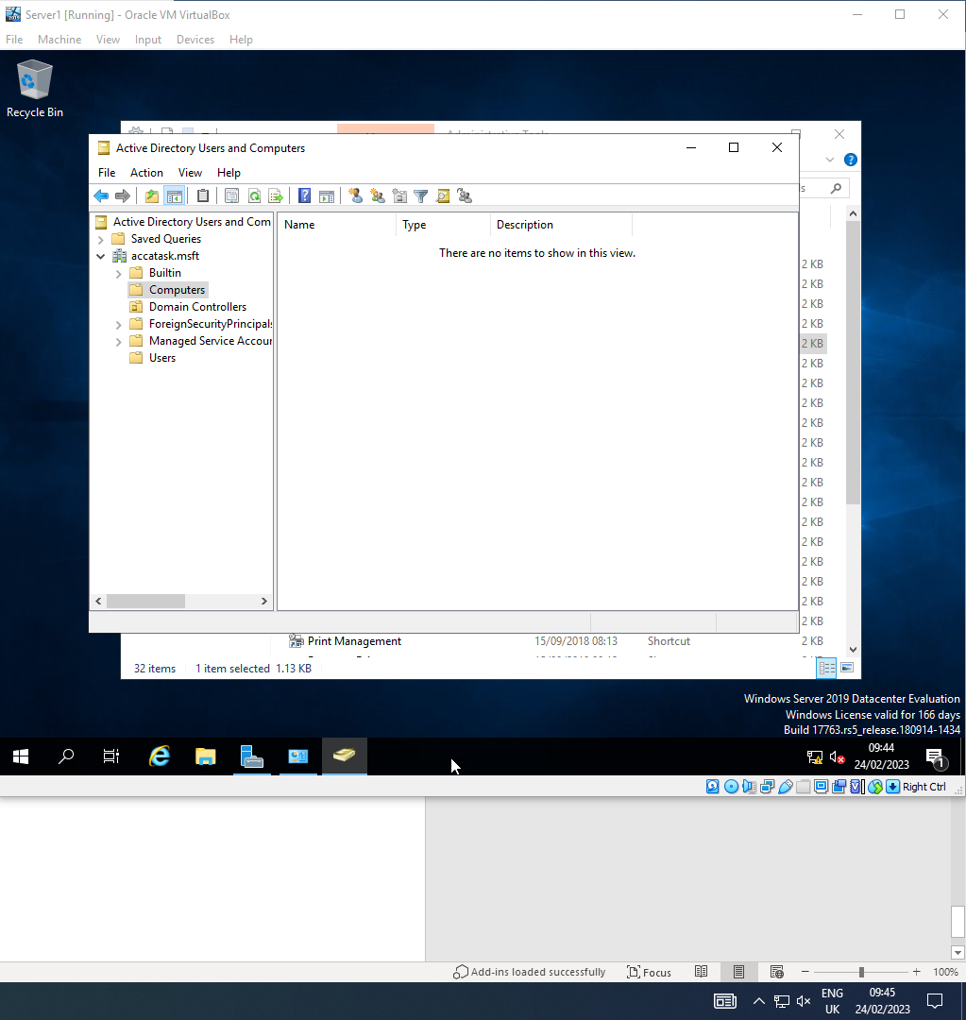
Computers folder empty
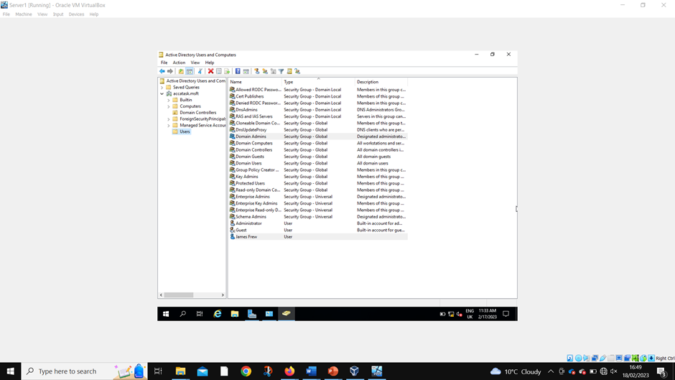
Admin account created
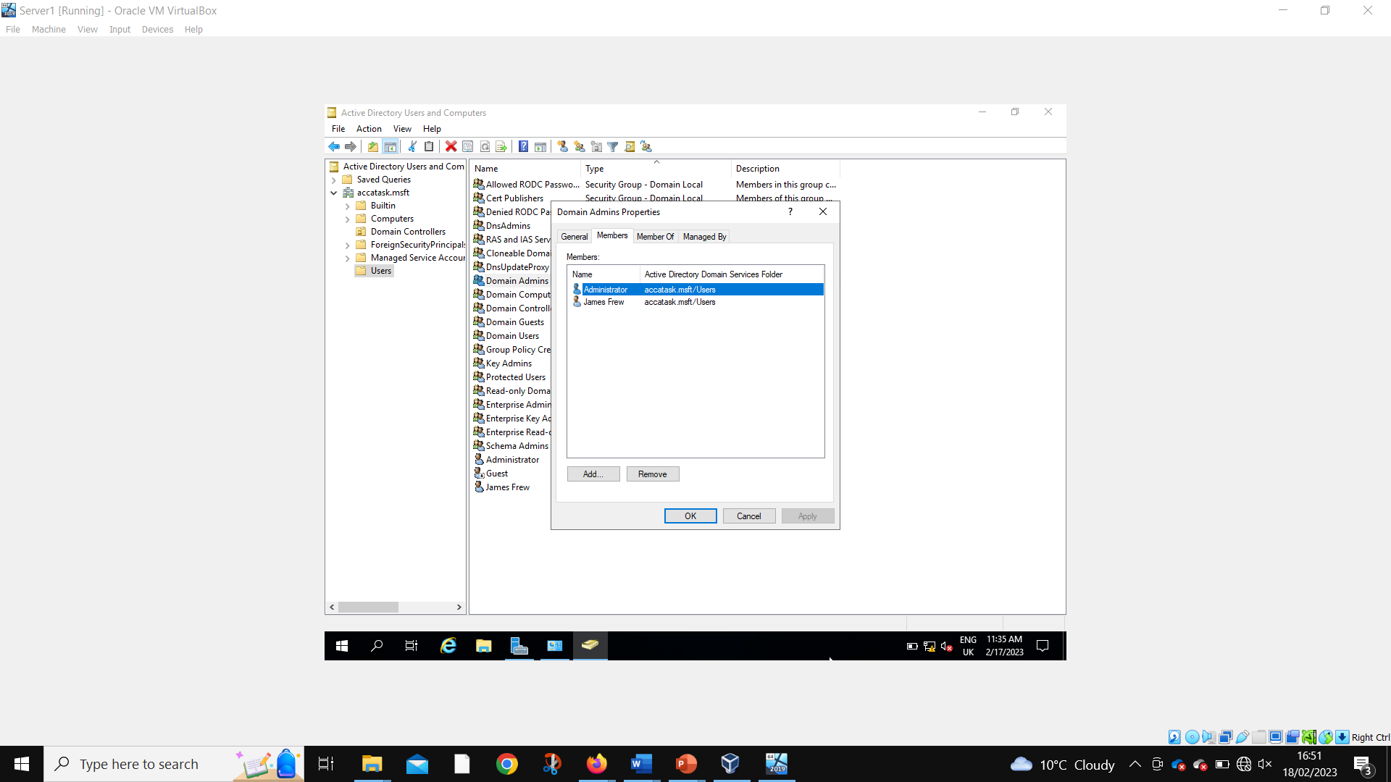
Admin account added to admin group
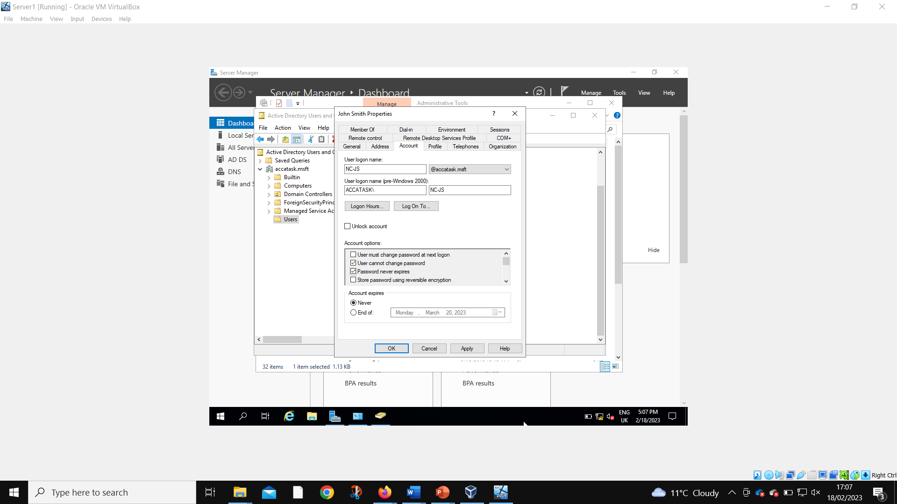
User account created
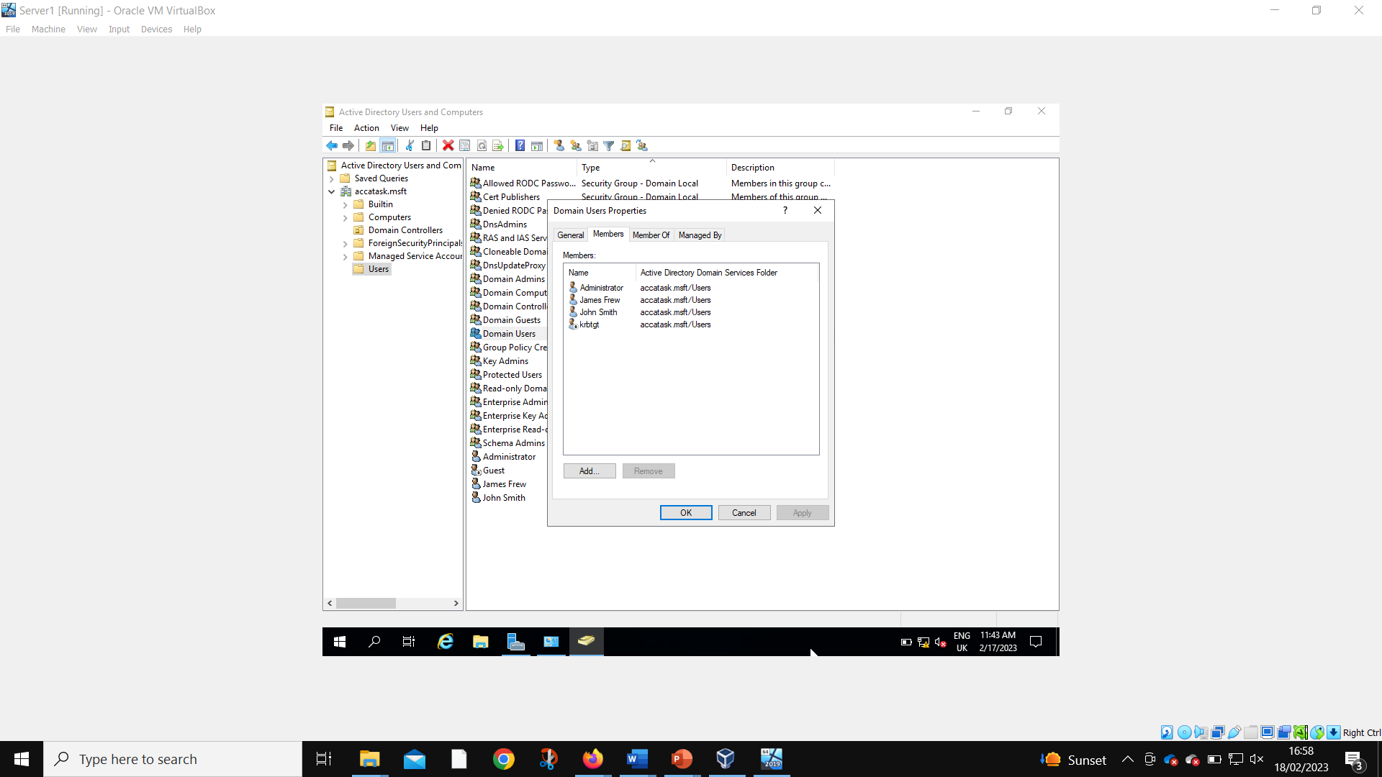
User account added to user group
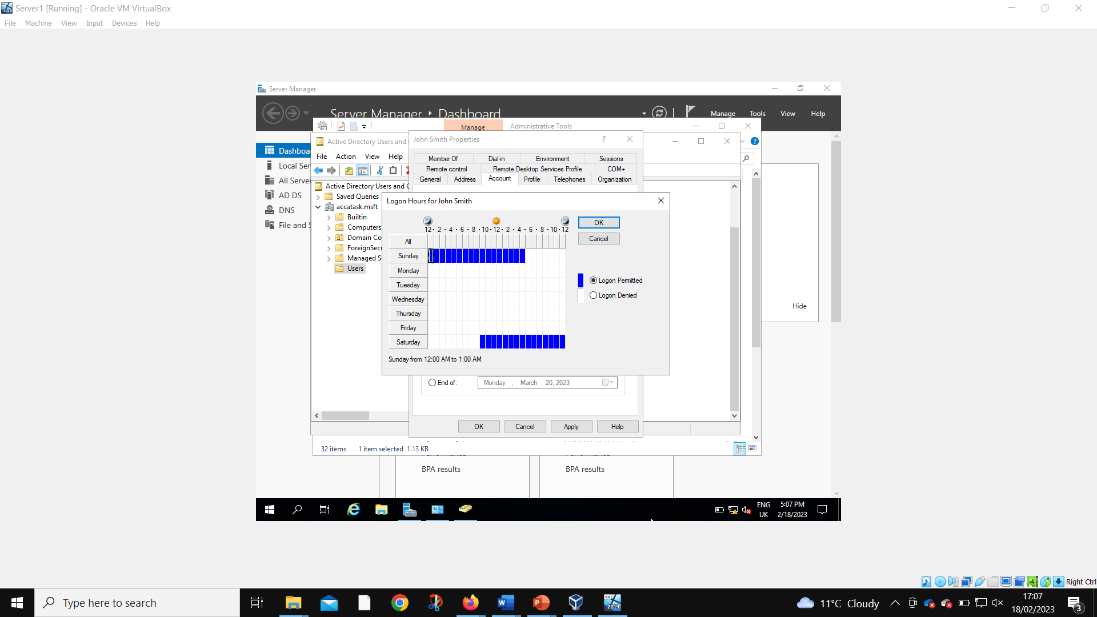
Access time restricted for user account
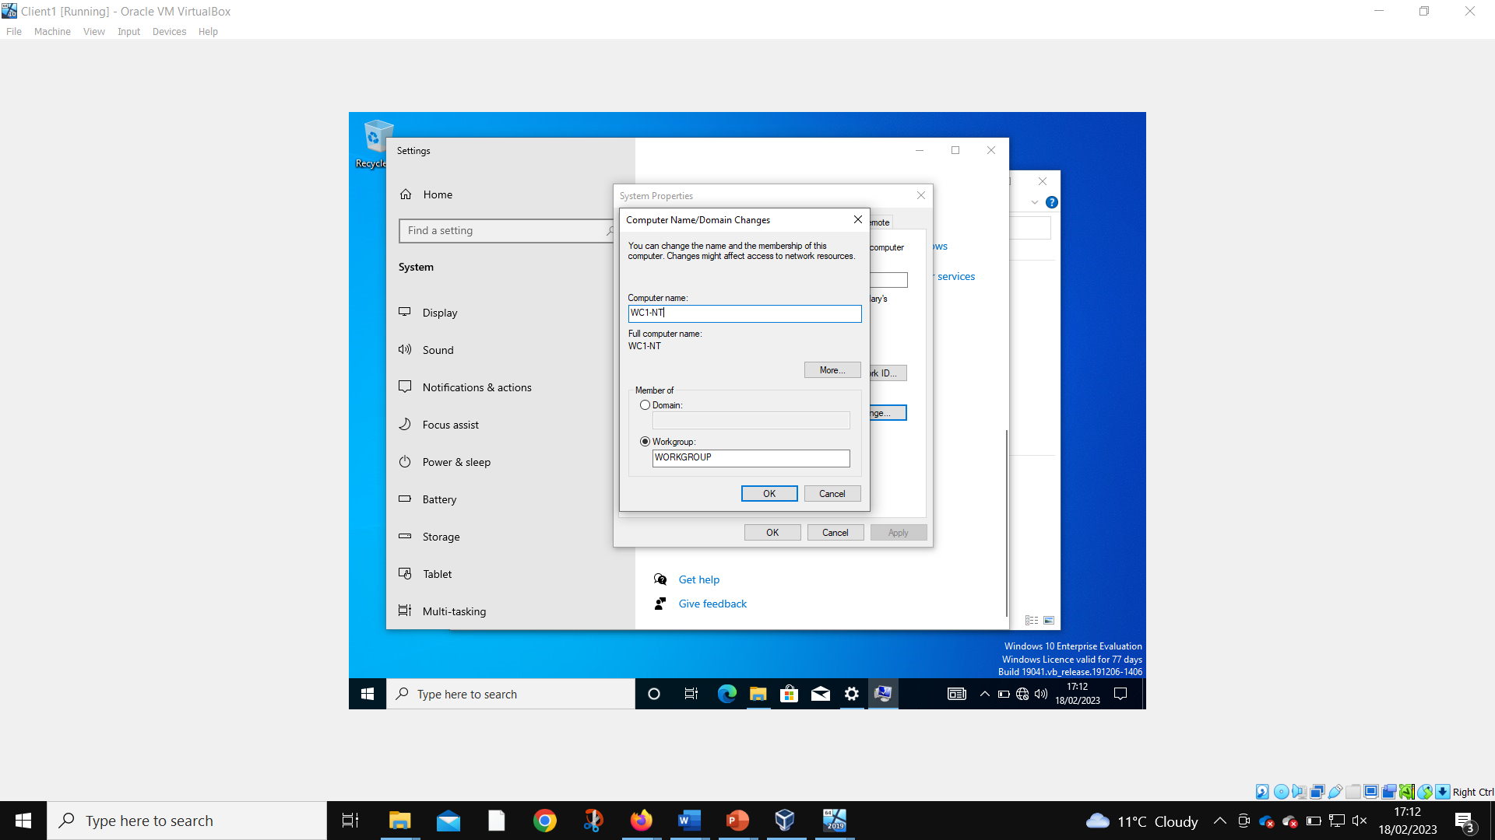
Client 1 computer name changed
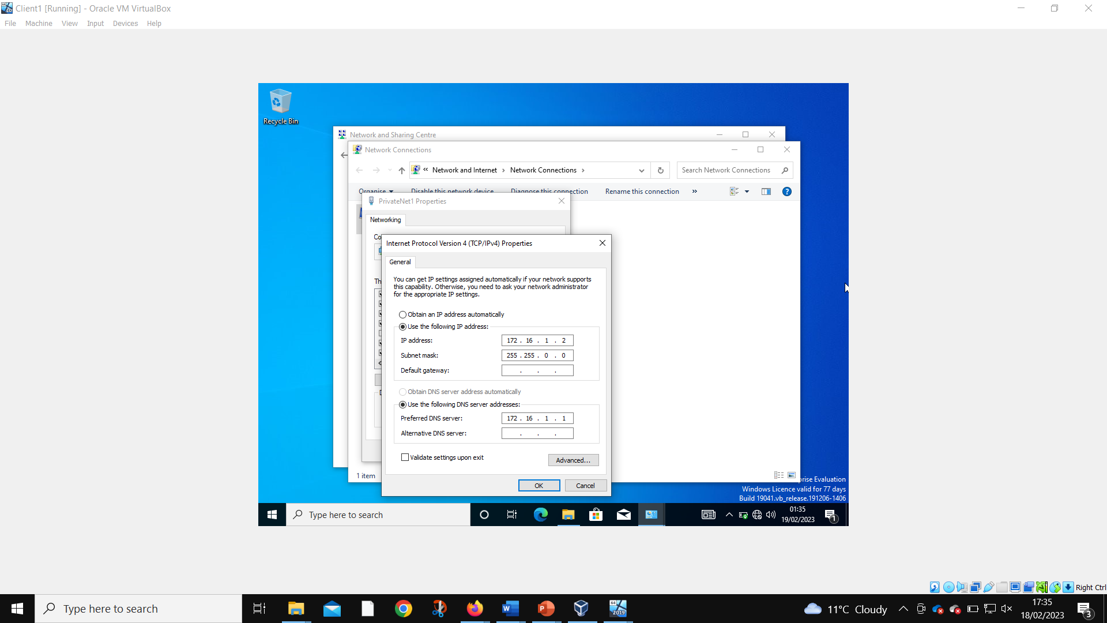
DNS IP assigned as 172.16.1.1. Instructions were to assign 10.10.10.1, but this is the address of the public network, and therefore wouldn’t work for the local DNS server connection
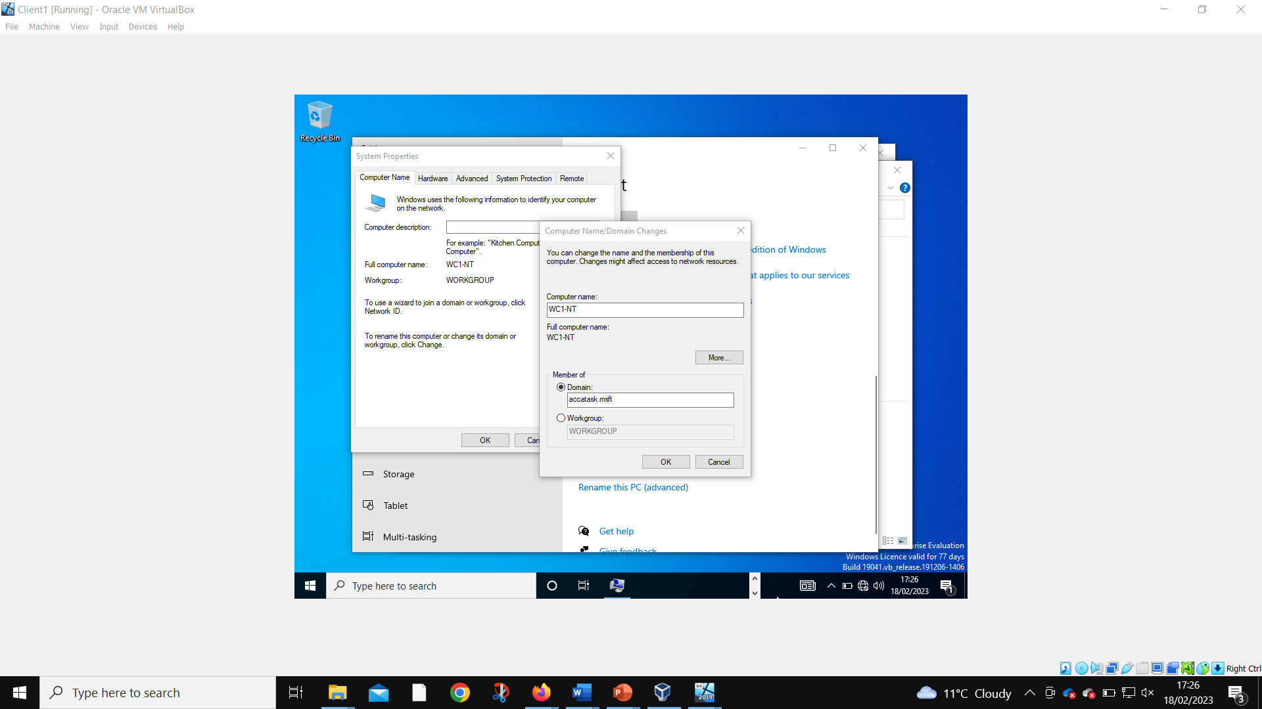
Client 1 member of domain changed 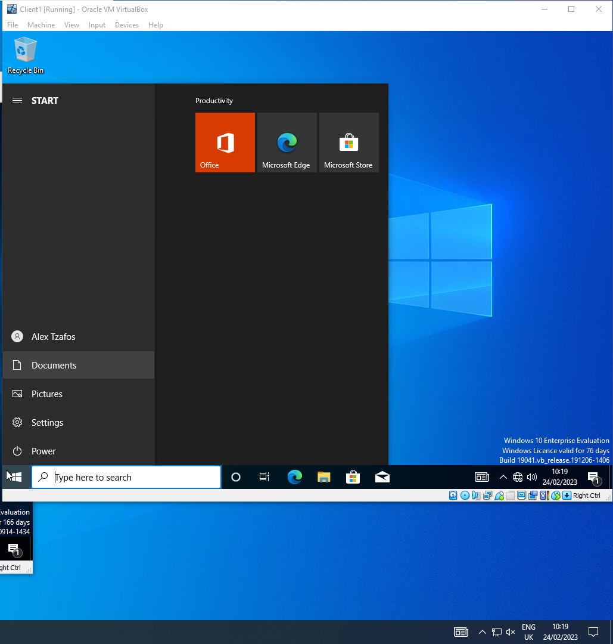
Admin account successfully logged into to Client 1
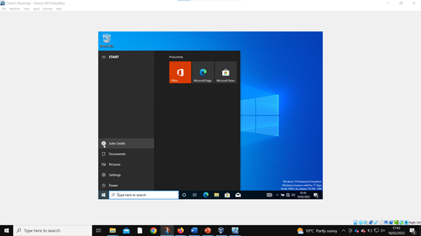
User account successfully logged into Client 1

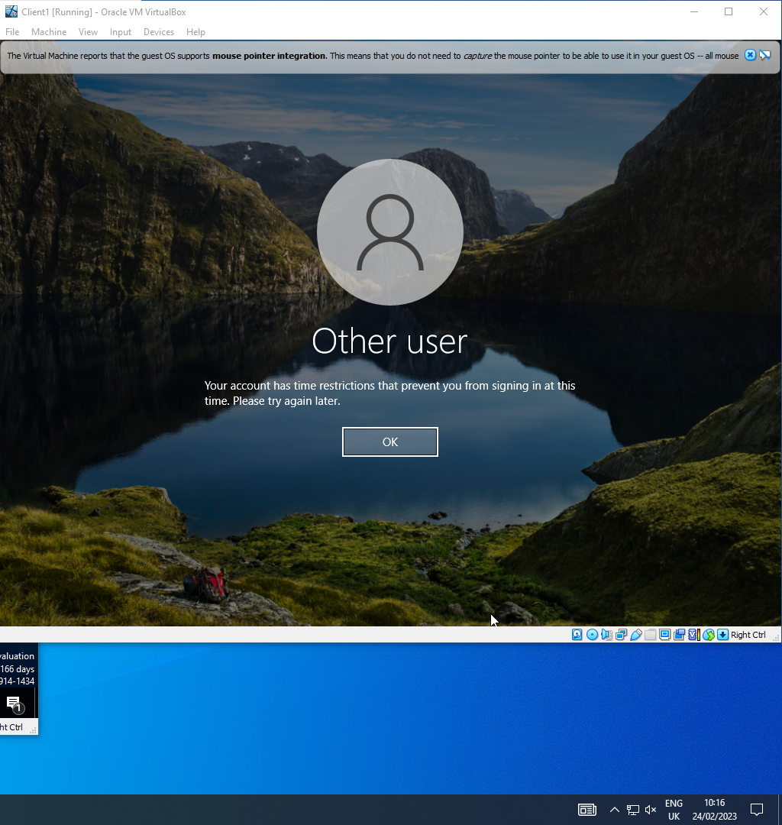
User account unable to log in to Client 1 due to time restrictions

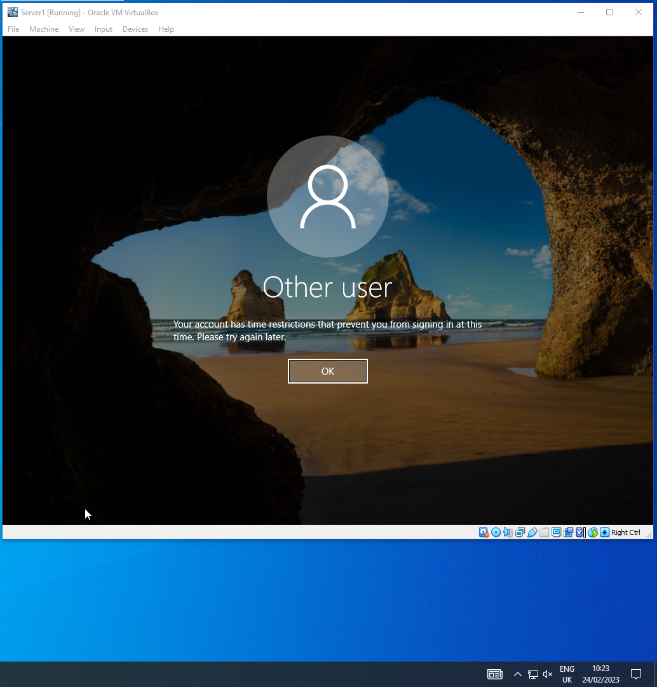
User account prevent from accessing/logging into Server 1

Hypervisors
We have used the type 2 hypervisors in this task as you are able to run lots of OS systems on there as we have two servers and two clients on the VM software. We have also used them as they are most common with end user systems as they are a benefit with the performance of the VM and it has a better security on them. the type 2 hypervisors are normally used “to create virtual desktops Type 2 hypervisors can support large and complex nested environments.” [1]. The best place to use the Type 1 hypervisors are used for production level workload as they are much more powerful than type 2 and then require a higher cost to run ad you must have a lot of RAM and CPU cores. They are mostly used for “support for software-defined storage and networking, which creates additional security and portability for virtualized workloads.” [2]. This will require much more management from the company that will be hosting it like Microsoft VM manager or VMware as you will need to access the full catalogue of the abilities. In the type 2 hypervisors can be a big flaw as if there is a virus you have a very high Chance of losing of the VMs that are running on your computer at the time.

DHCP
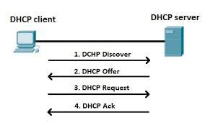

DHCP stands for dynamic Host configuration protocol it will automatically give out the IP address from the pool of IP address that are available to everyone. If we didn’t have DHCP you would have a very long time trying to find an IP address which will be time consuming, and you would probably make a few mistakes along the way, so it is much easier using DHCP. If a device would like an IP address, it will request it to the DHCP server then it will send the IP address to the device that wants it. It will then keep monitoring the address until the device that it was assigned. Then when the device either shuts down or when the time runs out it will take the IP address back and then it can be when you need it again the device will have to request un Ip address again, and it will go through the whole process again. There is lots of reason why DHCP is the best as it can give out reliable IP address as “You can’t have two users with the same IP address because it would create a conflict where one or both devices could not connect to the network.” [3]. It will also reduce the network admin as you won’t have to have a server for DHCP on every subnet as it can be centralized. The main components for the DHCP are the server as this is what will hold the IP address and all the information that will be related for configuration of the device. Then you have the DHCP client which is the end user of the whole of the process as they will have to request and receive the date that will configure the IP to the device. The software can be installed on anything that will have an internet connection as you will just need it to connect to the network.

Active Directory

The active directory is when you can store important data about the whole of the users and admin on the network. The active directory (AD) has more information than everyone thinks as it can include a global catalogue this is the” information about every object in the directory. This allows users and administrators to find directory information regardless of which domain in the directory contains the data.” [4]. The other tool you can find in the AD the schema, and this will define a set of objects or classes that will be contained in the directory. The directory is a hierarchical which means that is will store the data in the network, so it is easier to get for the users and the admin. The information stored would be things like “D DS stores information about user accounts, such as names, passwords, phone numbers, and so on, and enables other authorized users on the same network to access this information.” [5]. The AD will store the data as an object as the definition of the object is like a user, group, application or device like a phone or a printer. There are such things as trees and forest in an AD as a tree is one or more domain grouped together. This will use a namespace to gather data of the domains in a hierarchy. Then a forest is multiple trees, and this will share the catalogues, schemas, and domain configurations. In the active directory there is multiple ways it can share the data as the main 3 are one way trust this is where the first domain allows to share the data but the second doesn’t then there is two-way trust and that is where they both trust each other the last one is a trusted domain, and this is when a single domain allows users to access another domain.

Terminologies
The is description is the ping that you will need to test if the IP exists and that will receive a signal from the other computer. it can also be used to see if the host computer is reaching the destination. The next is the server management this is what you will have to do to the server to make the servers better as you will need to get the server up to the optimal performance levels like if you are using lots of space in one section you could get rid some of the data that might be slowing it down or if you need to replace a component as it is not working or being slow. You can also monitor the whole of the system from one place as like the updates and the maintaince you would like to do. You could also have the software on your phones so if you oversee managing the system you could be at home at get a notification on if the server breaks down or if there is a software problem. The windows firewall is some of the best firewall on the market as a lot more people have a window than any other software, but the firewall is probably the Linux one as “75% of the servers in the world use Linux firewall” [6]. The OOBE or out of box experience this can be a make or break for a consumer as the GUI will need to be easy to use and need to just click aways at pictures on the screen that must make sense like the license agreement or if they need to sign up to a Microsoft account. When setting up a PC for the first time you must have an easy set up but personal, I think apple set up is better as you can just move one computer to the other with one email and password, so you won’t need to set up a new device every time you get a new phone or computer. The PAE stands for Physical Address Extension, and this will expose the CPU to more than just 4 GB of RAM as you have more RAM which means you can access more on each VM, so you don’t have to worry about the VM crashing at any point.

Conclusion
I have done a lot in this assignment as there is a lot of screenshots which has been difficult to arrange then writing all about hypervisors and the different terminology used in the tasks.

Reflection

I think the tasks that were completed were easier than expected. The only thought was where you had gone back to the same server twice when the task you could of complete could have been done earlier one as this could save some time for everyone as if you must keep going back and forth when everything could have been done at once. It was also had harder to read by doing this as you need to think about if you have done it. After all that I think it was easy to navigate on how to complete the tasks that have been set. I think the hardest part was trying to get the windows on the VM as you had to download it on to the computer and then get it on the VM. The difficult part was trying to get the right windows on there as there was ones from different countries. You then had to set up all the VM as you had to create the windows size and the disk, but I think that was easy parts as you just had to set them up for the client and the client. It was simple setting up all the 4 servers as you just had to do 2 servers and 2 clients. When working out the IP address it was a bit difficult as I haven’t done the IP address in a while, so it was a learning curve.

References
[1], [2]
https://www.techtarget.com/searchitoperations/tip/Whats-the-difference-between-Type-1-vs-Type-2-hypervisor

[3]
https://www.networkworld.com/article/3299438/dhcp-defined-and-how-it-works.html
[4][5]
https://learn.microsoft.com/en-us/windows-server/identity/ad-ds/get-started/virtual-dc/active-directory-domain-services-overview
[6]
https://www.spiceworks.com/it-security/network-security/articles/top-10-linux-firewall-solutions/

