Claire Thomas
2210937
Presentation Link: https://uowtsd.sharepoint.com/:v:/t/ECGE4006PCHERIAUCYFOESCONTEMPORARYCHALLENGES_GRP/EYeJLH-PkFlNvOU1adHuMowBpUfjPyvexBpqveYlEiJD8A

Prototype
Let’s look at the recycling within our education system and how we can reduce plastic pollution. So, let’s take milk tops, around 92,067 with Wales are being used. According to the Welsh government data in 2022
Slide 13
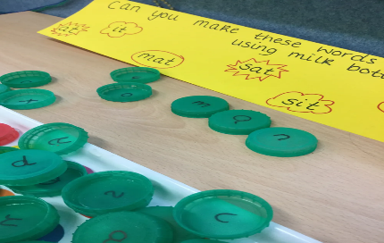
Milk tops can be used help with Phonics, Early CVC sounds spell their name, support speech, and language skills. It can also develop letter recognition and formation.
Slide 14
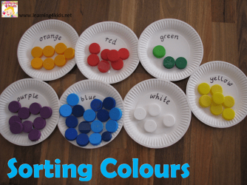
By painting the milk tops different colours such as identifying different shades and sorting. It can promote Fine Motor Skills, language skills and eye-hand coordination.

Slide 15
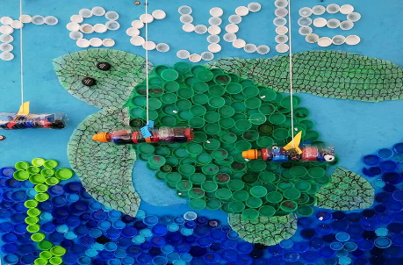
A school in Plymouth created art murals and sculptures using milk tops. By, recycling the milk tops the children can create their own animal such as jelly fish, shark, sea horse out of the milk tops and learn about the animal and the effects of plastic pollution.
Slide 16
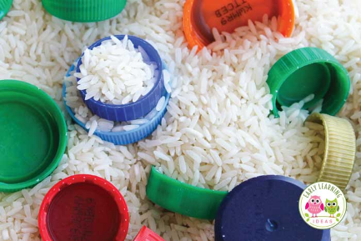
And finally, they also can be used as part of to a sensory bin within the classroom. They can be filled with rice, beans, etc in conjunction with milk tops and other recyclable material this can support multiple of senses such as touch, smell, and sound. Also, they can support brain development, fine motor skills and language development.
All of these can be used with hands on learning.

Reference List

Action for Children (2022). What is sensory play and why is it important. Available at: https://www.actionforchildren.org.uk/blog/what-is-sensory-play-and-why-is-it-important/ (Accessed 4 April 2023)
Early learning ideas (2023) Plastic bottle tops. Available at: https://earlylearningideas.com/plastic-bottle-caps/ (Accessed 4 April 2023)
Plymouth Herald (2022). Plymouth schools to help turn bottle tops into sculptures. Available at:https://www.plymouthherald.co.uk/news/plymouth-news/plymouth-schools-help-turn-bottle-6683344 (Accessed 4 April 2023)
Welsh government (2022). Pupils receiving milk by local authority, region, and year. Available at: https://statswales.gov.wales/Catalogue/Education-and-Skills/Schools-and-Teachers/Schools-Census/Pupil-Level-Annual-School-Census/Provision-of-Meals-and-Milk/pupilsreceivingmilk-by-localauthorityregion-year (Accessed 22 March 2023)
Woodland trust (2023) Recycle in School. Available at: https://www.woodlandtrust.org.uk/support-us/act/your-school/green-tree-schools-award/recycle-in-school/ ( Accessed 26 March 2023)

