

Managing Enterprise in the 21st Century

Business Plan

HARBOUR & TIDE
Premium Seaside Restaurant & Bar

Name: Enterprise and Entrepreneurship
Module: LCM4006
Student Name: Mylene Delosata
Student ID: 2508544
Assignment Tittle: Individual Written Business Plan
Lecturer: Riaz Bhatti

Table of Contents

Group Information 2
Executive Summary 4
Business Concept 5
Business Description 5
Product Description 5
Business Objectives (SMART Objectives) 5
Short-Term Objectives (less than a year) 5
Long-Term Objectives (less than a year) 5
Market Analysis and Marketing Plan 6
Market Analysis (Competitors, Customers, Target Groups) 6
PESTEL Analysis 6
SWOT Analysis 6
Marketing Mix (4Ps) 6
Management Team 6
Management Team and Their Background 7
Organisational Chart 7
Key Milestones 7
Financial Plan (One Year) 7
Sources of Finance 7
Cash Flow Forecast 7
Sales Forecast 7
Cost of Production Forecast 7
Break Even Analysis 7
Operations and Management Plan 7
Production of Good and Service 7
Technology Plan 7
Human Resource Plan 7
Expansion Plan 8
Reference List 8
Appendices: 9

Executive Summary

Harbour & Tide is a premium, yet relaxed seaside restaurant and bar located on a Uk coastal promenade or marina. It offers fresh, locally sourced seafood, modern coastal cuisine, and a curated drinks menu, with direct ocean views. The business integrates strong sustainability practices and community support to meet investor priorities and modern consumer values.

Target costumers include seasonal tourist, year-round residents, and private or corporate event clients. The concept stands out through responsible sourcing, strict environmental care, and a welcoming inclusive atmosphere.
This plan details the business model, market research, marketing strategy operational structure and financial requirements to demonstrate viability, projected returns and alignment with industry and regulatory standards.

Business Concept

Core Idea

Coastal quality responsibly served” to deliver high-quality dining and hospitality that celebrates local maritime heritage while actively protecting the marine environment and supporting the surrounding community. We fill a gap in the market for a venue that combines premium seaside dining with transparent ethical and environmental standards.

Business Description

Harbour & Tide operates as a Limited Company, while enabling investment and compliant governance (HM Government 2025). Located in a prime coastal tourism and leisure hub, the venue features indoor dining spaces, a sheltered outdoor terrace with sea views, and a dedicated private function room. Business operates year-round, balancing high-season tourism demand with consistent trade from local residents and events.

Sustainability & Community Focus:
- Sourcing seafood from local day-boat fisheries and MSC certified suppliers
- Sourcing fresh produce, dairy and drinks from regional producers to cut food miles
- Donating 2% of monthly net profit to local coastal conservation and community projects
- Eliminating single-use plastics, recycling fully composting organic waste

Product Description

- Food: fresh seasonal seafood (grilled fish, shellfish platters), modern coastal dishes, plus plant-based and dietary-friendly options
- Drinks: Signature coastal cocktails, local craft beers, regional ciders, and carefully curated wine list
- Services: Full table services dining, casual terrace services, private dining/event hire, and seasonal special events

Business Objectives (SMART Objectives)

Short-Term Objectives (0-12 months)

- Achieve consistent monthly turnover of £60,000 within 8 months of opening
- Reach break-even point within 10-12 months
- Secure supplier agreements with at least 8 local producers/fisheries
- Build social media following of 2,500+ local/regional followers and maintain 4.5+ star rating across major review platforms

Long-Term Objectives (More than a year)

- Achieve net profit margin of 12-15% by end of the Financial year 2
- Establish Harbour & Tide as the top-rated dining venue in the local coastal area
- Develop branded take-home and retail lines of local seafood/produce by Year2

Market Analysis and Marketing Plan

Target Groups Segment Revenue Share Profile & Needs. Tourists 60% annual revenue peak-season visitors, day-trippers and holidaymakers, seeking authentic local food, scenic settings and memorable experiences, with activity concentrated between spring and autumn (VisitBritain, 2026).
Residents 30% annual revenue Year-round core costumer base; prioritise consistent quality, fair pricing and businesses that contribute to their community, providing vital stability outside peak tourism periods (UK Hospitality 2025).
Private and Corporate Clients 10% annual revenue Bookings for weddings, celebrations, conference and retreats; require dedicated spaces, bespoke menus and reliable services delivery (Chartered Institute of Marketing, 2025).

Market Analysis (Competitors, Customers, Target Groups)

Direct competitors include 3 to 4 established restaurants along the same stretch, offering standard menus with limited ethical focus and basic event facilities; indirect competition comes from pubs, cafes and hotel dining rooms.
Our competitive advantages: primes waterfront location; verified sustainable sourcing, flexible events spaces; exclusive agreements with local fisheries and farms. Research confirms 76% of UK diners actively choose venues with transparent provenance standards (Marine Stewardship Council 2025) a gap currently unaddressed locally.

PESTEL Analysis

Political
The business have more prospects around the coastal side of the country. The business has achieved with the local authorities hygiene rating 5 out of 5 which shows the business is fully compliant and follows Health & Safety regulation as well as GDPR applications as per UK laws.
Economical
Restaurant industry is highly competitive and fairly priced its products and services. The business prospects depends on the economic situation in the country, if the DPI stays higher will help the restaurant business profitable.
Economic Cost-of-living shifts mean consumers prioritise meaningful experiences over low cost; 40% of coastal area revenue is typically generated in summer months, requiring careful cash flow management (Office for National Statistics, 2026).
Social
The business is widely recognised in terms of its menu in the town and one of the most popular foods in the local town.
Social Rising public expectation for environment responsibility accessibility and inclusive hospitality (Low Carbon Business 2025).
Technical
Premium Seaside Restaurant & Bar has introduced an app for its customers to pre-book appointments. Customers can also reserve booking through social medial platforms as well.
Technological Online booking review platforms and digital menus are now standard requirements for costumer engagement (Chartered Institute of Marketing 2025).

Environmental
Environmental Regulations covering waste disposal, single-use plastics and coastal protection, with eco-credentials strongly influencing patronage (Low Carbon Business, 2025).
Legal
Legal Compliance with food hygiene standards (Food Standards Agency, 2025) employment legislation, and Private Limited Company reporting rules (HM Government, 2025).

SWOT Analysis

- Strengths: Prime waterfront location; verified ethical positioning; experienced team; adaptable layout; established local supply network.

- Weaknesses: New brand with no existing reputation; higher initial cost of certified produce; seasonal revenue variation; limited launch marketing budget

- Opportunities: Restaurant business always have a potential to expand its existing seating capacity particularly in summer where customers like to enjoy more outside environment.

- Threats: High local competition, Government taxes, Inflation all can make an impact on the business existence.

Marketing Mix (4Ps)

Product
- Harbour & Tide offers fresh, locally sourced seafood, modern coastal dishes, plant-based options, and a premium drinks menu. Services include indoor and outdoor dining, private events, and seasonal specials. Sustainability and excellent customer service are key features.

Price
- A value-based pricing strategy will reflect the quality of the food, service, and waterfront location. Seasonal offers and event packages will attract customers during quieter periods while maintaining premium prices during peak tourist seasons.

Place
- The restaurant will be located on a busy UK coastal promenade or marina, attracting tourists and residents. Customers can book online, by phone, or in person, with takeaway and delivery services also available.

Promotion
- Marketing will focus on social media, the company website, online reviews, and local advertising. Partnerships with hotels and tourism businesses, together with seasonal promotions and loyalty offers, will help attract new and returning customers.

Marketing Objective

- Achieve 75% brand awareness among target groups within 12 months
- Maintain an average 4.5+ star rating across Google and TripAdvisor from opening
- Secure at least 12 confirmed event bookings in the first 8 months
- Grow combined social media audience to 2,500+ relevant followers within Year 1

Implementation & Budget rolled out in pre-launch, opening and ongoing phases budget split: 40% digital, 30% local activity, 20% events, 10% research and training (Hospitality Industry training Board, 2025) Performance measured via sales, feedback and engagement data.

Management Team

Owner / Director: Sets long term strategy, approves budgets, secures funding and holds final decision-making authority.
General Manager: Overall operations, finance, compliance, and investor relations background in hospitality management and finance.
Service Manager: Costumer experience, front-of-house leadership, staffing and service standards
Operations & Events Manager: Bookings, venue logistics, supplier liaison and maintenance.
Head Chef: Menu design, kitchen leadership, sourcing and quality control; experience in sustainable seafood and local cuisine.
Supervisor & Staff: Front of house and kitchen reams trained in hospitality standards, sustainability and safety.

Organisational Chart

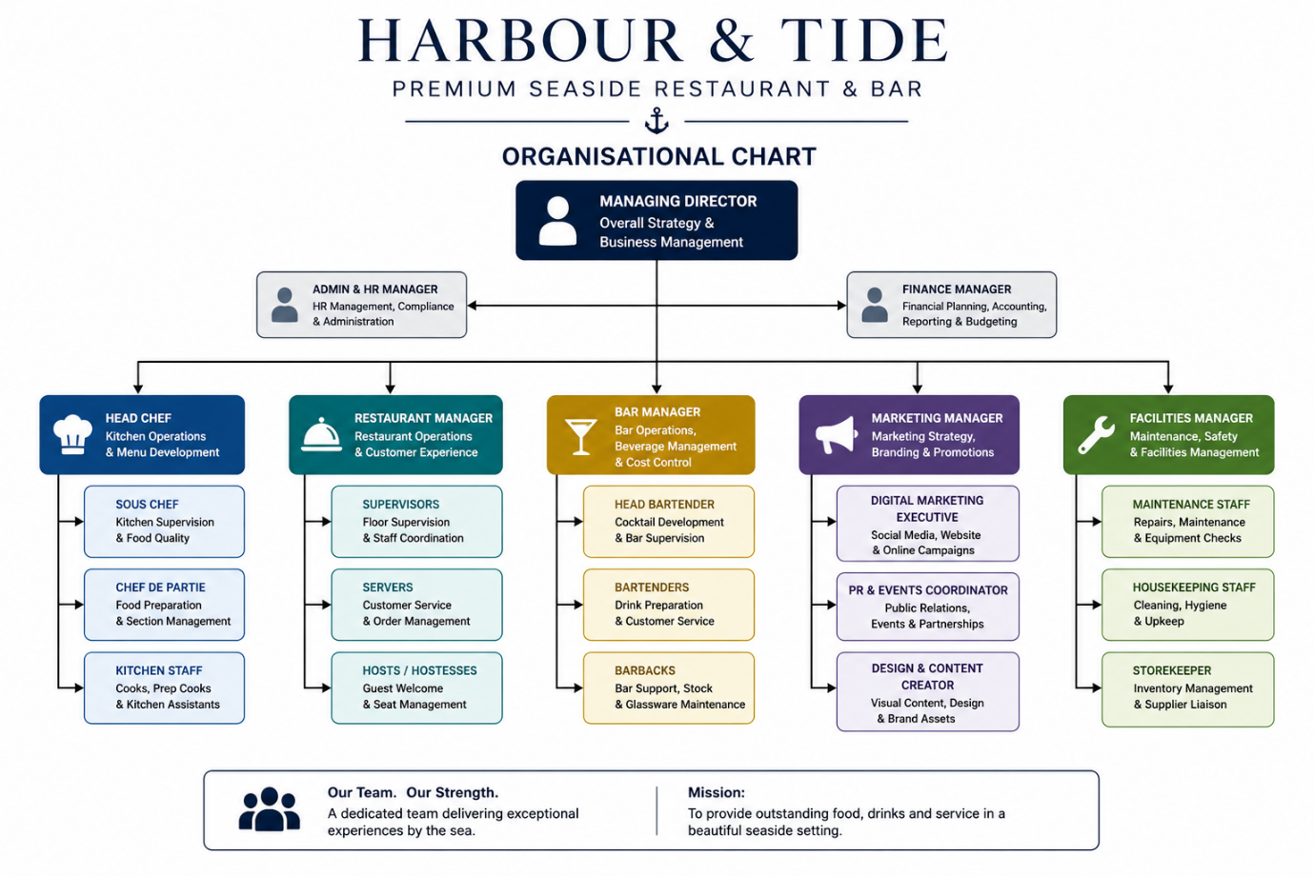

Key Milestones

Month 0-2: Lease signed permits/licences secured, fit-out complete, suppliers appointed
Month 3: Soft launch and full staff training
Month 4: Official public opening
Month 6: Launch of first seasonal event programme
Month 10-12: Reach break-even trading point

Financial Plan (6 months)

Sources of Finance

Total Funding Required: £320,000
Personal Investment: £120,000
External investor capital: £150,000
Small business loan from a bank: £50,000

On the next page is Profit & Loss (P&L) forecast for the business for the first six months are prepared, since the P&L is prepared on a cash basis therefore it can be taken as cash flow forecast for the business as well.

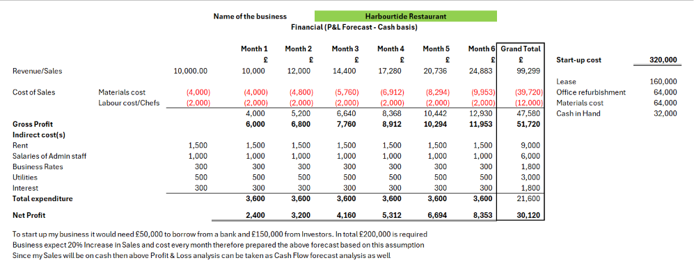

Cost of Production Forecast

- Gross margins: Food 65%, Beverages 78%, Events 82%
- Fixed cost: Rent, Utilities, Insurance, Salaries, Rates, Licence fees
- Variable costs: Ingredients, Drink stock, packaging, marketing, payment fees
- Start-up one-off cost total: £50,000

Break Even Analysis

- Average monthly fixed costs approx. £4,200
- Weighted average contribution margin: 8.75%
- Break-even sales point approximately£48,000
- Forecast break-even achieved: Month 11 of trading

Operations and Management Plan

Production of Good and Service

- Strict sourcing policies; daily fresh deliveries; full traceability records kept
- Standardise recipes and service procedures; rigorous quality control checks
- Zero single-use plastics; separate composting, recycling and waste streams

Technology Plan

- Cloud-based POS, booking and reservation system; integrated inventory management
- Xero cloud accounting software for live financial tracking
- Optimised website, social media management tools and digital marketing platforms
- Energy-efficient commercial appliances, LED lighting and smart heating controls

Human Resource Plan

- Phased recruitment of 12 full-time and up to 8 part-time casual staff
- Comprehensive induction training: food safety, allergen awareness, sustainability and service standards
- Competitive pay aligned with UK living wage; clear progression pathways and performance rewards to reduce turnover

Expansion Plan

- Post-Year 1: Extend terrace capacity and trial longer seasonal opening hours
- Year 2: Launch branded retail lines; explore pop-up events or second location feasibility
- Build formal partnerships with local accommodation providers and regional tourism bodies

Reference List

Companies House (2026) Incorporation and names (Accessed: 26 July 2026).
- Department for Business and Trade – Hospitality strategy (Accessed: 26 July 2026).
- Food Standards Agency (Accessed: 26 July 2026).
- Marine Stewardship Council (Accessed: 26 July 2026).
- Porter, M.E. (1985) Competitive Advantage: Creating and Sustaining Superior Performance. New York: Free Press.
- Kotler, P., Bowen, J.T. and Makens, J.C. (2022) Marketing for Hospitality and Tourism. 8th edn. Harlow: Pearson.
- Mare, Z.M. and Dogru Dastan, H. (2026) 'Internal marketing of sustainability (Accessed: 26 July 2026).
- Armstrong, G. and Kotler, P. (2021) Principles of Marketing. 18th Global edn. Harlow: Pearson.
- Westwood, J. (2020) How to Write a Marketing Plan. 5th edn. London: Kogan Page.
- Kotler, P. and Keller, K.L. (2022) Marketing Management. 16th edn. Harlow: Pearson.

