Student name: Rhys Llewellyn Jones
P Number: 2003816
Programme of study: Photography in the Arts
Module: m4X01684
Photographic art practice Lecturer’s Name: Ryan Moule

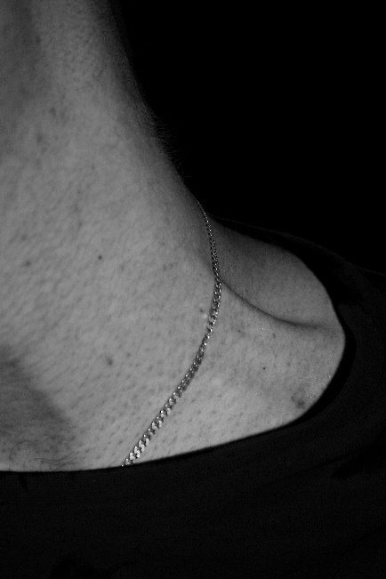
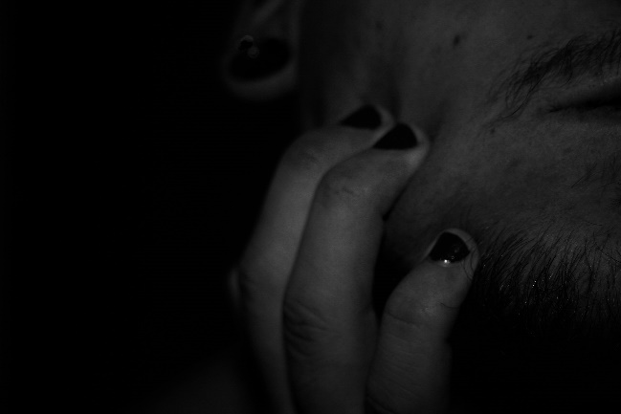
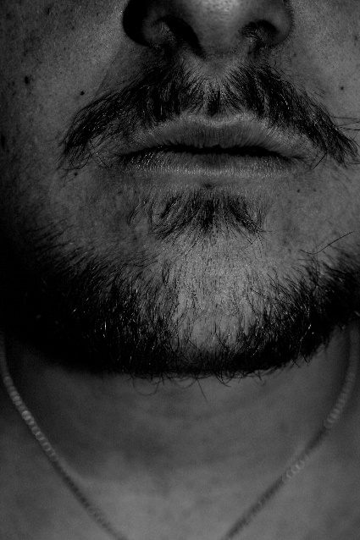
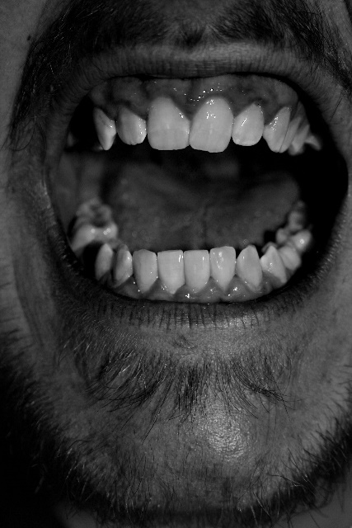
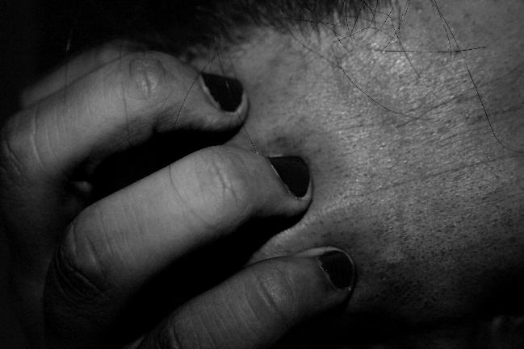
poetic image project

“My nerves are bad tonight. Yes, bad. Stay with me.
“Speak to me. Why do you never speak. Speak.
“What are you thinking of? What thinking? What?
“I never know what you are thinking. Think.”
(Eliot, 1922)
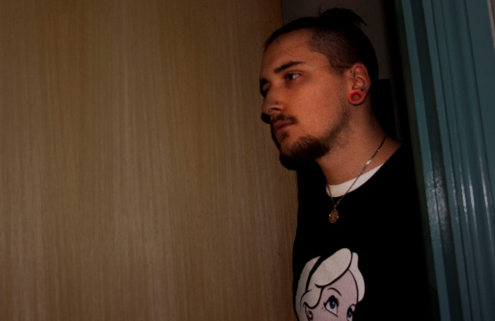
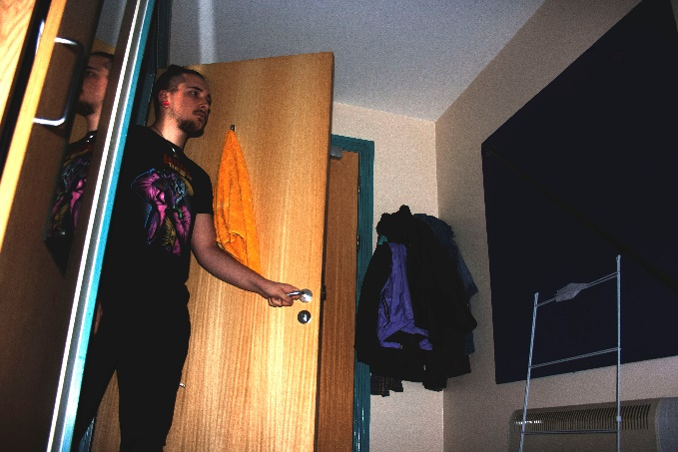
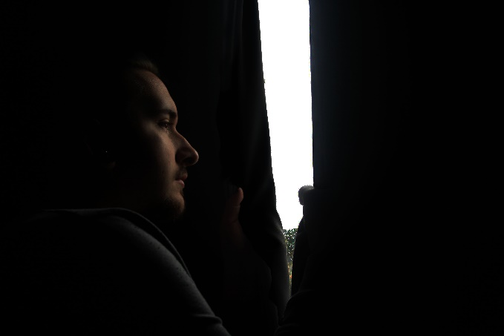
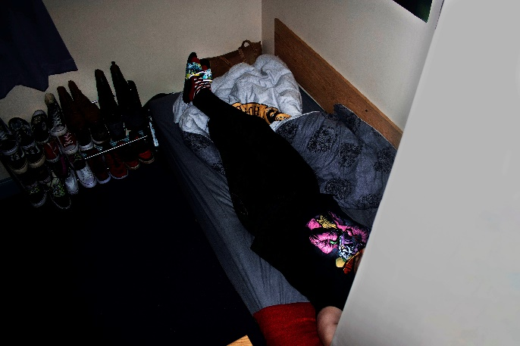
Cinematic
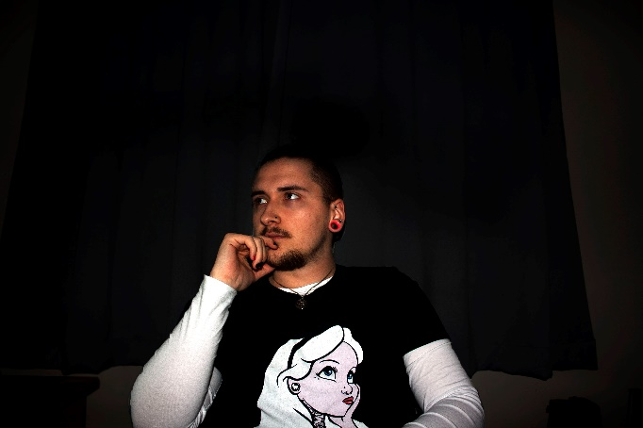

Isolated from life

Collaborative image

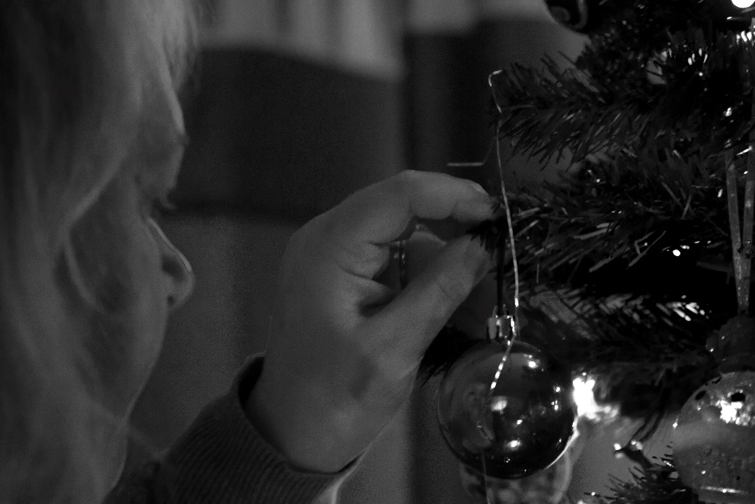
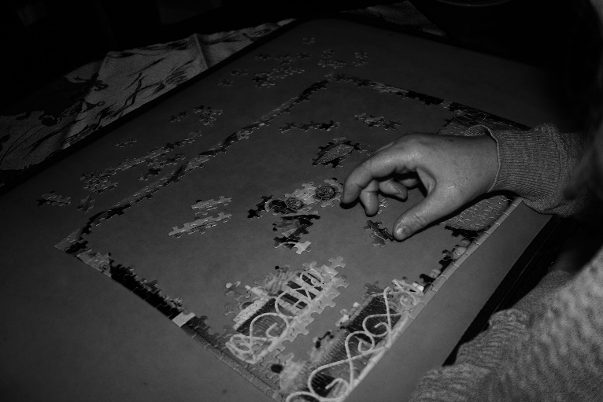
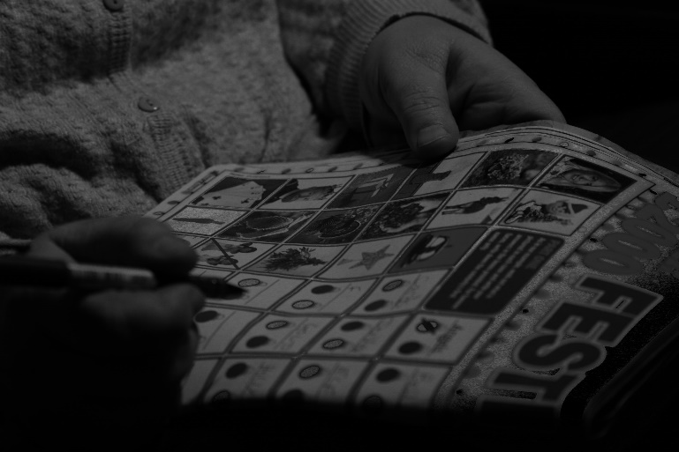

A covid christmas

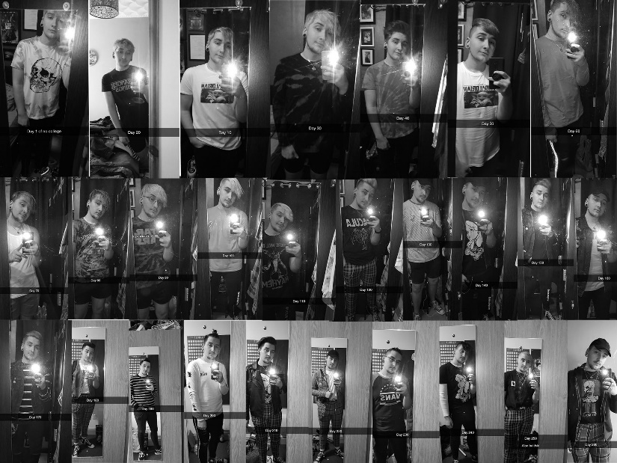
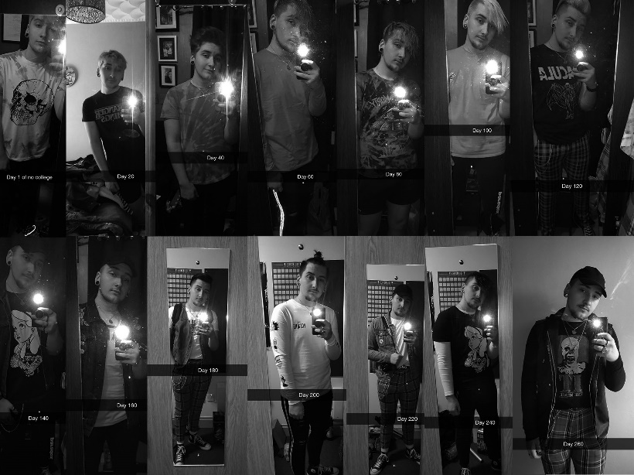
Network image
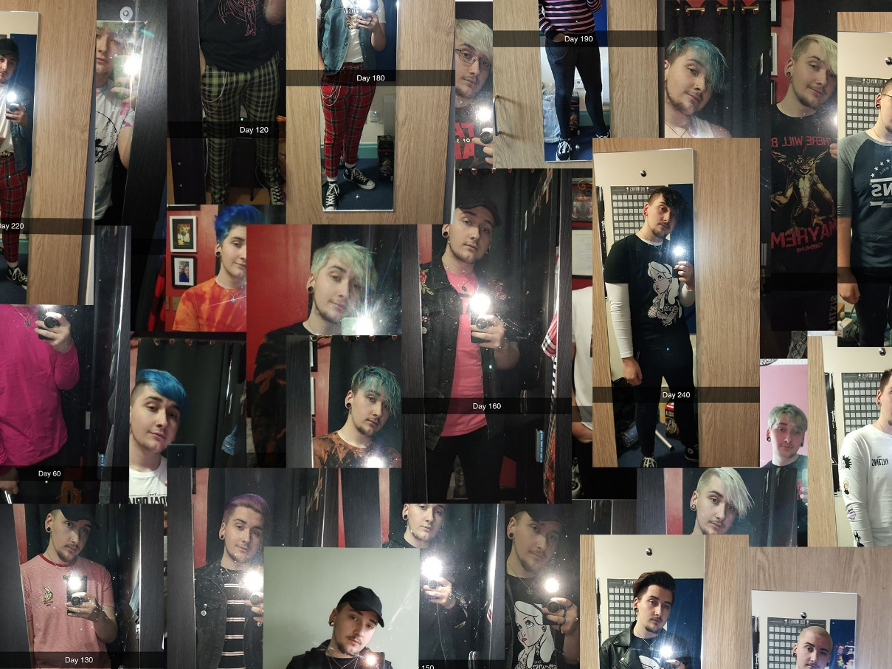

Daily pictures that fade away

Bibliography
Websites
Eliot, T. (1922) the waste lands. Available at: Poetry Foundation (accessed: 6 November 2020)

