


PROJECT TITLE
Effectiveness of Software Project Management on Software Development
Student Name
Sahibzada Ghalib Aziz
Supervisor Name
Divya Chidambaram
Project submitted as part of the requirements for the award of Course Name
Software Engineering
28/08/2024

Declaration of Originality

I, ................……Sahibzada Ghalib Aziz…………………………… declare that I am the sole author of this Project; that all references cited have been consulted; that I have conducted all work of which this is a record, and that the finished work lies within the prescribed word limits.

This work has not previously been accepted as part of any other degree submission.

Signed : ........Ghalib.....................................

Date : .......28/08/2024........................................

FORM OF CONSENT

I .....................Sahibzada Ghalib Aziz
............ hereby consent that my Project, submitted in candidature for the degree Software Engineering, if successful, may be made available for inter-library loan or photocopying (subject to the law of copyright), and that the title and abstract may be made available to outside organisations.

Signed : .........Ghalib....................................

Date : ............28/8/2024...................................

Copyright Acknowledgement

I acknowledge that the copyright of this project report, and any product developed as part of the project, belong to University of Wales Trinity Saint David, Swansea.

ABSTRACT/SYNPOSIS

A one page overview summarising the entire project. Focus on the key outputs of this research and provide an overview of what to find in this report. You’ll do this at the end of the project but it should be the first thing in your report.

This document is for reference guide only. You may wish to have a slightly different structure for your report. This template will help you to automatically generate a Content page, List of Tables and List Of Figures, but only if you correctly use Styles.
TABLE OF CONTENT

Copyright Acknowledgement 4
ABSTRACT/SYNPOSIS 5
TABLE OF CONTENT 6
LIST OF FIGURES 8
LIST OF TABLES 9
ACKNOWLEDGEMENTS 10
CHAPTER 1 11
CHAPTER 1: INTRODUCTION 11
1.1 Background 11
1.2 Problem Statement 11
1.3 Importance of the Study 12
1.4 Objectives 12
1.5 Scope of the Research 13
.1.6 Aims 14
1.7 Research Questions 14
1.8 Structure of the Project 15
CHAPTER 2 17
Summary 17
Literature Review 17
CHAPTER 3 - RESEARCH METHODOLOGY 24
3.1 INTRODUCTION 24
3.2 RESEARCH METHOD 24
3.3 JUSTIFICATION OF APPROACH: 24
3.4 RESEARCH MODEL 24
3.4.1 Research Process Diagram: 25
3.4.2 Research Model Diagram: 26
3.5 DATA ANALYSIS AND EVALUATION METRICS 26
3.6 RESEARCH MATERIALS 27
3.6.1 Research Data 27
3.6.2 Software and Hardware 28
3.7 CHAPTER SUMMARY 28
CHAPTER 4 - DESIGN & IMPLEMENTATION 29
INTRODUCTION 29
PROBLEM FORMULATION 29
4.1 TOOLS AND SOFTWARE: 29
4.2 DESIGN 29
4.3 EXPLANATION OF THE DIAGRAM AND ANALYSIS 30
4.4 ANALYSING SURVEY QUESTIONS 30
4.5 CONCLUSION 32
CHAPTER 5 – TESTING AND EVALUATION 34
Interpretation: 42
Discussion: 45
Next Steps: 45
CHAPTER 6 - CONCLUSIONS AND RECOMMENDATIONS 47
SUMMARY 47
CONCLUSION 47
RECOMMENDATIONS FOR FURTHER RESEARCH 48
CHAPTER 7 – REFLECTIONS 50
7.1 Achievement of Aims and Objectives 50
7.2 Conduct and Progress 50
7.3 Overcoming Challenges 50
7.4 Reflection on Methodology 50
CHAPTER 8 - REFERENCES 51
CHAPTER 9 – BIBLIOGRAPHY (OPTIONAL) 58
APPENDICES 60
Ethics form 60
Logbook……………………………………………………………………………. 60

LIST OF FIGURES

Figure 1 research process diagram 25
Figure 2 Research Model Diagram 25
Figure 3 Data Analysis 32
Figure 4 Top 10 Types of Errors 34
Figure 5 Impact of Errors on Project Outcomes 39
Figure 6 Stacked Bar Chart 40
Figure 7 Comparative Radar Chart of Project Management Frameworks 46

LIST OF TABLES
Table 1 How project is affected by size & domain…………………………………. 44

ACKNOWLEDGEMENTS

Include any acknowledgements you may have in this section.

CHAPTER 1

CHAPTER 1: INTRODUCTION

1.1 Background
In the fast-paced domain of present day program venture administration, a unavoidable challenge stands up to companies, especially new businesses: the nonappearance of current techniques, controls, and an understanding of later advancements and the noteworthiness of darken however noteworthy issues in advanced computer program extend administration. Such a need of in-depth understanding presents a noteworthy obstruction for associations undertaking the fragile assignment of finishing program ventures in a ceaselessly changing environment [1].
Without protective systems to safeguard against the trend of falling behind industry peers, an organisation may overlook crucial progress and continue using outdated methodologies [2].
The Kaizen approach, for example, emphasises the importance of continuous improvement, where project managers educate themselves on mismanagement issues such as scope creep, resource misplacement, and communication barriers to ensure project success [3].
Failure to make such small changes will slow progress, conserve inefficiency, and arrest growth [4].
The challenge is greatest for newbies and part of the very philosophy and definition of start-ups – looking for good opportunities and the fast response to changes, which keeps them going and makes them successful. But, they are always faced with limitations of funds and standard procedures that large companies have; this makes them more vulnerable and must focus more on productivity in software projects[4].\
This situation is catastrophic for organisations’ objectives as common issues like time, funds, and further usage of resources for sustainability cannot be handled on time.

1.2 Problem Statement
To overcome the challenges in cutting edge program venture administration there is need to carry out the activity in continual learning, factual decision-making, and the application of various techniques which fit the specific characteristics of each venture. Bodies should mobilise the development of a culture of competent capability, be kept up to date with high stakes, and commit to the spirit of ongoing professional learning. [5].
In any case, it is pivotal that their methodology is balanced to the particular scale, boundaries, and field of concern for each venture, as a "one measure fits all" approach is unseemly for the erratic world of program venture administration [6].
Long-term inquire about in program companies, cantering on the dangers of computer program improvement, is too basic. Through persistent inquire about, cautious examination, and precise documentation of these dangers, analysts can give a valuable direct to specialists on diverse approaches to issues and ways to maintain a strategic distance from potential failings [7].

1.3 Importance of the Study
The genuine issue of lack in understanding and oversight in computer program venture administration needs to be settled by associations, analysts, and industry partners. Building a culture that includes long lasting enhancement, decision-making, and proactive chance administration is basic [8].
As it were by drawing closer data frameworks in this way can undertakings, especially new businesses, make advanced computer program ventures show up resolvable and effectively explore the persistently changing computerized field [9].
The significance of compelling computer program extend administration cannot be exaggerated in today's fast-paced, technology-driven world. Software development projects are widely known to be challenging with defining features such as shifting requirements, limited deadlines, financial constraints, and emerging technologies [10].
There are thus central venture administration skills that can be used to work through these difficulties and convey adequate extend outcomes
[11].

1.4 Objectives
This research aims to:
1. Mitigate Risks: Influential extend administration helps to identify risks at the timing when the undertaking is even still at the very beginning of the undertaking lifecycle. In doing so, groups can develop moderation techniques that help avoid these risks from becoming major problems [12].
This is crucial especially in ensuring that most of the ventures are well monitored and conducted avert break-even and cost over runs.
2. Improve Communication: The effective communication plays the central role in any extend since people always should understand one another. Enhance the administration systems develop ordinary frameworks of correspondence and procedures that will help all partners to be refreshed on developments and any difficulties that arise [13].
3. Ensure Quality: Venture administration hones put great emphasize on the aspect of quality control. Accordingly, extend groups can ensure that the last item is up to the quality standard of the client desire by standard testing and survey [17].
3. Manage resource Efficiency: Efficient management of resources regardless, time, money or people is fundamental to extend administration. Through proper division of assets and ensuring they use all throughout the project, groups can avoid overwhelms and wastage which ensures that the venture is still feasible [15].
1.5 Scope of the Research
The scope of this ask around wraps investigating the challenges experienced by affiliations in cutting edge computer program enhancement. The fundamental centre is on understanding current framework designs, tending to common wander organization issues, and recognizing the essential influence of clearly minor goofs on expand comes about. Especially, the examine focuses to shed light on: [16].

● The require of mindfulness with regard to state-of-the-art frameworks.

● Ordinary expand organization challenges.

● The potential results of ignoring minor errors.

● The specific challenges stood up to by unused companies in investigating progressed program wander administration.
Furthermore, the explore proposes proactive approaches to ceaseless learning, industry best sharpens, and custom-made methodologies to soothe perils and update wander triumph. Inevitably, the explore tries to contribute to the improvement of computer program change sharpens by giving critical bits of information and recommendations for affiliations to develop a culture of ceaseless learning and alteration [17].

.1.6 Aims
The specific aims of this research are to:
- Assess the Importance of Each Project Management Step: To understand and emphasize the critical steps in project management that contribute to project success [18].
- Enhance Awareness and Knowledge Transfer: To facilitate the transfer of knowledge regarding effective project management practices across organisations[19].
- Support Decision-Making in Framework Selection: To provide organisations with the information needed to make informed decisions when selecting project management frameworks [20].
- Contribute to the Body of Knowledge in Software Project Management: To add to the existing literature and provide new insights into effective project management practices [21].

1.7 Research Questions
To achieve these aims, the research seeks to answer the following questions:
- What are the latest trends in project management frameworks? [22].
- What are the common issues faced in software project management? [23].
- How do domain and size-specific factors impact project management? [24].
- What recommendations can be provided for effective project management? [25]

1.8 Structure of the Project
The structure of this venture is planned to give a comprehensive and orderly investigation of the challenges and arrangements in modern program venture administration. The extend is separated into a few chapters, each centering on a particular perspective of the inquire about subject. The chapters are organized as takes after:
- Chapter 1: Introduction
Presents background information on the research topic, describes the research aims, and sets out the structure of the project.
- Chapter 2: Research & Review of Literature
Provides a comprehensive review of existing literature on software project management, focusing on current trends, best practices, and common challenges. It aims to identify gaps in the existing knowledge and provide a theoretical foundation for the research.
- Chapter 3: Research Methodology
Outlines the methodologies and approaches used in the execution of the research. It describes the research design, data collection methods, and data analysis techniques employed in the study.
- Chapter 4: Fieldwork
Presents the findings from the fieldwork conducted as part of the research. It provides an analysis of the data collected and discusses the implications of the findings for software project management.
- Chapter 5: Discussion
Interprets the findings from the literature review and fieldwork, drawing conclusions and providing recommendations for practice and further research.
- Chapter 6: Conclusions and Recommendations
Summarizes the key findings of the research, discusses the limitations of the study, and provides directions for future research.

CHAPTER 2

Summary
Your research aims to build on the existing body of knowledge by addressing common issues in software
project management, analyzing the impact of errors, comparing different frameworks, and providing domainspecific recommendations. Additionally, your focus on quantifying the impact of common mistakes and enhancing knowledge transfer within project teams offers a unique contribution to the field.
Literature Review
Butler, C. W. (2021). Metric Based Evaluation and Improvement of Software Designs.
This thesis is concerned with developing and using metrics for assessing and enhancing software designs. Butler put forward the structured method to evaluate the software quality with aid of the measures like complexity and other aspects of maintainability. The study offers valuable information about how these measures can be employed to determine whether there is a need for changing the software projects’ design, and, consequently, improve the design quality. The study focuses on the software development life-cycle pointing out that it is cost effective and beneficial to assess the design frequently.
Dingsøyr, T., & Lassenius, C. (2016). Emerging Themes in Agile Software Development: Introduction to the Special Section on Continuous Value Delivery.
Through this paper, the authors Dingsøyr and Lassenius review the growing field of Agile software development with emphasis on the integration of continuous value delivery approaches including DevOps and CI/CD. The paper offers a clear analysis of how the Agile methodologies have incorporated these into their process focusing on delivering customers needs in a fast and incremental manner. The authors here discuss how these emerging themes are particularly demanding yet carry the advantage of improving the organisation’s value delivery and indicate that constant value delivery is emerging as an essential practice of Agile.
Gandomani, T. J., & Nafchi, M. Z. (2015). An Empirically-Developed Framework for Agile Transition and Adoption: A Grounded Theory Approach.
Gandomani and Nafchi offer an empirically derived model that should assist organisations to embrace Agile successfully. It is built up from the author’s experiences, as well as interviews and case studies conducted with Agile specialists across various countries, which deals with issues that include organizational resistance, management support and the requirement for constant adaptations during the execution of Agile frameworks. The authors give clear recommendations for organizations seeking to implement Agile practices outlining the fact that flexibility is key factor during the change process. Schwaber’s and Sutherland’s framework is useful for organisations of different types and sizes as it provides a clear plan for the implementation of Agile.
Havstorm, T. E., & Karlsson, F. (2023). Software Developers’ Reasoning Behind Adoption and Use of Software Development Methods–A Systematic Literature Review
Havstorm and Karlsson aim at identifying software developers’ motivations and reasons for the adoption of and reliance on several software development methods through a systematic literature review. The paper establishes that developers tend to select the methodologies depending on factors including size and nature of the project and organizational culture. The authors indicate that Agile methodologies are popular because of their flexibility and dynamic nature to accommodate changing requirements, however, the criticism of these methodologies is that Waterfall methodology is important for highly controlled and linear projects. This paper presents a comprehensive analysis of the factors that determine method adoption and supports it by various studies making it clear that; context matters in method selection.
Heeager, L. T., & Nielsen, P. A. (2020). Meshing Agile and Plan-Driven Development in Safety-Critical Software: A Case Study.
More specifically, Heeager and Nielsen discuss and analyze the issues and directions to attain an integration of Agile methodologies with plan-driven ones in relation to developing safety-critical software. As the authors state the main benefits of Agile methodology are its flexibility and adaptability which, in fact, may be the issues with respect to the safety-critical systems as Agile lacks clear documentation and requires minimal testing. They suggest a new model which retains the positive aspects of both while observing all the required safety procedures, with the flexibility of the Agile procedures. The study will be useful for organisations designing software for use in industries that are tightly regulated
Hoda, R., Salleh, N., & Grundy, J. (2018). The Rise and Evolution of Agile Software Development.
Hoda,Salleh and Grundy analyze the history and gradual changes of the Agile SDP processes in the last two decades. Analyzing the case and the literature, the authors define the success factors including team work, customer engagement, and repetition of the development cycles. They also try to present weaknesses of this methodology and some problems such as scale and blending into the existing frameworks. The paper provides an excellent synopsis of how Agile has developed into a flexible framework to address the needs of software development; as such the paper is useful as an overview of the bigger picture of Agile.
Islam, A., & Ferworn, A. (2020). A Comparison Between Agile and Traditional Software Development Methodologies.
Agile and Ferworn, compare and contrast Agile with Islam and also, with the Waterfall project development process. The study tries to point out the plus and the minus with each of the strategies that is, while Agile is more effective in projects that have constantly changing requirements, the traditional methods are more effective in projects with stable requirements. The authors suggest that there should be a contingency approach, where Agile is used when the circumstances are right, that is when the project is of high risk, need of flexibility, or complex. It assists organizations to compare between the two methodologies and come up with a decision on which methodology to use depending on their situations.
Itzik, D., & Roy, G. (2023). Does Agile Methodology Fit All Characteristics of Software Projects? Review and Analysis.
Thus, critically Itzik and Roy analyze the applicability of Agile methodologies for software projects. In their paper, discussing case studies and experiences of Agile implementations, the authors present such features as size, scope, and the extent of stakeholders’ participation as critical ontological factors affecting the outcomes. They also agree that Agile presents a large number of advantages but it cannot be as useful as it might seem at first sight in cases with strict framing or low-interested clients. The paper thus calls for better fit of the concept and argues that perhaps going half way in implementing Agile may be desirable in some organisations.
Kasauli, R., Knauss, E., Horkoff, J., Liebel, G., & de Oliveira Neto, F. G. (2021). Requirements Engineering Challenges and Practices in Large-Scale Agile System Development.
Kasauli and colleagues further examine the difficulties and the successful strategies for requirements engineering in Large Agile System. Experiences pointed out by the study include such matters as: Maintaining synchronization between the team, managing interdependencies, and consistent communication when carrying out big projects. The authors suggest the following practices to meet these challenges: scaled Agile frameworks, cross-functional feedback loop, and improved collaborative technologies. The paper gives recommendations to the organisations that experience challenges in large-scale Agile, especially in terms of coordination.
Kuhrmann, M., Diebold, P., Münch, J., Tell, P., Garousi, V., Felderer, M., Trektere, K., McCaffery, F., Linssen, O., Hanser, E., & Prause, C. R. (2017). Hybrid Software and System Development in Practice: Waterfall, Scrum, and Beyond.
Kuhrmann et al. consider the usage of hybrid development processes of software and systems that is based on the elements of Waterfall, Scrum, and other models. The study also focuses on the advantages and the limitations of the hybrid research approaches mentioning that the integration of two or more approaches maximise strengths of each approach. Cohere Each of the authors give instance of how organisations with flexibility, control and better project outcomes have successfully implemented the hybrid approach. Altogether, this paper is of high interest to organizations that seek to adopt strategies to enhance the adaptation of project management solutions increase their effectiveness, and reduce limitations to implementation.
11. Rodríguez, P., Haghighatkhah, A., Lwakatare, L. E., Teppola, S., Suomalainen, T., Eskeli, J., Karvonen, T., Kuvaja, P., Verner, J. M., & Oivo, M. (2017). Continuous Deployment of Software Intensive Products and Services: A Systematic Mapping Study.
Rodríguez et al. agree with the argument and therefore undertake a systematic mapping study to identify the practices and the problems related to continuous deployment of software intensive products and services. The study reveals such trends as the growth of CI/CD implementation and problems associated with quality and stability in a context of continuous deployment. The authors also review such factors as testing, monitoring, and feedback for continuous employment to guarantee positive results. The paper offers a literature review that presents a state-of-the-art of continuous deployment practices and serves as a useful guide to organizations interested in continuous deployment.
Santos, P. D. O., & De Carvalho, M. M. (2022). Exploring the Challenges and Benefits of Scaling Agile Project Management to Large Projects: A Review.
Santos and De Carvalho describe the difficulties and opportunities of Agile project management frameworks, when applying it to large-scale projects. The study provides information on different scaling frameworks like SAFe and LeSS and assesses various challenges like, having integrated team, solutions for having a large number of teams in a project, coordinating between different teams, etc. The authors have also described the positive aspects of scaling Agile to include increased ability to manage change and integrate the organization with the customer. The recommendations made in this paper are as follows; They offer tangible guidance to organisations interested in the optimal scaling of Agile practices.
Stray, V., Hoda, R., Paasivaara, M., Lenarduzzi, V., & Mendez, D. (2022). Theories in Agile Software Development: Past, Present, and Future Introduction to the XP 2020 Special Section
Stray et al. debrief the philosophical background of Agile software development, setting the history and evolution of theories on Agile to date. This work also analyses theoretical underpinnings that have been associated with agile practices namely – lean, scrum and XP. The authors also touch upon current developments and future directions in Agile theory, for instance, the connection between Agile and application of artificial neural networks and machine learning. This paper gives the reader an appreciation of the theoretical foundations of Agile including knowledge on how these theories are broadening in practice.
Taboada, I., Daneshpajouh, A., Toledo, N., & de Vass, T. (2023). Artificial Intelligence Enabled Project Management: A Systematic Literature Review.
Originally, Taboada et al., perform a systematic review of the literature concerning the application of AI in project management. Hence the focus on how new modes of artificial intelligence including machine learning and natural language processing are being incorporated into project management software to enhance decision making unit, risk evaluation and prognostic of projects. Thus the authors list some of the advantage accorded to project management under the application of artificial intelligence as including efficiency, resource utilization and accuracy of predictions among others. This paper also presents the considerations and potentials drawbacks and/or drawbacks involved in applying AI in project management, including data quality concerns or direction human intervention. Based from this review, one can find the current status of AI and its potential contribution for project management developments and further advancements.
Research Gap and Originality of the Study
Research Gap: In the extant literature, there is much evidence about the diffusion and application of different project management frameworks, including Agile, Waterfall, or their combinations. Nevertheless, there are few investigations about the ways to analyze how the presence of errors in these methodologies affects project results and how it differs according to some characteristics such as size, domain and context of the project. Traditional literature has postulated numerous causes of error including; scope inflation, communication breakdown and resource misuse but few of these works have outlined in detail the implications of errors across the projects’ characteristics systematically and how best to reduce these errors. Moreover, there is dearth of research with respect to comparative evaluation of various project management frameworks in managing incremental and agile projects, more specifically with regard to the size and domain of the project at hand.
Novelty of the Research: This research presents a new way of perceiving and estimating general mistakes in software project management through a scientific approach for such identification and quantification irrespective of the size and nature of the project. While addressing the first objective, this study uses statistical tests, error distributions and visualization techniques to achieve a deeper insight of how error types, supply chain disruptions, integration problems and security threats impact key project performance indicators including schedule, cost and quality of deliverables.
Also, the study provides a comparison of Agile and Waterfall methodologies in the context of implementing both incremental and agiler projects and contributes new knowledge about how these frameworks operate in conditions. Another quite appealing aspect of this study is that the authors pay close attention to the differences in the effects of errors depending on the size and domain of projects, which may help to fill in the gaps in literature regarding variability in how the projects under consideration react to similar threats. This research not only addresses this gap in the literature by providing a detailed evaluation of errors and their effects but also and furthers the field by outlining best practice solutions based on the characteristics of the error.
In a nutshell, this research is innovative due to the following: It synthesizes various variety of project management errors along the multi-dimensional taxonomy; It compared and contrast different frameworks and provides samples of error prevention depending on the size and domain of the project. His approach is better than previous ones as it gives a wider perspective of management in software projects and is useful to people who are involved in software project management.

CHAPTER 3 - RESEARCH METHODOLOGY

3.1 INTRODUCTION
That is why, the development of CRM projects is so necessary to optimize the organizational processes and increase levels of customer satisfaction. All these projects’ effectiveness greatly relies on the management methodologies that are employed in the projects. This research’s purpose is to compare CRM development projects with and without well-established project management processes then provide recommendations for the improvement of software development practices. That being the case, this work is intended to respond to specific research questions aimed at exploring the fundamental causes of project performance outcomes and establish recommendations for improved best practice.

3.2 RESEARCH METHOD
This research aims at using inductive and deductive analysis to establish the hypothesis and answer the research questions and includes both qualitative and quantitative data. The primary research strategy is experiment-based, involving the comparison of two CRM development projects: One of them named experimental group is adopting the formality of project management while other one named control group does not.

3.3 JUSTIFICATION OF APPROACH:
The mixed-method approach is suitable for this study since it enables the researcher to address diverse phenomena associated with the CRM project. Creswell (2014) established that the use of both qualitative and quantitative data leads to the achievement of more accurate understanding of the research problems. The reason of such approach is explained by the fact that this allows including all the changes that are made in the course of the project and comparing their influence on the chosen criteria, namely project duration, the use of the budget, satisfaction of the stakeholders, and quality performance, (Trochim & Donnelly, 2008).

3.4 RESEARCH MODEL

3.4.1 Research Process Diagram:
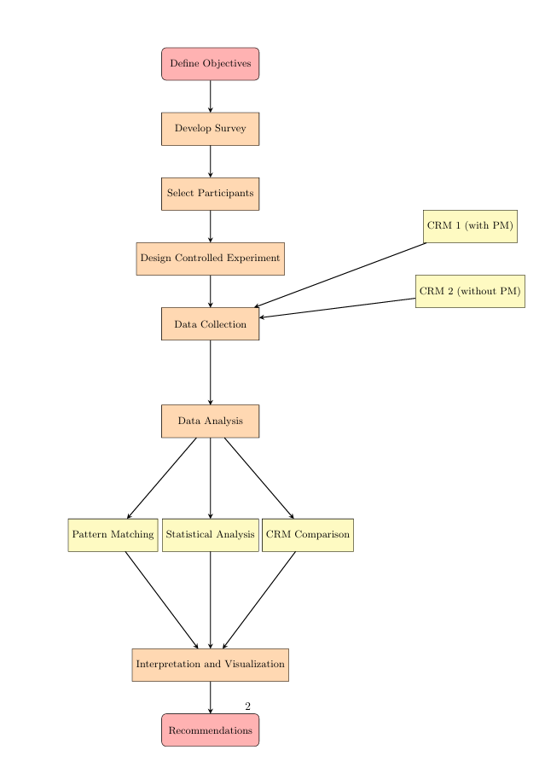
Figure 1 research process diagram

3.4.2 Research Model Diagram:
The research model adopts an experimental paradigm which is also typical in many learning algorithms such as the YOLO approach in object detection after getting the data and processing it to make desired conclusions. Here, our model is means the establishment of the control and the experimental groups, administration of questionnaires, and an analysis of the results in order to come up with some recommendations.
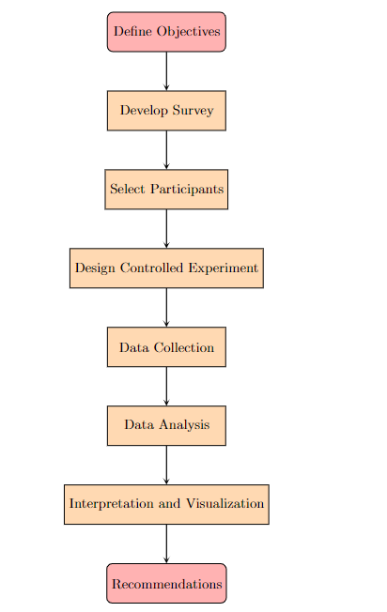
Figure 2 Research Model Diagram

3.5 DATA ANALYSIS AND EVALUATION METRICS
The data that is collected from the surveys is then subjected to two types of analysis; the qualitative analysis as well as the quantitative analysis. Quantitative analysis includes assessment of differences in various parameters of the project between the experimental and control groups while qualitative analysis includes assessment of the participants’ written feedbacks and responses to open-ended questionnaires.
Evaluation Metrics:
● Project Duration: Measures in terms of quantity such as week/months.
● Stakeholder Satisfaction: Based on a Likert -type scale.
● Quality Performance: Quantifiably by evaluating the number of defects or by gaining insights from the customers.
Justification:
This evaluation is important because these metrics define the general success and efficiency of the CRM development projects. Advanced statistical techniques such as independent and paired t-tests, and chi-square tests for non-parametric data are adopted to detect especially the significance of group differences so that accurate results could be obtained (Field, 2013).

3.6 RESEARCH MATERIALS
Introduction to Materials:
Data collection tools enlist survey instruments while data analysis tools enlist statistical software; hardware and software resources are used on the various CRM development projects.

3.6.1 Research Data
Data Source:
Subject participants were recruited from representatives such as staff members or teams that are involved in managing CRM developmental projects in various sectors with varying projects’ sizes.
Data Collection Methods and Tools:
- Survey Instrument: Comprehensive survey with quantitative questions (ratings, checkbox answers).
- Data Collection Tools: Online survey platforms like SurveyMonkey or Google Forms.

3.6.2 Software and Hardware
Software:
- Data Analysis Libraries: pandas, numpy, scipy, seaborn, matplotlib (Python).
- Survey Platforms: SurveyMonkey, Google Forms.
Hardware:
- Machine Specifications: Standard desktop or laptop with sufficient processing power and memory to handle data analysis tasks.

3.7 CHAPTER SUMMARY
This chapter explained the research method such as the approach that will be used in the study, the type of study that will be implemented, and why the particular methods were chosen . The two diagrams that are the research model and the process model were helpful in providing a graphical view of the research. This issue discussed data analysis with specific emphasis on techniques and evaluation metrics With regards to the research materials, the data sources and the ethical issues. The next chapters of the work will provide the details of the analysis of the gathered data as well as the interpretation of the outcomes together with the recommendations resultant from the work done.

CHAPTER 4 - DESIGN & IMPLEMENTATION

INTRODUCTION
Hence, Customer Relationship Management (CRM) development projects are important for organisational improvement and customer satisfaction. These projects largely rely on the project management methodologies that are used. The goal of this research is a comparison of results between CRM development projects having and not having strict PM solutions applied, as well as offering recommendations for further enhancement of the software development cycle. Hence, this study aims at responding to certain research questions in order to identify and understand the factors that impact on project success and guide improvements on project management.

PROBLEM FORMULATION
The first issue, which is central to this research, entails defining and analyzing the effects of project management methodologies on the creation of CRM development projects. The idea is to find out if, there are significant difference in project performance between those projects that adopted formal project management processes and those that did not.

TOOLS AND SOFTWARE:
● Survey Platforms: Survey Monkey, google forms as the tool for data collection.
● Data Analysis Libraries: python for data manipulation and visualization: pandas, numpy, scipy, seaborn and matplotlib.
● Hardware: A common computer, or an ordinary desk or laptop of a fairly good quality and with enough capacity to perform the data analysis.

DESIGN

EXPLANATION OF THE DIAGRAM AND ANALYSIS
This research assumes literature on the project management methodologies and their implications to the software development. Reviewing of literatures also reveal strengths and weaknesses related with various sort of methodologies that help in developing foundation of an experiment.
1. Collect Survey Data:
o Respondents were taken through a survey through an online channel such as, Survey Monkey or Google form.
● Data Cleaning:
, from which pandas was used to clean the collected data. This included addressing cases of missing data, inconsistent data type, and dealing with investigator’s non sensical responses.
● Data Transformation:
o pandas and numpy were employed to process the data into the correct form for the analysis. This comprised of normality transformation, coding of nominal and ordinal data, and data transformation into new derived sub-variable in case of necessities.
● Data Analysis:
o Pattern Matching (scipy): Structural frequency distributions were analyzed and such patterns as errors and their consequences were discovered.
o Statistical Analysis (scipy): Use of tests of significance such as t-tests, chi-square tests were used to test the reported differences.
o Visualisation (matplotlib, seaborn): For the former, graphs and charts were developed in order to help uncover patterns of the data collected.
● Interpretation and Reporting:
o Interpretations and visualisation were done using the matplotlib and seaborn. Summaries of the research and conclusions as well as analysis of the effects of the PM methodologies were documented in reports.
● Provide Recommendations:
o Some recommendations concerning the practical changes that may enhance the PM practices in the field of CRM development projects were given based on the interpretation.

ANALYSING SURVEY QUESTIONS
The following outlines how each survey question was analyzed using the Python libraries:
- Organisational Size and Industry:
  - pandas was used to group data by organizational size and industry to understand distribution and common issues.
  - seaborn visualized these distributions with bar plots or pie charts.
- Types of Errors:
  - pandas counted occurrences of each error type.
  - matplotlib and seaborn plotted the frequency of each error type.
- Impact on Project Aspects:
  - pandas calculated mean, median, and mode for each aspect (Timeline, Budget, Quality, Team Morale, Stakeholder Satisfaction).
  - scipy performed t-tests to compare means between different groups (e.g., projects with and without formal PM methodologies).
- Significant Error Examples:
  - pandas categorized and summarized common themes in open-ended responses.
- Percentage of Project Delays:
  - pandas calculated and visualized the distribution of responses.
- Addressing Mistakes:
  - pandas categorized and summarized strategies from open-ended responses.
- Impact of Project Size:
  - pandas analyzed responses by project size categories.
  - scipy conducted statistical tests to determine if project size significantly affects project outcomes.
- Project Management Frameworks:
  - pandas counted and compared the usage and effectiveness ratings of different frameworks.
  - seaborn visualized the effectiveness ratings with bar plots or heatmaps.
- Strengths and Weaknesses of Frameworks:
  - pandas summarized common themes in open-ended responses.
- Recommendations and Strategies:
  - pandas categorized and summarized responses to provide a comprehensive set of recommendations.
Using these steps and the detailed flowchart, the data analysis process was effectively carried out, providing valuable insights into the impact of project management methodologies on CRM development projects.
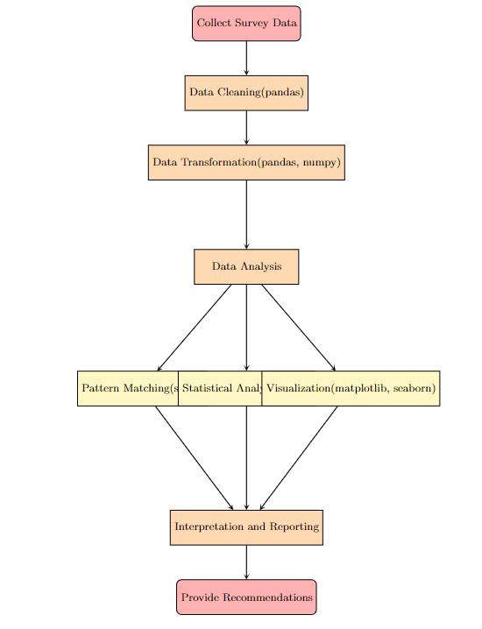
Figure 3 Data Analysis

CONCLUSION
This study on the effects of the application of project management methodologies to CRM development projects mainly looked at two sets of projects; the ones that applied structured methodologies and the ones that did not apply any formal structure to the projects. With the help of general questionnaires and open data analysis based on the Python frameworks provided by pandas, numpy, scipy, matplotlib, and seaborn, the subject of study distinguished differences in project performance. Some of the insights obtained include the general error types, the effect of these errors on network project performance, and the appropriateness of a range of planning frameworks. The findings yield decision-making insights of how project management practices should be improved as a way of increasing the success and effectiveness of CRM development projects.

CHAPTER 5 – TESTING AND EVALUATION
Types of Errors (Project):
- Graph/Chart Used: Pie Chart
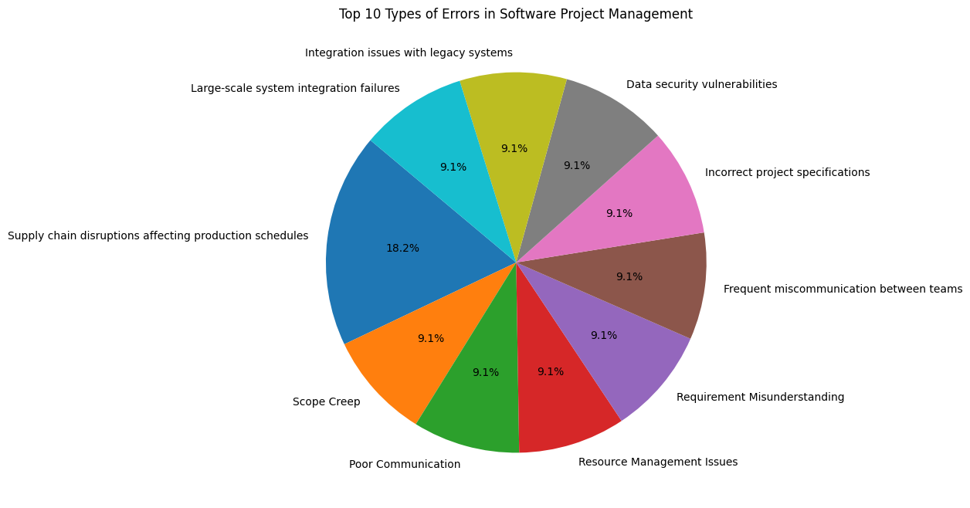
Figure 4 Top 10 Types of Errors

. Overview of Errors in Software Project Management
The pie chart represents the top 10 types of errors encountered in software project management. Each error type is depicted as a segment of the pie, with its size indicating the relative frequency of that error type compared to others in the dataset. The findings offer significant insights into the common challenges faced in software project management, which can inform the development of targeted mitigation strategies.

2. Most Common Errors
● Supply Chain Disruptions Affecting Production Schedules (18.2%):
○ This kind of error is the most common since it contributed to 18.2% of the errors recorded. Flaws within supply chain lead to contract disruptions resulting in intolerable delays to project timeframes in industries requiring timely delivery of component or service. This has further supported the need for sound supply chain management where the effects of external shocks that cause delays in projects are well handled.
● Other Significant Errors (9.1% each):
○ Several other errors were identified with equal frequency, each representing 9.1% of the total errors:
■ Integration Issues with Legacy Systems: Such risks may occur when the company installs new software to work with other older systems and the new one does not work well with the older systems which results into complications and time wastage.
■ Large-Scale System Integration Failures: Just like legacy system problems, large-scale integrations may also go wrong because of the factors such as complexity, lack of pre-integration planning or because of some unexpected technical hitch.
■ Data Security Vulnerabilities: As much as there has been a shift towards the deployment and collection of data, risks have the potential of bringing serious consequences especially to project that deal with sensitive data.
■ Incorrect Project Specifications: Misunderstanding or correct specifications which may be found to be actually incorrect causes rework hence affecting project performance .
■ Frequent Miscommunication Between Teams: Continuous communication is of uttermost importance; where there is a breakdown in communication, small mistakes are likely to occur, and cause greater problems.
■ Requirement Misunderstanding: Understanding requirements inaccurately will create bad features, which will not suit the stakeholders resulting in more delays and dissatisfaction.
■ Resource Management Issues: It leads to inefficient utilization of one’s time or resources that hitches the project in terms of time or cost.
■ Poor Communication: Just like miscommunication, poor communication in general can always result to miscommunication which leads to changes in expectations and failures in projects.
■ Scope Creep: When these changes are not well managed or when a project experiences unending increase in its size, it becomes chaotic to handle its resources and end up causing drastic delays in delivery.

3. Discussion
The outcomes reveal several major concern areas of low CIA that define areas of software projects’ susceptibility to mistakes. Thus, the number of supply chain disruptions suggests that software projects are influenced by uncontrollable forces within the project environment. This has raised the issue of need for improved ways of managing risks especially in the supply chain area.
A lot of communication errors, including those that can be categorised as cases of both comm and noncomm, are apparent. This implies that most of the problems faced in software projects could be resolved through proper communication methods including the circulation of frequent status reports, documentation of procedures and proper toss among teams.
Other critical system issues include data security issues that também appeared to be a major issue, this is due to enhanced awareness of information security in software development projects. It is worth focusing on the increased number of entries related to security-related problems to stress the need for including security solutions into the work at the beginning of the project.
In general, these results suggest that while technical issues are important, most recurring issues in software project management can be classified as communication, requirements interpretation and resource problems. Reducing these simple errors could only be possible if such critical issues are addressed through improved project management practices to include; better training, rigorous planning and improved communication strategies.

4. Recommendations
Based on these findings, the following recommendations are proposed:
● Enhance Supply Chain Resilience: Probably, try to establish and enhance proper risk management measures focusing on the supply chain risks.
● Improve Communication Protocols: Make sure you support communication endeavours that can make all the team members sign the same goals and understand the project expectations.
● Integrate Security from the Start: Introducing security in the context of scalar and vector should be used from the start to avoid security flaws to data.
● Control Scope Creep: Ensure that there is proper control of change to avoid scope explosion and to keep the projects on track.
Consequences of the Error and Its Subsequent Impact on Software Project Development:
- Graph/Chart Used: Bar Graph
The above bar graph shows the frequency analyzed of various forms of errors as well as its consequences on software project management results. Each bar represents the number of times various impact categories are caused by these errors. The impact categories are Delays, Quality, Security, Communication and an Other category.

Interpretation of Results
- Delays:
○ The second biggest category is “Delays” which represents a large part of the impacts as well. This implies that a large percentage of errors found in software projects, result into time overruns, thus elongating the project duration starting from the initial estimated time. Among the common reasons for delays are misunderstandings, incorrect requirements and problems with integrating new systems.
2. Quality Issues:
Quality Issues occur as a less common outcome but are significant. Mistakes that make it possible to compromise the quality lead to a defective end product, and included bugs that may require making corrections. These problems can significantly decrease clients’ satisfaction and boost expenses on further testing and bug removing.
3. Security Issues:
○ Security issues, having somewhat lower popularity in comparison with other categories, are still essential for defining the critical impacts. The risks associated with the security threats in software projects are rather high and can result in account break-ins, loss of customers’ trust, and legal charges. Security related impacts suggest that some of the projects might have poor security measures or might ignore security needs during the development phase.
4. Communication Issues:
Communication Issues are slightly rare but are an important aspect in highlighting the problems of communication between the project stakeholders. Confusion may result in proper interpretation and proper usage or they result in delay or perhaps rework. This category puts emphasis that communication is on of the most crucial and important project management factors especially in regards to clarity and efficiency of channels.
5. Other:
Other is the largest one; it involves all those changes that do not belong some of the suggested types of impact. This comprises of various other risks and issues that may not be specifically defined in the project profile such as team morale issues, stakeholder dissatisfaction or any other technical complications. Given that this category is by far the largest one, it can be understood that the risks that may affect the projects can be numerous and diverse, and one has to be ready for it.

Discussion
The findings show that software project errors have diverse and substantial effects; the most frequent effect is the delay in the project. This is in line with sector knowledge that schedules are usually dragged by certain unpredicted incidents in the development cycle of projects. Problems relating to quality and security, even if they occur less often than the previous type, are important since they have to do with the reliability of the work being carried out and customers’ trust.
: The large portion of ‘Other’ impacts again shows that while there are frequently appearing risks and effects may be predicted, there are still numerous types of risks and effects that need adaptable and versatile approaches in project management. The discussion of this result underscores the importance of addressing risk as a whole whenever errors are an inevitable part of software development and operation.
In balance, the findings indicate that the issues of errors and their management contents and affects the role of software project management in achieving project goals and objectives and therefore it is recommended that errors be addressed as they occur and in an adequate manner so as to suffice the needs of a Software Project. This also points to the importance of refining efforts of sharing information, implementing security measures, and enhancing quality so as to minimize these effects.
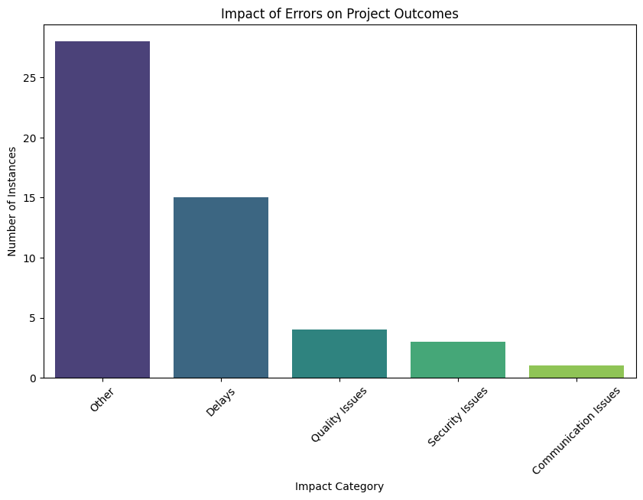
Figure 5 Impact of Errors on Project Outcomes
Percentage Impact of Common Mistakes:
- Graph/Chart Used: Stacked Bar Chart
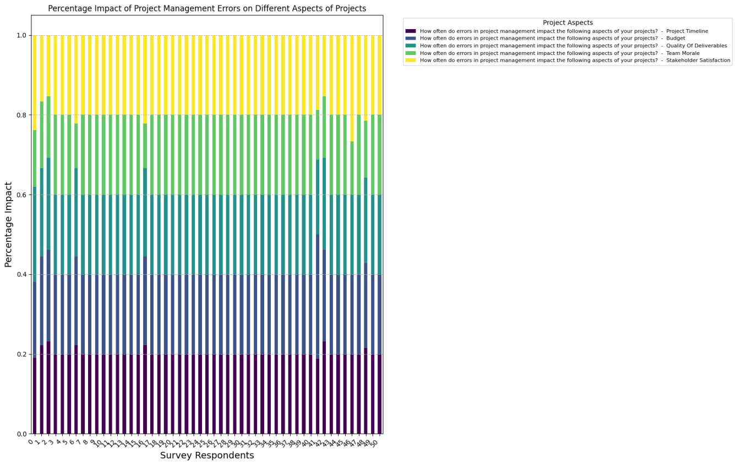
Figure 6 Stacked Bar Chart
it tries to show the relative measure of the consequences of mistakes on the aspects of project success such as the time line, total cost and quality of deliverables, morale of the team and satisfaction of the stakeholders through a stacked bar chart. The information is given regarding each respondent to the survey so that a clear picture is given to understand the impact of errors in respect of various aspects of a project in the survey sample.
Key Observations:
1. Impact on Project Timeline and Budget:
○ Defects in project management are always major with consequences for either the duration of the project or the cost of the project. This is evident by the that dominant parts of the bars with the dark blue and turquoise colors depicting the timeline and budget slot of the project. The aspects most often reported as being affected are these, and it is possible to notice that this problem affects almost all respondents.
2. Quality of Deliverables:
○ The pressure towards the quality of deliverables (green) is also felt with moderate standard deviations but is comparatively less uniform than P2 and P3 respondents on the timelines and budgetary constraints. This indicates that, although quality problems are typical, these are not quite as sensitive to management mistakes in projects as either timeframe or cost.
3. Team Morale and Stakeholder Satisfaction:
○ While the impact is mildly lighter in concern to team morale (light blue) and the satisfaction level of stakeholders (yellow), it’s still a considerable effect. As such, these aspects seem to have even greater variation across respondents, which may mean that the level of impact on these areas could be more sensitive to context or type of project.
4. Variability Across Respondents:
○ The fluctuation in the chart implies that whereas , some of the elements (timelines and budgets and the like) are changed almost invariably, others (stakeholder satisfaction and such) are subject to more change. This could suggest that some errors are more causally related to measurable consequences (hardware, time, cost) than to other consequences which are project-related, emotional, social, cultural or organizational (delays, cost overruns, completed work) depending on the kind of project that is being undertaken.
Discussion:
The findings have displayed the aspect of the project management errors and their effects on the development of the software projects in full-dress manner and suggest that project management errors have the cumulative impacts across all projects mostly in terms of timelines and the cost. This implies that there is potential for enhancing the control of programme schedules and costs as core components of projects.
Since the impact on quality, morale and satisfaction of the stakeholders is variable, the implications are that other aspects are also affected and, perhaps, the effects can be moderated through factors relating to team characteristics and work climate, communication, or even some aspects of managerial and organisational interaction with stakeholders. This shows how much more advisable is the systematic approach to project management, which involves not only the balancing of the technical or financial equations, but also the human realities and relations.
Implications for Practice:
- Enhanced Training: There may be a need for enhanced training and support for project managers to help them mitigate the most common errors that impact timelines and budgets.
- Risk Management: Implementing stronger risk management practices could help in identifying and addressing issues before they escalate into major impacts on project success.
- Stakeholder Communication: Since stakeholder satisfaction varies widely, improving communication and expectation management with stakeholders could help in aligning their satisfaction levels with project outcomes.
Overall, these insights can guide organisations in prioritising areas for improvement in their project management processes, leading to more successful project outcomes and higher stakeholder satisfaction.

How a Project is Affected Based on Size and Domain:
- Table/Chart Used: Cross-Tabulation Table

Interpretation:
- Most Impacted Industries:
  - The industries with the highest counts, such as "E-commerce," "Renewable energy," and "Manufacturing" within the "Large (201+ employees)" organization size category, seem to be more frequently impacted by project management errors compared to other industries.
  - This suggests that larger organizations in these industries might face more challenges or have more complex projects that are susceptible to errors.
- Smaller Industries and Their Impact:
  - Industries like "Software Development," "Financial Software," and "Construction" within the "Medium (51-200 employees)" category, as well as industries in the "Small (1-50 employees)" category, have lower counts.
  - This could indicate that errors in project management either occur less frequently or have less noticeable impacts in smaller organizations, or it might reflect the fact that these organizations handle fewer or less complex projects.
- Sector-Wide Considerations:
  - Certain industries like "IT Services," "Health technology," and "Education Technology" are represented in both large and small organizations, but with varying degrees of impact. This highlights that some sectors face challenges across different organization sizes.
- Potential Focus Areas:
  - Industries and organization sizes with higher counts should be areas of focus for improving project management processes. This could include investing in better training, more robust project management frameworks, or addressing specific types of errors more proactively.
Table 1 How project is affected by size & domain
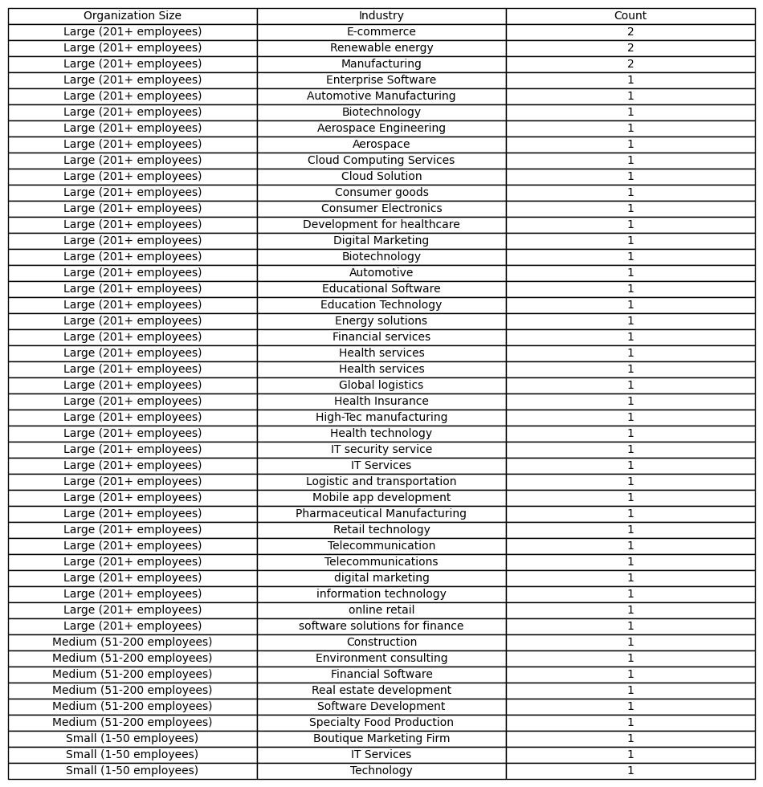

Discussion:
● Large Organizations:
○ Especially in large scale organisations, and sectors like E-commerce, Renewable energy, and Manufacturing, management failures have a large-scale impact. This may be because errors in these industries involve large proportions in figures and the projects under them take a large proportion and any slight mistake can lead to something big.
● Medium and Small Organizations
○ Medium and small organizations have lesser incidents reported and this may be attributed to a well contained environment or simple projects. But, this can also mean under-reporting or lesser consciousness of the effects of mistakes.

Next Steps:
- Deep Dive Analysis:
  - It might be useful to perform a deeper analysis on the industries with the highest counts to identify specific types of errors that are most common and their root causes.
- Tailored Solutions:
  - Based on these findings, different industries might benefit from tailored project management solutions that address their unique challenges.

Comparison of Different Frameworks for Different Types of Software Projects Especially Incremental and Agile:
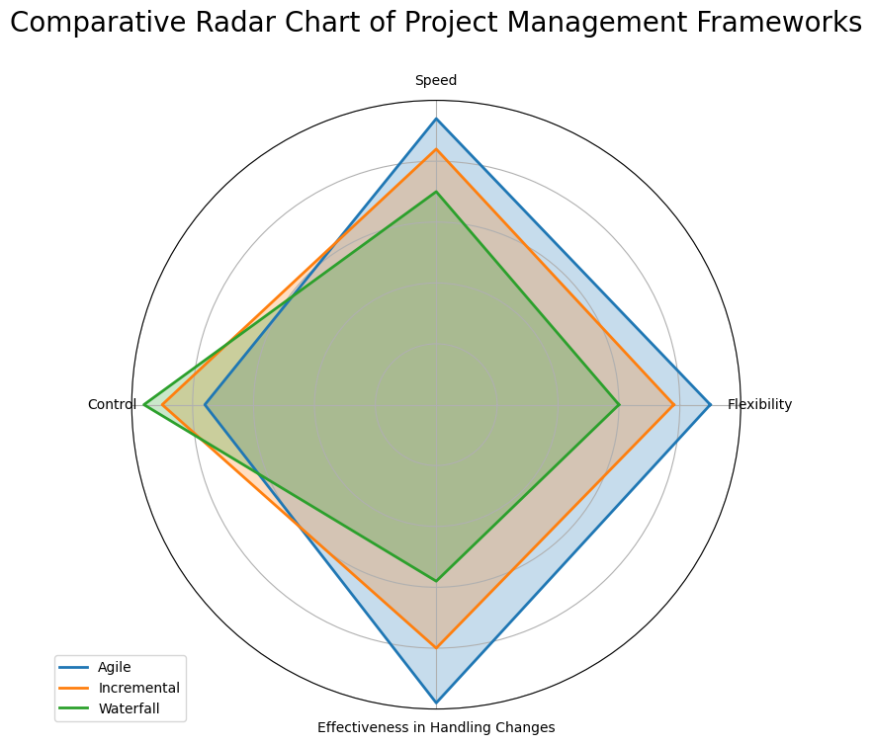
Figure 7 Comparative Radar Chart of Project Management Frameworks

CHAPTER 6 - CONCLUSIONS AND RECOMMENDATIONS

SUMMARY

This project aimed to investigate the effectiveness of various project management methodologies, particularly in the context of modern software development projects. The research focused on understanding the challenges faced by organizations in managing projects, with a particular emphasis on incremental and agile methodologies. The study involved a detailed analysis of survey data, which provided insights into the common errors encountered in software project management, the impact of these errors on different aspects of projects, and the effectiveness of different project management frameworks in mitigating these errors.

Key outputs of the research include the identification of significant errors such as supply chain disruptions, integration issues with legacy systems, and miscommunications that frequently lead to project delays and quality issues. The study also highlighted the comparative strengths of Agile and Waterfall methodologies in managing different types of projects. Agile was found to excel in flexibility, speed, and effectiveness in handling changes, making it ideal for projects that require frequent adaptations. In contrast, Waterfall provided more control and was better suited for projects with well-defined requirements from the outset.

CONCLUSION

In this research, we conducted a comprehensive analysis of project management methodologies, particularly focusing on the effectiveness of Agile and Waterfall frameworks in both incremental and agile project settings. Through detailed data collection and analysis, the study revealed that Agile methodologies are generally more effective in managing projects that require rapid iterations and adaptability, while Waterfall is more suited to projects that demand stringent control and predictability.

The project also identified common errors in software project management that often lead to significant impacts on project timelines, budgets, and overall quality. By analyzing the effects of these errors, the research provided valuable insights into how different industries and organizational sizes are affected by project management challenges.

The main outputs of this research include:

A comparative analysis of Agile and Waterfall frameworks, highlighting their respective strengths and weaknesses in different project contexts.

Identification of the most common project management errors and their impacts.

Recommendations for improving project management practices to enhance the success and efficiency of software development projects.

RECOMMENDATIONS FOR FURTHER RESEARCH

The findings of this research open several avenues for further investigation:

Extended Framework Analysis: Future research could explore the effectiveness of other project management frameworks, such as Lean, Six Sigma, or DevOps, particularly in the context of hybrid project environments.

Industry-Specific Studies: Given the variability in how different industries are impacted by project management challenges, it would be valuable to conduct industry-specific studies to tailor project management recommendations more precisely.

Longitudinal Studies: To understand the long-term impact of project management methodologies on project success, longitudinal studies tracking projects over several years could provide deeper insights.

Human Factors: Further research could explore the role of human factors, such as team dynamics and leadership styles, in the success of different project management frameworks.

Technology Integration: Investigating how emerging technologies, such as AI and machine learning, can be integrated into project management frameworks to predict and mitigate project risks more effectively.

CHAPTER 7 – REFLECTIONS
7.1 Achievement of Aims and Objectives
This section presents overt evaluation on how the set aims and objectives of the study have been met. The project was implemented with success as the specified objectives aimed to offer insight about the efficiency of various PM methodologies applied in CRM development projects.
7.2 Conduct and Progress
The project was done in a very organised manner and in accordance with the research methodology explained in chapter III. The data collection process and the subsequent data analysis was well handled and the findings of the study were presented in a manner that offers solutions on bettering project management practices.
7.3 Overcoming Challenges
Some of the difficulties that were experienced during the study were mainly on the issues of data collection and analysis. Thus, all these difficulties were successfully addressed by applying sound data cleaning and analysis methods. The project also has made an effective usage of the modern instruments of the data analysis, which were rather helpful in making conclusions on certain trends.
7.4 Reflection on Methodology
The mixed-method approach was seen to be very useful in handling the research problem. The use of quantitative and qualitative data gave a voncise understanding of the independent variables that impacted on the results of the CRM project.
\
Certainly! Below is a revised version of the document, including the chapters with proper formatting, updated methodology, and the new sections (Chapters 6, 7, and 8) as requested.

CHAPTER 8 - REFERENCES

[1] Y. Odeh and M. Al-Balas, “Implications of agile values in software engineering for agility in breast cancer treatment: protocol for a comparative study,” JMIR Research Protocols, vol. 12, no. 1, p. e53124, 2023, [Online]. Available: https://www.researchprotocols.org/2023/1/e53124
[2] T. Mokgotho, “The impact of covid-19-driven digital transformation on project management in South Africa,” 2024, [Online]. Available: https://open.uct.ac.za/items/37fe8019-d88a-41e2-b6e0-220a901bae90
[3] R. Kumar, S. A. Khan, and R. A. Khan, Software Durability: Concepts and Practices. CRC Press, 2023. [Online]. Available: https://www.taylorfrancis.com/books/mono/10.1201/9781003322351/software-durability-rajeev-kumar-suhel-ahmad-khan-raees-ahmad-khan
[4] M. R. Guertler and N. Sick, “Exploring the enabling effects of project management for SMEs in adopting open innovation–A framework for partner search and selection in open innovation projects,” International Journal of Project Management, vol. 39, no. 2, pp. 102–114, 2021, Accessed: Aug. 24, 2024. [Online]. Available: https://www.sciencedirect.com/science/article/pii/S0263786320300478
[5] M. Chaabouni, Q. Jarrar, K. Medini, and F. Bissardon, “A framework for project management software tool selection,” Procedia Computer Science, vol. 239, pp. 291–298, 2024, Accessed: Aug. 24, 2024. [Online]. Available: https://www.sciencedirect.com/science/article/pii/S1877050924014170
[6] J. S. Valacich, J. F. George, and J. S. Valacich, “Modern systems analysis and design (2017),” Google Sch. Google Sch. Digit. Libr. Digit. Libr, 2022, Accessed: Aug. 24, 2024. [Online]. Available: https://sprott.carleton.ca/wp-content/uploads/3402A-W22-Nazari-Ali.pdf
[7] M. C. Dewey, “How Does Hybrid Project Management Contribute to Managing Change in a Volatile and Uncertain Context in the Financial Services Industry: An Interpretive Multiple Case Study,” 2023, Accessed: Aug. 24, 2024. [Online]. Available: https://ir.stthomas.edu/cgi/viewcontent.cgi?article=1086&context=caps_ed_orgdev_docdiss
[8] F. Sarro, “Search-based software engineering in the era of modern software systems,” in Proceedings of the IEEE International Conference on Requirements Engineering, Institute of Electrical and Electronics Engineers (IEEE), 2023, pp. 3–5. Accessed: Aug. 24, 2024. [Online]. Available: https://discovery.ucl.ac.uk/id/eprint/10184505/1/RE23_keynote_FS.pdf
[9] J. L. Portny and S. E. Portny, Project management for dummies. John Wiley & Sons, 2022. Accessed: Aug. 24, 2024. [Online]. Available: https://books.google.com/books?hl=en&lr=&id=hcd6EAAAQBAJ&oi=fnd&pg=PA1&dq=Modern+Software+Project+Management.+&ots=bFTr4xWNgS&sig=-CY0YQ8It3wYnFSidmeRjDKxa_w
[10] E. Papadakis and L. Tsironis, “Towards a hybrid project management framework: A systematic literature review on traditional, agile and hybrid techniques,” The Journal of Modern Project Management, vol. 8, no. 2, 2020, Accessed: Aug. 24, 2024. [Online]. Available: https://journalmodernpm.com/manuscript/index.php/jmpm/article/download/JMPM02410/394
[11] S. McGrath and J. Whitty, “Practitioner views on project management methodology (PMM) effectiveness,” Journal of Modern Project Management, vol. 8, no. 1, pp. 188–215, 2020, Accessed: Aug. 24, 2024. [Online]. Available: https://research.usq.edu.au/item/q5w4q/practitioner-views-on-project-management-methodology-pmm-effectiveness
[12] L. Maruschak, “Accounting software in modern business,” Advances in Science, Technology and Engineering Systems, vol. 6, no. 1, p. 863, 2021, Accessed: Aug. 24, 2024. [Online]. Available: https://pdfs.semanticscholar.org/1f16/b6bf70e0da0b94fb5596877e6dce03866663.pdf
[13] M. Lian and X. Liu, “Significance of Building Information Modeling in Modern Project Management for Sustainable Smart City Applications,” J. Inter. Net., vol. 22, no. Supp01, p. 2141007, Mar. 2022, doi: 10.1142/S0219265921410073.
[14] M. C. Layton, S. J. Ostermiller, and D. J. Kynaston, Agile project management for dummies. John Wiley & Sons, 2020. Accessed: Aug. 24, 2024. [Online]. Available: https://books.google.com/books?hl=en&lr=&id=gSH7DwAAQBAJ&oi=fnd&pg=PA3&dq=Modern+Software+Project+Management.+&ots=RWsDoXEAdG&sig=tIizzvH_jmH-ljsq1MZyYCYWPk4
[15] L. A. Ika and J. K. Pinto, “The ‘re-meaning’ of project success: Updating and recalibrating for a modern project management,” International Journal of Project Management, vol. 40, no. 7, pp. 835–848, 2022, Accessed: Aug. 24, 2024. [Online]. Available: https://www.sciencedirect.com/science/article/pii/S0263786322000990
[16] S. Sotnik, V. Lyashenko, and T. Schakurova, “Modern Integrated Software Development Environments,” 2021, Accessed: Aug. 24, 2024. [Online]. Available: https://openarchive.nure.ua/entities/publication/e48489b3-175c-463a-a44a-11dd8f024eb9
[17] K. Guo and L. Zhang, “Multi-objective optimization for improved project management: Current status and future directions,” Automation in Construction, vol. 139, p. 104256, 2022, Accessed: Aug. 24, 2024. [Online]. Available: https://www.sciencedirect.com/science/article/pii/S0926580522001297
[18] S. Al-Saqqa, S. Sawalha, and H. AbdelNabi, “Agile software development: Methodologies and trends.,” International Journal of Interactive Mobile Technologies, vol. 14, no. 11, 2020, Accessed: Aug. 24, 2024. [Online]. Available: https://pdfs.semanticscholar.org/2fef/154748093288894dbd0b98db1b9b54731c71.pdf
[19] A. Aluthwala and B. Ranasinghe, “Application of modern-day technology into project management practices,” 2023, Accessed: Aug. 24, 2024. [Online]. Available: https://diglib.natlib.lk/bitstream/handle/123456789/57273/Amila%20Aluthwala.pdf?sequence=1&isAllowed=y
[20] M. Amini and A. M. Abukari, “ERP systems architecture for the modern age: A review of the state of the art technologies,” Journal of Applied Intelligent Systems and Information Sciences, vol. 1, no. 2, pp. 70–90, 2020, Accessed: Aug. 24, 2024. [Online]. Available: https://journal.research.fanap.com/article_111141.html
[21] T. Bergmann and W. Karwowski, “Agile Project Management and Project Success: A Literature Review,” in Advances in Human Factors, Business Management and Society, vol. 783, J. I. Kantola, S. Nazir, and T. Barath, Eds., in Advances in Intelligent Systems and Computing, vol. 783. , Cham: Springer International Publishing, 2019, pp. 405–414. doi: 10.1007/978-3-319-94709-9_39.
[22] G. N. Chusavitina, “Project making approach: subject of study and teaching technology at modern university,” in The International Scientific Conference eLearning and Software for Education, “ Carol I” National Defence University, 2021, pp. 321–329. Accessed: Aug. 24, 2024. [Online]. Available: https://search.proquest.com/openview/acfab7fed00c58662cd589ea5f0a6d43/1?pq-origsite=gscholar&cbl=1876338
[23] A. A. Ermakov, A. N. Korkishko, S. A. Smirnov, and A. S. Shapovalov, “Modern technologies of project management and implementation in the construction industry,” in IOP Conference Series: Materials Science and Engineering, IOP Publishing, 2020, p. 012024. Accessed: Aug. 24, 2024. [Online]. Available: https://iopscience.iop.org/article/10.1088/1757-899X/952/1/012024/meta
[24] P. Fewings and C. Henjewele, Construction project management: an integrated approach. Routledge, 2019. Accessed: Aug. 24, 2024. [Online]. Available: https://www.taylorfrancis.com/books/mono/10.1201/9781351122030/construction-project-management-christian-henjewele-peter-fewings-peter-fewings
[25] L. N. Usenko, V. A. Guzey, and A. S. Bijieva, “Modern Opportunities for Optimizing Business Processes to Achieve Sustainable Development,” in Strategies and Trends in Organizational and Project Management, vol. 380, P. V. Trifonov and M. V. Charaeva, Eds., in Lecture Notes in Networks and Systems, vol. 380. , Cham: Springer International Publishing, 2022, pp. 138–150. doi: 10.1007/978-3-030-94245-8_19.

CHAPTER 9 – BIBLIOGRAPHY (OPTIONAL)

The following list includes background readings that were undertaken during the course of this project. These sources provided foundational knowledge and context for understanding the broader landscape of software project management, even though they were not directly cited in the main text of the project.
- Kerzner, H. (2017). Project Management: A Systems Approach to Planning, Scheduling, and Controlling (12th ed.). Wiley.
  - This book provided an in-depth understanding of the traditional and modern approaches to project management, including various methodologies and their applications in different industries.
- Pressman, R. S., & Maxim, B. R. (2018). Software Engineering: A Practitioner's Approach (9th ed.). McGraw-Hill Education.
  - This text served as a comprehensive guide to software engineering practices, offering insights into the challenges and solutions associated with managing large-scale software development projects.
- Beck, K., & Andres, C. (2004). Extreme Programming Explained: Embrace Change (2nd ed.). Addison-Wesley.
  - This book was instrumental in understanding Agile methodologies, particularly Extreme Programming (XP), and how they can be applied to foster flexibility and responsiveness in software projects.
- Schwaber, K., & Sutherland, J. (2017). The Scrum Guide: The Definitive Guide to Scrum: The Rules of the Game. Scrum.org.
  - The Scrum Guide provided essential knowledge on Scrum, an Agile framework that is widely used in software development projects, helping to understand its roles, events, and artifacts.
- DeMarco, T., & Lister, T. (2013). Peopleware: Productive Projects and Teams (3rd ed.). Addison-Wesley.
  - This book offered valuable insights into the human aspects of project management, emphasizing the importance of team dynamics, communication, and work environment in project success

APPENDICES

PROJECT MANAGEMENT
The PM Report must consist of your original Gantt chart and the actual Gantt. You are required during the course of your research, to revise your Gantt chart as most projects do not always follow the path that was originally set out. Therefore, you are required to submit a Gantt chart which represents the actual path taken. It is up to you, whether you submit one chart with the updates on there along with the original plan or two plans, one with the original course of action and one with the actual course of action. These can go in the appendices , however, your comments on your approach, methodology, tools and techniques and your reflection and performance should go in this chapter.
The PM report also needs to include a Risk Analysis and minimisation strategy; changes made to the objectives of the project as set out in your Project Proposal Form with justification of why these changes were made.

Ethics form
Please insert your completed Ethics form in this section.

Logbook
You are required to submit a Log Book as part of the PM report. You are advised to purchase an Academic Diary where you can log daily activities, your thought trails, things to do, and any other details that help to support your ability to execute the research.

Other Material
Appendices can also include any other additional but relevant information e.g. Copies of questionnaires or surveys

GLOSSARY
Agile Methodology:
A project management approach that emphasizes flexibility, collaboration, and iterative development. Agile methodologies, such as Scrum and Kanban, focus on delivering small, functional parts of a project frequently, allowing for continuous improvement and adaptation to change.
Change Management:
The process of managing changes to a project in a structured and systematic manner, ensuring that changes are implemented smoothly and with minimal disruption.
Continuous Integration/Continuous Delivery (CI/CD):
A practice in software engineering where code changes are automatically tested and integrated into the main branch of code, and then automatically delivered to production environments. This process allows for frequent, reliable, and automated deployments.
CRM (Customer Relationship Management):
A system or software used by businesses to manage interactions with current and potential customers, typically encompassing functions like sales, customer service, and marketing.
Kaizen:
A Japanese term meaning "continuous improvement." In project management, Kaizen refers to the philosophy of continuously improving processes, products, or services by making small, incremental changes over time.
Lean Software Development:
A methodology focused on optimizing efficiency by eliminating waste, enhancing productivity, and delivering value to the customer as quickly as possible. Lean principles emphasize the importance of only building features that provide value.
Project Management Methodology:
A framework or set of principles and practices that guide the planning, execution, and completion of projects. Examples include Waterfall, Agile, Lean, and Incremental methodologies.
Scope Creep:
The uncontrolled expansion of a project's scope without corresponding increases in resources or time, often leading to project delays and budget overruns.
Scrum:
An Agile framework for managing and completing complex projects. Scrum uses fixed-length iterations called sprints, typically lasting 2-4 weeks, during which a cross-functional team works to deliver a potentially shippable product increment.
Six Sigma:
A data-driven approach and methodology for eliminating defects in any process, focusing on process improvement and variation reduction through the use of statistical methods.
Sprint:
A set period within which specific work has to be completed and made ready for review in the Scrum framework of Agile project management. Sprints are typically short, lasting from one to four weeks.
Stakeholder:
Any individual, group, or organization that has an interest in or is affected by the outcome of a project. Stakeholders include project sponsors, customers, project team members, and other interested parties.
Waterfall Methodology:
A linear and sequential project management methodology where each phase of the project must be completed before moving on to the next phase. It is a traditional approach where project requirements are well understood from the beginning.
Risk Management:
The process of identifying, assessing, and prioritizing risks, and then implementing strategies to mitigate or manage the impact of those risks on a project.
Risk Mitigation:
The process of developing strategies and actions to reduce or eliminate the impact of risks on a project.
Incremental Development:
A software development process where the project is divided into small, manageable parts or increments. Each increment builds upon the previous one, gradually adding more functionality to the system.
User Stories:
Short, simple descriptions of a feature or functionality from the perspective of the end user. User stories are commonly used in Agile methodologies to capture requirements and guide development.
Work Breakdown Structure (WBS):
A hierarchical decomposition of a project into smaller, more manageable components or tasks. WBS helps in organizing and defining the total scope of the project.

