Assessment 1

Module: Leadership and management, theory and practice

Module code: LCBB6003 Lecturer: Laila Maazouz

Individual Report

‘A Leader? A Manager? Both?'

Simona Filipova Vasileva
University of Wales Trinity Saint David, London Campus,
BA Business and Management, London, United Kingdom
2030587@student.uwtsd.ac.uk

Table of Contents
Task 1 2
Introducion 3
Management vs. Leadership: 3
Authority and Decision-Making: 4
Organizational Focus: 4
Nurturing vs. Directing: 4
Examples 4
Conclusion 6
Task 2 Part 1 7
Introduction 7
Manage, by getting people to do what needs to be done. 7
Lead, by getting people to want to do what needs to be done. 8
Task 2 Part 2 9
Development of Management Skills 9
Development of Leadership Skills 9
Conclusion 10
References 11

Task 1

Introducion
The statement "A manager can be a leader, but a leader cannot be a manager" is a topic of ongoing debate in the fields of management and leadership. To address this, we can use various concepts, theories, and real-world examples to support our arguments. It's important to note that the distinction between managers and leaders is not always clear-cut, as there can be overlap and interplay between the two roles (Post, 2023). However, we can analyse this statement by examining the following aspects.
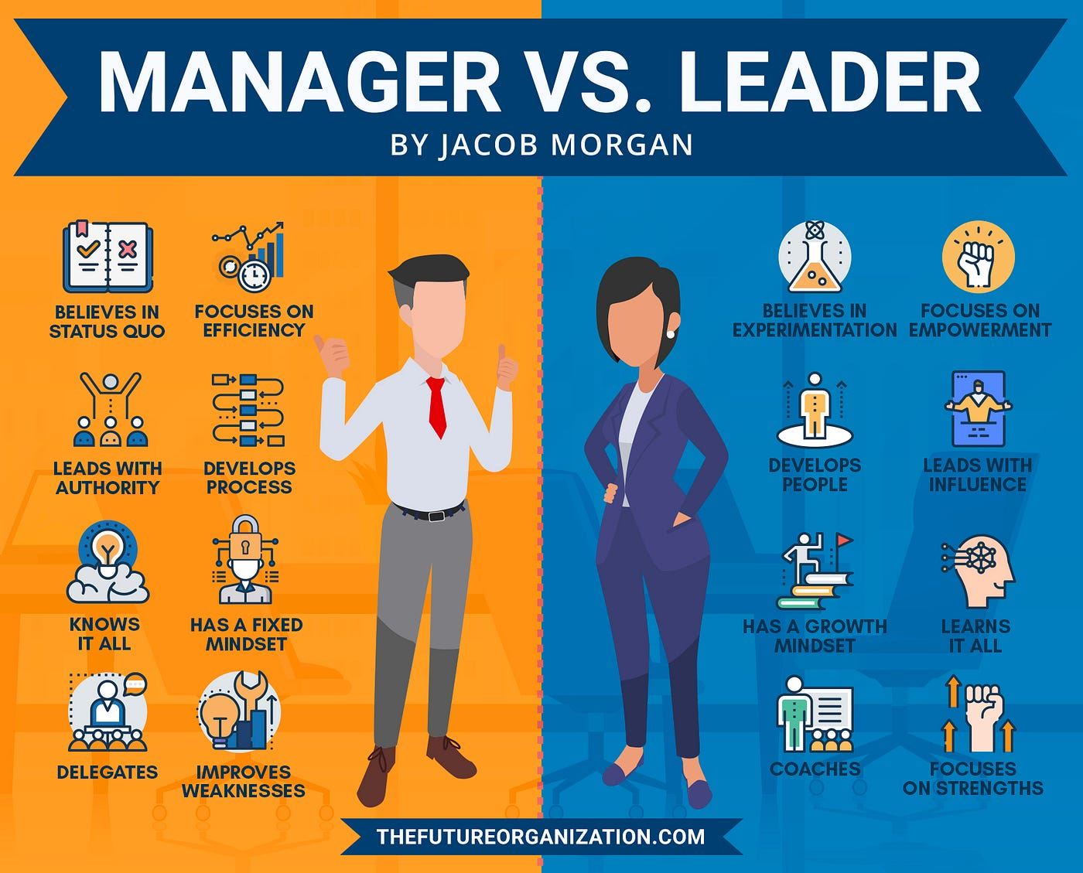

Management vs. Leadership:
  - Transactional Leadership and Management: In the business world, transactional leadership is often associated with management. This style focuses on maintaining routine operations, following established procedures, and ensuring that tasks are completed efficiently. For example, a store manager at a retail chain ensures that daily sales targets are met and employees follow set protocols.
  - Transformational Leadership: Transformational leadership, on the other hand, is often associated with visionary leaders who inspire and motivate their teams to achieve long-term goals. Elon Musk, the CEO of Tesla, is a prime example. He has a strong vision for the future of sustainable energy and has inspired his company and the industry to push the boundaries of what's possible.

Authority and Decision-Making:
  - Managerial Decision-Making: Managers typically make decisions based on their authority and the company's policies and procedures. For example, a production manager may decide to increase the workforce to meet production targets, guided by company rules and budgets.
  - Leadership Decision-Making: Leaders often have the latitude to make strategic decisions that can significantly impact an organization's direction. Jeff Bezos, the founder of Amazon, made critical decisions to diversify Amazon's offerings from an online bookstore to a global e-commerce and cloud computing giant.

Organizational Focus:
  - Managerial Focus: Managers tend to focus on short-term, day-to-day operations, aiming for efficiency, productivity, and stability. For instance, a project manager in a construction company ensures that the construction project is on schedule and within budget.
  - Leadership Focus: Leaders often take a long-term view and focus on creating a vision and inspiring others to follow it. Steve Jobs, the co-founder of Apple, was known for his visionary leadership in developing products like the iPhone that transformed the technology industry.

Nurturing vs. Directing:
  - Managers Direct: Managers typically direct and control the work of their subordinates, ensuring tasks are completed as per specifications. An example would be a restaurant manager directing staff to follow standardized recipes.
  - Leaders Nurture: Leaders often nurture the personal and professional development of their team members, helping them reach their full potential. Howard Schultz, the former CEO of Starbucks, is known for creating a company culture that values and invests in its employees.

Examples
Here are more examples from the business world to illustrate the concept that a manager can be a leader, and a leader can exist without traditional managerial roles:
- Manager as Leader:
- Mary Barra (General Motors): Mary Barra, the CEO of General Motors, serves as an example of a manager who embodies leadership qualities. While she holds the top managerial position, she has also led a transformation in the automotive industry, emphasizing electric vehicles and sustainability (Rosen, 2014). Her visionary approach and her commitment to innovation make her a leader as well as a manager.

- Tim Cook (Apple): As the CEO of Apple, Tim Cook combines managerial excellence with leadership. Cook manages Apple's day-to-day operations, ensuring the company's products are delivered efficiently and reliably. He also played a crucial role in the company's expansion into services and a more significant focus on privacy, demonstrating leadership in charting Apple's course for the future (Khartit, 2023).

- Leadership without Managerial Role:
- Nelson Mandela: Nelson Mandela, while not holding a formal managerial position in business, is a prime example of a leader. His leadership as the President of South Africa and his ability to unite a divided nation is a testament to his extraordinary leadership qualities (Freiberg, 2018). His vision of reconciliation and forgiveness transcended typical managerial responsibilities.

- Mahatma Gandhi: Gandhi is another example of a leader who didn't hold a managerial title in a business context. He led a movement for Indian independence using non-violent civil disobedience, inspiring a nation to act. His leadership brought about significant change without traditional managerial authority (Acharya, 2019).
By these examples, we can see that individuals can be both managers and leaders in various capacities, depending on the context and the role they assume. The distinction lies in the nature of their influence, the scope of their decision-making, and the extent to which they inspire and guide others.
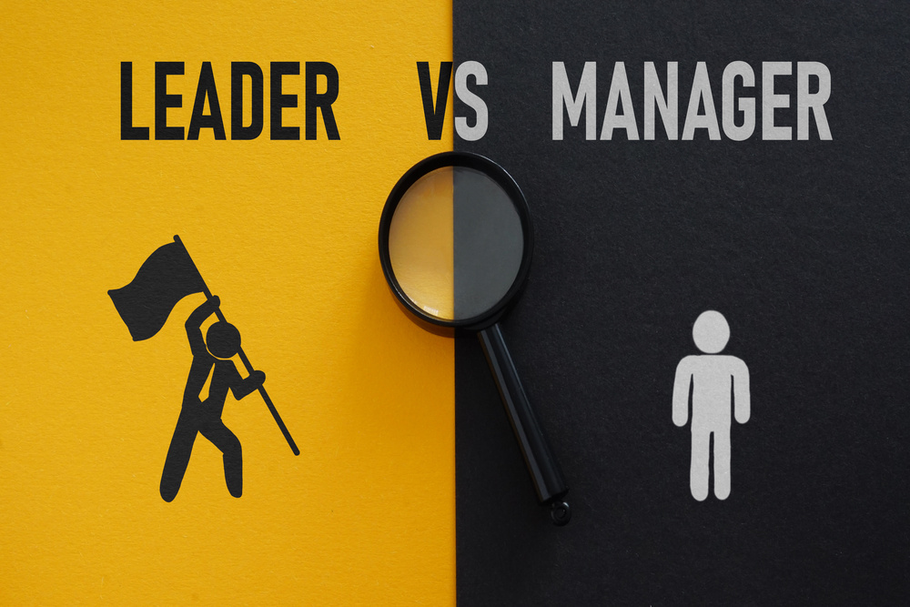

Conclusion
In conclusion, while there is a distinction between managers and leaders, the relationship between the two roles can be fluid, and individuals can exhibit qualities of both. However, it is evident from the business world that a manager can indeed be a leader when they exhibit leadership qualities in addition to their managerial responsibilities. For instance, a project manager who not only ensures a project's timely completion but also inspires the team to excel can be considered both a manager and a leader (Bartleby, 2023). On the other hand, leaders who don't engage in traditional management activities like budgeting, resource allocation, or process optimization may not be considered managers. The key lies in understanding that leadership and management, while distinct, are not mutually exclusive, and effective individuals in both roles often blend elements of each to achieve success.

Task 2 Part 1

Introduction
In this next part I will be discussing two variants of leadership and management and the personal employability skills I would use:
- “Manage, by getting people to do what needs to be done.”
To effectively manage and get people to do what needs to be done, a manager must possess a range of personal and employability skills.
- “Lead, by getting people to want to do what needs to be done.”
Leading by getting people to want to do what needs to be done requires a distinct set of personal and employability skills. These skills are essential for motivating and inspiring individuals to voluntarily commit to tasks and goals.

Manage, by getting people to do what needs to be done.

- Communication Skills:
  - Justification: Clear and effective communication is paramount in getting people to understand their roles and responsibilities.
  - Business Example: Consider the case of Steve Jobs, co-founder of Apple. He was known for his exceptional communication skills, as evidenced in his product launch presentations. His ability to articulate a vision and inspire his team was key to Apple's success.
- Leadership Skills:
  - Justification: Leadership skills help in motivating and influencing individuals to work towards common goals.
  - Business Example: Elon Musk, as the CEO of SpaceX and Tesla, exemplifies strong leadership skills. He has a clear vision for the future, and his leadership has driven both companies to innovate and achieve remarkable goals (Percy, 2023).
- Problem-Solving Skills:
  - Justification: Managers often encounter challenges that require creative solutions to keep things on track.
  - Business Example: In my own experience, I encountered a situation where a project was falling behind schedule due to unforeseen issues. By applying problem-solving skills, we restructured the project plan and allocated resources more effectively, ultimately meeting the deadline.
- Time Management:
  - Justification: Efficient time management ensures that tasks are completed on schedule, which is essential in managing a team's productivity.
  - Business Example: Warren Buffett, the legendary investor, is known for his meticulous time management. He prioritizes tasks, focusing on what's most important and delegating effectively, allowing him to run a successful investment firm.
- Empathy:
  - Justification: Understanding and acknowledging the needs and feelings of team members can improve morale and cooperation.
  - Business Example: Tony Hsieh, the late CEO of Zappos, was known for his empathetic leadership style. He cared deeply about employee satisfaction and created a unique company culture based on employee well-being, which contributed to the company's success (Paulise, 2020).

Lead, by getting people to want to do what needs to be done.

- Visionary Leadership:
  - Justification: A clear and compelling vision can inspire and align people towards a common goal.
  - Business Example: Martin Luther King Jr. had a powerful vision for civil rights and inspired millions to participate in the civil rights movement, leading to transformative change.
- Inspirational Communication:
  - Justification: The ability to articulate the vision and goals in a way that emotionally resonates with people can drive motivation.
  - Business Example: Oprah Winfrey, through her talk show and media ventures, has been a master of inspirational communication, encouraging her audience and followers to make positive changes in their lives.
- Empathy and Understanding:
  - Justification: Understanding the needs and concerns of your team fosters trust and a sense of being valued.
  - Business Example: Satya Nadella, the CEO of Microsoft, is known for his empathetic leadership style. He transformed Microsoft's culture by emphasizing empathy and active listening, making employees more engaged and motivated (Gallo, 2023).
- Motivation and Inspiration:
  - Justification: A leader should possess the ability to motivate individuals intrinsically, making them want to contribute to the greater good.
  - Business Example: Walt Disney's ability to inspire creativity and innovation among his team members led to the creation of iconic characters and the success of Disney's entertainment empire.
- Collaborative Decision-Making:
  - Justification: Involving others in decision-making can make them feel invested in the outcomes.
  - Business Example: Jack Ma, the co-founder of Alibaba, fostered a culture of shared decision-making, involving employees in critical business decisions (Atkinson, 2023). This approach helped employees feel ownership of the company's success.

Task 2 Part 2

The development of both management and leadership skills can significantly improve individual and organizational performance. However, the impact may vary depending on the context and the specific skills being developed. Here's how the development of these skills can enhance performance at both levels:

Development of Management Skills

- Efficiency and Productivity Improvement:
  - Individual Level: Learning how to plan, organize, and control tasks can make individuals more efficient and productive. Time management, delegation, and process optimization can help them complete tasks more effectively.
  - Organizational Level: When employees are better at managing their workloads, it translates into higher productivity at the organizational level. Well-managed teams can achieve their goals with fewer resources and in less time (Langat, 2023).
- Resource Allocation and Budgeting:
  - Individual Level: Developing skills related to budgeting and resource allocation can make individuals more accountable and responsible for their use of resources.
  - Organizational Level: Proper resource allocation ensures that the organization optimally uses its assets. It leads to cost savings and allows for strategic investments and growth.

Development of Leadership Skills

- Aspiration and Motivation:
  - Individual Level: Developing the ability to inspire and motivate others can enhance an individual's interpersonal and team-building skills, leading to better collaboration.
  - Organizational Level: Inspired and motivated teams tend to be more engaged and productive. This can lead to higher morale, reduced turnover, and improved employee performance (Adiguzel & Zafer, 2020).
- Strategic Decision-Making:
  - Individual Level: Learning how to make strategic decisions improves an individual's critical thinking and problem-solving abilities.
  - Organizational Level: Effective leaders who make sound strategic decisions can guide the organization in the right direction, leading to growth and competitive advantage.

Conclusion

In conclusion, the development of both management and leadership skills benefits both individuals and organizations. Effective management skills enhance individual efficiency and resource allocation, leading to improved overall organizational productivity and stability. Leadership skills, on the other hand, improve individual interpersonal and strategic abilities, which in turn foster a positive organizational culture, innovation, and long-term growth. A balance of both skill sets is often necessary for an organization to excel in a competitive environment.

References
Acharya, N., 2019. Mahatma Gandhi At 150: Lessons On Leadership. [Online]
Available at: https://www.forbes.com/sites/nishacharya/2019/10/02/mahatma-gandhi-at-150-lessons-on-leadership/?sh=7d04fd5fd7c1
[Accessed 31 October 2023].

Adiguzel, F. S. C. & Zafer, 2020. Analysis of Leader Effectiveness in Organization and Knowledge Sharing Behavior on Employees and Organization. [Online]
Available at: https://journals.sagepub.com/doi/10.1177/2158244020914634
[Accessed 1 November 2023].

Atkinson, C., 2023. Jack Ma’s Leadership Approach. [Online]
Available at: https://strategicleaders.com/jack-mas-leadership-approach/
[Accessed 1 November 2023].

Bartleby, 2023. Would you rather be a manager or a leader?. [Online]
Available at: https://www.economist.com/business/2023/10/23/is-being-a-leader-really-sexier-than-being-a-manager#
[Accessed 29 October 2023].

Freiberg, K. a. J., 2018. Madiba Leadership: 5 Lessons Nelson Mandela Taught The World About Change. [Online]
Available at: https://www.forbes.com/sites/kevinandjackiefreiberg/2018/07/19/madiba-leadership-5-lessons-nelson-mandela-taught-the-world-about-change/?sh=24024fe441ba
[Accessed 30 October 2023].

Gallo, C., 2023. Satya Nadella’s Simple Framework For Clear, Concise Communication. [Online]
Available at: https://www.forbes.com/sites/carminegallo/2023/01/25/satya-nadellas-simple-framework-for-clear-concise-communication/?sh=3e9d09f73ac3
[Accessed 29 October 2023].

Khartit, K., 2023. Tim Cook: Apple CEO's Strengths, Reputation, and FAQs. [Online]
Available at: https://www.investopedia.com/ask/answers/032515/what-tim-cooks-managerial-style.asp
[Accessed 31 October 2023].

Langat, A., 2023. Does Leadership Impact organizational performance?. [Online]
Available at: https://www.tryhighrise.com/blog-posts/does-leadership-impact-organizational-performance
[Accessed 30 October 2023].

Paulise, L., 2020. Here Are 5 Leadership Lessons From Retiring Zappos CEO Tony Hsieh. [Online]
Available at: https://www.forbes.com/sites/lucianapaulise/2020/08/31/here-are-5-leadership-lessons-from-retiring-zappos-ceo-tony-hsieh/?sh=6e0f61c138cc
[Accessed 2 October 2023].

Percy, S., 2023. Is Elon Musk The Greatest Leader On Earth?. [Online]
Available at: https://www.forbes.com/sites/sallypercy/2023/09/26/is-elon-musk-the-greatest-leader-on-earth/?sh=5801c87a4f82
[Accessed 1 October 2023].

Post, J., 2023. Can Managers Become Leaders?. [Online]
Available at: https://www.business.com/articles/can-managers-become-leaders/
[Accessed 30 October 2023].

Rosen, B., 2014. Harnessing Kinetic Energy at General Motors. [Online]
Available at: https://www.iedp.com/articles/leadership-journeys-mary-barra/
[Accessed 31 October 2023].

