Shaibah Riaz - (2314358)
BSc Health and Social Care
Health, Wellbeing and Sustainable Development
BMHP6030
Lecturer – Hamdi Hussain

Contents
Introduction 2
Relationship between health, wellbeing, and sustainable development 3
Critical Analysis of SDG 3: Good Health and Wellbeing 4
Critical Analysis of SDG 10: Reduced Inequalities 5
Evaluating health and well-being initiatives 7
Recommendations 8
Conclusion 8
References 10

Introduction
Health and wellbeing play an essential part in sustainable development as populations that are healthy are economically productive and part of an inclusive and resilient society. Understanding this connection, the United Nations declared SDG 3 (Health and wellbeing) and SDG 10 (Reduced inequalities) to ensure equal health and a better life for everyone. To achieve these goals action needs to be taken beyond healthcare, and wider social determinants such as income, education, employment and living conditions play a key role in health (Valentine et al., 2016; Fernandez, 2019). It is important to recognise that, although policy commitments have been made and progress has been made in reducing preventable mortality, there remain important inequalities of health in the United Kingdom. The NHS Diabetes Prevention Programme is just one in a series of preventive health initiatives that will increase the focus on prevention rather than treatment. This report examines the impact of SDG 3 as well as SDG 10 on sustainable development and investigates the strengths and weaknesses of national and local health programmes in tackling health inequalities.

Relationship between health, wellbeing, and sustainable development
Health, well-being and sustainable development are understood through various perspectives. The conventional biomedical paradigms conceptualise health as absence of illness, but these perspectives have been criticised because they do not examine the holistic determinants that can affect the wellbeing of the individuals. Eze (2024) argues that sustainable development must be evaluated in terms of the capabilities of individuals to pursue valued life outcomes, such as good health. This point of view is especially important as it moves the focus not only on healthcare provision but also on the circumstances that allow individuals to lead healthy lives. Figure 1 illustrates that health, wellbeing and sustainable development are closely connected.
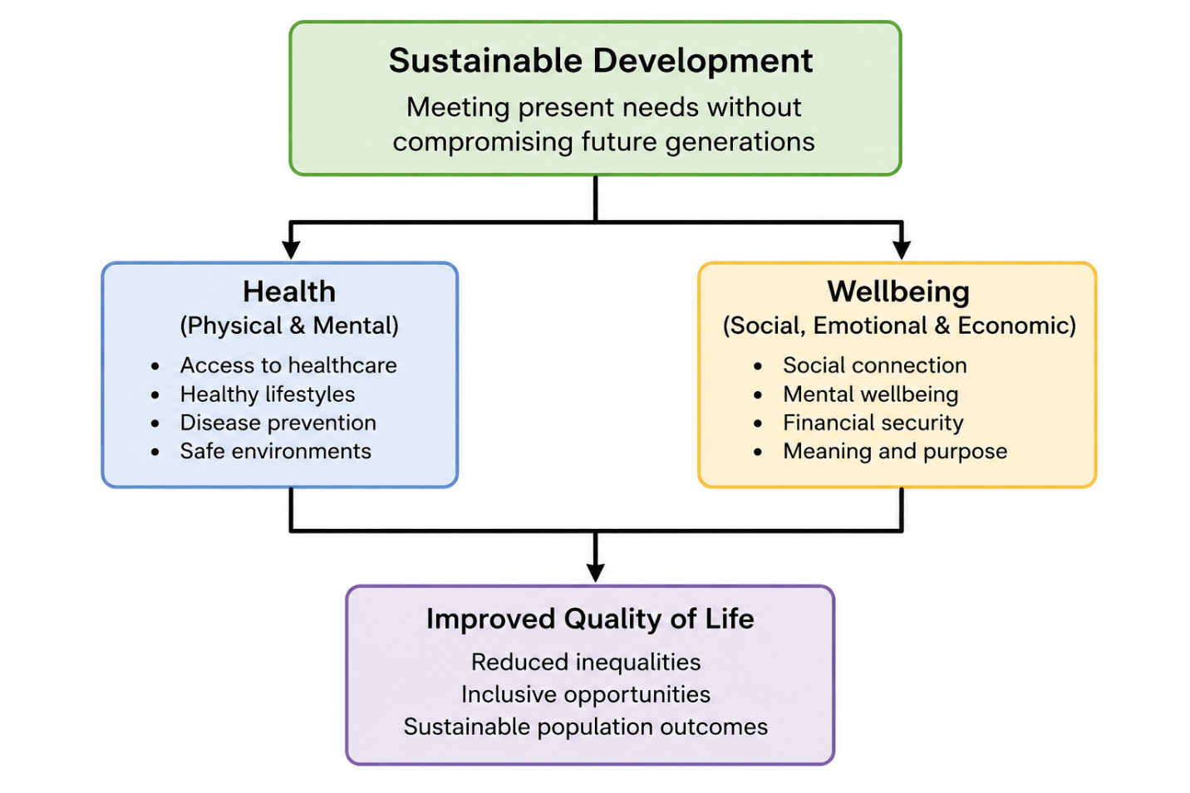
Figure 1: Connection between health, well-being, and sustainable development
Fernandez (2019) argues that health acts as a result and facilitator of sustainable development whereas Howden-Chapman et al. (2017) prove that health advances heavily rely on the success in poverty alleviation, education and sustainable societies. This correlation is aligned with the Social Determinants of Health framework that posits that health outcomes are influenced by larger social, economic and environmental factors than just healthcare services (Valentine et al., 2016). However, greater government attention to health and sustainable development does not automatically result in effective policy. As Venkatesh (2022) observes, trade-offs between economic, environmental and health priorities are frequent SDG synergies. That is why, sustainable development policies are to be assessed based on their capacity to decrease inequalities and bring observable changes to population wellbeing.

Critical Analysis of SDG 3: Good Health and Wellbeing
SDG 3 takes centre stage in the 2030 Agenda since health as a development outcome and as a presupposition of the overall social and economic development (BBC, 2022). The ultimate goal is to improve a variety of health outcomes including; communicable and non-communicable diseases, mental health, maternal and child mortality, universal health coverage and resilience of health systems (WHO, 2022). Child mortality has fallen considerably, alongside improvements in access to basic healthcare services UNICEF (2025). The under-five mortality rate fell by 44 deaths per 1,000 live births in 2015 and to 37 per 1,000 in 2023. However, a significant number of obstacles have yet to be tackled, with some 4.8 million children under the age of five dying in 2023 with most of such deaths being avoidable (United Nations, 2025). These figures show that, despite considerable progress, inequalities in access to healthcare and health outcomes continue to prevent SDG 3 from fully being achieved.
The United Kingdom also demonstrates limitations in the implementation of SDG 3. The UK government have made public commitments to promote health and wellbeing through sustainable development policies (GOV.UK, 2021; GOV.UK, 2023). The Marmot Review suggests that the inequalities in health in England have grown over an extended period of policy inaction despite its being a long plan (Marmot et al., 2020). There has been no further increase in life expectancy and those living in poorer communities still have much worse health outcomes than those in richer communities. An example of this is the Greater Manchester Integrated Care Partnership (ICP) which brings together NHS organisations and local authorities and community stakeholders to take concerted action on prevention, employment and community wellbeing, housing to reduce health inequalities. (Greater Manchester, 2024) This local project illustrates how SDG 3 and SDG 10 can be turned into local action by responding to broader determinants of health, instead of focusing on only healthcare delivery.
Moreover, research shows that investment in sustainable health performances strongly rely on a wider socioeconomic context than spending on health care. The fact that sustainable wellbeing of countries in Europe is linked strongly with the indicators of social and economic development was established by Gavurova and Megyesiova (2022). Lack of policy ambition is therefore another limitation of SDG 3 – as long as governments operate within structural inequalities that inhibit the actions of health improvement. Even though SDG 3 has been successful in elevating health in the global policy agendas, there is limited success in the long term due to endemic inequality of wealth, access and opportunity to the resources.

Critical Analysis of SDG 10: Reduced Inequalities
Although SDG 3 directly pertains to the health sector, its successful realisation depends on progress towards SDG 10 (Reduced Inequalities). Internationally, SDG 10 is integrated into the United Nations 2030 Agenda that aims at alleviating inequalities within and between nations by enhancing equal access to opportunities, services and resources (Oerther and Rosa, 2020). At the national level, the UK has invested in fighting health inequalities by commiting to its Sustainable Development Goals and taking evidence-based policy measures (GOV.UK, 2021; GOV.UK, 2023). In the UK, examples of local initiatives, like the Greater Manchester Integrated Care Partnership, show how integrated action between NHS organisations, local authorities and community organisations can respond to broader social determinants of health (Greater Manchester, 2024). These cases demonstrate that to decrease inequalities, coordinated action is necessary at global, national and local levels.
The UK offers a good example of the on-going challenges related to the attainment of SDG 10 regardless of such efforts. Despite the existence of universal healthcare that is delivered by the NHS, there are still significant disparities in the health outcomes among socioeconomic groups (Humphries, 2019). Marmot et al. (2020) found that the life expectancy rate has not increased, and the healthy life expectancy is still much lower in disadvantaged areas. This implies that the current national and local efforts have also made more people aware of health inequalities but have not succeeded in tackling the structural determinants of poverty, education, housing and employment which still restrict the achievement of SDG 10.
These results question the belief that universal healthcare is sufficient to decrease health inequalities. The limitation can be described in terms of the Capability Approach by Eze (2024), according to which it is crucial to address the skills of individuals to combine the resources at their disposal into the meaningful health outcomes. Although healthcare services are expected to be universal, inequality in the access to education, employment, good housing and healthy living conditions continue to restrain the possibility of the poor groups. Therefore, it is doubtful that healthcare alone can ensure this charter of SDG 10 without additional social change. The pandemic has brought to light structural inequalities that were never eradicated, which have taken a disproportionate toll on children, the youth and the deprived, write Marmot (2021). This means policies in place were not adaptive or protective enough in times of crisis for the vulnerable. SDG 10 has however contributed positively towards the rise in political and institutional awareness of inequality as a public health challenge. Efforts that support integrated care and place-based strategies are more conscious of social determinants of health (Humphries, 2019). But awareness is not to be conflated with effectiveness. The fact that the gap between the wealthy and the poor has remained large indicates that the progress of SDG 10 has been more of rhetoric than concrete.

Evaluating health and well-being initiatives
The NHS Diabetes Prevention Programme (NDPP) is a national program to prevent Type 2 diabetes by lifestyle modifications, such as healthier diets and more physical activity and behaviour change support (NHS England, 2023). The prevention aspect of the programme involves raising awareness of the danger of diabetes and stimulating healthier behaviours in people before they develop the disease. It also aims to enhance the confidence by providing personalised guidance and continuous support. Nonetheless, involvement is still affected by practical barriers such as inadequate housing, economic deprivation and insufficient access to nutritious food or recreational amenities. As a result, despite the programme supporting in behaviour change, its efficacy is limited by broader social and economic disparities diminishing the capacity of people to lead healthy lives (Marmot et al., 2020; Hales and Birdthistle, 2023).
Nevertheless, participation rates or clinical outcomes alone cannot be used to evaluate the effectiveness of the programme. In line with the claims of other authors, such as Marmot et al. (2020), health interventions are often advantageous to people who already have more social and economic resources. Poor housing and inability to access healthy environments, lack of employment security, and belonging to deprived communities are some of the barriers that individuals in deprived communities encounter, which diminishes their capacity to access preventative programmes (Hales and Birdthistle, 2023). Therefore the NDPP supports the aim of SDG 3 goals, but it fails to reduce the health disparities unless wider determinants are addressed simultaneously.
On the local level, we have integrated care programs through Integrated Care Systems (ICSs) that seek to improve the collaboration between the healthcare providers, local authorities and community organisations. A local example of how SDG 3 and SDG 10 are put into practice, can be the Greater Manchester Integrated Care Partnership. The partnership was founded based on the need to enhance the population health and lower inequalities in Greater Manchester by uniting the NHS organisations with the local authorities and community services to tackle broader determinants of health, such as housing, employment and social inclusion (Greater Manchester, 2025). Humphries (2019) states that the population health can be improved through integrated approaches to reduce the aspects of service delivery fragmentation. The Greater Manchester model shows how local projects and strategies can help achieve sustainable development through the promotion of prevention, overcoming health inequities and improving the coordination of health and social care services. Nonetheless, the lack of workforce and financial strains still restrict the optimal accomplishment of these goals (The King’s Fund, 2024).
The effectiveness of the integrated care reforms is still threatened by workforce shortages, financial limitations, and the growing service demand (The King's Fund, 2024). In turn, even though the existing efforts are more appreciative of the interplay between health and inequality, their overall effectiveness is limited by structural influences that go beyond the healthcare field. This shows the existing disparity between the policy aspiration and the reality.

Recommendations
- Recommendation for SDG 3: Good Health and Wellbeing
The UK Government needs to invest more in preventative health services and place-based interventions in communities with the lowest healthy life expectancy. An increase in community health programmes, early intervention services and preventative care would help reduce to avoidable disease besides addressing health inequalities, as outlined by Marmot et al. (2020). This would strengthen the development of SDG 3 to achieve equitable access to healthcare and enhance long term population wellbeing.
- Recommendation for SDG 10: Reduced Inequalities.
Integrated Care Systems must strengthen partnership between them and local authorities by implementing common performance indicator for housing, education, and employment and health outcomes instead of focusing on healthcare indicators. These broader social determinants would support effective cross-sector working and decrease structural inequalities that still have an impact on health outcomes (Humphries, 2019; The King's Fund, 2024).

Conclusion
In conclusion, SDG 3 and SDG 10 highlight the interdependent relationship between health, wellbeing and sustainable development. Even though SDG 3 has considerably succeeded in elevating health to the global policy (as well as national) debate, the situation has suggested that not all people have been growing equally due to the outstanding socioeconomic inequalities and the unequal access to resources. The example of the UK demonstrates that even the healthcare reforms and preventative measures could not guarantee the achievement of sustainable health outcomes in the situation when the social determinants occurring behind them are unaddressed. Despite these positive steps like the NHS Diabetes Prevention Programme and the Integrated Care Systems, more focus should be on minimising structural inequalities in order to effectively and fairly fulfil the goals of both SDGs.

References
BBC (2022). Global health and wellbeing - UN Sustainable Development Goal 3: Good health and wellbeing - 4th level Geography Revision - BBC Bitesize. [online] BBC Bitesize. Available at: https://www.bbc.co.uk/bitesize/guides/zn6cg7h/revision/1. [Accessed: 8 June 2026].
Das, T., Holland, P., Ahmed, M., Husain, L., Ahmed, M. and Husain, L., (2021). Sustainable development goal 3: Good health and well-being. In South-East Asia eye health: Systems, practices, and challenges (pp. 61-78). Singapore: Springer Singapore.
Eze, B.S., (2024). Capability approach as a tool for achieving sustainable development goal 3–good health and well-being: A case of the United Kingdom and Australia. In The Capability Approach and the Sustainable Development Goals (pp. 300-311). Routledge.
Fernandez, R.M., (2019). SDG3 good health and well-being: integration and connection with other SDGs. In Good health and well-being (pp. 629-636). Cham: Springer International Publishing.
Gavurova, B. and Megyesiova, S., (2022). Sustainable health and wellbeing in the European Union. Frontiers in Public Health, 10, p.851061.
GCCA (2022). SDG 3: Good Health and Well-being. [online] Available at: https://gccassociation.org/sustainability-innovation/the-un-sustainable-development-goals/sdg-3-good-health-and-well-being/. [Accessed: 8 June 2026].
GOV.UK (2021). Implementing the Sustainable Development Goals. [online] GOV.UK. Available at: https://www.gov.uk/government/publications/implementing-the-sustainable-development-goals/implementing-the-sustainable-development-goals--2. [Accessed: 8 June 2026].
GOV.UK. (2023). The UK is committed to promoting the health and well-being of all to advance the Sustainable Development Goals: UK statement at the UN General Assembly. [online] Available at: https://www.gov.uk/government/speeches/the-uk-is-committed-to-promoting-the-health-and-well-being-of-all-to-advance-the-sustainable-development-goals-uk-statement-at-the-un-general-assembl. [Accessed: 8 June 2026].
Greater Manchester (2024). Greater Manchester Integrated Care Partnership. [online] Greater Manchester Combined Authority. Available at: https://democracy.greatermanchester-ca.gov.uk/ieListMeetings.aspx?CommitteeId=426.
Hales, R. and Birdthistle, N., (2023). The sustainable development goal–SDG# 3 good health and well-being.
Howden-Chapman, P., Siri, J., Chisholm, E., Chapman, R., Doll, C.N. and Capon, A., (2017). SDG 3: Ensure healthy lives and promote wellbeing for all at all ages. A guide to SDG interactions: from science to implementation. Paris, France: International Council for Science, pp.81-126.
Humphries, R. (2019). Health and Wellbeing Boards and Integrated Care Systems. [online] The King’s Fund. Available at: https://www.kingsfund.org.uk/insight-and-analysis/long-reads/health-wellbeing-boards-integrated-care-systems. [Accessed: 8 June 2026].
Izutsu, T., Tsutsumi, A., Minas, H., Thornicroft, G., Patel, V. and Ito, A., (2015). Mental health and wellbeing in the Sustainable Development Goals. The Lancet Psychiatry, 2(12), pp.1052-1054.
Marmot, M. (2021). Editorial Perspective: Health inequalities, children and young people and the pandemic. Child and Adolescent Mental Health, 26(3), pp.267–268. doi:https://doi.org/10.1111/camh.12492.
Marmot, M., Allen, J., Boyce, T., Goldblatt, P. and Morrison, J. (2020). Health Equity in England: the Marmot Review 10 Years on. [online] The Health Foundation. Available at: https://www.health.org.uk/reports-and-analysis/reports/health-equity-in-england-the-marmot-review-10-years-on-0. [Accessed: 8 June 2026].
NHS England (2023). NHS Diabetes Prevention Programme (NHS DPP). [online] NHS England. Available at: https://www.england.nhs.uk/diabetes/diabetes-prevention/. [Accessed: 8 June 2026].
NHS England (2025). NHS England» NHS diabetes prevention scheme helps one million people. [online] England.nhs.uk. Available at: https://www.england.nhs.uk/2025/12/nhs-diabetes-prevention-scheme-helps-one-million-people/.
Nunes, A.R., Lee, K. and O'Riordan, T., (2016). The importance of an integrating framework for achieving the Sustainable Development Goals: the example of health and well-being. BMJ global health, 1(3).
Oerther, S.E. and Rosa, W.E. (2020). Advocating for Equality: The Backbone of the Sustainable Development Goals. AJN, American Journal of Nursing, 120(12), pp.60–62. doi:https://doi.org/10.1097/01.naj.0000724256.31342.4b.
The King's Fund (2024). The King’s Fund. [online] The King’s Fund. Available at: https://www.kingsfund.org.uk/.[Accessed: 8 June 2026].
UNICEF (2025). SDG Goal 3: Good Health and Well-being. [online] Unicef. Available at: https://data.unicef.org/sdgs/goal-3-good-health-wellbeing/.[Accessed: 8 June 2026].
‌United Nations, U. (2025). — SDG Indicators. [online] Un.org. Available at: https://unstats.un.org/sdgs/report/2025/Goal-03/.
Valentine, N.B., Koller, T.S. and Hosseinpoor, A.R., (2016). Monitoring health determinants with an equity focus: a key role in addressing social determinants, universal health coverage, and advancing the 2030 sustainable development agenda. Global Health Action, 9(1), p.34247.
Venkatesh, G., (2022). A brief analysis of SDG 3–Good health and well-being–and its synergies and trade-offs with the other Sustainable Development Goals. Problemy Ekorozwoju, 17(2).
WHO (2022). Targets of sustainable development goal 3. [online] World Health Organisation. Available at: https://www.who.int/europe/about-us/our-work/sustainable-development-goals/targets-of-sustainable-development-goal-3. [Accessed: 8 June 2026].

