

Student Name: | Charles Uzor
Student Number: | 1809185
Module No: | LCMB 7006
Module Title: | International Marketing
Lecturer: | Dr Tushara Balendran

Statement of Confirmation of Authenticity
By the act of making this submission, the student declares that this is the work of the student named above. The work has not, in whole or in part, been knowingly presented elsewhere for assessment, or where assessment has been built on a previous assessment, this has been identified. Where materials have been used from other sources it has been properly acknowledged. If this statement is untrue, the student acknowledges that an assessment offence has been committed.
Attention is drawn to the plagiarism and unfair practice policies of both the University and of ILM.

Contents
Introduction 4
Company Background: 4
Analysis of PepsiCo Macro Environment: 5
Political Factors: 6
Economic Factors 7
Social Factors: 8
HOFSTEDE Module of cultural Dimension: 9
Country Comparison India and United Kingdom 10
Power Distance: 10
Individualism: 10
Masculinity: 11
Uncertainty Avoidance: 11
Long Term Orientation: 12
Indulgence: 12
Technological Factors: 13
Environmental factors: 13
Legal: 14
Analysis of industry Attractiveness for PepsiCo in UK and India Markets 15
Porter’s Five Forces: 15
The Bargaining Power of Suppliers: 15
Bargaining Powers of Buyers: 16
The Threat of New Entrants: 17
Competitive Rivalry: 17
Benefits of Applying Porters Five Forces Situational Model: 19
SWOT Analysis Highlighting PepsiCo Strength, Weaknesses, Opportunities and Threats in UK and Indian Markets: 19
Similarities and Differences in SWOT for PepsiCo in UK and Indian Markets 22
PepsiCo Marketing Mix Elements and Market Segmentation Strategies 22
Segmentation 22
Geographic: 23
Demographic: 23
Targeting and Positioning. 23
Similarities and Differences in both Markets: 24
Marketing Mix: 25
Product: 26
Price: 28
Place: 28
PepsiCo Market Entry Methods: 29
Advantages and Disadvantage of Chosen Entry methods: 30
Promotion: 30
People: 31
Process: 31
Physical Evidence. 31
Directional Development Strategy: 32
Ansoff Matrix: 32
Market Penetration: 33
Product Development: 33
Recommendation: 33
TOWS Matrix 34
Conclusion: 35
References 36

Introduction
Organisations are always on the lookout for ways to achieve competitive edge within their respective markets and beyond, with a primary aim of gaining a greater share of the market by increasing their consumer base. The drive for continued growth and expansion has led to organisation developing strategies that allows them to venture into new territories and markets in search of growth opportunities. The recent surge in technological advancement has made the Global market an attractive prospect for many organisations, as the global market becomes increasingly integrated across national borders. Organisations in turn have faced various challenges when developing effective business strategies, that allows them to achieve their objectives across international borders. Issues such as establishing a clear approach on how the business operations are managed in each area of operation, considering factors such as differences in culture, religion, laws and political climate, factors that otherwise may impact the organisation competitive edge in its dominant market.
Understanding the differences and similarities in international markets have led to organisation adopting strategies that provides best fit approach that allows it to maintain acceptable levels of standards across international markets, which in turn allows for truly integrated and global operations (Douglas & Craig, 2010). This document will seek to examine similarities and differences across a range of variable within the United Kingdom and Indian markets, which PepsiCo group faced when developing its global marketing strategies. The document will further look to critically discuss the adopted marketing strategies, highlighting key differences and similarities in both markets and how significant these have been in achieving the organisation marketing objectives in the chosen markets.

Company Background:
PepsiCo Group is the world’s second largest food and beverage company with over $70 billion in net revenue as of 2020, representing 5% growth year on year from its financial report in 2019 (PEPSICO, 2021). The organisation was founded in the United States in 1919 and was later re-incorporated following a merger of Pepsi-Cola and Frito-Lay in 1965, creating one of the world’s largest drinks and food company, with a portfolio of globally recognised brands. The organisation aggressive expansion programme has led to it acquiring many households name brands such as KFC, Pizza-hut, Quaker food, Tropicana, PepsiMAx, Walkers crips, Mount Dew brands, allowing it to maintain global presence in over 200 countries and territories using authorised bottlers, contract manufactures and other third parties through whom they fulfil their business operations. The organisations current CEO, Donald Kendall, under whom the brand has continued to expand its product and brand portfolio, have overseen a healthy growth of 2.3% within its global operation despite the recent economic challenge. The organisation currently employs over 291,000 employees globally through direct and indirect employment and community initiatives, consistently demonstrating strong initiatives in arears of diversity and equality within its workforce (PespsiCo, 2022).
The organisation Mission Statement which has been fully adopted and embraced by the PepsiCo family, is to “Create More Smiles with Every Bite” has led to a strong organisational culture and values, which is centred on a vision of “becoming a global leader in convenient food and beverages, by winning with purpose and creating strong partnerships between the organisation and its stakeholders”. PepsiCo began operations in India in 1989 and is currently led by Indra Nooyi, who have overseen the growth of the organisation brand portfolio in India to over $6.07billion earning it over 53% revenue from its food range and 47% from its drinks range in India in 2018 (Abhijeet, 2022), and subsequently in the United Kingdom in 1993, where Jason Richard currently heads its UK operation with a net revenue of £3.7billion as of 2021 and have since grown and diversified its product range within this market to suit its consumer demand while complementing the organisations business and operational growth strategies within these markets.

Analysis of PepsiCo Macro Environment:
The Global economy have remained relatively stable in the last decade following the last global economic recession of 2008, many economies and global markets have made remarkable recoveries despite various geographical related challenges arising as a result of political, social and economic factors. Fluctuation in international currencies and continued changes in international relations has further impacted global trade as countries review and implement new trade policies and regulations that impact on organisation business operation. Factors as those mentioned have important implications to any brand or organisation that operates across international borders, as all PESTLE conditions must be considered favourable enough for any brand to operate seamlessly in the global remit.

An organisation Macro environment relates to external factors outside of the organisation that creates opportunities or/ and threats to the existence of the organisation.
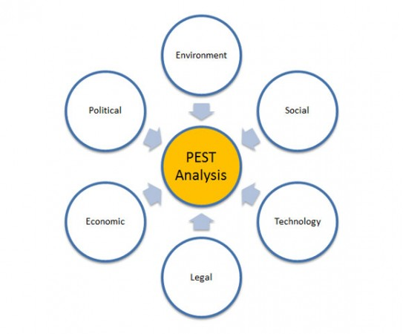
Fig1: Macro Environment

Political Factors:
UK
Political conditions in any market have considerable impact on how businesses function within that market. The more stable the political climate of a country is the more likely it is for the economic conditions to be favourable. Unstable political conditions such as civil unrest disruption, war, or unfavourable political policies, can directly affect sales, supply chain activities and ultimately potentials for a market to be profitable. The United Kingdom has a very favourable and stable political climate, in that it has been free from any major political crises in the past decades and has maintained a consistent approach in economic policies through successive governments, making it a politically conducive for foreign direct investment. However, the recent exist of UK from the European economic area (BREXIT), and recently introduced import tariffs because of Brexit, have meant massive disruptions to PepsiCo supply chain activities, distribution channels and increased costs in accessing raw materials and other resources such as skilled labour, needed for production in the UK markets. Changes in regulatory processes such as the introduction of the Sugar Tax law on soda drinks, is one that can impact PepsiCo operating margins. Further economic policies such as VAT returns Rebates, Low borrowing rates and FARLOGH, introduced by the UK government have gone some way to mitigate the BREXIT impact on the UK markets, helping to maintain a good levels of favourable economic conditions for international trade.
India
The political climate in India has been somewhat stable in the past decade. There has been consistency in a transfer of power in successive governments and this is also reflected in the continuation of economic policies that have seen the Indian economy maintain a growth pattern over the years. Though issues of poverty, illiteracy, religious difference, and low infrastructural development as well as a culture of corruption, has remained a hot topic within its political domain, the share size of the population, coupled with low labour costs and growth potential within the Indian market, has made it an attractive prospect for foreign direct investment. Though PepsiCo earns significant part of its revenue from developed markets such as US and UK and European markets, it has remained heavily involved in lobbying governments, spending over $2M in lobbying, in certain developing markets such as India to ensure favourable business conditions are implemented (Pratap, 2021).
For PepsiCo, key positive similarities exist within the UK and Indian Markets in that both markets have stable political environments allowing for PepsiCo to easily conduct its business within both markets. However, if government in India launches policies against unhealthy products that may lead to obesity, this may impact PepsiCo brand in India.

Economic Factors
UK
Global and national markets are often impacted by economic factors arising from changes in social and environmental conditions, which directly impact the economic conditions. The recent Covid-19 pandemic and recent sharp rise in global oil price has led to a sharp rise in inflation. The restriction to travel and forced closure of retail outlets within the UK markets at the height of the pandemic, which in-turn has led to increased levels of unemployment, has directly impacted ability of consumers to buy PepsiCo products within the UK markets (PEPSICO, 2021) . Consumer spend confidence has further been affected as Inflation rises to 7.8% and energy prices rise by as much as 54% driven by supply chain factors in the international arena (IGD , 2022). These conditions are unfavourable to PepsiCo brand as increased costs will most certainly affect the most vulnerable households who spend more on food, drinks, and energy, as spending powers are reduced due to the rises in cost of living. On the other hand, the reduced rate of borrowing within the UK market makes it easy for PepsiCo to finance its operations.

India
The impact of the last global recession is still present in many developing economies such as the Indian markets. Economic recovery has been slow due to the Strong dollar rates and the difficulty of the Indian Rupee to recover against the dollar. This condition is particularly favourable for PepsiCo as the strong dollar means reduced exposure in running costs and investments in the Indian Markets. However, a strong dollar may lead to reduced profits in foreign markets for PepsiCo. The Inflation rates in the Indian economy is currently at 6.01% a rise of 0.55% in 7months prior (Government Of India, 2022). Food inflation has soared for the 4th consecutive month, driven by rising costs of fuel and light (Trading Economic, 2022), such rises are bound to lead to a slowdown in economic activities and shift in consumer preferences as prices of goods continue to rise and may impact the ability of consumers to buy PepsiCo Brand products.
Currently the economic conditions in both the UK and Indian markets can be said to be Unfavourable as continued increase in inflation and living costs, may force a change in consumption preferences for consumers, as most PepsiCo brand products are not considered essential for survival, especially within low-income households in the UK and wider poorer community in the Indian markets.

Social Factors:
UK
Social factors have become increasing important to brand that carter to the need of societies in diverse markets and economies. Changes in social and cultural trends such as demography’s, habits and lifestyle, can impact global brands such as PepsiCo. Majority of PepsiCo consumers are within the 13 to 35years age group, and the drive for healthier eating habits and reduction in sugar consumption to combat the rise of obesity in the UK, have led to decrease in demand for PepsiCo products such as Pepsi cola and walkers crips, presenting unfavourable market conditions for PepsiCo. Also, the drive for higher ethical business processes and better social image for brands, has led to more scrutiny from consumers on organisations business activities and social responsibility programmes. These have led to increased operational costs for PepsiCo, as it continues to invest heavily in research and development of new healthier alternatives and business processes, in other to mitigate the adverse impact these changes are having on its operational profits.

India
The drive for healthier lifestyle and eating options is a trend that is sweeping across the Indian markets especially in the Urban and heavily populated areas, because of the concerns about sugar, salt and fat content in products. Poor health facilities in the rural areas have further led to increased awareness of the health impact of over consumption of these products as the government adopt a proactive approach in changing consumer habits. PepsiCo must continue to improve its product offerings to mitigate these changes and take advantage of the growth opportunities it presents within the Indian market as the economy continues to develop. The introduction of the good-for you, and better-for-you range of products within this market has somewhat shaped a favourable future for the PepsiCo brand, as it appears to appeal to the wider social and cultural sectors of the in the Indian communities.

HOFSTEDE Module of cultural Dimension:

Cultural dimension is another key social factor that impact consumer behaviour and should be given careful consideration when developing and analysing marketing strategy. Hofstede suggests that culture is the collective programming of the mind that distinguishes the members of one group or category of people from others in six key areas, Power distance, Individualism, masculinity, uncertainty Avoidance, long term Orientation, indulgence (Hofstede, 1980). This can be applied to a wide variety of groups such as nations, regions, ethnic groups, organisational groups, occupations, gender, and age. Each group contain different individuals and if the mindset of an individual within a group is varied due to a particular behaviour or set of patterns, it usually can be linked to variation in culture when an individual moves from one group to another (Hofstede, et al., 2010).

Country Comparison India and United Kingdom
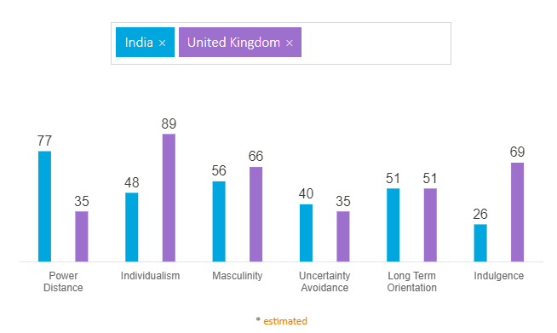
Fig 2. Hofstede insights on behavioural comparisons (Hofstede , 2022).

Power Distance:
The power distance is defined as the extent the less powerful members of an institution or organisation in a specific community or country expect and accept that power is unequally distributed. This index is concerned with the aspect that suggests that all individuals within a society are not equal and the attitude or culture displayed towards the inequalities.
United Kingdom scored a low score of 35 within this index, suggesting that the society believes that inequality within its society should be minimised, and a sense of fairness should be encouraged which in turn drives the culture of everyone being treated equally.
India in other hand score high on the power distance index, suggesting that the societal culture accepts hierarchy structure showing a Top-down structure where individual a placed at certain levels within that hierarchy and there is dependency culture on the power holder for direction.

Individualism:
The Individualism Index deals with the levels of interdependence a society maintains among its members. it highlights the prominent cultural mindset of individuals when discussing issues concerning their community with regards to using a singular of plural description, e.g., in a collective mindset “we” will be preferred whilst “I” will be used in an individualist mindset culture.
UK scored a high number 89 in the individualism index, suggesting an individual or private mindset culture is dominant within the UK society. Individuals are thought from an early age to fend for themselves and strive for self-fulfilments.
India on the other hand has a low score of 48, which indicates that India has communal culture as a dominant treat. The communities have a preference of belonging to a bigger framework where people are more considerate and care more about the greater good of the wider community.

Masculinity:
The masculinity dimension is concerned with what drives a society towards achievements and how success is viewed. The value systems instilled at early age that drives a society in the search for success and gaining competitive edge. This dimension suggests that a culture the motivates people wanting to be the best is considered masculine or liking what you do is considered feminine.
UK with a score of 66 in this dimension is considered a masculine society, with a high success and driven oriented culture. People in the UK are known to be very ambitious with an attitude of living to work and high-performance ambitions. Though this can be somewhat contradicted by the modest nature in which people approach situations in the UK.
India with a score of 56 is similar to the UK and considered having a masculine culture. Display of wealth and success is widely practised and accepted; however, India also has a strong value system of humility and abstinence, which puts a check on peoples overindulging in masculine display.

Uncertainty Avoidance:
The Uncertainty index deals with how a society handles uncertainty, whether a culture of accepting the status quo or trying to change the future is adopted. How threatened does the society feel by ambiguous or unknown situations and steps they have take to either try to avoid or mitigate the beliefs.
UK with a low score of 35 suggests that the UK has a spontaneous culture, they are happy to wake up to the unknow and change plans on the go as new information emerge. This culture allows for experimentation as details of how things are done are not always clear but are recorded showing a higher level of creativity and openness in the culture.
India with s score of 40 shows a medium to low levels of acceptance for avoiding uncertainty. There is a culture that nothing is perfect, and imperfection is considered normal, while rules in places are used to set norms, but can be circumvented should the situation require it.

Long Term Orientation:
This dimension is concerned with how every society maintains some link with its own past while dealing with the challenges of the present and future. A low score will suggest a society that may prefer to maintain a known tradition and not too keen on change, while a high score may look to change as a way of preparing for future challenges.
UK scored 51 and due to the intermediate score, a dominant culture could not be determined. Similarly, a dominant culture could not be determined for India as a similar score of 51 was attained. Though India is known as having a high religious belief with a view that thing will always fall in place.

Indulgence:
The Indulgence index deals with the extent to which individuals try to control their desire and impulse based on the way they were raised. A high score suggests a high indulgence culture while a low score suggests a culture of restraint and moderation is practiced.
UK with a high score of 69 suggests that there is a dominant culture of indulgence, where individuals display a willingness to realise personal desires and impulse and generally enjoy life, having a positive attitude and optimism.
India has a low score of 26 meaning that a culture of restraint is more dominant, suggesting a tendency to display more cynicism and pessimism in their approach to indulgence. People show more control to gratification as this is frowned upon in the society.
Advantages of Hofstede Culture Model:
- It provides insight of intended market culture and practices
- May help in market strategy development and campaign formulation
- May assist in accurate market segmentation, targeting and positioning strategy.
- May assist in achieving market synergy in cross border markets
Disadvantages
- May not apply to relevant market or target market.
- Information contained may be dated and misleading
- Does not consider the current changes happening in the wider global stage.
Overall culture defines our values and values drives brands and the synergy of the two leads to marketplace success. Therefore, principles suggested by the Hofstede culture model should be carefully considered when analysing a marketplace.

Technological Factors:
Technological factors have major impact on ability of organisations to carry out business functions especially in cross border trade. This is because all functions of the business process such as marketing, HR, finance and production, rely on some form of technology-based application to function and organisations such a PepsiCo invest heavily on technology to help foster its international operation.
UK
In the UK PepsiCo has a dedicated website for its UK market which is linked to the global website for easy corporate information circulation. PepsiCo UK site host information and product offerings for the UK marketplace and its social media platforms with YouTube having over 900K followers, contain thousands of video and marketing communications connecting it many brands and consumers who follow them on their social network pages. The recent movement restriction in the UK placed as a result of the Pandemic saw an increase on the use of the electronic channels for consumers to access PepsiCo products. PepsiCo has continued to invest heavily in the UK in research and development and has recently completed a £14M upgrade of its southern region distribution centre (SRDC) in Leicester, upgrading the facilities with the state-of-the-art equipment’s and technology (Attar, 2022).
India
PepsiCo has continued to invest heavily in research and development and finding new ways of improving its food and beverage sectors, using technological advances to improve its source of raw material production and sources, as wells as using dedicated website and social media platforms to segment their product offerings into distinct categories “good for you” fun for you” and better for you”. This aspect has a big similarity with their activities on social media in the UK market demonstrating a major growth opportunity for the organisation in both markets.

Environmental factors:
Changes in environmental laws in the UK such as the introduction of emission targets and reduction of the use of single use plastic are factors that impact PepsiCo operation in UK and Globally. PepsiCo is committed to use of 100% of renewable energy for all its owned plants globally and its efforts to reduce waste by setting a target of 100% rPET for PepsiCo brands in nine European countries including the UK by 2022. This amounts to a total reduction of over 70,000 tons of virgin fossil fuel-based plastic per year. (PEPSICO, 2021).
Similarly. PepsiCo environmental strategy and sustainability programmes in India has seen it become the first food and beverage company in India to achieve a positive water balance, saving more than 12billion litres more than it consumed in its production processes. It has also committed to use of eco-friendly packing initiatives and renewable energy source and has reduced its non-renewable sources by 74% since 2015 through improved operation efficiency and technology interventions (PepsiCo, 2022).
Although these initiatives impact its operational margins, the environmental conditions on both markets are considered favourable.

Legal:
UK
The changes in social trends and government drive to combat obesity has seen the introduction of new labelling laws requiring detailed information on food and beverage content. Also, the introduction of sugar tax laws and abolition of zero contract working hours as well as awareness of child labour laws, are all factors that impact PepsiCo operation in the UK, as any perception of failure by the brand in any of the mentioned areas, could adversely affect the brand.
India:
PepsiCo have faced similar legal issues in the India market as the drive for healthier alternatives and compliance to better business practices intensifies. Recent Laws in India bans the use of pesticides in production of raw materials used in drink and certain snack. PepsiCo must ensure that its supply chain complies with these laws as any exposure may impact the brand. Overall, the legal factors in both markets are considered similar and favourable.

Similarities and Differences in the Macro Analysis of PepsiCo:
The key similarities identified when analysing the Macro business environments in both the UK and India markets, lay within the political and social realms of the macro environments. Both the UK and India markets have relatively stable political conditions in the past decade, that have shown consistencies in policies and laws which can be considered favourable to an organisation such as PepsiCo. Both governments pursue policies which are aimed at promoting healthy eating practices and have high tax laws as means of achieving these policies. Economic policies are considered similar and favourable in both countries as the government introduce policies that mitigate the rise of Inflation and other market forces that impact the economy such as the recent covid-19 pandemic.
The social aspect finds a wide range of differences in areas of culture and consumer behavioural approach. Applying the Hofstede Model, Indian culture was identified as more community driven approach where overindulgence and self-control are not practiced, while the UK culture identifies as highly individualistic and excessive indulgence culture with the show of wealth as a way of demonstrating success.

Analysis of industry Attractiveness for PepsiCo in UK and India Markets

Porter’s Five Forces:
The porters Five forces model for industry analysis was developed by Michael Porter in the early 80’s and is used in analysing the different competitive markets pressures and conditions, to determine how each condition may affect the ability of a business to easily operate in each market environment when developing their operational strategies (Lumpkin, 1995). Five key areas are considered by Michael Porter in developing the model and are viewed as essential considerations to make when entering a new market.
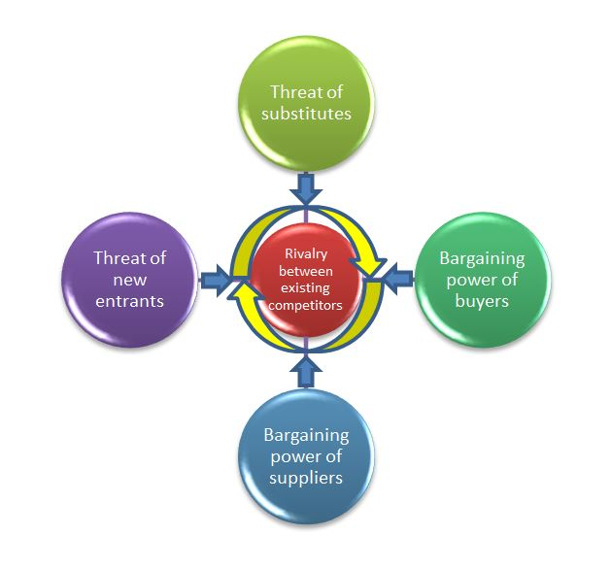
Figure 3: Source: abdo.org.uk

The Bargaining Power of Suppliers:
This relates to the power or hold various suppliers may hold over PepsiCo in relation to the need for their products in their production processes. This factor is considered low in the UK due to PepsiCo using its size advantage and long supply contracts when negotiating with suppliers. This provides little room for variation of terms, allowing for PepsiCo to maintain a degree of control.
Similarly in the Indian Market, this factor is considered low as using its vertical integrated model of operation, PepsiCo embarks in directly or indirectly owing 70% of the raw material sources and farms in India, while the other 30% are tied into Global supply contracts such as the metal used in production of the cans for some of the beverage and other eco-friendly packaging plants in India.

Bargaining Powers of Buyers:
The bargaining power of buyers have increased in recent times, this maybe because of the shift in social trends and buyers becoming more aware and demanding more variety and quality from manufactures. This have led to increased competition and a shift in power from manufactures to consumers. This factor may be considered medium to moderate in the UK, as while the industry remains highly competitive, PepsiCo has remained in-touch with changes in the social trend especially within its target demography of 13-35years, ensuring that its consumers are engages in new product development, controlling a 20% of the UK carbonated drinks industry. Also, its primary buyers in the UK are supermarkets, service stations and other food chains such as KFC, Nando’s etc., and these outlets have some level of controls as they stock large amounts of products in the UK.
Leading soft drink brands ranked by grocery sales value in the United Kingdom (UK) in 2018
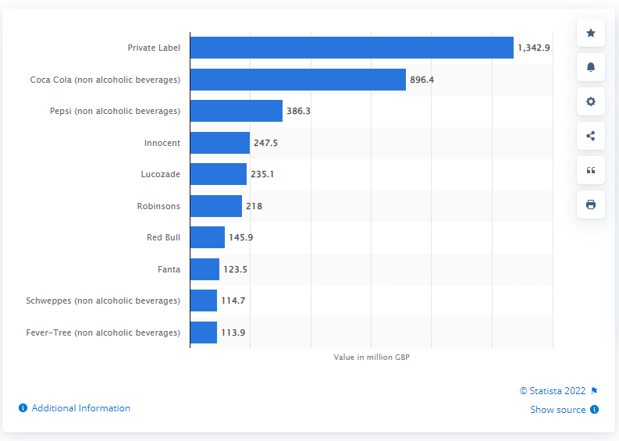
Fig:4 Source (Statista, 2022)
In Indian Market, the bargaining power of buyers is considered medium to high, this is due to dominance of the rival brand Coca-Cola has in the Indian Market. PepsiCo has 34.1% of the food and beverage markets whilst Coca-Cola has a 57% share of the market (Shashidhar & Pande, 2013). Its main Sources of distribution are through wholesalers and major food outlets and must remain competitive to allow them to stock more of the PepsiCo brand.
The main difference in this factor is that PepsiCo engages more with the community programmes and as such has more acceptance within the rural Indian communities.

The Threat of New Entrants:
The Threat of new entrants in the UK beverage and food snacks industry is Low. This is because there is very high competition within this industry and two main brands Coca-Cola and Pepsi control over 80% of the market. Entrants to the market will require vast sums of capital investment and extensive marketing activity leaving the barriers to entry very high. Furthermore, there are legal requirements necessary to meet before a new player can enter the soda market in the UK, however it is worth noting that the demand of healthier alternative and changes in social behaviours has seen an increase in micro brands offering healthy options such as flavoured water and fresh squeezed juices.
Similarly, the threat of new entrant is low in the Indian market as the market is also dominated by two main players Coca-Cola and PepsiCo, both holding a combined market share of over 85% of the beverage and market, requiring any new entrant to hold large capitals base and extensive investments in marketing and technology infrastructure. In both markets, the factor is considered favourable for PepsiCo to trade and continue its expansion programmes.

Competitive Rivalry:

Competitive Rivalry in both the UK and Indian markets could be considered medium to moderate and said to be favourable. This is because whilst there is increase demand for more choices and options in the soda drinks and snack industry in both markets, and therefore increased competition, two main brands Coco-Cola and PepsiCo still dominate market share with their large portfolio of brand offerings in both markets.

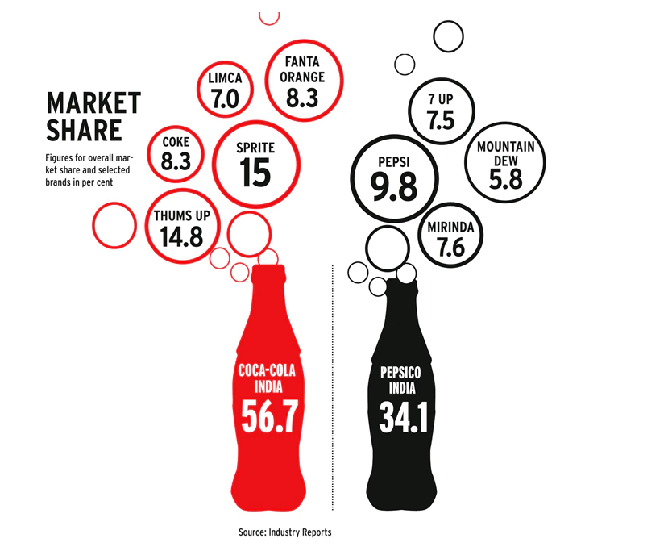
Fig 5: market share in soda drinks in India (Shashidhar & Pande, 2013).

Similarities In Market Forces Analysis

In analysing the different effects of the markets forces for PepsiCo in both the UK and India markets, certain similarities are identified. The main being the relative low bargaining power of its suppliers. This could be because of the organisations operational model where it takes over and enhances an existing supply-chain through joint ventures or acquisitions, and vertical integrated approach where it owns most of its raw material supply chain. Furthermore, the threat of new entrants in both markets are considerable low, due to the high levels of finance needed to effectively compete in the food and beverage sectors in both markets. (Abhijeet, 2022)
The key difference found will lie in the bargaining power of buyers. Though this factor is considered medium to high in both markets, the reasons for this, is different in both markets. The demography is UK is fast changing and awareness and the demand for healthier alternatives is a lot higher in the UK markets, as consumers have more freedom of thought and choice. The opposite will be the case in India as the market is still considered a developing market and the main driver of this factor is the community led culture and the dominance of the rival brand Coca Cola.

Benefits of Applying Porters Five Forces Situational Model:

The porters five force model can be particularly beneficial when correctly applied especially in cross boarder market trade. It may help highlight key differences in market driving forces in target markets and may aid market entry methods strategy development.
It will provide for a balanced approach in distributing organisations resources, as internal strength and weaknesses are aligned with key market forces, to ensure synergy in operational strategy development and gaining competitive edge (Dalken, 2014).
It may allow the organisation to focus more on external factors that may have bigger impact on an organisation’s activities, such as the activities of the competitor and how profitable a prospective market may be.
A major downside to the Porters five forces model is that it doesn’t consider the fast changes occurring in the macro environment and therefore one could question the accuracy of the chosen environmental forces. Furthermore, there is no guarantee in sustained competitive advantage due the static nature of its findings (Aktouf, 2004).

SWOT Analysis Highlighting PepsiCo Strength, Weaknesses, Opportunities and Threats in UK and Indian Markets:

Strengths Weaknesses
  UK | India
  Strong corporate Brand equity. $3.8 Billion in 2021 | Strong corporate Brand Equity with a turnover of $6.07B in 2021
  Strong Market Share 20% | Strong market Share of 34.1%
  Strong Product Offering and Portfolio 22 product range | Strong product offering portfolio with local content 16 product range
  Strong marketing capabilities with a combined following of over 30million across its social media Platforms | Strong marketing Capabilities and major association and sponsorship of with key National sport
  Strong Financial base manufacturing processes and Employee based | Strong Vertical integrated structure and employee base
  Integrated Leadership and management structure across European locations offering a wider market | Strong leadership and management structure from CEO Indra Nooyi
  UK | India
  Reliance on third-party production platform through its licencing strategy | Weak distribution network, reliance on third party platform for distribution
  High dependency on supply chain for production | Perception Consumers have of unhealthy product range
  High dependency on the US market for product development | Risk of product Adulteration and subsequent scandal
   | Fluctuation of interest rates have negative impact on PepsiCo revenue

Opportunity Threats
  UK | India
  Increase research and development in healthier alternatives for the food and beverage section | Improve health implication for food and drink products, especially in the soda beverage sector
  Increase diversification into other industries to increase market presence as UK only accounts for 3% of PepsiCo global revenue generation (PespsiCo, 2022) | Increase effectiveness of corporate social responsibility by incorporating its global plastic rPET reduction strategy to the Indian Market.
   | Increase in technological innovation and digitalization in its distribution networks
  UK | India
  Increased competition in the beverage industries as demand for healthier drinks increase and many new and smaller manufactures enter the market. | Rapid decline in sales of Carbonated drinks as awareness continue to grow due to health implications.
  Change in demography as people live longer and the youth are adopting different food preferences | High number of product recall rates due to quality scandals
   | High amount of sugar and salt in product and the increased attention drawn from the government and non-government health organisations.

Similarities and Differences in SWOT for PepsiCo in UK and Indian Markets
PepsiCo as a global brand holds some of the world best known brands in the food and beverage industry, within its corporate umbrella, and have shown strong financial growth in both the UK and India market. However, the organisation business model and operational strategy does not always provide synergy in its operational and market strategies as it continues to adapt to the different market forces in each market environment. Some of the other key similarity found when comparing PepsiCo SWOT in India and UK markets goes someway in re-enforcing this claim.
PepsiCo enjoys high brand equity in both markets with its main rival being Coca Cola. They offer more product range within its portfolio in its UK market than in the India market. (PepsiCo, 2022). This however is not reflected in its market share within the UK market. Some of the most success brands such as the PepsiMAx or PepsiMAx zero, are not currently present in the India market and can be introduced to mitigate the decline in perception of the Pepsi Cola brand.
PepsiCo is known for its commitment to reducing the impact of its business operation to the environment through various environmental and community led initiatives, however its use of rPET and plastic in production in the Indian market remains an issue to be addressed by PepsiCo management in India. (PEPSICO, 2021), as the market is still considered a developing market. This is not the same in the UK market as this is factor is tied to the European market target, which as seen huge reduction of the use of rPET plastics.
UK market has a high dependency on supply chain for most of its production raw materials, while its vertical Integrated model in India allows it to own over 80% of the farms in India as source of its raw materials for production.

PepsiCo Marketing Mix Elements and Market Segmentation Strategies

Segmentation
The process of market segmentation relates to market development strategies adopted by an organisation, when deciding who their customers are, what their target market is and how to position their products or services. In entails strategically splitting a market or consumer group into geographical territories, small or distinct groups, where specific needs, characteristics and behaviours can be accurately targeted (Kotler , 2018). There are four distinct categories to consider in any segmentation process, these are geographic, which focuses on markets based on geographical locations, demographic, which is based on age, gender, ethnicity societal status, psychographic, which focuses on lifestyles and personality, and Behavioural, which focuses on user benefits.
PepsiCo uses a combination of market segmentation strategies which cuts across the four identified styles, however, two main segmentation strategies standout in their operations.

Geographic:
This Segmentation Process involves strategically identifying potential markets based on factors such as climate, population density, resources, culture, and other variables specific to those locations, which may influence an organisations decision on what product or services that will be best suit the market. PepsiCo has a global presence in over 200 countries globally with a strong brand portfolio of 22 brands. The organisation growth strategy is based on identifying markets with concentrated population density where it can sell it product range. India and UK market represent geographical segmentation strategies with Unique identifiable differences such as culture (in the case of India, community led) and UK individualistic approach. This have somewhat influenced PepsiCo decisions on its brands made available in India market and how they may have to be adapted to suit the market.

Demographic:
This Segmentation Process entails developing a market strategy based on factors such as age, gender, income, and lifestyle. A popular strategy used in market development as it provided organisations easy ways of measuring market variables. PepsiCo main consumer focus are within the 13-35year age bracket and positioned its products to reflect young and energy commonly associated with this age bracket. PepsiCo target customers goes slightly beyond these ages groups to include individual of modern and fast lifestyle as it continues to expand its product range (Pratap, 2018).
PepsiCo segmentation strategies are very similar in both the India and UK markets as their key consumer targets are the same in both countries, their product portfolios are very similar with only a slight difference in areas of packaging and promotion, where they have used young celebrities relevant to the individual markets to promote certain brands.

Targeting and Positioning.
This involve the evaluations of each market segment to determine which segment that is most suited to an organisation’s products or services. Factors such as competitive advantage and premium pricing, are largely dependent on consumer perception that the product or services offered is considerably different from the competition (Hollensen, 2014).
PepsiCo appears to use a combination of differentiated and undifferentiated targeting strategy in both UK and India, due the having similar product portfolio and target audience in both markets. It applies an undifferentiated strategy in the beverage section with products such as Pepsi-Cola, tropicana, Aquafina and Gatorade targeted at mass market and positioned to be good for everyone. However, the organisation applies differentiated targeting when dealing with its wholesalers and major distributors.
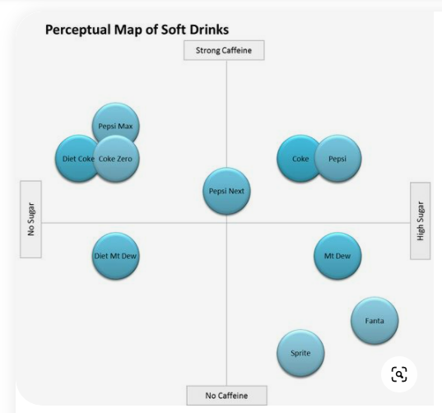
Fig. 6 perceptual map for soft drinks. Source: (Vilmi, 2022)

Similarities and Differences in both Markets:
PepsiCo attempts to position its beverage products to reflect the growing trends for healthier options drinks. In the UK its uses celebrity endorsements such as Premier league footballers such as Paul Pogba to position its PepsiMAx soda drink as a healthy sugar free alternative soda drink.
In Indian PepsiCo uses young Celebrities actors and singers in launching the tropicana juice under the “good for you banner”, the main difference being that certain product brands such as PepsiMAx, is not available in the Indian market, while the Sting energy drink popular with consumers in India, is not part of PepsiCo product offering in the UK.

Marketing Mix:
The concept of marketing Mix was first studied in Harvard University in 1929 (Jersey, 1991) and was further developed in 1964 by McCarty as principles of marketing which dominated the marking world today (Beckwith, 2001). Marketing mix includes product, price, promotion, and place, to cover the product element of the offering, and suggests that each element should be compatible to the other (Bhatt & Emdad,, 2001). These marketing principles were further developed by Booms and Bitner to cover the service aspect offerings, as they believed that similar principles should apply to services, hence a further 3P’s known as personnel, Physical assets, and procedures, was introduced (Jain, 2013). Marketing mix in essence is the set of tools which organisations use in achieving their marketing goals and objectives in any target market (Jain, 2013).
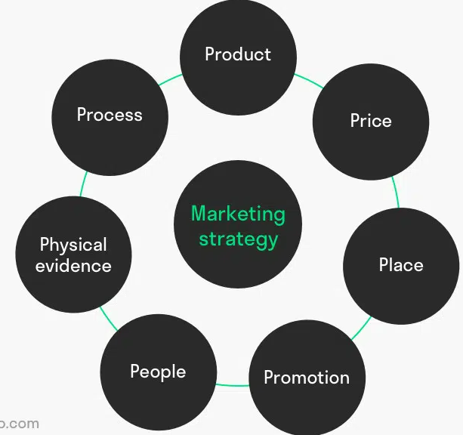
Fig.7 source: Modified from Booms & Bitner (1981)
PepsiCo is the second largest food and beverage manufacture with a global portfolio of 22 brands, sold in over 200 countries. The organisation is only second to Coca-Cola who is the market leader in the carbonated drinks section. Its food and beverage range consist of some the worlds most recognised brands such as the Pepsi Cola, tropicana juice, Gatorade, Lipton, 7Up, Diet Pepsi, PepsiMAx, Mirinda, Mountain dew, Aquafina, Doritos, Cheetos, Quaker, Lays, Slice, walkers.
PepsiCo predominantly adopts Standardised product offering for its international product range, with a few exceptions where certain food brands such as the Cheese Puffs have been adapted to suit target markets, in India and called Kurkure, which contains the local food chapati. The key benefit of adopting the standardisation strategy is to take advantage of the main benefits this presents in cross border trade. Benefits such as economies of scales in production, cost savings in research and development, cost saving in marketing, ease in market integration and global competition. However, a major drawback in adopting a standardised approach in global trade, is that demand and usage of certain products or services may significantly vary in different markets (Hollensen, 2014).

Product:
PepsiCo have several products under its product portfolio. Most of its product range are grouped into two main categories, either food or beverage. The product features are standardised in features and benefit and are easily recognised globally. The packaging depending on brand is distinctively recognised by the blue and black encircled PepsiCo logo for their Soda range and Bright coloured yellow or orange foil wrapper for the Lays and Walker brands. These are packed and sold individually or in multi-pack cases depending on source of purchase.

UK product range:
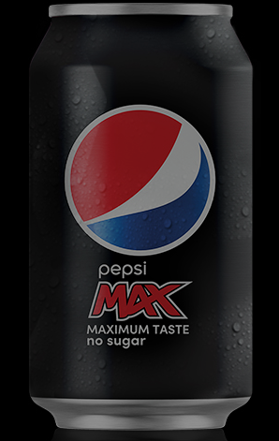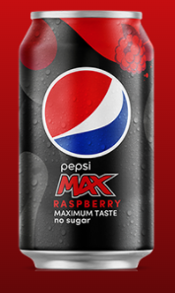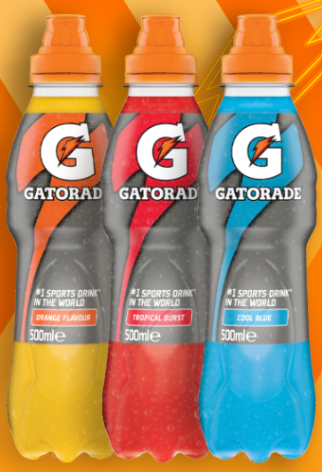
PepsiMAx 330ml cans Gatorade 50ml bottles in three flavours

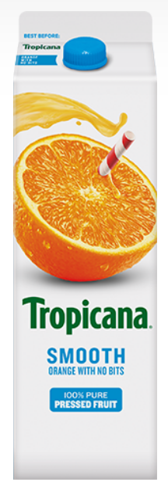
Tropicana 250ml carton offered in UK positioned as containing 40% less sugar
Source (PepsiCo, 2022)
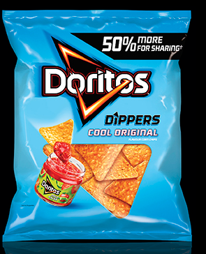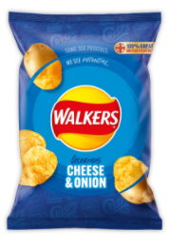
Doritos and Walkers crisps, offered in UK with 50% bigger in size and less salt and saturated fat content.
India:
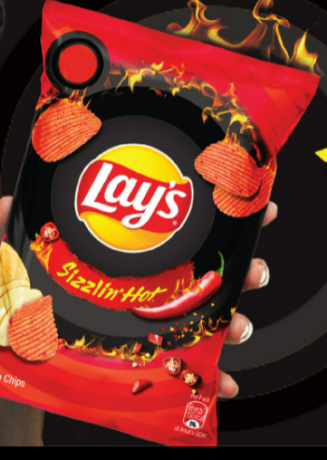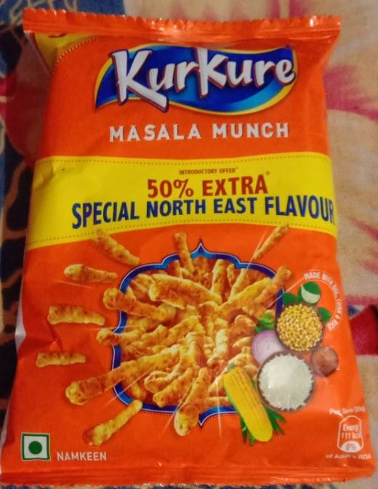
Source (PepsiCo, 2022)
Lays crips offered as sizzling hot snacks with reduced salt and saturated fat.
330ml 7UP soda offered in India as completely sugar free and in a 100% recycled bottle

Similarities and Differences in product offerings In UK and India Markets.
Key similarities exist within the product offerings for PepsiCo in both markets due the fact the organisation predominantly adopts standardisation strategy for most of its product offerings in both markets. All Pepsi cola offering have the distinct PepsiCo logo, with similar can sizes and package distribution packs. Also, the Food products offerings have clear brand identification packaging as standalone brand such as the Walkers crips and Doritos.
There are differences in available pack sizes and product availability in both countries. The Doritos original is available in 500g packs in UK and only available in 250g bag sizes in India. PepsiMAx cola is not offered in India, while the Lays crips heatwave crips is not available in the UK market.

Price:
Price is another key communication strategy which marketers use to engage their customers and can be used to gauge how customers perceive a brand and value a brand. The higher consumers are willing to pay for a brand suggests the amount of value or satisfaction attached to or derived from the brand. Price is defined as the amount of money, which is given up, in other to gain something (Winkler , 1995). Price is often controlled by factors such as demand, culture, income levels and competition and help shape organisations strategy when setting price for a product or service. The food and beverage industry are highly competitive especially in the UK market where the market is termed as saturated and even higher in India due to the growth potentials. PepsiCo adopts a market-oriented pricing strategy for is product range, with a cost leadership pricing approach. Though in some case it adopts psychological and bundle pricing strategy when running promotions in both markets, this is however affected by exchange rate as certain product may appear cheaper to purchase in India due the difference in exchange rate.

Place:
Place is concerned with the channels in which organisation use to deliver their product or service. It deals with the strategies adopted in cover all locations where their products can be found. PepsiCo as a global brand adopts a hybrid approach in its distribution strategies. This is because of the extensive nature of their product portfolio and varied strategies they have adopted in developing many of their international market locations. The organisation mostly adopts an indirect channel for its beverage, using intensive distribution, as it uses middlemen such as wholesalers and contract distributors to take advantage of their knowledge of the target markets. PepsiCo also uses direct channels such as vending machines, e-commerce channels, and other third-party partner platforms whom they have strategic alliance with such as restaurant chains (McDonalds) and other food delivery companies.
In India PepsiCo predominantly operates DSD systems to deliver snacks and beverages to retail stores. These products are merchandised in retail stores which provides more visibility for the products. In the UK as well as using the DSD system, PepsiCo recently completed a £14M construction of is new distribution centre in Leicester (PepsiCo, 2022), this will further support distribution of all PepsiCo product brands within the southern part of UK and further strengths their operational and market entry strategies.

PepsiCo Market Entry Methods:

Market entry methods relates to strategies adopted by an organisation wishing to engage in international or cross border trade. It involves considerations and decision an organisation makes, to ensure they gain or achieve competitive edge in a new market. These considerations form the core of their Global marketing strategies.
Organisation’s marketing strategies can be defined as strategies that are based on not only identifying target customers’ needs and interest in terms of values created but matching an organisations distinct capability relative to those of other competitors in the marketplace (Douglas & Craig, 2010).
There are various strategic approaches used when developing global marketing strategies, a transaction cost approach allows an organisation to adopt the most appropriate mode of entry into international markets, with cost controls for resources at the core of this approach (Williamson, 1981). Standardisation/ adaptation approach allows for organisations to take advantage of the benefits of standardising different elements of the marketing mix, as opposed to adopting a localised strategy, due to the potentials gains from economies of scales in production, distribution, marketing, and management (Levitt, 1983). Global configuration and coordination approach focuses on the need to configure and coordinate activities of a firm at different stages in the value chain across countries to improve efficiency and maintain maximum competitive advantage. Activities must be cited where they can be performed most effectively and cost efficiently (Craig & Douglas, 2000).
PepsiCo as a global organisation with a large portfolio of products, adopts a cross section of the strategies in deciding market entry methods for each target market. PepsiCo uses Licencing and contract manufacturing, as a mode of entry into markets for most its beverage products. it goes into strategic partnerships with Local bottling companies allowing it to take advantage of their local knowledge of the target market and they provide their standardised products range into the new markets. PepsiCo also uses acquisition and vertical integrations or direct investments strategies as entry methods for its food and snack section, allowing it to optimize cost efficiency and maximise speed of response to changes in demand or competitor moves.
PepsiCo adopts product standardisation as addition to their market entry methods, this allows them to transfer ideas, experience and knowledge developed in one market to another, at the same time facilitating the development of uniform image of product quality, service, and a strong corporate brand image globally (Douglas & Craig, 2010). This further allows for coordinated control of operations in target markets as similarities in operational standards are achieved, further easing the processes of comparing product performance in different target markets.
Standardisation strategy has its shortfalls as differences in consumer behaviour, culture, lifestyle, geographical location or preconceived perceptions may require the need of developing new products, promotional or distribution strategies.

Advantages and Disadvantage of Chosen Entry methods:
- Licencing and contract manufacturing negates most barriers to entry as licensee will be well established in target market.
- Standardised approach allows firm to gain economies of scales in research and development and production. Also allows for easy transfer of knowhow and knowledge into new markets.
- Acquisitions reduce investment risks as most operational processes are already established. It further allows for easy recognition and development of strong corporate brand image while establishing a uniform operational standard.
Disadvantage:
- A major disadvantage of licencing is risk of reputation damage through bad publicity.
- Risk of increased costs in case of direct investments and vertical integrations
- Risk of divulging product unique secrets and tacit knowledge.
(Douglas & Craig, 2010)

Promotion:
PepsiCo uses a range of standardised promotion and communication strategies in promoting its brands. The organisation marketing spend was more than $5B in 2020 (PEPSICO, 2021), with majority of the spend on digital and data driven advertising. The organisation uses in-store product promotions, print advertising, media advertising and sales promotional events. It also uses celebrities’ endorsements and sponsorships to promote and create more visibility for its product range. In their push to achieve a unified brand image, the organisation adopts integrated marketing communication across all their digital platforms with standalone brand pages to increase consumer engagement.
Integrated marketing communication is a process of strategically organising and coordinating an organisations marketing communication channel with a view of delivering a unified and consistent message about the brand across all channels (Kotler & Armstrong, 2018).
Promotional activities are similar for PepsiCo in India and UK in that the organisations engages known celebrities to endorse its brands, creating instant connection with its target audience. In UK PepsiCo sponsors grass root football with premiership footballer such as Paul Pogba and Sterling endorsing the PepsiMAx brand. While in India PepsiCo sponsors many major cricketing events, with Bollywood stars such as Jo Dikhti endorsing it tropicana brand.
The main differences in promotion will be the way the products brands are grouped and marketed in three distinct groups in India, “better for you” (containing products with healthy benefits) “good for you” (contain products with energy source) “fun for you” (contains regular snacks).

People:
This aspect of the marketing mix refers to the people or personnel involved in the service delivery. Their knowledge and training levels and contribution in delivering consumer satisfaction. PepsiCo employs over 291,000 staff globally through direct employment, and a further 1million through indirect and third parties across its network (PespsiCo, 2022). The organisation has a robust diversity and equality programme which have seen it achieve a 41% of female representation in their leadership roles. The organisation has recently launched a $400M racial equality initiative aimed at breaking down racial barriers within the organisation. PepsiCo provides direct and indirect employment to over 1,070,000 people in India with a further 24000 partnerships forged with farmers (PepsiCo , 2022). In UK the organisations employ over 4500 distributed over 10 operational sites with a further 2800 indirectly employed through long-term exclusive supply partnerships,

Process:
PepsiCo adopts an identical service delivery across the different markets it operates, in a bid to maintain standards approach and safeguard its brand image. The organisation provides a direct point of contact across all its marketing channels where issues such as complaints and enquiries can be lodged. This system is replicated in individual markets websites as in the case of India and UK as well as in the brands social media platforms.

Physical Evidence.
This aspect deals with the environment or avenue which an organisation uses to deliver its product or service and communicate with its customers, with the view of increased consumer satisfaction. Organisations service environment helps increase customer satisfaction as customer can be exposed to various degrees of stimuli (Duhaime, 1998). PepsiCo has a robust website which contains all information relating to the organisation’s operational activities, the leadership team, annual financial information and all product and services offerings. Also contained within its website are their sustainability programs as well as their corporate social responsibilities commitments.
The main similarities between the UK and India are that sustainability programs contained within their website show information relating to the respective markets and how this tie into the global sustainability objectives.

Directional Development Strategy:
Directional development strategy can be defined as processes or plans an organisation adopts and implements to achieve business growth, increase revenue, and achieve set objectives. These processes and plans are commonly influenced by factors within organisation Macro environment such as competition or desire to gain competitive advantage (Moghaddam, et al., 2011).

Ansoff Matrix:
Igo Ansoff (1957) developed a strategic model which uses an organisations core competency, within its value chain to determine how best to approach their new strategic choice. The model focuses on four areas of strategy development which an organisation may adopt to gain competitive advantage within a specific market and seeks to align these to the organisations resource and capabilities (Porter, 1985). The four areas highlighted by the model are market penetration, market development, Product development, diversification.

Ansoff Matrix Table
 | Existing Customer | New Customers
Existing Products | Marketing Penetration | Market Development
New products | Product development | Diversification
Fig: 8 Modified from I Ansoff (1957); Source. (Taylor, 2012)

Market Penetration:
This strategy option uses existing organisations resources within its value chain to develop new growth strategies within existing target market. PepsiCo uses market penetration Strategy as its growth model in both UK and Indian Markets. The organisation leverages on their large product portfolio and strong brand image in pushing its brands. Specific promotional campaigns using well known celebrities who endorse the brands are used to provide visibility for its brands. Brand community followings are created on their social media channels to increase consumer engagements while build stronger relationships with customer bases. E.g., Mount Dew brand with over 2million community followers. Other penetration promotional strategies such as multi pack purchases containing a varied range of products, e.g., Pepsi cola flavour range, are offered in a slight reduced costs in UK, to increase product sales, bulk purchase cross brand discounts are offered to wholesalers, who are then encouraged to pass on similar discount to consumers. E.g., a wholesaler who buys 100 packs of PepsiMAx, gets offered a 40% discount on similar quantities, if other food products such as walkers crips/ Doritos are purchased at same time. This is then sold to the consumer on similar package purchase as lunch deals at reduced costs.

Product Development:
This process entails targeting existing consumer base or markets with new products or enhanced or redeveloped products, to meet the changing demands within an existing market. This is also known as line filling and is often used to increase consumer base and further develop a market space. PepsiCo is constantly investing in R&D and finding way to improve its product range either by making them healthier or targeting a particular culture in a target market. The KurKure masala cheese puff snack was recently developed in the India market due to masala being a well-loved food spice in the Indian market. This new product range was a huge hit on launch that it has since gained over 2million likes and following on its social media community page (PepsiCo, 2022). The Asian flavoured snack range Sensation was developed and introduced in the UK markets, to target the huge Asian and growing diversified culture for spice. This new snack range has over 7 flavours all stemming from the Asian continent and have seen similar success since its launch in the UK market (Sensations, 2022).

Recommendation:
Changes in global trends, social cultural behaviours and well as economic and environmental situations have led to changes in consumer behaviour, consumption patterns and demand for changes in product preferences and usage. The drive for healthier living and eating habits, coupled with the increased legislation and taxes aimed at supporting this drive, have led to decrease in demand of certain beverages and snacks. Also increase in environmental concerns and perceptions held abouts impact certain products have on the environment, for example the use of single use plastics, have led to increased pressure on organisations to improve manufacturing processes. The aforementioned factors are all that can directly impact PepsiCo consumers in both the UK and India market, therefore it is important that the organisation take measures within its capabilities to mitigate these impacts.

TOWS Matrix
TOWS is a strategic Planning tool commonly used to align key organisations strength and weakness to mitigate impacts of threats or further develop opportunities. It can add real value to organisations, helping move strategic planning a step further by using identified organisations external and internal analysis findings in formulating operational strategies (Lucidity, 2022). Internal factors such as strengths and weaknesses are used in developing strategies emanating from external factors such threats and opportunities. Examples may be developing operational processes, new product development, marketing campaigns.
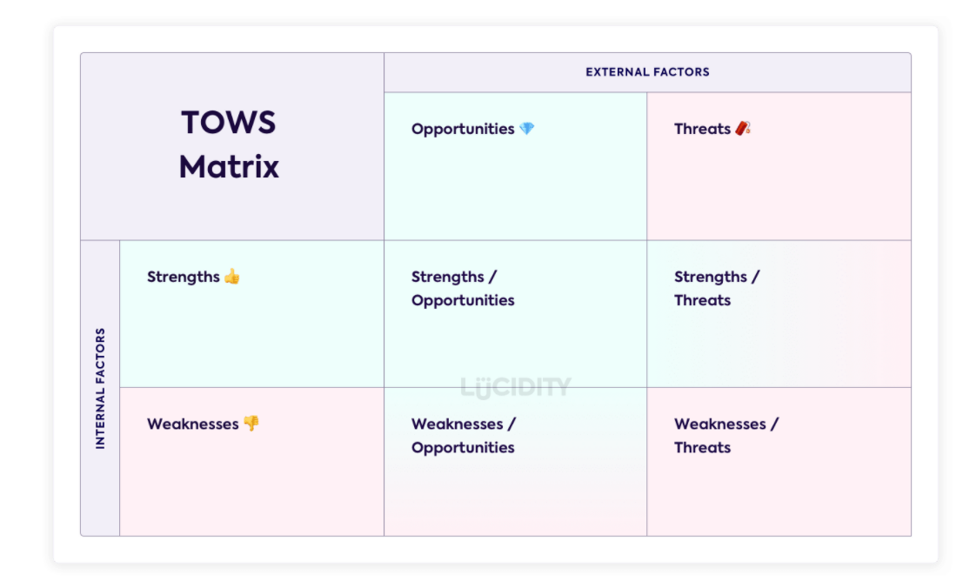
Fig. 8, source (Lucidity, 2022).

Strengths to Opportunity: This is also known as the Max-Max strategy and involves using known strengths to create opportunities.
Strengths to Threats: Also known as Max-Min strategy and involves using strengths to minimise threats.
Weakness to opportunities: Also Known as Min-Max to and involves developing a strategy where minimise impact of weakness by taking advantage of opportunity it present.
Weakness to Threats: Also Known as Min-Min and involve developing strategy that minimises weakness as well as threats.
PepsiCo as globally recognised brand with huge resources at their disposal, should adopt the Maxi-max strategy and look to further develop their corporate level strategies by increasing their investment in Research and Development of New healthier products that will help mitigate the threats it currently faces with changes in social trends and changes in consumer consumption preferences in both the UK and India Markets. Though the organisation is already investing heavily in research and development in ways to improve its manufacturing processes, $540M in 2020 (PEPSICO, 2021), more resources should be allocated to researching on developing an improved range of healthier snacks and beverages, that will appeal more to their targets market and demography and reduce the heavy tax implications this attracts from the governments.
Further to this PepsiCo should look to incorporate the Max-min strategy and further develop their business level strategies by developing their marketing strategies through related diversifications. Changes in social trends have seen an increase in small fresh juice bars, offering real alternatives to PepsiCo beverages. The organisation can look to use their global image to partner with or develop similar distribution outlets where it will offer freshly squeezed juices as well as its existing product range. This will help minimise threats and increase barriers to entry of new juice bars within its target markets.

Conclusion:
PepsiCo is one of the world’s largest food and beverage company with well established house-hold name brands under its corporate umbrella. As the organisation continue to expand its operations into new markets and geographical locations, it must ensure it adopts strategies that will best suit the changes in global social trends, ensuring these are properly aligned to markets forces present within its target markets, before reaching decision on product offering to introduce into new markets. Furthermore, PepsiCo should look to use their sustainability and improvements made in their manufacturing processes more as part of their product promotion campaign as this may help improve perception held about its product range and further improve the organisations competitive edge.

References
Abhijeet, P., 2022. Pepsi Business Growth and Marketing Strategies. [Online]
Available at: https://notesmatic.com/pepsi-business-growth-and-marketing-strategies/

Aktouf, O., 2004. The false expectations of Michael Porter's strategic management framework. Revista Universidad & Empresa,, 6(6), pp. 9-41.

Attar, W., 2022. Supply chgain Analyst. [Online]
Available at: https://sca.igd.com/news/news-article/t/pepsico-completes-distribution-centre-upgrade/i/28828
[Accessed 15th March 2022].

Beckwith, H., 2001. The Invisible Touch- The Four keys of mordern marketing. s.l.:Texere publishing.

Bhatt, G. & Emdad,, . A. F., 2001. An Analysis of the Virtual Chain in Electronic Commerce.. Logistics Information Management, , 14(1), pp. 78-85.

Craig, C. S. & Douglas, S. P., 2000. Configural Advantage of Global markets. Journal Of International Marketing, 8(1), pp. 6-25.

Dalken, F., 2014. Are Porter’s Five Competitive Forces still Applicable? A Critical Examination concerning the Relevance for Today’s Business. The Netherlands, s.n.

Douglas, S. P. & Craig, S. C., 2010. Global Marketing Startegy; Perspective and Approaches, s.l.: Wiley International Encyclopedia of Marketing.

Douglas, S. P. & Craig, S. C., 2010. Global marketing Strategies; perspective Approach, s.l.: Johj Wiiley & Sons ltd.

Duhaime, C., 1998. Consumer Satisfaction with distribution system for Durable Goods. Journal of Customer Satisfaction, Dissatisfaction and Complaining Behaviour, 88(1), pp. 53-59.

Government Of India, 2022. Ministry of Statistics and programme implementation. [Online]
Available at: https://www.mospi.gov.in/
[Accessed 14th March 2022].

Hofstede , 2022. Hofstede Insights. [Online]
Available at: https://www.hofstede-insights.com/country-comparison/india,the-uk/
[Accessed 15th March 2022].

Hofstede, G., 1980. Culture’s consequences; International differences in work-related values., Beverly Hills CA: Sage.

Hofstede, G. et al., 2010. Comparing Regional Cultures Within a Country: Lessons From Brazil. Journal of Cross-Cultural Psychology, 3(41), pp. 336-352.

Hollensen, S., 2014. Dimension of the International product offer. In: Global Marketing. Edinburgh Gate: pearson education ltd, pp. 499-500.

IGD , 2022. IGD.com UK inflation continues to climb higher. [Online]
Available at: https://www.igd.com/articles/article-viewer/t/uk-inflation-continues-to-climb-higher/i/29433?gclid=Cj0KCQiAybaRBhDtARIsAIEG3kmdRWw5nJ9llE34oBraUrWrXlt1iAy8r4iIa52nRpDWQ9672YddnjIaAmGbEALw_wcB
[Accessed 14th MArch 2022].

Jain, M. K., 2013. An Analysis of Marketing Mix: 7Ps or More. Asian Journal of Multidisciplinary Studies, 1(4), pp. 23-31.

Jersey, N., 1991. Prentice hall, Baungartner J. Non Marketing professionals need more that 4P's marketing [Interview] 1991.

Kotler , P. A., 2018. Principles of Marketing. Harlow: Pearson Education Ltd.

Kotler, P. & Armstrong, G., 2018. Principles of Msrketing. Harlow: pearson.

Levitt, T., 1983. The Globalization Of Markets. Harvard Business Review, pp. 61, 92-102.

Lucidity, 2022. Lucidity. An introduction to TOW Analysis. [Online]
Available at: https://getlucidity.com/strategy-resources/an-introduction-to-tows-analysis/
[Accessed 1st April 2022].

Lumpkin, G. T., 1995. Is Strategy different for very small and anew firms. Journal of small business strategy, 2(21), pp. 10-11.

PepsiCo , 2022. PepsiCo India. [Online]
Available at: http://www.pepsicoindia.co.in/company/pepsico-india/about-us
[Accessed 31st March 2022].

PEPSICO, 2021. PepsiCo Annual Report. [Online]
Available at: https://www.pepsico.com/docs/album/annual-reports/pepsico-inc-2020-annual-report.pdf?sfvrsn=d25439e4_4
[Accessed 15th March 2022].

PepsiCo, 2022. KurKure Facebook page, India: s.n.

PepsiCo, 2022. PepsiCo India. [Online]
Available at: http://www.pepsicoindia.co.in/company/pepsico-india/about-us#:~:text=PepsiCo%20entered%20India%20in%201989,100%25%2C%20Gatorade%20and%20Quaker.
[Accessed 15th March 2022].

PepsiCo, 2022. PepsiCo UK. [Online]
Available at: https://www.pepsico.co.uk/news/stories/distribution-centre-upgrade
[Accessed 28th March 2022].

PespsiCo, 2022. Pepsico. [Online]
Available at: https://www.pepsico.com/docs/album/annual-reports/pepsico-inc-2020-annual-report.pdf?sfvrsn=d25439e4_4

Porter, M., 1985. Competitive advantage; creating and sustaining superior advantage, New York: New York Press.
Pratap, A., 2018. PepsiCo Business Growth Strategy. [Online]
Available at: https://notesmatic.com/pepsi-business-growth-and-marketing-strategies/#t3
[Accessed 25th March 2022].

Pratap, A., 2021. Notesmatic. [Online]
Available at: https://notesmatic.com/a-pestpestlepestel-analysis-of-pepsico/
[Accessed 12th March 2022].

Sensations, 2022. Sensations Snack Facebook , Liecester: s.n.

Shashidhar, A. & Pande, S., 2013. Business Today.In. [Online]
Available at: https://www.businesstoday.in/magazine/features/story/a-rough-summer-for-pepsi-in-india-39556-2013-06-29
[Accessed 15th March 2022].

Statista, 2022. Statista. [Online]
Available at: https://www.statista.com/statistics/296662/soft-drink-brand-ranking-in-the-united-kingdom-uk-by-grocery-market-value/
[Accessed 15th March 2022].

Taylor, E., 2012. Competitive Improvement Planinng; using Ansoff Matrix with Abells Model to Inform the strategic managment process.. Academy of Strategic Managment, 1(11), pp. 21-27.

Trading Economic, 2022. India Inflation. [Online]
Available at: https://tradingeconomics.com/india/inflation-cpi
[Accessed 14th March 2022].

University of Wales Trinity St Davids, 2022. Moodle. [Online]
Available at: https://moodle.uwtsd.ac.uk/course/view.php?id=4120
[Accessed 29th March 2022].

Vilmi, P., 2022. Manifested Marketing press. [Online]
Available at: https://www.pinterest.co.uk/pin/456130268495332777/
[Accessed 28th March 2022].

Williamson, O. E., 1981. The Economics of organisations; the transational cost approach. American journal of Sociology, 87(3), pp. 548-577.

Winkler , J., 1995. Pricing Marketing Book. Third edition ed. s.l.:Bart press .

