

MSc Public Health and Social Care in Practice
Quality Assurance and Service Improvements
LCHS7006
Component 2: Service Improvement Report
Topic: Investigating Quality Failures and Service Improvement in Healthcare: Lessons from the Lucy Letby Case at Countess of Chester Hospital
Student Name: Sonali Solanki
Student ID: 2523936
Word count: 3009


Table of Contents
Abbreviations 4
1. Introduction 5
1.1 Background to Quality Assurance in Healthcare 5
1.2 Overview of the Lucy Letby Case 5
1.3 Identification of the Quality Concern 6
1.4 Aim and Scope of the Report 7
2. Main Body: Critical Analysis 7
2.1 Quality Management and Patient Safety in Healthcare 7
2.2 Root-Cause Analysis of the Quality Concern 8
2.2.1 Fishbone Diagram 8
2.2.2 5 Whys Analysis 9
2.3 Donabedian Model Analysis 10
2.5 SWOT Analysis of Quality & Patient-Safety Management 11
2.5 Critical Evaluation of the Quality-Improvement Issues 12
3. Recommendations and Implementation Strategy 14
3.1 Recommendation 1: Improve the Reporting and Escalation of incidents 14
3.2 Recommendation 2: Enhance Clinical Governance 14
Recommendation 3: Further Tune Communication and Speaking Up Connections 14
3.4 Recommendation 4: enhance Data Monitoring and early-warning systems 15
3.5 PDSA Implementation Strategy 15
3.6 Implementation Measures 16
4. Conclusion 17
4.1 Summary Key Points 17
4.2 Implications for Healthcare Quality 17
4.3 Final Recommendation 17
References 18

Abbreviations
- NHS – National Health Service
- CQC – Care Quality Commission
- PDSA – Plan-Do-Study-Act
- SWOT – Strengths, Weaknesses, Opportunities and Threats
- PS – Patient Safety
- KPI – Key Performance Indicator

1. Introduction

1.1 Background to Quality Assurance in Healthcare
Quality assurance in the health and social care sector is a systematic procedure designed to ensure that services are delivered to a certain standard set out, and service improvement is an ongoing process that focuses on improving safety, effectiveness and patient experience.
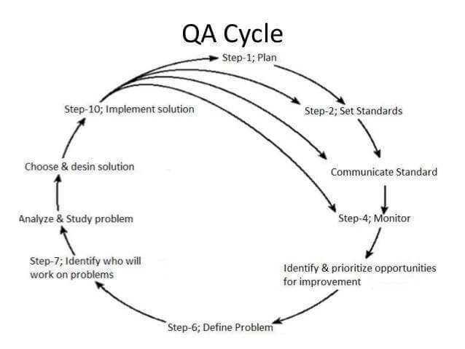
Figure 1: Quality Assurance in Healthcare
(Source: Broshkov, 2023)
Patient safety, clinical governance and effective monitoring are needed because of accountability, early detection of harm and to help ensure practice is evidence-based and aligned with guidelines (Broshkov, 2023). Quality failures are also public health and organisational issues, lose trust, lead to more disease and death, and indicate poor systems of leadership, culture, and resource allocation.

1.2 Overview of the Lucy Letby Case
Between 2015 and 2016, Countess of Chester Hospital's neonatal unit looked after very premature and sick babies who were at risk. An unusual number of deaths and collapses have occurred during this time for which there is no explanation, leading to internal investigations and a criminal investigation (Whiteing, 2023). Neonatal nurse Lucy Letby was tried again and sentenced to 15 whole-life terms for seven counts of murder, and seven attempted murders in August 2023. It is a case of patient safety (PS) and health care quality failure because, despite the recurrence of clinical incidents, these were not sufficiently escalated or investigated (Humphries, 2025). At trial, witnesses shared stories of air injection procedures, insulin overdoses, and physical assaults, but some experts doubt the medical explanations, and a cross-disciplinary panel of experts found “no evidence to support malfeasance” and referred deaths to natural causes or suboptimal care.

1.3 Identification of the Quality Concern
Concerns include: patient safety is compromised, no action is taken despite doctors’ concerns, there is lack of reporting of incidents which hides the death trend, there is poor clinical governance which allows risks to continue, poor communication with other professionals with consultants saying they have been silenced, there is a late organisational response when incidents have been reported and repeated, and usual incidents are not being monitored effectively (Wang et al., 2023).
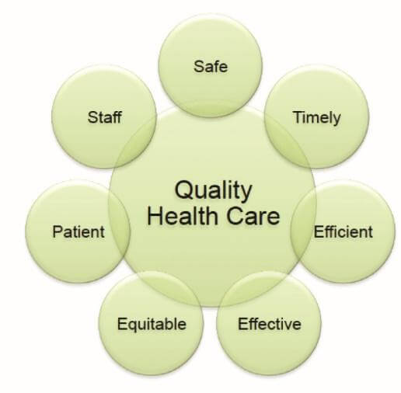
Figure 2: Quality Concern in Healthcare
(Source: Broshkov, 2023)
There was evidence that hospital managers initially thought rising death rates were a business risk more than a reputation, and that external inspection revealed deficiencies in staffing, infection control, overcrowding and an outbreak of Pseudomonas aeruginosa (NHS England, 2022). There are gaps in systems of monitoring, with a statistics expert telling the Thirlwall Inquiry eight deaths in one year would not trigger an external investigation.

1.4 Aim and Scope of the Report
This report examines the implications for quality and service improvements in the context of the following investigative questions: how governance, culture and systems failed to protect neonatal patients when considering the Lucy Letby case.
It will find practical ways of enhancing the reporting of incidents, developing staff escalation and communication between different disciplines, increasing independent checks to ensure patient safety and, if possible, preventing any further incidents relating to babies (Queen Mary University of London, 2024). The report juxtaposes between the fact and the interpretation, to guide evidence-based reforms in which patient well-being trumps institutional image.

2. Main Body: Critical Analysis

2.1 Quality Management and Patient Safety in Healthcare
The elements of healthcare quality are effectiveness, safety, timeliness, efficiency, equity, and patient-centredness, and patient safety is about ensuring that health care is delivered safely as opposed to doing harm (NHS England, 2023). Clinical governance is the structure that ensures NHS organisations are held to account for continuously improving the quality of the services they deliver, and maintaining high standards it is a structure that creates a culture where excellence in clinical care will thrive. The fundamentals of effective quality-management systems are based on accountability, risk management and incident investigation looking after causes instead of just reacting effectively (Bhasale et al., 2021).
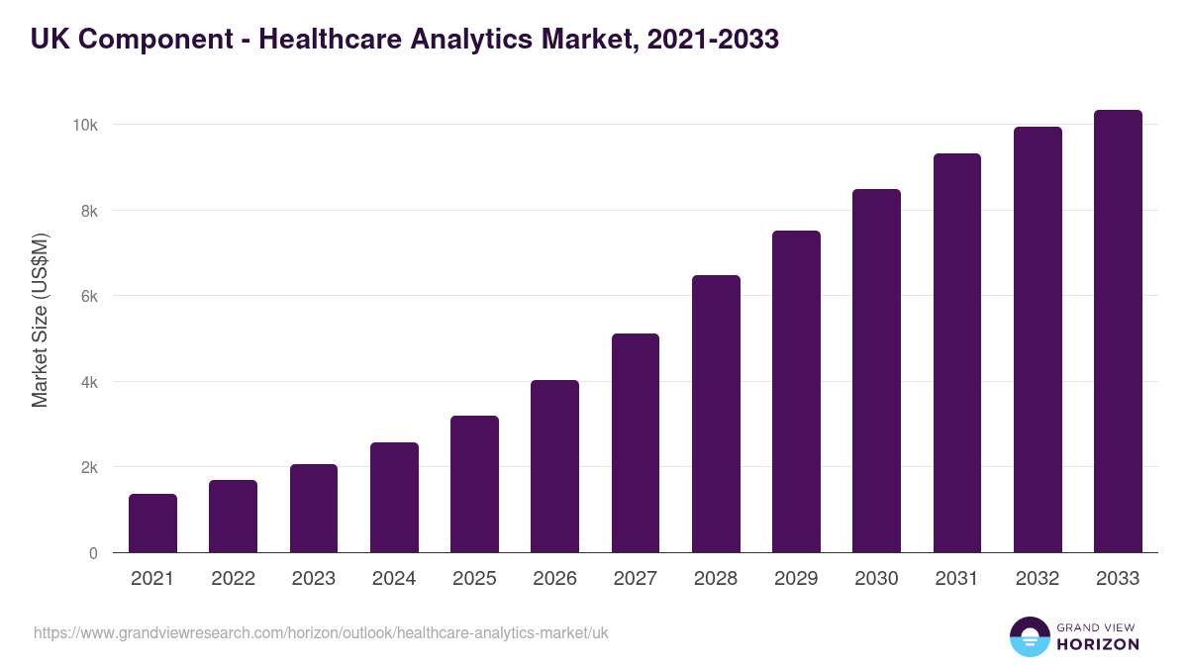
Figure 3: Outlook of UK Healthcare Analytics based on Marlet Size
(Source: Grand View Research, 2025)
Grand View Research (2025) report shown that by 2033, the UK healthcare analytics market is predicted to generate US$10,336.7 million in sales. The UK healthcare analytics market is projected to increase at a compound annual growth rate of 14.4% between 2026 and 2033.
In the case of Countess of Chester Hospital, these systems failed (literally) to prevent. Although high-profile paediatricians repeatedly raised concerns regarding unusual patterns of death, management failed to escalate these concerns between deaths appropriately and failed to carry out timely and systematic investigations of links between deaths (Enahoro et al., 2024). Later, the CQC found that important issues related to sepsis treatment were missing, a lack of cleanliness, infection control issues and patients receiving care while exposed in the hospital's corridors (CQC, 2026).

2.2 Root-Cause Analysis of the Quality Concern

2.2.1 Fishbone Diagram
The Fishbone model (also known as the Ishikawa model) lists six categories of possible factors that can cause a problem in the organisation. People, personnel out of reach the unit was over-staffed and also lacked knowledge of care for critically ill babies (Kumah et al., 2024). Through poor incident reporting, a poor escalation process and no timely incident investigation, processes failed.
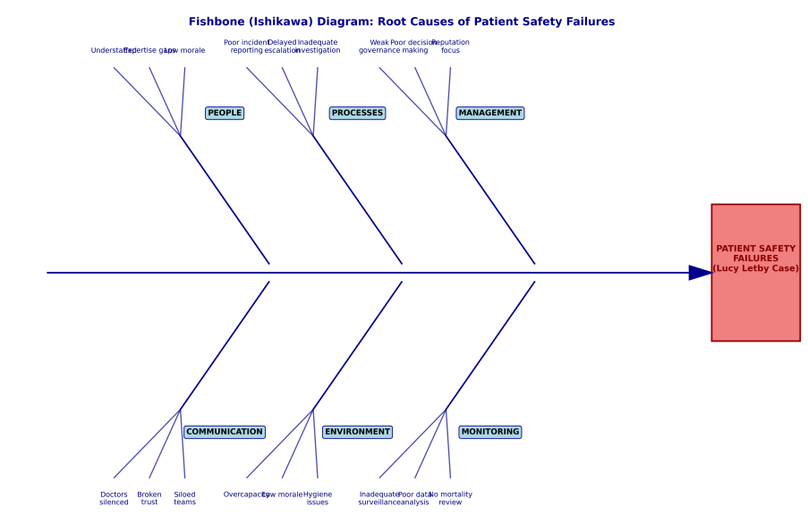
Figure 4: Fishbone Diagram based on case analysis
(Source: Self-Made)
Executives did not follow policies such as duty of candour and whistleblowing procedures, and management lacked good leadership and decision-making. Some lapses of communication arose between doctors and nurses, and management and consultants, who were claimed to be silenced when raising concerns (Tagaram and Chen, 2024). Environmental concerns encompassed an overloaded unit with depleted morale, and contaminated hygiene problems of a Pseudomonas aerugionosa outbreak and sewage back-up. Weaknesses in monitoring included the neglect of proper surveillance and a lack of data analysis, and a failure to thoroughly conduct and investigate any suspicious incidents (Kumah et al., 2024).

2.2.2 5 Whys Analysis
Question | Answer
What went wrong in relation to patient safety? | Frequent safety issues were not addressed appropriately
Why were the reasons not responding to concerns? | Some issues were not raised in a manner or at a level that warranted a response from senior management or other outside agencies
Why was escalation not enough? | There was a lack of clarity of leadership, and organisational processes of escalation were not adequate
What are the reasons for lack in processes? | Governance and accountability structures were weak, and there were repeated failures to respond to known risks
What caused poor governance? | As a result of an organisational culture where reputation was valued over transparency, barriers at a systemic level imposed limitations on learning
Table 1: 5 Whys Analysis for the case of Lucy Letby UK
(Source: Self-Made)
This analysis finds that failures boil down to issues that are not necessarily individual problems but rather of culture and structure.

2.3 Donabedian Model Analysis
Structural weaknesses were below standard staffing levels for the number of babies in the unit, a lack of linkage between the role of neonatal unit leadership and trust governance processes, and limited resources and staff time for the administration of the neonatal unit, where babies were shown to be in a critical state; and reporting systems that did not reflect mortality trends (Tossaint-Schoenmakers et al., 2021). Many weaknesses captured in the Royal College of Paediatrics and Child Health report included a lack of resources and a lack of medical care, which the hospital could not maintain, and it was unable to keep the fragile babies alive.
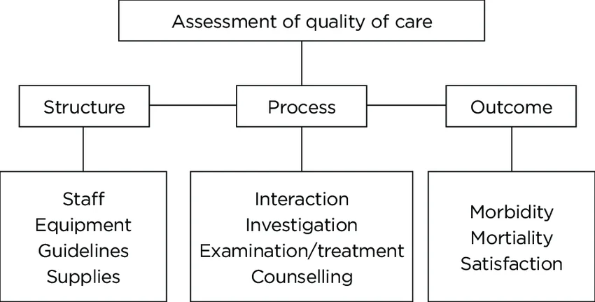
Figure 5: Donabedian Model Analysis
(Source: Tossaint-Schoenmakers et al., 2021)
Process failures included lack of timely clinical monitoring, poor multi-disciplinary communication (including doctor warnings not being followed), poor documentation of incidents so that they did not get picked up across the NHS system and a lack of immediate investigations to pursue death connections (England, 2025). Management was not transparent in informing CQC during inspection about rising numbers of babies who died while at the centre.
Consequences were lost patient lives (7 murders and 7 attempted murders), babies' lives at risk, neonatal mortality rates increased from an average of 2-4 babies a year to 17 over 13 months, loss of staff confidence, loss of organisational responsibility, and patients' and the public's loss of trust (McCullough et al., 2022). Such outputs illustrate the direct impact of structural and process weakness on healthcare outcomes, thus supporting the Donabedian framework of a group of interconnected outcomes.

2.5 SWOT Analysis of Quality & Patient-Safety Management
Strengths | Weaknesses
Paper-based existing clinical governance structures  Professional knowledge of the senior paediatricians  Reporting uptake within NHS framework systems  Regulatory oversight (CQC / national bodies) | Potential weaknesses in escalation procedures  Communication problems between professionals  Potential delays with responding to concerns  Organisational learning issues/cultural barriers
Opportunities | Threats
Identifying trends within incidents and data  Increased multi-disciplinary collaboration  Widespread lack of public trust of health services  data-driven quality improvement programs | National Health Service (NHS) incidents are repeating  Workforce pressures and staffing shortages  Enhanced staff training on whistleblowing and escalation  Trusts and legal/reputational repercussions
Table 2: SWOT Analysis of Quality & Patient-Safety Management
(Source: Self-Made)
There is a need for immediate action to resolve communication difficulties and escalation weaknesses as these are key failure points that professional concerns in principle were knowingly ignored. Improvement can be achieved by strengthening organisational aspects such as regulatory oversight, increasing CQC inspection intensity and introducing compulsory mortality reporting requirements (Madine et al., 2025).

2.5 Critical Evaluation of the Quality-Improvement Issues
The Fishbone analysis highlights numerous organisational factors that can affect quality issues, each with its own set of dimensions, showing that most quality failures have multiple causes which could involve one or more factors from different dimensions. The 5 Whys shows the procedural breakdown beneath the surface; the real problem lay in the cultural issue in which reputation management had become more important than patient care (Lawrence and Conn, 2024).
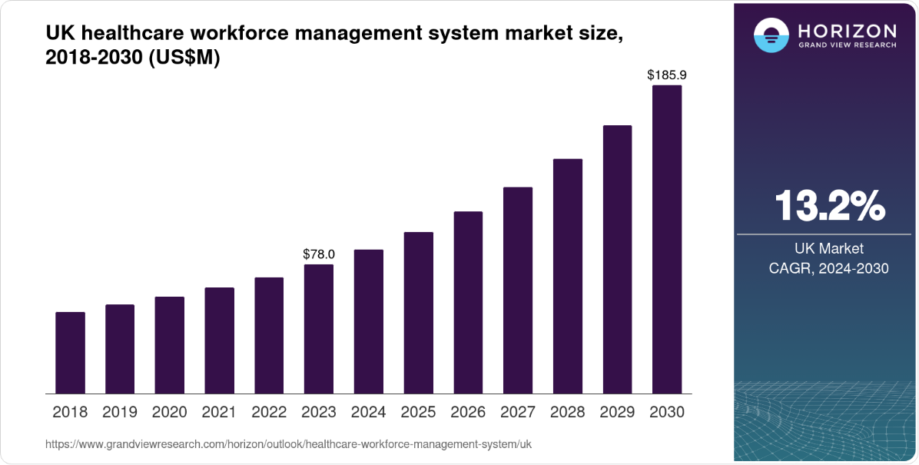
Figure 6: Outlook of UK Healthcare workforce Management system market size
(Source: Grand View Research, 2025)
By 2030, the UK's healthcare workforce management system is anticipated to generate US$185.9 million in income. The UK healthcare workforce management system is anticipated to develop at a compound annual growth rate of 13.2% between 2024 and 2030 (Grand View Research, 2025).
Donabedian shows the causal chain of structural weaknesses leading to process failures, to adverse outcomes, and offers a comprehensive framework for considering system-level failures. SWOT shows important priorities for the organisation – communicate and escalate these weaknesses so they can be addressed, and regulatory oversight can provide opportunities to do so.
These models work together: Fishbone gives breadth of causal factors, 5 Whys gives depth of root causes, Donabedian gives structure to the relationship of structure, process, and outcomes, and SWOT prioritises the improvement actions. However, limitations exist. Fishbone can be simplistic about complex interrelationships, 5 Whys is linear thinking in complex adaptive systems, Donabedian may be light on a focus on culture, and SWOT can be subjective.
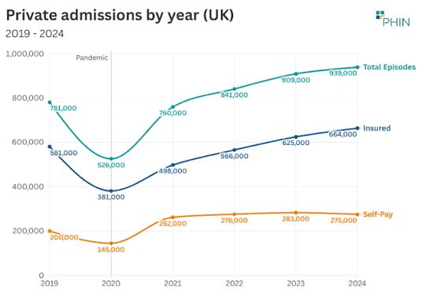
Figure 7: Private Healthcare Market update in June 2025 UK
(Source: PHIN, 2025)
The UK health expenditure estimated across £345 billion in 2025, the spending accounted at the rate of 11.4% of the country GDP for the private health status development (PHIN, 2025).
Most important of all, as highlighted by the NYT, all models are subject to retrospective bias; some experts reject the malfeasance narrative altogether, with an international panel reporting no evidence of deliberate harm, but rather that deaths were the result of “suboptimal treatments” from systemic failures the models purport to “warn about” (UK, 2026). The paradox indicates that even though quality improvement frameworks have many layers of interpretation, they need to always be open to multiple meanings, but should never avoid calling attention to patient safety concerns, no matter what the individual case may involve.

3. Recommendations and Implementation Strategy

3.1 Recommendation 1: Improve the Reporting and Escalation of incidents
There had been weaknesses in how patients' incidents were reported and escalated, such as senior paediatricians raising concerns over the higher rate of deaths that they should have expected to have a response to, as evidenced in the Countess of Chester Hospital case. Clear escalation levels should be established within healthcare organisations to define when a concern should be referred to senior management, notifiable to the external or appropriate for immediate action (Lawrence and Conn, 2024). Where several strange events, such as multiple unexplained deaths in a short time, occur repeatedly, the events should be reviewed formally and independently rather than at the discretion of management. Teams to investigate serious incidents should be multidisciplinary with clinicians, quality specialists and independent advisers, with the aim that diversity of views helps minimise organisational blind spots (Stayt et al., 2022).

3.2 Recommendation 2: Enhance Clinical Governance
Clinical governance failures included a lack of connectedness of leadership and a lack of oversight. Quarterly neonatal safety review with independent panels, using mortality data, incidence and adherence to safety policies and procedures should be part of governance (Wawersik et al., 2023). Independent review should be required if the mortality rates are above baseline thresholds or staff have concerns that are raised many times. At all levels (wards to boards), governance responsibilities must be documented. Dedicated patient safety committees, reporting directly to boards, should be added as part of stronger board oversight. Briefing on safety should be provided to non-executive directors (Atinga et al., 2024).

Recommendation 3: Further Tune Communication and Speaking Up Connections
How hierarchy can affect patient safety was illustrated in the case, when consultants, as experts, were dissuaded from confronting issues. Organisations must have a range of procedures available for confidential reporting; for example, an anonymous reporting scheme and protected time for discussion of safety issues (Jones et al., 2021). Psychological safety should be encouraged by leadership behaviours that encourage challenge, acknowledge staff who raise concerns and do not allow individuals to suffer repercussions. Culture Surveys should include the measurement of speaking-up confidence. Any concerns should be recorded in a structured manner and action taken to record responses. A daily safety huddle should be provided, in addition to weekly mortality review and monthly joint quality forum for systematic multidisciplinary communication.

3.4 Recommendation 4: enhance Data Monitoring and early-warning systems
Because the monitoring of death patterns was not sufficient, the cause of death patterns continued. Monitoring of neonatal deterioration, incidents and mortality should be done within an organisation through statistical process control methods that detect any deviations from the baseline rate (Ient, 2025). Incident data has to be analysed proactively to find the approaching risk in advance; predictive analytics should be used. Quality dashboards should include vital safety measures and be seen at each governance meeting, looking for trends, not just single events. There should also be comparison to national/regional performance, minimising the normalisation of the unusual.

3.5 PDSA Implementation Strategy
Implementing these recommendations through evidence is being effectively addressed using the Plan-Do-Study-Act (PDSA) cycle.
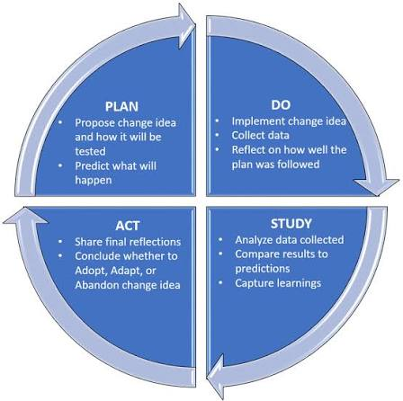
Figure 8: Plan-Do-Study-Act (PDSA) cycle
(Source: England, 2021)
During Plan, a neonatal safety improvement team should be formed, which should include clinicians, quality specialists, patient representatives and data analysts. Receiving staff, mortality, reporting rate and escalation response times should be indicated (England, 2021). Procedures to ensure escalation thresholds, multidisciplinary investigations and independent review triggers.
The Do phase involves implementation of the enhanced system for 3 months in the neonatal service. Training for Staff: Reporting and speaking up. If psychological safety isn't addressed, team-level daily seated safety huddles, weekly mortality reviews and monthly quality dashboards should be added to the safety strategy (Connelly, 2021).
The Study phase should determine if reporting rates go up, the time that incidents are escalated goes down, and there is an improvement in incident patterns. Direct observation of staff assessment should be gathered pre- and post-implementation and should be complemented with staff survey and focus groups (Fox et al., 2023).
Findings in the Act phase should feed into changes of thresholds, training/reporting. Further PDSA cycles should be used to create standardisation across the trust for successful practices.

3.6 Implementation Measures
Recommendation | KPI | Expected Outcome
Better escalation processes | Response time to escalations | Shortened response time and less harm
Incident reports | Incidents evaluated | Early warning about potential risks
Staff training | Training completion rate | Developing safety skills
Speaking-up system | Concerns raised and reviewed | Greater psychological safety
Governance review | Frequent safety checks | Greater accountability from the Board on safety issues
Table 3: KPIs For Measures Future Growth
(Source: Self-Made)
The case of Lucy Letby is a good example of the fact that recommendations need to be implemented in a systematic way in order to be effective and achieve changes that lead to a safer future. Making interventions sensitive to evidence through PDSA cycles helps healthcare organisations build their learning, enhance resilience, and evaluate and react to new risks (Ferro-López et al., 2021).

4. Conclusion

4.1 Summary Key Points
Chief areas of concern are poor incident reporting, failure to escalate, poor governance, weak communications, poor mortality monitoring, and reputation over transparency cultures. At a system level, there were multiple factors identified from Fishbone Analysis across People, Process, Management, Communication, Environment and Monitoring. The 5 Whys revealed more deep-seated culture issues that allowed for governance failures. Donabedian showed that structural, process and outcome relationships are interdependent. In a SWOT exercise, communication and escalation were highlighted as immediate needs of intervention. All these models state that failures in patient safety are the result of multiple organisational problems, rather than individual errors.

4.2 Implications for Healthcare Quality
Good governance, communication, escalation and monitoring are vital, as they provide infrastructure which allows concerns to be expressed, explored and addressed before harm can take place. The Countess of Chester illustrates that in the absence of these systems, even the most senior clinicians' warnings can still be ignored and preventable deaths can build up undetected.

4.3 Final Recommendation
To improve sustainably, structures need to be robust that support patient-safety systems with clear escalation, independent governance oversight, monitor of patient-safety trends and iterative PDSA cycles for ongoing quality improvement. We are working on robust systems that allow staff to speak in safety, management is on top of patients rather than institutions, there is no room for tragedy like Countess of Chester, there is constant attention to the quality and staff are continuously driven to look for how to improve the situation.

References
Atinga, R.A., Gmaligan, M.N., Ayawine, A. and Yambah, J.K. (2024). “It’s the patient that suffers from Poor communication”: Analysing communication gaps and associated consequences in Handover events from Nurses’ experiences. SSM - qualitative research in Health, [online] 6(100482). doi: https://doi.org/10.1016/j.ssmqr.2024.100482
Bhasale, A.L., Ameet Sarpatwari, Lipworth, W., Mathias Møllebæk, McEwin, E.J., Gautam, N., Adrian Santiago Ortiz and Mintzes, B.J. (2021). Regulatory authority and clinical acceptability: Physicians” responses to regulatory drug safety warnings. British journal of clinical pharmacology, 88(2), pp.713–722. doi:10.1111/bcp.15007.
Broshkov, D. (2023). Defining quality assurance in healthcare. [online] ZenBit. Available at: https://zenbit.tech/blog/what-is-quality-assurance-in-healthcare/ [Accessed 12 Aug. 2026].
Connelly, L.M. (2021). Using the PDSA model correctly. Medsurg Nursing, 30(1), pp.61-54. https://www.proquest.com/info/openurldocerror;jsessionid=EF365236719B9110EC0F161A7A370AEA.i-0720c97162504c0a1
CQC (2026). CQC rates leadership and services run by South london and maudsley NHS foundation trust - care quality commission. [online] Cqc.org.uk. Available at:
Enahoro, A., Osunlaja, O., Maha, C.C., Kolawole, T.O. and Abdul, S. (2024). Reviewing healthcare quality improvement initiatives: Best practices in management and leadership. International journal of Management & entrepreneurship research, [online] 6(6), pp.1869–1884. doi:10.51594/ijmer.v6i6.1171.
England, N. (2025). NHS England » National Medical Examiner’s report for 2025. [online] England.nhs.uk. Available at: https://www.england.nhs.uk/long-read/national-medical-examiner-report-2025 / [Accessed 12 Aug. 2026].
England, N.H.S. (2021). Plan, Do, Study, Act (PDSA) cycles and the model for improvement. UK: NHS England. https://aqua.nhs.uk/wp-content/uploads/2023/07/qsir-pdsa-cycles-model-for-improvement.pdf
Ferro-López, L., Barnett, N. and Minshull, J. (2021). Improving shared decision-making in pharmacist-led haematology clinics: a ‘Plan Do Study Act’approach. European Journal of Hospital Pharmacy, 28(e1), pp.e180-e184. https://ejhp.bmj.com/content/28/e1/e180.abstract
Fox, C., Hammond, S.P., Backhouse, T., Poland, F., Waring, J., Penhale, B. and Cross, J.L. (2023). Implementing PERFECT-ER with Plan-Do-Study-Act on acute orthopaedic hospital wards: Building knowledge from an implementation study using Normalization Process Theory. Plos one, 18(2), p.e0279651. https://journals.plos.org/plosone/article?id=10.1371/journal.pone.0279651
Grand View Research (2025). UK Healthcare Analytics market size & Outlook, 2030. [online] Grandviewresearch.com. Available at: https://www.grandviewresearch.com/horizon/outlook/healthcare-analytics-market/uk [Accessed 12 Aug. 2026].
Humphries, J. (2025). Who is Lucy Letby and why is her case back in the news? [online] 2 July. Available at: https://www.bbc.com/news/articles/c0l46ngg468o [Accessed 12 Aug. 2026].
Ient, A. (2025). NHS resolution resolves record numbers of compensation claims through collaboration - NHS resolution. [online] NHS resolution.
Jones, A., Blake, J., Adams, M., Kelly, D., Mannion, R. and Maben, J. (2021). Interventions promoting employee “speaking-up” within healthcare workplaces: a systematic narrative review of the international literature. Health Policy, 125(3), pp.375-384. https://www.sciencedirect.com/science/article/pii/S0168851021000026?__cf_chl_tk=X3gfdgNjGPcKtpA6n.J1gnoz8GAeOOqULecjoOuVPEY-1786525324-1.0.1.1-skOSRV1L8t4P5vep_cEstH7pqlE0Jp075QU_FinIAvU
Kumah, A., Nwogu, C.N., Issah, A.R., Obot, E., Kanamitie, D.T., Sifa, J.S. and Aidoo, L.A. (2024). Cause-and-effect (fishbone) diagram: a tool for generating and organizing quality improvement ideas. Global journal on quality and safety in healthcare, 7(2), pp.85-87. https://innovationsjournals-jqsh.kglmeridian.com/view/journals/jqsh/7/2/article-p85.xml
Lawrence, F. and Conn, D. (2024). A superbug, doctor shortages and a neonatal unit ‘out of its depth’: Failures at Lucy letby hospital revealed. [online] The guardian. Available at:
Madine, M., Simsekler, M.C.E., Salah, K. and Ellahham, S. (2025). Applying quality improvement science to Patient safety: Strategies, frameworks, and sustainable solutions. Risk management and healthcare policy, [online] Volume 18, pp.3781–3791. doi:10.2147/rmhp.s564459.
McCullough, K., Andrew, L., Genoni, A., Dunham, M., Whitehead, L. and Porock, D. (2022). An examination of primary health care nursing service evaluation using the donabedian model: A systematic review. Research in Nursing & health, [online] 46(1), pp.159–176. doi:10.1002/nur.22291.
NHS England (2022). Patient safety incident response framework. [online] Www.england.nhs.uk. Available at: https://www.england.nhs.uk/patient-safety/patient-safety-insight/incident-response-framework/ [Accessed 17 July 2026].
NHS England (2023). NHS England » Verdict in the trial of Lucy Letby. [online] www.england.nhs.uk. Available at: https://www.england.nhs.uk/long-read/verdict-in-the-trial-of-lucy-letby/ [Accessed 12 Aug. 2026].
PHIN (2025). June 2025 private healthcare market update from PHIN | PHIN. [online] Phin.org.uk. Available at: https://www.phin.org.uk/news/phin-private-market-update-june-2025-united-kingdom [Accessed 12 Aug. 2026].
Queen Mary University of London (2024). The Lucy Letby case: What does it mean for the United Kingdom’s healthcare system? [online] Qmul.ac.uk. Available at: https://www.qmul.ac.uk/lac/our-legal-blog/2019-2024-blogs/items/the-lucy-letby-case-what-does-it-mean-for-the-united-kingdoms-healthcare-system.html [Accessed 12 Aug. 2026].
Roy Valiant Salomo and Krisna Puji Rahmayanti (2023). Progress and institutional challenges on local governments performance accountability system reform in Indonesia. SAGE open, 13(4). doi:10.1177/21582440231196659.
Stayt, L.C., Merriman, C., Bench, S., M. Price, A., Vollam, S., Walthall, H., Credland, N., Gerber, K. and Calovski, V. (2022). ‘Doing the best we can’: Registered nurses” experiences and perceptions of patient safety in intensive care during <scp>covid</scp>‐19. Journal of Advanced nursing, 78(10), pp.3371–3384. doi:10.1111/jan.15419.
Tagaram, S.D. and Chen, C. (2024). Quality tools and techniques (Fishbone diagram, Pareto chart, process map). In StatPearls [Internet]. StatPearls Publishing. https://www.ncbi.nlm.nih.gov/sites/books/NBK607994/
Tossaint-Schoenmakers, R., Versluis, A., Chavannes, N., Talboom-Kamp, E. and Kasteleyn, M. (2021). The challenge of integrating eHealth into health care: systematic literature review of the Donabedian model of structure, process, and outcome. Journal of medical Internet research, 23(5), p.e27180. https://www.jmir.org/2021/5/e27180/
UK (2026). Healthcare expenditure, UK health accounts. [online] Ons.gov.uk. Office for National Statistics. Available at: https://www.ons.gov.uk/peoplepopulationandcommunity/healthandsocialcare/healthcaresystem/bulletins/ukhealthaccounts/2024and2025 [Accessed 12 Aug. 2026].
Wang, H., Chen, Y., Wang, L., Liu, Q., Yang, S. and Wang, C.-Q. (2023). Advancing herbal medicine: Enhancing product quality and safety through robust quality control practices. Frontiers in Pharmacology, [online] 14(2). doi:10.3389/fphar.2023.1265178..
Wawersik, D.M., Boutin, E.R., Gore, T. and Palaganas, J.C. (2023). Individual characteristics that promote or prevent psychological safety and error reporting in Healthcare: A systematic review. Journal of Healthcare leadership, Volume 15(15), pp.59–70. doi:10.2147/jhl.s369242.
Whiteing, P. (2023). Lucy letby inquiry could be a missed opportunity if it does not look at the wider issue. Journal of patient safety and risk management, 29(1). doi:10.1177/25160435231212956.

