

UWTSD Swansea

Managing a Hardware/Software Project Integrated with Enterprise and Innovation Group Project
Sue Maw

Daniel Algie 1706977

Table of Contents
Project Inaction Document 3
Background 3
Objectives 3
Scope 4
Must have 4
Should have 4
Could have 4
Won’t have 4
Project sponsors 5
Constraints 5
Authority 5
Project Manager 5
Responsibility 6
Job roles 6
Project Team 6
Stake holders 6
Resources 6
Appendix 7
Gantt chart 7
Activity chart 8

Project Inaction Document
Ddraig Coch Enterprise

Background
With cars becoming more and more of a convenience and a necessity with an average rise of 680,00 a year [1] from 2013 to 2016, because of this rise in cars on the road safety and motor vehicle theft is always a high priority. Statistics show that in 2016 69,353 people in the UK were fined or received points for driving illegal without a licence [2] and car theft in the UK has risen by 8 thousand offences in 2018 from 2017 with over 114 thousand thefts in the UK alone [3] . when comprising the cark-e the idea was to help make car thefts harder and more of a deterrent by making it only possible to start the car if your fingerprint is registered to the car.

Objectives
The objective of the cark-e is to make your car safer that with fingerprint recognition the car can only be driven by people who have access to it. Using the web app to fill in the details of the user and database we can store the owner’s data and fingerprint making capable that only those saved to the key can have access to drive the vehicle. The device should also help assist medical personal if there has been an accident with displaying medical issues, it will also help law enforcement by keeping details of the vehicle driver and not allowing anyone who does not own a licence from driving lowering the number of illegal drivers keeping the roads safer. [4]

Scope

Must have
This is a list of the must have features for the cark-e
- Biometrics/fingerprint
- Bluetooth
- Prototype(key)
- Website / App
- Database

Should have
This is a list of should have features for the cark-e
- LCD screen
- GPS
- Indicator to show the user that there fingerprint has been recognised or refused entry such as a light or a sound
- Charging capabilities (being able to change the key when driving the car)

Could have
These are things the cark-e could have later once the must haves have been implemented into the cark-e
- Medical records of the driver
- Security features
- Alcohol content reader
- SOS feature
- Taxi or public transport feature for when you pass alcohol level
- Voice recognition
- Used for insurance purposes install the same features in the cark-e as a black box
- DVLA connection to check for points or if a user is banned using their driver licence number
- Police accessibility making it easier for the police to check quicker who the driver is and their details.

Won’t have
- ECU connection
- Not universal (meaning that the cark-e isn’t multi-functional it is only for one car)
- Won’t have input features (the LCD screen won’t be able to accept data entered into it all data must be entered from the website or app)
- Voice recognition

Project sponsors
The cark-e could benefit a lot of organisations from the government sector this would include all emergency services and the DVLA, it could also be appealing to insurance companies to see who on their insurance plan is using the car the most and will limit driving the vehicle illegally.
Also, with the functionality and specs used to make this cark-e better than the original car key car manufactories would also benefit and make a better experience for their users to feel safer and confident.

Constraints
The cark-e timescale will take 20 weeks to complete due to Christmas this will shorten the timescale down to 19 weeks leaving less room for mistakes to make sure that there is less error within the dead line for completion all teams involved in the creation of the cark-e have been chosen and but in the correct roles. Though there are always uncertainties employees could leave for another job or fall sick needing time off due to the completion date this will be rectified by moving staff members from different departments as all our staff are cable and update with each section of the project.

Authority

Project Manager
Due to the nature of the assignment the project manager will change every week so each member of the team can gain managerial experience. The main roles included for the project manager are: [4]
- Making sure all team members are on target and track to completing the project on time.
- Making sure the completion of the cark-e is within the budget set.
- Dealing with any absences to make sure that the department can still function to its full potential.
- Managing reports and necessary documentation.
- Ensuring customer satisfaction.

Responsibility

Job roles
Daniel Algie- Web Development / Database Management / Marketing.
Ryan Morgan – Web Development / Database Management / Printing Engineer.
Nathan Morgan- Software Engineer / Electronic Engineer / Marketing.
Martin Dunn – Software Engineer / Electronic Engineer / Marketing.
Anthony Smith – Web Development / Database Management / Printing Engineer.

Project Team
The project team consists of five team members Project Manager (PM) Daniel Algie Software Developer, Ryan Morgan Software Developer, Nathan Morgan Software Developer, Anthony Smith Software Developer and Martin Dunn Games Developer.

Stake holders
- James Williams
- Sue Maw
- Kapilan Radhakrishnan
- Dean of university

Resources
The finance for the project will be received from the university of wales trinity saint David of a rough estimate of 70 pounds depending on the cost of the supplier this will include:
- LCD screen which is for the front of the cark-e
- A biometric fingerprint reader
- Bluetooth receiver
When creating the cark-e we will be using some of our own parts which has been collected between the group this will include:
- Laptops to create the website/database/software development
- Node MCU kit
The creation of the fitting and final production of the key will be made using a 3d printer and this will also be provided by the university of wales trinity saint David.

Bibliography

[1] | d. f. transport, “vehicle licensing statistics annual 2016,” 13 april 2017. [Online]. Available: https://assets.publishing.service.gov.uk/government/uploads/system/uploads/attachment_data/file/608374/vehicle-licensing-statistics-2016.pdf. [Accessed 28 11 2019].
[2] | S. Jamieson, “telegraph,” 26 may 2016. [Online]. Available: https://www.telegraph.co.uk/news/2016/05/25/nearly-70000-illegal-drivers-given-points-despite-not-having-lic/. [Accessed 28 november 2019].
[3] | D. Clark, “statista,” 9 august 2019. [Online]. Available: https://www.statista.com/statistics/303551/motor-vehicle-theft-in-england-and-wales/. [Accessed 28 november 2019].
[4] | m. t. c. team, “mind tools,” [Online]. Available: https://www.mindtools.com/pages/article/newPPM_85.htm. [Accessed 30 november 2019].
[5] | D. Haughey, “project smart,” [Online]. Available: https://www.projectsmart.co.uk/the-role-of-the-project-manager.php#:~:targetText=A%20project%20manager%20is%20a,and%20closure%20of%20a%20project.&targetText=The%20project%20manager%20should%20make%20sure%20they%20control%20risk%20and%20minimise%20uncertai. [Accessed 04 november 2019].

Appendix

Gantt chart
This is the Gantt chart for the cark-e project
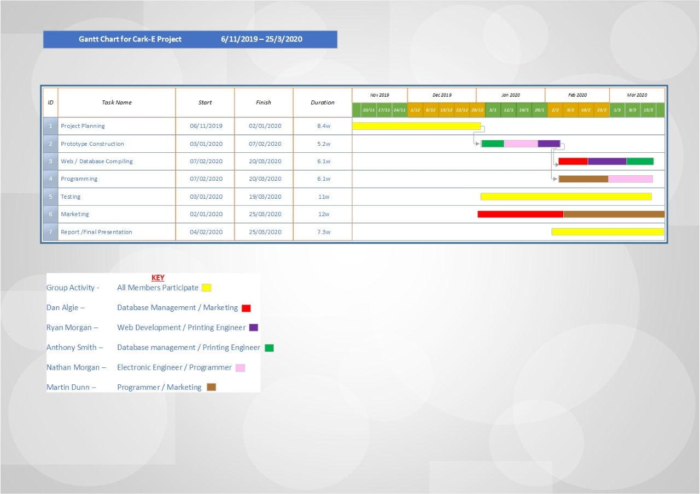

Activity chart
Activity network for the cark-e project


