Sustainable Hospitality & Tourism Management
BMIH5006
Assignment 2
Tutor
Ruth Taylor

Student Name: Elena Roxana Chelaru
Student Id: 2118844

Contents
Introduction 3
Relevance of Adopting Green Practices 3
Financial Consideration 5
Responsibility Vs Consumer Driven 6
Can the Hospitality Industry Ever Be Truly Green? 8
Financial Resiliency: A Key Factor 9
Recommendations 10
Conclusion 11
References 12

Introduction
Eco-friendly and sustainability is no longer a fashionable word in the hospitality industry. In the last decade, green practice has become one of the major trends in the hospital industry. Many hotels and restaurants incorporate green practices not only for environmental consciousness but also with long-term profitable business models. As Milton Friedman stated, "The social responsibility of an organisation is to increase profits" (Jhamb & Singh, 2016). Profit-centric view of Corporate Social Responsibility has evolved significantly over time and emphasis on a more holistic approach to shifting paradigms of CSR to societal realisation. This report will explore the relevancy of statements with sustainability practices in business organisations from the perspective of Marriott International, Inc. an extensive portfolio hospitality company.

Relevance of Adopting Green Practices
Sustainability or practices meet the needs of the current generation without sacrificing the needs of future generations that consider social, economic and environmental dimensions also known as the "triple bottom line" (Jhamb & Singh, 2016). Recently environmental issues have become a global issue in the hospital industry which urges the adoption of green practices. Eco-friendly practice in the hospitality industry is undeniably pertinent. Consequently, governments put strict regulations to promote sustainability. The primary aim of the three bottom lines is to social equity, balance economic prosperity and environmental protection. Demand and supply factors highly affect the tourism industry. High demand for a tourist destination may create overcrowding but low demand may lead to a loss of economic opportunities.
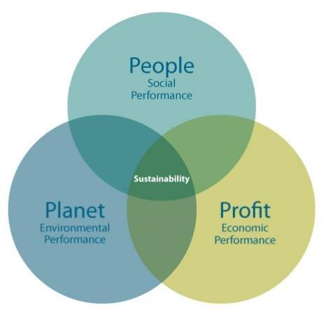
Figure: Elkington’s Triple Bottom Line
Source: (Jones & Comfort, 2019)
Elements of “Triple Bottom Line”-
- Economic bottom line: Marriott needs to consider financial stability to provide high-quality service, and be more cost-efficient to remain economically viable while making any long-term strategies like sustainability practice. Here, CSR influences Marriott to pay liveable wages, workplace health and ethical sourcing (Jones & Comfort, 2019).
- Social bottom line: Practising sustainability at this level affects the well-being of stakeholders including local communities. For example, the hospitality industry can influence or hamper the way of living standards of local communities. Organisations working in the hospital industry like Marriott contribute to social performance by considering all stakeholders by advancing human rights, ending poverty by giving job opportunities to local communities and ending gender equity in the workplace. Marriott is also promoting accessibility for guests with disabilities (Ecolab, 2021). In order to attract more customers and increase their brand reputation they improve some of their facilities to be available for disabled people and train their employees to learn their needs fostering a more empathetic and inclusive attitude.
- Environmental bottom line: The last bottom line is environmental performance considering emission carbon footprint. These factors can lead to habitat disruption, pollution and an increase in resource consumption and affect the environment negatively including waste generation and habitat degradation. For example, Marriott Has set their goal of reducing 30% carbon emissions by 2030 to mitigate these impacts. Marriott, like other major hotel chains, must comply with standards related to greenhouse gas emissions and energy consumption (Ambition-to-go-net-zero, 2021).

Financial Consideration
The hospitality industry takes financial situations into first consideration and goes for long-term profitability that should not be underestimated. Green practices take initial investment which may result in long-term profit, cost saving, reduced waste, energy efficiency and customer loyalty. Hospitality industries are focusing on historical development which influences economic patterns and the growth rate of the organisations. In the 21st century, Marriott has had remarkable expansion all over the world due to growing demand for tourist accommodation, technological advancement and increased demand for sustainable environment (Revila & Moure, 2022). Marriott's global strategies with green practices change the economic pattern such as presence in emerging economies such as China and India. Marriott's global reach and diverse brand offerings allow it to adapt to varying economic development patterns. Financial consideration of Marriott's adaptability to changing consumer needs and wants reflects the organisation’s ability to meet a wide range of consumer demands and preferences, making it a global leader in the field.
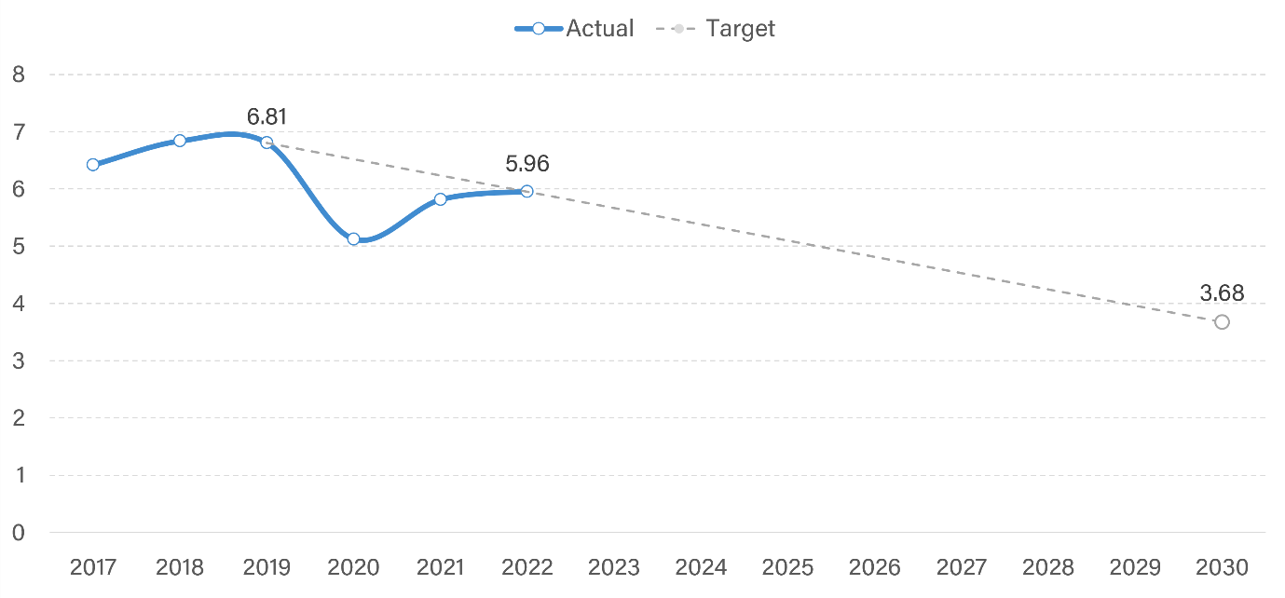
Figure: Carbon emission target of Marriott
Source: (WWF Footprint, 2022)
Sustainable development and financial consideration are interconnected. The country's principles and policies are integrated with the hospitable industry. For example, Marriott actively supports the UN SDGs which are considered as international environment policy. The organisation also cooperates with national policies and principles like the UK initiated Zero greenhouse policy by 2050 and making strategies with focuses on clean growth, and promoting sustainable practices (Marriott Newscenter, 2022). Marriott's operations in Wales align with this act, which includes measures to enhance biodiversity, reduce waste, and promote the efficient use of resources. So, financial decisions are highly influenced by governments' rules and regulations, customer demand, and international policies before making any sustainable development plan.

Responsibility Vs Consumer Driven
Environmental soundness concerns should come from both businesses and consumers. Business has the responsibility for environmental benefits and social well-being not only for monetary concern. However, business is influenced by customer demand to adopt green practices. So, it can said that green practice is both responsibility and customer-driven and organisations should adopt these to remain competitive in the hospitality industry.
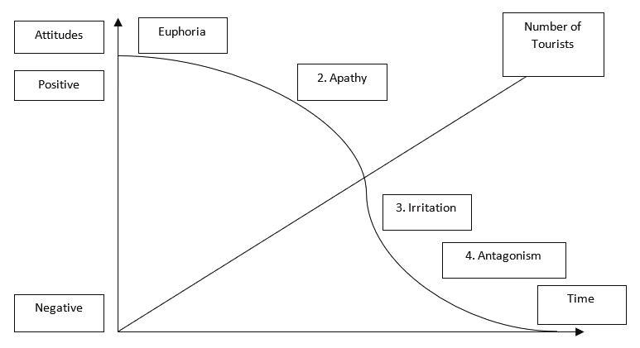
Figure: Doxey’s Irridex model
Source: (Saarinen, 2020)
Although this model is not directly related to environmental sustainability, it shows the host-guest relationship in the hospitality industry and drives customer demands for green practices. For example, in the euphoria stage customers demand the natural environment. In the second stage, a high number of tourists creates more pressure on the environment. Environmental degradation and overcrowding become annoying and lead to a decline in tourism in the third stage. In the antagonism stage, the environment may suffer greatly and lead to a decline in tourism (Zientara & Zamojska, 2020). Marriott tailors its strategies by analysing customer experience by promoting responsible tourism, minimising waste generation, and minimising annoyance towards a sustainable business practice. The "Serve 360: Doing Good in Every Direction" sustainability motto is the best example for Marriott (Marriott Newscenter, 2022). Marriott County Hall in London promotes sustainable urban tourism by offering electric vehicle charging stations, sourcing local and sustainable food for its restaurants, and educating guests about public transportation options (WWF Footprint, 2022).

Can the Hospitality Industry Ever Be Truly Green?
Running a completely sustainable business is much more complex than it sounds. There are many operational activities which create difficulties in making a completely sustainable business which also leaves many opportunities for further improvement. For this organisations should set measurable realistic goals like reducing waste and minimising environmental effects and so on.
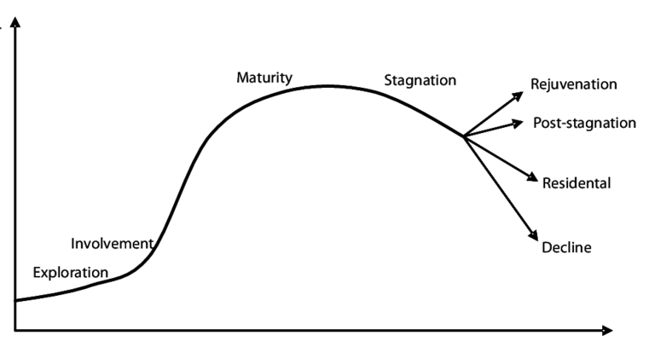
Figure: Butler’s life cycle model
Source: (Jhamb & Singh, 2016)
It is a development model of the hospitality industry but it can explain that there are some ever-changing variables that create challenges for hospitality organisations to become fully green. In the exploration stage, a place may be explored by an adventurous tourist and makes a little promotion. In the next stage, people become aware of the place and start to grow. Maturity explains the full growth of tourism and leads to infrastructure and different developments which leads to stagnation and a decline number of customers. For example, Marriott in number of visitors as it is located in a historic urban area and customers change their preference of visit. The organisation is planning to invest in the renovation of historic buildings and partner with historical places and local cultural institutions. To attract more environment-friendly guest they include workshops and cultural tours in their service.

Marriott's St. Kitts Beach Club promotes sustainable coastal tourism by engaging in initiatives to protect the island's marine life and natural beauty. Coral reef conservation projects are one of their sustainable projects. The "Plastic Free Bournemouth" campaign emphasizes reducing the use of one-time plastic and clean-up initiatives from a managerial marketing perspective. The New Forest Marriott Hotel is located in a rural area known for its natural beauty. In their marketing policy, they support local national forest parks for their outdoor activities and get a natural source for their restaurant ingredients (Marriott Newscenter, 2022).

Financial Resiliency: A Key Factor
Financial resiliency helps to navigate uncertainties that an organisation may face to continue its sustainability practice. It also helps to invest in sustainable investment. It also can be said that financial resiliency and sustainability are interconnected.
- Investment in Sustainable Practices: These types of investments have an initial cost but bring long-term profitability and save costs (Jones & Comfort, 2019). For example, Marriott has invested in many sustainability investments like west reduction, energy-efficient lighting and so on.
- Long-term Commitment: Sustainability is focused on long-term practice. Organisations which practice financial resilience can turn economic cards even during downturn times when others may step back. As a result, during the Pandemic time, Marriott was able to maintain its commitment towards customers "Serve 360: Doing Good in Every Direction" when the hospitality industry was facing economic challenges.
- Corporate Social Responsibility: Organisations often took many philanthropic activities to support CSR that are integral to green practice. "World of Opportunity" is one of the community engagements of Marriot where the organisation decides to create job opportunities for 40,000 young people by 2024 (Marriott Newscenter, 2022). For these reasons, management needs to cope with more sustainable marketing strategies like sustainable event hosting, and sustainable reporting including all sustainable achievements as marketing tools to build customer demand. Marriott's "Spirit to Serve Our Communities" program is a cornerstone of its commitment to sustainability. In this program, they include disaster relief, youth education and so on.
Sustainability is also known as “being green” which considers a lot of challenges not only to meet the customer demand but also to make a business more profitable in the long term (Jones & Comfort, 2019). As one of the global leaders in the hospitality industry, Marriott offers valuable insights into the future of hospitality and the profitability of going green.

Recommendations
Although Marriott can approach sustainable development in all kinds of places whether rural, urban or coastal, they also have a long way toward green practice. Here are some strategic recommendations for Marriott International and fostering a culture of environmental responsibility.
Marriott should set sustainable development goals aligned with national and international policies like UN' SDGs. Making more financial strategies to increase investment in solar, wind and energy resources and actions that help to reduce carbon footprint through hotel operations. The organisation should follow Green Building Standards when making any new contractions and retrofitting old constructions and renovating them to meet the standard of green practice making a profit by reducing waste and increasing efficiency. They should also support the local community by sourcing local ingredients and promoting sustainable seafood choices to reduce the environmental impact of dining services. Fostering partnerships with local communities and educating employees to build a culture of responsibility.

Conclusion
The future hospitality business should strive for more green practices as it is not only for financial profit but also to gain more market share, increase goodwill, and stay competitive with trends that make a wise business decision. While remaining competitive, the organisation should try to lessen its environmental footprint. Its high commitment to the sustainability of Marriott reveals that profitability and green initiatives are mutually inclusive. ensuring a resilient and competitive future, organisations like Marriott set sustainability as a fundamental pillar for success not just a trend.

References
Abbas, T. and Hussien, F. (2017) ‘The effects of Green Marketing and Green Corporate Social Responsibility on customers’ willingness to patronize a casual dining restaurant’, International Academic Journal Faculty of Tourism and Hotel Management, 3(3), pp. 137–157. doi:10.21608/ijaf.2017.95536.
Ambition-to-go-net-zero (2021) Marriott International announces ambition to go net-zero, Marriott International Newscenter (US). Available at: https://news.marriott.com/news/2021/09/22/marriott-international-announces-ambition-to-go-net-zero (Accessed: 22 October 2023).
Ecolab (2021) Marriott Sustainability Goals for 2025 and beyond | ecolab. Available at: https://www.ecolab.com/stories/marriott-sustainability-goals-for-2025-and-beyond (Accessed: 22 October 2023).
Jhamb, R. and Singh, G. (2016) ‘Corporate Social Responsibility in hotel industry’, Corporate Social Responsibility in the Hospitality and Tourism Industry, pp. 1–8. doi:10.4018/978-1-4666-9902-1.ch001.
Jones, P. and Comfort, D. (2019) ‘Sustainable development goals and the world’s Leading Hotel Groups’, ATHENS JOURNAL OF TOURISM, 6(1), pp. 1–14. doi:10.30958/ajt.6-1-1.
Marriott Newscenter (2022) Marriott International publishes latest report on environmental, social, and governance progress, Marriott International Newscenter (US). Available at: https://news.marriott.com/news/2022/10/27/marriott-international-publishes-latest-report-on-environmental-social-and-governance-progress (Accessed: 22 October 2023).
Revila, R.G. and Moure, O.M. (2022) ‘Corporate Social Responsibility (CSR) and the 2030 agenda in the framework of new trends in tourism and Hotel Companies’ performance’, Research Anthology on Developing Socially Responsible Businesses, pp. 573–591. doi:10.4018/978-1-6684-5590-6.ch028.
Saarinen, J. (2020) ‘Tourism and Sustainable Development Goals: Research on Sustainable tourism geographies’, Tourism and Sustainable Development Goals, pp. 1–10. doi:10.1201/9780429324253-1.
WWF Footprint (2022) WWF Footprint Calculator. Available at: https://footprint.wwf.org.uk/#/ (Accessed: 22 October 2023).
Zientara, P. and Zamojska, A. (2020) ‘Green organizational climates and employee pro-environmental behaviour in the hotel industry’, Corporate Social Responsibility for Sustainable Tourism, pp. 116–133. doi:10.4324/9780429027383-7.

