

Student name: Mihaela Achim
Student ID: 2435447
Module name: Professional Career Development in Health and Social Care
Module code: LCHS 4009
Lector name: Christopher Mafuva

Acknowledgement of AI Use:
I confirm that I have used an online translator to help me with some words that I found difficult. However, the rest of the work, including the ideas, and writing, is my own.

Table of Contents
Task 1 of 4 3
Practical Portfolio 3
Introduction 3
Curriculum Vitae 4
Task 2 of 4 6
Personal Statement for Nursery Assistant 6
Task 3 of 4 7
A) SWOT 7
B) PDP 8
Summary 9
Task 4 of 4 10
Introduction 10
Description 10
Feelings 10
Evaluation 10
Analysis 11
Conclusion 11
Action Plan 11
Referencias 11

Task 1 of 4

Practical Portfolio

Introduction
This portfolio has been created as part of my Health and Social Care studies and is focused on the role of a Nursery Assistant in early years settings. The aim of this work is to show my understanding of the skills, knowledge, and personal qualities needed to work with children in a professional care environment.
In this portfolio, I will look at a real job vacancy for a Nursery Assistant and adapt my CV to match the role. I will also complete a personal statement, a SWOT analysis, and a personal development plan to reflect on my strengths and areas for improvement. In addition, I will include a reflection based on my presentation using Gibbs’ reflective model.
This portfolio is based on my interest in working with children and my experience in informal childcare. It is also linked to my current Health and Social Care studies and my future career goal of working in early years education.

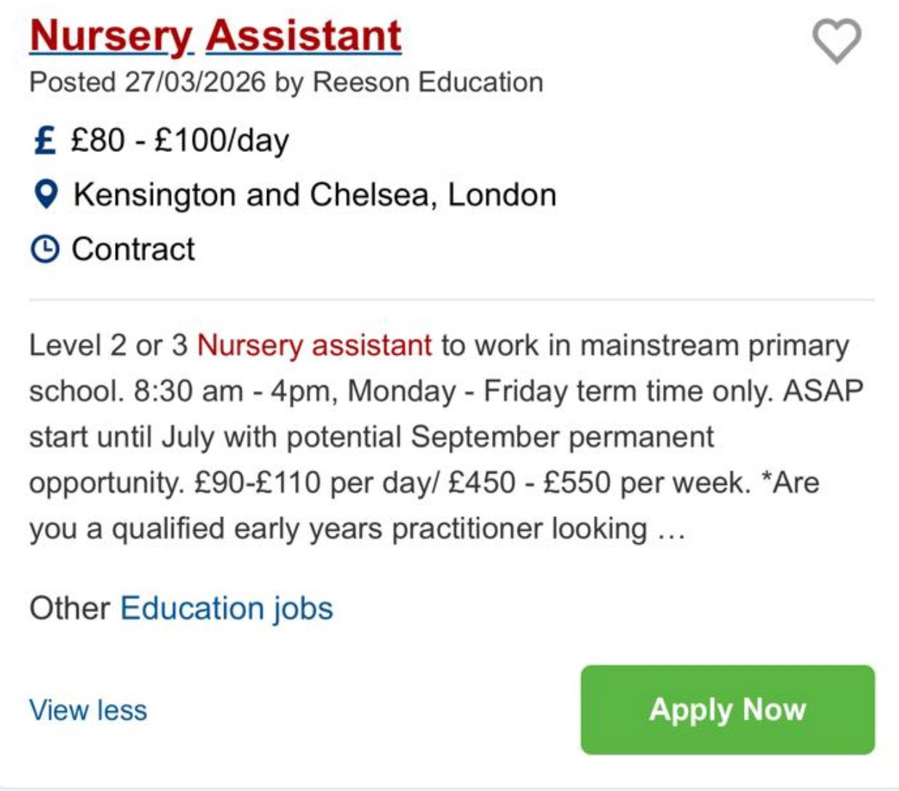

Curriculum Vitae

Name: Mihaela Nina Achim
Address: 391 Old Ford Road
Telephone: 07840322161
Email: mihaelaachim25@gmail.com

Personal Profile
A motivated and caring student currently studying Health and Social Care, with a strong passion for working with children. I have several years of experience caring for children in both family and informal settings. I am patient, responsible, and enjoy supporting children’s learning and development through creative and engaging activities. Alongside this, I have developed strong communication, leadership, and teamwork skills through my experience in customer service and hospitality. I am enthusiastic about building a career as a Nursery Assistant and providing a safe, nurturing, and positive environment for children.

Education
University of Wales Trinity Saint David (UWTSD)
BSc Health and Social Care
2025 – Present (Expected graduation: 2028)
- Studying child development, health, and wellbeing
Administration Course (1 Year)
Spain | 2014 – 2015
- Developed organisational, communication, and administrative skill
Secondary Education (ESO Completed)
Spain | 2009 – 2014
- Mathematics
- Spanish Language
- Science
Work Experience
Customer Service Assistant (Current)
Bagel House, Hackney, London
June 2025 – Present
- Communicate effectively with customers in a fast-paced environment
- Handle enquiries and resolve issues professionally
- Develop strong interpersonal and teamwork skills
- Maintain a positive and friendly attitude at all times
Head Chef
Arepa & Co, Bethnal Green, London
2020 – 2025
- Managed kitchen operations in a busy restaurant environment
- Led and supported a team to deliver high-quality service
- Maintained high standards of food hygiene and safety
- Developed strong leadership, organisation, and time management skills
- Worked under pressure while ensuring efficiency and quality

Childcare (Family and Informal Work Experience)
Spain | 2014 – 2017
- Supported children with homework and learning activities
- Planned educational and recreational activities
- Ensured children’s safety and wellbeing
Childcare (Informal Work and Volunteering)
London, UK | 2019 – Present
- Provided care for children of colleagues, friends, and family
- Supported learning through play, creative, and educational activities
- Volunteered by supporting colleagues with childcare needs
- Helped children improve and maintain Spanish language skills
Key Skills
- Patience and empathy when working with children
- Strong communication and interpersonal skills
- Ability to support children’s learning and development
- Organisation and time management
Languages
- Romanian – Native / Fluent Spanish – Fluent English – Intermediate
Interests
I enjoy supporting children’s learning and development through creative and educational activities. I am interested in reading, outdoor activities, and sports, as well as volunteering and helping within the community.
References
Avallable upon request.

Task 2 of 4

Personal Statement for Nursery Assistant
I am a caring and motivated Health and Social Care student with a strong interest in working with children in early years settings. My long-term career goal is to become a Nursery Assistant, where I can help children learn, grow, and feel safe in a positive and supportive environment. I am currently studying a BSc in Health and Social Care at the University of Wales Trinity Saint David, where I am learning about child development, health, safeguarding, and the importance of providing high-quality care.
I have gained valuable experience caring for children in an informal way in both Spain and London. I have looked after children of family members, friends, and colleagues on a regular basis. In these situations, I supported children with their daily routines, such as meals, homework, and playtime activities. I also organised games, creative activities, and educational tasks to help them learn in a fun way. In addition, I helped children to learn and practice Spanish, supporting their language development in an enjoyable and simple way. These experiences helped me develop patience, responsibility, creativity, and strong communication skills. I also learned how to adapt my approach depending on the age and needs of each child.
Alongside my childcare experience, I have developed strong transferable skills through my work in customer service and hospitality. I currently work as a Customer Service Assistant, where I communicate with customers, solve problems, and work effectively in a busy and fast-paced environment. Before this, I worked as a Head Chef for five years at Arepa & Co. In this role, I developed important skills such as leadership, teamwork, organisation, time management, and the ability to work under pressure. These experiences have helped me become more confident, responsible, and able to stay calm in challenging situations, which are important skills when working in a nursery.
I believe I have strong personal qualities that are suitable for working with children. I am patient, kind, reliable, and I enjoy helping children learn through play and creative activities. I also have good communication skills, which help me work well with both children and adults. My ability to speak Romanian, Spanish, and English allows me to communicate with people from different backgrounds and support inclusion in diverse environments.
My studies in Health and Social Care are helping me develop a strong understanding of child development, safeguarding, and the importance of providing safe and supportive care. I am committed to continuing my learning and gaining more practical experience in early years education. In the future, I would like to complete training in childcare and safeguarding to improve my skills and become a more confident and qualified professional.
In conclusion, I am highly motivated to work as a Nursery Assistant. I am eager to use my skills, experience, and passion for childcare to support children’s learning and development in a safe, happy, and caring environment.

Task 3 of 4

A) SWOT
A SWOT analysis is a tool used to identify strengths, weaknesses, opportunities, and threats in a specific role or situation. It is commonly used in education and career planning to support reflection, decision making, and future development (Investopedia, 2025).
Strengths | Weaknesses
- Caring and patient personality  - Experience caring for children informally  - Good communication skills  - Ability to work well in a team  - Experience working under pressure (Head Chef & Customer Service) | - No formal nursery work experience  - Limited knowledge of professional safeguarding procedures  - Still developing confidence in early years theory  - Need more experience in structured childcare environments
Opportunities | Threats
- Gain experience through nursery placements or volunteering  - Develop skills through Health and Social Care studies  - Complete childcare or safeguarding training courses  - Improve professional experience in early years settings | - Competition from candidates with formal qualifications  - High expectations in childcare safeguarding and policies  - Balancing study, work, and gaining experience  - Need to continuously improve professional skills

In terms of strengths, I have several qualities that are important for a Nursery Assistant role. I am caring, patient, and responsible, which is essential when working with young children. I also have informal experience caring for children in Spain and London, supporting daily routines and learning activities. Additionally, I helped children practice Spanish, showing creativity in supporting learning. My communication and teamwork skills have developed through customer service roles, and I am able to stay calm under pressure, which is important in busy nursery environments.
In the weaknesses, one of my main challenges is that I do not yet have formal professional experience working in a nursery. Most of my childcare experience is informal, so I still need to learn more about professional early years practices and routines. Another weakness is that I am still developing my knowledge of safeguarding policies and early years frameworks. However, I am currently studying Health and Social Care, which is helping me improve my knowledge and skills in these areas (NSPCC, 2013).
In terms of opportunities, my course provides knowledge of child development, safeguarding, and care practices. I can also gain practical experience through volunteering or work placements in nurseries. In the future, I plan to complete additional childcare and safeguarding training to improve my skills and confidence.
Finally, there are some potential threats. There is strong competition from candidates with more qualifications and experience. I will also need to meet high standards in safeguarding and childcare practice. Balancing study, work, and gaining experience may be challenging, but I am motivated to manage my time effectively and continue developing my skills.

B) PDP
A Personal Development Plan (PDP) is a structured process used to identify learning needs, set personal and professional goals, and plan how to achieve them over time. It is commonly used in education and healthcare to support reflective practice and continuous professional development. A PDP includes clear objectives, planned actions, and methods for monitoring and evaluating progress. It is widely used in academic and professional settings to support skill development and career progression (PMC2600112, 2008).

Goal | Description | Importance | Development & Evaluation
1 Gain nursery experience | Gain practical experience in a nursery or early years setting while studying, before April 2028. | This will help me understand how children’s learning, development, and safety are supported in real practice | Over the next 2 years, I will apply for volunteer or part-time roles in nurseries and support daily routines and activities. I will evaluate my progress through feedback from supervisors and my own reflection on what I learn.
2 Improve knowledge of child development and safeguarding | Improve my knowledge of child development, safeguarding, and early years education by April 2028. | This is essential for working safely and effectively with children in a professional environment. | I will develop this through my university studies, online training, and independent reading about early years practice. I will measure my progress through assignment results, lecturer feedback, and self-reflection
3 Improve communication and confidence | Develop my communication skills and confidence when working with children, parents, and colleagues over the next 2 years. | Good communication is important for teamwork and supporting children’s learning and wellbeing. | I will improve these skills through my current job in customer service and any childcare experience I gain. I will monitor my progress through feedback from colleagues and reflecting on my performance.

Summary
My PDP focuses on gaining practical experience in a nursery or early years setting over the next two years, before I complete my studies in April 2028. This will help me develop a better understanding of how children are supported in their learning, development, and safety in real working environments.
Second, my PDP focuses on improving my knowledge of child development, safeguarding, and early years education. I will develop this through my university studies, online courses, and independent reading. This will help me become more confident and prepared to work safely and effectively with children.
Finally, my PDP focuses on improving my communication skills and confidence when working with children, parents, and colleagues. I will develop this through my current customer service job and any childcare experience I gain. I will also use feedback from others and personal reflection to monitor my progress and identify areas for improvement.

Task 4 of 4

Introduction
Gibbs’ Reflective Cycle is a structured model used to reflect on experiences in a clear and systematic way. It was developed by Graham Gibbs in 1988 and is widely used in education and health and social care to help individuals learn from their experiences and improve future practice. The model includes six stages: description, feelings, evaluation, analysis, conclusion, and action plan (University of Edinburgh, n.d.). This reflective framework helps people think critically about what happened, how they felt, and what can be improved in the future.

Description
In my LCHS4009 Component 1 presentation assessment, my topic was teamwork in Health and Social Care. The aim of the presentation was to demonstrate my understanding of how teamwork is essential in care settings and how professionals work together to support service users. I prepared my slides in advance and organised my ideas carefully so I could explain them clearly and logically. During the presentation, I spoke about the importance of teamwork, communication, and cooperation in health and social care environments, and I tried to give clear examples to support my points.

Feelings
Before the presentation, I felt quite nervous. One of the main reasons was my English level, as English is not my first language and I consider myself to have a medium level. I sometimes still feel unsure when speaking in front of other people, especially in an academic setting. I was worried about making mistakes or not expressing my ideas clearly. However, I also felt prepared because I had practised my presentation several times and understood my topic well. During the presentation, I gradually became more confident as I continued speaking. After finishing, I felt relieved and proud that I had completed it successfully.

Evaluation
Overall, I think my presentation went well. One of my strengths was that I was able to answer a question from my teacher correctly during the presentation. My teacher gave positive feedback, and my classmates also clapped after my answer, which increased my confidence. I believe I stayed focused on the topic and explained my ideas in a simple and understandable way. However, I also noticed some weaknesses. In particular, I need to improve my fluency and confidence when speaking English in front of a group, as I sometimes pause too much or feel unsure of my pronunciation.

Analysis
This experience helped me understand that communication is a key skill in Health and Social Care. Working in this sector requires effective teamwork, clear communication, and confidence when interacting with others. My nervousness mainly came from speaking English in public, as I sometimes worry about making mistakes or not being fully understood. Even though I understood my topic well, my lack of confidence affected how comfortably I spoke. This experience showed me that improving my spoken English and gaining more practice in public speaking will help me feel more confident in future presentations and professional situations.

Conclusion
In conclusion, I believe my presentation was successful because I demonstrated my understanding of teamwork and was able to respond to questions correctly. However, I also learned that I need to improve my confidence and fluency when speaking English in public. I am capable of expressing my ideas, but I need to feel more comfortable and relaxed when doing so in formal situations.

Action Plan
In the future, I will continue working on improving my English speaking skills by practising more regularly. I plan to speak more in class and take opportunities to present in front of others to build my confidence. I also want to improve my fluency by practising pronunciation and speaking more naturally on a daily basis. Additionally, I am considering taking an English course to strengthen my language skills further. I believe that improving my English communication skills will help me feel more confident and perform better in future presentations and in my future career in Health and Social Care.

Referencias
Investopedia (2025) SWOT analysis. Available at: https://www.investopedia.com/terms/s/swot.asp (Accessed: 15 April 2026).
Healthcare Success (n.d.) SWOT: The High-Level Self Exam. Available at: https://healthcaresuccess.com/blog/case-studies-best-practices/swot.html (Accessed: 15 April 2026).
University of Edinburgh (n.d.) Gibbs’ Reflective Cycle. Available at: https://reflection.ed.ac.uk/reflectors-toolkit/reflecting-on-experience/gibbs-reflective-cycle (Accessed: 15 April 2026).
PMC (2008) Personal development plans and self-directed learning for healthcare professionals: are they evidence based? Available at: https://pmc.ncbi.nlm.nih.gov/articles/PMC2600112/pdf/518.pdf (Accessed: 15 April 2026).
Mikuska, E. (2021) Nursery workers' narratives: what makes a 'good' nursery worker? Doctoral thesis. London Metropolitan University. Available at: https://repository.londonmet.ac.uk/6893/1/MikuskaEva_Thesis-2021.pdf (Accessed: 16 April 2026).
NSPCC (2013) How safe are our children? 2013 report. Available at: https://locallink.childhub.org/sites/default/files/library/attachments/1599_how-safe-2013-report_wdf95435_original.pdf (Accessed: 16 April 2026).

