Ellen Jenkins
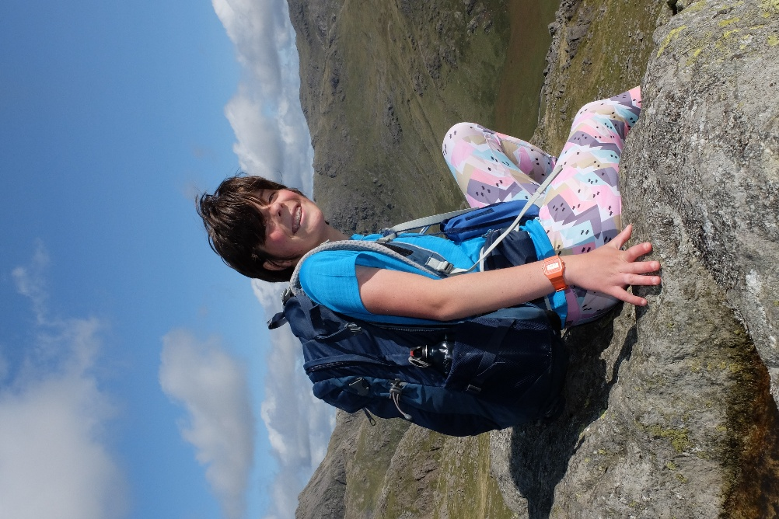
Likes
- Mountain climbing
- Long distance walking
- Camping
- Working with young people
- Orangutans
- Traveling
Dislikes
- Heights
- Seagulls
- Speed
- Planes (will do on one if the only option of transport)
How did I find out about this course?
I found out about this course through a friend that I worked with. Last year I had a placement at a youth club and my friend there that I worked with, did a similar outdoor course at a different university. I then looked on the UCAS website for all different outdoor courses and found this one.

