Table of Contents
1. Executive Summary 3
2. Introduction 3
3. Financial Accounting 4
3.1 Budget 4
3.2 Problems of Blue Thread Ltd 5
3.3 Budget control system 7
3.4 Traditional approaches to budgeting 11
4. References 13

Executive Summary

This report, prepared for the module BMSW5012, Principles and Concepts of Finance, examines the importance of financial accounting and budgeting in maintaining the financial health and sustainability of an organization.

The research centres on Blue Thread Ltd.'s financial concerns, which include large loan repayments, cash flow issues, and stock management issues. Blue Thread Ltd. has negative cash balances even though it reported a positive profit of £260,350. This is mostly because of excessive stock purchases and fixed loan disbursements. The need for better financial management techniques is highlighted by these financial issues.

The report examines the fundamentals of financial accounting, such as the methodical gathering and examination of financial data, which offers important information for resource allocation and decision-making. The importance of budgeting in financial planning is also covered, with particular attention paid to the development of precise income and expense estimates, as well as the control of cash flow and inventory.

Several traditional budgeting techniques are assessed, such as value proposition, incremental, activity-based, and zero-based budgeting. Despite its advantages, such methods may be too inflexible for contemporary, fast-paced work settings. To adjust to shifting market conditions, the research advises businesses to implement more adaptable and agile budgeting strategies that incorporate real-time data.

Introduction

Effective planning and financial accounting are essential to any organization's sustainability. An organization's financial transactions are systematically recorded, compiled, and reported as part of financial accounting, which offers crucial information on the performance and health of the organization's finances. It assists companies in producing accurate financial accounts, which are essential for strategic planning, decision-making, and upholding stakeholder confidence.

Budgeting, on the other hand, is an essential procedure that aids businesses in projecting and controlling their income and expenses, guaranteeing that they have the resources needed to meet their objectives. It can also be used to optimise resource allocation, limit expenses, and prepare for unexpected financial difficulties.

Issues like negative cash flow, excessive stock purchases, and expensive loan repayments underscore the significance of effective budgeting and financial management strategies in the context of Blue Thread Ltd. Even if it works well in stable settings, traditional budgeting techniques might not be adaptable enough to quickly shifting market situations. Adopting more flexible, data-driven budgeting techniques is essential for preserving financial stability and attaining long-term success as companies deal with changing and dynamic market circumstances.

Financial Accounting

Procedure for documenting, compiling, and reporting the financial transactions of an organisation. It focusses on creating financial statements for external stakeholders, including creditors, investors, and regulators, including the cash flow, income, and balance sheets. Because it is produced from the methodical collecting and analysis of accounting data, it offers crucial information that supports the making of the best management decisions. (Rotaru et al,.2020). Accurate, consistent, and systematic methods are used to collect accounting data. This reduces errors in financial reporting and guarantees reliability. The information gathered by accounting procedures offers important financial insights in addition to being used for maintaining records. These insights assist managers in assessing the success of the business, allocating resources efficiently, and pinpointing areas in need of development. By offering precise and swift data these technologies facilitate better choices, which raises operational performance. (Puspitawati et al,.2020).

Businesses run the danger of poor management, mistakes, fraud, and fines from the government if they don't have adequate financial accounting. Insufficient financial information undermines the stability and expansion of an organisation by causing poor judgements, inefficiencies, and a decline in the trust of creditors and investors.

3.1 Budget

The process of creating and managing a financial record that projects revenue and expenditure over time is known as budgeting. Budgeting is a crucial ability for managers, executives, and business owners to make sure teams and organisations have the funds to carry out projects and accomplish objectives. In addition to helping people manage present financial circumstances, this method also gets ready for future financial planning and unanticipated costs. (Budgeting basics,2008).

A key element of financial planning is the stock budget, which makes sure the business keeps the right amount of inventory on hand to support sales and effectively manage cash flow. Effective stock management avoids understocking, which can result in missed sales opportunities, and overstocking, which ties up cash. It also means that a stock budget might be a part of more comprehensive budgeting procedures meant to maximise operational effectiveness and resource allocation. (Al-Mekhlafi,2023).

3.2 Problems of Blue Thread Ltd

The following calculations were performed using a plan that Blue Thread Ltd. had created several months prior.

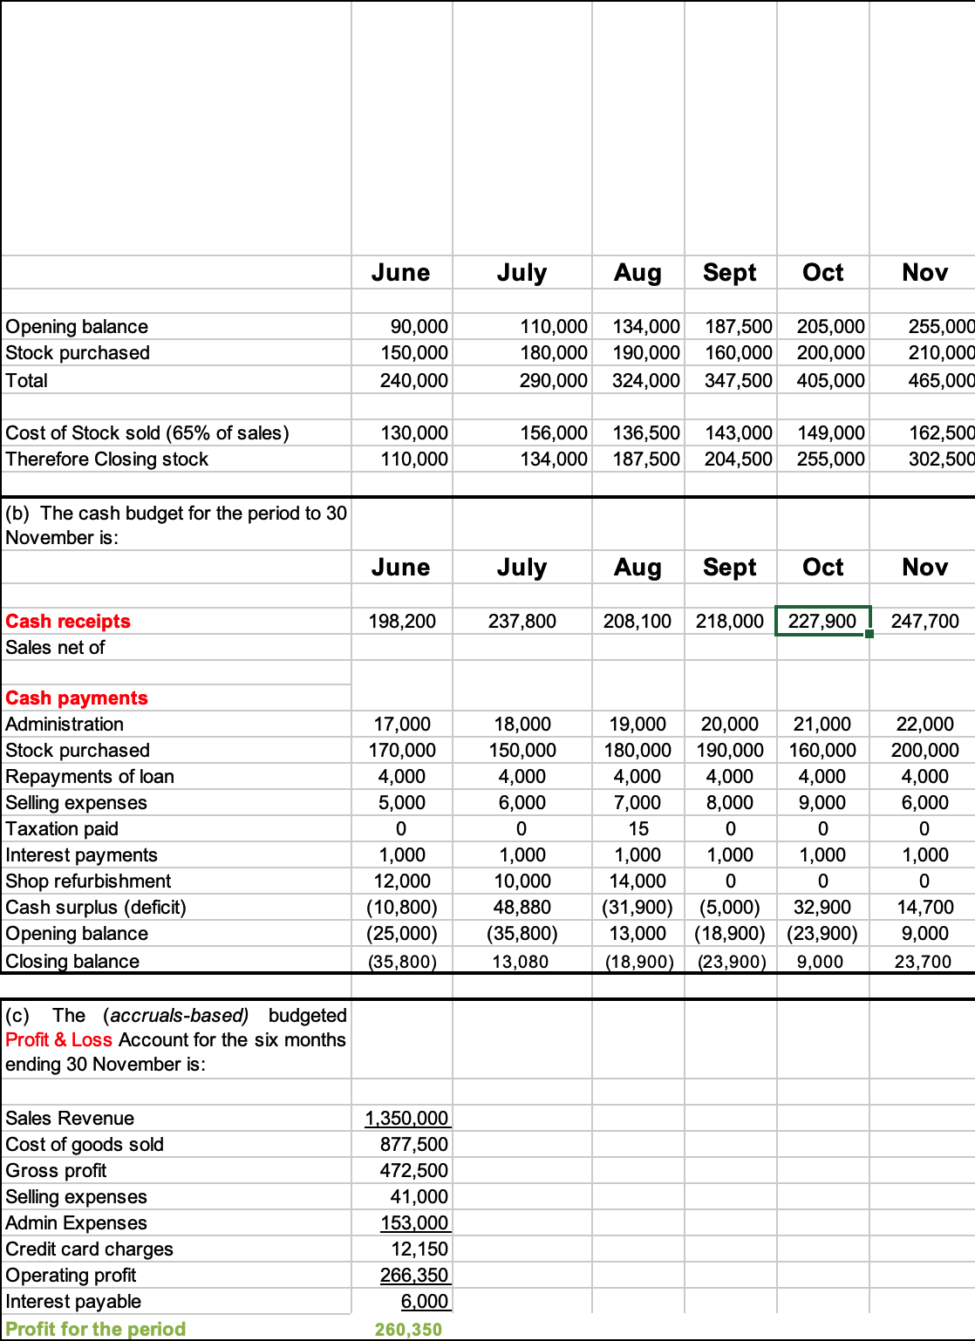

The financial information presented indicates that Blue Thread Ltd will probably encounter several significant financial difficulties during the upcoming six months. These difficulties mostly centre on stock management, cash flow problems, and possible inefficiencies in cost control. Blue Thread Ltd. may experience severe operational and financial consequences if these financial issues are not resolved, which might eventually threaten the company's sustainability. To improve output and lower financial risks—both of which are critical for sustainable business practices—effective financial management models are required. In addition to promoting profitable growth over time, integrating sustainability into financial management helps companies better achieve their sustainability goals. (Hota et al,.2024).



Figure 1, SMEs’ most common issue is cashflow (Williams,2019).

A company's liquidity and financial health are reflected in the flow of cash and cash equivalents into and out of the business. Since it shows how successfully a business can pay its debts and fund its activities, it is an essential part of financial management. (Nandini,2024). A company's capacity to pay its short-term debts with easily accessible assets, such cash, is referred to as liquidity. A business with positive cash flow has enough incoming funds to cover costs such as: repayments of loans, invoices from suppliers, pay for employees.

Even though the company's profit for the period was £260,350, it has experienced negative cash balances for several months. There is a constantly negative closing balance because of the cash budget's large cash deficits in June (£10,800), August (£31,900), and September (£5000). The company's cash position is still unstable; it has a negative closing balance for three of the last six months, with June seeing a low of -£35,800. High stock purchases in most months that reduce cash in inventory and loan repayments totalling £4,000 per month plus £1000 in interest payments that lower available cash are potential causes of the foregoing issues.

Since excessively significant purchases tie up capital, managers should minimise stock purchases wherever possible to reduce the problem mentioned previously. When possible, cutting back on stock purchases increases financial flexibility, reduces expenses, and frees up cash. Getting suppliers to extend their payment terms can assist reduce the strain on cash flow. The business ought to think about delaying store improvements until a steadier cash flow is established.

The value of unsold inventory at the end of an accounting period is known as the closing stock balance, and it is essential for creating financial statements like the balance sheet. (Bhattacharya, 2011). Because it shows that the business has inventory on hand to satisfy future client demand and maintain business continuity, a positive closing stock balance is significant. It also reduces the need for quick purchases to replenish supplies, which helps to maintain a healthy cash flow.

Between June and November, the closing stock balance rises dramatically from £110,000 to £302,500. This shows that the business is buying more stock than it is selling, which may result in high inventory holding expenses and possible depreciation risks.

Management could increase stock turnover to help move extra inventory more quickly and solve the problem mentioned earlier. The business should match stock purchases more closely with anticipated demand rather than continuing to make large purchases each month. By taking these steps, the business will be able to improve its overall financial performance, address its cash flow problems, and manage its inventory more effectively.

The business makes monthly loan repayments of £4,000 and interest payments of £1,000, for a total of £30,000 over six months. This continuous cash drain adds to problems with liquidity. This suggests that interest rates have a direct influence on creditors' financial choices and repayment strategies, which in turn affects how they manage their cash flow overall. (Ann et al,.2023). Since a sizable amount of cash is committed to fixed loan related outflows, the business may have cash shortages during months with lower than anticipated revenues or greater expenses, which would negatively impact its overall cash flow situation. To reduce interest expenses, managers ought to investigate more favourable loan conditions.

The main causes of Blue Thread Ltd.'s severe financial difficulties include ineffective cost control, cash flow, and stock management. Due in major part to excessive stock purchases and expensive loan repayments, the company has had negative cash balances for several months despite a positive profit of £260,350. Cash flow is stressed capital is tied up, and financial flexibility is reduced.

3.3 Budget control system

Several crucial requirements must be fulfilled for an organization's budgeting and budgetary control system to be successful. These conditions guarantee that the budgeting process is successful in directing financial choices, managing expenses, and accomplishing company.
objectives.

The importance of good budgeting techniques for financial performance is shown by the fact that ineffective budgeting can greatly contribute to organisational failure. (Srbinoska et al,.2023). Weak budgeting can result in judgements based on faulty financial data, a lack of strategic investment because of inadequate financial planning, and running out of money because of unanticipated costs.
The technique of efficiently controlling capital and cash flow by strictly observing set budgets is known as budget control. It involves avoiding overspending, making the requisite modifications when needed, and making sure that expenditure is in line with the assigned funds and the defined budget plan. The results showed that while budget participation had a minor long-term link with financial performance, effective budgetary management mechanisms had a considerable impact. This implies that improving financial results in educational institutions depends heavily on the efficacy and efficiency of budgeting procedures. (Olaniyan,2020). Budget control systems have drawbacks even though they are crucial for financial management like If a company strictly follows its budget, it may miss opportunities for innovation or growth. Instead of focusing on real needs, employees may make unnecessary expenditures.
To guarantee that an organization's financial resources are effectively distributed and used to accomplish its goals, a budgeting and budgetary management system is essential. When the budget and the organization's long-term strategic goals are clearly aligned, budgeting works best. Since it improves performance, strategic goals must be in line with a company's purpose, goal, and values. (Fayomi and Nakanazu,2024). It is challenging to achieve complete alignment between strategic goals and budgeting in practice. Budgets frequently concentrate on short-term financial performance, even if companies may have ambitious long-term goals. Conflicts between innovation and financial control may result from this discrepancy.
Strong commitment from management and leadership are necessary for effective budgeting. Participatory budgeting study shows that management performance is positively impacted by the relationship between organisational commitment and participatory budgeting. (Eferakeya and Edgars,2024). In addition to giving strategic direction, management must make sure that the budgeting process is handled seriously at all organisational levels. For the system to function well, they must provide resources, supervision, and training. Establishing attainable goals, assigning resources, and tracking progress can help demonstrate how activities are in line with vision and how intend to reach it. (LinkedIn,2024). Changes in the budgeting process may be resisted by management and staff because of perceived expenditure limits, habit, or a fear of liability. Even the best-designed financial systems can be undermined by opposition to innovative budgeting techniques.
Key stakeholders from all departments should participate in the collaborative process of budgeting. Effective budgetary control depends on departments communicating their requirements, goals, and difficulties. There is less chance of budgetary slack when task communication is strong, indicating that effective departmental communication of needs and goals might improve budgetary control results. (Yucel,2010). All parties involved are guaranteed to comprehend financial goals, spending caps, and budgeting strategies when there is clear communication. Lack of communication can result in inaccurate financial assumptions, misreported spending, and poor planning. Poor budgeting and resource allocation communication can result in departmental competition, as teams compete for limited finances instead of cooperating to achieve common objectives.
In addition to planning, budgeting and budgetary control should involve tracking and assessing performance in relation to financial goals. Key performance indicators and frequent financial reporting are essential for organisations to monitor their progress, spot mistakes, and take steps to correct them when needed. For example, performance budgeting procedures are thought to have a major influence on budget taking decisions, according to a poll of state executive-branch budget directors, indicating that funding allocation is becoming more and more linked to performance measures.(Jordan and Hackbart,1999).
When implementing a budgeting system, there are four habits to consider.
Management needs to be aware of the human dynamics involved while implementing a budgeting and budgetary control system. Managers can participate in the creation and approval of budgets thanks to this involvement, which may increase organisational commitment. (Illyas , 2021). Additionally, this encourages managers to fulfil objectives and take responsibility for results. In addition to improving managers' abilities and fostering teamwork and shared accountability, the approach strengthens their dedication to the organization's success. The actions of managers and staff have a big impact on whether the system works or fails.
- Employee motivation is among the most important factors to consider. If staff believe an effective budgeting system is reasonable and achievable, it can be used as a motivating tool. Compared to motivation from outside, study indicates that within motivation typically encourages more truthful reporting, particularly when management collectively. (Grediani et al,.2023). Employee demotivation and despair may result from budgets that are set too strictly or unfairly. Budgets should be challenging but possible, and rewards should be connected to good performance to increase motivation.

- For budgeting systems to be successful, accountability and responsibility are essential components. The importance of accountability in effective budgeting systems is further highlighted by the need to increase the ability of stakeholders to guarantee lasting improvements. (Park and Choi, 2013). Workers need to be fully aware of their duties and how their activities affect the bottom line. Employees might not feel pressured to follow financial restrictions in the absence of a strong culture of accountability. Without an effective accountability culture, employees might not feel compelled to adhere to financial limitations. Employees might ignore financial restrictions, mishandle business funds, or participate in unethical financial operations if there are unclear expectations and no oversight. Transparency can be improved, and responsible financial behaviour can be promoted by establishing clear performance metrics, this tactic can improve credibility and confidence among stakeholders while facilitating making decisions that are well (Rusu et al,.2024). Conducting frequent financial reviews and associating budget performance with rewards or responsibilities.

- Resistance to change is another important component. Workers may object to a new budgeting system because they don't understand it, are afraid of having more influence, or are unsure of how it will affect their jobs. Based on a study on workplace justice and knowledge exchange, employees are more likely to participate favourably when they believe the budgeting process is fair, indicating that acceptance depends on the budgeting process's clarity and transparency. (Suria and Ruhana,2019). Effective management of change techniques, like training programs, honest communication, and staff engagement in decision-making, should be used by management to overcome this resistance to lessen anxiety and promote acceptance. Improving understanding and increasing employee commitment can lead to smoother transitions and greater acceptance of changes.

- Last but important behavioural factor to consider is goal alignment. Individual and departmental targets should be in line with the overarching company goals when it comes to budgeting. An adjustment in budgeting procedures towards performance data might help departments better match their goals with the organization's overarching goals. (Worldbank,2012). Departments are more likely to find errors, optimise utilisation of resources, and make data-driven decisions that support long-term strategic planning when they use performance data to guide their budgets. Because departments are now required to show how spending plans contribute to the success of the company, this change also encourages accountability. Employees may oppose the system or behave dysfunctional, for as by actively underestimating profits or overestimating expenses, if they believe that their personal objectives clash with the expectations of the budget. Organisations should make sure that budgets are created in a way that strikes a balance between realistic expectations for various divisions and corporate financial aims to encourage goal congruence.

In summary, businesses must set clear financial goals, guarantee data correctness, gain leadership commitment, encourage transparency, engage staff, provide flexibility, and carry out efficient performance reviews for a budgeting and budgetary management system to be successful. To guarantee the budgeting system's seamless adoption and long-term efficacy, management needs to tackle behavioural factors including accountability, goal alignment, motivation, and resistance to change.

Traditional approaches to budgeting

Businesses often employ one of four budget types: incremental, activity-based, value proposition, or zero-based.
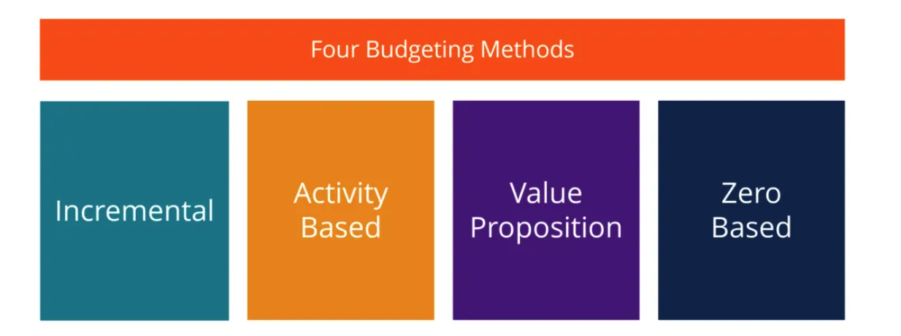
Figure 2, Four budgeting methods (Shmidt,2025).
The size, objectives, and tactics of company will determine the most effective budgeting technique. The incremental approach is clear and easy to use, but it isn't dependable for new organisations because it relies on historical data. (GoCardless,2023). Use value proposition or zero-based budgeting techniques if must make compromises. Activity-based budgeting might help reach growth goals as company expands.
Traditional budgeting entails establishing financial goals based on previous financial information and anticipated future patterns. It is a methodical procedure that includes performance evaluation, financial setting objectives, and resource allocation. (Yvanovich,2023). Although it guarantees consistency with company goals, it may be restrictive if management lack the flexibility to react swiftly to unanticipated difficulties. Furthermore, the procedure might not adequately take into consideration the nuances of team dynamics or the complexity of human behaviour, both of which might affect productivity and resource use.
Incremental budgeting is one of the most used methods, where the previous year’s budget is taken as a base, and adjustments are made, usually in the form of percentage increases or decreases. Because it is based on previous information, it is nevertheless a practical and rather quick method for many well-established organisations, regardless its drawbacks. (Datarails,2025). The approach ignores unexpected market shifts, new possibilities, and external interruptions and instead assumes that the budget from the previous year serves as a reasonable basis for the one to come. This reduces the method's ability to adjust to rapidly changing environments. This rigidity can limit a company's ability to respond effectively to new challenges or innovations. Incremental budgeting discourages creative approaches and ambitious investments because it places too much emphasis on minor changes. (The Finance Weekly,2024).
Activity-based budgeting, which focusses on the expenses related to creating goods or services, distributes resources according to the activities that propel business performance. This approach can offer more thorough information about how resources are being used and whether initiatives are producing value. Businesses can cut expenses and increase sales revenues by implementing activity-based budgeting (Drury,2020). By knowing the actual cost of each operation, businesses can optimise resources and eliminate inefficient expenditures, which will ultimately boost sales revenues through improved cost control and resource allocation. Because it requires monitoring and evaluating every organisational activity, implementing ABB can be difficult and time-consuming. Each technical detail must be documented as it happens, just as all expenses related to a company's operations are tracked. (Schmidt,2025). This could impede agility or take resources away from more urgent activities for companies who operate rapidly.
The goal of value proposition budgeting is to match the company's value proposition with the distribution of financial resources. The main goal of value proposition budgeting, also known as priority-based budgeting, is to evaluate and support the worth of each item on an expense list. (The Bill Team ,2025). Although this approach promotes alignment between strategic goals and budgeting, it can be difficult to measure and convert subjective value propositions into exact budgetary allocations. This approach can be slower to adjust and cannot promptly catch shifts in consumer demand or competitive positioning in businesses where value propositions or customer preferences differ often.
Zero-based budgeting requires managers to justify every expense from scratch for each new budget period, rather than simply adjusting previous budgets. It's a method of budgeting that divides every pound of monthly income into areas that suit company, such investments, purchasing, or utilities. (Starling Bank,2023). Zero-based budgeting can guarantee that resources are distributed effectively and result in a more complete evaluation of expenditures. Nevertheless, this method is labour-intensive and time-consuming, which makes it challenging to apply in a rapid business environment.
Budgeting techniques that rely on past data and minor adjustments can quickly become outdated in dynamic business circumstances in which market dynamics can shift suddenly. Future modifications and present adaptations are not taken into consideration in traditional budgeting. Access to current time data is crucial in a corporate setting where circumstances can change drastically in a couple of days or even hours. (Jedox,2025). To remain competitive, businesses must adopt more flexible budgeting techniques that integrate real-time data, enabling quicker adaptations to evolve circumstances and improving responsiveness in a dynamic market.
3.5 Conclusion.
Effective budgeting and financial accounting are essential to an organization's long-term financial stability and success. Businesses can reduce risks, make sensible choices, and preserve the trust of creditors and investors by using accurate financial documentation, such as cash flow reports, balance sheets, and income statements. When properly implemented, financial accounting procedures not only aid in record keeping but also offer insightful information for enhancing operational effectiveness, allocating resources, and identifying possibilities for expansion. The stability of the company, however, may be at risk due to poor financial accounting, which can result in ineffective management, inefficiencies, and even legal liabilities.
As a financial planning tool, budgeting is essential to coordinating the organization's resources with its strategic goals. It assists in projecting income and costs, making sure the company has enough money to reach its objectives and budget for unanticipated costs. Avoiding financial mistakes requires effective cash flow management, debt repayment plans, and stock management. The problems Blue Thread Ltd. is facing—such as cash flow issues, stock mismanagement, and large loan repayments—make it clear that a more efficient budgeting approach is required, one that puts operational effectiveness and financial flexibility first.
Every traditional budgeting method has its own advantages and disadvantages, including incremental, activity-based, value proposition, and zero-based budgeting. Even while these approaches could have worked effectively for companies in the past, they may be too inflexible to adjust to the dynamic, fast-paced environment found in contemporary corporate settings. Organisations need to implement more adaptable and agile budgeting techniques that use real-time data and enable quick modifications if they want to be responsive and competitive. Businesses can guarantee improved financial performance and long-term success by coordinating budgeting procedures with organisational objectives, promoting openness, and cultivating an accountable culture.
In conclusion, companies must adopt modern budgeting strategies and enhance their financial management procedures if they want to prosper in a market that is changing quickly.

4. References

Abdulah Al-Mekhlafi. (2023). Asian economic and financial review. The extent of the commitment of Saudi manufacturing firms to a budget and its impact on planning, controlling, and perfo. 12(13), pp.1030-1045.
Amy Drury. (2020). What Is Activity-Based Budgeting (ABB)?. [Online]. Investopedia. Last Updated: 16 March 2020. Available at: https://www.investopedia.com/terms/a/abb.asp [Accessed 12 March 2025].
Bodapati Nandini. (2024). CASH FLOW STATEMENT KOTACK. International journal of management research and reviews, 14(4), pp.153-163.
Budgeting basics. (2008). [Film]. Chicago: Learning Seed.
Daria Rotaru, Svetlana Mihaila, Violeta Codrean. (2022). THE ROLE OF FINANCIAL-ACCOUNTING INFORMATIONIN THE DECISION-MAKING PROCESS. Journal of Social Sciences. 5(2), pp.155-163.
Datarails. (2025). Incremental Budgeting. [Online]. Datarails. Last Updated: 2025. Available at: https://www.datarails.com/finance-glossary/incremental-budgeting/ [Accessed 12 March 2025].
Dzaky Illyas, Abdurohman Tri, Muhammad Zulfikar, Christian Sukma. (2021). A Review: The Influence of Participation Budgeting Toward Organization Behavior Factors. Turkish journal of computer and mathematics education. 12(4), pp.734-739.
Evi Grediani, Hadri Kusuma, Mahmudi, Ataina Hudayati. (2023). Moderating effects of Machiavellianism, management control, and fairness on a motivation-honesty relationship in budget. Problems and perspectives in management. 21(3), pp.164-175.
GoCardless. (2023). 4 Budgeting Methods for Businesses. [Online]. GoCardless. Last Updated: February 2023. Available at: https://gocardless.com/guides/posts/budgeting-methods-for-business/ [Accessed 8 March 2025].
Hrishikes Bhattacharya. (2011). Understanding the Balance Sheet. In: Hrishikes Bhattacharya (Ed.). Banking Strategy, Credit Appraisal, and Lending Decisions. Delhi: Oxford University Press. pp.230-266.
Idowu Eferakeya, Patani Edgars. (2024). Participative Budgeting, Organizational Commitment and Managerial Performance: Evidence from Nigeria. Iranian journal of management studies. 17(5), pp.1015-1030.
Jeff Schmidt. (2025). Activity-Based Budgeting. [Online]. CFI. Last Updated: 2025. Available at: https://corporatefinanceinstitute.com/resources/fpa/activity-based-budgeting/ [Accessed 12 March 2025].
Jeff Schmidt. (2025). Four budgeting methods. [Online]. CFI. Available at: https://corporatefinanceinstitute.com/resources/fpa/types-of-budgets-budgeting-methods/ [Accessed 8 March 2025].
Jedox. (2025). Why traditional budgeting methods are failing modern CFOs. [Online]. Jedox. Last Updated: 2025. Available at: https://www.jedox.com/en/blog/why-traditional-budgeting-methods-are-failing/ [Accessed 12 March 2025].
Leena Hota, Sonali Pattnaik, Yagyaseni Champatiray, Swarupa Mallick, Anuj Kumar. (2024). SUSTAINABLE FUTURE: THE ROLE OF MODERN ANALYTICS IN FINANCIAL PLANNING. Faculty of Tourism and Hospitality Management in Opatija. Biennial International Congress. Tourism & Hospitality Indust. 0(0), pp.185-193.
LinkedIn. (2024). How can you use budgeting and forecasting to be a more effective leader? [Online]. LinkedIn. Last Updated: 17 September 2024. Available at: https://www.linkedin.com/advice/3/how-can-you-use-budgeting-forecasting-more-mgvae [Accessed 8 March 2025].
Lilis Puspitawati, Iqbal Lhutfi, Inomjon Qudratov. (2014). Enhancing inventory efficiency: the role of Strategic Management Accounting and Integrated Management Accounting Informa. Cogent business & management. 11(1), pp.1-20.
Meagan Jordan, Merl Hackbart. (1999). Performance budgeting and performance funding in the states: A status assessment. Public budgeting & finance. 19(1), p.68.
Nia Williams. (2019). SMEs’ most common issue is cashflow. [Online]. UKTN. Available at: https://www.uktech.news/accountancy/smes-most-common-issue-is-cashflow-20190402 [Accessed 7 March 2025].
Nowook Park, Jae-Young Choi. (2013). Making Performance Budgeting Reform Work: A Case Study of Korea. Washington: The World Bank. pp.1-28.
Olapido Olaniyan, Olusegun Efuntade. (2020). Budget and the budgetary control system on tertiary institution’s financial performance in Nigeria. KIU Interdisciplinary Journal of Humanities and Social Sciences. 1(2), pp.281-302.
Oloruntoba Fayomi, Humphrey Akanazu. (2024). Strategic Goal-Setting And Organisational Effectiveness In Selected Trading And Manufacturing Companies. Department of Library and Information Science. 21(2), pp.25-39.
Rahmi Yucel. (2010). The Role of Budgetary Participation, Distributive Fairness, and Communication on the Relationship Between Budgetary Cont. Iranian journal of management studies. 10(4), p.1257.
Rick Yvanovich. (2023). Advantages and Disadvantages of Traditional Budgeting Approach. [Online]. TRG. Last Updated: 12 December 2023. Available at: https://blog.trginternational.com/bid/162036/traditional-budgeting-approach-advantages-and-disadvant [Accessed 8 March 2025].
Simin Ann, Bo Li, Minxue Wang, Wei Zheng. (2023). Financing strategy of the capital-constrained supply chain under uncertainty: the impact of blockchain technology on the. Industrial management + data systems. 123(10), pp.2659-2680.
Stevceska Srbinoska, Snehzana Hristova, Victorija Kazic. (2023). Why Budgeting in Small and Medium Enterprises Matters? Timisoara Journal of Economics and Business. 16(2), pp.99-118.
Team Starling. (2023). What is zero-based budgeting? [Online]. Starling Bank. Last Updated: 3 September 2023. Available at: https://www.starlingbank.com/blog/zero-based-budgeting/ [Accessed 12 March 2025].
The BILL Team. (2025). Value proposition budgeting: Is it right for your business? [Online]. Bill. Last Updated: 2025. Available at: https://www.bill.com/learning/value-proposition-budgeting [Accessed 12 March 2025].
The Finance Weekly. (2024). What is Incremental Budgeting? [Online]. The Finance Weekly. Last Updated: 17 November 2024. Available at: https://www.thefinanceweekly.com/post/what-is-incremental-budgeting [Accessed 12 March 2025].
WorldBank. (2012). Improving the Quality of Public Expenditure in the Dominican Republic. Washington: Inter-American Development Bank. pp.1-51.

