School of Engineering
Two methods applied in manufacturing bushes and sleeves
Xiaona LIN
1805194
Undergraduate
18/01/2019
Materials and Introduction to Manufacturing M4X02063

ABSTRACT: Bushes and sleeves are used for mechanical parts, in order to achieve sealing, wear protection and other functions, and refer to the ring sleeve functioning as a cushion. The materials of bushes and sleeves are mostly soft metal, rubber, nylon and non-metal polymer, such as casting iron, PTFE, casting bronze. Gravity die casting and centrifugal casting are special casting technologies that have played a very important role in the modern foundry industry including manufacturing bushes and sleeves. This paper describes the theory of centrifugal casting and gravity casting, and analyzes the advantages and disadvantages of gravity die casting and centrifugal casting compared with sand casting.

Contents
1.Introduce 1
2.Gravity die casting 1
2.1Introduction 1
2.2 Comparisons between gravity die casting and sand casting 2
2.3Gravity Die Casting Process 2
3.Centrifugal casting 5
3.1 Introduction 5
3.2 Characteristics of centrifugal casting 6
4.Conclusion 7
5.References 7

1.Introduction

Bushes and sleeves are used for mechanical parts, in order to achieve sealing, wear protection and other functions, and refer to the ring sleeve functioning as a cushion. In the field of valve applications, they are used inside the bonnet, generally using corrosion-resistant materials such as PTFE or graphite for sealing (baikebaidu, 2019). The materials of bushes and sleeves are mostly soft metal, rubber, nylon and non-metal polymer, such as casting iron, PTFE, casting bronze (Fig.1). These materials are relatively soft in texture and low in cost. Bushes and sleeves are subjected to vibration, friction and corrosion in a variety of harsh working environments to protect the wrapped components (baikebaidu, 2019).

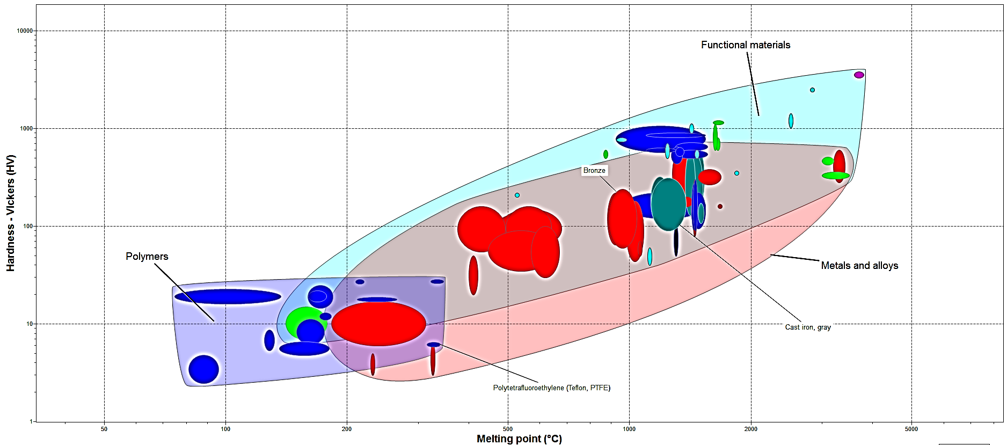
Fig.1 The properties of materials

Nowadays, there are many casting used in manufacturing bushed and sleeves. In this paper, it only introduces two methods - gravity die casting and centrifugal casting, about their theory, advantages and disadvantages compared with sand casting.

2.Gravity die casting

2.1Introduction

Gravity die casting, also known as permanent mold casting, is a casting method in which liquid metal is poured into a metal mold to obtain a casting. The mold is made of metal and can be used repeatedly (several hundred to several thousand times) (baikebaidu, 2018).

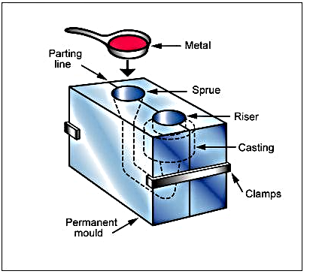
Fig.2 Gravity die casting (S. R. ENGINEERING CORPORATION)

2.2 Comparisons between gravity die casting and sand casting

The comparison between gravity die casting and sand casting has the following advantages (Gong, 1932).

1 The mechanical properties of gravity die castings are higher than those of sand castings. For example, aluminum alloy castings can increase the tensile strength by an average of 25% and the yield strength by about 20% on average, which is the result of high cooling rate of the casting during solidification. For the same reason, the clean surface of the casting is fine and the "casting hard shell" is formed, and the corrosion resistance and hardness of the casting are also significantly improved.

2 The precision and surface finish of castings are higher than sand castings, and the quality and size are stable. For castings produced by metal type, the average balance of precision is 7 grades, and the average of two sand castings can only reach 8 grades, the average finish of the sand can reach 4, and the sand casting can reach 3, which can reduce the processing allowance and save the processing time and reduce the processing time. cost.

3 The casting process has a high yield and the liquid metal consumption is reduced, which generally saves 15%-30%.

In addition, gravity die casting has high production efficiency, simple process, and easy mechanization and automation.

2.3Gravity Die Casting Process

The gravity die casting process includes metal preheating, coating, casting, and molding. It involves four steps (Harrison Castings Ltd, 2018; Gong, 1932):

First, the mold should be heated before casting, and spray it with a refractory coating. The aim to spray coating is to control the temperature of the mold during casting process and also benefit to remove the casting. Then the molten metal is poured into the mold to cure it. Later, the mold is open and the casting is removed. Finally, the waste from the casting is removed, including gates, runners, gates and burrs. The casting is then machined to remove sharp edges and excess material and then blast cleaned.

Metal types that are not preheated cannot be cast. This is because the metal type has good thermal conductivity, the liquid metal cools rapidly, and the fluidity is drastically reduced, which easily causes defects such as cold separation, insufficient pouring, inclusions, and pores in the casting (Gong, 1932). When the metal type of the stomach is hot, the casting will be subjected to a strong heat shock, and the gravitational force will be doubled, making it extremely easy to break.

Therefore, the metal type should be preheated before starting work. The appropriate preheating temperature depends on the type of alloy, the structure and size of the casting, and the preheating temperatures of the following alloys are obtained through tests (Table 1) (Gong, 1932).
Table 1 Different alloys for metal preheating temperature requirements
Aluminum alloy | magnesium alloy | Tin bronze | Lead bronze | cast iron | Cast copper
200-300 | 200-250 | 150-250 | 50-125 | 250-350 | 150-300
The preheating methods are as follows:
1 Preheat with a blowtorch or gas fire. The method is simple and convenient, but the temperature distribution on the metal type is uneven.
2 Using a resistance heater. For large and medium metal types, when the transportation is inconvenient, a resistance heater can be provided on the back side.
3 Preheating with a heating furnace, that is, heating in a metal-type heating furnace, the temperature is uniform, but only for small metal types.
4 First put the metal type on the road to bake, and cast the liquid metal to heat the metal type. This method is only suitable for small molds, and the metal liquid is wasted to reduce the life of the mold.

In the gravity die casting process, it is often necessary to spray coating on the metal working surface (Gong, 1932). The effect of the coating is as follows:
1 Adjust the cooling rate of the casting.
2 protection metal type. Liquid metal has an erosion-damage effect on the wall when pouring, so coatings are often used to prevent direct enrichment and thermal shock of the high-temperature metal liquid to the wall.
3 using the paint layer to store gas and exhaust. Because the coating layer has a certain porosity compared with the metal type, it has a certain gas storage and ventilation capacity.
In the case of gravity die casting, the casting temperature and casting speed of the alloy must be appropriate.

Due to the strong thermal conductivity of the metal wall, if the alloy temperature is too low during casting, it will lead to defects such as cold separation, pores and inclusions in the casting (Kalpakjian, 2006; Gong, 1932). Suitable casting temperatures are generally higher than for sand casting. It can be determined according to the type of alloy, chemical composition, casting size and wall thickness. For thin-walled small parts, the working temperature of the mold is low, and the upper limit is taken; when the thick-walled large parts are cast, the working temperature of the mold is high, and the lower limit is taken (Gong, 1932).
Table 2 Casting temperature of various alloys
Alloy type | Pouring temperature | Alloy type | Pouring temperature
Lead-tin alloy | 350-450 | brass | 900-950
Zinc alloy | 450-480 | Tin bronze | 1100-1150
Aluminum alloy | 680-740 | Aluminum bronze | 1150-1300
magnesium alloy | 715-740 | cast iron | 1300-1370

Due to the chilling and airtightness of the metal type, the casting speed should be slow, fast and slow. The slower is to prevent splashing, the liquid metal can be filled well soon, and the slower is to prevent metal spillage at the end of pouring. The flow should be as stable as possible during the pouring process (Gong, 1932).

3.Centrifugal casting

3.1 Introduction

Centrifugal casting is a technique and method for injecting liquid metal into a mold that rotates at a high speed, so that the molten metal is centrifuged to fill the mold and form a casting. Since the centrifugal movement can make the liquid metal fill the mold well in the radial direction and form the free surface of the casting, the centrifugal casting can obtain the cylindrical inner hole without using the core, which helps the elimination of gases and inclusions in the liquid metal (baikebaidu, 2010).

The axis of rotation may be horizontal or inclined at any angle up to the vertical position. Molten metal is poured in to the spinning mould cavity and the metal is held against the wall of the mould by centrifugal force. The speed of rotation and metal pouring rate vary with the alloy and the size and shape being cast (spin-n-cas, 2019).

British Erchardt proposed the first centrifugal casting patent in 1809 to guide the method to be gradually adopted in the early 20th century (Gong, 1932). Centrifugal casting has become a widely used casting method, especially in the production of tubular castings such as iron pipes, copper bushings, cylinder liners and the like (Gong, 1932; revoly, 2018). Centrifugal casting is almost a major method. Almost all cast alloys can be produced by centrifugal casting. Centrifugal castings have a minimum internal diameter of 8 mm, a maximum diameter of 3 m, a maximum casting length of 8 m, and casting weights ranging from a few kilograms to more than a dozen tons.

According to the different positions of the rotary shaft of the mold, there are two types of vertical centrifugal casting machines and horizontal centrifugal casting machines (Fig. 3) (Gong, 1932; spin-n-cas, 2019). 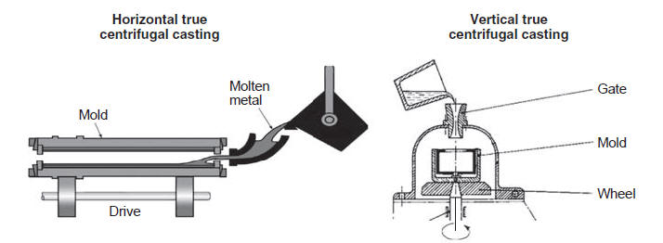
Fig.3 Centrifugual casting (CCTM-USA, 2015)

The mold on the vertical centrifugal casting machine rotates around the vertical axis and is mainly used to produce ring-shaped castings with a height smaller than the diameter. The horizontal centrifugal casting machine's mold is rotated around a horizontal axis. It is mainly used to produce sleeves and pipe castings with a length greater than the diameter.

3.2 Characteristics of centrifugal casting

Since the liquid metal is filled and casted under the condition of centrifugal casting, the centrifugal casting has the following characteristics (Gong, 1932):
1 Liquid metal can form a hollow cylindrical free surface in the mold, so that the central control casting can be cast without the core, which greatly simplifies the production process of the sleeve and the tube casting.
2 Due to the centrifugal force generated by the liquid metal during the rotation, the centrifugal casting process can improve the ability of the metal to fill the mold, so that some of the less fluid alloys and thin-walled castings can be produced by centrifugal casting.
3 Due to the centrifugal force, the feeding conditions are improved, and the gas and non-metal magazines are also easily discharged from the liquid metal. Therefore, the microstructure of the centrifugal casting is dense, and the defects such as shrinkage cavities, pores, and magazines are less.
4 Elimination or significant savings in metal consumption in the gating system and risers.

4.Conclusion

Gravity casting and centrifugal casting are suitable for high-volume casting and can be automated. They are widely used in the manufacture of bushes and sleeves, with high precision castings and low material consumption.

5.References

baikebaidu bushes [Online] // baikebaidu. - 01 02, 2019. - https://baike.baidu.com/item/%E8%A1%AC%E5%A5%97.
baikebaidu centrifugal casting [Online] // baikebaidu. - baikebaidu, 11 12, 2010. - 01 10, 2019. - https://baike.baidu.com/item/%E7%A6%BB%E5%BF%83%E9%93%B8%E9%80%A0/320631.
baikebaidu gravity die casting [Online] // baikebaidu. - 12 29, 2018. - https://baike.baidu.com/item/%E9%87%91%E5%B1%9E%E5%9E%8B%E9%93%B8%E9%80%A0.
CCTM-USA Centrifugal Casting Technology & Molding [Online] // cctm-usa. - cctm-usa, 11 21, 2015. - 1 10, 2019. - http://www.cctm-usa.com/services/services.htm.
Gong keqiang special casting [Book]. - beijing : Mechanical Industry Press, 1932.
Harrison Castings Ltd aluminium gravity die castings [Online] // Harrison Castings Ltd. - Harrison Castings Ltd, 01 04, 2018. - 01 04, 2019. - https://www.harrisoncastings.com/casting/aluminium-gravity-die-casting/.
Kalpakjian Serope Manufacturing, Engineering & Technology [Book]. - Boston : Pearson Education (US), 2006. - Vol. 1.
revoly centrifugal casting [Online] // https://www.revolvy.com. - revolvy, 01 11, 2018. - 01 05, 2019. - https://www.revolvy.com/page/Centrifugal-casting-(industrial).
S. R. ENGINEERING CORPORATION Gravity Die Castings [Online] // S. R. ENGINEERING CORPORATION. - S. R. ENGINEERING CORPORATION. - 01 05, 2019. - http://www.srengg.com/gravity-die-castings-1817246.html.
spin-n-cas spin-n-cas [Online] // spin-n-cas. - 01 03, 2019. - http://spin-n-cast.com/centrifugal_casting.html.

