Title Page

Transmission Matching
Lecturer: Abi Summerfield
Module: Powertrain Technology
Name: Xingjie Yu
ID: 1901221

Contents
Contents
Title Page 1
Contents 2
Introduction 3
Experimental Procedure 4
Results 6
References 10

Introduction
Aim
In this report, a group of students will be set as a transmission analysis team that will carry out performance data collection on the BMW s1000 RR. The group of students will be going to the workshop and use chassis dynamometer to collect the vehicle performance data. The group of students will decide a specific gear ratio, different road speeds and then record the tractive effort and power at the road wheel.
After the group of students collect all the data that was required, the group of students will be split up and work alone. All the data will be put into the Microsoft Excel and then the calculations will be put into the Excel and three graphs will be created.
All the calculations in the Excel:
- The transmission efficiency
- Torque at the road wheels and create a torque vs engine speed graph
- The tractive effort across the engine speed range and create a graph of tractive effort vs engine speed
- The final drive ratio
- The maximum tractive effort will have in each gear
- The speed ratio
- The theoretical intermediate gear ratios
- The drag power for all the values of the road speed and create a P drag vs velocity to find the maximum road speed
- The maximum road speed in all gears

Background information
The BMW S1000 RR will have 196 horsepower at the rear wheel and power to weight ratio is about 700bhp per tonne. It also has 0-60mph in 2.9 seconds and top speed exceeding 190mph. The BMW s1000 RR electronics systems is better than most motorbike at the time. Most motorbikes have ABS and a few motorbikes have adjustable engine mapping, but it is not better than the BMW s1000 RR. The BMW s1000 RR is one of first mass market super sport bike to have traction control.
(Oxley, 2010)
The chassis dynamometer is a test equipment that fitted with rollers for the wheels of a vehicle so this will provide a drive input and it can measure the output such as road speed and power at the wheels. Another name for chassis dynamometer is rolling roads, the rollers is very heavy metal drums that connected to sophisticated electronic measuring instruments that can measure how much speed and power the vehicle can produce by measuring how fast the drums take to accelerate. It uses the drums heavy inertia to soak up the car engine’s power.
(Woodford, 2020)

Experimental Procedure

The group of students went to workshop to test the BMW S1000 RR in the rolling roads. Before the testing, the technician set up have set the exhaust gas extraction and the computer was already set and the software was already open to test the BMW S1000 RR. The technician was the who was on the bike to test and he first did a practice run to check if anything is fine. After that, the technician did a full run of the test.
The result was given to the students on Moodle and it was in the excel so the student can work alone to get calculate the equation and create three graphs.
All the equation that was required:
1. Calculate transmission efficiency
η = Power @ Wheels
Power @ Engine
2. Calculate torque at the wheels
T= T @ Engine x p x f x n x η
3. Calculate tractive Effort and create a graph of tractive effort v engine speed
TE = Torque @ the wheels
Rolling Radius
4. Using V = 2 π R N, calculate and confirm the differential ratio as 2.65:1
60 p f n

Rearrange: f = 2 π R N
60 V n p
5. Find the maximum Te in each gear and this will happen at maximum torque

Then use TE = T x p x f x n x η
R
6. Calculate the Speed ratio = Max Torque engine speed
Max Power engine speed

7. Calculate the theoretical intermediate gear ratios:
1st ratio = n1
2nd ratio = n1 x speed ratio
3rd ratio = n1 x speed ratio x speed ratio
4th ratio = n1 x speed ratio x speed ratio x speed ratio
5th ratio = n1 x speed ratio x speed ratio x speed ratio x speed ratio
8. Use the equation and create a graph to find the maximum road speed achievable:
$$P_{drag}=\frac{1}{2}ρC_{d}A{(V+V_{0})}^{2}.V$$
9. Calculate the maximum road speed in all gears, N must be 14200rpm:
$V=\frac{2πRN}{60pfn}$

On equation 8, I have researched what the air density is. The International standard atmosphere states the density of air is 1.225kg/m3 at sea level and at 15 degrees. (Helmenstine, 2020)

Results
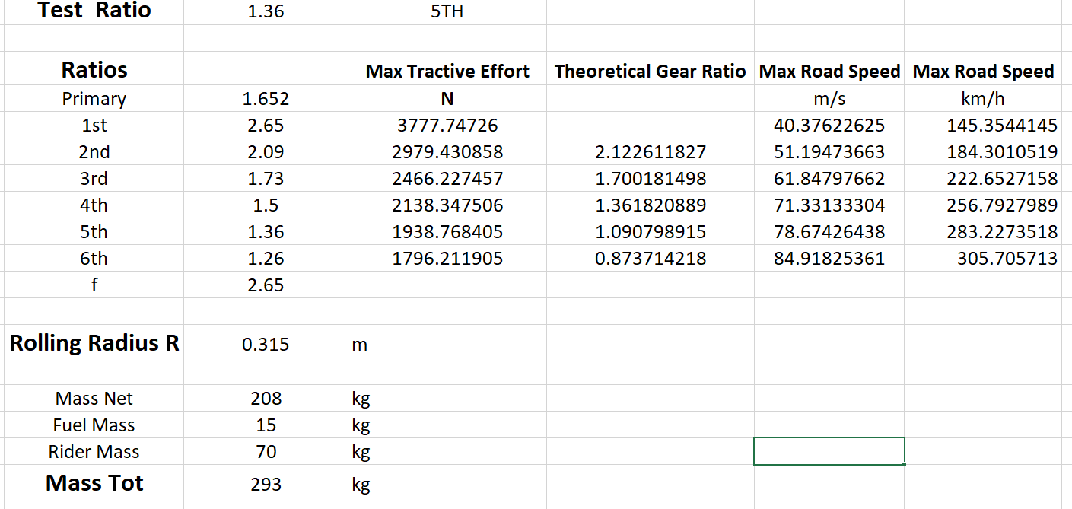

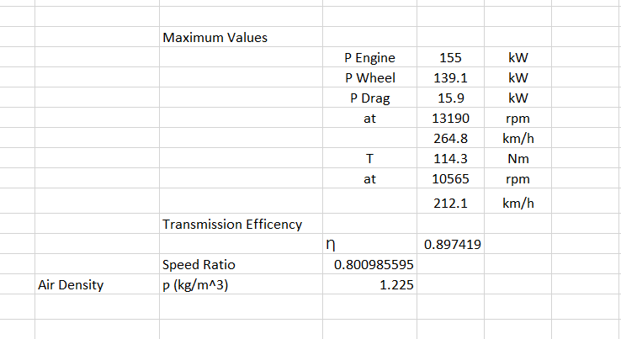

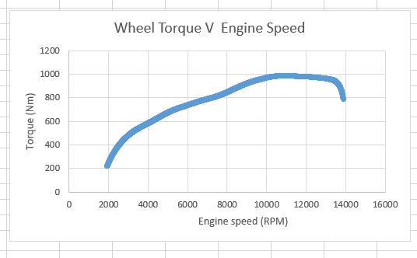
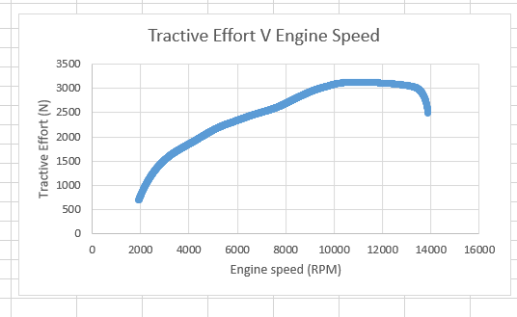

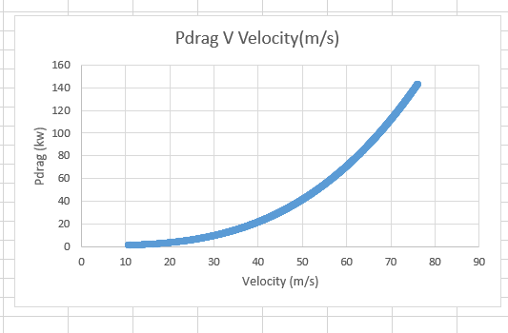

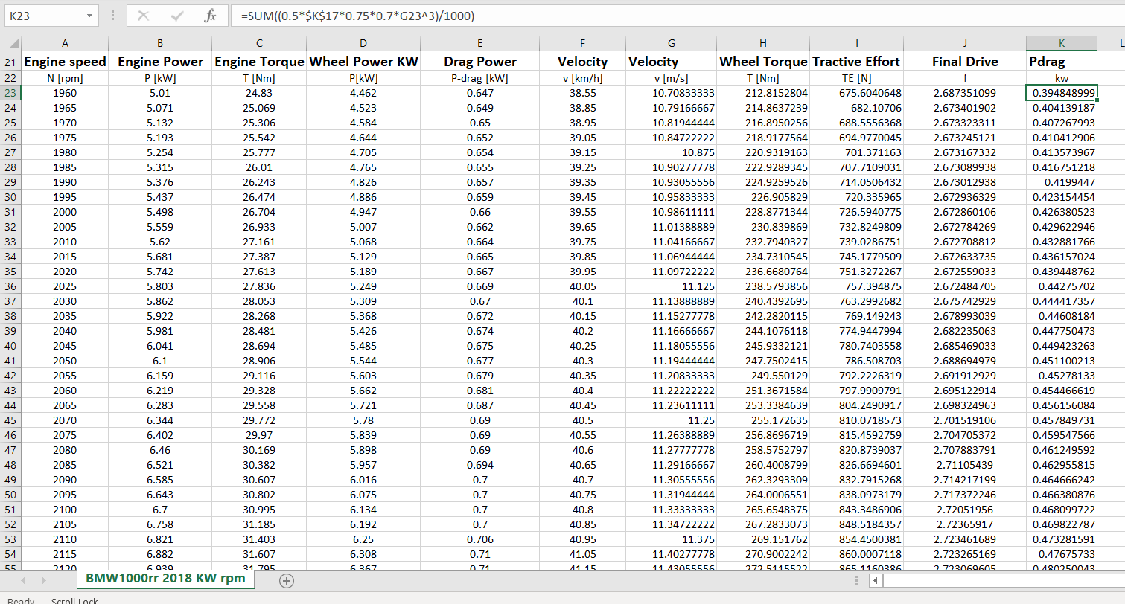

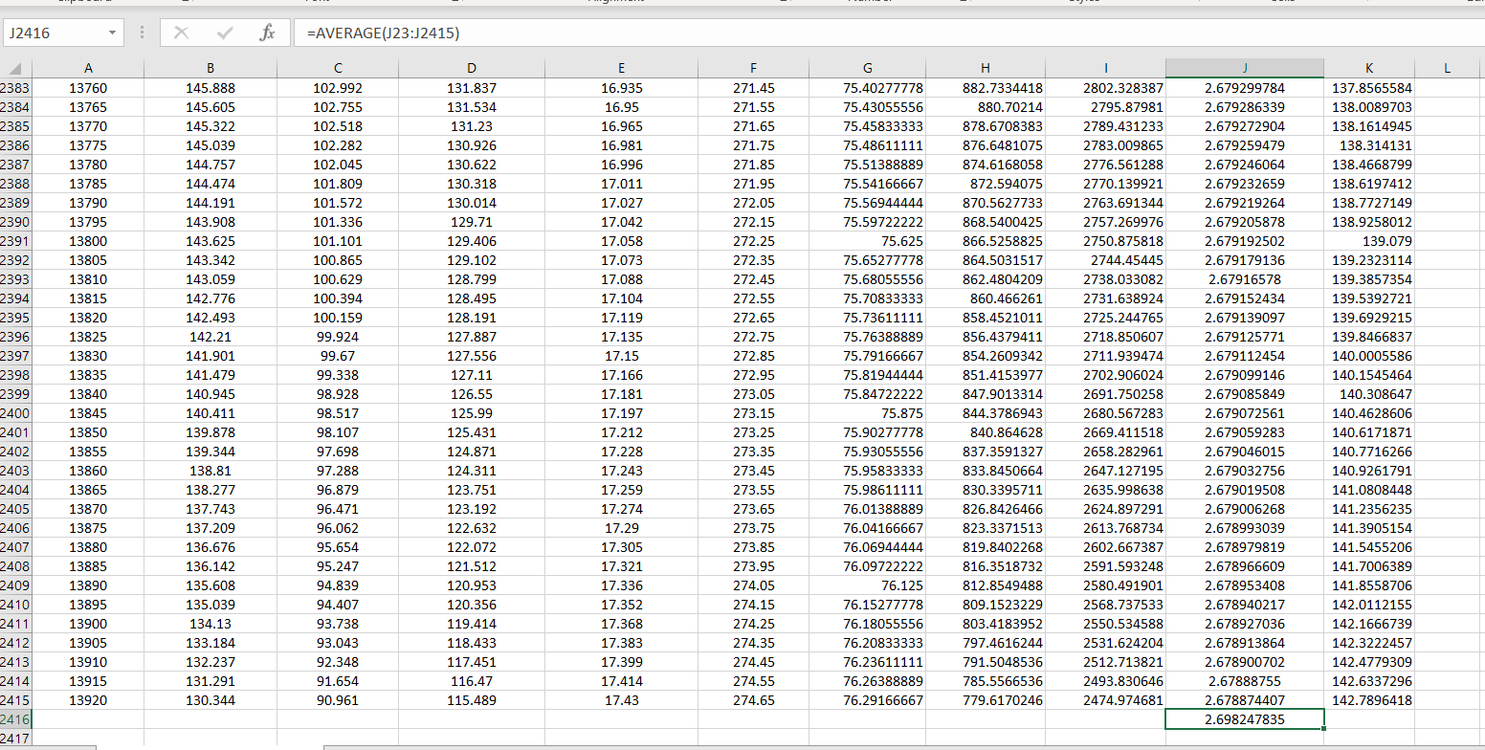

References

Helmenstine, A. M. (2020, February 04). What Is the Density of Air at STP? Retrieved April 26, 2020, from thoughtco: https://www.thoughtco.com/density-of-air-at-stp-607546
Oxley, M. (2010, october). BMW S1000RR. Retrieved April 24, 2020, from motorsportmagazine: https://www.motorsportmagazine.com/archive/article/october-2010/101/bmw-s1000rr
Woodford, C. (2020, January 27). Dynamometers. Retrieved April 26, 2020, from explainthatstuff: https://www.explainthatstuff.com/how-dynamometers-work.html

