3/23/2026
University of Wales Trinity Saint David
London campus
E-Portfolio Link: Click Here
Module Name: Learning In the Digital Era
Module Code: ACCA 4025

Student Name:Tejinder Singh Aulakh
Student ID:2533151
Group: 2

Lecturer’s Name: Koushik Modak

LDE Assignment 1
E-Portfolio
Table of Contents
Main Body 3
Task 1: Essential Academic and Employment Skills for the future career Path 3
Task 1 (a): Report on Essential Academic and Employment Skills 3
Task 1 (b): Evaluation of Task 1 (a) based on Similarity report 5
Task 2: Collaborative Mind Map and Individual Poster 5
Mind Map (Collaborative) 5
Task 3: Virtual Collaboration and RefWorks 8
Report on Virtual Collaboration 8
Step-by-step process of using RefWorks with visuals 10
Task 4: E-Portfolio Creation and Evaluation 27
Task 4 (a): E-Portfolio Creation 27
Task 4 (b): Illustrative Review of E-Portfolio tool Selection 31
References 34
Task 1 References: 34
Task 3 References: 35

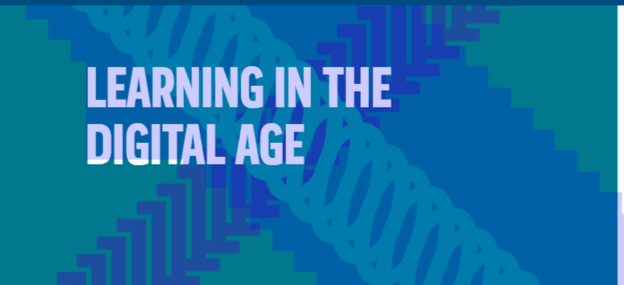

Introduction
Humanity’s desire to learn and progress has been both a catalyst and a challenge for the development of education. The greatness of a civilization often relies on the number of its scholars and its capacity to share their knowledge with successive generations.
To quote Aristotle, “the fate of empires depends on the education of youth”
LEARNING IN THE DIGITAL ERA: -
1)The Dawn of Digital Pedagogy - In this module the landscape of education is experiencing a profound, technology-driven, metamorphosis, transitioning from traditional classroom-bound models to dynamic, hybrid, and personalized learning environments. The Digital Era has redefined how knowledge is accessed, disseminated and constructed. This shift, accelerated due to the COVID-19 pandemic, has transformed E-Learning from a supplementary tool into a fundamental pillar of Morden Pedagogy.
2) A Paradigm Shift – Learning in the Digital Era requires a balanced approach one that leverages technology as a transformative force for good while fostering the critical, creative and human centric skills necessary for a rapidly changing future.

Main Body

Task 1: Essential Academic and Employment Skills for the future career Path

Task 1 (a): Report on Essential Academic and Employment Skills

Academic and employment skills definition
Academic skills refer to a blend of theoretical knowledge, understanding, practical abilities and attributes gained through formal education such as reading, writing and analytical thinking to succeed in both educational settings and the professional place.
Academic skills focus on acquiring knowledge, employment skills (often called soft skills) and focus on applying that knowledge in a professional manner.
Employment skills (often called employability skills) on the other hand encompass the practical skills and competencies necessary to perform a job effectively including communication, problem solving and teamwork. These skills are very essential for transitioning from academic success to workplace performance. This will ensure long term career success and adaptability and are often sought after by employers [1].



Figure: A picture showing an interaction between Academic and Employment skills [2].

Academic skills required for your studies
Students need a variety of academic skills to succeed in their studies. These skills include CRITICAL THINKING which is understanding concepts in-depth and developing new ideas. Then it is PROBLEM SOLVING for overcoming challenges and finding solutions. Another is MOTIVATION which is self-discipline and the ability to manage time and workload. FLEXIBILITY in adapting to changing demands and workloads. Having TECHNOLOGY and RESEARCH skills for effective learning, finding and using relevant information sources. Student should have WRITING skills to write concisely, critically and with an academic tone. TIME MANAGEMENT to juggle multiple courses, assignments and extracurricular activities. To have COMMUNICATION skills for effectively communicating thoughts and feelings. These skills are essential for both academic success and future career opportunities. [2]

Employment skills required for future employment
The future workplace is undergoing a transformation driven by technological advancements, globalization and shifting market demands. These skills include DIGITAL LITIERACY helps in understanding technology online, communication and basic coding. The next is CRITICAL THINKING and PROBLEM SOLVING which helps in analysing information logically, making decisions and solving problems. COMMUNICATION skills help in clear verbal and written communication across diverse platforms. TEAMWORK and EMOTIONAL INTELLIGIENCE(EC)helps working effectively with others from diverse backgrounds, both in-person and virtually. CREATIVITY and INNOVATION to generate new ideas and embrace creative solutions. Then need ADAPTABILITY and FLEXIBILITY to learn new skills and adapt to changing environments.

Need LEADERSHIP and INITIATIVE to take charge, inspire others and show self-motivation. FINANCIAL LITERACY to help basic money management, budgeting and understand economic principle. GLOBAL AWARENESS to appreciate cultural diversity and work across borders. These skills are essential for students to thrive in the job market to be successful in their future careers. [3]

Task 1 (b): Evaluation of Task 1 (a) based on Similarity report
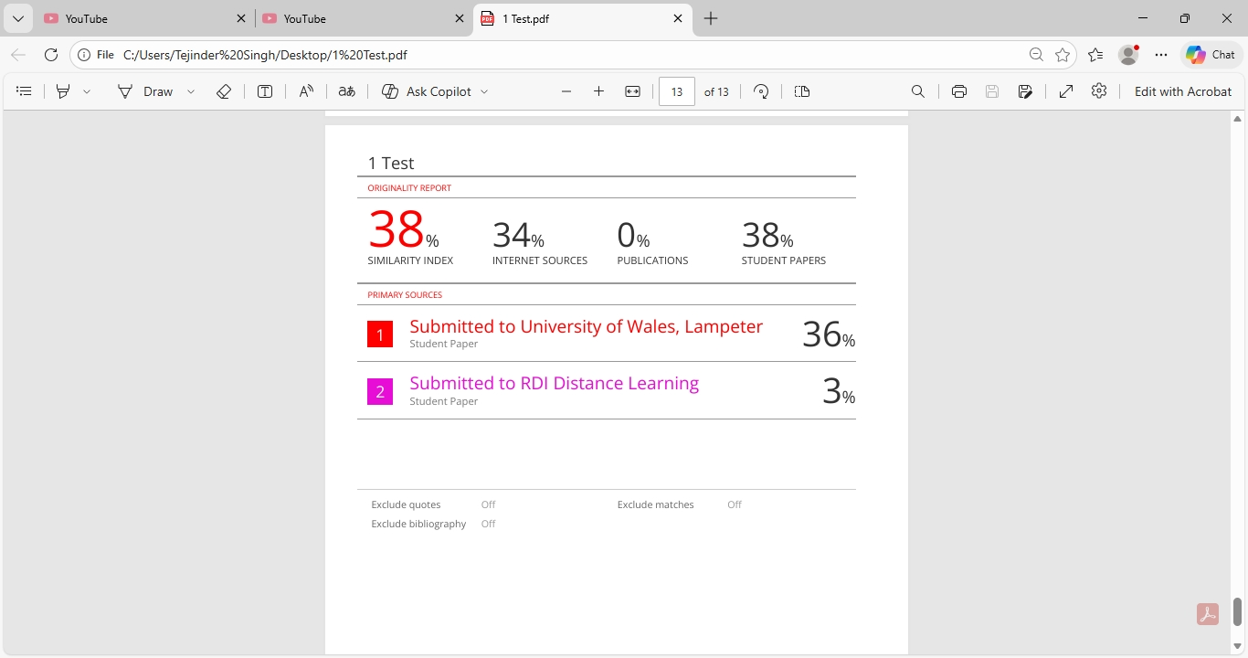

The similarity report is showing some similarity as same templates were used by many students. Rest of the work for paraphrasing, referencing, IEEE references, citations has been very good. Some similarity is also due to use of student papers, internet sources and some to distance learning.
The marks as per my work should be 78 out of 100 as I have studied a lot of student papers, distance learning articles, websites and tried to put a picture showing relevance to my assignment for academic and employment skills. This also shows that I am following my tutor’s lectures and brief for my assignments.

Task 2: Collaborative Mind Map and Individual Poster

Mind Map (Collaborative)
Mind map link: https://mm.tt/map/3952804656?t=lRLOV3WVag
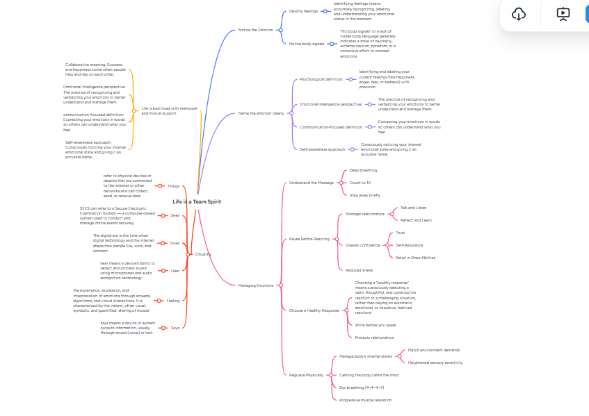

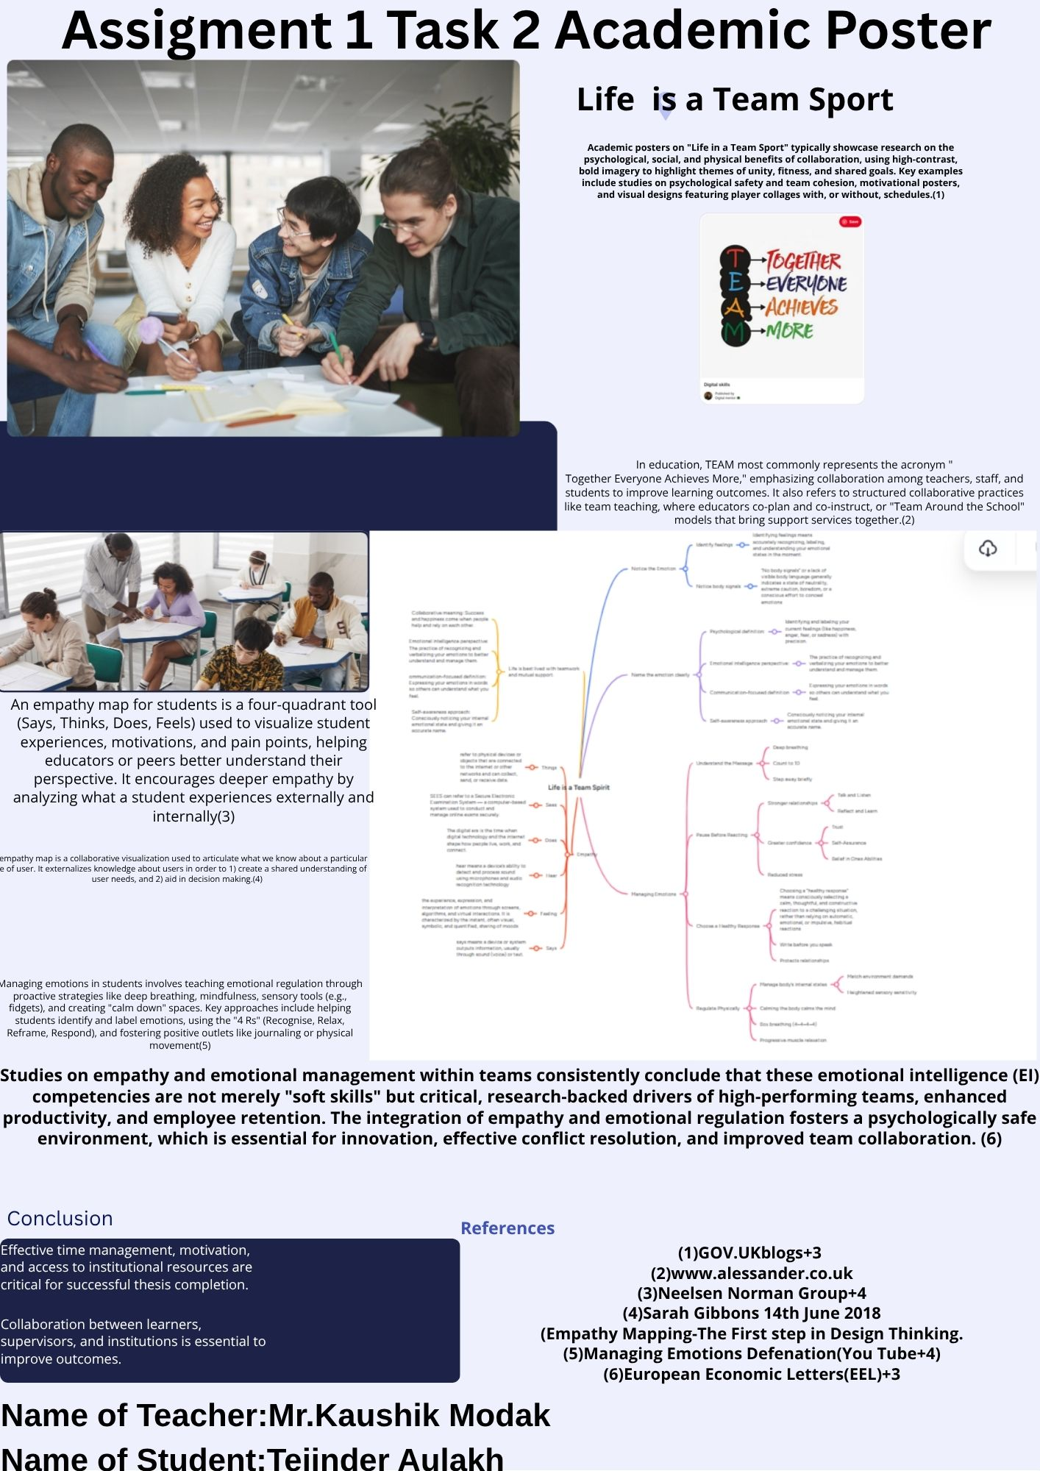Poster (Individual)
Click Here

Task 3: Virtual Collaboration and RefWorks

Report on Virtual Collaboration

Commonly used terms to describe Virtual Collaboration are collaborative and cooperative learning, group works, group interaction, group learning and teamwork. A constructivist pedagogy, group-based process with a shared purpose, support and web-based technology is required for virtual collaboration to take place. Consequences of virtual collaboration are higher order thinking and learning to work with others. (Henny Breen PhD, 2013) [1]

The interdisciplinary research endeavour of computer-supported collaborative work has already investigated information technology that supports collaboration. With rise of artificial intelligence (AI), new forms of collaboration need to be considered that involve AI as an active partner within a collaborative setting. (Dominik Siemon (Technische Universität Braunschweig, 2018)[2]
Under Virtual Collaboration we have four topics: - 1) Forming a team 2) Riding the storm 3) The new norming 4) Lights, cameras, action!
RIDING THE STORM
We will look at how conflict and friction occur between Virtual Team (VT) members and the dangers associated with conflict avoidance.
1)We will look at impact of conflict and conflict management style on deadbeats and deserters in Virtual Teams (V T’s). Deadbeats and Deserters reported experiencing more conflict and less trust, group cohesion, communication more difficult and satisfaction when working in virtual teams. The deadbeats and deserters more likely to use an avoidance conflict management style and active team members will use an integrative approach to conflict management. [3]
2)With globalisation and advances in communication technology we have now Global Virtual Teams (GVT’s)and much more potential of conflicts as members works across cultural, geographical and time boundaries. This all-effects team performance and cultural diversity contribute to both task and relationship conflict while functional diversity may result in task conflict. [4]
3)In the past decade we have had tremendous studies focusing on VIRTUAL TEAMS. It has now been identified that management of conflicts and emotional behaviour of virtual team members as one of the most critical difficult tasks facing virtual teams.[5]
By extending the theory of conflict, emotion and virtuality: -
- We tried to trace the development of conflicts and emotions in virtual teams.
- Emotions trigger conflict and are indicative of need to progress group development.
- Emotional regulation and feedback seeking are used to manage conflicts and emotions.
- Based on results we model the management of conflict and emotions in virtual teams.[6]

Consistent with contemporary views on the classic four stages of group development ‘forming’ ‘storming’ ‘norming’ and ‘performing’ it was found that all teams did not experience all four stages of group developments. Some teams found it difficult to make the transition from one stage to another especially from Stage 2 ’storming’ phase. This demonstrates that Virtual Teams experience cognitive, affective and role ambiguity conflict. VT members respond to conflicts by communicating negative emotions online and this escalates cognitive conflict. [7]

4)With the rise in remote work models particularly in IT and GAMING industries which are high stress, innovation-driven sectors, conflict management has become essential. This aims to give practical strategies that HR professionals can use to resolve conflicts in VIRTUAL TEAMS. The conclusion is that while remote work does not inherently create conflicts, it brings unique challenges such as asynchronous communication, lack of non-verbal cues and cultural differences can lead to misunderstandings. Other factors that impact team dynamics, are psychological adaptability and time limited interactions. This discussion emphasizes the role of HR and leadership in mediating conflicts and fostering effective communication. It also highlights practical strategies, including one-to-one meetings and tools that compensate the absence of informal, in-person communication and offers insights into tailored conflict resolution approaches for remote settings. [8]

Step-by-step process of using RefWorks with visuals

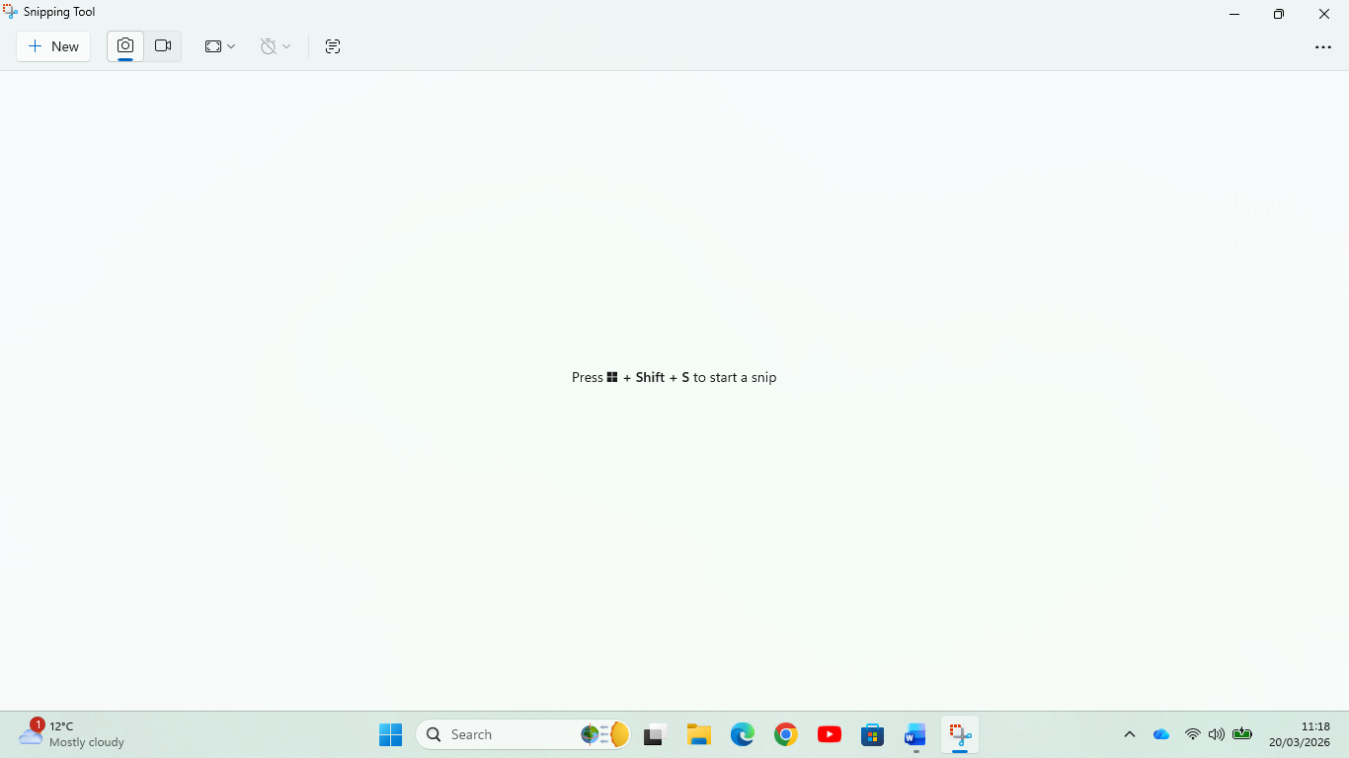

All screenshots were taken using this formula in above slide.

Step-by-Step process of using RefWorks with visuals and meaning of RefWorks and its Key Features.
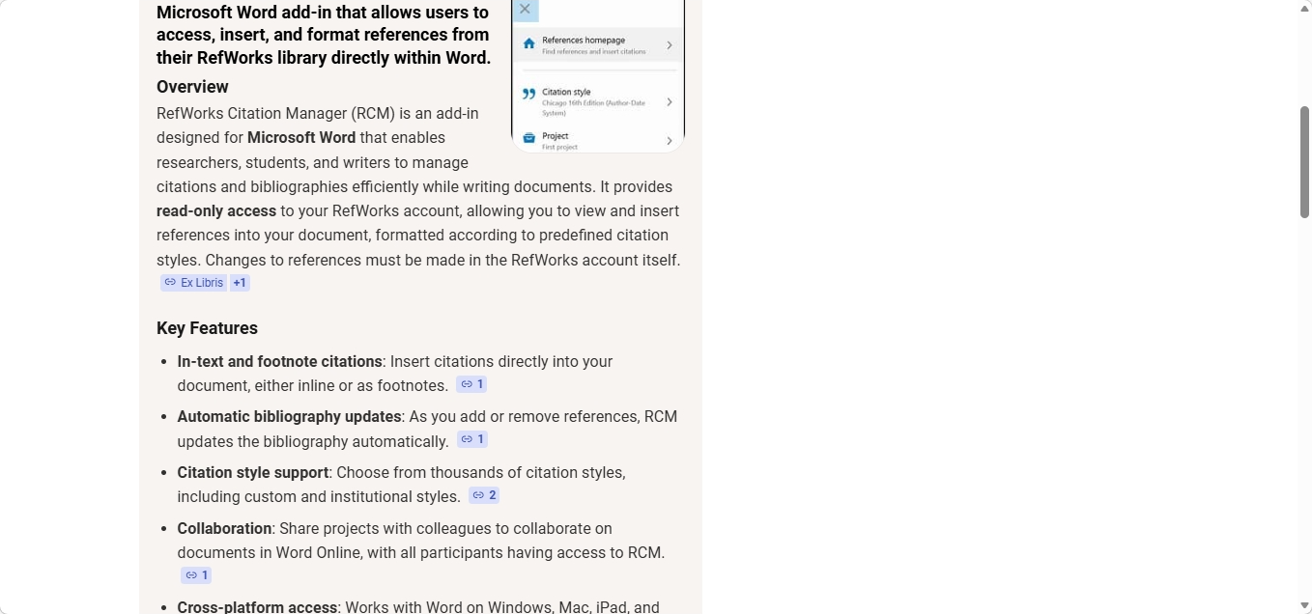
The above picture gives us detailed meaning of RefWorks and its Key Features.

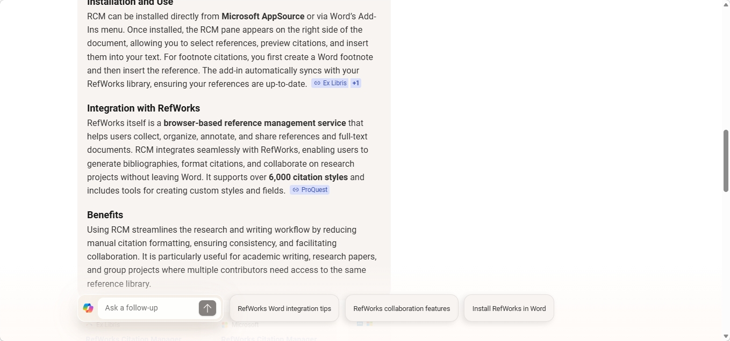
The above slide shows us the installation and use of RCM
And integration with RefWorks and Benefits.
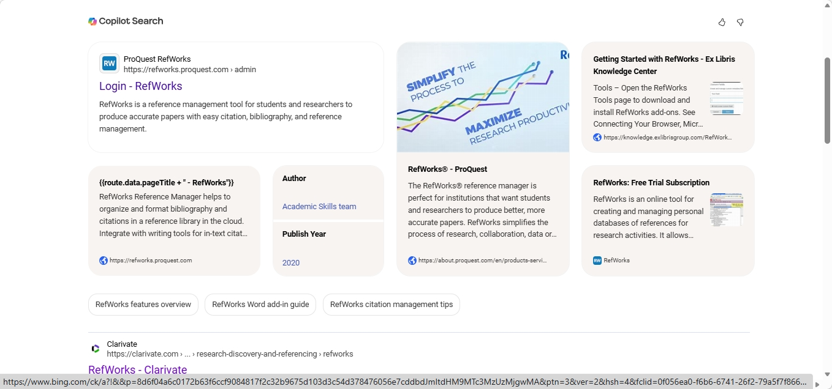
This slide shows login details for Ref Works

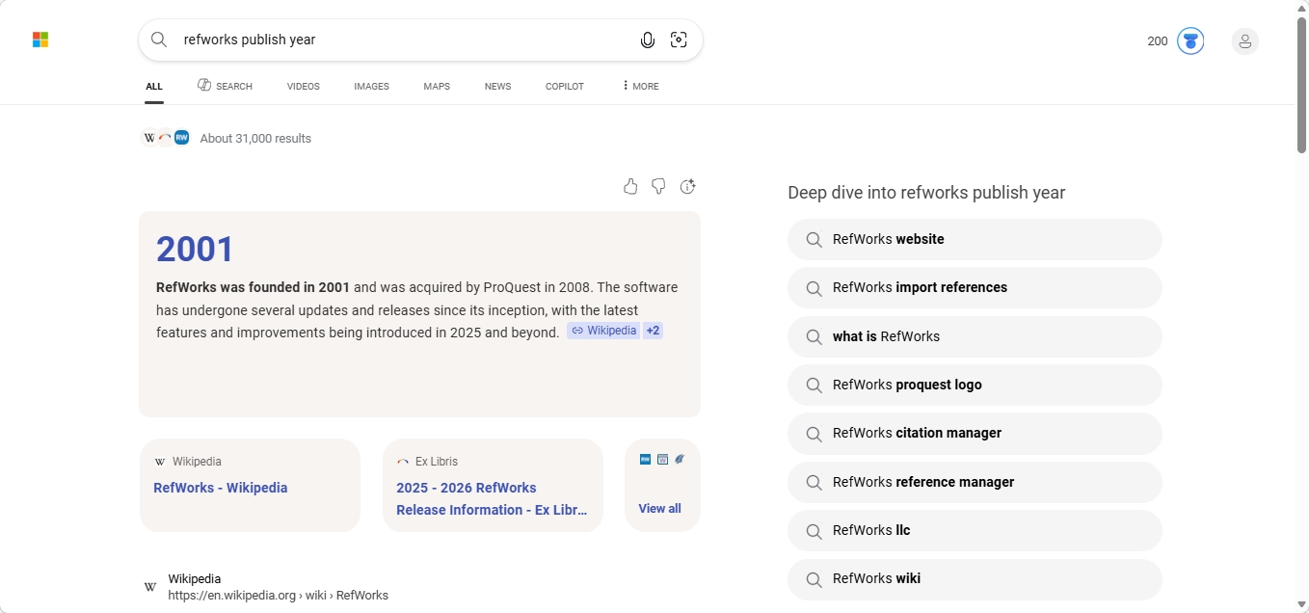The above screenshot shows RefWorks was founded in 2001
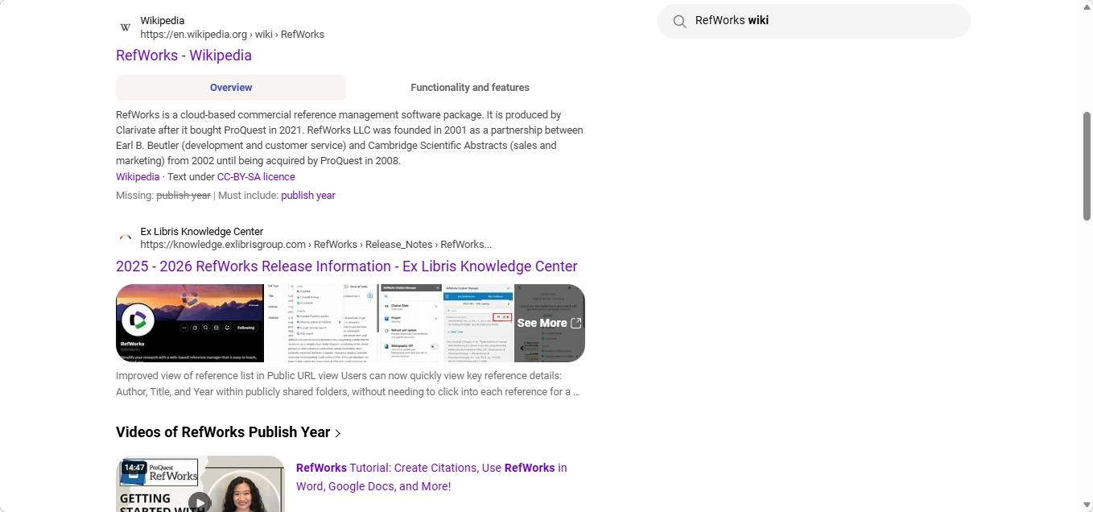

The meaning of RefWorks is explained in the above slide.

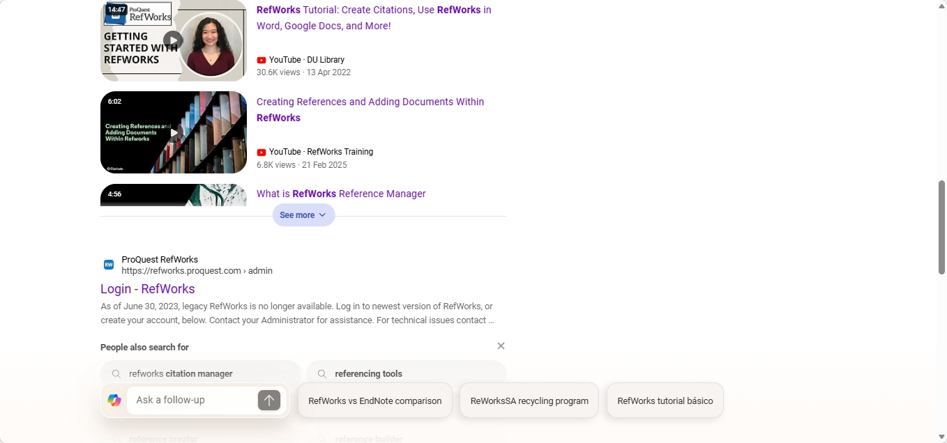
These are the videos I watched to understand how RefWorks works is used in different ways.
These are results for RefWorks
Search instead for RefWorks login
Login - RefWorks - ProQuest
RefWorks
https://refworks.proquest.com › login

Reset your RefWorks password easily. Enter your registered email, and we'll send a link to help you regain access to your account


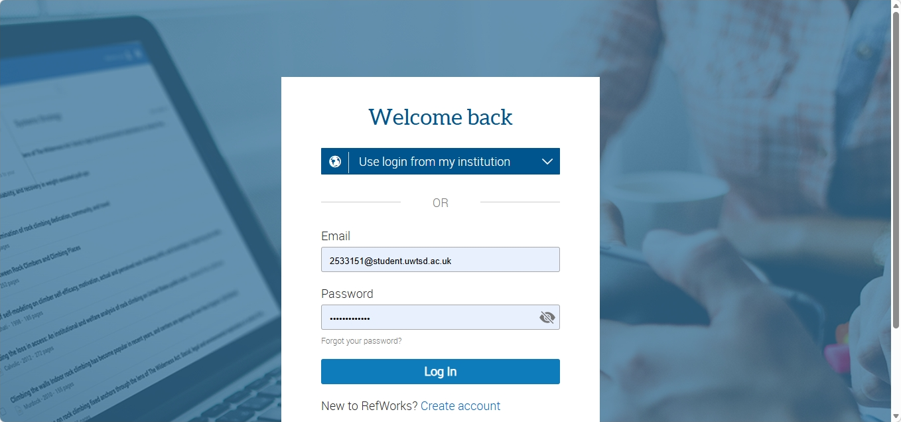
This was how I logged into RefWorks with my institution E-Mail and set my Password.

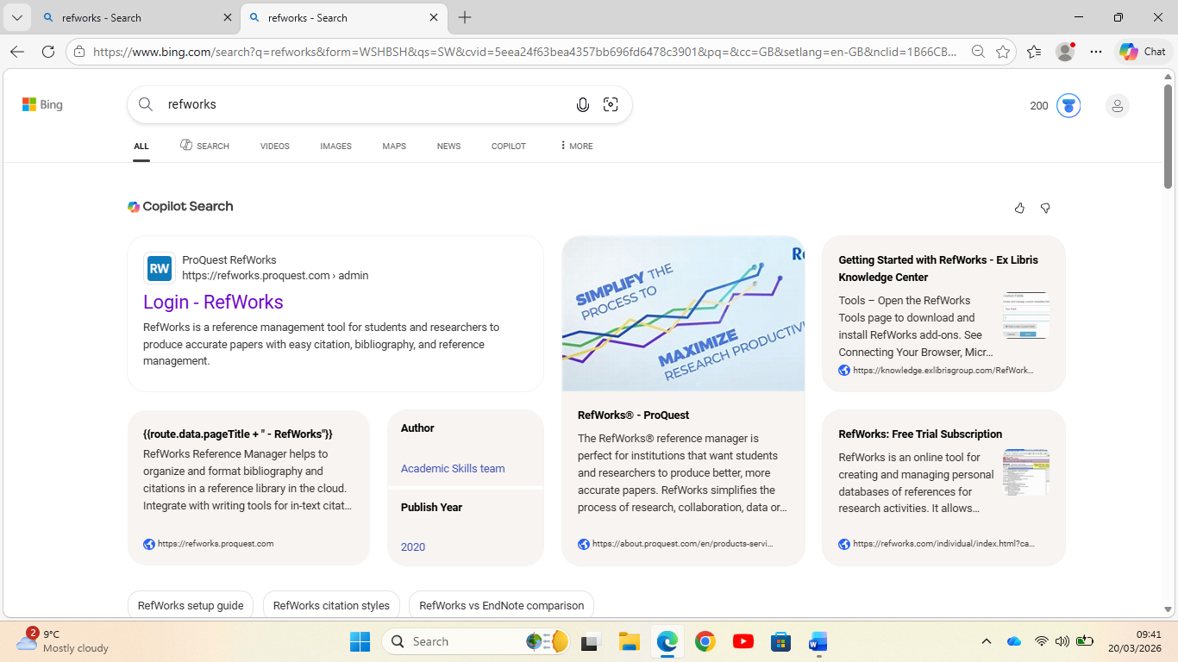
The slide shows the login feature for RefWorks

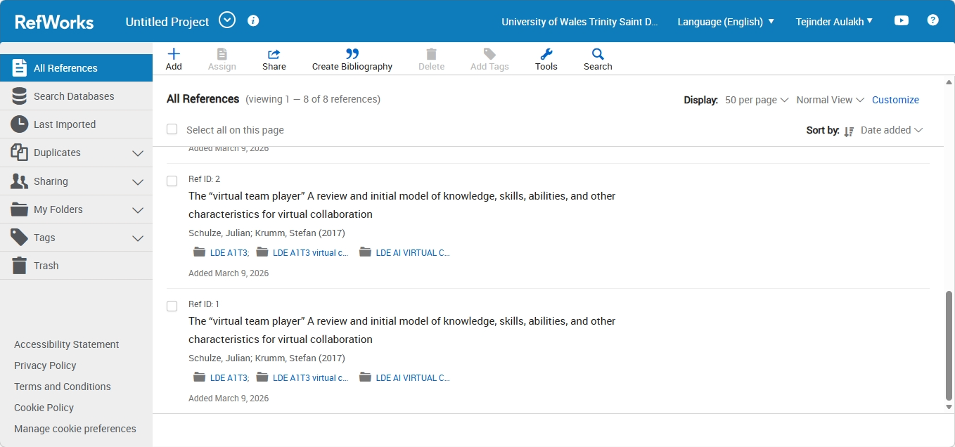
This shows the RefWorks practice we did in the Classroom with our Professor.
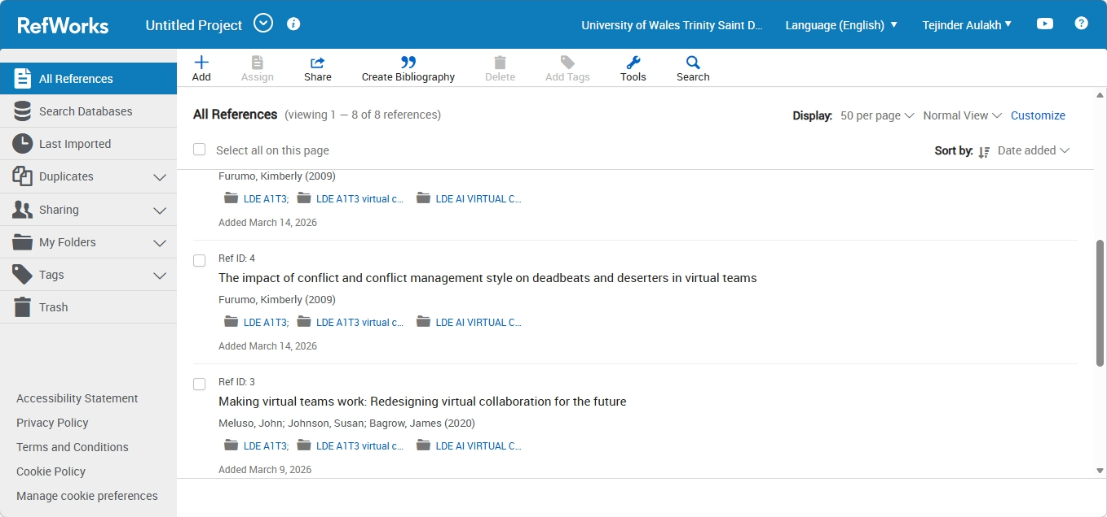In this picture we have the references in RefWorks I used in my writing Virtual Collaboration topic Riding the Storm from two websites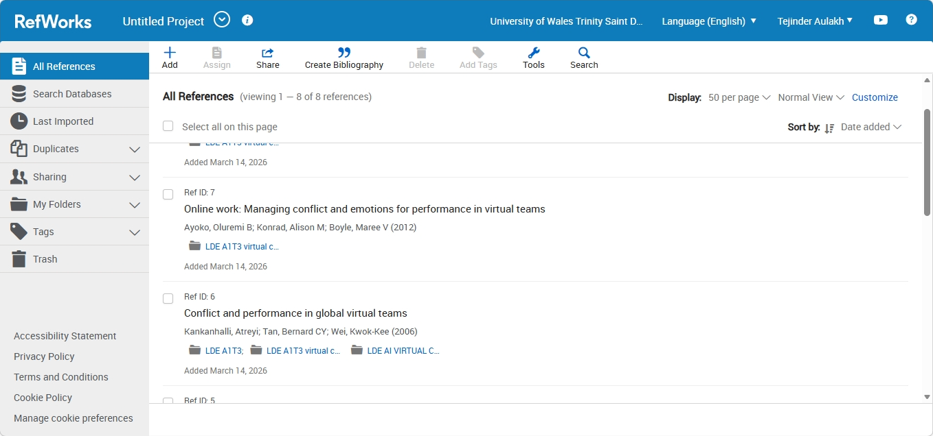
This screen also shows RefWorks used for other two websites I used for my writing on the topic Riding the Storm.

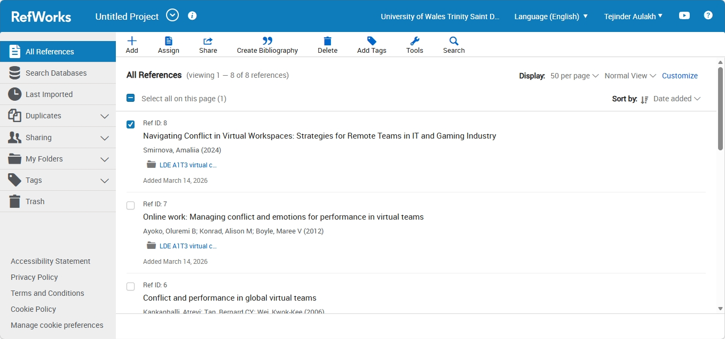
The above slide shows the final websites RefWorks I used for writing on the topic Riding the Storm.
Google Scholar provides a simple way to broadly search for scholarly literature. Search across a wide variety of disciplines and sources: articles, theses, ...

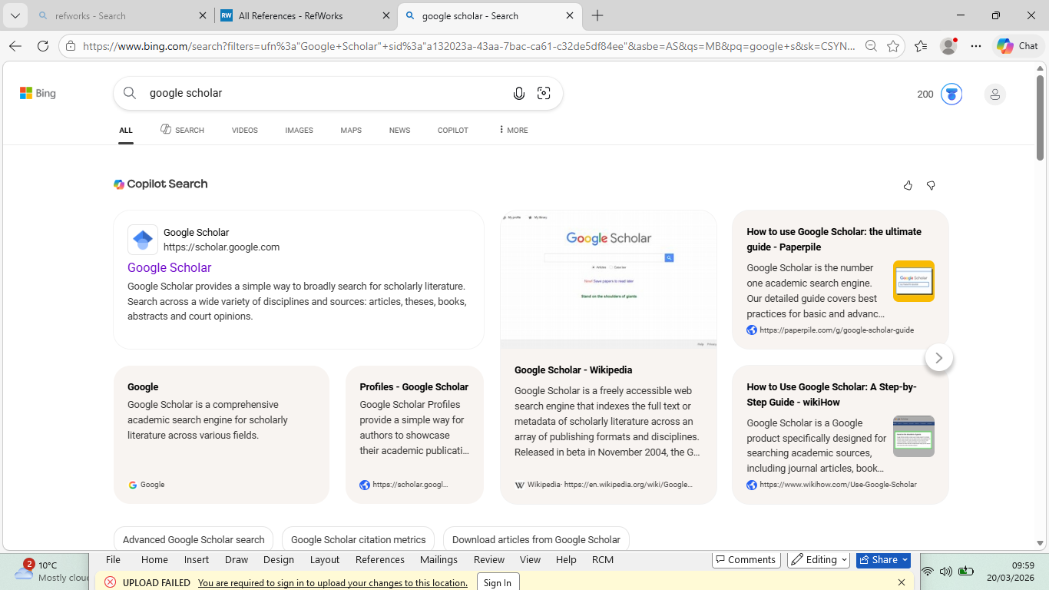

This slide shows for writing the report on Riding the Storm I used Google Scholar.
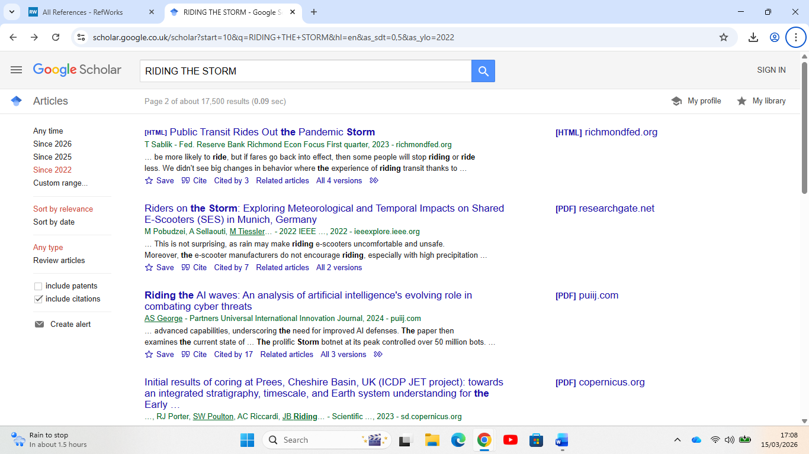
This slide in google scholar I put topic Riding the Storm to look for different writeups in websites and journals.
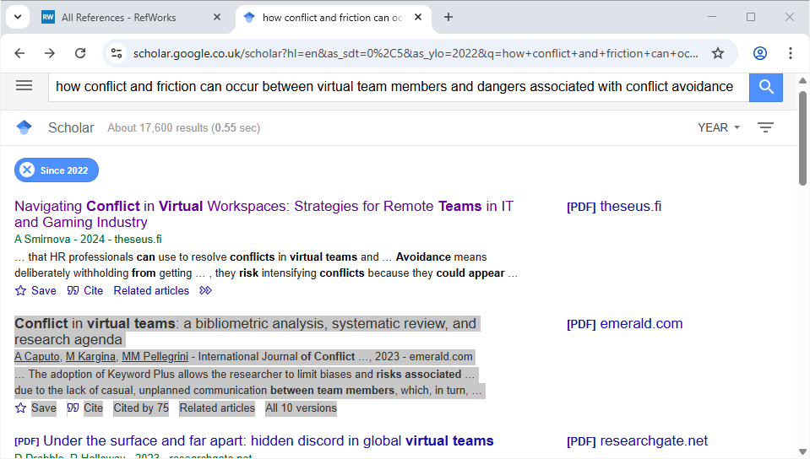
I tried getting answers from google scholar by putting what we were looking to achieve by the title Riding the Storm then I added what we were looking for. It was how conflict and friction can occur between virtual team members and the dangers associated with conflict avoidance.
Conflict in virtual teams: a bibliometric analysis, systematic review, and research agenda
A Caputo, M Kargina, MM Pellegrini - International Journal of Conflict …, 2023 - emerald.com
… The adoption of Keyword Plus allows the researcher to limit biases and risks associated …
due to the lack of casual, unplanned communication between team members, which, in turn, …
Save Cite Cited by 75 Related articles All 10 versions

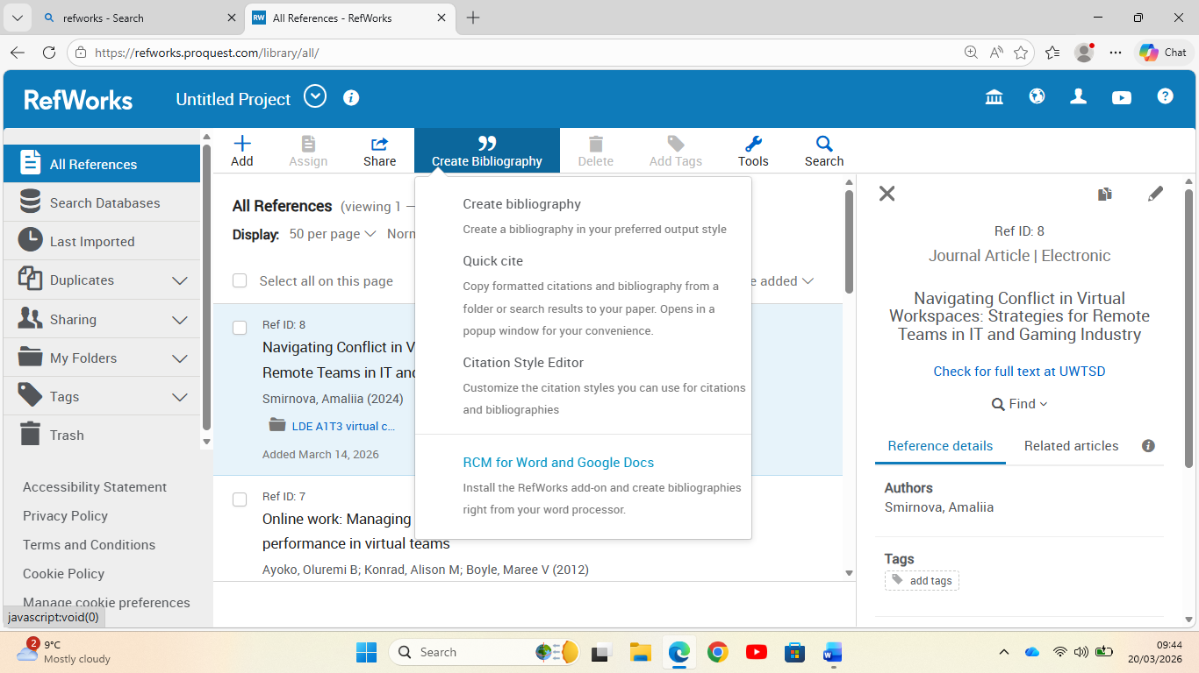
This slide explains how to create Bibliography

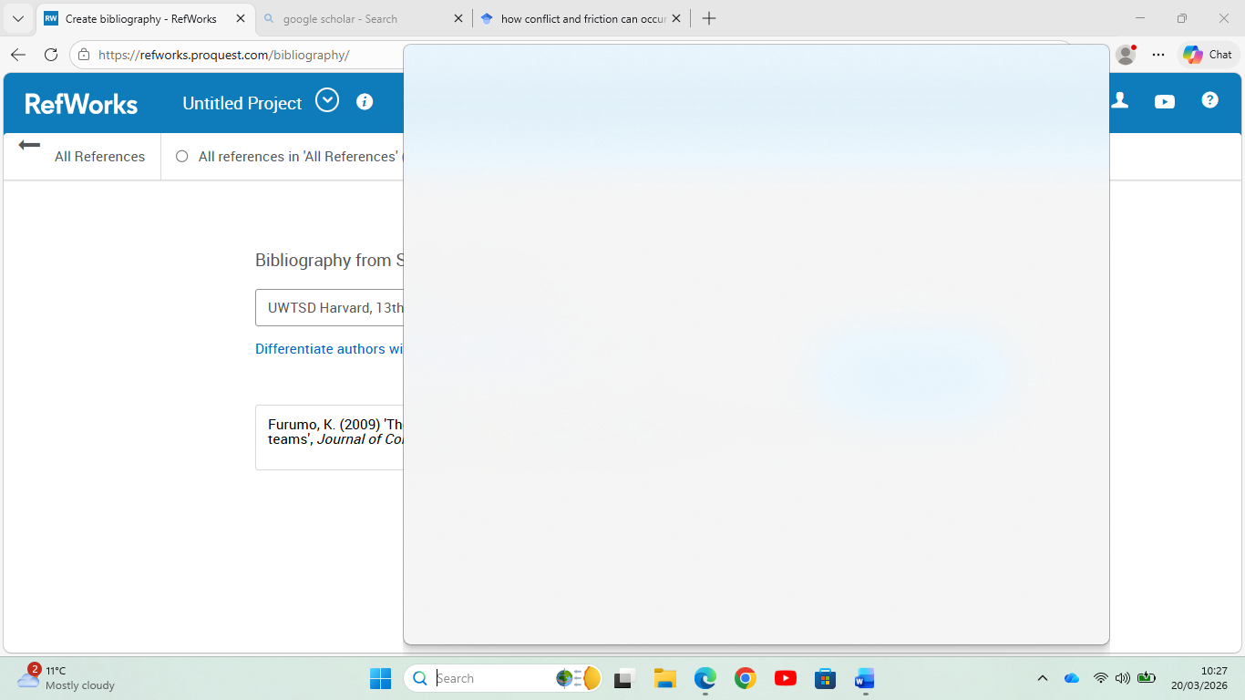

The above slide shows when I pressed bibliography after doing my cite this screen came up.

use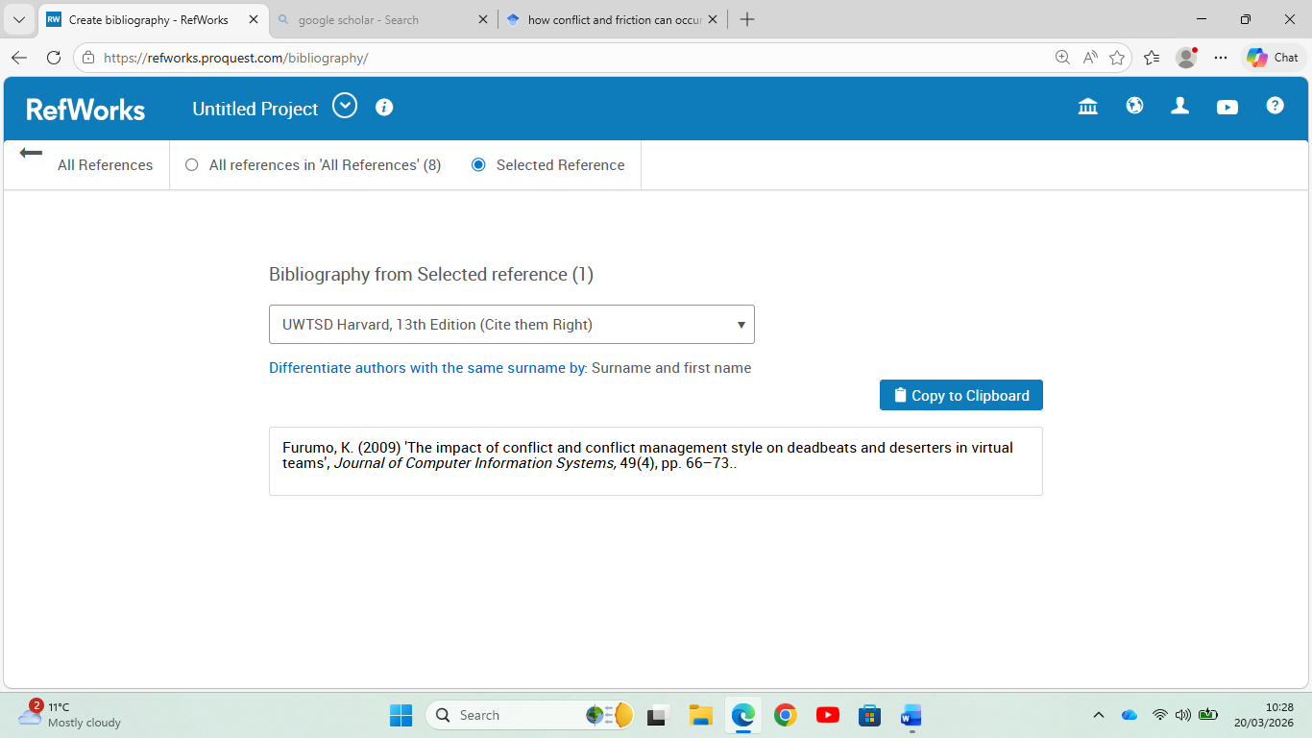
This slide shows Bibliography for one of the articles used for my Project.

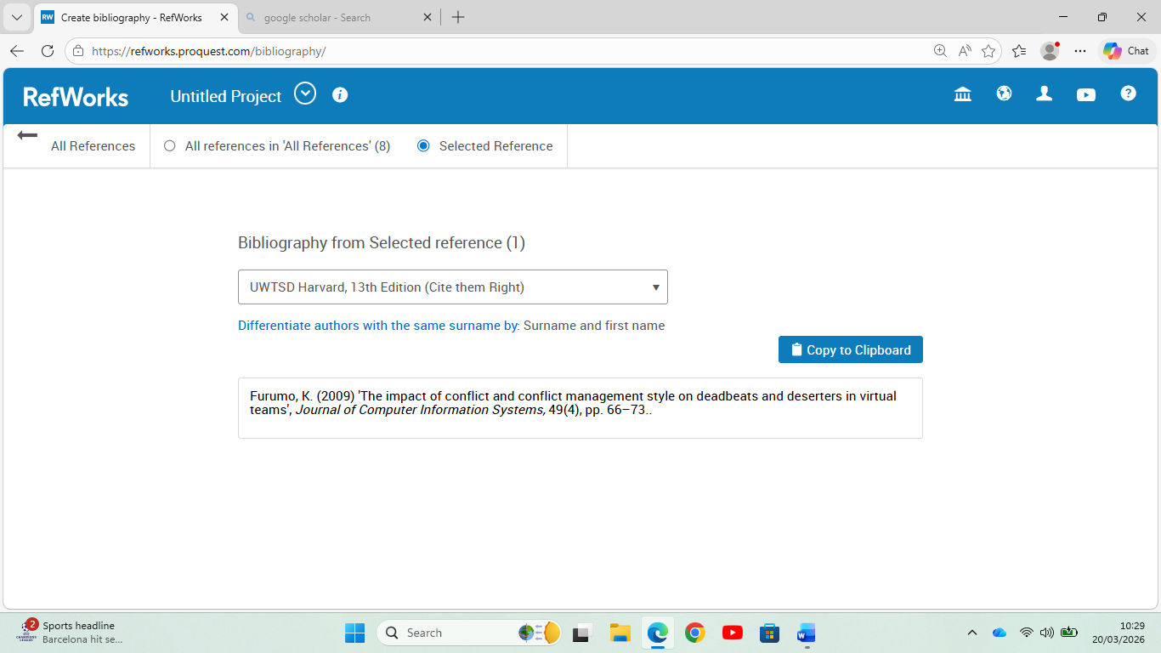
This slide shows I copied to Clipboard.

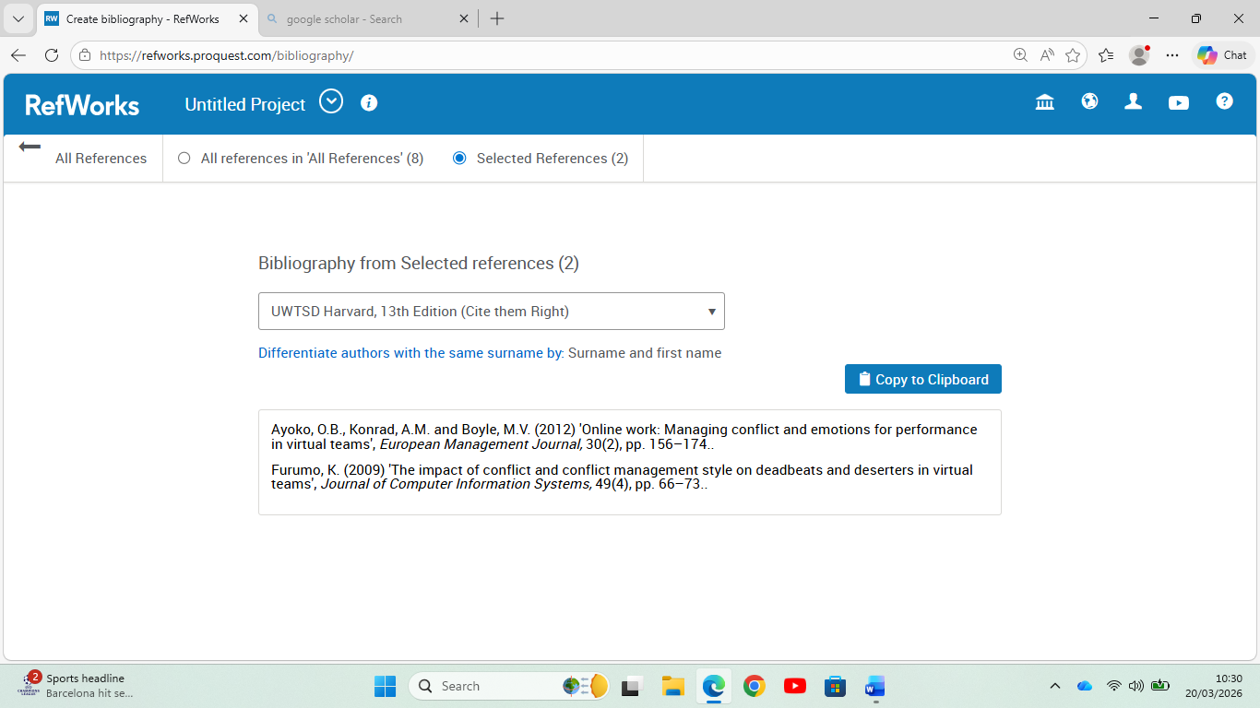
This slide above shows Bibliography for second article after the cite function.

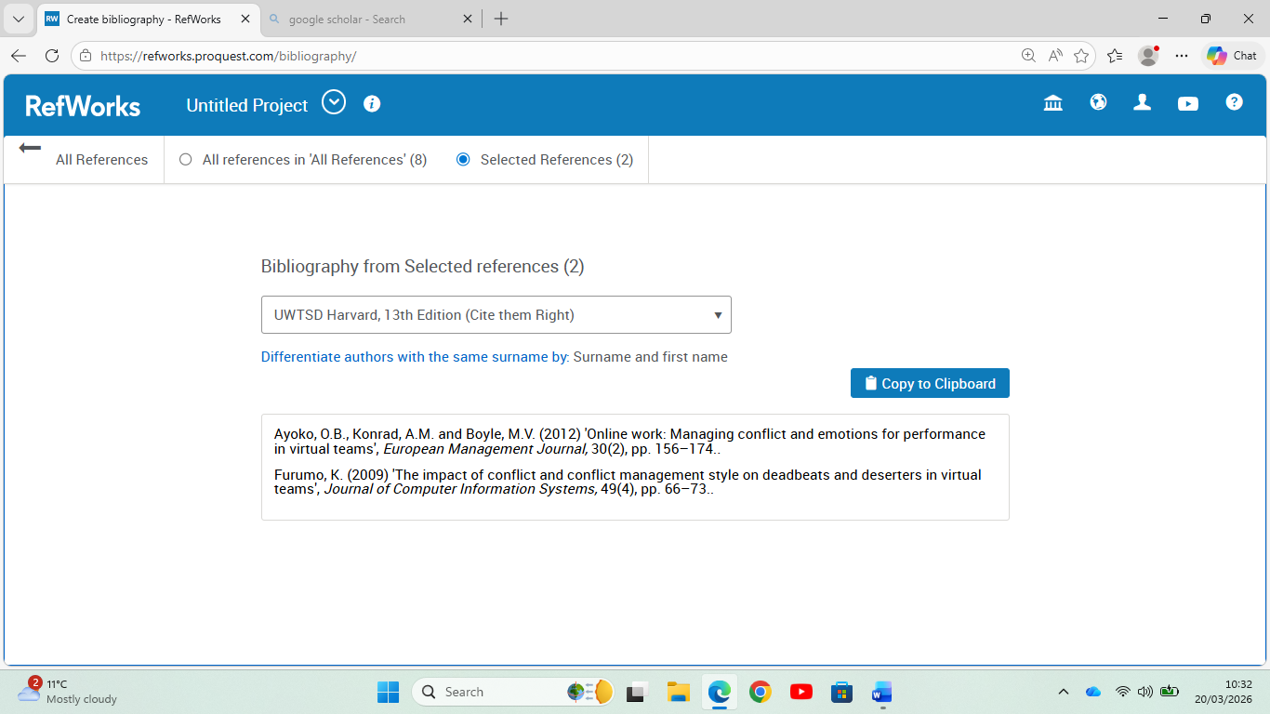
Then it was copied to Clipboard.

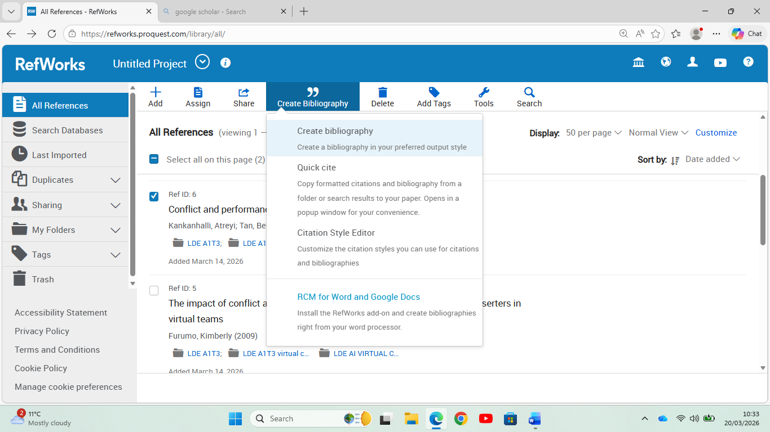
The same step repeated for Bibliography for next article used after Cite.

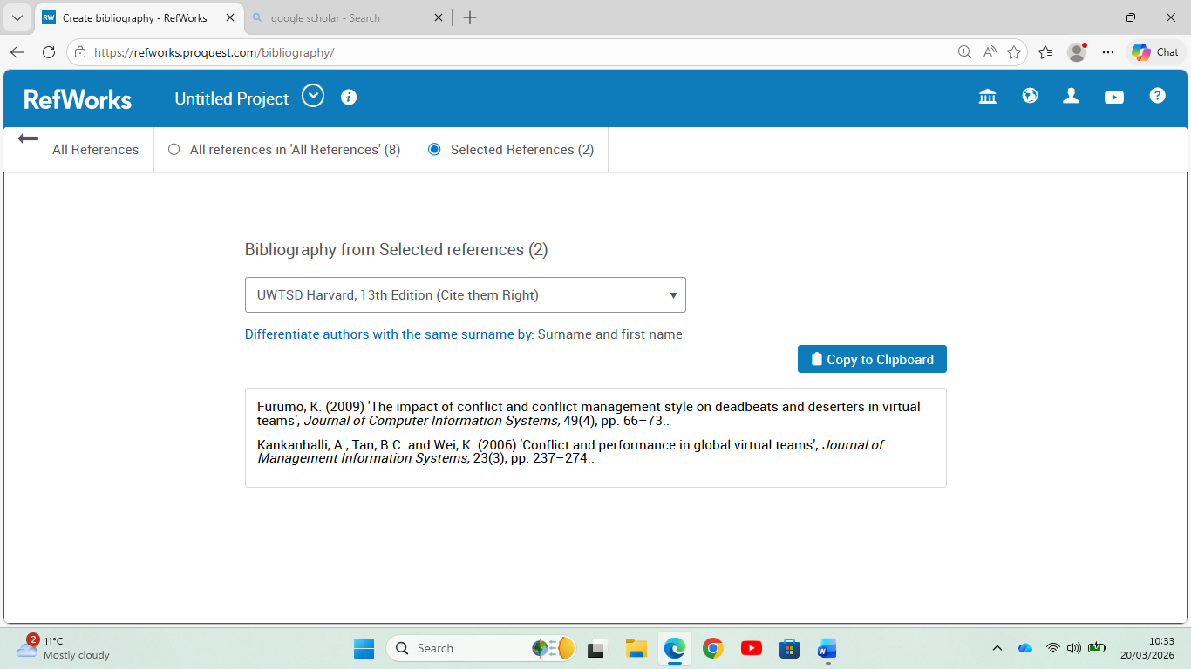
Bibliography step used for second reference in above slide.

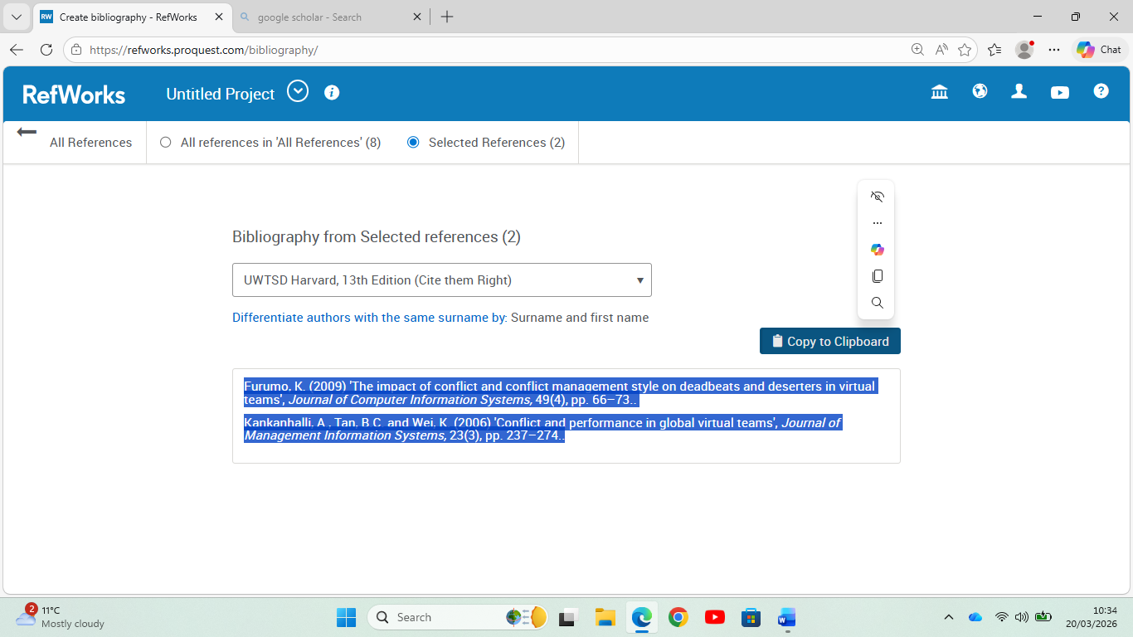
In the above slide again copying Reference (2) to clipboard.

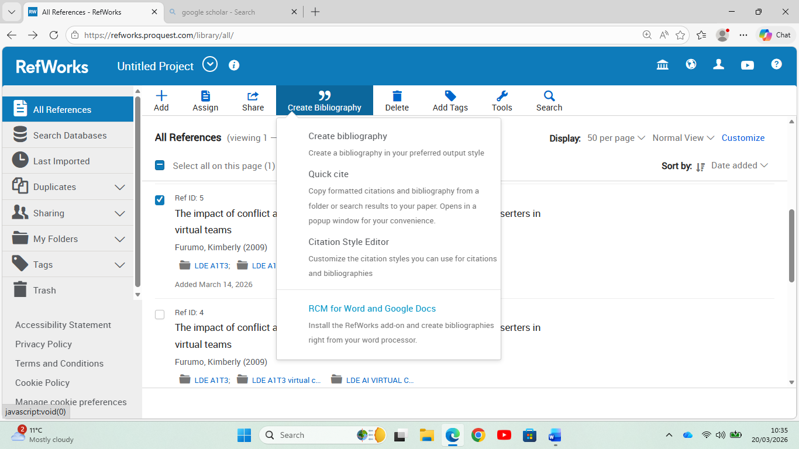
Here in above slide creating Bibliography for Reference (5)

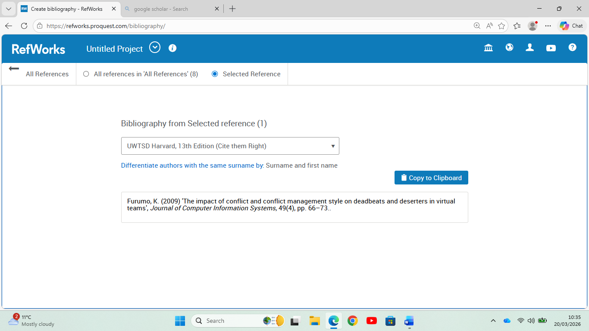
In the above screen after the Bibliography of Reference (1).

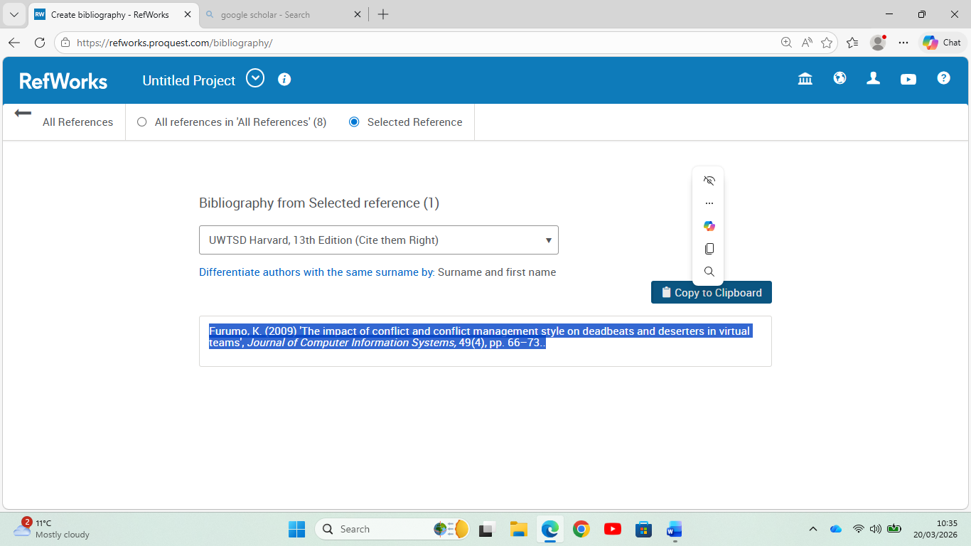
Here we copied to clipboard after the Bibliography of Reference (1).

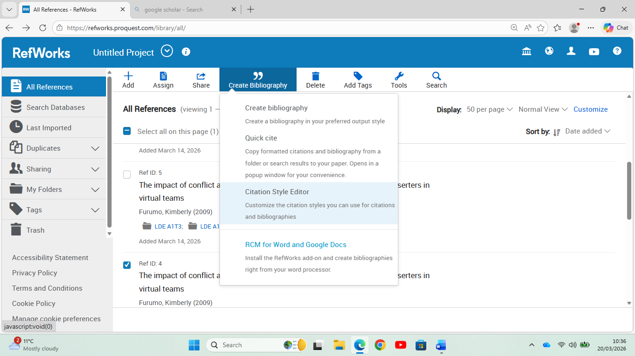
The above screen we are applying step of Bibliography to Reference (4).

Task 4: E-Portfolio Creation and Evaluation

Task 4 (a): E-Portfolio Creation
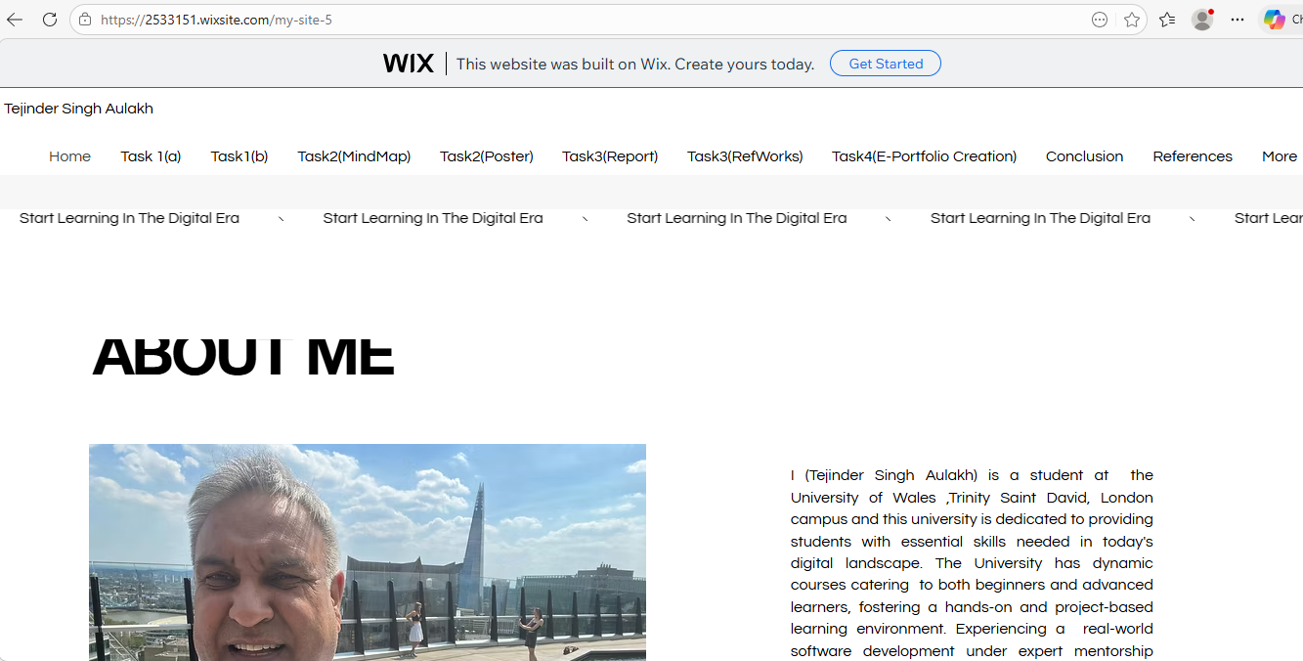
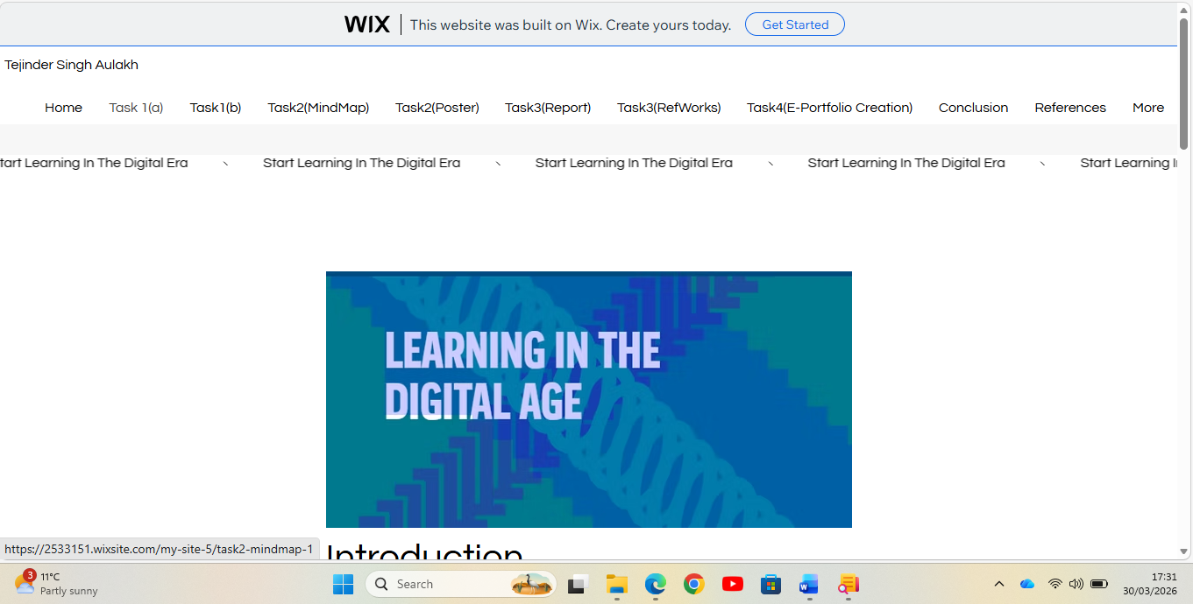
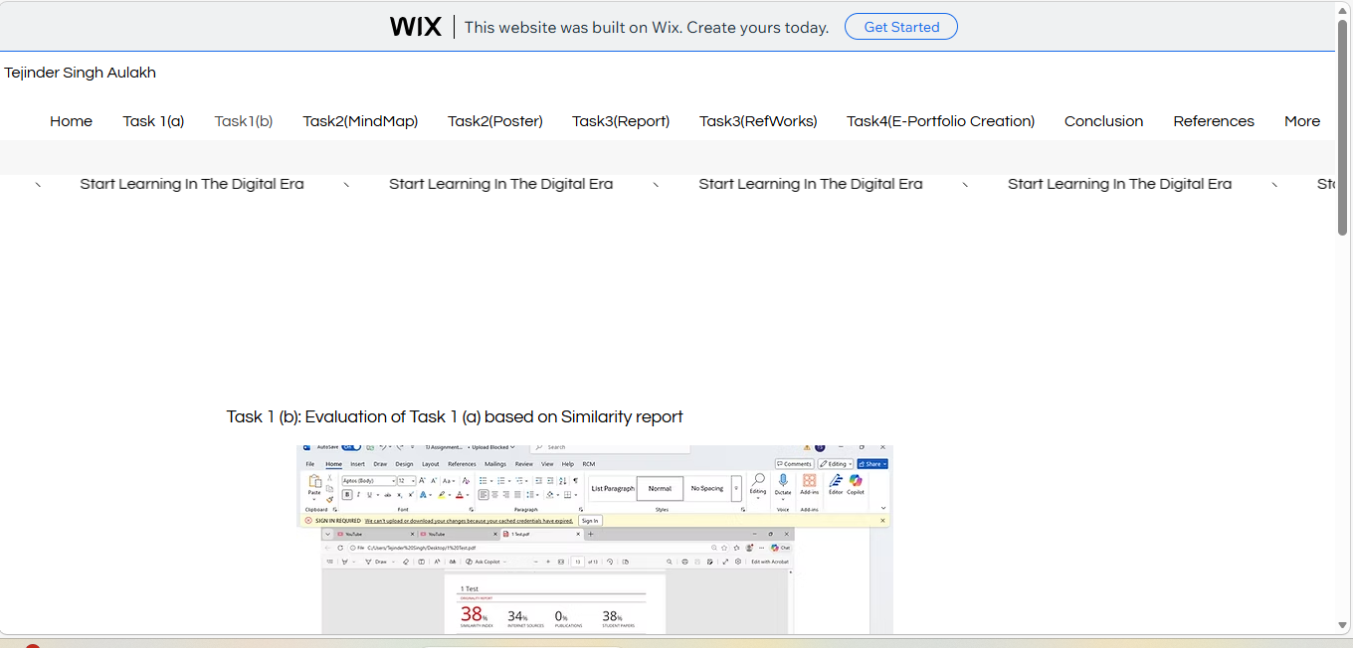
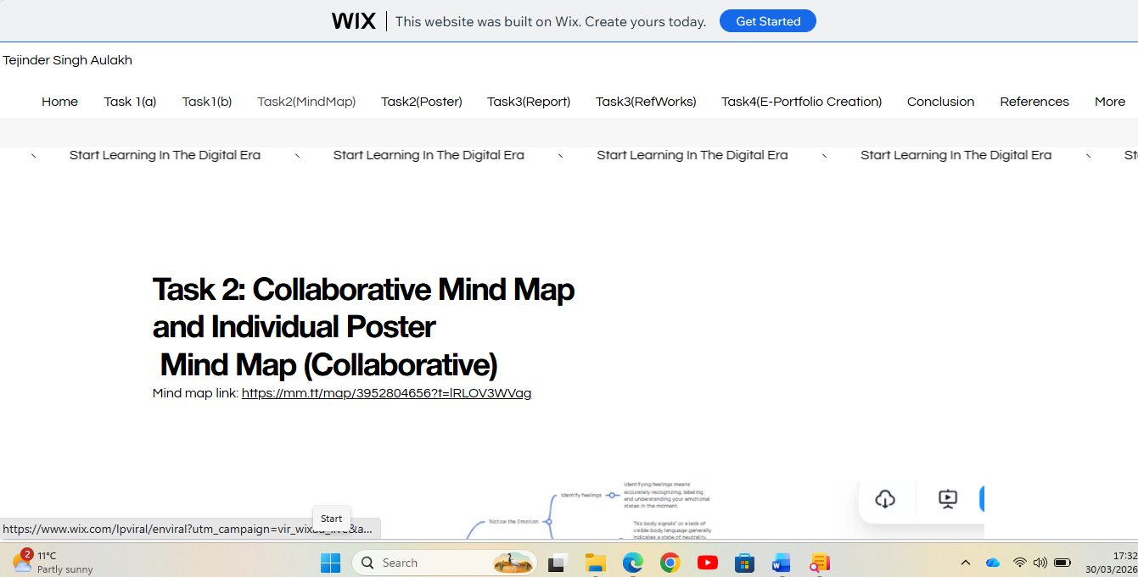
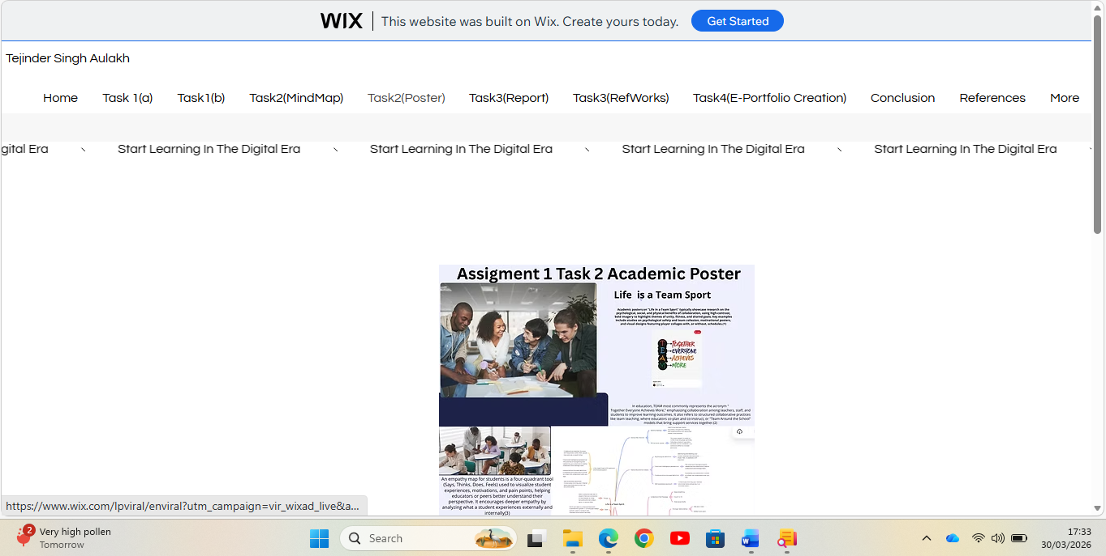
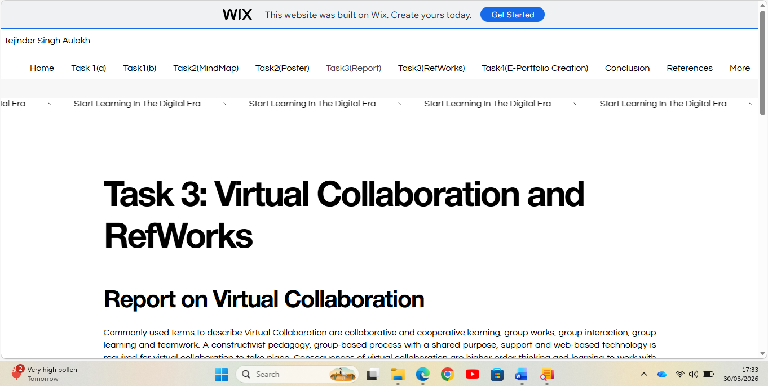
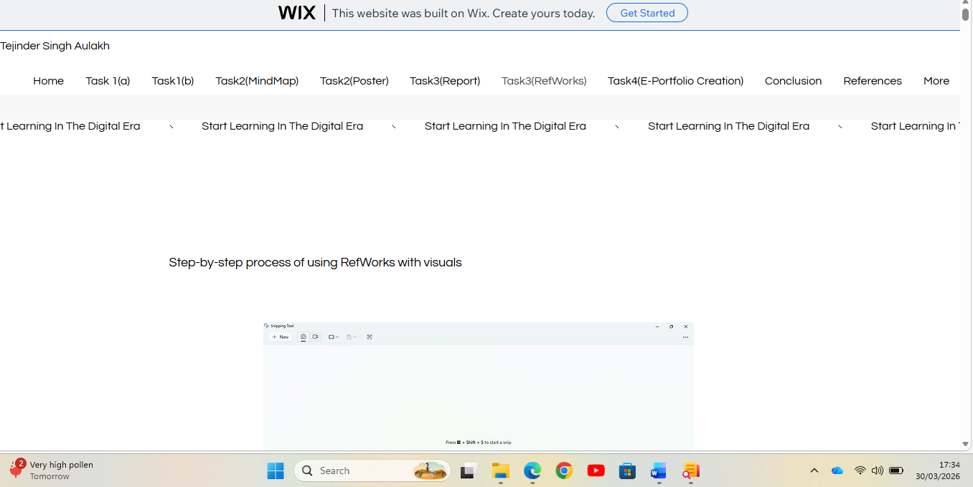
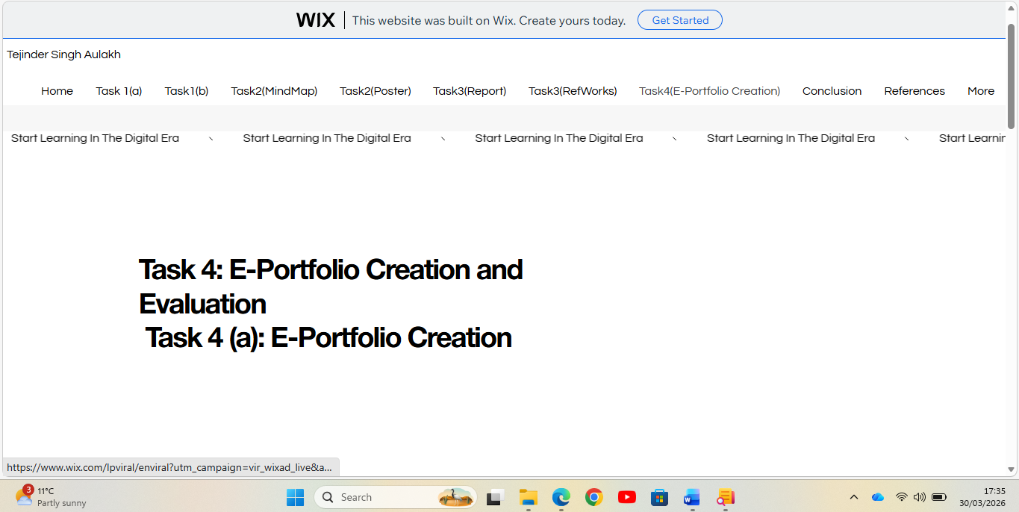
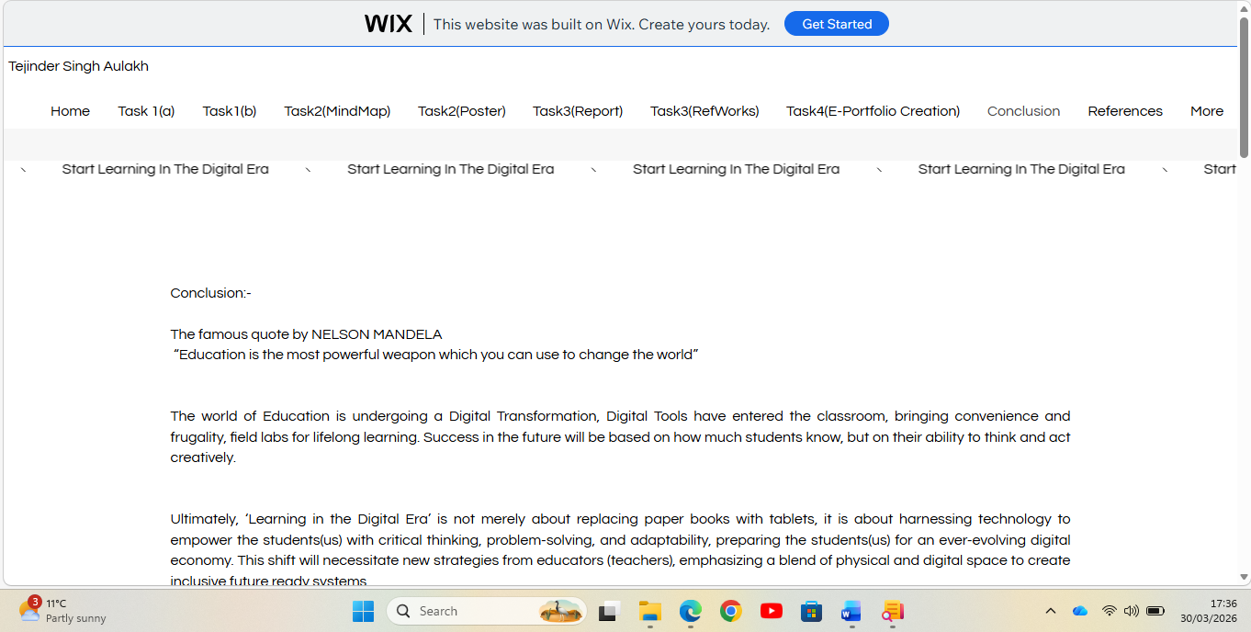
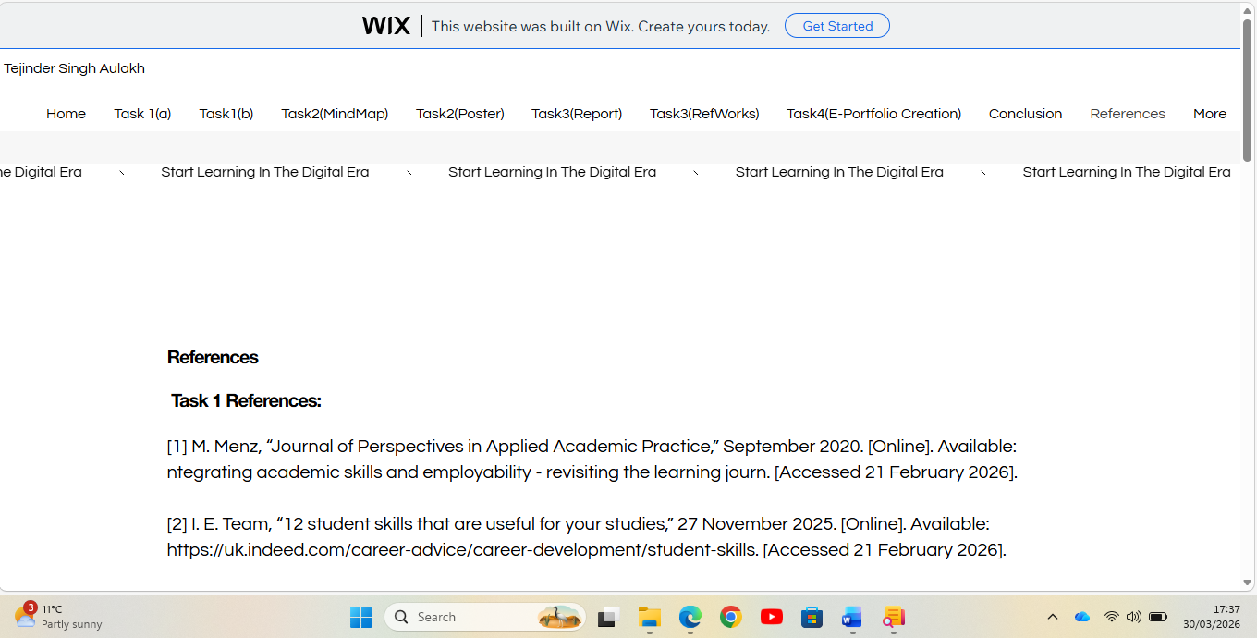

Task 4 (b): Illustrative Review of E-Portfolio tool Selection
An effective e-portfolio tool selection process is a structured approach that aligns technology with pedagogical goals, ensuring the chosen platform facilitates reflection, documentation, and assessment. Key steps in this selection process include defining the purpose, setting evaluation criteria, assessing technical needs, and piloting tools. (UCL Discovery +4)


The Wix e-portfolio tool selection process is characterized by a "guided freedom" approach, allowing users to choose between AI-powered generation or manual, high-customization design templates. It is widely chosen by creative professionals and jobseekers for its drag-and-drop editor and specialized, visually oriented portfolio apps. (Wix.com +4). We discovered that tools like Wix, with their blogging features, are better at supporting the development of co-regulated learning skills and social learning.

Key Stages in the Wix Portfolio Selection Process
Initial Setup & Goal Identification: Users start by creating a "Portfolio & CV" site, where they can either use Wix ADI (Artificial Design Intelligence) to generate a site quickly, or choose to manually pick a template.
Template Selection: Wix offers over 900 templates, with specialized options for photographers, illustrators, architects, and designers, allowing for specialized curation of projects.
Structure & App Integration: Users often select the "Wix Portfolio" app to automatically build a portfolio page, collection pages, and project pages.
Customization Level: Users choose between utilizing pre-built structures for rapid deployment or utilizing the Wix Editor for deep, drag-and-drop customization. (YouTube +6)

Selection Decision Factors
Design Flexibility: Users often choose Wix for its ability to drag and drop elements freely, which is superior to more restrictive builders, though it can be less structured than competitors.
Visual Focus: The platform is preferred for its "photo-friendly" nature, featuring automatic image optimization for speed and quality.
Client Tools: The selection process often weighs the need for built-in, password-protected galleries and project organization tools. (Wix.com +4)

Wix vs. Others: Competitors like Squarespace (for design), WEB flow (for deep customization), or WordPress (for blogging) are often compared, with Wix chosen for its balance of features and ease of use. (YouTube +4

Conclusion:
The famous quote by NELSON MANDELA
“Education is the most powerful weapon which you can use to change the world”
The world of Education is undergoing a Digital Transformation, Digital Tools have entered the classroom, bringing convenience and frugality, field labs for lifelong learning. Success in the future will be based on how much students know, but on their ability to think and act creatively.
Ultimately, ‘Learning in the Digital Era’ is not merely about replacing paper books with tablets, it is about harnessing technology to empower the students(us) with critical thinking, problem-solving, and adaptability, preparing the students(us) for an ever-evolving digital economy. This shift will necessitate new strategies from educators (teachers), emphasizing a blend of physical and digital space to create inclusive future ready systems.

References

Task 1 References:

[1] | M. Menz, “Journal of Perspectives in Applied Academic Practice,” September 2020. [Online]. Available: ntegrating academic skills and employability - revisiting the learning journ. [Accessed 21 February 2026].
[2] | I. E. Team, “12 student skills that are useful for your studies,” 27 November 2025. [Online]. Available: https://uk.indeed.com/career-advice/career-development/student-skills. [Accessed 21 February 2026].
[3] | L. Bradford, “Future Workplace,” 17 August 2024. [Online]. Available: https://lancebradfordscholarship.com/10-skills-every-student-needs-for-the-future-workplace/. [Accessed 21 February 2026].

Task 3 References:

[1] J. Schulze and S. Krumm, "The “virtual team player” A review and initial model of knowledge, skills, abilities, and other characteristics for virtual collaboration," vol. 7, no. 1, pp.66–95, 2017,
[2] J. Schulze and S. Krumm, "The “virtual team player” A review and initial model of knowledge, skills, abilities, and other characteristics for virtual collaboration," vol. 7, no. 1, pp.66–95, 2017,
[3] J. Meluso, S. Johnson and J. Bagrow, "Making virtual teams work: Redesigning virtual collaboration for the future," vol. 1, no. 1, pp.1–14, 2020,
[4] K. Furumo, "The impact of conflict and conflict management style on deadbeats and deserters in virtual teams," vol. 49, no. 4, pp.66–73, 2009,
[5] K. Furumo, "The impact of conflict and conflict management style on deadbeats and deserters in virtual teams," vol. 49, no. 4, pp.66–73, 2009,
[6] A. Kankanhalli, B. C. Tan and K. Wei, "Conflict and performance in global virtual teams," J.Manage.Inf.Syst. vol. 23, no. 3, pp.237–274, 2006,
[7] O. B. Ayoko, A. M. Konrad and M. V. Boyle, "Online work: Managing conflict and emotions for performance in virtual teams," vol. 30, no. 2, pp.156–174, 2012,
[8] A. Smirnova, "Navigating Conflict in Virtual Workspaces: Strategies for Remote Teams in IT and Gaming Industry," 2024,

