

Student name: | Yizhi Chen | Student ID number: | 2105786
Programme: | Professional Doctorate Art & Design
Module:
  Qualitative Research Methods within the Creative Industries
Module code: | ADAD7016 | Contribution to Overall Module Assessment (%): | 100
Lecturer: | Rob Charters | Internal Verifier: | Timi O’Neil
Assignment Title: | Research Proposal & supporting evidence. | Word count (or equivalent): | 7500 words
Submission deadline: | 27th June 2022 at 10am UK TIME | Return date of provisional marks & written feedback: | 15th July 2022 11.59pm
Submission Type | - critically consider the underpinnings of qualitative research principles and be able to recognise strengths and limitations of qualitative research techniques.  - critically assess the various contexts appropriate for qualitative research and be able to apply qualitative data collection and analysis techniques in order to address a research question.  1.Critically Analyse minimum of 2 (maximum of 3) Research Methodologies (3750 Words)  2.Present your Research Findings (Supporting your conference paper) (3750 Words)

Section 1

Critically Analyse Ethnography and Autoethnography Methodology in the Research of Digital Identity

Abstract
In this section I would break down the method I would use in my next paper and I have used it in the paper “From self to selfie: self-representation in the social media age”. Critically analyze the methodology been applied and would apply. Although there are lots of methodologies, or to say research strategies such as ethnography, grounded theory, phenomenology, narrative analysis, and case studies that emerged recently in much qualitative research, how to target the appropriate one in my research is worth considering. Due to the first part of my research, defining people’s self-representation through selfie on social media, and how artist reflects on the digital identity constructed by selfie, narrative analysis, and case study has been used. But the second part of my research is to investigate how artists use social media to represent their self-identity through selfies, I would use the ethnography methodology to interview artists, and apply the autoethnography approach to research my self-re-presentation on social media. This paper would demonstrate several parts, I would clarify what philosophy leads to my research approach in the beginning and why qualitative research is more conform to my research in the beginning. And then Describe methods of data collection. Moreover, describe methods, and how to process and analyze the data. Finally, evaluate and justify methodological choices including ethical considerations of the research design.
Image 1 Research structrue diagram

Introduction

Based on the ontology aspect, trying to get the knowledge about how people’s digital identity builds up through their selfies, and how their self-representation leads to the consequence. Therefore, it comes up with the Epistemology that human personality is constructed by the society which is announced in symbolic interactionism. It guide me to think about how people’s identity cultivated on social media since social media surround us every day even when we are alone. So how to gather that knowledge leads to my methodology, in the first paper, I used narrative analysis to approach it. It’s divided into two methods, contextual analysis to analyze research on symbolic interactionism, and a case study approach to dissect artist’s reflections in depth. In the second paper, I would use the ethnography methodology to investigate how the artist constructs their digital identity on social media. Use the interview method to gather their thought about this. And for the practice part, I would use autoethnography to observe myself as a part of the native digital residence since 2010.

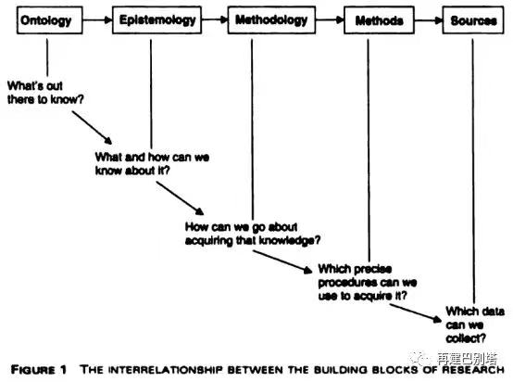
Image 2 The interrelationship between the building blocks of research

Before the investigation, I consistently question myself what’s the initial question I seeking? What information I should gather to demonstrate that. I need to address the basic elements of symbolic interaction in society, and explore other researchers’ thoughts about symbolic interaction on social media, to see what’s the difference between them, and what’s a similar part of them? To comprehend that social media is similar to our real life, and it has become an important part of the majority of people. In that case, I have to respond to what types of data could help me answer those questions? How do I present my results? First of all, it’s a very humanities question that requests the word data, such as the secondary data collected from other articles to help me understand the process of identity construction, the words that the artist said in the interview would help to understand the event they go through, their narrative about that. Understanding the behaviors they did on social media, and the experiences of the native digital residents is a quiet exploratory approach suitable to the qualitative paradigm.

For this qualitative approach diagram, explore people’s lives on social media by requesting their stories of individual experiences, I would use the book Culture of the selfie as an example to demonstrate how to use this approach appropriately. When in the second paper to describe and interpret artist digital identity sharp by social media, I would dissect how the article “The Presentation of Self and Identity Construction in Virtual World: A Case Study of Avakin Life” combine the case study and ethnography. Last but not least, with a profound understanding of my own research, Sherry Turkle’s book “alone together” gives me inspiration of using autoethnography, to explore, explain and express my life and the impact of people around me in the construction of digital identity.

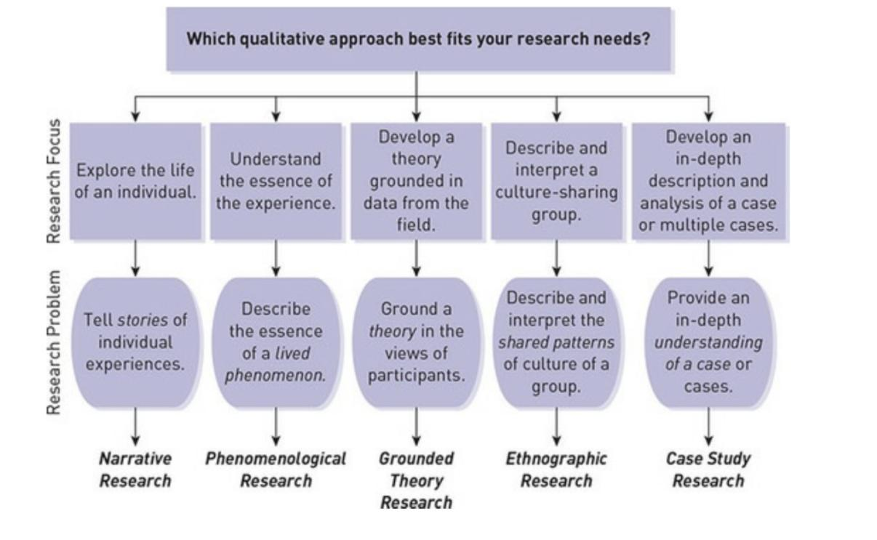
Image 3 Creswell, J.W. and Poth, C.N. (2018) “Qualitative inquiry & research design : choosing among five approaches”，p.110, Thousand Oaks, CA: SAGE.

To further explore the methodology leading to the method that would be used, there are two patterns to approach it. From the aspect of social constructivism, people perform different persona in front of different people, on social media, people perform different persona on different platforms. Due to that difference, how those influence their personality became the key thing to discover. Especially for the artist, their identity is constructed by galleries, art schools, and art museums, in the social media age, what would impact their identity? To narrow down the scope, in the paper I targeted artists to represent their changes by selfies, just like in the past artist create their own selfies to reflect the society’s influence. Before photography was invented, artist capture their own image by drawing self-portraits, after photography was invented, we would call it a selfie. (Saltz, 2014) The first artist's selfie shows off is in the mirror behind a couple, that’s how the artist illustrates his position. After that, artist selfies increasingly emerged, artist Durer even draws himself like a Jesus, in that case, we could understand the artist’s identity through the holiness he draw. In one of the very famous selfies that Van Gogh paint himself, he started to draw his inner world through a self-portrait. When photography was invented, we could see that the way artists represent themselves through selfies has been expanded. In the social media age, an appropriate way to explore their identity is to investigate their work about selfies on social media.

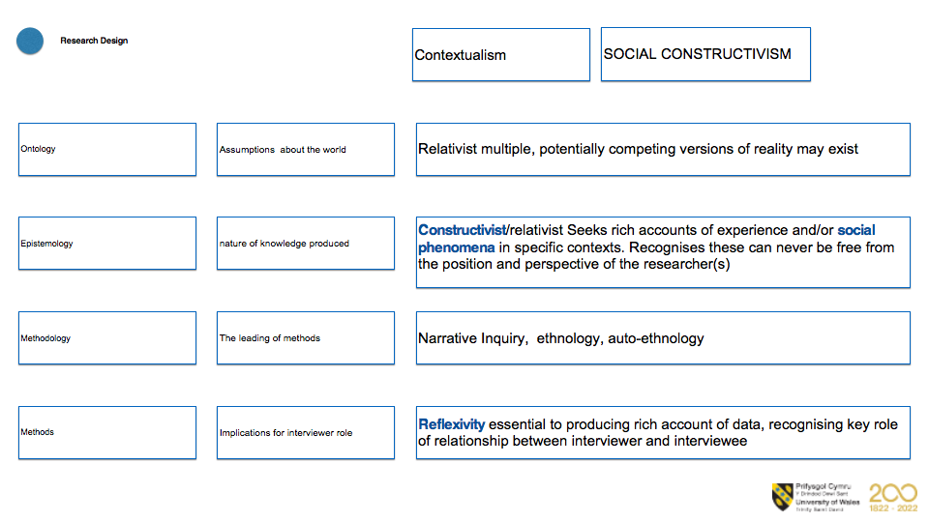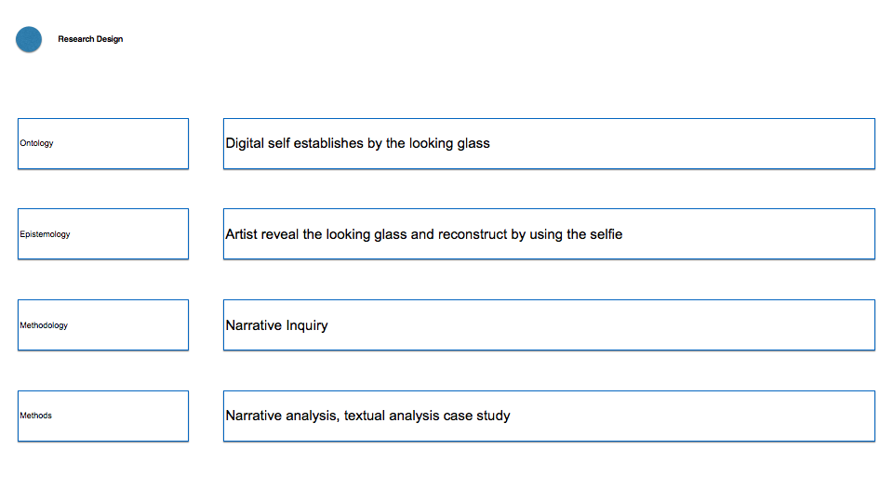
Image 4 Research philosophy

Due to this main core of exploration, the whole research is gonna interpret their works through the theory of self-representation and symbolic interactionism, inductively interprete their behavior online. In two steps to understand their works, case study and ethnography have been combined together.

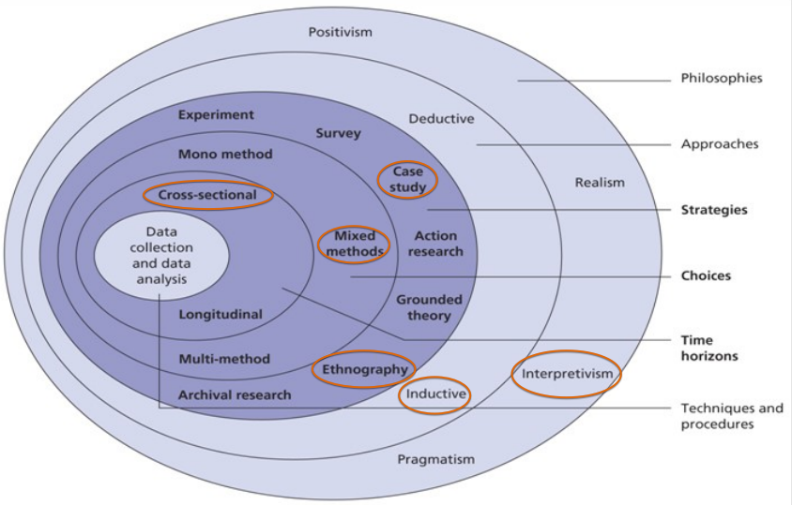

To subdivide different approaches would be separated into four steps to talk about it. Research strategy, Data collection methods description, Analysis methods description, Methodological choices evaluation. Due to the word limitation, I would only demonstrate ethnography and autoethnography in the upcoming second paper.
1.0 Research strategy
My research problem aim is to describe the characteristics of the digital identity of people, especially artists, and to gain more understanding of the topic. For this aim, it needs the textual and image types of data, including interview text and secondary data by other researchers. Based on the paper there would be a contextual analysis of online identity reconstruction (which has been displayed in the finding part.) According to online identity reconstruction, reviewed research methods and theories in other articles. What elements will affect online identity reconstruction behavior, and what’s the consequence. Figure out the purpose of people’s reconstruction of their identity online. Seeking for the way people construct their identity online by interaction? What are the positive influence and negative impacts of online identity reconstruction?

Ethnography focuses on the culture-sharing group being studied (Creswell, 2018). The word in Greek means “folk, people, and nation”, which means “portrait of a people” (Haradhan, 2018). Because research on artists’ behavior online, this research would involve cyber-ethnography method to approach it.“Like other early Internet researchers, early online ethnographers such as Sandy Stone and Sherry Turkle observed that participants in online role-playing communities performed social performances that could be quite different from their offline personas. This has led to the idea that online identities can be distinguished from offline ones. Cyberethnography was seen as a new methodology that might reveal how the Internet would fundamentally change society. However, as the Internet entered the mainstream and cyberethnographers sought legitimacy, cyberethnography was redefined as an adaptation of traditional methods to the new environment. Understanding the extent to which different representations in online and offline contexts reflect a segmentation of identity or a continuum of identities that are represented in different ways in different contexts remains an important consideration for cyberethnographers.”( Robinson& Schulz， 2011)

In the introduction of Turkle's book (Trukle, 2011), she combline ethnography and autoethnography to write that she witnessed the massive transfer time, the computer makes people rethink the human thought, memory, and understandability. She found that people started treating themselves in different ways, they reflect themselves in the mirror of the computer. So she wrote the first book called “The Second Self” in 1984, which is a special year related to George Orwell’s book “1984”. Until she wrote the second book “Life on the screen”, society has intensive change, she discovered that people are no longer confined to a limited social circle of dozens of friends, but can have hundreds or even thousands of friends, thus opening up an unprecedented breadth of social interaction. Her research has also shifted the focus from one-to-one relationships to computer-mediated ones. She hosts parties at her home, inviting various friends over to meet and talk about their new lives in the virtual world. They talk about their lives on and off-screen, depicting how the boundaries between virtual and reality are eroding. People's self-roles are no longer monolithic but are accompanied by the transformation of online and offline, virtual reality to form multiple identities. In one of the interviews, a university student talked about having four avatars in three different online virtual worlds. He always had several virtual worlds open at the same time and easily traveled between them. He told Trukle that real life is just one more window to open.

By the 1990s, she sensed the complete networking of her life and the ability to use the internet wherever and whenever she wanted. She wrote her third book, "Alone together", in response to these changes. Through her observations of her own life and the lives of those around her online and offline, she found that: "Today we are insecure yet crave intimacy, which is why we turn to technology to find a way to be in some kind of human relationship and still protect ourselves”(Trukle, 2011). We wander through different windows, interacting with robots and relying on technology rather than each other. She senses that she is witnessing a third change in the relationship between witnesses and technology. So she documented these transformations by writing about them. Her research is based on the feelings of real-life people and virtual reality communities made up of avatars. Her research is based on "field research" and "clinical diagnosis". In 'field research' she travels to places where people and technology meet to observe, interact, ask questions and take field notes. There are also informal meetings. During the 'clinical diagnosis' she conducts in-depth interviews as a researcher in a quiet environment. Her research interests lie in the 'inner history' of technologies.

It relates to my work to investigate myself and the same generation of artists around me, how we face the world, and trigger our thought about overlapping life.

2.0 Data collection methods description

In this section, I would describe the procedures for gathering data: the criterion or sampling technique I use to choose my sources or participants; the equipment, process, and materials I employ for gathering data; Methods used to measure the variables.LeCompte and Schensul(1999) divided ethnographic data collection into serval ways, for example, surveys, content analysis, interviews, network research, observations and spatial mapping, and so on. And use ethnography approach means that this is a long-term journey that as possible as I could to tough with more artists using social media to create works.

Focusing on the culture-sharing of the native digital more resident (Use social media over 10 years), I’ve set up questions below to observe their use of social media, and how that affects their identity. “It consists of what people do (behaviors), what they say (language), the potential tension between what they do and ought to do, and what they make and use, such as artifacts.”(Spradley, 1980) By using the semi-structured methods, this is only the main question, I would follow what they try to explain to extend different questions：

Field work, Informal interviews | Chatting with people around me in everyday life to gather their self-representation in different platforms, chatting with offline or online about their thought to the reconstruction of digital identity.
Semi-structured  interview for people arround me | Question for interview people their self-representation, behaviour online, and constrution of identity  - What website would you apply in your work?  - Did you agree with the statement that the whole world is composed by the information?  - How many hours a day do you spend looking at various electronic screens, including computers, mobile phones, iPads, TVs, billboards on the road and everything else you can think of?  - Do you think being on a computer screen for long periods of time every day has any effect on you?  - What are your personal interests?  - Do you show electronics to your children?  - Which apps do you use the most on a daily basis?  - Do you think there is an app that you think is doing better or worse?  - You usually use social media for these too right? QQ, WeChat, instagram, facebook, even metaverse.  - It's because everyone uses it, so it becomes compulsory, right?  - If one day he makes you feel uncomfortable, for example if he can monitor you completely, or if some kind of information appears that makes you uncomfortable, do you think there will be a desire to change or to use other software?  - I'd like to ask you about programs like WeChat, which you have to use every day, and then do you have to communicate your work through WeChat after work, or Tencent meetings to communicate your work, do you feel that it is taking up your personal time?  - Because nowadays there are people who want to say that outside of work they say turn off their phone and don't want people to find them they want to say leave it for a while. What do you think of that?  - What would you like to see?  - Do you want to do the same things you see others doing?  - What do you think of the fact that everyone uses a different face on the internet. Like using filters and then not recognising who they are when they see them in person.  - Do you think prolonged use of social media has had any impact on your character building?
Semi-structured  interview for artist | Question for interview artist their self-representation, behaviour online, and constrution of identity  - Could you show me that the selfie you used in different platform?  - How does the different you present on different social media?  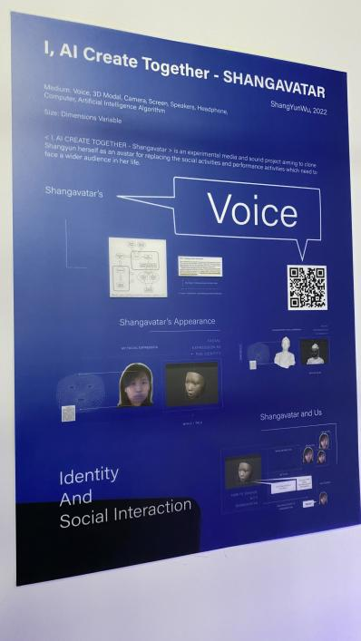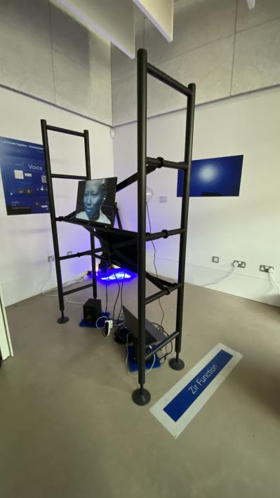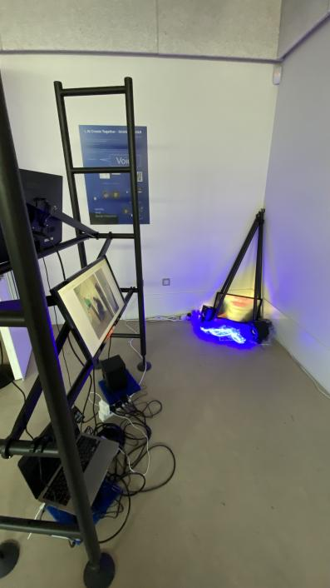  Yunwu Shang’s work shows in Royal College of Art Master degree final show, she create a avatar for herself to face people she have to chat with. She said that she used to be a project manager, she need to talk with a lot of people, but that was not her comfort zone, so she hope to create a avatar to avoid that. But I am curious about, does that really help her, how did it change her?  I asked she the question below, since she has already relize or created their avatar online:  - Why you try to create the avatar? What element urge you to do that?  - What does that avatar stand for?  - How does your avatar looks like, does it help you to solve the problem you can not solve before?

3.0 Analysis methods description
This part would describe the analysis procedures, including how we prepared and looked at the data. The analysis will be based on language, visuals, interpretations, themes, and patterns due to the qualitative concentration on words.

After collecting the semi-structured interview data, in this step need to analyze the patterns and describe the culture of this group of people. “Analyzing data through the description of the culture-sharing group and thems about the group.”(Creswell, 2018). It requests the presenting of data in a narrative way, using a logical reasoning way to induct the observations, in order to describe a phenomenon by using more general statements. The inductive data analysis presents a method to manipulate any information or data that gather from the interview. There are some common qualitative data analysis processes according to Matthew Mile: coding, noting, abstracting and comparing, checking and refinement, generalizing, and theorizing(Kozinets, 2010).In this view, I would categorize the data collect from interviews and documents, such as which social media, which social media people react differently, and how that changes them. Abstracting the concept map of the knowledge they provide, comparing the similar or different data events. Bring those thoughts to return back to the field for testing, examining, or altering the understanding of patterns, processes, commonalities, and differences.

When I interview one of my friends who wrote the code for the social media website or app. How long would he face the internet using, he said it is over 15 hours, no matter during work or at home, he always is with his phone. Another interviewee said that he has a different profile on different social media accounts. He never posts things on WeChat, because the WeChat list, there are included his family, parents, and colleagues. But on another platform, he acts like another person, he would post his daily life, and his photography works, he said that on Weibo, there are friends he encounters on the internet who have the same interest. So he is more willing to post things on Weibo. In daily life, he seldom talks, is I want to know the whole part of him, I need to see his active posting on social media.

In “along together”, Trukle incisively capture the change of the new generation, technology has changed their life, and virtual interaction reconstructed their personality, making them always online but even more lonely than before. She collected the data by fieldwork with the teenager and free talking with them, about how they use social media, using coding, or noting ways to analyze the data she collect in a narrative way by quoting words from the interviewee, which is charming and persuasive in drawing the portrait of the new generation. There are three statuses concluded from the observation and interview. On the one hand, the digital native is “escaping from the real world”, maybe there are just right beside you, but their spirit has always been somewhere else, which we call it virtual world. On the other hand, the status is they have the “dual experience”, they could experience both virtual and real-life in the meantime. The third one is some people win more time instantaneously dealing with multitasking. The “role play games” to perform different characters always attracted people. It change people’s thoughts of living, they believed that “I share, therefore I am”.

Although Turkle wrote this book ten years ago, the virtual world has already entirely invaded our life, and we even couldn’t feel it invading, just like teenagers they used the internet since they were born, so the question would be how the relationship looks like. But in my field, the final aim is to observe how new generation artists deal with those questions.

4.0 Methodological choices evaluation
This part would be the evaluation of why chose ethnography and autoethnography as the methodology, analyze and defend methodological decisions: Why choose these specific techniques, especially because I did not approach my subject most conventionally? Why weren't previous tactics effective for achieving my goals? Describe how this strategy adds to our knowledge or comprehension. Demonstrate how my strategies support my goals. persuade the reader that the method is the most effective for responding to the research questions. Making sense of the data and connecting it to my research topic and how it fills a knowledge gap are the objectives.

Cite sources:

In (Ghaill and Haywood, 2015), The researcher used an ethnography study to draw the full picture of a group of working-class Pakistani and Bangladeshi guys who were born in British. The study lasted over three years. The data collection goes into different details about their life, including how they grow up, what their social life looks like, and how they act in their school. In “Transcending boundaries”, Xiang draws the vivid portrait of a group of people living in The Zhejiang Village in Beijing, it is neither a natural village nor an administrative unit, it is a spontaneous settlement of Zhejiang people (mostly from Wenzhou) who have come to Beijing to do business(Xiang, 2004). He discover that: “The theme of the World Bank's 1999 Global Development Report was "Globalisation and Localisation". We should cherish the spontaneous growth of economies such as Zhejiang Village, where globalization cannot solve the employment and development problems of the majority of the population. My greatest fear is that people will destroy these organic social ties for the sake of temporary ‘good looks’. ” (Xiang, 2004) He spent 6 years living with them, in the meantime, he maintain critical thinking about the existence of Zhejiang Village. His work inspires me to observe a group of artists’ lives overlap acting online and being alive in reality.

So it kind of like sharing what’s the group looks like through describe each individual life. It’s tough work, it is necessary to follow or keep in the tough almost whole group. In my research, it’s not just tough with the real artist in my real life but also observing artists online. So the scale would be widened by the internet, but the artwork would focus on social media the majority of artists would use to post their work, such as Instagram, Facebook, and WeChat.

In that case, since my research target is based on the artist who use social media to create work through selfies, it needs to collaborate with the cyberethnography for interviewing artists online. Another limitation of web ethnography is that it complicates the issue of privacy. While researchers will always have to consider people who are not initially involved in ethnographic research, web ethnography allows researchers to actually see "an identifiable record of these connections and interactions". Researchers may therefore have to take the extra precaution of asking informants to allow them to participate in their research, as well as hiding the identity of said informants(Lane,2015 ).

In the autoethnography research, I would observe my life online, try to understand why I’ve been trapped on social media, dissect to a different time of my life, and describe how it impact my artworks. On the basis of Turkle Sherry’s three books, we could see how people establish their digital identity gradually. It gives me the confidence to observe nowadays digital identity online. But she just observes people surrounding her, her students, her colleagues, and even her daughter, she is kind of combines ethnography and autoethnography together. Her book is written ten years ago, what things changed is that social media has been more widely used than ten years ago. Especially after the pandemic, almost everyone relies on social media, no matter work, order food, or meet with friends, even the art institution operate depends on social media, the last Basel exhibition was disseminated by social media. Turkle's research supported my methodology choice to observe artists work relied on social media.

Discuss obstacles

To some extent, cyberethnography is similar to ethnography in localized spaces, which raises similar ethical considerations. However, the nature of the online space does raise new ethical issues, including those relating to informed consent of human subjects, the protection of privacy or anonymity of research subjects, and whether cyberethnography may be a form of 'electronic eavesdropping. Thus, in applying cyberethnography to the study of artists' online identity. (Wilson and Peterson, 2002) To deal with the difficulties part, I would fill out the ethics form to confirm with my tutor if the ethics problem works, and check what should be careful when investigating artists online and offline. In the research, the analysis of the image is inevitable, it’s important to request the artist for the right to use it.

Data collection takes a lot of time and necessitates spending a lot of time outside. Many ethnographies write their histories in a literary, almost storytelling style, which may limit the audience for the work and provide difficulties for authors used to more formal styles of scientific writing. The chance that the researcher will "become native" and become compromised or unable to continue the study exists. This is only one of the several challenging fieldwork issues that ethnographers who enter an unfamiliar cultural group or system must deal with. It is crucial to be sensitive to the needs of the people being examined, and the researcher must assess and communicate how their research has affected the people and the locations being investigated. There are many discussions on how funding frequently restricts the amount of time for ethnographic fieldwork and how data influences the creation of an ethnographic study. (Creswell and Poth, 2018)

I would minimize the impact of obstacles according to Kaiser’s advice “Ethical considerations of research design: Participant vulnerability, The nature of the topic, Consent, Confidentiality and anonymity, Method for collecting data, Researcher vulnerability”(Kaiser, 2009).

Section 2

Research Findings about the Self-representation of Digital Identity

Abstract
In this section, findings would be separated into different parts, through the contextual analysis, narrative, ethnography, and autoethnography approaches. The self-representation on social media could be treated as performing in another simulated stage. People’s self-representation was been recorded by the system, either they present good or reveal the bad side of them. The behavior online might be different from how they react in everyday life. The consequence might be in a positive or negative aspect, but the self-representation online would affect their personality in reality. In view of how artists used the selfie to represent the reconstruction of self-identity, I’ve traced back to the first self-portrait show-off and demonstrated how social impact them, and what lead to their representation by selfie. Last but not least would be general talk about the reconstruction of self-identity.

Introduction
In Section 1 I have already dissert the methodology I used about how to collect the data, how to analysis the data, and how to minimized the impact of obstacles.

Led by the three key question to be disscussed:
1. How symbolic interactionism explore the selfie on social media?
2. What can we learn from observing the construction of digital self in artworks?
3.How this discussion would influence my practice?

Here included three main point to be disscussed:
- Digital self might be constructed by the filter, others’ comments, influencers.
2. By Impression management and self-display we are losing ourselves.
3. What things would construct one’s digital self? Does their digital self affect their real life? (This would present in next paper)

Social media also a stage
By contextual analyzing articles and books about self-representation online, there are some findings that came from articles written by the researcher on symbolic interaction.
It is easy to see in everyday life that in society you would get comments from your friends, your family, your boss, and so on. Everyone is under the other’s gaze. Even when we are alone in our home, we are still “online”, chatting with others, losing independent time. (Trukle, 2011)

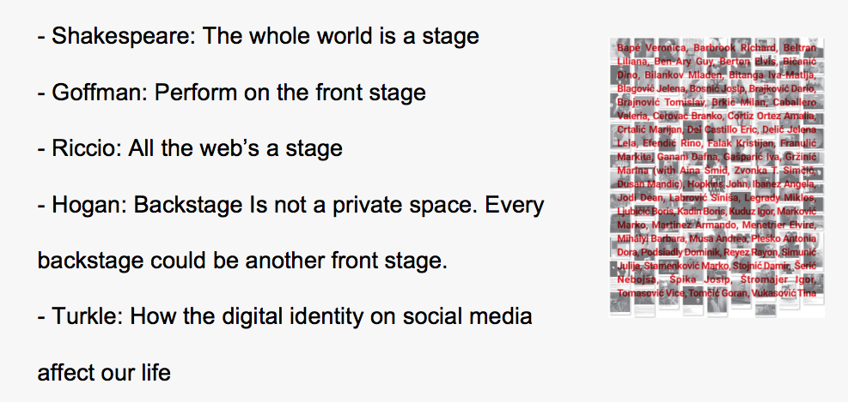
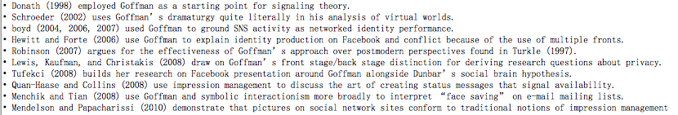

Social media provide a stage for people to upload selfies, exchange ideas, got thumbs up, like, subscribe, and comment from known and unknown others. Those above were the articles that us Goffman’s theory for understanding the presentation of self online summarized by Hogan.

The most famous saying from Shakespeare, the whole world is a stage, men and women are just players on the stage revealing the nature of our life. Goffman further develops this into a theory that people perform on the front stage, and there is backstage when you are alone, but nowadays, there is no backstage, we perform different characters every time (Goffman, 1971). In Hogan’s article, he found that backstage is not a private space, every backstage could be another front stage. He also found that on social media, it is not just performance, and also self-exhibition online, everyone displays their avatar(Hogan, 2010). Riccio: All the web’s a stage(Riccio, 2013). Turkle, People have their second life online, and they already have a virtual avatar online, the digital identity on social media has affected our life (Trukle, 2005). Due to the dramaturgy theory nowadays, we can conclude that social media is a simulation stage of society in real life.

self-representation on social media
To further discover people’s self-representation on social media, it’s appropriate that use theories from Lacan, Cooley, and Mead, the metaphor of the mirror has been revealed in their research. They contributed to the symbolic interactionism about how people constructed their own identity when they were children, when they grow up, they got more interactions with others in the society. If we consider the mirror theory still operating online, the mirror reflecting us used to be mothers, friends, and colleagues would become the virtual ones. If we combine it with Goffman’s theory, we could treat others online be the virtual audience, who watch our performance every day. There would be some unexpected audience except the people we already know in real life. It’s hard to depart the virtual life and real life, since the smartphone was invented, we can’t live without the phone. Some say that what makes Apple powerful is that it changes people’s way of life. They always keep in touch with others by the touchable phone.

Here I concluded three points about things that happened in the mirror. Firstly, In society, the audience act as a mirror. They would give you the feedback immediately. Secondly, The virtual audiences’ feedback might be vague, so the “mirror” might be not that reflective. Thirdly, If the “mirror” is not reflective, how would that affect the construction of your identity online?

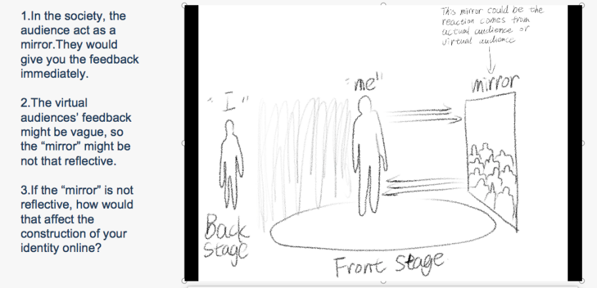
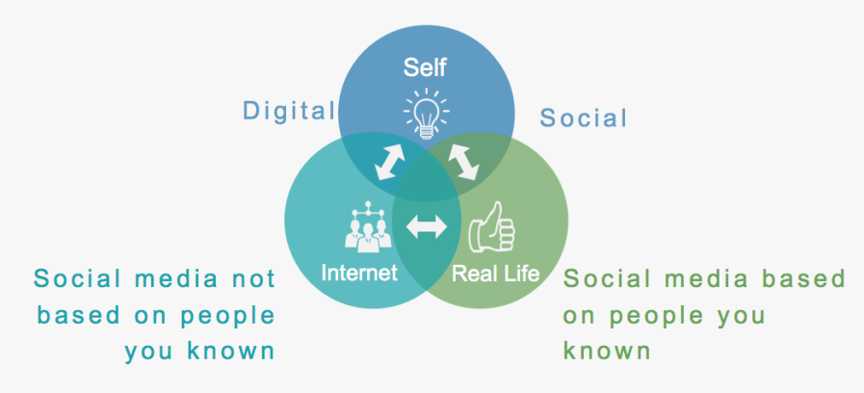

Behaviour online
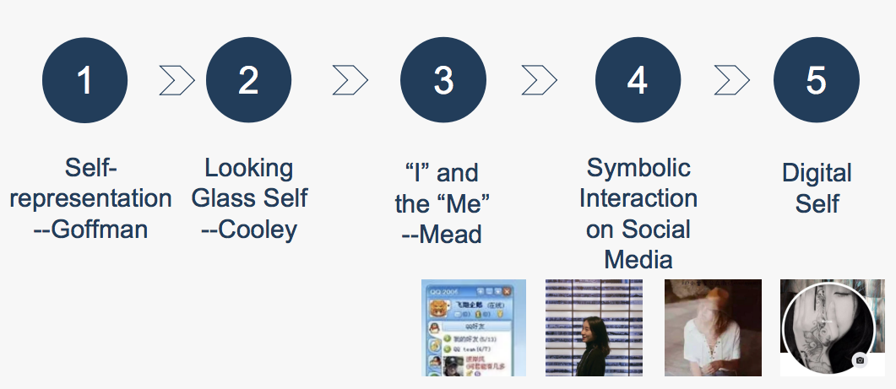

Through the ethnography and autoethnography approach to observe others and me, I find out that I have a different avatar on different social media platforms, I would use the different selfies to represent the different me. For example, on Wechat, I used the more formal one with my works as the background, since on Wechat there are lots of my colleagues and potential clients, so I presented a professional artist. But on Instagram, I don’t want to be recommended by the algorithm of Instagram to people on Wechat, so I used the half-face selfie to avoid them. In there, I could pose whatever I want on it. But the point is that Instagram is a platform where everyone could see your index, so I still protect my privacy that never posting any of my selfies on it. But when you open Instagram you could see that everyone uploaded their selfies when thinking about why they are so keen to record their face, I think is that the internet gives everyone a chance to be immortal. Their share represents they are alive.
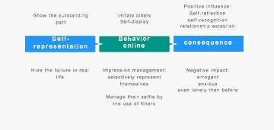
Some would show their most outstanding part online, some might hide their failure in real life to protect a perfect individual. They would imitate others doing and use social media as a gallery to self-display their every action online. From some articles, we could see that people would have impression management online, they selectively represent themselves and manage their selfies by the use of filters. For the consequence, it would be divided into the positive and negative aspects. The positive influence would be self-reflection on themselves their behavior, learning some new knowledge, Self-recognition of themselves based on others' advice, and relationships established with others. But the point is that how to know that the knowledge we gather from the internet is correct? How to define if it’s positive or not, before one has not set up one recognition, will they take too seriously what others told them, rather than discovered by themselves? That’s the most difficult part of this research, I got too many voices from others about who I am, when my tutor told me to research myself, it became very difficult that I have been sharp into a different persona, and I have no idea which is the real me. It is like a broken mirror, too many fragments of me shatter on different platforms. When using autoethnography to observe me, it is not enough just to investigate me in real life, but also to include my avatar of me online.

Self reconstruction of identity

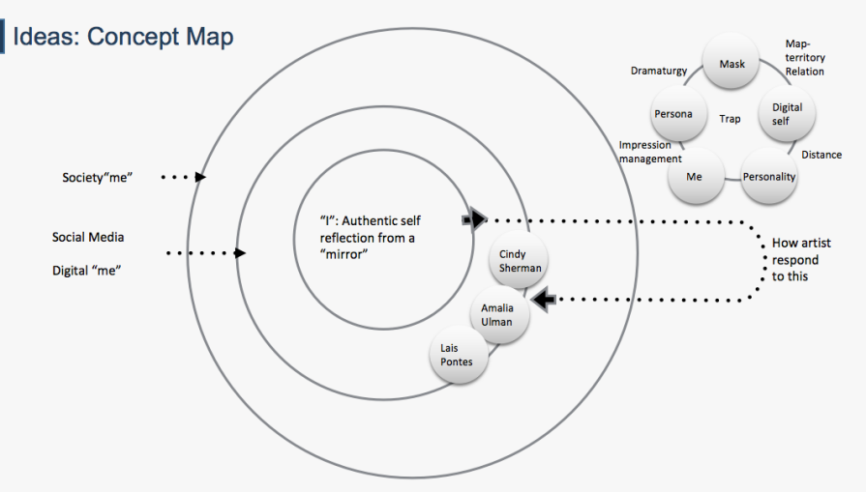
Therefore, when I look back to myself, what could be found from the past, from the first time I met with social media? I got a pattern since the first use of social media, I found myself trapped in social media when it emerged in 2010, that was my first time to use social media, and I was attracted by creating a new persona online. But somehow it became my mask. It makes me got distant from others in the real life. It is kind of shaping my personality. When I created the persona online, I would use impression management to maintain the character I created, no matter how much offered to it, everytime when I posted something, I would think if this fix to the figure I create on this platform? Until one day I feel tired of it, and I realize that my impression management force me to separate myself, it gives too much pressure on me. Every time I want to escape social media, I would more found that I can’t live without it. My relationship, my entertainment, and even the course are online. So the personas have already been a lot of masks over me, it seems like some map-territory relationship between me in the real-life and me on social media. The digital self has already been there, and could not be erased.

Self identity represent through selfie

Since the first time artist show off in the painting, increasingly self-portraits emerged. Connected to the thought shaping people’s behavior, we would go back to see why artists started to draw themselves beside the technology that enables them to do so.

At the beginning of the Renaissance in 1300, Dante woke up the self-awareness of people. In1434, researchers found that the artist draws himself in the mirror in the painting The Arnolfini Portrait. In 1460, the mirror was invented by Venetian, so we could see more artists use the mirror to draw themselves. From 1596 to 1650, Descartes claimed “I think, therefore I am” compare to Trukle’s “I share, therefore I am” nowadays, that was the first moment that people take themselves higher than the existence of others. In1950, Heidegger wrote a book about “The Age of the World Picture“ that represent our world is full of pictures, including selfies. In 1970, Baudrillard proposed “consumer society” and in 1973 Debord stated “Spectacle” society. Those thoughts make us think about did we really need so many selfies in our generation. In the past, who could have the portrait present their position in the society, but now everyone could have their selfie exhibition online. When everyone could do it, the challenge to the artist would be different from before. They observe people’s behavior online and reflect on how social media reconstructs their identity. Cindy Sherman, Lais pontes, and Amelia Ulman use selfies to create their artworks, they reveal the process by that people sharpen their digital identity through others' comments, influence by an influencer, and the filter could change their thought about themselves as well.

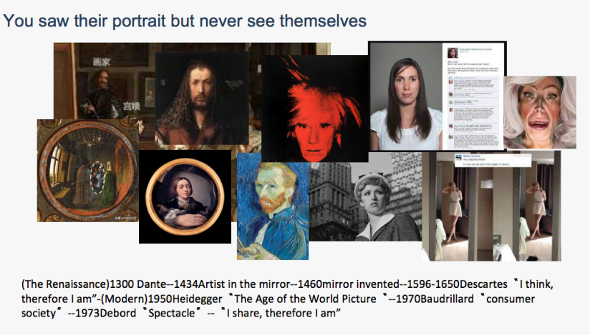

Reconstruction of self identity
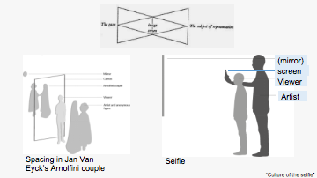
To consider how the artwork represents the reconstruction of self-identity, we could refer to the “Culture of the selfie”， Representation in Contemporary Visual Culture Paperback, written by Ana Peraica. She analyses the selfie author’s position behind the viewer.

The image above is from Lacan, he stated that image and screen come from the subject of representation and the gaze of others. In the works of selfies created by the artist, the author’s position changes to the artist. You could see the artist’s position behind the viewer. In the selfie, the artist takes photos through the mirror just like we would do, Although the artist’s position is still behind the viewer, they looking at the artist from the screen, and what the artist wants to represent has changed. If our digital self is constructed by the reflection of the vague “mirror”, would we regard ourselves as vague as well? And this time, the artist became invisible.

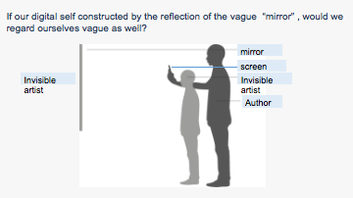

Therefore, this led to my thought about my practice, for representing the invisible artist-researcher in the position behind the screen, I use the vague image loading pattern to cover those selfies. 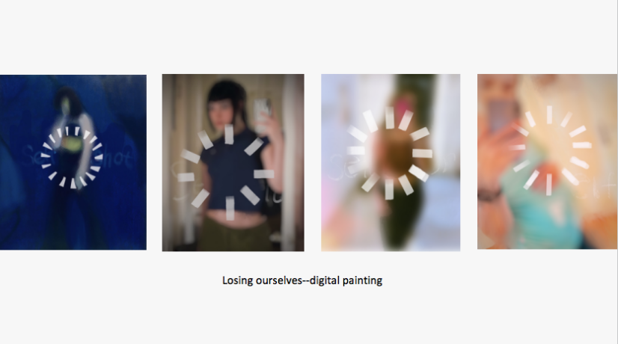
But this research is still ongoing, the next step would be the interview with an artist. Here are some discussions in the end.
1. Digital self might be constructed by the filter, others’ comments, and influencers. What else would you think about it?
2. By Impression management and self-display we are losing ourselves. Did you have the same feelings?
3. What things would construct your digital self? Does your digital self affect your real life?
And this would be my next research.

Conclusion
The selfie has irreversibly influenced visual culture, contemporary art, and portraiture. As researchers and image-makers, there is a need to adapt and innovate in terms of responding to the latest forms of self-representation. People’s everyday life is posted online, so that also provides artists a fleid to research it. Based on people’s self-representation, the artist uses the selfie not just for posting, but also to reveal the fact that how social media change us.

ADAD7016reference
Atkinson, P. (2015) “For ethnography”, Thousand Oaks, CA: Sage.
Chua, T. H. H., & Chang, L. (2016) “Follow me and like my beautiful selfies: Singapore teenage girls’ engagement in self-presentation and peer comparison on social media”, Computers in Human Behavior, 55, pp.190-197.
Clandinin, D.J. (2006) “Narrative Inquiry: A Methodology for Studying Lived Experience”, Research studies in music education, 27(1), pp.44–54. doi:10.1177/1321103X060270010301.
Creswell, J.W. and Poth, C.N. (2018) “Qualitative inquiry & research design : choosing among five approaches”，Thousand Oaks, CA: SAGE.
Hyvarinen, M. et al. (2010) Beyond narrative coherence. Amsterdam: John Benjamins
Hogan，B.（2010) “The presentation of self in the age of social media：
Distinguishing performances and exhibitions online”, Bulletin of Science， Tech
nology & Society，30（6），pp.377-386.
Liu,H.（2007) “Social network profiles as taste performances”，Journal of
Computer ‐ Mediated Communication，13(1)，pp252-275.
Lehner, A. (2021) Self-Representation in an Expanded Field : From Self-Portraiture to Selfie, Contemporary Art in the Social Media Age. Basel: MDPI.
Jande, L. V. & Ibrahim, N. A., (2020) “The Presentation of Self and Identity Construction in Virtual World: A Case Study of Avakin Life”, LSP International Journal, 7(2), pp.107–118, Malaysia: Universiti Teknologi Malaysia, DOI: https://doi.org/10.11113/lspi.v7.15271
Kaiser, K. (2009) “Protecting respondent confidentiality in qualitative research”, Qualitative health research, 19(11), pp.1632-1641.
Lane, J. (2016) “The digital street: An ethnographic study of networked street life in Harlem”, American Behavioral Scientist, 60(1), pp.43-58.
Madison, D. S. (2011). Critical ethnography: Method, ethics, and performance (2nd ed). Thousand Oaks, CA: Sage.
Mohajan, H. (2018) “Qualitative research methodology in social sciences and related subjects”, Journal of economic development, environment and people, 7(1), pp.23–48, doi:10.26458/jedep.v7i1.571.
Marwick,A. E, & Boyd, D.（2011) “I tweet honestly，I tweet passionately： Twitter users, context collapse, and the imagined audience”, New media & society，13（1）, pp114-133.
Kozinets, R.V. (2010) Netnography : doing ethnographic research online. Los Angeles: SAGE.
King, N., Horrocks, C., & Brooks, J. (2018) Interviews in qualitative research, Los Angeles: SAGE.
Robinson, L., & Schulz, J., "New fieldsites, new methods: New ethnographic opportunities," Ch. 8 In The Handbook of Emergent Technologies in Social Research.
Riccio, J. R. (2013) “All The Web's a Stage: The Dramaturgy of Young Adult Social Media Use” , Doctoral dissertation of Syracuse University.
Reed-Danahay, D. (1997) Auto/ethnography : rewriting the self and the social. Oxford: Berg.
Pink, S. (2001) Doing visual ethnography : images, media, and representation in research. London: Sage.
Saltz, Jerry. (2014) Art at Arm’s Length: A History of the Selfie, https://www.vulture.com/2014/01/history-of-the-selfie.html (Accessed at 20th, 06, 2022)
Squire. (2014). “What is narrative research?” (1st ed.). Bloomsbury. https://doi.org/10.5040/9781472545220
Tufekci,Z.（2008)“ Grooming，gossip，Facebook and MySpace：What can we learn about these sites from those who won't assimilate, Information,Communication & Society，11（4），pp.544-564.
Turkle, S. (1995) Life on the Screen: Identity in the Age of the Internet. New York: Simon & Schuster.
Turkle, S. (2005) The second self: Computers and the human spirit. Cambridge: MIT Press.
Turkle, S. (2011) Alone together: Why we expect more from technology and less from each other. New York:Basic Books.
Wolcott, H. F. (2010). Ethnography lessons: A primer. Walnut Creek, CA: Left Coast Press.
Walther，J. B.（1996)“Computer- mediated communication：Impersonal， interpersonal，and hyperpersonal interaction”, Communication research，23（1)，pp.3- 43.
Wilson, S. M., & Peterson, L. C. (2002) “The anthropology of online communities”, Annual review of anthropology, pp.449-467.
Xiang, B. (2004). Transcending boundaries: Zhejiangcun: the story of a migrant village in Beijing. Leiden and Boston: Brill.

Appendix
There is the articles below as the contextual analysis. Due to the social media platforms been observed both from all over the world, so there would be some articles talking about the user on chinese social media as well. And the second file was the article in the website.


