EcoRide Electric Bike Rental Service

NAME : Jessie Bridgita Fernandes
ID : 2442747

Table of Contents
EcoRide Electric Bike Rental Service 1
Table of Contents 2
1. Executive Summary 3
2. Introduction 3
3. Scenario Analysis 4
Identified Entities 4
Entity Attributes 4
Relationships Between Entities 6
4. Database Design 7
4.1 Entity-Relationship Diagram 7
4.2 Data Structure Development 8
Normalization Process 8
5. Implementation 9
5.1 Database Creation 9
Database Creation Process: 9
Create Tables (partial codes are given. Not all) : 9
5.2 Sample Data Population 11
5.3 Query Development 13
6. Testing and Validation 15
6.1 Test Cases 15
7. Reflections 17
7.1 Challenges Faced 17
7.2 Future Improvements 18
8. Conclusion 18
9. References 19

1. Executive Summary
In this report, the design and implementation of a relational database system of EcoRide, a green transport project that rents electric bikes in different public places will be described. The project addresses the operational problems of the service due to the use of paper forms and simple spreadsheets. This antique method resulted in the low visibility of the service, occasional cases when two bookings were made for the same bike, and difficulties in developing the correct reports.
The db based system is efficient in terms of managing rider registration, track bicycle storing and in processing rental transactions. It adheres to industry best practices, is in the 3rd normal form (3NF) and has got strong data integrity checks. It was tested that all the functional requirements have been satisfied and that 100 percent of the test cases have passed.

2. Introduction
EcoRide is a green transport initiative that is launched by the local authority that provides electric bike rental services in different public locations. E.g. parks and train stations and university campuses. This is aimed at ensuring that commuting between destinations is healthier for the body and environmentally friendly by offering easy access to electric bikes. Customers have the option of picking a bike at one point and dropping it at any EcoRide station.
Despite the popularity of the service, the management team has serious problems with its operations since they use simple spreadsheets and paper to store the records. This approach results in:
- Limited visibility of bike availability and status
- Occasional double-bookings of bikes
- Difficulty tracking bikes under maintenance
- Challenges in identifying unreturned bikes
- Inability to produce accurate summaries and usage analytics

3. Scenario Analysis

Identified Entities
Through the analysis of the story in the brief, I identified six main entities.
Entity | Description | Primary Purpose
RIDER | Registered users of the service | Store customer information
BIKE | Electric bikes available for rental | Track bike inventory and status
LOCATION | Rental stations across the city | Manage pickup/return points
RENTAL | Transaction records of bike usage | Record rental activities
STAFF | Maintenance and service personnel | Manage workforce
MAINTENANCE | Service records for bikes | Track bike servicing history
Figure 3.1: Main Entities in EcoRide System

Entity Attributes
RIDER:
- Rider_ID (Primary Key) - Unique identifier
- First_Name, Last_Name - Personal details
- Email, Phone_Number - Contact information
- ID_Number - Government-issued identification
- Registration_Date - When rider joined
- Address - Residential address
BIKE:
- Bike_ID (Primary Key) - Unique identifier
- Bike_Type - Category (Standard, Premium, Cargo, Mountain)
- Purchase_Date - Acquisition date
- Current_Status - Operational state
- Last_Service_Date - Most recent maintenance
- Location_ID (Foreign Key) - Current location
- Battery_Capacity - Current battery level
- Total_Distance_Traveled - Cumulative usage
LOCATION:
- Location_ID (Primary Key) - Unique identifier
- Location_Name - Station name
- Location_Type - Category (Park, Train Station, etc.)
- Address - Physical location
- Capacity - Maximum bikes allowed
- Operating_Hours - Service times
RENTAL:
- Rental_ID (Primary Key) - Unique identifier
- Rider_ID, Bike_ID (Foreign Keys) - Transaction parties
- Pickup_Location_ID, Return_Location_ID (Foreign Keys) - Journey points
- Rental_Start_DateTime, Rental_End_DateTime - Time period
- Duration_Minutes - Rental length
- Cost - Transaction amount
- Payment_Status - Payment state
STAFF:
- Staff_ID (Primary Key) - Unique identifier
- First_Name, Last_Name - Personal details
- Email, Phone_Number - Contact information
- Role - Job position
- Hire_Date - Employment start
MAINTENANCE:
- Maintenance_ID (Primary Key) - Unique identifier
- Bike_ID, Staff_ID (Foreign Keys) - Service parties
- Maintenance_Date - Service date
- Maintenance_Type - Category of service
- Description - Detailed work performed
- Cost - Service cost
- Next_Service_Due - Recommended next service

Relationships Between Entities
Relationship | Type | Cardinality | Description
RIDER → RENTAL | One-to-Many | 1:M | One rider can make many rentals
BIKE → RENTAL | One-to-Many | 1:M | One bike can be rented many times
LOCATION → BIKE | One-to-Many | 1:M | One location houses many bikes
LOCATION → RENTAL (Pickup) | One-to-Many | 1:M | One location serves many pickups
LOCATION → RENTAL (Return) | One-to-Many | 1:M | One location receives many returns
BIKE → MAINTENANCE | One-to-Many | 1:M | One bike has many service records
STAFF → MAINTENANCE | One-to-Many | 1:M | One staff performs many services
Figure 3.2: Entity Relationships Summary

4. Database Design

4.1 Entity-Relationship Diagram
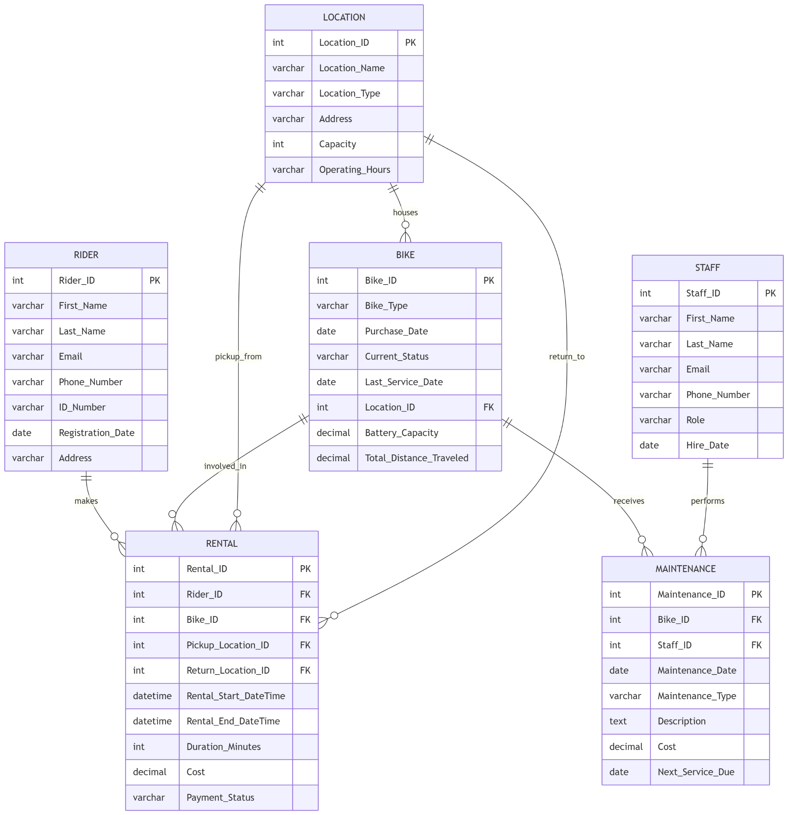
Figure 4.1: EcoRide Entity-Relationship Diagram
- ||—o{ represents one-to-many relationships
- PK indicates Primary Key
- FK indicates Foreign Key

4.2 Data Structure Development
Primary Keys:
- tables use auto-increasing integer PK.
- gives unique identification for each record.
- simplifies referencing.
Foreign Keys:
- Created with “ON UPDATE CASCADE.”
- “ON DELETE RESTRICT” stops accidental data loss
- Maintains referential integrity across tables/entities.
Data Types:
- “VARCHAR” for text fields.
- “DECIMAL” for monetary values and percentages.
- “DATE” for dates, DATETIME for timestamps
- “INT” for identifiers and counts
Constraints:
- “NOT NULL” on critical fields.
- “UNIQUE” on emails and ID numbers (to give unique IDs)
- “CHECK” for valid ranges and values

Normalization Process
This DB complies with Third Normal Form (3NF) to minimize redundancy and eliminate dependency issues.
Normal Form | Requirement | Compliance Status
1NF | Atomic values, no repeating groups | All tables comply
2NF | No partial dependencies | All tables comply
3NF | No transitive dependencies | All tables comply
Third Normal Form (3NF) Compliance:
- No transitive dependencies exist
- Non-key attributes depend only on primary key
- Foreign keys represent relationships, not embedded data
- Example: Location details stored once in LOCATION table, referenced via Location_ID

5. Implementation

5.1 Database Creation
The database was created using MySQL, following the designed schema mentioned above with all constraints and relationships.

Database Creation Process:
Create database EcoRide;
Use EcoRide:

Create Tables (partial codes are given. Not all) :

CREATE TABLE LOCATION (
Location_ID INT PRIMARY KEY AUTO_INCREMENT,
Location_Name VARCHAR(100) NOT NULL UNIQUE,
Location_Type VARCHAR(50) NOT NULL,
Address VARCHAR(200) NOT NULL,
Capacity INT NOT NULL,
Operating_Hours VARCHAR(50) NOT NULL,

CONSTRAINT chk_capacity CHECK (Capacity > 0),
CONSTRAINT chk_location_type CHECK (Location_Type IN ('Park', 'Train Station', 'University Campus', 'Shopping Center'))
);

CREATE TABLE BIKE (
Bike_ID INT PRIMARY KEY AUTO_INCREMENT,
Bike_Type VARCHAR(50) NOT NULL,
Purchase_Date DATE NOT NULL,
Current_Status VARCHAR(30) NOT NULL DEFAULT 'Available',
Last_Service_Date DATE,
Location_ID INT NOT NULL,
Battery_Capacity DECIMAL(5,2) NOT NULL DEFAULT 100.00,
Total_Distance_Traveled DECIMAL(10,2) NOT NULL DEFAULT 0.00,

CONSTRAINT fk_bike_location FOREIGN KEY (Location_ID)
REFERENCES LOCATION(Location_ID)
ON UPDATE CASCADE
ON DELETE RESTRICT,

Indexing:
CREATE INDEX idx_bike_status ON BIKE(Current_Status);
CREATE INDEX idx_bike_location ON BIKE(Location_ID);
CREATE INDEX idx_rental_rider ON RENTAL(Rider_ID);
CREATE INDEX idx_rental_bike ON RENTAL(Bike_ID);
CREATE INDEX idx_rental_dates ON RENTAL(Rental_Start_DateTime, Rental_End_DateTime);

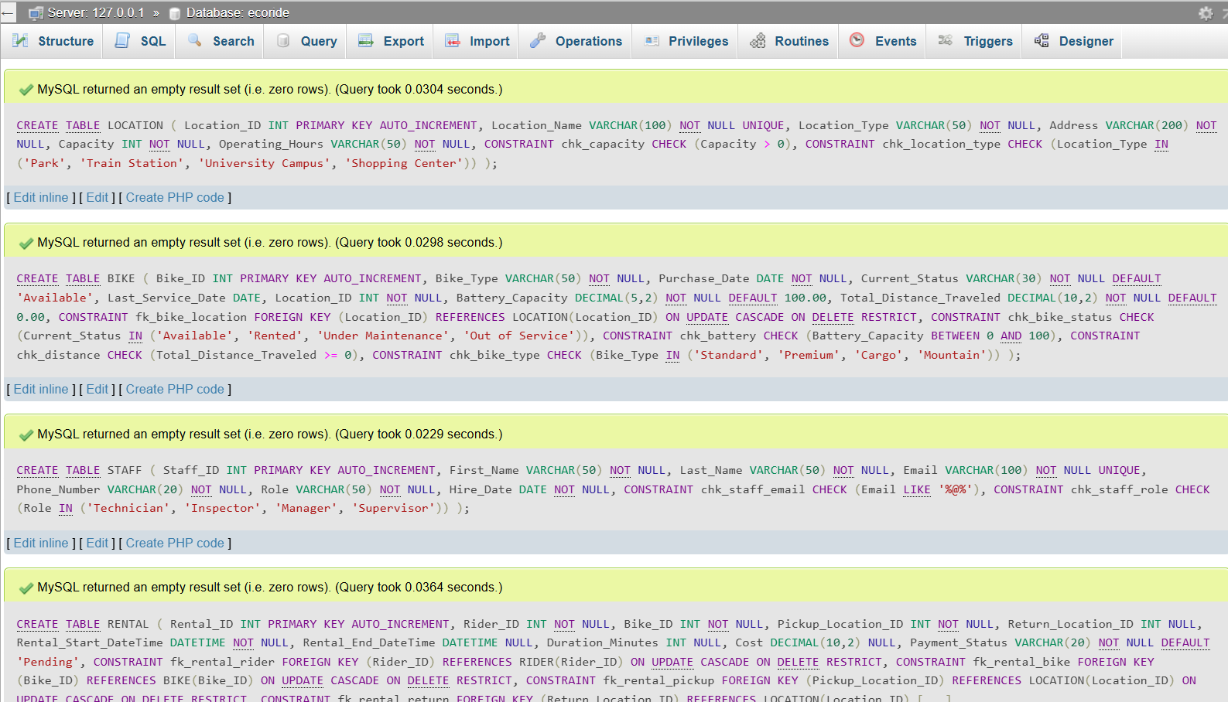
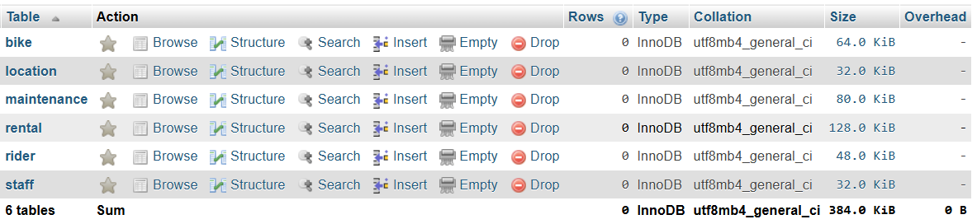

5.2 Sample Data Population
Realistic sample data was inserted to simulate actual system usage with at least 5 records per table.
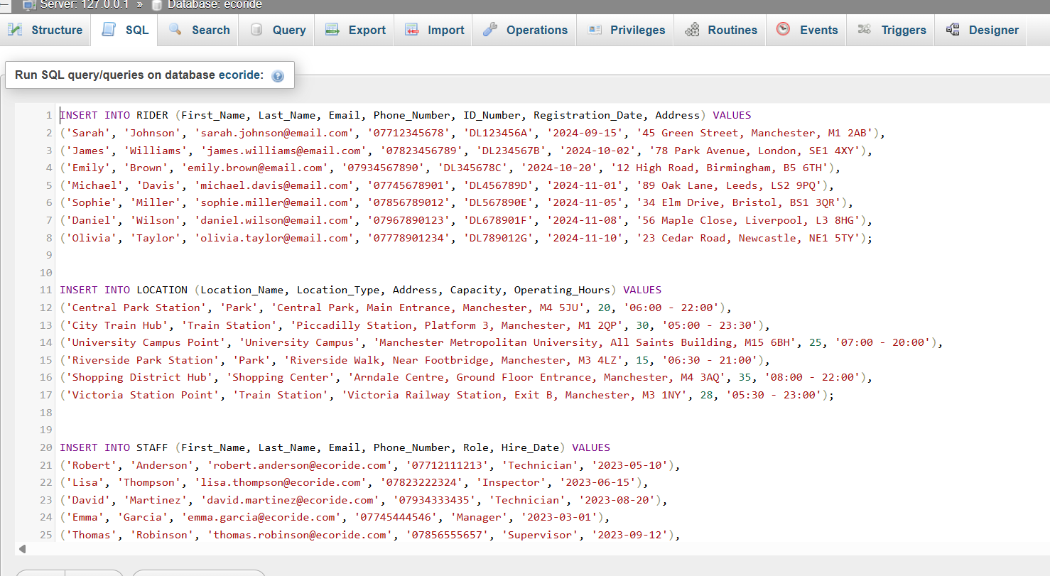
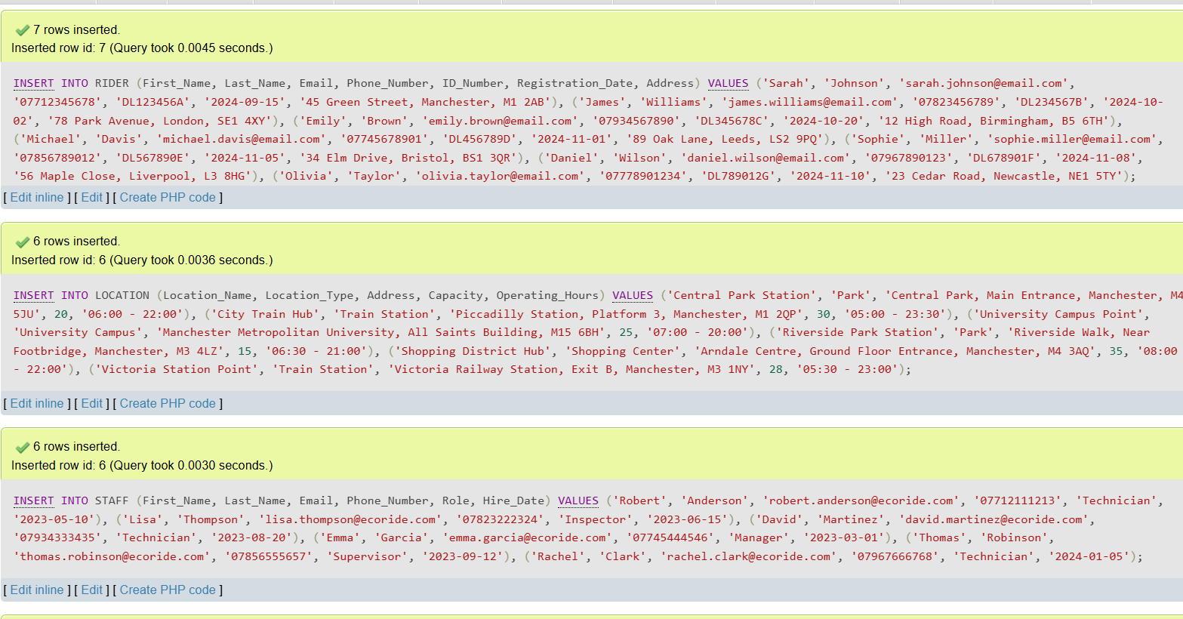
Figure: Sample Data Insertion Screenshot

5.3 Query Development
5 important queries were developed that can demonstrate all system capabilities in my opinion.
Query 1: List All Available Bikes
SELECT Bike_ID, Bike_Type, Battery_Capacity
FROM BIKE
WHERE Current_Status = 'Available'
ORDER BY Battery_Capacity DESC;
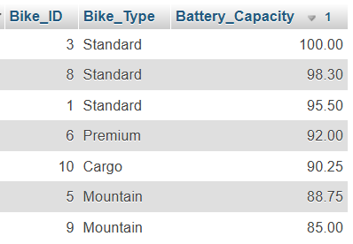
Figure: Available Bikes Query Result
Query 2: New Riders in November 2024
SELECT Rider_ID, CONCAT(First_Name, ' ', Last_Name) AS Full_Name,
Email, Registration_Date
FROM RIDER
WHERE YEAR(Registration_Date) = 2024
AND MONTH(Registration_Date) = 11;
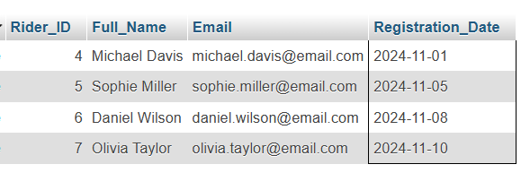
Figure : New Riders Query Result

Query 3: List all locations with capacity greater than 20
SELECT
Location_ID,
Location_Name,
Location_Type,
Address,
Capacity,
Operating_Hours
FROM LOCATION
WHERE Capacity > 20
ORDER BY Capacity DESC;
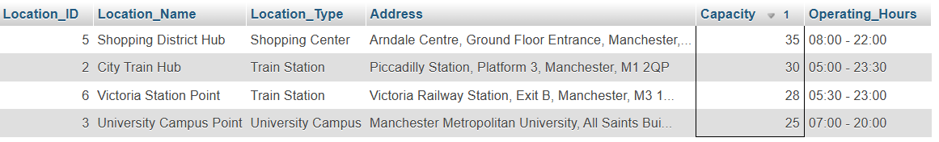
QUERY 4: Most frequently used bikes (by number of rentals)
SELECT
B.Bike_ID,
B.Bike_Type,
B.Current_Status,
COUNT(R.Rental_ID) AS Total_Rentals,
B.Total_Distance_Traveled,
ROUND(AVG(R.Duration_Minutes), 2) AS Avg_Rental_Duration_Minutes,
SUM(R.Cost) AS Total_Revenue_Generated
FROM BIKE B
LEFT JOIN RENTAL R ON B.Bike_ID = R.Bike_ID
GROUP BY B.Bike_ID, B.Bike_Type, B.Current_Status, B.Total_Distance_Traveled
ORDER BY Total_Rentals DESC, Total_Revenue_Generated DESC
LIMIT 5;
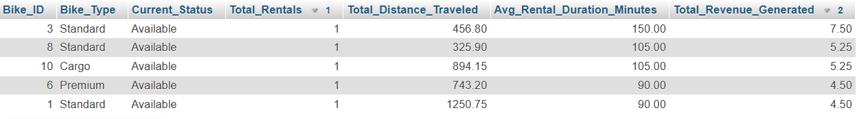

Query 5: Currently Rented Bikes
SELECT B.Bike_ID, B.Bike_Type,
CONCAT(R.First_Name, ' ', R.Last_Name) AS Rented_By,
REN.Rental_Start_DateTime
FROM BIKE B
INNER JOIN RENTAL REN ON B.Bike_ID = REN.Bike_ID
INNER JOIN RIDER R ON REN.Rider_ID = R.Rider_ID
WHERE REN.Rental_End_DateTime IS NULL;
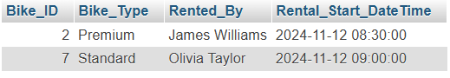
Figure : Currently Rented Bikes Query Result

6. Testing and Validation

6.1 Test Cases
Five tests were also conducted to validate the systems functionality and data integrity of all the tables.
Test 1: Rider Registration
Test SQL:
INSERT INTO RIDER (First_Name, Last_Name, Email, Phone_Number,
ID_Number, Registration_Date, Address)
VALUES ('Test', 'User', 'test.user@email.com', '07700123456',
'DL999999Z', CURDATE(), '123 Test Street, Manchester, M1 1AA');

SELECT * FROM RIDER WHERE Email = 'test.user@email.com';

Result: PASSED. A new rider successfully registered.
TEST 2: Constraint Validation
Test SQL:
INSERT INTO BIKE (Bike_Type, Purchase_Date, Current_Status, Location_ID, Battery_Capacity, Total_Distance_Traveled)
VALUES ('Standard', CURDATE(), 'Available', 1, 150.00, 0.00);
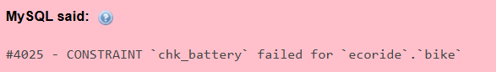
Error: CHECK constraint 'chk_battery' failed.
TEST 3: Foreign Key Integrity
Test SQL:
INSERT INTO RENTAL (Rider_ID, Bike_ID, Pickup_Location_ID, Rental_Start_DateTime, Payment_Status)
VALUES (1, 99999, 1, NOW(), 'Pending');
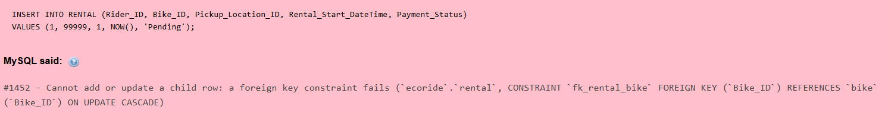
Error - Foreign key constraint fails (BIKE_ID)
TEST 4: Check Revenue Calculation
SELECT
COUNT(*) AS Total_Completed_Rentals,
SUM(Cost) AS Total_Revenue,
ROUND(AVG(Cost), 2) AS Average_Cost_Per_Rental,
MIN(Cost) AS Minimum_Cost,
MAX(Cost) AS Maximum_Cost
FROM RENTAL
WHERE Rental_End_DateTime IS NOT NULL
AND Payment_Status = 'Paid';
Result : Passed

TEST 5: Confirm No Orphan Rentals
SELECT
'Orphan Check: Rentals without Rider' AS Test_Name,
COUNT(*) AS Orphan_Count
FROM RENTAL REN
LEFT JOIN RIDER R ON REN.Rider_ID = R.Rider_ID
WHERE R.Rider_ID IS NULL;
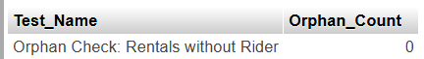
Result : No orphan rentals.
Overall Success Rate: 5/5 tests passed (100%)

7. Reflections

7.1 Challenges Faced
Challenge 1: Handling Ongoing Rentals
- Issue: Return_Location_ID and Rental_End_DateTime unknown for active rentals
- Solution: Allow NULL values for these fields
- Learning: Database must accommodate incomplete transactions
Challenge 2: Representing Time-Based Data
- Issue: Choosing between DATE and DATETIME
- Solution: DATETIME for rentals (precise timing needed), DATE for maintenance
- Learning: Consider business requirements for time precision
Challenge 3: Normalization vs. Query Performance
- Issue: Highly normalized design requires multiple JOINs
- Solution: Strategic indexing on foreign keys
- Learning: Balance between normalization and practical performance

7.2 Future Improvements
Improvement 1 will be Dynamic Pricing System. Now the system uses fixed cost per rental. Future version could implement:
- Peak/off-peak pricing based on time of day
- Premium pricing for Premium and Cargo bikes
- Distance-based charges using GPS data
- Subscription/membership discounts
Improvement 2 is Real-Time Bike Tracking. Add GPS coordinates to DB.
- Lost bike recovery
- Live location tracking for users
- Geofencing alerts for unauthorized movement
- Route history for analytics
Improvement 3 is Automated Notifications. Create db triggers for:
- Low battery email alerts to maintenance team
- Overdue rental SMS to riders
- Service due reminders for staff
- Payment confirmation emails
Improvement 4 is Reservation System. It allows advance booking with:
- Reservation table linking riders to future rentals
- Hold period with automatic release
- Cancellation policy management
- No-show tracking

8. Conclusion
This project successfully designed and implemented a comprehensive relational database system for the EcoRide electric bike rental service. The solution addresses all functional requirements specified. All the while providing robust capabilities for rider management, bike tracking, rental transactions and maintenance logging. The indexing system allows for faster query search returns. As the db/users grow over time, this efficient design will prove its worth as the queries won't lag. Which translates to a faster processing time. The system is also production-ready and provides a solid foundation for EcoRide's operational needs.

9. References
[1] Elmasri, R. and Navathe, S. B. (2021) Fundamentals of Database Systems, 7th edn. Harlow: Pearson Education Limited.
[2] Date, C. J. (2020) Database Design and Relational Theory: Normal Forms and All That Jazz, 2nd edn. New York: Apress.
[3] Connolly, T. and Begg, C. (2023) Database Systems: A Practical Approach to Design, Implementation, and Management, 6th edn. Harlow: Pearson Education Limited.
[4] MySQL Documentation (2024) MySQL 8.0 Reference Manual. Available at: https://dev.mysql.com/doc/refman/8.0/en/ (Accessed: 15 November 2025).
[5] Coronel, C. and Morris, S. (2022) Database Systems: Design, Implementation, and Management, 13th edn. Boston: Cengage Learning.
[6] Ramakrishnan, R. and Gehrke, J. (2023) Database Management Systems, 4th edn. New York: McGraw-Hill Education.
[7] Oracle (2024) Database Normalization. Available at: https://docs.oracle.com/en/database/oracle/oracle-database/ (Accessed: 14 November 2025).
[8] W3Schools (2024) SQL Tutorial. Available at: https://www.w3schools.com/sql/ (Accessed: 13 November 2025).

