

Name: Oana-Andreea Puscuta
ID number: 2232738
Module code: BMIH4002
Module Title: Food & Beverage Operations
Lecturer: Antoinette Milne, Ka Po Chong, Philippa Fitzgerald
Programme: BA International Hotel Management
Assignment Title: Assignment 2 Menu Engineering

Part 1: Restaurant concept
The Il Gusto Italiano is now available at restaurant trinity that will showcase the authentic taste of Italy in the UK. The concept behind this restaurant is to serve people with authentic flavour and ambiance defining the unique character to give people exclusive dining experience. The overall themes of the restaurant are designed to give original essence and the food is the essential blend of all the facets. The Il Gusto Italiano will serve Italian cuisine that is loved all around the world and the menu will encompass a wide range of pastas, Risotto, polenta, cured meats, sea food and pizzas. Additionally, Il Gusto Italiano at hotel Trinity will also serve people with wide range of Italian drinks. Italian cuisine is famous for the fact that offers a wide range of diverse recipes that are simple yet delicious prepared from fresh ingredients that make it more appealing (Presenza et al., 2020; Parasecoli 2019). The concept behind this restaurant is to serve people with traditional Italian food made from fresh ingredients following natural cooking methods.

Target audience
Italian cuisines can be regarded as one of the most liked cuisines around the globe. Target market of a restaurant is usually analyzed from wide range of angles and aspects that encompasses the décor, ambiance, dessert options and the cheese used (Ayoub et al., 2023; Tian et al., 2021). The restaurant has the focus on people that love traditional Italian cuisine, people who are affectionate towards Italy and its foods, people belonging to Italy, people who are looking for restaurants offering fine dining experience and the individual wanting to revive Italian cuisine experience (Iofrida et al., 2022; Putra et al., 2023). The largest segment of the target market belongs to people who love Italian food in general and have understanding of popular cheese and wines. People who have great love for Italian cuisine look for original experience are targeted to satisfy the longing for a piece of Italy (Pesaresi and Abbasian 2023; Lin., 2020).

Reason behind the menu choices
One of the most important factor for a restaurant is it menu choices that is vital for attracting wide range of market. Original Italian dishes will be incorporated in the menu that will serve broader range of audience and provide with original essence from the Italy. To enhance the experience the ambiance and décor will also be focus upon styles from Italy and the restaurant will also serve people will with live pastas prepared in hollowed cheese wheel. It has been noted that Italian food is among the most favorite food of British consumers (Kavya et al., 2022; Ingrassia et al., 2023).

Part 2: Menu design


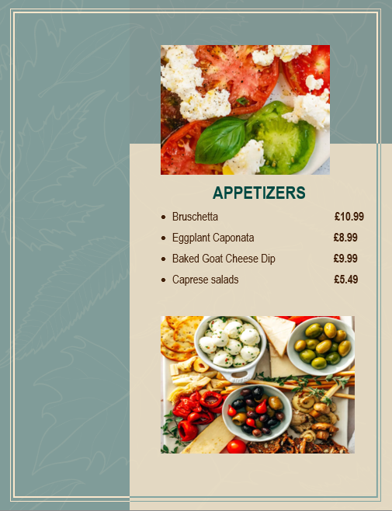
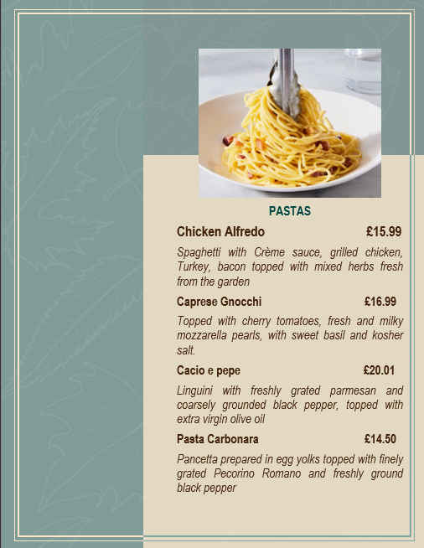
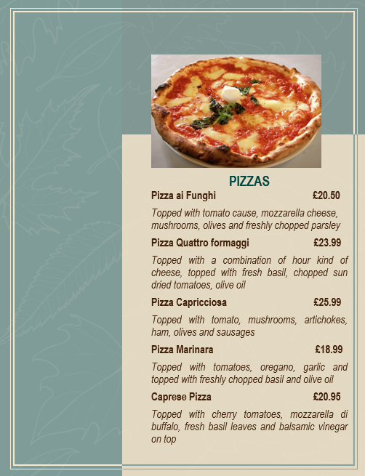
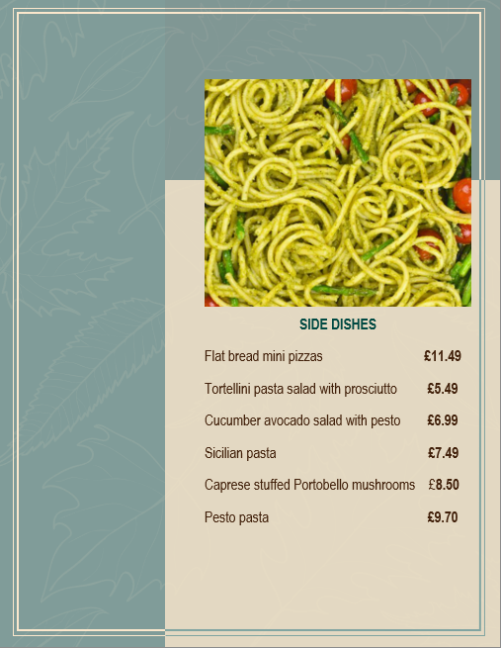
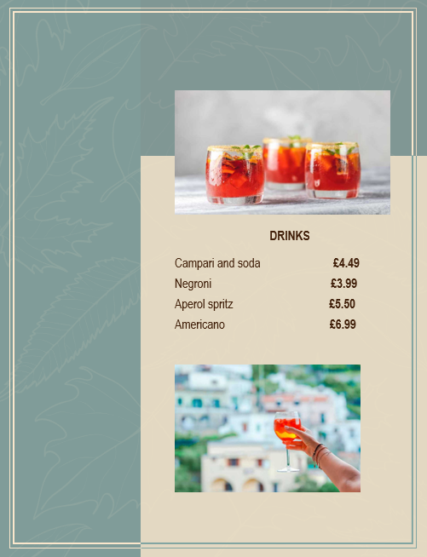
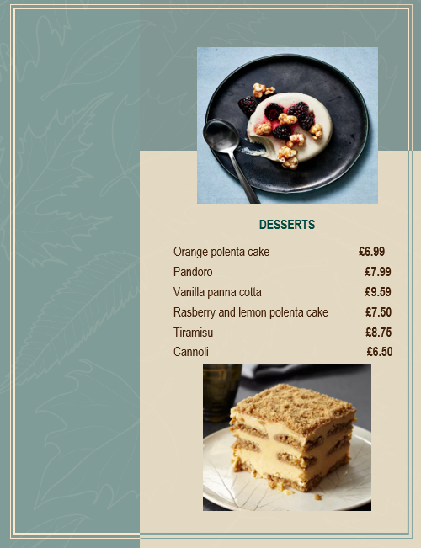

References
Iofrida, N., De Luca, A.I., Zanchini, R., D'Amico, M., Ferretti, M., Gulisano, G. and Di Vita, G., 2022. Italians’ behavior when dining out: Main drivers for restaurant selection and customers segmentation. International Journal of Gastronomy and Food Science, 28, p.100518.
Lin, L.C., Cerros, L.D. and Kumar, S., 2020, May. Capitalizing on the Increasing Influence of Latin American Cuisine: A Marketing Plan on High Tide. In Tarumanagara International Conference on the Applications of Social Sciences and Humanities (TICASH 2019) (pp. 478-485). Atlantis Press.
Parasecoli, F., 2019. The invention of authentic Italian food: Narratives, rhetoric, and media. Italians and food, pp.17-41.
Pesaresi, A. and Abbasian, S., 2023. Reality and fiction: Scandinavian tour operators’ image of Italy through photographs. Journal of Quality Assurance in Hospitality & Tourism, 24(3), pp.253-278.
Presenza, A. and Messeni Petruzzelli, A., 2020. Haute cuisine and country of origin. British Food Journal, 122(1), pp.136-150.
Putra, F.K.K., Putra, M.K. and Novianti, S., 2023. Taste of asean: traditional food images from Southeast Asian countries. Journal of Ethnic Foods, 10(1), pp.1-15.
Tian, G., Lu, L. and McIntosh, C., 2021. What factors affect consumers’ dining sentiments and their ratings: Evidence from restaurant online review data. Food Quality and Preference, 88, p.104060.
Wulandari, R., Tandri, R.A. and Putra, A.A., 2019. Factors affecting choice of chinese restaurants in bandung: Important of ambiance. In 6th Bandung Creative Movement 2019 (pp. 338-341). Telkom University.
Kavya, B., Deetchika, R., Radhamani, V. and Manju, D., 2022. Food Inventory Demand Forecasting Tool.
Ingrassia, M., Altamore, L., Columba, P., Raffermati, S., Lo Grasso, G., Bacarella, S. and Chironi, S., 2023. Mediterranean Diet, Sustainability, and Tourism—A Study of the Market’s Demand and Knowledge. Foods, 12(13), p.2463.

