Problem
Analysis and Solution
Development

Module Name: Analysing and Solving Problems
Module Code: ACCA 4019
Student Name: Joao Soares
Student ID: 2430573
Group:3
Lecturer’s Name: Dr Redhwan Al-amri

Table of Content
Table of Contents 1
1. Introduction 2
2. Deconstruct the Problem 2
2.1 MoSCoW Technique Requirement 2
2.2 Variables Identification 2
3. Proposed Solution 2
3.1 Flowchart 2
3.2 Flowchart Explanation 2
4. Reflection and Justification 2
4.1 Abstract thinking 2
4.2 Sub-dividing 2
4.3 Justification of solution 2
4.4 Limitation 2
4.5 Assumption 2
5. Conclusion 2
References 2

Introduction
In this assignment I will be covering the following topics and what I manage to complete, I explained about how to deconstruct the problem and to break them down to each station to tackle it accordingly. Being able to use the Moscow technique will be here and variables identification will also be demonstrated, proposed solutions, reflection and justification.

Deconstruct the Problem
This is about how we can tackle the problem affectively, to break a large overwhelming complicated problem, you must first split the problem into smaller and manageable parts so that we able to identify the roots of the problem and the required solutions for it. So, you can understand and solve it step-by-step. Instead of trying to complete or accomplish everything at once you identify the components separately and tackle them in each category. Clearly define the problem, once the problem has been identified, try and find the different factors that contribute
1st identify the objective to see exactly what we are trying to achieve, so that we can be specific.
2nd we need to find the reason why it’s a problem, what caused the problem, to see it clearly what the symptoms are.
3rd break the problem into sub-problems; categories can also work as a solution.
4th you can also utilise tools for the example, mind map or logic trees in order to bring more clarity and more organised and to define the problem with a bit more structure.
5th isolate variable and assumptions this will separate the facts from assumptions and will be able to get more clarity. [1]

MoSCoW Technique Requirement

    - must have
- Allocation of each classroom depending on class size and room capacity
- The timetable that prevents clashes, so no double booking for rooms or teachers
- Making sure that all the lessons are scheduled within available time slots, this will include things like rooms capacity and availability. Classes with appropriate size, time and subject.
    - should have
- An effort of making and keeping classes in nearby rooms, in order to minimise movement time between classes.
- Optimal room allocations that are programmed to automate automatically, to enhance efficiency and usability.
- Notifications are crucial for schedule changes; this is for conflict alerts when scheduling issues arise
- Allow editing and updates of timetables easily.
    - could have
- A visual timetable like calendar view type style so that students exactly what day it is and what subject
- Weekly reports on room usage, under or over utilisation
- Create a website for students, staff and access with mobile devices.
    - won’t have
- Creating a GPS for optimal movement tracking
- Fully automated decision with no individual input.
- Transport of attendance tracking

- AI based prediction system for students for each subject and results [2]

Variables Identification
Variables: | Description: | Data type
Rooms | Stores all classrooms available in the college | List/ array
Room_capacity | Maximum number of students that room is able to hold | Integer
Room_location | Building or area where the room is located | String
Classes | Stores all classes that need to be scheduled | List/ array
Class_size | Number of students in a class | Integer
Teacher | Name/ID of the teacher assigned to class | String
Time_slots | Available time periods in the timetable | List/ array
Schedule | Stores final timetable, room, time, class | 2D array/ table
Assigned_room | Room allocated to class | String
Assigned_time | Time slot assigned to a class | String
Is_available | Indicates if a room or teacher is free | Boolean
Best_room | Most suitable room based on size and location | String

Proposed Solution
It basically means ideas and methods that can be the solution the problems, in simpler terms it basically means suggestions or put forward. They are not necessarily proven or the results, they do this for consideration and testing for further discussion. Proposed solutions are not random ideas, these ideas have to clear enough to be implanted and understood, it is also obligated to relevant to the problem and it is also important for it to be practical and realistic.
Example: proposed solutions for classroom space management
Use a computer-based scheduling system to automatically assign each classroom depending on room capacity and class size. This will help avoiding underused rooms, preventing overcrowding and it also reduces human error in scheduling
Example: centralised classroom booking system
Use a single system that can create all classrooms that are booked and tracked throughout the whole time, while staff check room availability before setting any schedule, this will ensure no double-booking errors. This will help eliminate any problems with timetable clashes and it will ensure all available rooms are used effectively.
Secondly, an automated timetabling system can be used for room capacity and class size. This will make sure larger classes are placed in bigger classrooms. Meantime while smaller classes and be used for smaller groups, reducing overcrowding and underused. Classroom booking system can be placed, and it will help clashes of timetable by giving the staff members the opportunity check room availability before scheduling lessons.[3]

Flowchart
The meaning of a flowchart would be a visual diagram that explains the process of something with step-by-step instructions, for it to be understood to the public eye view, it’s normally used in business processes, engineering and software development. Flowcharts use symbols to identify each process or action to connect them with arrows to show the flow of the process.
Examples: - oval means terminal that’s where there will be beginning and end of the process
- Rectangle which represents an action or a process, this is when the operation or computation takes course.
- Parallelogram is the input and output of the operation; this is mostly for data retrieval or output like displaying results.
- Diamond basically means a decision point; this is when the flowchart can lead to two or more decisions depending on the conditions
Variable content | Description | Example
Capacity | Maximum students | Room 40
Location | Building | Yorkshire
Availability | Available classes | Classroom 15
Schedule_ID | Unique schedule ID | S003
Class_ID | Linked Class | R304
Room_ ID | Assigned room | R12
Time_slot | Time assigned | 13:00 – 17:00
- Arrow line is a flow line that shows directions of the flow between each step, it basically connects the symbol and defines the the sequence of actions. [4]
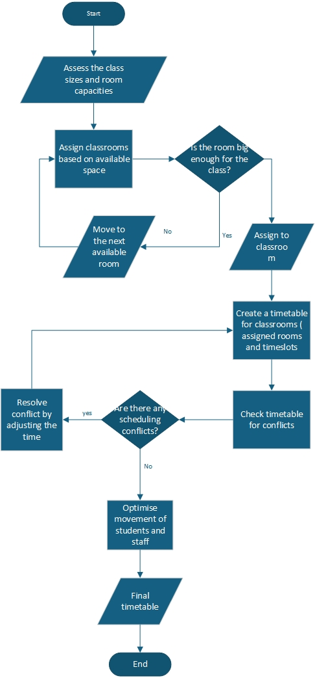

Flowchart Explanation
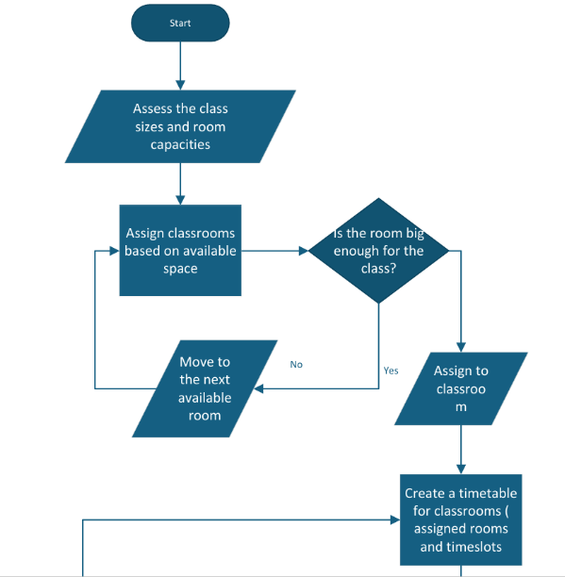
- This is when you put the input of class data and room capacity.

- The output of this will be list of rooms and class sizes.

- This when I put a decision if the room is big enough and assign them into classes.

- Create timetable for available room and timeslots.

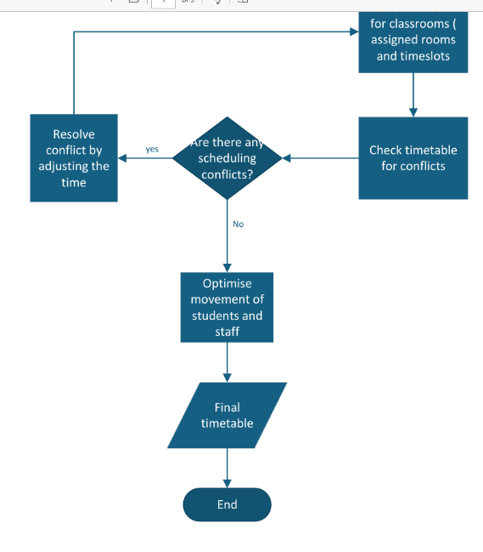
- Adjusting the time for the timetable conflict.

- Then I continued to put the input of class schedule and room allocation.

- The output minimising of time spent moving.

- The final output was to put accurate timetable and room allocation with no conflicts.

Site: draw.io

Reflection and Justification

Abstract thinking
Abstract thinking is being able to understand concepts and ideas and relationships that are not necessarily tied to direct sensory experiences, concrete and physical objects this allows us to cooperate with patterns, meanings, symbols and hypothetical situations
The key features of abstract thinking, one of them being pattern recognition this is when you can identify relationships and patterns between ideas. For example, similarities between different types of problems and applying the same solutions. Hypothetical reasoning is one of them as well because it creates scenarios of “what if” predicting outcomes if certain conditions change. Conceptual thinking, this is the ability to think outside the physical world but to experience love, justice, freedom and infinity. Symbolic thinking, this is when you use symbols, numbers, diagrams or language. Critical thinking and analytical thinking, this is basically drawing assumptions and logical solutions and evaluating information.[5]

Sub-dividing
To define Sub-dividing means breaking down large problems into smaller ones this makes it easier to be manageable, to be better understood, organised and worked on.
The core definition would be being able to divide something complex into smaller units to simplify analysis and to plan and to execute.
Key examples would be:
- Breaking down complexity
Meaning being able to divide large tasks or ideas into smaller pieces to make it manageable to handle.
- Step by step approach
Allow you to to tackle and complete stages instead of tackling it all at once
- Better understanding
To make it easier and smaller sections, you must break it down into small pieces to study analyse and manage.
- Improved organisation
Each piece can be organised logically, making the overall system a lot clearer[6]

Justification of solution
This is a process of logical reasoning, evidence and giving clear idea, action or conclusion, to why is acceptable or correct. The core definition would be the act of providing valid reasons and evidence to prove or defend something. Elements of this would be relevance, evidence, clarity, reasoning and the importance of justification.

Limitation
The true definition of this is something that has boundaries, weaknesses and restrictions that can affect on individuals, because limitations are factors that can restrict accuracy, effectiveness or performance. And this can fall into any category like idea, study, method and system.

Assumption
Is the principal of accepting something that is true without having solid concrete proof, this is a chance to to have decision making or analysis. Core of this is that it can be for a statement that can be taken true but not having direct evidence, only for basic of further thinking and creating conclusions.

Conclusion
To conclude problems analysis and solution development what I got from this is a firm base understanding for solutions for certain problems and how we can break it down and tackle certain tasks and how we use it in the real world. Flowcharts is probably the highlight in all this because it gives you a visual diagram of how it all works step by step.

References
[1] de Lima, de Souza Rodrigues, "Integration of BIM and design for deconstruction to improve circular economy of buildings," vol. 80, pp.108015, 2023,
[2] Vijayakumar, Krishna, "Assessing the effectiveness of MoSCoW prioritization in software development: A holistic analysis across methodologies," vol. 10, 2023,
[3] Tang"Student-centered approach in teaching and learning: What does it really mean?" vol. 2, no. 2, pp.72–83, 2023,
[4] Muratore"No title," 2025,
[5] Liu, Wang, "Visual abstract thinking empowers multimodal reasoning," pp.arXiv: 2505.20164, 2025,
[6] Yung "Sub-Divided Units: Property Rights and Market Versus Right to Housing," in Rights and Urban Controversies in Hong Kong: From the Eastern and Western Perspectives, Springer, 2023, pp. 31–48.

