
Assessment 1
Elizabeth line
LCBB5005 - Project Management

submitted by
Student Name: Kristina Ivanova
Student ID: 2020522

Table of Contents
Introduction 2
Project Scope 2
Project Assumptions 3
Project Budget 4
Project Time 4
Project Quality 5
Project Constraints 5
Project Stakeholders 6
Project Risk Factors 7
Conclusion 8
Referencing List 9

Introduction
The project management requires that the different aspects related to the project are planned and executed in an effective manner. The project can be faced with different challenges and constraints that may hinder its completion on timely basis. Some of these challenges are of such a nature that they cannot be foreseen or avoided. The analysis of these factors is important to learn about them and avoid such mistakes in the future (Cleland and King, 2020). The Elizabeth line is rapid transit service and hybrid commuter rail service that operates in London and its suburbs. The passenger service on the project started on May 24, 2022 and was named after Queen Elizabeth. The project was initiated under the name of Crossrail in 2007 while the actual construction of the project began in 2009. The project was initially planned to be successfully completed in 2018. However, the project faced rapid delays including the closure of work for several months due to Covid-19 pandemic (Crossrail, 2022). This was a large-scale project in London that was planned to improve the public transport facility in the area. The different challenges faced by the project resulted in several delays that could have been avoided. The delay in public projects result in difficulties for the public as well as huge expenditures from the public accounts. In this report, we will critically review the initial project management plan of the project including some of its core elements. Based on the analysis, we will be able to better comprehend the problems with project management and provide recommendations relevant to the subject.

Project Scope
The Crossrail project was initiated as a big scale project that will connect the different areas of London and its suburb. The project was aimed to connect West and East side of London and offer a broad range of passenger services to the public. The project also connect two existing and major railway lines in London i.e. Great Eastern Main Line and Great Western Main Line (Chodrowski, Ingram and Black, 2021). The scope of the project also included the improvement in the frequency of travel. The project plan was initially expected that around 24 passenger trains would be running in each direction per hour after the completion of the whole project (Crossrail, 2022). The project was initiated with a big scope and it was extremely important that the other core factors of the project plan should be designed in such a manner that the project can be completed in an effective manner.

Project Assumptions
The project was initiated after making assumptions about certain different aspects of the project. Each project includes some assumptions that can be described as factors assumed to be true for the particular project for its successful completion. The project assumptions are considered true with any need for a proof of them (Clough Sears and Sear, 2020). The Elizabeth line project was also initiated and different assumption were made about the project in the beginning. One of the assumptions of the project were that the materials required for the construction of the project would be available on time and in the projected costs. Another assumption was that the necessary human resources that have knowledge, skills and other competencies for carrying out the project would also be available. One of the bigger assumption about the project was related to the availability of funds for the project with any delays or difficulty. The project was assumed to be completed without any major unexpected event that may disturb the flow of the project and cause a delay in its completion (Day, 2017). The initial design of the project was assumed to be final and the project will be completed without any changes in the design. The project also assumed that the approvals from government and other authorities will be given timely and without any delays.
The project was faced with different challenges as some of the assumptions did not remain true. The project was faced with a big challenge in the form of worldwide pandemic. The pandemic caused the stoppage of work on the project for several months as restrictions were put in place for public safety. Additionally, the construction re-initiated slowly after the pandemic as the safety requirements for worker health were still very high. One of the basic assumption of each project is that no changes in the initial design will take place in the project at all (Healy, 2017). This assumption also did not hold true for this project. Although, there were no major changes in the project design but there were small tweaks that resulted in delaying the launch of the project. This has caused the project to not be fully completed till yet. However, the services have been opened for many different stations across London.

Project Budget
The budget is one of the most important aspects of a project as it outlines the different expenses that will be incurred on the different parts and tasks in the project. The budget also helps in getting the required finances available for the project without any hindrance in the future (Kerzner, 2017). The Crossrail project was initiated as a public project and the budget forecast for this was important because the necessary approvals for the finances will be given by the authorities accordingly. The project was initially budgeted to be £14.8 billion before the start of the project. The funds for the project will be met by UK government, Mayor of London and different businesses in London. The project-funding envelope was revised to £17.6 billion in 2018 as the project was delayed and required further costs. The latest addition in the funding envelope for the project is £18.8 billion (Crossrail, 2022). The budgeting of the project is an important issue as additional fund requirements has resulted in a strain on public funds. The project final completion budget exceed by £4 billion from the initial budget. This is a huge difference and should not have happened. One of the reason for this variance in budget is non-timely completion of the project. The inflationary factors affect the forecasts that have been made many years ago. The pandemic has also caused the budget of the project to go higher as additional finances were required for high worker safety and also the high inflation levels around the world.

Project Time
The time management of a project are an important aspect of the project management. It requires that the work in the project to be analysed and a timeline is developed for efficient completion of each task and consequently the whole project (Mir and Pinnington, 2017). The timeline for the completion of the whole project was 2018. The whole project was estimated to be completed within 9 years from the actual start of the construction in 2009. The project had nine different stages that were to be completed in order for the project to finish. The project timelines were delayed and only three of the stages were completed in 2018. Currently, the Elizabeth line has been opened for the passengers by a formal inauguration but still there are two stages of the project that are remaining and expected to be completed by next year (Crossrail, 2022). There were no major changes in the project design but still the project was behind its proposed timeline. One of the reason for this delay is that the project timeline should have been established after more research to include different factors that eventually resulted in the delay in construction (Day, 2017).

Project Quality
The project quality is an important aspect of the project management. The first aspect of managing project quality is defining the desired quality output of the project. Once the desired quality has been established, all the project activities are continuously measured to ensure that the desired level of outputs can be achieved in the project (Basu, 2017). The corrective actions are also advised based on the monitoring of the project activities. The project quality was clearly established for the Elizabeth line project. The project was monitored to ensure that the desired quality of outcome is achieved. The project quality management informed that some changes are required in order to make sure the quality is of expected standards. The project quality management resulted in some changes in the project that should have been included in the project plan from the beginning for its effective completion.

Project Constraints
There are different constraints in each project. The constraints can be described as the factors that may hinder or limit the project. The constraints of the project can be related to availability of funds, skilled manpower, equipment, materials or the limitations of the project scope (Cleland and King, 2020). The Crossrail project was initiated with a view of providing higher frequency of traveling to the public as well as connecting the East Side and West Side of London. There were no major constraints that were included in the initial project plan because it is a public project and have been initiated after keeping different factors in mind. The project was faced with different constraints that should have been included in the project plan. The boring was met with challenges in some areas and minor changes in the designs had to be planned. Similar constraints were faced related to underground construction at some points. Such constraints should have been anticipated by the project team and included in the project plan (Day, 2017). The pandemic also caused a big constraint on the project and this type of constraint cannot be anticipated in the project.

Project Stakeholders
There are different stakeholders of each project and it is important to meet the different needs of each project stakeholder in a right manner for the successful completion of the project. The project stakeholder can be described as anyone that hold an interest or a legitimate relation to the project. We can also consider all those who will avail benefits from the project and may get affected from the project as its stakeholders (Healay, 2017). The Elizabeth Line is a huge public project in London and therefore, it has different internal and external stakeholders. The people of London, government authorities, funding businesses, contractors, staff members, and environmental associations are the key stakeholders of this project. The power and interest graph (See Figure - 1) is a useful way to understand different stakeholders of a project and satisfy their needs accordingly.
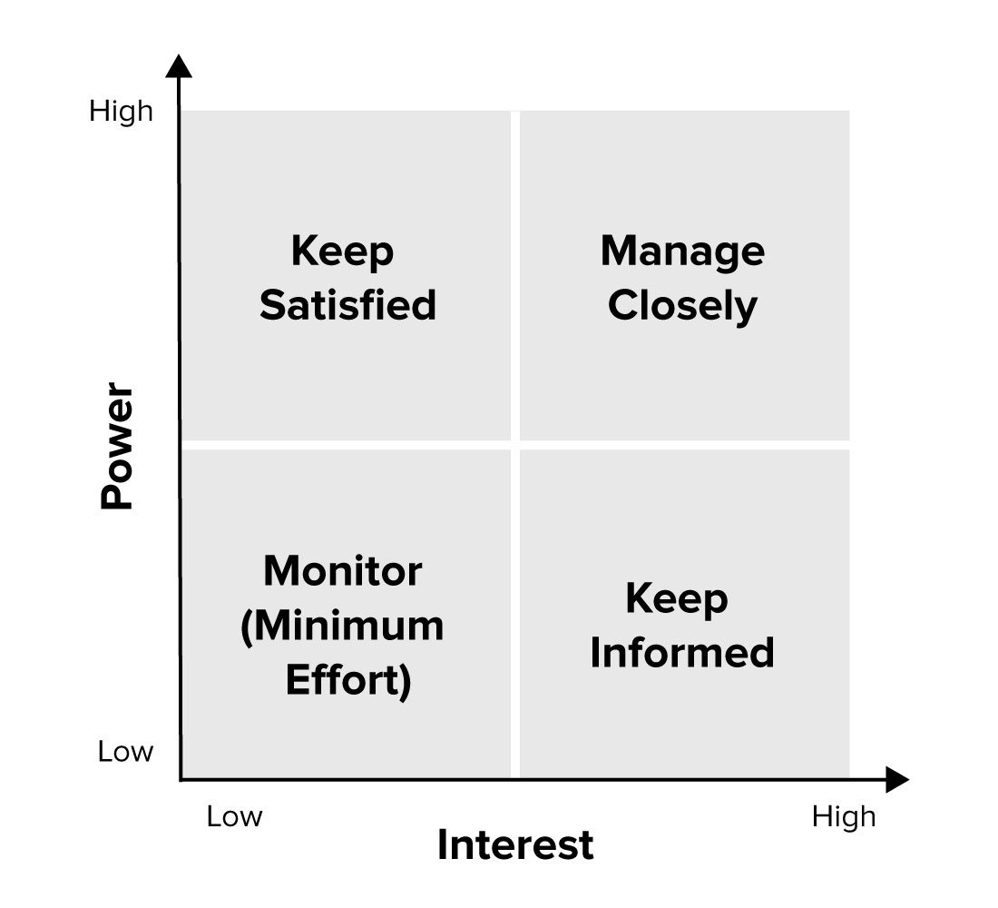
Figure - 1 Power and Interest Graph (Lienert, 2018)
This graph helps in categorizing the stakeholders based on the power they can exercise and the interest they may have in the project. The project management team should make sure they understand the needs of stakeholders in each quadrant and take actions accordingly (Ljungblom and Lennerfors, 2018). The stakeholders that may have lower interest and lower power in the project should be monitored and responded as per their needs. The people in London that do not use public transport fall in this category. The next type of stakeholders are those that do not have high power but their interest level in the project is very high. These stakeholders should be kept fully informed as they hold high levels of interest (Clough, Sears and Sear, 2020). The people that use public transport, contractors and environmental organisations fall in this category. Such stakeholders were informed regular about the updates related to the happenings in the project. Then there are stakeholders that may not have much interest in the project but they can exercise high power levels. Different local government bodies that approve certain activities fall in such category. The different requirements of these stakeholders were met timely in the project to keep them fully satisfied. Last but not the least, there are stakeholders that have high power of influence as well as high level of interest in the project. These stakeholders should be managed closely as they are of key importance (Dwivedula, 2019). The project management team, London government and UK government fall in this category of stakeholders. The project was able to meet the needs of different stakeholders in a very successful manner.

Project Risk Factors
There are also different risks associated with a project that can cause problems in its completion and may also result in complete failure of the project. The risks can be associated with the costs that will be incurred, the completion of the project as per the schedule and / or the performance of the team involved in the project (Kerzner, 2017). One of the biggest risk of the project were related to the geotechnical aspects. The boring of the ground and constructing tunnels was a difficult task and involved many risks. This risk factor is one of the reason the project was met with unexpected delays. The planning to manage this risk was done in the project but still some areas proved to be more challenging and the actions were have to be taken in order to such risks. This caused a huge delay in the project. The project incurred higher costs and delayed from the schedule. The project was public and managed by the government; otherwise, the project may have been a big failure.

Conclusion
The project management can help in efficiently and effectively completing a project. There are different factors in the project that can play an important role in its successful completion or failure. The project management involves use of different processes, techniques and methods that can facilitate the management of the project in a better manner (Cleland and King, 2020). The Elizabeth line is a public transport project that combines the West Side and East Side of London and provides more frequency travelling options to the public. The construction on the project started in 2009 and was expected to be completed by 2018. The project met with different challenges and was delayed. The official inauguration has been done in 2022 but some of the project parts will be completed by next year. The review of the initial project management plan has shown that some of the assumptions related to the project were not fully met. The pandemic was a huge event that delayed the action on the project for several months. The project’s initial budget was £14.4 billion while the current estimated budget is 18.4 billion. This is an increase of £4 billion. The delay in the project due to tunnel construction challenges and pandemic caused the budget estimates to go much higher. These challenges also resulted in a delay in the project completion date. The project quality was established and monitoring the project as per the desired quality identified different challenges in the project that should have been included in the initial project plan. The construction of the project had some risks that were managed but caused the delay. The different internal and external stakeholders were managed in a very effective manner. There are some recommendations related to the management of the Crossrail project based on the critical review. The assessment of the time and budget requirements of each stage of the project should have been done more carefully. The construction of the project were faced with different geotechnical challenges that caused delays in time and money. The project risks should have included an unforeseen major event and the backup plan for dealing with this challenge must be included. The financial forecasting could have been done in a better manner because the higher inflations was a factor that caused some increases in the budget of the project.

Referencing List
Basu, R., 2017, September. Quality management tools and techniques in major infra-structure projects. In 2017 6th International Conference on Reliability, Infocom Technologies and Optimization (Trends and Future Directions)(ICRITO) (pp. 114-126). IEEE.
Chodorowski, A., Ingram, P. and Black, M., 2021. Crossrail project: the impact of 4–18 Bishop's Bridge Road on the new Elizabeth line, London, UK. Proceedings of the Institution of Civil Engineers - Geotechnical Engineering, 174(1), pp.83-90.
Cleland, D. I., and King, W. R., 2020. Project Management Handbook. New York: Van.
Clough, R.H., Sears, G.A., and Sears, S.K., 2020. Construction project management. John Wiley & Sons.
Crossrail. 2022. Welcome to Crossrail. [online] Available at: <https://www.crossrail.co.uk/> [Accessed 7 August 2022].
Day, G., 2017. UK skills crisis: learning lessons from Crossrail for staffing future infrastructure projects. Proceedings of the Institution of Civil Engineers - Civil Engineering, 170(2), pp.56-56.
Dwivedula, R., 2019. Human Resource Management in Project Management: Ideas at the Cusp. European Project Management Journal, 9(1), pp.34-41.
Healey, P., 2017. Project Management. London: Routledge.
Kerzner, H., 2017. Project Management: A Systems Approach to Planning Scheduling and Controlling. 12th ed. Wiley.
Lienert, J., 2018. Stakeholder Importance and Influence | SSWM. [online] Sswm.info. Available at: <https://www.sswm.info/humanitarian-crises/prolonged-encampments/planning-process-tools/exploring-tools/stakeholder-importance-and-influence> [Accessed 7 August 2022].
Ljungblom, M. and Lennerfors, T., 2018. Virtues and Vices in Project Management Ethics. Project Management Journal, 49(3), pp.5-16.
Mir, F. and Pinnington, A., 2017. Exploring the value of project management: Linking Project Management Performance and Project Success. International Journal of Project Management, 32(2), pp.202-217.

