Table of Content

Educational Background …………………………………………………………………………………………………………..2

CV …………………………………………………………………………………………………………..3

Job Description ……………………………………………………………………………………………………….….5

Log of Clinical Placements …………………………………………………………………………………………………………11

Study Days …………………………………………………………………………………………………………12

Feedback …………………………………………………………………………………….…………………...14

Reflective accounts ………………………………………………………………………………………………….……...16

Log of educational experiences …………………………………………………………………………………………………….…...17

Feedback ……………………………………………………………………………………….………………...18

Reflective accounts ………………………………………………………………………………………………….……..20

Education and Professional Background
My name is Gwenllian Hall, and I am going to give you a brief introduction to my personal education and career life. I currently live at home with my parents in Pontargothi whilst I do my Nursing Studies and Health Diploma course at University of Trinity Saint Davids. Before studying at UWTSD I went to sixth form in Bro Myrddin school, I was planning on doing my Nursing degree after passing my A-levels but unfortunately I didn’t get the grades, but I’m hopefully planning on going in September 2019. I was lucky enough after my A-levels to get a Health Care support worker job in the hospital and this has given me an insight working on wards, I really do love this job but would like to go further with my Career. I knew after working on wards that nursing is the job for me.

Professional Goals
The purpose of completing my Nursing Health and Studies diploma course is to enable me to do my Nursing Degree. I feel as if I have stuck to this goal, and this will provide me with new challenges to learn. I love to expand my learning, and to do my Nursing Degree this gives me a sense of satisfaction knowing that I’m so close do achieving this goal.
Educational Goals
My education goals include improving my essay writing skills, insight into research, more in-depth knowledge into anatomy and physiology. Being successful in my Diploma in Nursing studies will help me achieve these goals.

Importance of Nursing Portfolio
A portfolio is a living and changing collection of records that reflect your accomplishments, skills, experiences, and attributes. It highlights and showcases samples of some of your best work, along with life experiences, values and achievements. The personal information that you incorporate into your portfolio can greatly reflect on your abilities as an individual as well as become a useful tool in marketing yourself to employers, corporations, colleges and universities. A portfolio does not take the place of a resume, but it can accentuate your abilities and what you can offer in the chosen field.

Gwenllian Rose Hall
Tyonnen, Llys Egwad, Pontargothi, Carmarthenshire SA32 7NT
01267 290984 07815674475
Gwenllianhall@aol.com

Personal Statement
I am 18 year old girl who attends University of Trinity St Davids studying Nursing Studies and Health. In school I studied History, Health and care and also Drama for my GCSE’s and for my A-levels I studied Drama, Public services and Welsh Bac. I’m a very determined person when it matters, confident and ambitious who always gives the best into everything. I get described as a loving and caring person. In the future I would love to be a Nurse and have been working hard these last few years to achieve this goal.

Key Skills
- Welsh Language speaking
- Excellent organisational skills, within varying fields
- Excellent communicator within a team
- Self motivated and work well on my own or as part of a team
- Work well under pressure
- Confident at communicating effectively with different members of the public

Employment History Hywel Dda Health Board- Catering Staff
September 2017- May 2018

The role of this job was to assistant to help out in the kitchen and to be responsible for hygiene and cleanliness within food preparation areas. I am also responsible for carrying out basic food preparation tasks, such as washing and peeling food. This job allowed me to get closer to wards and to see what it was like on the wards. It also enhanced my people skills and made me more confident in the hospital.

Hywel Dda Health Board- Health Care Support Worker
February 2018- to date

In this role I had to assist healthcare professionally in the delivery of patient care. I must work with an individual practiceoner or a team, taking on some more routine tasks such as welcoming and preparing patients, explaining treatment and updating patients records. I would also wash and assist patients to the toilet and take daily OBS which included doing patients blood pressure, temperature and pulse. I really enjoy this job because it allows me to work closely with nurses and patients and also enhance my patient care.

Education History
Bro Myrddin
14/09/11 to 22/07/18

Qualifications
Maths – GCSE C
English Lan – GCSE C
Science- GCSE C
Drama – GCSE C
English Lit – GCSE C
Health& Care - GCSE C
Public Services A-level C
Welsh Bac A-level C
Further courses
Skills to Care January 2018
Corporate Induction May 2017

References
Donna Major
Nursing Bank Manager
Hafan Derwen
St Davids Park
Carmarthen
01267235151

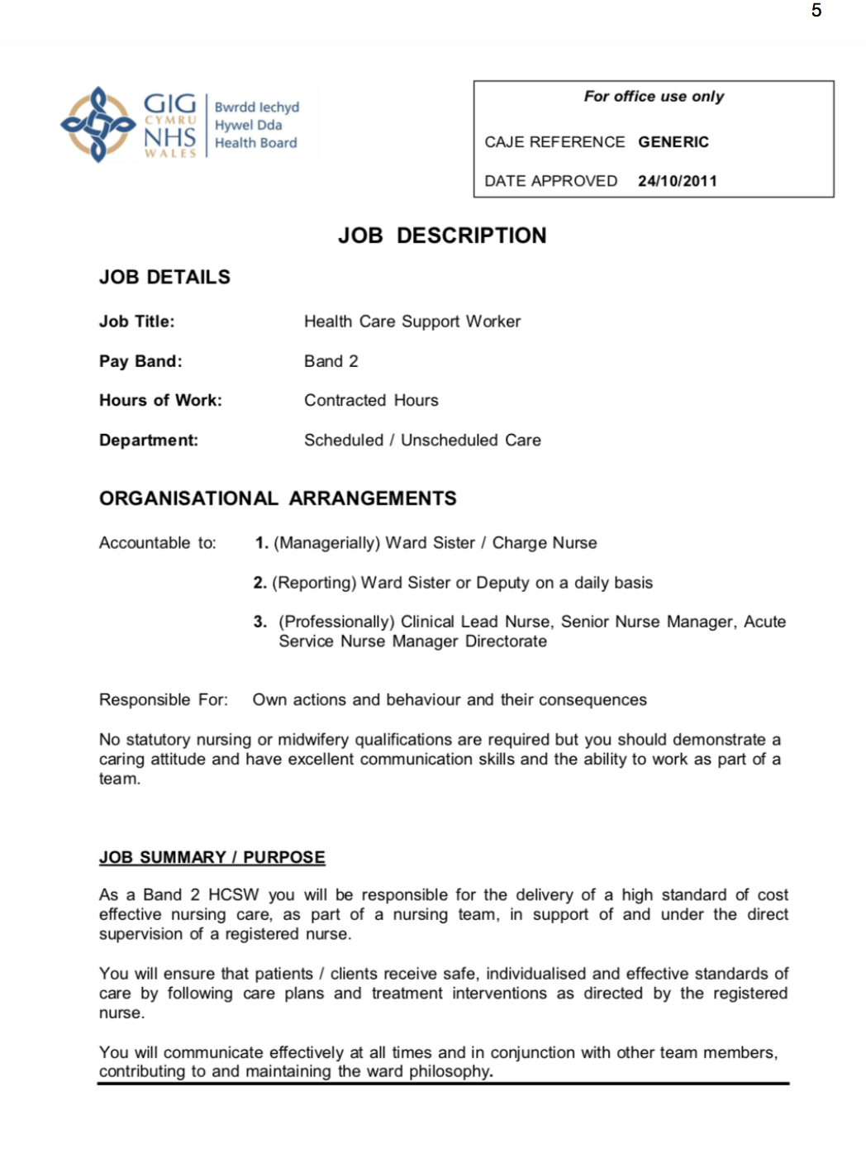

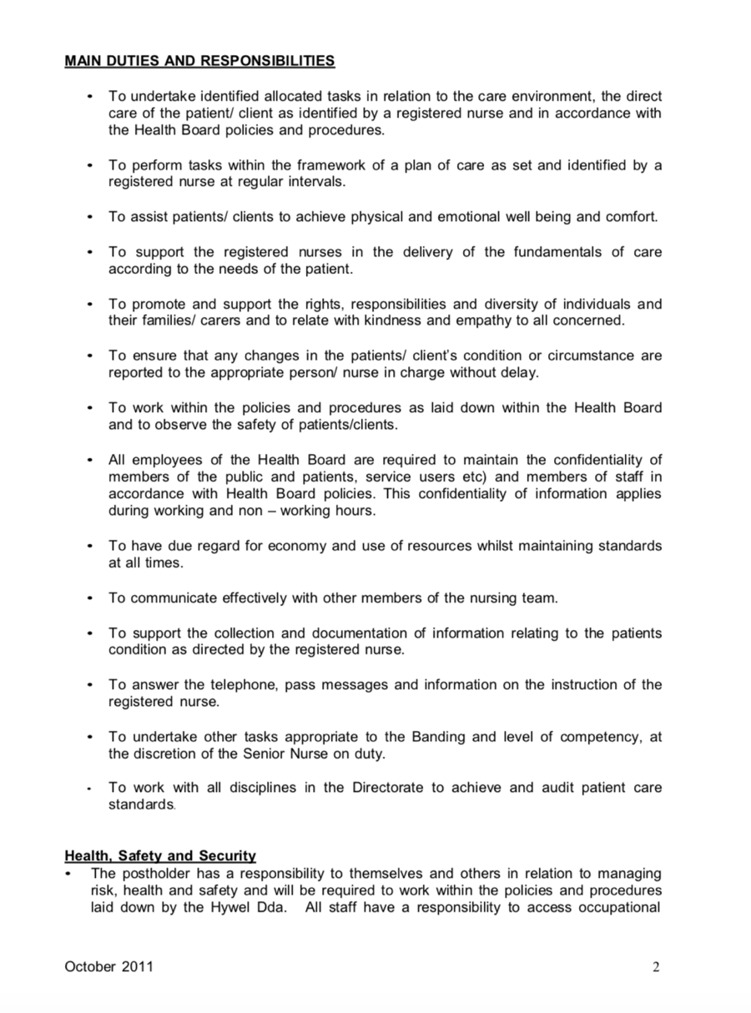

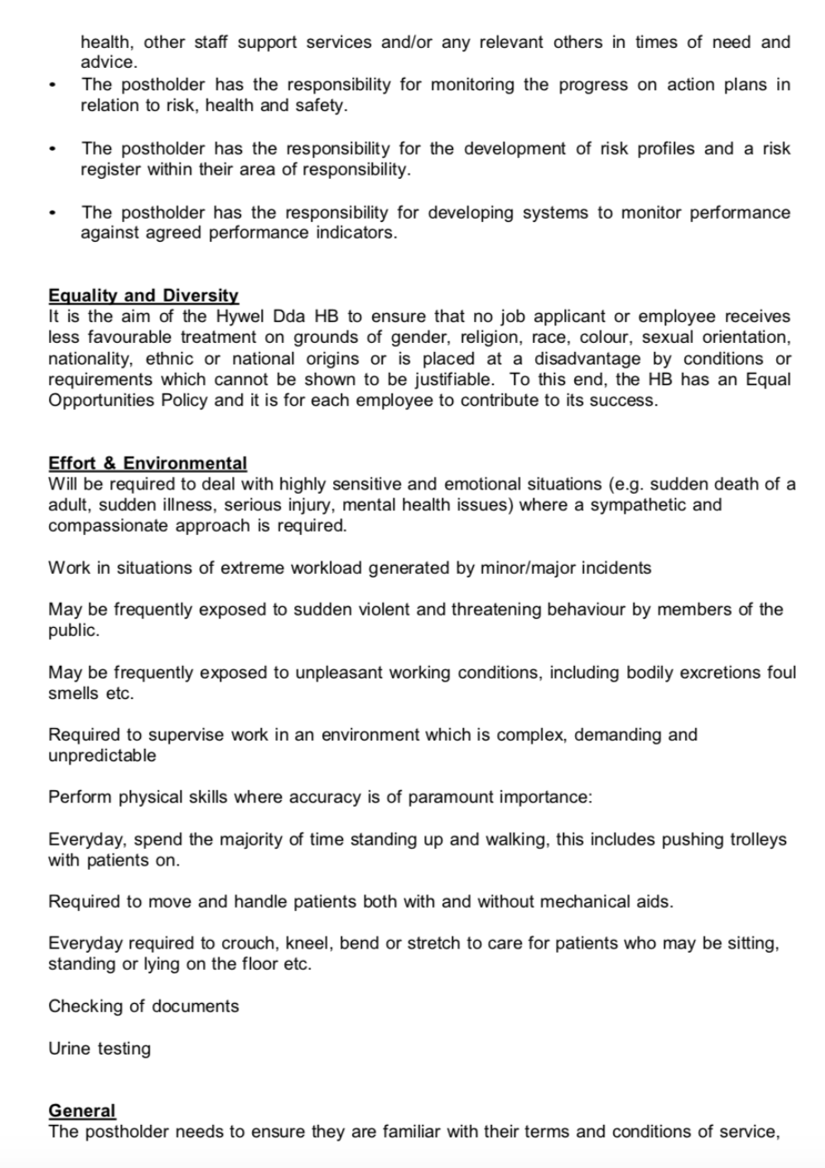

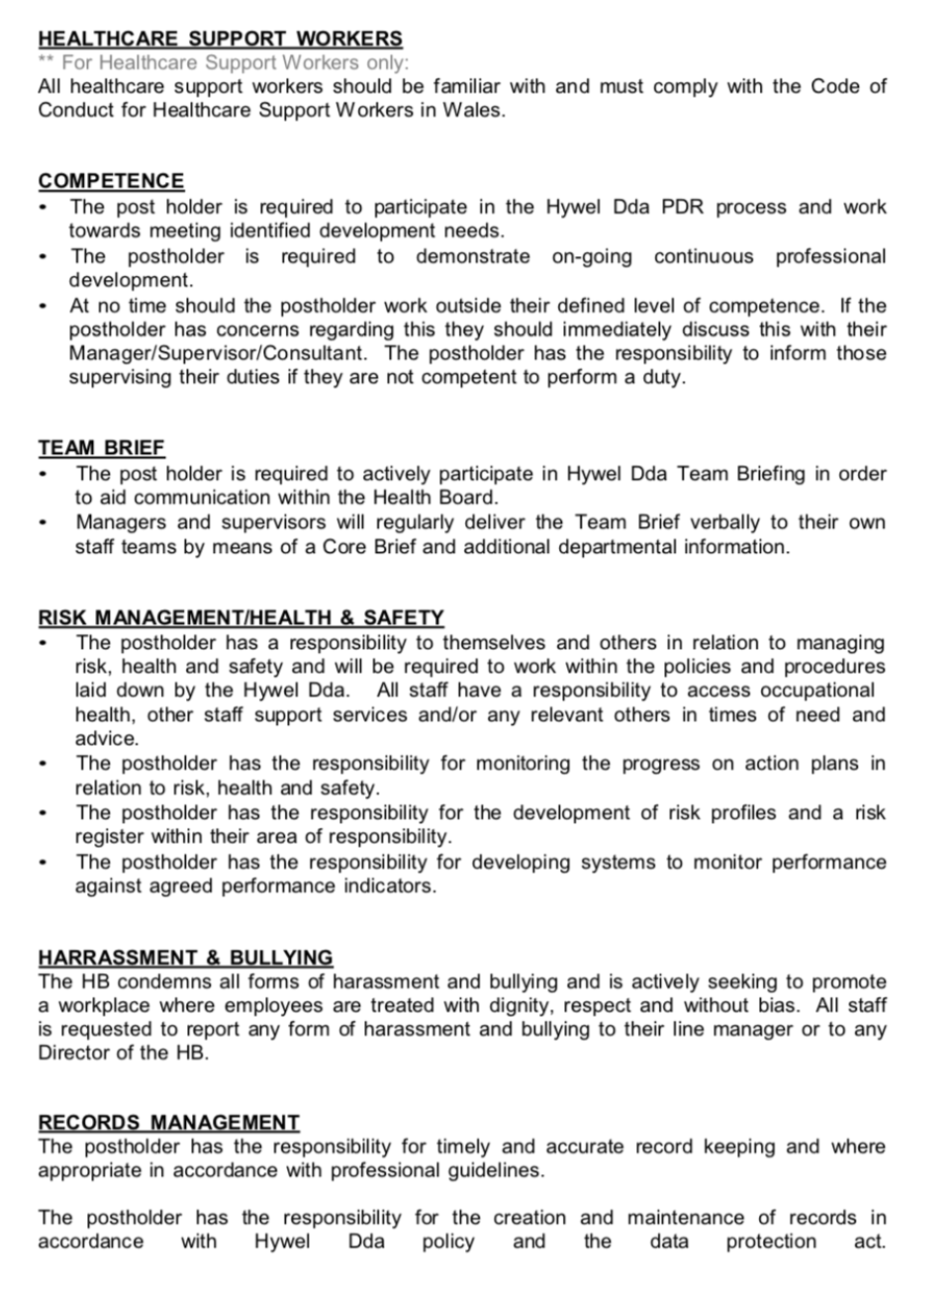

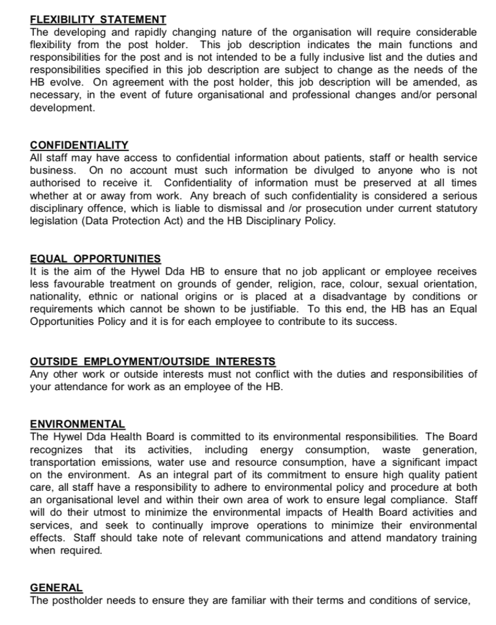

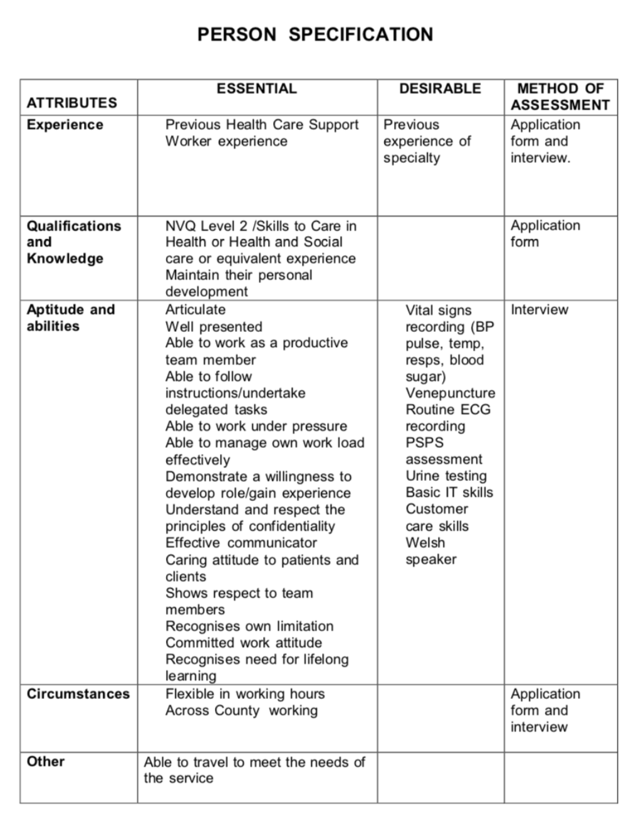

Month | Speciality | Number of Hours
April 2018 | Medical- Stroke ward | 15
May 2018 | Orthopaedics | 20
June 2018 | Medical | 8
July 2018 | Respiratory medicine | 8
August 2018 | Rehabilitation | 20
September 2018 | Surgical | 17
October 2018 | Rehabilitation | 10
November 2018 | Medical | 18
December 2018 | Orthopaedics | 15
January 2019 | Surgical | 20
February 2019 | Rehabilitation | 18
March 2019 | Surgical | 20
April 2019 | Respiratory medicine | 20

Log of Practise Hours

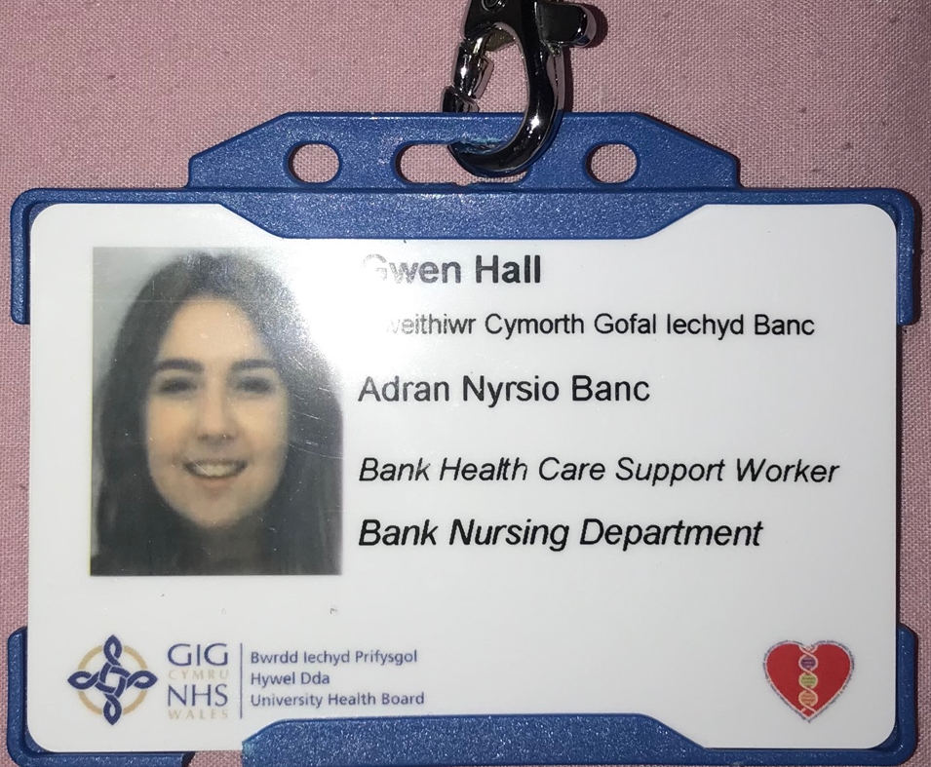

Courses Attended- Basic Life Supoort

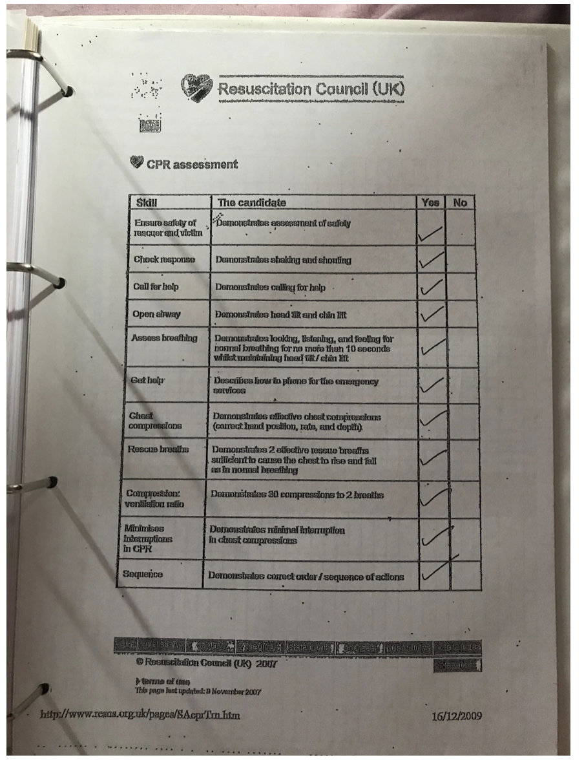

Skills to Care
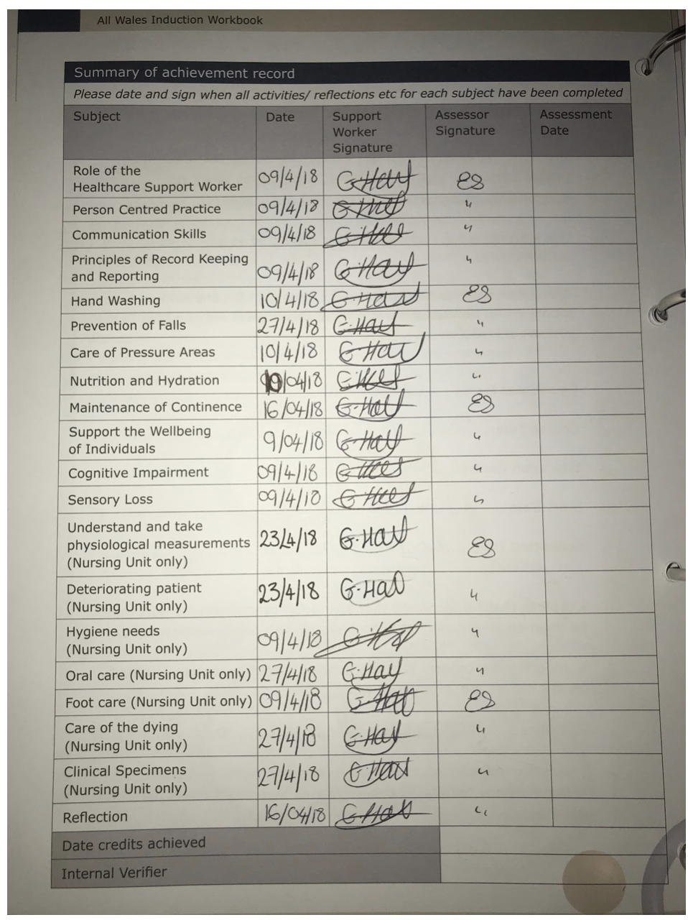

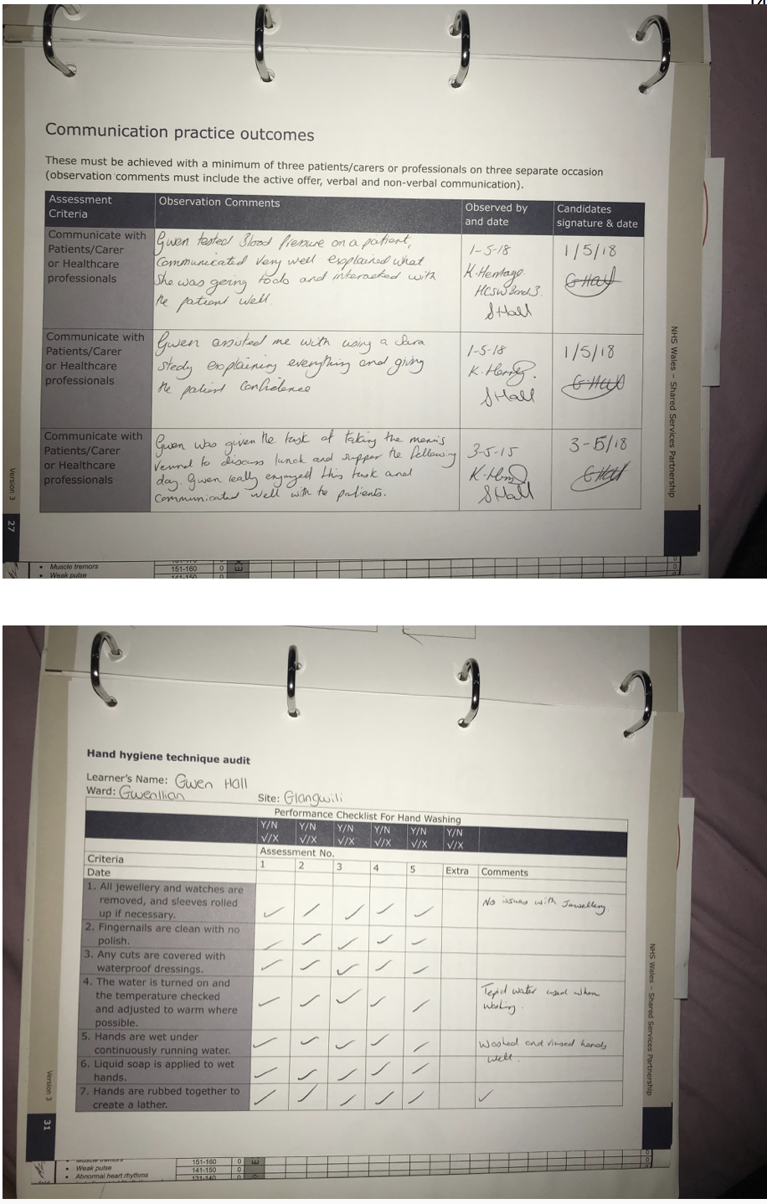
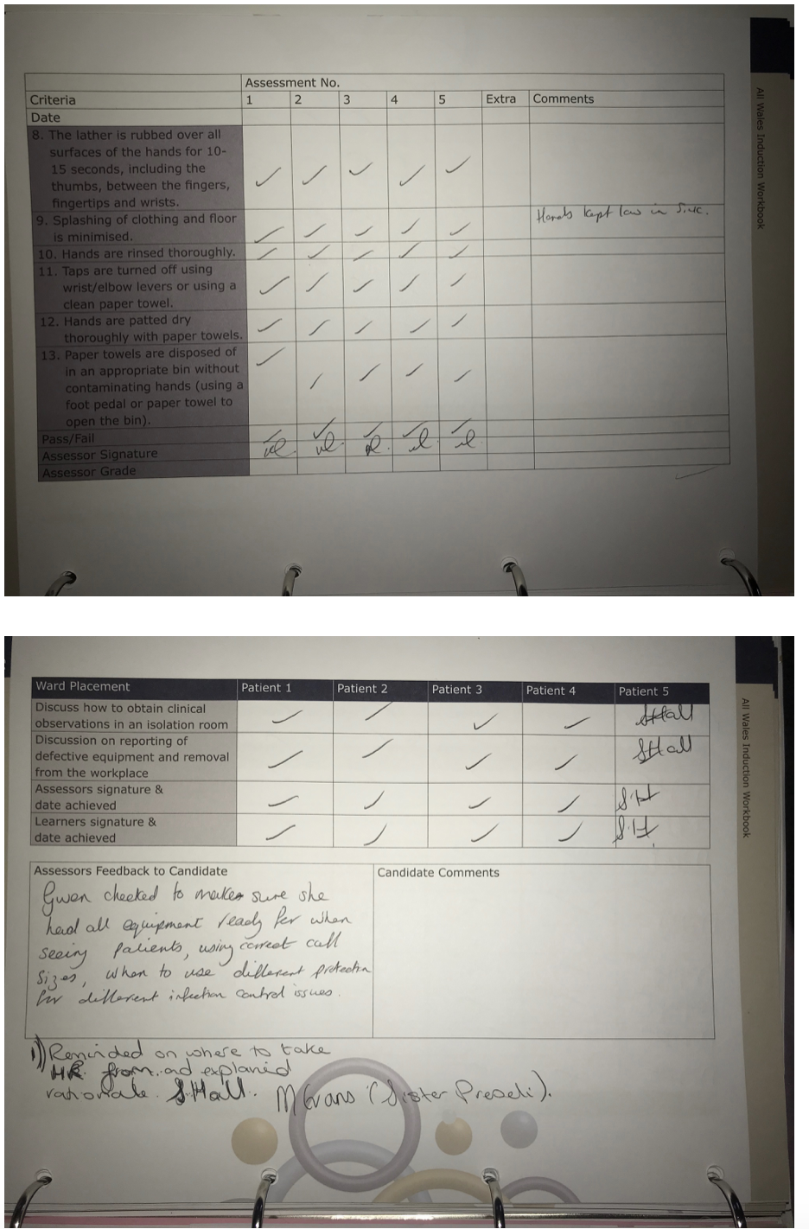

Reflective Accounts
Shift 1
I started off my career as a Health Care support worker on medical wards and mainly adult wards as this would help towards my nursing career. A week after finishing all my mandatory training I started off working in Glangwili Hospital. I had been placed on a Medical stroke ward and whilst working I had a ‘Buddy’ to help guide me through training on the wards. This Buddy would show me everything on the wards that I needed and would guide me through if I was lost with anything. I chose to work an early morning shift which started at 7 and finish at 3 because this would allow me to see what morning shifts are like. Throughout the day I had to deal with a lot of patients with sensory loss and this was a challenge as they couldn’t walk, talk or eat. I only thought this was a challenge as when the patients were asking me to do something I couldn’t understand as they couldn’t communicate with what they needed. Whilst working one patient stood out for me and touched me as he was getting frustrated when trying to communicate as he could talk or move his arms much. I had the patience to sit down with him and try to listen to what he wanted, but this was still very difficult. I made sure he wasn’t getting to distressed by calming him down and supporting him. I did get upset whilst sitting down with him as I didn’t know what else to do and it was frustrating as I couldn’t figure out what he wanted and by this point he was getting angry. I got a paper and pen so that he could write anything down to try and make me understand, but the loss in his arms was to much for him to write. I asked the nurse in charge if they had any aids that could help me understand but they didn’t. I made a phone call to Skills to Care (where I did my training) and they had aids to help me. They gave me flash cards that had photos of a toilet, bed, walk, food etc and this made it much easier for me because the patient could point at the cards and this took a lot of stress off me and the patient. I felt a lot of joy after finding this aid because I feel like I did something good.

Log of educational experiences
Communication and Counselling

Date | Module- Communication and Counselling | What I will learn | What I can improve on
Oct 2nd 2018 | Video Critique- In this lecture we were given our first assignment to complete a video counselling simulation with a partner and also write a 1000 word reflective using Carl Rogers Humanistic Theory. | To be able to demonstrate communication and counselling skills through using Carl Rogers Skill. | Group Work
Oct 9th 2018 | Lecture 1- Introduction to the Module | Understanding counselling and counselling theories. | Listening skills and writing notes.
Oct 16th 2018 | Lecture 2- Communication and counselling | To understand what counselling is. | In this lecture we had to discuss what communication is, with this I could improve on my commutation skills with team members.
Oct 23rd 2018 | Lecture 3- Basic Counselling Skills | Knowing the basic counselling skills
Oct 30th 2018 | Lecture 4- Person-centred practise | Looking at Carl Rogers humanistic therapy | Search more into Carl Rogers theories
Nov 6th 2018 | Creating the counselling simulation video, this was a challenge as you had to act like a counsellor. We had to do a 10 minute video of any subject that we had a problem with it and reflect on it. I had a difficult time creating mine as my partner didn’t want to carry on with the course. | To be able to demonstrate counselling skills. | I would make sure I left enough time to do the video again and organised myself.
Nov 20th 2018 | After creating the video we had to write 1000 word reflection. | Be able to select upon the value of communication and counselling skills within nursing.

Introduction to Health Research

Date | Module- Introduction to Health Research | What I will learn | What I can improve on
Jan 4th 2019 | In this assignment we would have to produce 2000 word report that considers why research is important within nursing. | How to produce a report and research. | My research
Jan 11th 2019 | Lecture 1- Get to know session | An overview of the module-  Module Content  Assignment proformas  What is research  Discuss abstracts
Jan 18th 2019 | Lecture 2- Looking at how to find a research paper. | How to find a good research paper. | My research
Jan 25th 2019 | Lecture 3- Complete the question sheet related to research paper. | How to complete a research question paper. | Make sure I answered this fully.
Feb 1st 2019 | Lecture 4- Discussing ethics and create ethical committee’s | Understand what ethics is | My knowledge of what ethics is.
Feb 8th 2019 | In this lecture we will begin to write our assignment and the lecturer will help guide us through | Understanding of the research process as documented in a published paper. | Engagement with literature skills

Reflection:
This assignments was a challenging one as there was a lot of research to do and understanding of different terms. Unfortunately I didn’t manage to understand the concept of a report and how to identify the research terms within my chosen paper. I didn’t manage to pass this assignment as I didn’t understand the learning outcome for this module. I did however get some feedback from my tutor on how to improve. First of all I was given specific headings to use which I did not include and also to identify key research terms. I did identify some research terms but didn’t explain them properly. I should also have defined the research terms using my chosen paper and define them using reliable and credible sources. By looking at the assignment I have shown that I have undertaken some reading and did define qualitative and quantitative research. Albert states that you should research widely for your nursing research paper, which I did not manage to do and should have done. Albert also states that you should draft your nursing research paper in a proper structure from introduction, the body and conclusion. I did however manage to do this as I started with the introduction but when its came to the main body this however went very confusing. If I was to do this assignment again I would do more search into nursing research and take my time on choosing a paper on nursing research. I would also use more references to show credible sources.

Feedback from Tutor:
Well done on attempting this assignment as you have had limited attendance in class.
Unfortunately you have not achieved the learning outcomes for this module.
This was supposed to have been a report which includes a content page and headings.
You were given specific headings to use. You were required identify the research terms within your chosen paper and define them using reliable and credible sources.
You have shown you have undertaken some reading and you did define qualitative and quantitative research.
Managing Organisation

Date | Module- Managing Organisation | What I will learn | What I can improve on
Jan 8th 2019 | In this assignment we would have to write 2000 word essay evaluating the role of leadership and management within the NHS. We would also have to provide evidence of one management/ leadership theory. | Evaluate a contemporary theme in health management and its impact on organisational behaviour within the health care sector.
Jan 15th 2019 | Lecture 1- What is leadership? | Understanding the meaning of leadership and how the word influences people | Listening skills
Jan 22nd 2019 | Lecture 2- Culture and change | Understanding the meaning of culture and change and what it means to other people.
Jan 29th 2019 | Lecture 3- Mintzberg | Understanding the role of Mintzberg
Feb 5th 2019 | Lecture 4- Perspectives of the organisation | Understanding what is organisational structure

