L4: Networks and Cyber Security Essentials (ACCA4024)

Assignment: Synthesize a solution to a potential real-life scenario

Applied Computing, University of Wales Trinity Saint David, UK

Kawam De Oliveira
Student ID: 2412430
2412430@student.uwtsd.ac.uk

May 3, 2025
Table of Contents

Introduction 4
1. Identification of Threats 5
1.1 Internal Threats 5
1.1.1 Malicious Insiders 5
1.1.2 Negligent Insiders 5
1.1.3 Compromised Insiders 5
1.1.4 Shadow IT 5
1.2 External Threats 5
1.2.1 Phishing and Social Engineering 6
1.2.2 Malware and Ransomware 6
1.2.3 Zero-Day Exploits 6
1.2.4 Supply Chain Attacks 6
1.2.5 Credential Theft 6
1.2.6 Distributed Denial of Service (DDoS) Attacks 6
2. Security Policies & Countermeasures 7
2.1 Remote Work Policy 7
2.2 Incident Response Policy 7
2.3 Firewalls and Intrusion Detection Systems (IDS) 7
2.4 Antivirus and Antimalware 8
2.5 Multi-Factor Authentication (MFA) 8
2.6 Data Encryption 9
2.7 Threat Intelligence and Automated Sharing 9
3. Mitigation Measures 10
3.1 Phishing and Social Engineering 10
3.2 Malware and Ransomware 10
3.3 Zero-Day Exploits 10
3.4 Supply Chain Attacks 10
3.5 Credential Theft 11
3.6 Distributed Denial of Service (DDoS) Attacks 11
4. Monitoring and Response 12
4.1 Monitoring Architecture 12
4.2 Incident Response Workflow 12
5. Training and Awareness 14
5.1 Objectives 14
5.2 Programme Lifecycle 14
5.3 Role Based Curriculum 14
5.4 Delivery Methods 15
5.5 Metrics & Key Performance Indicators (KPIs) 15
5.6 Compliance and Record Keeping 15
5.6.1 Tracking of Cloud Security 15
Conclusion 16
References 17
Appendix 21

Introduction

In the increasingly complex landscape of financial services, institutions face a relentless wave of cyber threats targeting their digital assets and critical financial data. The stakes are high, as a single breach can disrupt operations, erode customer trust, and result in severe regulatory penalties. As a provider of financial services, FinSecure Ltd must navigate this challenging environment, balancing operational efficiency with robust cybersecurity to protect its clients and maintain market confidence.
Effectively mitigating these risks requires a multi-layered cybersecurity strategy that integrates technical controls, strict policy enforcement, and continuous staff training. This comprehensive approach establishes a robust security posture, reducing vulnerabilities, enhancing threat detection, and ensuring the confidentiality, integrity, and availability of critical systems.
The sections that follow will outline the essential components of this strategy, including threat identification, technical countermeasures, staff training, and incident response, with the objective of safeguarding the organisation’s digital infrastructure against a rapidly evolving threat landscape.

1. Identification of Threats
Systematic identification of cyber threats is foundational to comprehensive security strategy development. Threats can originate from malicious insiders or advanced external actors. Rigorous assessment enables vulnerability anticipation and targeted policy design, aligning with industry regulations and cybersecurity standards.

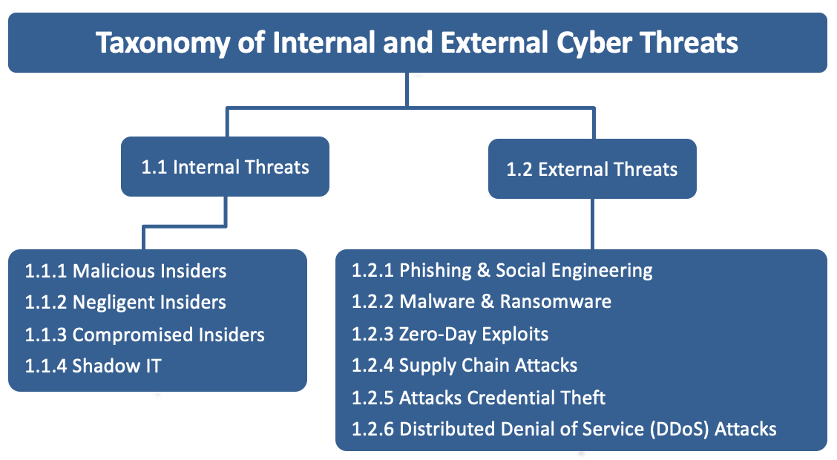
Figure 1. Classification of internal and external cyber threats relevant to the risk landscape for FinSecure Ltd. Source: author’s own elaboration. [1].

1.1 Internal Threats
Internal threats originate within the organisation and can result from staff, contractors, or business partners who, either intentionally or inadvertently, compromise the company’s security posture.

1.1.1 Malicious Insiders
Disgruntled employees or former staff with retained access may exploit credentials to steal data or sabotage systems. [2]

1.1.2 Negligent Insiders
Unintentional errors such as clicking phishing links or accidentally sharing confidential information account for a significant proportion of internal threats. [2]

1.1.3 Compromised Insiders
Stolen user credentials can transform legitimate users into internal threats. [3]

1.1.4 Shadow IT
Shadow IT refers to the unauthorised adoption of technologies by employees. [2]

1.2 External Threats
External threats arise from outside the organisation and are typically aimed at disrupting operations or stealing sensitive information.

1.2.1 Phishing and Social Engineering
Phishing and social engineering attacks remain among the most successful tactics, involving some form of human error or manipulation. [4]

1.2.2 Malware and Ransomware
While ransomware attacks on enterprises declined, threat actors shifted their focus to identity theft, with email-based distribution of infostealers. [5]

1.2.3 Zero-Day Exploits
Zero-day vulnerabilities were exploited with increasing frequency, in attacks initiated through unpatched software flaws. [4]

1.2.4 Supply Chain Attacks
Supply chain breaches represented illustrating the growing risk of third-party dependencies. [4]

1.2.5 Credential Theft
Credential theft remains the preferred method for attackers. [3]

1.2.6 Distributed Denial of Service (DDoS) Attacks
DDoS attacks continue to grow in scale and frequency, aided by DDoS-for-hire services and accessible tools. [6]

2. Security Policies & Countermeasures
Security policies and technical countermeasures are fundamental to establish a proactive framework of defence against cyber threats. These measures must address both human and technological vulnerabilities while aligning with best practices and regulatory expectations of cyber security in the financial sector.

2.1 Remote Work Policy
Based on the guidelines of the National Credit Union Administration (NCUA) [7], remote work must include device management, encrypted communication channels, and strict policy compliance. A robust policy should mandate the use of Virtual Private Networks (VPNs) for endpoint security and use the prohibit unauthorised personal devices.

2.2 Incident Response Policy
Pursuant to the National Institute of Standards and Technology (NIST) [8], effective incident response includes preparation, detection, containment, eradication, recovery, and post-incident activity. The 2025 revision aligns these steps with the NIST Cybersecurity Framework (CSF) 2.0, recommending dedicated Computer Security Incident Response Teams (CSIRTs) for financial institutions.

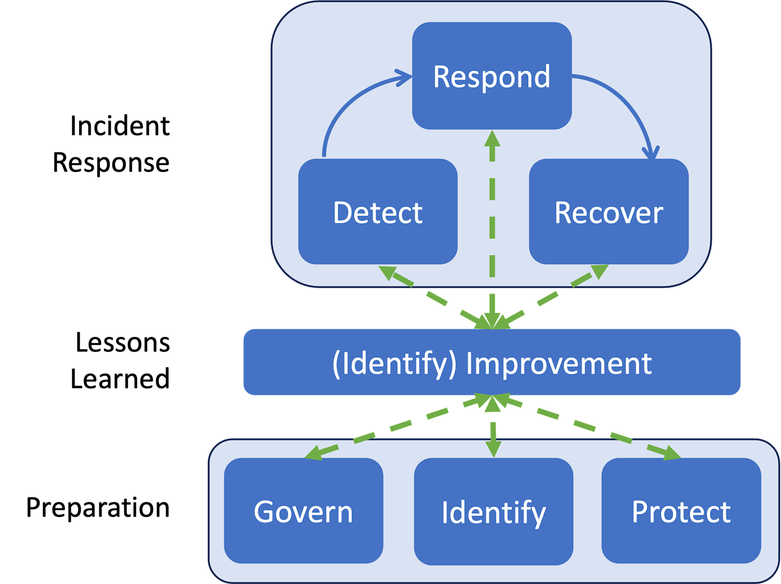
Figure 2. Incident response life cycle model based on CSF 2.0 Functions.[7]

2.3 Firewalls and Intrusion Detection Systems (IDS)
Firewalls regulate inbound and outbound traffic based on established rules, preventing unauthorised access to critical systems. IDS, in turn, continuously monitor network activity to detect anomalies and known threat signatures, issuing alerts to security staff when suspicious behaviour is observed. The Federal Financial Institutions Examination Council (FFIEC) highlights the implementation of such as controls fundamental to safeguarding customer information and ensuring institutional security. [9]
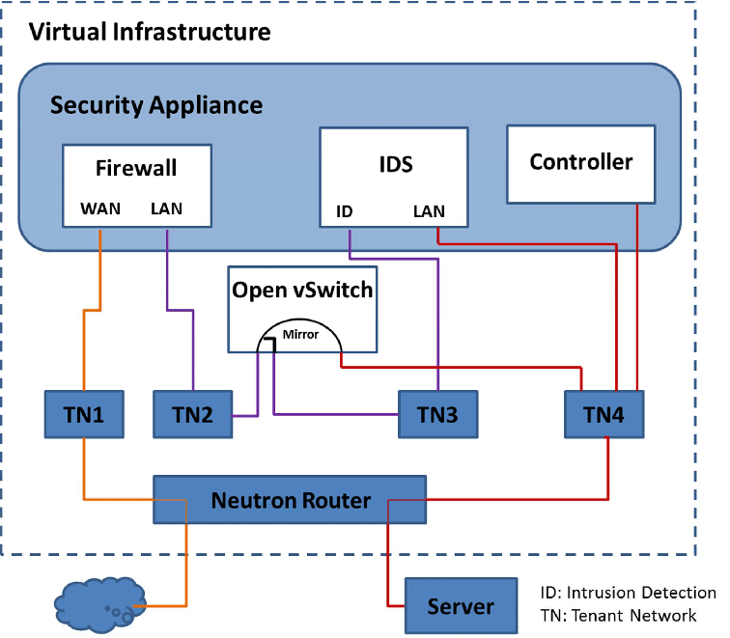
Figure 3. Intrusion Detection System (IDS) process diagram. [10]

2.4 Antivirus and Antimalware
Antivirus and antimalware software are essential to protect against threats such as viruses and ransomware. Ensuring that trusted protection tools are in place and kept current is a key measure for reducing the risk of cyberattacks on financial systems. [11]

2.5 Multi-Factor Authentication (MFA)
Multi-Factor Authentication (MFA) enhances security by requiring users to verify their identity through at least two distinct authentication factors, typically a password and either a biometric or device-based verification. It shall be implemented for high-risk activities and transactions as part of a broader layered security strategy. [12]

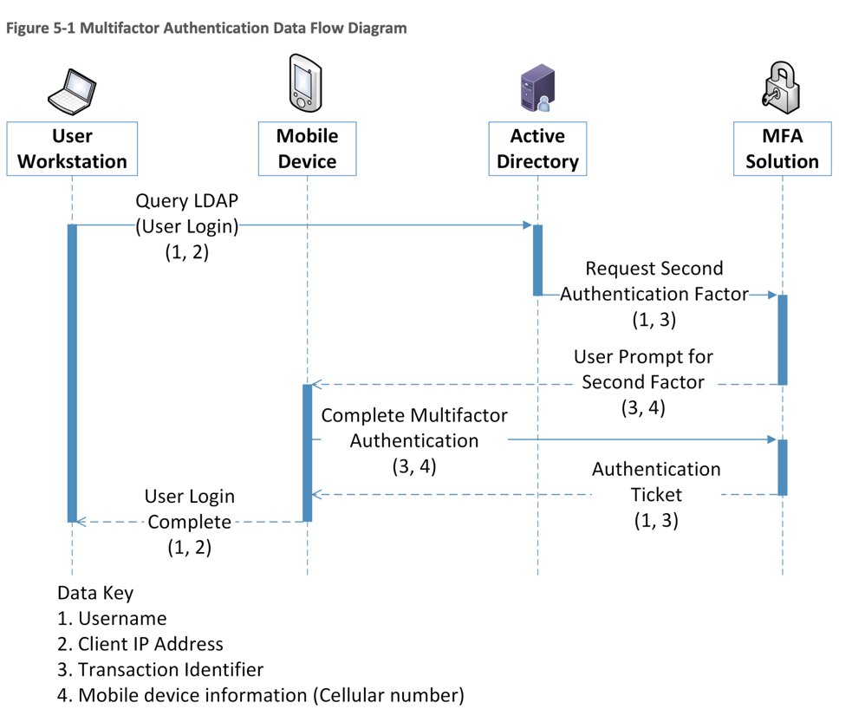
Figure 4. Multi-Factor Authentication Data Flow Diagram. [13]

2.6 Data Encryption
Effective data encryption relies on a combination of robust algorithms, comprehensive data protection strategies, and disciplined key management.
Core best practices include:
- Utilising strong encryption algorithms.
- Encrypting data at rest and in transit.
- Implementing secure key management.
- Regularly updating encryption protocols.
- Employing end-to-end encryption.
- Training staff on encryption. [14]

2.7 Threat Intelligence and Automated Sharing
Organisations with hybrid infrastructures, must address cloud-based risks, such as misconfigured Infrastructure as a Service (IaaS) and shared platform vulnerabilities to strengthen threat response, the adoption of structured threat intelligence tools . According to the Cybersecurity and Infrastructure Security Agency (CISA) [15], the Automated Indicator Sharing ecosystem enables real-time exchange of machine-readable threat data, improving institutional resilience and cross-sector situational awareness.

3. Mitigation Measures
The following mitigation strategies are aligned on the comprehensive guidelines provided by the National Institute of Standards and Technology (NIST) and the Cybersecurity and Infrastructure Security Agency (CISA), emphasising proactive defence, continuous risk assessment and robust security controls.

3.1 Phishing and Social Engineering
To secure critical systems, implement phishing-resistant multi-factor authentication (MFA) methods, such as physical tokens or certificate-based credentials. Additionally, conduct regular cybersecurity awareness, emphasising phishing detection and safe browsing. [16]
Implementation:
Multi-Factor Authentication (MFA): Employing MFA solutions that do not rely solely on SMS or email, opting instead for physical tokens or encrypted authenticator applications.
Security Awareness Training: Provide continuous training campaigns, including realistic phishing simulations and regular knowledge assessments.

3.2 Malware and Ransomware
Deploying advanced anti-malware software, Intrusion Detection Systems (IDS), and strict application allowlisting across all systems. Timely patching of known vulnerabilities is also essential to reduce exploitability. [17]
Implementation:
Endpoint Security: Employing endpoint protection tools with behavioural analytics capabilities to detect and block ransomware and unknown malware strains.
Patch Management: Enforcing automated patch deployment across critical assets.

3.3 Zero-Day Exploits
A robust defence strategy involves continuous monitoring for anomalous activity, vulnerability scanning, and proactive threat detection. These measures enable early detection of unknown threats and help prevent exploitation by ensuring that weaknesses are identified and addressed promptly. [18]
Implementation:
Endpoint Detection and Response (EDR): Implementing tools that analyse behavioural patterns to identify anomalous activity indicative of zero-day attacks.
Vulnerability Management: Conducting regular scanning and controlled penetration testing to detect and remediate exposures before exploitation occurs.

3.4 Supply Chain Attacks
Cybersecurity due diligence must be enforced when onboarding suppliers. This includes mandatory adherence to baseline security controls and continuous third-party risk monitoring. [19]
Implementation:
Third-Party Evaluation: Conducting rigorous assessments and background checks for all vendors.
Contractual Safeguards: Including security requirements in all procurement contracts.

3.5 Credential Theft
Credential theft is a critical risk for financial institutions, enabling unauthorised access and data compromise. Mitigation includes enforcing strong password policies, credential verification against breach databases, and requiring multi-factor authentication for all sensitive system access. [20]
Implementation:
Password Policy Enforcement: Enforcing unique, complex passwords with high entropy, and monitor credentials against known data breach repositories.
Multi-Factor Authentication (MFA): Mandating MFA for all users accessing sensitive or regulated systems and services.

3.6 Distributed Denial of Service (DDoS) Attacks
DDoS risks may be mitigated through layered defence strategies including rate limiting, access filtering, and upstream traffic scrubbing via cloud-based mitigation services. [21]
Implementation:
Cloud-Based Mitigation: Subscribing to trusted DDoS protection services capable of absorbing large-scale attacks.
Network Hardening: Configuring access control lists and traffic filters at perimeter devices.

4. Monitoring and Response

Effective cybersecurity monitoring preserves the resilience given the complex and evolving nature of modern cyber threats, this approach should emphasise the structured incident escalation, and precise documentation to support both immediate response and long-term security improvement.

The implementation of a Security Information and Event Management (SIEM) system is recommended to aggregate and analyse log data across the network, endpoints, and applications in real time.

The incident response process must follow the NIST recommended lifecycle: Preparation, Detection and Analysis, Containment, Eradication, Recovery, and Post-Incident Activity. [22]

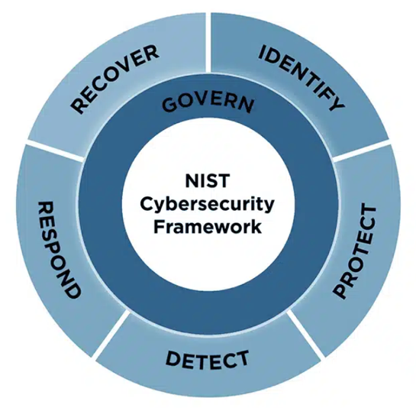
Figure 5. NIST Cybersecurity Framework (CSF) 2.0 core functions. [23]

4.1 Monitoring Architecture
The proposed monitoring framework include:
- Security Information and Event Management (SIEM) for real-time threat detection.
- Network Intrusion Detection Systems (NIDS) for analysing traffic patterns.
- Endpoint Detection and Response (EDR) for behavioural analysis.
- User and Entity Behaviour Analytics (UEBA) to flag anomalies in user activities.
- Cloud workload monitoring, particularly for hybrid deployments.

4.2 Incident Response Workflow
This monitoring and response plan is structured in accordance with the NIST Computer Security Incident Handling Guide, which provides a lifecycle-based approach to incident management widely adopted across the financial service sector.
A dedicated Computer Security Incident Response Team (CSIRT) must be established, comprising technical analysts, risk officers, and compliance representatives.
All incidents must be logged using a centralised case management system integrated with the SIEM, allowing for traceability, metrics analysis, and compliance auditing. The diagram below illustrates the incident handling process based on the NIST lifecycle model. [22]

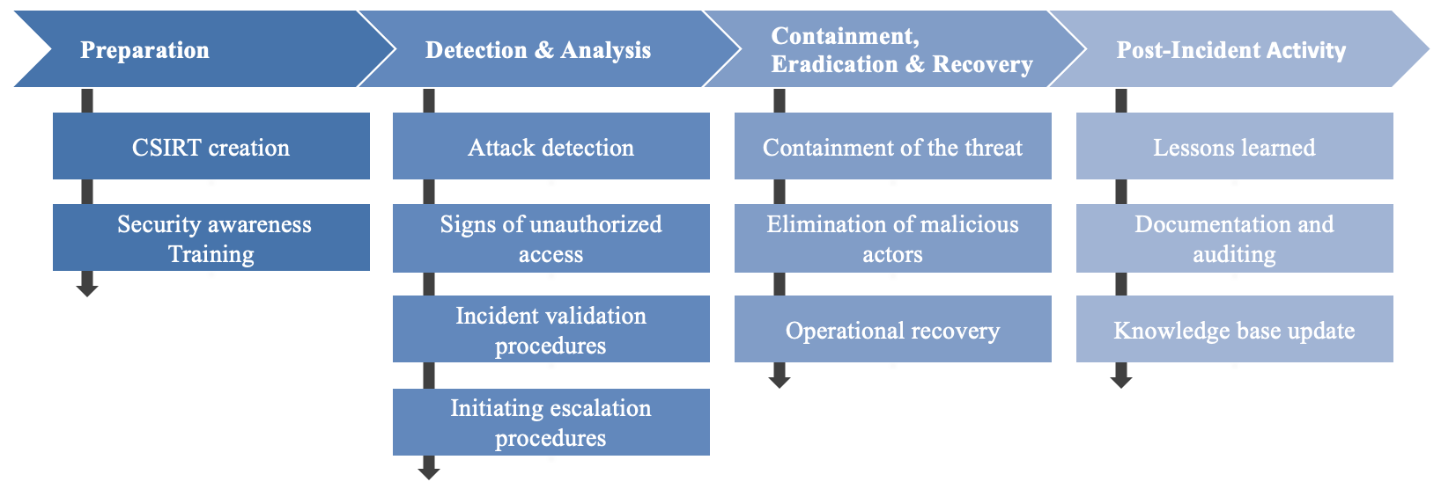
Figure 6. Incident Response Lifecycle, adapted to scenarios, aligned with NIST SP 800-61 Rev3 Framework.
Source: author’s own elaboration. [24]

This structured approach strengthens operational continuity, reduces incident impact, and promotes a cycle of continuous improvement.

5. Training and Awareness

Establishing a structured and lifecycle-based training programme is critical f to ensure the effective embedding of its new security policies and to meet the expectations of sector regulators for demonstrable staff competence in cybersecurity risk management.

The programme is managed and overseen quarterly, aligning with the Federal Financial Institutions Examination Council (FFIEC). [25][26]

5.1 Objectives
- Raising baseline awareness of both internal and external cyber threats, as well as the corresponding policies designed to mitigate these risks. [25]
- Equipping each employee with the specific skills required to perform their roles securely, with a focus on policy compliance and risk mitigation [26]
- Driving measurable behavioural change, such as sustained reductions in phishing-click rates and improved incident reporting times [25]
- Promoting a security-first mindset across all departments, reducing the likelihood of human error leading to security breaches.

5.2 Programme Lifecycle
Training and awareness programme follows the four phase of lifecycle model recommended in NIST. This model is implemented on an annual cycle, with mid-year checkpoints to assess progress and adjust strategies as needed. Each phase is structured with clearly defined exit criteria, allocated budget, and designated ownership, ensuring accountability and alignment with strategic security objectives. [25]

5.3 Role Based Curriculum
The curriculum controls for people management, ensuring compliance with international best practices in cybersecurity training. This approach includes tailored modules for different employee roles, reflecting their specific risk profiles and responsibilities within the organisation. [27]

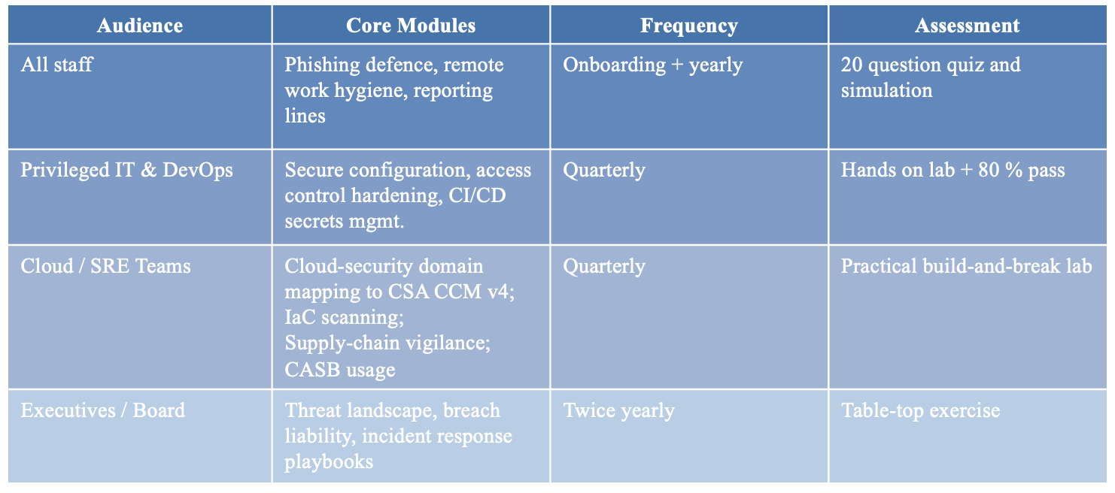
Figure 7. Mapping of controls to ISO/IEC 27002:2022, Clauses 6.3–6.8 (People Controls), to ensure alignment with global best practices. Source: author’s own elaboration [27].

5.4 Delivery Methods
- Self-Paced E-Learning: modules updated quarterly to reflect emerging threats and policy changes. [27]
- Instructor Led Workshops: Scenario driven sessions, including live demonstrations of policy breaches and mitigation strategies. [27]
- Simulated Attacks: Monthly phishing campaigns with adaptive difficulty, with repeat offenders automatically enrolled in targeted remediation. [27]
- Micro-Nudges: Videos or context sensitive tooltips pushed to Microsoft Teams during high-risk periods. [27]
- Zero-Trust Labs: Hands-on exercises in secure sandboxes to illustrate principles like micro-segmentation and continuous verification. [28]
- Cloud-Attack Simulations: Drills simulating common cloud security misconfigurations for DevOps and SRE teams. [29]

5.5 Metrics & Key Performance Indicators (KPIs)
The training programme’s effectiveness is evaluated against the SANS Security Awareness Maturity Model, with a year target of achieving Level 3 on the Maturity Key. [30]
Performance metrics include:
- Minimum audit score of 90% on FFIEC training controls [26]
- Reduction in phishing click rate below 5% over a 12-month period [28]
- 100% policy acknowledgment and training completion rates each quarter [28]
- Mean Time to Report (MTTR) phishing incidents of 15 minutes or less [28]

5.6 Compliance and Record Keeping
Training records are retained for six years per Financial Conduct Authority (FCA) and FFIEC requirements, with automated HR integration for compliance enforcement, including privilege revocation for non-completion [30]

5.6.1 Tracking of Cloud Security

To ensure comprehensive cloud governance and compliance, should adopt the Cloud Security Alliance (CSA) Cloud Controls Matrix (CCM) version 4 such as the dedicated framework for managing hybrid cloud workloads. This framework aligns operational controls with industry best practices, supporting a structured approach to risk management.
Key steps include: [30]
- Selection of Relevant Controls. [30]
- Internal Mapping. [30]
- Integration with Governance, Risk, and Compliance (GRC) Platforms. [30]
- Continuous Audit. [31]
- Board Reporting and Automation. [31]

Conclusion

These recommendations provide a systematic roadmap for FinSecure Ltd to align its policies and technical controls with best practices, enhancing its security posture and embedding a culture of security awareness across the organisation. This document presents a holistic cybersecurity framework for the financial services sector, integrating systematic threat identification with layered technical controls and adherence to internationally recognised cybersecurity standards to ensure sector-specific compliance. Defence-in-depth is realised through the deployment of firewalls, intrusion-detection and endpoint-detection solutions, multi-factor authentication, and end-to-end encryption. A security-first culture is fostered via continuous staff education and simulated phishing campaigns, whilst real-time monitoring through security information and event management, user behaviour analytics, and cloud workload analytics supports rapid anomaly detection and containment in accordance with established incident-response lifecycles. Incorporation of adaptive threat intelligence feeds, automated orchestration, and regular evaluation against metrics enables FinSecure Ltd. to anticipate emerging cyber threats while maintaining the confidentiality, integrity, and responsibility of its financial ecosystem.

References

[1] O. Kawam, Classification of internal and external cyber threats relevant to the risk landscape of FinSecure Ltd, own elaboration, Synthesize a Solution to a Potential Real-Life Scenario, May 2025.

[2] IBM Corporation, Insider threats: Understanding and managing internal risk, IBM Think, 2024. [Online]. Available: https://www.ibm.com/think/topics/insider-threats. [Accessed: 3 May 2025].

[3] IBM Corporation, X-Force Threat Intelligence Index 2025: Attackers steal and sell user identities, IBM Think, 2025. [Online]. Available: https://www.ibm.com/think/x-force/x-force-threat-intelligence-index-2025-attackers-steal-sell-user-identities. [Accessed: 3 May 2025].

[4] Verizon, 2024 Data Breach Investigations Report, Verizon Enterprise, 2024, pp. 25-45. [Online]. Available: https://www.verizon.com/business/resources/reports/2024-dbir-data-breach-investigations-report.pdf. [Accessed: 3 May 2025].

[5] IBM Corporation, Credential theft escalates in 2025, threat actors pivot to stealthier tactics, IBM Newsroom, Apr. 2025. [Online]. Available: https://newsroom.ibm.com/2025-04-17-2025-ibm-x-force-threat-index-large-scale-credential-theft-escalates,-threat-actors-pivot-to-stealthier-tactics. [Accessed: 3 May 2025].

[6] Cisco Systems, Radware Threat Report Summary 2024, Cisco Security Conclave, 2024, pp. 9. [Online]. Available: https://www.cisco.com/c/dam/m/en_in/events/security-conclave-2024/radware-threat-report-summary-2024.pdf. [Accessed: 3 May 2025].

[7] National Credit Union Administration (NCUA), Cybersecurity Considerations for Remote Work, 2025. [Online]. Available: https://ncua.gov/regulation-supervision/letters-credit-unions-other-guidance/cybersecurity-considerations-remote-work. [Accessed: 3 May 2025].

[8] National Institute of Standards and Technology (NIST), Incident Response Recommendations and Considerations for Cyber Risk Management, NIST Special Publication 800-61 Revision 3, Apr. 2025. [Online]. Available: https://nvlpubs.nist.gov/nistpubs/SpecialPublications/NIST.SP.800-61r3.pdf. [Accessed: 3 May 2025].

[9] Federal Financial Institutions Examination Council (FFIEC), Interagency Guidelines Establishing Information Security Standards, [Online]. Available: https://www.federalreserve.gov/supervisionreg/interagencyguidelines.htm. [Accessed: 3 May 2025].

[10] Y. Rebahi, IDS process flow diagram: The different components of the architecture interwork in the virtual infrastructure, ResearchGate, 2015. [Online]. Available: https://www.researchgate.net/figure/IDS-process-flow-diagram-The-different-components-of-the-architecture-interwork-in-the_fig3_282733880. [Accessed: 3 May 2025].

[11] Western Bank, 9 Best Practices for Staying Secure When Using Online Banking, 2024. [Online]. Available: https://www.westernbanks.com/advice-center/9-best-practices-for-staying-secure-when-using-online-banking. [Accessed: 3 May 2025].

[12] Federal Financial Institutions Examination Council (FFIEC), Authentication and Access to Financial Institution Services and Systems, August 2021. [Online]. Available: https://www.ffiec.gov/press/pdf/Authentication-and-Access-to-Financial-Institution-Services-and-Systems.pdf. [Accessed: 3 May 2025].

[13] National Institute of Standards and Technology (NIST), Data Confidentiality: Detect, Respond to, and Recover from Data Breaches, NIST Special Publication 1800-29B, Feb. 2024, pp. 20. [Online]. Available: https://www.nccoe.nist.gov/sites/default/files/2024-02/dc-rr-nist-sp-1800-29b-final.pdf. [Accessed: May 3, 2025].

[14] WHT4Advisors, Data Encryption Best Practices for Financial Advisors, 2024. [Online]. Available: https://wht4advisors.com/data-encryption-best-practices-for-financial-advisors. [Accessed: 3 May 2025].

[15] Cybersecurity and Infrastructure Security Agency (CISA), How to Share Cyber Threat Information through AIS, 2024. [Online]. Available: https://www.cisa.gov/topics/cyber-threats-and-advisories/information-sharing/automated-indicator-sharing-ais/how-share-cyber-threat-information-through-ais. [Accessed: 3 May 2025].

[16] National Institute of Standards and Technology (NIST), Security and Privacy Controls for Information Systems and Organizations, NIST SP 800-53 Rev. 5, Sep. 2020, pp. 132. [Online]. Available: https://doi.org/10.6028/NIST.SP.800-53r5. [Accessed: 3 May 2025].

[17] National Institute of Standards and Technology (NIST), Guide to Malware Incident Prevention and Handling for Desktops and Laptops, NIST SP 800-83 Rev. 1, Jul. 2013, pp. 13-16. [Online]. Available: https://nvlpubs.nist.gov/nistpubs/specialpublications/nist.sp.800-83r1.pdf. [Accessed: 3 May 2025].

[18] National Institute of Standards and Technology (NIST), Security and Privacy Controls for Information Systems and Organizations, NIST SP 800-53 Rev. 5, Sep. 2020, p. 312-412. [Online]. Available: https://doi.org/10.6028/NIST.SP.800-53r5. [Accessed: 3 May 2025].

[19] National Institute of Standards and Technology (NIST), Cybersecurity Supply Chain Risk Management Practices for Systems and Organizations, NIST Special Publication 800-161 Revision 1, May 2022, pp. 41-46. [Online]. Available: https://doi.org/10.6028/NIST.SP.800-161r1. [Accessed: 3 May 2025].
[20] National Institute of Standards and Technology (NIST), Security and Privacy Controls for Information Systems and Organizations, NIST SP 800-53 Rev. 5, Sep. 2020, pp. 357-370. [Online]. Available: https://doi.org/10.6028/NIST.SP.800-53r5. [Accessed: 3 May 2025].

[21] Cybersecurity and Infrastructure Security Agency (CISA), Volumetric DDoS Against Web Services Technical Guidance, Sep. 2023. [Online]. Available: https://www.cisa.gov/sites/default/files/2023-09/TLP%20CLEAR%20-DDOS%20Mitigations%20Guidance_508c.pdf. [Accessed: 3 May 2025].

[22] A. Nelson, S. Rekhi, M. Souppaya and K. Scarfone, Incident Response Recommendations and Considerations for Cybersecurity Risk Management: A CSF 2.0 Community Profile, NIST Special Publication 800-61 Revision 3, National Institute of Standards and Technology, Gaithersburg, MD, Apr. 2025, pp. 4-8. [Online]. Available: https://doi.org/10.6028/NIST.SP.800-61r3. [Accessed: 3 May 2025].

[23] C. Martinez, “NIST CSF 2.0 Updates - What’s New?,” cyberconIQ.com – We Mitigate & Quantify Cyber Threats, Mar. 20, 2024. https://cyberconiq.com/blog/nist-csf-2-0-updates-latest-developments-in-cybersecurity-framework/ [Accessed: 3 May 2025].

[24] O. Kawam, Incident Response Life Cycle Flowchart aligned with NIST SP 800-61 Rev. 3, own elaboration, Synthesize a Solution to a Potential Real-Life Scenario. [Accessed: 3 May 2025].

[25] National Institute of Standards and Technology, Building a Cybersecurity and Privacy Learning Program, NIST SP 800-50 r1, Sept. 2024. [Online]. Available: https://doi.org/10.6028/NIST.SP.800-50r1. [Accessed: 3 May 2025].

[26] Federal Financial Institutions Examination Council, Information Security Booklet, FFIEC IT Examination Handbook, Aug. 2021. [Online]. Available: https://ithandbook.ffiec.gov. [Accessed: 3 May 2025].

[27] International Organization for Standardization, ISO/IEC 27002:2022 — Information security, cybersecurity and privacy protection — Information security controls, Feb. 2022. [Online]. Available: https://www.iso.org/standard/75652.html. [Accessed: 3 May 2025].

[28] S. Rose, O. Borchert, S. Mitchell, and S. Connelly, “Zero trust architecture,” NIST Special Publication 800-207, no. 800–207, Aug. 2020. [Online]. Available: https://doi.org/10.6028/nist.sp.800-207. [Accessed: 3 May 2025].

[29] Cloud Security Alliance, Cloud Controls Matrix v4.0, Mar. 2024. [Online]. Available: https://cloudsecurityalliance.org/artifacts/cloud-controls-matrix-v4. [Accessed: 3 May 2025].

[30] SANS Institute, 2023 Security Awareness Report: Managing Human Risk, Jul. 2023. [Online]. Available: https://www.sans.org/blog/sans-2023-security-awareness-report-managing-human-risk. [Accessed: 3 May 2025].

[31] Cloud Security Alliance, CCM v4.0 Auditing Guidelines, Jul. 2022. [Online]. Available: https://cloudsecurityalliance.org/artifacts/ccm-v4-0-auditing-guidelines. [Accessed: 3 May 2025].

Appendix

Presentation link: FinSecure Ltd - Presentation (2412430).pptx


