Module code: BMIH5007
Lecturer: Tristan Hawkins
Assignment Title: Report Case Study: The City Hotel
Student ID number: 2022840
Word count: 2096 words

Declaration
“I agree to use Grammarly on 12th November 2024 to detect spelling mistakes of my
Work. When using Grammarly, I did not have to type in the prompt but was only given the
Annotative document for spelling and grammar checks. To avoid this I wanted to exclude a change among the issues that it presented.”
“I confirm that I working on this research or creation of this assignment I have not used any of the GAI tools whatsoever. I confirm that I have had no opportunity to present any GAI-specific materials as my work. I confirm I have copies of my When returning to aggregated data and at the request of a specialised secretary, the drafts, notes and other materials used by me are submitted to Evidence”

Table of Contents
Executive summary 3
1 Introduction 4
2 Scope of the Objectives 4
2.1 Trends and patterns in the hotel's financial performance over the past three years 4
2.1.1 Revenue Trends 7
2.1.2 Expenses 8
2.1.3 Profitability Challenges 9
2.1.4 Liquidity 9
2.1.5 Solvency 9
2.2 Key reasons behind the decline in profitability 10
2.3 Turnaround Strategy for City Hotel: Rebranding and Strategic Partnerships with the Triple Bottom Line 10
3 Conclusion 11
4 References 13

Executive summary
City Hotels face various financial challenges like the decline of their revenue, low occupancy rates, and low customer satisfaction. The following report highlights the key strategies to improve the financial conditions of the hotel. In the report, the turnaround strategy was also recommended that focused on the People, Planet and Profit approach. The turnaround strategy is rebranding to attract guests, adopting eco-friendly approaches to low costs, making partnerships to improve the business, and improving the guest's experiences. The report aims to regain the financial stability of City Hotel so that it again attracts guests and makes the hotel strong for the long-term growth.

Introduction
The City Hotel is an urban establishment that offers a diverse range of facilities like restaurants, event facilities, and bar facilities. The City Hotel faces significant challenges in its operation and finances. Over the past three years, the revenue of the hotel seems to be declining, and the occupancy rates and the customer satisfaction ratio have also lowered, which raises issues about future viability. The owners of the hotel are eager to maintain their reputation and profitability. It has sought a comprehensive assessment to identify how the turnaround strategy revive the business. The given report evaluates the financial performance of the business, analyses the factors that contribute to the downturn, and proposes strategies that enhance the hotel operations' stability and financial condition.

Scope of the Objectives

Trends and patterns in the hotel's financial performance over the past three years
City Hotel seems to they faced significant challenges in the past three years, the key metrics are revenue, expenses, profitability, liquidity, and solvency. Analysing each of these areas based on financial statements helps to analyse the significant trends and patterns that affect the current financial condition of the hotel and determine the significant factors that drive the strategic adjustments (Adams, 2024). The analysis focuses on the downturn trends of the hotel in revenue, determines the expense level of the hotel, and evaluates the decline in profitability, liquidity, and solvency issues.
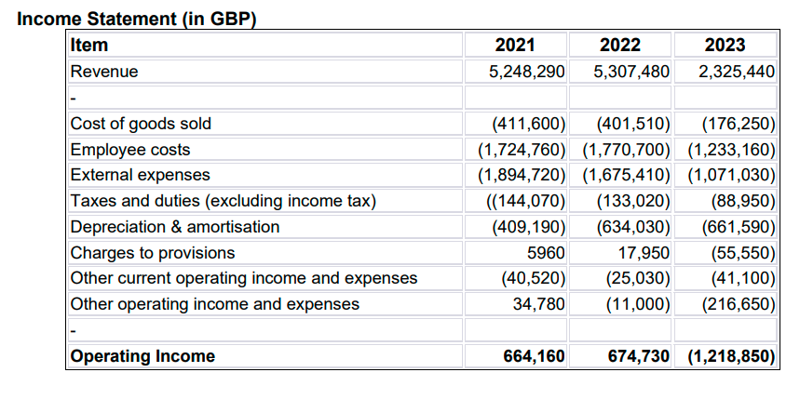
Table 1: Income Statement
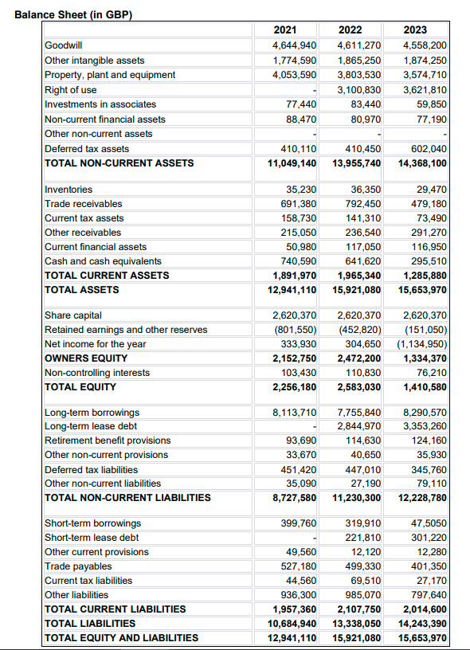
Table 2: Balance Sheet

Revenue Trends

Figure 1: Revenue
In the City Hotel one of the significant challenges is the finance, the revenue of the City Hotel declined significantly from £5,248,290 to £2,325,440 from the year 2021 to 2023. It shows that the hotel revenue has decreased by 56% over the past three years. The downturn strategy in revenue emphasizes the substantial challenge. Revenue is the key driver of liquidity and profitability. (Adelopo et al., 2022). The factors that are considered are the decreased occupancy rates, the pressure of competition or the shifting of guest demands that explain the demand. In the hotel industry, the decline in revenue can tied to broader market conditions such as travel restrictions, economic downturn, or customer behaviours. The hotels can conversely their declined revenue which is vital in stabilising their financial position (Yacoub and ElHajjar, 2021). It is continuous reductions in top-line performance that make the significant challenges to maintain their performance and investment.

Expenses

Figure 2: Operating Expenses
The operating expenses have also come down with the revenue, but fixed costs remain an issue as they adversely affect profits (Hayes et al., 2021). The majority of the expense costs including the cost of sales, employees and other expenses have been reduced, though the cost of sales has decreased by half by 2023 from £411,600 in 2021. Even the expenses of employees, listed under the cost line, fell from £1 724 760 in the financial year ending in 2021 to £1 233,160 in the financial year ending in 2023, that is, a cut of 28.5%. External expenditure also reduced from £1,894,720 to £1,071,030 within the same period thus a reduction of 43%. However, they are not comparable to the extent of the resulting lost revenue and, consequently, expenses continue to exceed revenue, restraining profit-making.
In addition to that, depreciation and payback expenses have been on increased from £409,190 in 2021 to £661,590 in 2023 due to recent asset investments or merely every time an asset is updated among other reasons. The depreciation has the effect of reducing the organisation’s bottom line when revenues are not growing (Kruse et al., 2020). Moreover, all other operating revenues and costs were uneven, including operating losses that equalled £216,650 in the financial year ending 2023. This category includes both income from activities that are outside the basic business model and any irregular expenses; if the income is negative and the expenses are consistently so as well, there will be many limitations to cash flow and stability.

Profitability Challenges
City Hotel's profitability is declining due to the hotel's operating income and net income trends. In 2021 the operating income of the hotel was £664,160 which is a slight raises to £674,730. However, the operating income in 2023 decreases to £1,218,850. The operating income fluctuates to an operating loss that reveals the fixed cost added to the decreasing revenues. Moreover, net income also follows the tendency of the company (Kadim et al., 2020). The projected net income year is £333,930 in 2021, £304,650 in 2022 and finally a net loss of £1,134,950 in 2023. The revenue is incapable of supporting operational and fixed costs, and unless action is taken right away, the hotel may also lack the capital to continue daily operations, growth, or investments. Managing the cost structure of the hotel to become more variable and seeking out the possibility of additional revenues, like charging for additional services, or diversifying in customer’ base, could offset these losses (Lopez, 2020).

Liquidity
Several liquidity indicators that can demonstrate the ability to meet current liabilities have deteriorated at City Hotel during the three years (Brozović et al., 2021). Current assets also declined, and in particular cash, cash equivalents and deposits, decreased from £740,590 in 2021 to £295,510 in 2023 or a 60% decline. A decrease in the cash reserves in a business refers the fewer cash inflows or more cash outflows and such a situation reduces the profit that a hotel can make financially (Sunmola, 2021). Moreover, the trade receivables reduced from £691,380 in 2021 to £479,180 in 2023 which is less credit sales to the business that hinders the availability of cash.
The total current assets from £1,891,970 in 2021 to £1,285,880 in 2023 showing that there is less working capital available. This trend poses a small ability to cope with short-term obligations without the proper financing. Tactics for increasing liquid assets in less than a year are reducing inventory that is not a priority, receiving payments for accounts more actively, or offering suppliers better payment conditions (Hofmann et al., 2021).

Solvency
In the City Hotel, the solvency is also seen to the worse because of the increases in debt and decrease in equity. The long-term debt of the hotel in 2021 increased £8,113,710 from 2023 which is £8,290,570. This is significantly leased debt that increases in 2022 from £2,844,970 to £3,353,260 in 2023. The increasing debt shows that the hotel relies significantly on loans to cover its expenses or to improve its business performance (Botta, 2019). The hotel took a loan because their generating revenue was not enough to operate the hotel. The high loan put the hotel a risk particularly the hotel making more efforts to return these loans. Additionally, the equity of the hotel is the net worth or the value that continues dropping or shrinking, the city Hotel equity in 2021 was £2,256,180 and in 2023 its equity was £1,410,580. This shows that the hotel equity is dropping because of the losses that lower the hotel's retained earnings. The mixture of high debt and less equity makes the hotel debt-to-equity ratio which refers to the high amount of debt compared to their funds (Sukma et al., 2022). The ratio is vital, it helps to determine the effects of the ability of hotels to know the good terms for future loans.

Key reasons behind the decline in profitability
The profitability of the City Hotel decreases continuously because of a mixture of falling revenue, high operating costs, and accumulated debt. The Hotel revenue will decrease in 2022 from £5,307,480 to £2,325,440 in 2023. Because of the low occupancy rates or high competitive pressure. With this, the operating expenses like costs of employees and external expenses are reduced slightly which is heavy on finance (Kotter, 2023). With the efficient control of these costs, these must not decrease as previously.
In addition, high amortisation expenses and high depreciation reflect the continuous investment and also decrease the net income (Nechitaylo and Tomshinskaya, 2022). The growing reliance of the hotel on debt to cover expenses has significantly increased the financial obligations and interest payments (Botta, 2019). All these factors affect the operating income making it challenging for the City Hotel to maintain their profitability during the decline in revenues and high fixed and variable costs.

Turnaround Strategy for City Hotel: Rebranding and Strategic Partnerships with the Triple Bottom Line
People: Prioritising Community and Guest Well-Being
The hotel name changes to incorporate experience care as a part of a guest journey, develop programs like gyms and classes (yoga, spa or mental health workshops) and create an accessible and healthy environment (Stringam and Gerdes, 2021). Further, partner with other industries to package, unique and come up with things that may include but are not limited to guide tours, cultural activities, or discounted meals at local restaurants. This not only aids the local businesses but enhances the guest experience with real community engagement. In addition, training the employees in customer service, ecology and health promotion will result in motivated performers and better services to guests (Ali et al., 2020). This commitment to the conservation of employee resources goes a long way in guaranteeing efficiency and effectiveness for the hotel.
Category | Estimated Cost (GBP)
Rebranding for Guest Experience Care | £8,000
Marketing Campaign | £4,800
Gym and Yoga Classes Setup | £8,000
Spa and Mental Health Workshop Initiatives | £6,400
Community Activities Program | £4,000
Accessibility Improvements | £5,600
Strategic Partnerships Setup | £3,200
Discounted Package Offerings | £2,400
Customer Service Training | £4,000
Ecology and Health Promotion Training | £3,200
Total for Community and Guest Well-Being = £49,600
Planet: Embedding Sustainable Practices
Replace lighting systems with energy-efficient ones, fixtures and fittings in bath areas and linen to conserve water supply and use environmentally friendly furniture and equipment in the hotel. Installation of energy from solar or choosing a more cost-effective green electricity supplier could reduce the bills soon (Menegaki and Agiomirgianakis, 2019). Moreover, embrace green procurement policies whereby there is a procurement of local products and reduce of products with many packs. Further, use the hotel website and social media to promote sustainability to the guests and engagement; for instance free giveaways for the guests who reuse towels and linen (Gil-Soto et al., 2019). A special web page of the site can inform clients about its environmental objectives and achievements as well as flaunt eco-friendly projects.
Category | Estimated Cost (GBP)
Energy-Efficient Lighting | £6,000
Water Conservation Fixtures | £4,500
Eco-Friendly Furniture | £5,500
Solar or Green Electricity | £15,000
Local Product Procurement | £2,500
Packaging Reduction | £1,500
Website Sustainability Page | £3,000
Guest Engagement Initiatives | £1,500
Total for Embedding Sustainable Practices= £39,500
Profit: Ensuring Financial Stability and Growth
The variable costs are preferable where possible such as having temporary job training for occasions of peak traffic. It can make adjustments in a way that brings expenses to be level with revenues hence increasing profitability without necessarily cutting down on the quality delivery of the service. To improve the internet presence by redesigning the website, utilising search engine optimisation and enhancing social media marketing (Casais et al., 2020). The positive feedback makes the business more noticeable, while working with the platforms, makes the rooms rented. Modify the prices concerning the demand and also attract customers of known segments like the environmentally conscious clients, the clients with families or the business people. Many promotional strategies or incentives may draw in more customers so that the revenues and occupancy are boosted (Viglia et al., 2021).
Category | Estimated Cost (GBP)
Variable Staffing Model | £3,500
Website Redesign | £5,000
Search Engine Optimisation | £2,500
Social Media Marketing | £3,000
Demand-Based Pricing Strategy | £6,000
Customer Segmentation Marketing | £3,000
Promotional Campaigns | £4,000
Total for Stability and Growth= £27,000
Overall Budget Summary
Triple Bottom Line Element | Total Cost (GBP)
People | £49,600
Planet | £39,500
Profit | £27,000
Grand Total =£116,100
Grand Total with Contingency (10-15%)
Total Budget with Contingency | Final Cost (GBP)
Total with 10% Contingency | £127,710
Total with 15% Contingency | £133,515

Conclusion
This report highlights that City Hotel face challenges from financial and operations questions that have affected its revenue, profits and customer experience. This report includes a detailed financial analysis of trends and a strategic plan for turnaround plan highlighting both of which are based on the ‘’People, Planet, Profit’’ model. Policy options are aimed at improving guests’ experience through the supply of community services, the adoption of greener measures, and improving financial performance. Through changing the name and developing some affiliation programs, City Hotel can work out the financial problems, gain more people, who care about the environment, and earn back public confidence. The strategic plans and actions outlined are tasked to restore the hotel’s functionality and competitiveness meeting current and future needs.

References
Adams, D., 2024. Management accounting for the hospitality, tourism and leisure industries: A strategic approach.
Adelopo, I., Vichou, N. and Cheung, K.Y., 2022. Capital, liquidity, and profitability in European banks. Journal of Corporate Accounting & Finance, 33(1), pp.23-35.
Ali, A.A.A.M., Kee, D.M.H., Singh, A., Pandey, R., Alhamlan, H., Ahmad, K.M., Quttainah, M.A., Siw, M.Y., Ong, R.S. and Narayanan, Y., 2020. Does motivation improve employees job performance? A case of absolute hotel services. International journal of Tourism and hospitality in Asia Pasific (IJTHAP), 3(3), pp.9-21.
Botta, M., 2019. Financing decisions and performance of Italian SMEs in the hotel industry. Cornell Hospitality Quarterly, 60(4), pp.335-354.
Brozović, M., Mališ, S.S. and Božić, L., 2021, June. FINANCIAL POSITION AND PERFORMANCE OF LISTED HOTELS IN TIMES OF PANDEMIC–CASE OF CROATIA. In Proceedings of FEB Zagreb International Odyssey Conference on Economics and Business (Vol. 3, No. 1, pp. 38-54). University of Zagreb, Faculty of Economics and Business.
Casais, B., Fernandes, J. and Sarmento, M., 2020. Tourism innovation through relationship marketing and value co-creation: A study on peer-to-peer online platforms for sharing accommodation. Journal of Hospitality and Tourism Management, 42, pp.51-57.
Gil-Soto, E., Armas-Cruz, Y., Morini-Marrero, S. and Ramos-Henríquez, J.M., 2019. Hotel guests’ perceptions of environmental friendly practices in social media. International Journal of Hospitality Management, 78, pp.59-67.
Hayes, D.K., Hayes, J.D. and Hayes, P.A., 2021. Revenue management for the hospitality industry. John Wiley & Sons.
Hofmann, E., Templar, S., Rogers, D., Choi, T.Y., Leuschner, R. and Korde, R.Y., 2021. Supply chain financing and pandemic: Managing cash flows to keep firms and their value networks healthy. Rutgers Business Review, 6(1), pp.1-23.
Kadim, A., Sunardi, N. and Husain, T., 2020. The modeling firm's value based on financial ratios, intellectual capital and dividend policy. Accounting, 6(5), pp.859-870.
Kruse, T., Mohnen, M., Pope, P.F. and Sato, M., 2020. Green revenues, profitability and market valuation: Evidence from a global firm level dataset.
Lopez, S., 2020. Value-based marketing strategy: pricing and costs for relationship marketing. Vernon Press.
Menegaki, A.N. and Agiomirgianakis, G.M., 2019. Sustainable technologies in tourist accommodation: A qualitative review. Progress in Industrial Ecology, an International Journal, 13(4), pp.373-400.
Nechitaylo, I. and Tomshinskaya, I., 2022. Depreciation of Fixed Assets in The Context of Company Evaluation. Cuadernos de Economía, 45(128), pp.176-186.
Stringam, B.B. and Gerdes, J.H., 2021. Hotel and guest room technology. University of South Florida (USF) M3 Publishing, 17(9781732127593), p.6.
Sukma, R.P., Nurtina, A.R. and Nainggolan, B.M., 2022. Effect of Debt Ratio, Long-Term Debt To Equity, and Firm Size on Profitability. Journal of Management and Leadership, 5(1), pp.27-37.
Sunmola, P.T., 2021. The Use of Cash Flow Ratios for Risk Evaluation in An Organisation (Doctoral dissertation, Bachelor’s thesis, Tallinn: Tallinn University of Technology School of Business and Governance).
T. Gustafson, M. and D. Kotter, J., 2023. Higher minimum wages reduce capital expenditures. Management science, 69(5), pp.2933-2953.
Viglia, G., De Canio, F., Stoppani, A., Invernizzi, A.C. and Cerutti, S., 2021. Adopting revenue management strategies and data sharing to cope with crises. Journal of Business Research, 137, pp.336-344.
Yacoub, L. and ElHajjar, S., 2021. How do hotels in developing countries manage the impact of COVID-19? The case of Lebanese hotels. International Journal of Contemporary Hospitality Management, 33(3), pp.929-948.

