Contents
Managing a Project 1
1. Project plan 1
1.1 Project Overview 1
1.2 Microsoft project 1
1.3 Gantt chart 1
Gantt Chart view 3
Tracking Gantt view 3
Task Assignment view 4
Calendar view 4
Network Diagram view 5
1.4 Milestone 5
2. Teamwork 6
2.1 Team structure 6
2.2 Improve teamwork 7
Team member 7
Team 7
3. Risk management 8
3.1 Risk map 8
3.2 Causal map 8
3.3 Network diagram 10
4. Sustainability 12
5. Ethical 14
5.1 Public Interest 14
5.2 Professional Competence and Integrity 14
5.3 Duty to Relevant Authority 14
5.4 Duty to the Profession 14
5.5 Ethnic risk management 14
6. Legal 16
6.1 GDRP 16
6.2 Overseas sales 16
6.3 Brexit influence 16

Managing a Project

Project plan

1.1 Project Overview
The main goal of the project is to establish a document management system that will hold the appropriate data and manage 25 members of staff. To achieve this goal, a four-person team was set up to develop this document management system. This project includes creating PIDs, creating prototypes, creating full system and testing it, implementing system and training relative person.
The project began with the approval of the school on 15th November 2018 and ended on 11th July 2019. The project is estimated to use 237 days at all. This document management system design for using 5 years, and the total project investment will be approximately 31,488.00 pounds.

1.2 Microsoft project
Microsoft project is a software that focuses on project management. Project management involves resources, costs, tasks, schedules, multi-project collaboration, and communication within the workgroup. Due to the particularity of our document management system, resources, costs and other aspects are not suitable for our management. However, Microsoft project is a very efficient and convenient software to create Gantt chart which is suitable for project management with low project complexity and simple relationship between subtasks like this document management system.

1.3 Gantt chart
This is the initial project plan which was created at the Project Initiation Document.
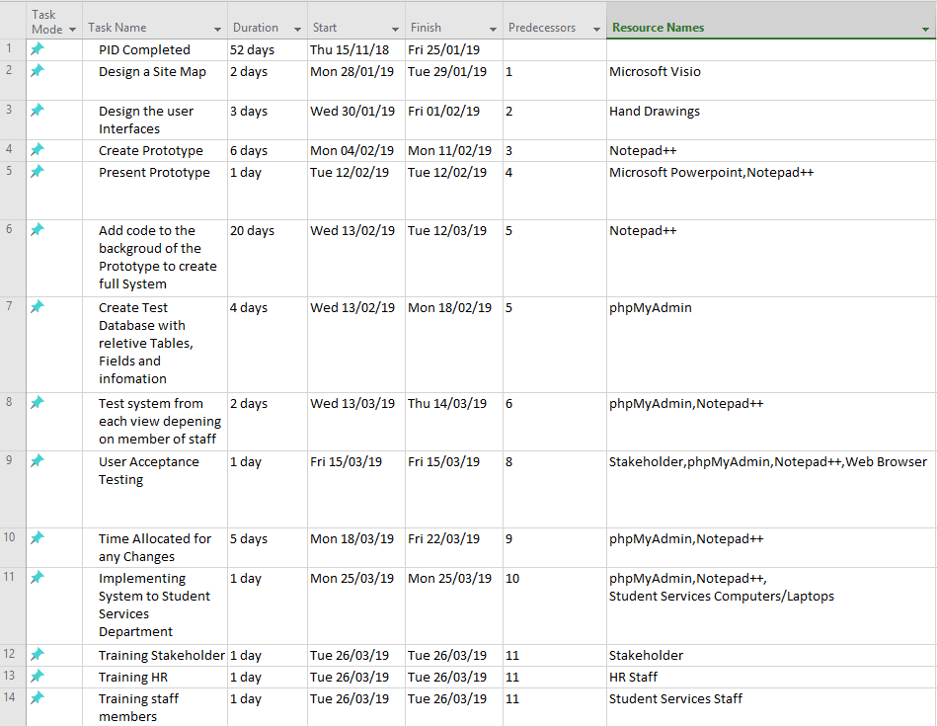
Figure 1PID Gantt Chart Details
This is the final project plan which was adjusted at the process of creating the prototype based on the initial project plan.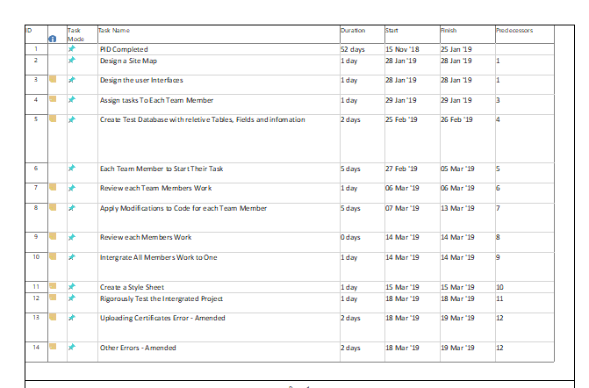
Figure 2 Final Gantt Chart Details(1)
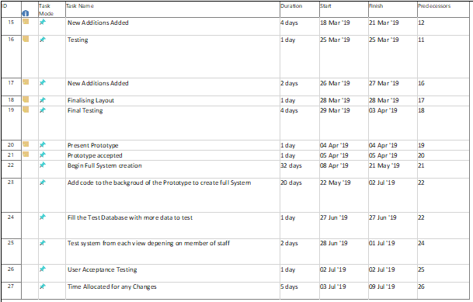
Figure 3Final Gantt Chart Details(2)
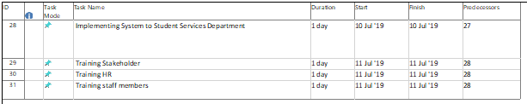
Figure 4 Final Gantt Chart Details(3)
Compare with this two Gantt chart, it is easy to see that we add many details and the project process is slower than the initial project plan because we didn’t consider that creating the prototype cost so much time.
Microsoft project have different view to display the project plan. Here are some useful view below

Gantt Chart view
The Gantt Chart view displays basic task information in the form of worksheets and bar charts. Using Gantt Chart view is easy to view the duration, start and end time of the task, and resource information. It is convenient to use the Gantt Chart view to create an initial plan, view the schedule, and adjust the plan.
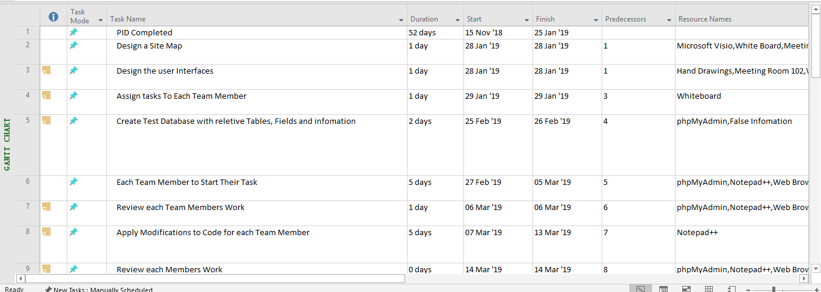
Figure 5 Gantt chart view

Tracking Gantt view
The Tracking Gantt view shows the extent to which the project offset was originally estimated, which helps determine how to adjust the plan to accommodate any delays.
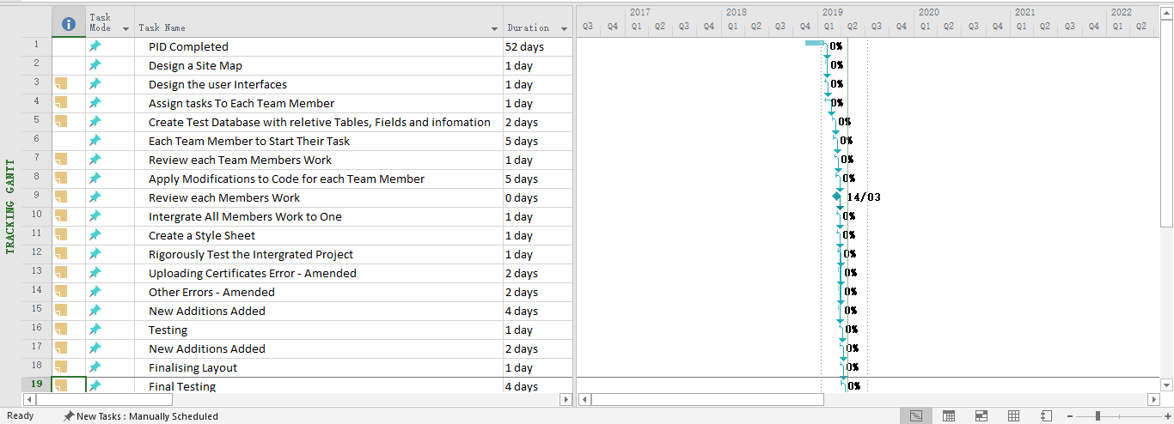
Figure 6 Tracking Gantt view

Task Assignment view
The Task Assignment view lists the resources assigned to the task, and each resource completed work hours in each time period (perhaps daily, weekly, monthly, etc.).
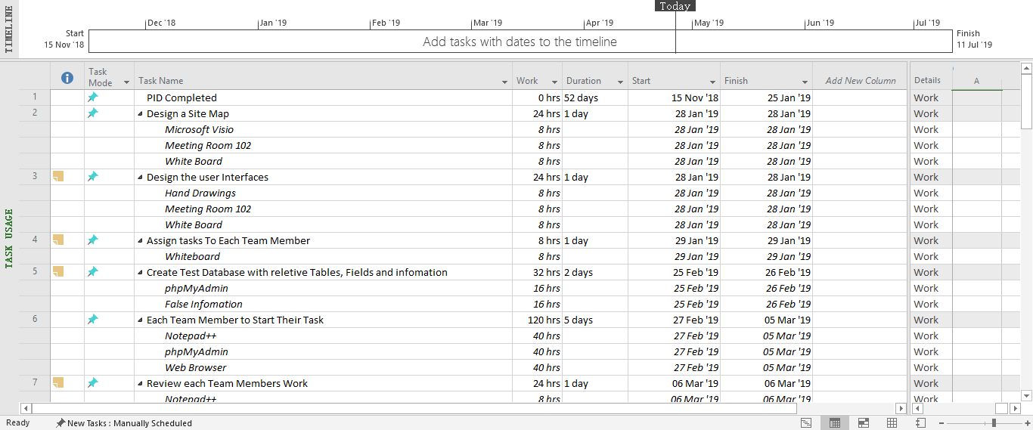
Figure 7 Task Assignment view

Calendar view
The Calendar view uses a calendar format in months, using days or weeks to calculate the task time. Among them, non-working days are greyed out, although the duration line will travel through non-working days (Saturday and Sunday), but the duration does not include non-working days.
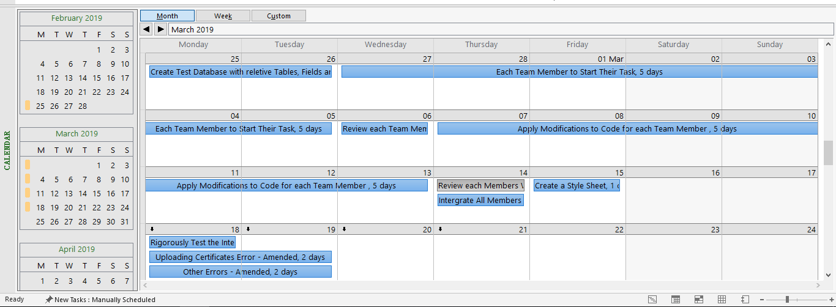
Figure 8 Calendar view

Network Diagram view
The Network Diagram view shows the tasks and their dependencies in a flowchart. A box (sometimes called a node) represents a task, and a line between boxes and boxes represents the correlation between tasks.
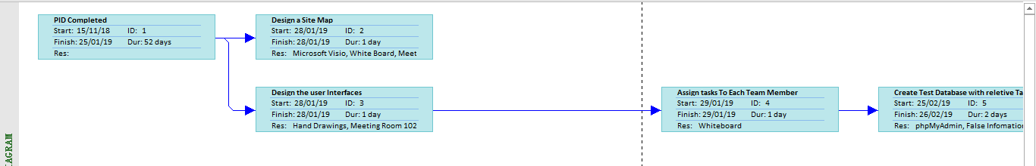
Figure 9 Network Diagram view

1.4 Milestone
The major milestones for this project will include;
- Create PID.
- Create Prototype.
- Receive Approval from Stakeholders
- Completion of full design of the system.
- Completion of background coding and functionally of the system.
- Completion of Testing
- Completion and Approval after user acceptance testing
- Implementing the system to the stakeholder’s department.
- Training for Val complete.
- Training for HR complete.
- Training for several members of staff from student services complete.

Teamwork

2.1 Team structure
Throughout project initiation document the roles were rotated around the team. A schedule was produced to ensure each one of the team members were able to be project manager for a scheduled amount of time. This allowed for the role to be shared out equally between the team members. Including the period where each team member completed the project manager, each member also had their own individual roles to fulfil throughout this project.
Once this project continues and goes into the next phase of the process, further roles are required to be allocated for the development stage. This ensures that the team is organised. Below are the names of the team members whom are working for ‘GetitrIT’ and the roles that have been assigned to the team for the development stages of the system.
Job Role | Allocated Team Member | Duties
Project Manager | Lauren Collins | - Planning Project Resources  - Assembling and Leading Project Team  - Time Management  - Budget  - Manage Issues and Risk  - Progress Monitoring of system  - Documenting and Reporting
Website Programmer | Paige Harris | - Working with the web designer to complete system  - Constant communication with colleagues to develop and deploy content  - Researching software programs and maintaining software  - Create contingency plans  - Maintaining and expanding the website once implemented
Website Designer | Meher Arasada | - Working with the web programmer to complete system  - Writing and editing code  - Designing webpage layout  - Updating websites  - Creating back up files  - Solving code problems
Database Analyst | Lu Han | - Interpret data and analyse results to produce reports  - Develop and implement databases  - Acquire data from data sources and maintain databases  - Filter and clean data  - Work with management to prioritise information needs
Based on the above roles that have been assigned to the team members, it displays that the Functional organisational structure has been applied. Each person is placed within the subject area due specialty and “the advantage of a functional structure is that individuals are dedicated to a single function. These clearly defined roles and expectations limit confusion”. [14] This also allows for communication to take place between team members to ensure successful completion of the system.

2.2 Improve teamwork

Team member
Lauren is project manager who organize every meeting and monitor our project process to make sure we can complete the prototype in time. Although the meeting is hosted by her, every team member can express our opinion, she always fully respects everyone's opinions and meditate different opinions to reach everyone’s agreement. Of course, it will take a lot of time, but it makes our team's atmosphere good. There is no contradiction between team members, and everyone is working together to accomplish the task.
Paige is good at using various office software, such as Microsoft Project, Microsoft Visio, etc . When we met together to integrate our idea and work, it was always her who typing down the results of discussion. This makes every meeting be well documented and our project progress is guaranteed.
Meher is a hard-working person. He is strict with website design and programming. When we met some code problem, He is always willing to spend a lot of time solving this problem. Sometimes, his work may not be accepted, but he can quickly change his mind. He gave us the confidence to complete website programming.
I will make some disagreements during team meetings, which may prolong the meeting time, and most of them are not accepted, but this ensures the correctness of our conclusions.

Team
Because prototype is not a very complex project, it is not easy to decompose into multiple sub-tasks, so we find that the efficiency is not very high after assigning tasks in the early stage. For example, when we design websites, we design our own databases, but each person's databases are different, which makes it difficult to integrate code. At this stage, the workload of four people is not four times that of one person, or even less than that of one person programming independently. At a later stage, we'll get together to solve the code problem, and then the team's strengths come out again. It's very effective for four people to solve the problem through discussion.
We should have a better understanding of the project, which means that not everyone is required to complete a part independently. We can cooperate to design a complete database before assigning tasks, which may be more efficient.

Risk management

3.1 Risk map
This is the risk map showing all the potential risks identified for this project. From here it is quick to identify the more likely risks which will occur and the higher impacting risks. The more likely risks with the highest impact are Scheduling and timekeeping, personnel matters, Competitors and Security. The least likely and with the smallest impact would be the market changing.
Impact |  | low |  |  | - Customer Changes Specifications  - Design Changes  - Maintenance |  | - The Market Changes
Impact |  | Moderate |  |  |  |  | - Implementation Issues
Impact |  | High | - Scheduling and Timekeeping  - Personnel Matters  - Competitor  - Security |  | - Becoming Over budget |  | - Financial Risk,  - The need becomes out of date
Impact |  |  | High |  | Medium |  | Low
 |  |  |  | Likelihood
Figure 10 Risk map

3.2 Causal map
Here is a list of the key events and actions in this project (in time order)：
- Creating PIDs
- Create prototype
- Create full system
- Test full system
- Implement system
- Train relative person
Based upon Risk map and Event list, we draw up a causal map which analyses the reasons for the problems faced by this project.

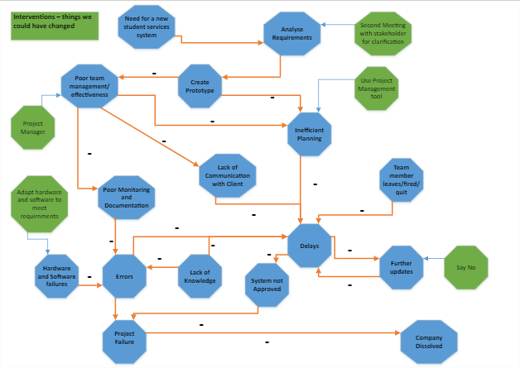
Figure 11 Causal map
By using the causal map, we can identify interventions which could have prevented the problems arising.
- ‘Poor team management/effectiveness’ might lead to ‘inefficient planning’, ‘lack of communication with client’ and “poor monitoring and documentation’, which shows the importance of team management. Once project managers neglect management, the project may have many problems from the beginning, leading to the failure of the project.
- ‘Errors’, ‘delays’ and ‘lack of knowledge’ form a circle shows that once one of these three situations occur, the project may fall into this cycle and eventually lead to ‘project failure’. We must continue to learn, and we must solve the problems in time.
- ‘Team member leaves/fired/quit’ and ‘hardware and software failures’ are not likely t happen in this project. However, we also need to be paid attention to people and equipment. In the process of the project, we need to adjust the software and hardware to meet the requirements, while focus on the personal situation of team members, to prevent ‘errors’ and ‘delays’.

3.3 Network diagram
Looking at network diagrams is an effective way to study the relationship between tasks in a project.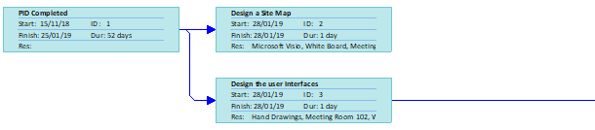
Figure 12 Network diagram (1) 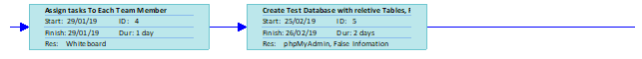
Figure 13 Network diagram (2) 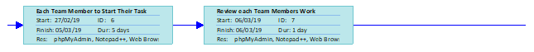
Figure 14 Network diagram (3) 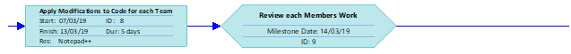
Figure 15 Network diagram (4) 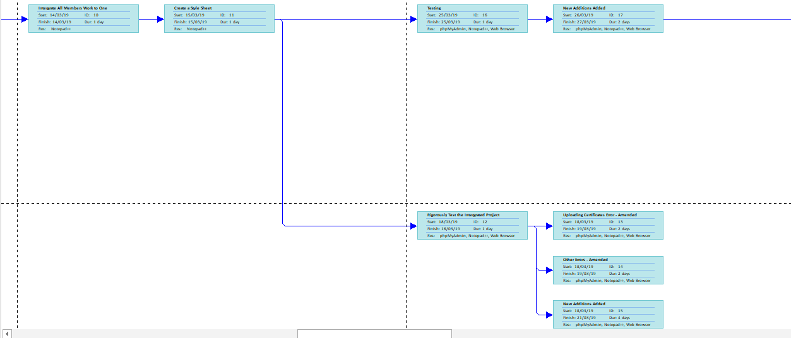
Figure 16 Network diagram (5)
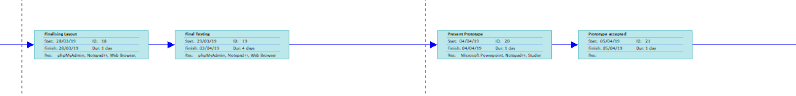
Figure 17 Network diagram (6)
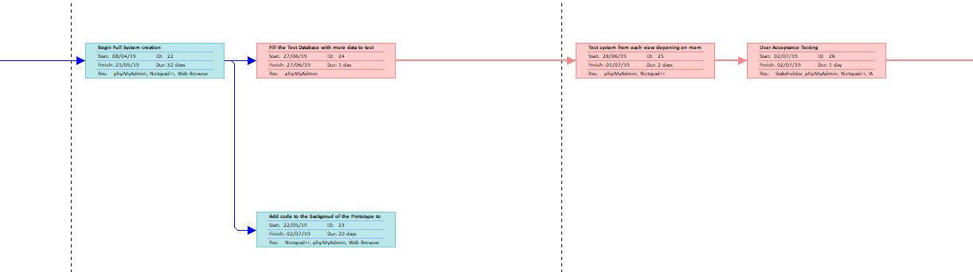
Figure 18 Network diagram (7)
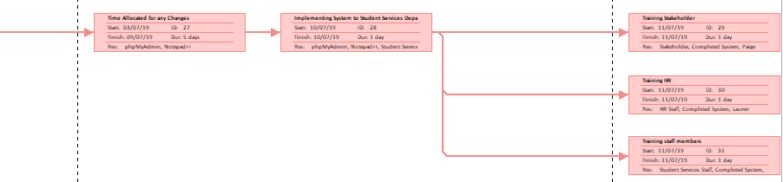
Figure 19 Network diagram (8)
From the network diagram, we can see that although there are many subtasks in this project, the relationship between tasks is not complex. Most subtasks must be completed before the previous task is completed, so any errors are likely to lead to delays.
‘PID completed’, ‘create a style sheet’, ‘begin full system creation’ and ‘implementing system to student services’ must complete on time for they have more subsequence tasks than others which shows their importance. If other tasks are not completed on time, the time of subsequent tasks can be reduced to meet the final deadline.

Sustainability
At ‘Carbon Reduction Commitment’, UK Government commit CO2 emissions reduction by 80% of 1990 levels by 2050. IT industry accounts for about 2% of global carbon emissions. In student service projects, we must comply with relevant industry standards to achieve ‘green IT’.
Relevant Industry Standards:
- ISO14001 Environmental Management Systems
- ISO14040, 64/5 - footprinting
- WEEE – waste disposals
- EPEAT
- Energy Star
- PAS 2050 – footprinting
- EU Datacentre Code of Conduct
- The Well-being of Future Generations Act
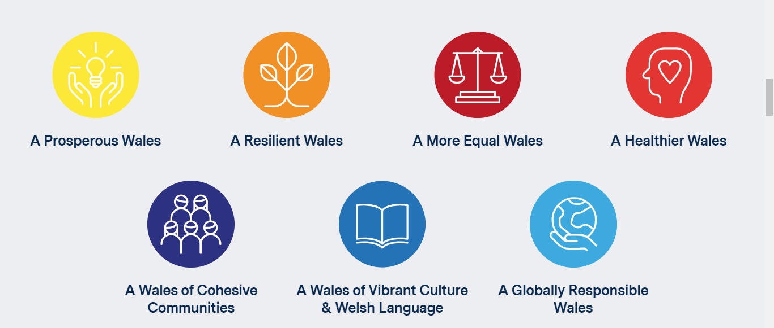
Figure 20 Seven Well-being Goals
Combine those guidelines, Lami’s Green IT framework was used to create a table as below.
Green Drivers | Power | Effort/Time | Materials | Paper | Fuel
People
University Staff | PCs | Training for new system;  Quicker and Easier working |  | paperless
Managers | PCs | New system much quicker |  | paperless
Developers | Own Laptops |  |  | Printed meeting records;  Used mobile application and email to communicate | Team member  location
Project Content
Resources | New hardware |  | Hardware and software |  | Web dashboard alternative to meetings and paperwork
Technology | Open source MySQL PHP | Web dashboard and data entry |  |  | Teleconference
Development Process
Project meetings |  |  |  |  | Car travel, some train travel
Institutional Context
University | Issues integrating with University systems |  |  | paperless sustainability meetings
Figure 21 Lami’s Green IT framework
First of all, the implement of this document management system can reduce the use of paper. But sometimes, for example, when record the meeting content and staff attendance, we can use only Recycled Paper, and set a date to be paper free, and when printing move towards using only soy-based inks.
Secondly, the majority of people go to school by car or train, which consumes so much energy and time. After each meeting, mobile phone software and e-mail should be used to communicate in time to ensure the smooth progress of the task. In order to save energy, we should use teleconferencing or video conferencing to communicate some problems that need not be solved face to face.
Thirdly, In the design of document management system, we should pay attention to the simplicity of code, the friendliness of user interface and the corresponding speed of browser. In the long run, it can improve the system performance and reduce energy consumption.
Finally, the new document management system will bring many new changes to the student service when it is adopted. These changes are not only technological changes, but also the optimization of the whole school workflow and how to maximize sustainable development.

Ethical
Technological ethics can be defined as the risks of IT systems (such as the disadvantages or injuries of individuals or groups), and practical measures can be taken to manage risks to avoid these problems. BCS CODE OF CONDUCT is a good reference standard for investigating the ethics and morality of computer industry practitioners.

5.1 Public Interest
In this document management system project, an amount of data including personal privacy of staffs are stored in the database. In order to safeguard the interests of employees, strict confidentiality measures must be taken.
Firstly, in the database, passwords are stored in the database using encryption algorithms such as MD5 to prevent hacker to steal passwords. In order to prevent computer from violently decrypting codes or large-scale machine login leading to website paralysis, the use of digital or graphical authentication codes to enhance the security of website login. The password can be retrieved by binding an account with a cell phone number or an e-mail address.

5.2 Professional Competence and Integrity
As a computer engineer, we should clearly understand our professional competence level and communicate with Student Service project manager honestly, rather than pretending to have more ability to be obtain agreement by manager. Although all members have learned PHP and MySQL, programming is fast updated and endless. We must constantly learn to enrich ourselves to fulfil the requirements of the project. Especially when encountering an error, we should be bravely admitting error rather than cover it up, although it may not be discovered by others.

5.3 Duty to Relevant Authority
According to the requirements of the student service department, the professional responsibility of computer engineers should be performed with caution and diligence in exercising professional judgment. In the course of the project, I assume professional responsibility for my work and the work of colleagues in the development team. In the final implement of this information system, we should not take advantage of student service staff lack of professional knowledge or experience to distort or conceal the relevant information.

5.4 Duty to the Profession
As a member of a large group of IT engineers, we must maintain a professional reputation at work and do not take any action that might damage our professional reputation. Never do any hacking to undermine the professional image. It is worth emphasizing that even if we have done similar projects, we cannot directly use the results of other projects to complete this management system project.

5.5 Ethnic risk management
Key ethnic risks:
1. The management system does not have the expected quality because it does not have sufficient resources.
2. Data security is insufficient. Measures to protect data are not good enough, which may hurt users by exposing personal information.
3. If a failure occurs, the user may lose important data or services.
To manage the risks above, through a clear process, it is easier to confirm whether a function and its monitoring level meet the ethical standards. We can define a simple checklist and implement them to see if they work.
Highlight the subjective position of the person in management risk and realize the people-centred management spirit and requirements:
(1) Respect for human values and dignity.
(2) Affirming the equality of people's personalities and regard corporate management as a common cause for all employees of the company.
(3) Affirm the rationality of people seeking legitimate interests, and emphasize that all management activities must benefit the broad masses of the people.

Legal
Any company that stores or processes personal information about EU citizens in EU countries must comply with GDPR even if there is no business in EU. Therefore, the student service project must comply with the regulation of GDPR to store users data.

6.1 GDRP
According to GDPR, the rights of individual users in privacy data are proposed as below:
1. Users can query the school whether their personal data is processed and used, and the purpose of use, the type of data collected and so on. This provision mainly guarantees users'right to know about personal privacy.
2. Users have the right to request enterprises to delete their personal data. If the data has been acquired by third parties, users can further request them to delete. Users have registered an account, and schools should provide users with a channel for cancellation.
3. If the user thinks that the personal data collected by the school is inaccurate, or uses illegal means of processing, but does not want to delete the data, he can ask for restrictions on the use of personal data.

6.2 Overseas sales
The geographical scope of European privacy laws is expanding through GDP R. It is precisely because of this expansion of the scope of application that many organizations located outside the EU and not subject to the current European privacy laws will have to apply EU privacy laws with the implementation of GDP R. GDP R requires these organizations to respond to the "compliance" requirements of GDP R in a timely manner.
In theory, it can provide a special version of the management system or services outside the EU and develop another set of privacy provisions. But in order to demonstrate their sincerity in respecting and protecting personal data, it is best to follow GDP R overseas as well.

6.3 Brexit influence
As a local school in the UK, Brexit does not affect the compliance of the project with GDPR. GDPR is implemented in the UK's DPA law and will continue to be implemented after the UK leaves Europe. The difference is that Britain only needs to change the EU regulations into its own. At present, it is not difficult to complete this process.
If the data of the management system is exported to EU Member States after the Brexit, or the EU countries are required to receive the data, this involves data transfer, which is precisely the area that regulators are most concerned about. Data exported to EU countries will automatically be subject to the jurisdiction of GDPR regardless of the source; at the same time, data received from EU countries must conform to the standard of GDP R. Without specific legal safeguards, it will be defined as illegal to export data to "third-party countries". Britain will become a "third-party country" after its separation from Europe and will be subject to these rules. Similarly, cloud computing-related services will be affected.

