Circuit Design and Analysis: Assignment 1
Ashleigh Elder P141924
February 7th 2018

Contents

- Abstract

- Introduction

- Background Theory
  - Passive RC Filters
  - Sallen-Key Filtration

- Materials and Methods

- Discussion and Results
5.1 Conclusion

- Bibliography
6.1 References
6.2 Research
6.3 Appendix

1 Abstract
The design of analogue passive and active filters are an important part of the electronics field when transmitting and processing different signals, the environment and man-made electronics can create noise which when added to a signal can make it unintelligible. This report demonstrates an active filter using the Sallen-key topology in action with detailed descriptions of the procedure for designing and creating a band pass filter. The properties of this filter were determined by using the students student number “1450464” to determine the high (145kHz) low (4kHz) and source (64kHz) frequencies. This report has been mostly successful although there were some issues with the final received signal that do not correspond with the theory used therefore more research is needed in order to ensure these issues do not arise in the future. The filter crated for this project is not ideal as it has a high Q factor (2.87) which was not seen earlier in the project and can be corrected by choosing cut off and cut on frequencies closer to the source signal.
2 Introduction
This report aims to demonstrate an understanding of the basic principles of active and passive filters by designing a circuit to filter a given value from a high and a low frequency “noise”. This active filter should be able to remove noise from a noise corrupted signal. The filter shall be designed using Proteus 8 and the Sallen Key method of filtering.
In order to achieve this values for the noise and source signals shall be decided using the Student Number of the writer of this report “1450464” where 145kHz is the high noise, 04kHz is the low noise and the source signal is 64kHs. After designing and creating this filter the pros and cons of this method shall be analysed and tested against ideal filter theory.
3 Background Theory
3.1 Passive RC Filters
Passive filters consist of capacitors and either resistors or inductors connected in parallel with nonlinear loads such as diode rectifiers[1]. Theses filters are designed to provide low impedance paths for particular frequencies in order to remove unwanted frequencies. The frequencies kept by the filter are determined by the Q factor which also determines the sharpness of the filter:
Q=fs/Bw
“Passive filters have a value-added function of achieving power-factor correction of inductive loads. This function brings an advantage to passive filters in many cases, but not in all cases.” [1] The design of a passive filter (and likewise an active filter) should make exceptions for the tolerance of it components and variations in the environment as typical capacartor and resistor values are only usualy correct to a tolerance of 5% and can vary due to temperature increases caused by current flowing through the components themselves.
“Ideally, a filter will not add new frequencies to the input signal, nor will it change the component frequencies of that signal, but it will change the relative amplitudes of the various frequency components and/or their phase relationships”[2] Below can be seen a set of images demonstrating four of the main kinds passive filter that are most commonly used. Low pass filter allow low frequencies to pas and block higher frequencies whilst a high pass filter does the opposite, if these two filters are combined however we can create a tuned band pass filter.
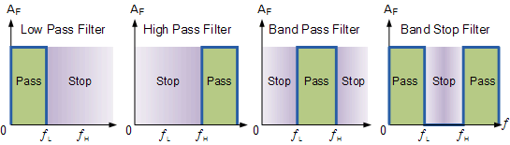[2]
Pictured below is an example of a passive band pass filter created using only resistors and capacitors the properties of a filter depend on the way around the capacitors and resistors are positioned in series with a capacitor connected to ground creating a low pass filter and a capacitor crating a high pass.
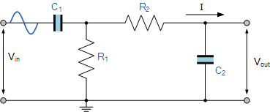[3]
A band pass filter differs from a lowpass and a high pass filter as a lowpass filter passes all frequencies from the cutoff frequency to 0Hz and a high pass filter does the opposite allowing frequencies through up to infinity a band pass filter keeps the frequencies between two tuned cut off and cut on points. In order to determine what frequencies are kept we measure the bandwidth of the filter which is equal to the frequency range between 3dB below the resonant peak.[3]
“Then for widely spread frequencies, we can simply define the term “bandwidth”, BW as being the difference between the lower cut-off frequency ( ƒc_{LOWER} ) and the higher cut-off frequency ( ƒc_{HIGHER} ) points. In other words, BW = ƒ_{H} – ƒ_{L}.”[3]
The cutoff and cut on frequencies are determined using the equation below and using this we can determine any of the values for the resistors and capacitors by rearranging them:
f(cutoff)=1/2πRC, ω = 2πf (angular frequency), R =1/ωC, C =1/ωR

3.2 Sallen-Key Filtration
In the field of electronics filter topology is used to define an electronic circuit without using the specific values for components used and instead only using the connections of those components. Filters are primarily defined by their transfer function as opposed to their topology (for example high pass, low pass and band pass) although for this assignment the Sallen-key topology is going the be used to create a band pass active filter. [4]
One kind of filter is a Butterworth Filter, and the frequency response of this filter is often referred to as “maximally flat” which means it has no ripples as the pass band is designed to have a frequency response that is as flat as possible up to the cutoff frequency (at -3dB) with no ripples.[5] The ideal frequencies for a butterworth filter can be seen below and this shows that the higher order the filter the closer it gets to the ideal “brick wall” frequency response but this “brick wall” is unattainable in practice as the sharper the curve the more excess passband ripple is produced.
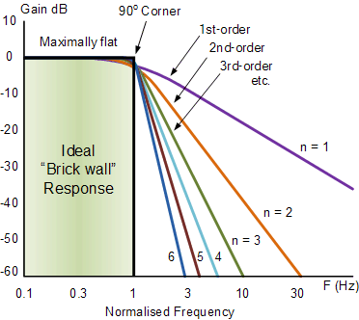[4]
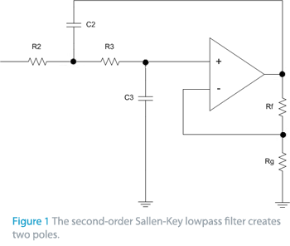[4]

4 Materials and Methods
In order to design a usable filter for this assignment the E24 series of resistors were used as these are a relatively cheap resistor series with enough variety considering their cost. The E24 series of resistors contains 24 individual resistor values between zero and ten ohms, hence the name E24. These resistor values are also particularly accurate in the real world (although nothing acts the same way as they do in theory in reality) as they are effective to a 5% tolerance[6]. The values included in the E24 series can be seen below:
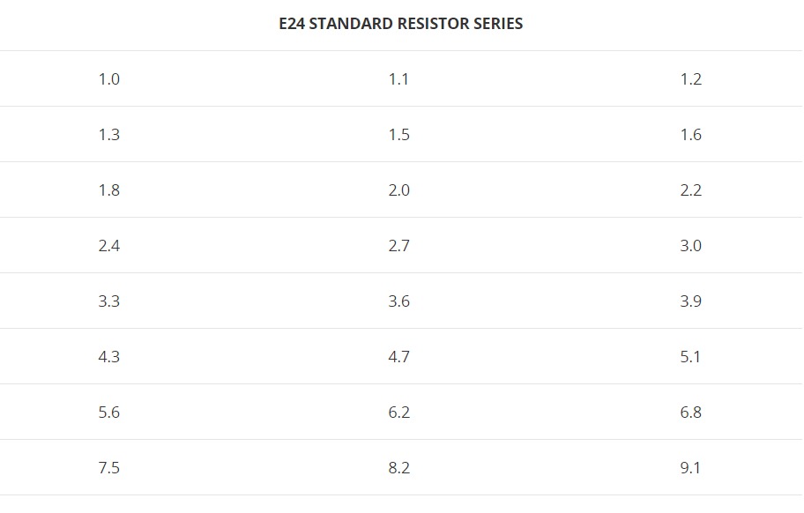[6]
Proteus 8 Professional was used in order to create the simulation for these filter designs with the ideal values being calculated by hand using the equations shown in the research section of this report.
For this assignment three values are given to create the noise and source frequency required and these are given by the student number of the author, “1450464” where the high frequency is equal to 145kHz, the low frequency is 4kHz and the expected signal frequency is 64kHz. Using these values the high and low cutoff frequencies can be determined. The high pass cut-off frequency can be determined by taking the middle value between the lowest and the expected frequencies (((Fs-Fl)/2)+Fs) which in this case is equal to 34kHz. The low pass cut-off frequency can be determined in a similar fashion using the equation (((Fh-Fs/2)+Fs) which equals 104.5kHz in this instance.
In order to decide on resistor values for this filter a generic capacitor value of 1nF shall be used using this information we can use the equation to calculate R for both the high and low pass filters as seen below:
$Flp=\frac{1}{2πRC}$ $104.5k= \frac{1}{2π×104.5×{10}^{3}×1×{10}^{-9}}=1523Ω$
$Fhp=\frac{1}{2πRC} 34k=\frac{1}{2πRC} R=\frac{1}{2π×34×{10}^{3}×1×{10}^{-9}}=4681.03$Ω
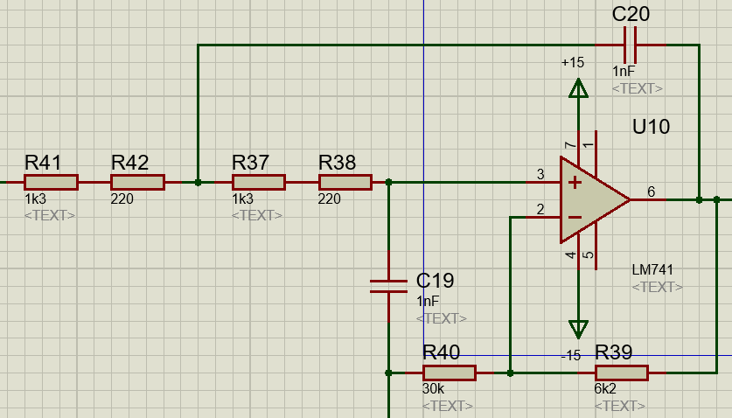
These resistor values need to be rounded to the nearest E24 resistor value therefore 1523 = 1300Ω and 220Ω shall be used for the low pass filter and 4681 = 4700Ω for the high pass filter. Using the above values a second order high pass and low pass filter using the Sallen-Key topology were created in proteus respectively and can be seen below:
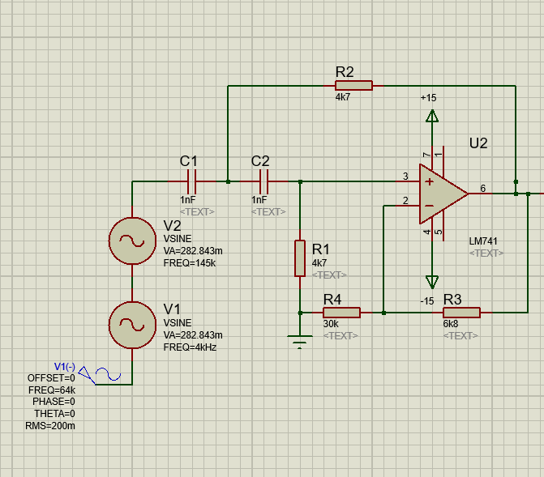

The gain resistor values have been adjusted as each stage of the filter has been added to get the optimal level of attenuation for the circuit as this changes as more and more orders are added to the filter. As reality does not tend to follow theory with exact numbers (due to external influences and imperfectly built components) the values for this filter do not need to be perfect but a close approximation of what’s needed for the filter to function serviceably.

5 Results and Discussion
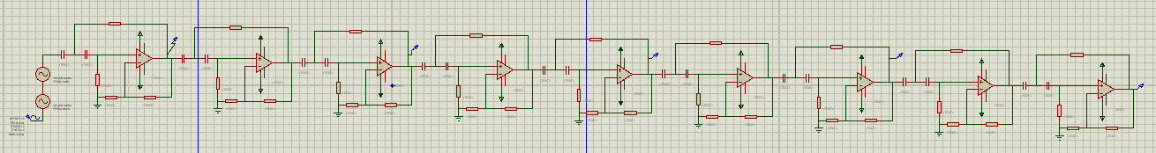
As seen above in order to achieve a reasonable level of filtration and attenuation it was decided that an 18th order high pass filter be used for this project. By using an 18th order filter the signal is at -30dB at the high pass frequency (34kHz) whilst the required frequency (64kHz) sat at almost 0dB. This means that everything below 34kHz is filtered out of the final signal completely. This Butterworth filter can be seen in action in the screenshot below with the angle of filtration getting steeper the more orders are added to the filter (for convenience sake the measurements were taken every four orders after the first second order filter) where a second order filter fails to filter out most of the lower frequencies. By adding more orders to the filter circuit we get closer to the ideal “wall” of filtration needed but the closer we get to this the more parts are required when in reality the imperfect signal below should do a good enough job of filtering out the unwanted low frequency noise.
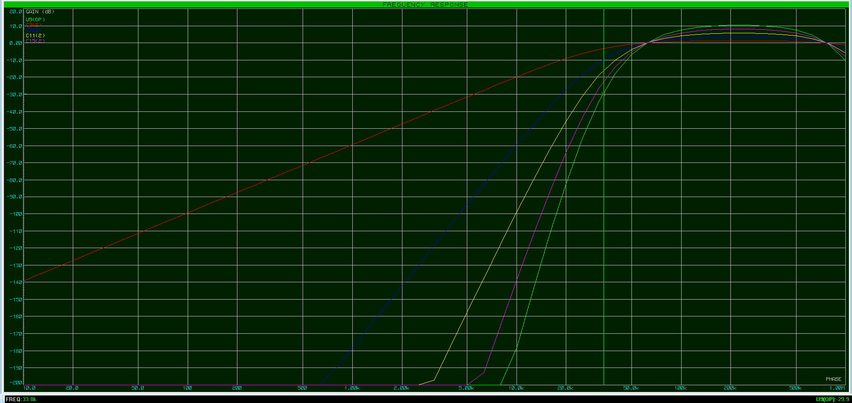
The screenshot below shows the completed 36th order Sallen-key filter during this process the gain resistors needed adjusting again as the circuit got more attenuated with each 2nd order filter. It was decided that an 18th order low pass filter was an acceptable addition to the overall filter design as this caused the frequency 105kHz to rest on -30dB whilst the source signal’s frequency again peaked at around 0dB therefore allowing the original signal through the filter at the same amplitude it had to begin with. Below this can be seen improving with each additional 4th order filter block added to the circuit and both the high pass and low pass filters demonstrate that the closer to the “brick wall” the filter gets the more diminishing returns are seen and the more stages of filtering are required thus increasing the cost, for this reason it was decided that a 36th order Sallen-key filter was enough for this project.

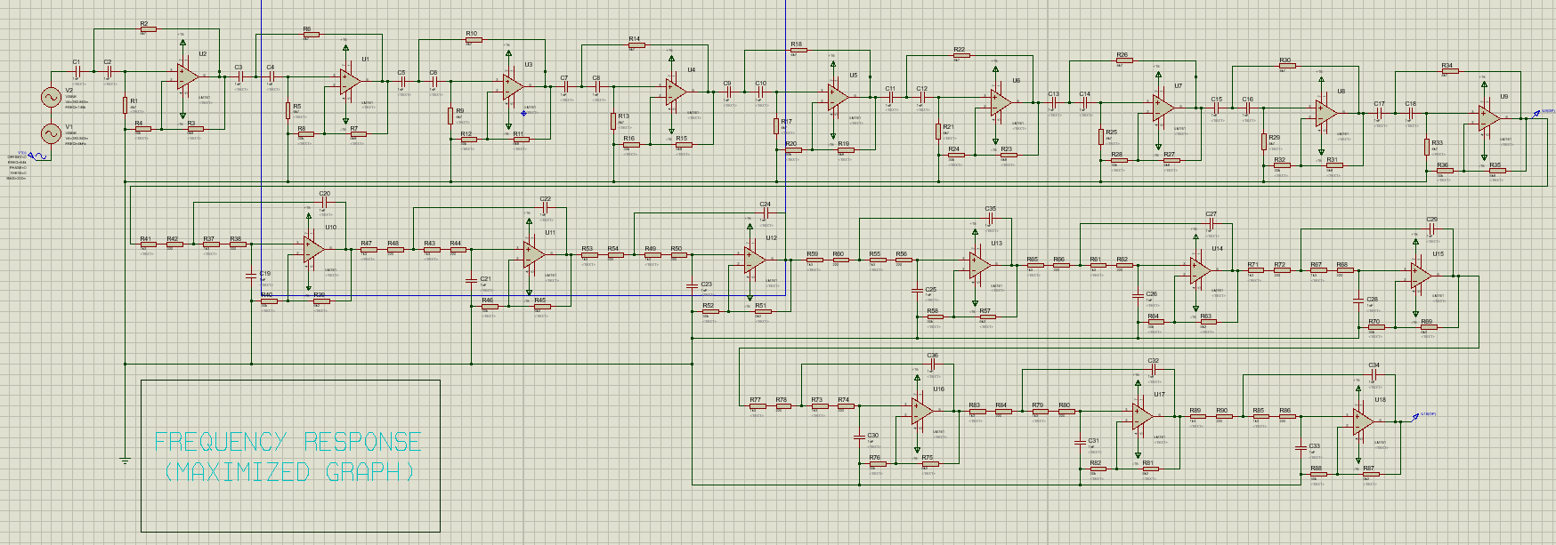
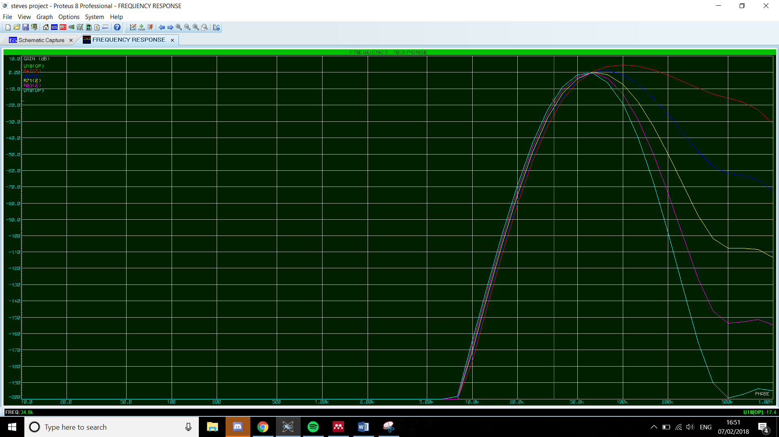
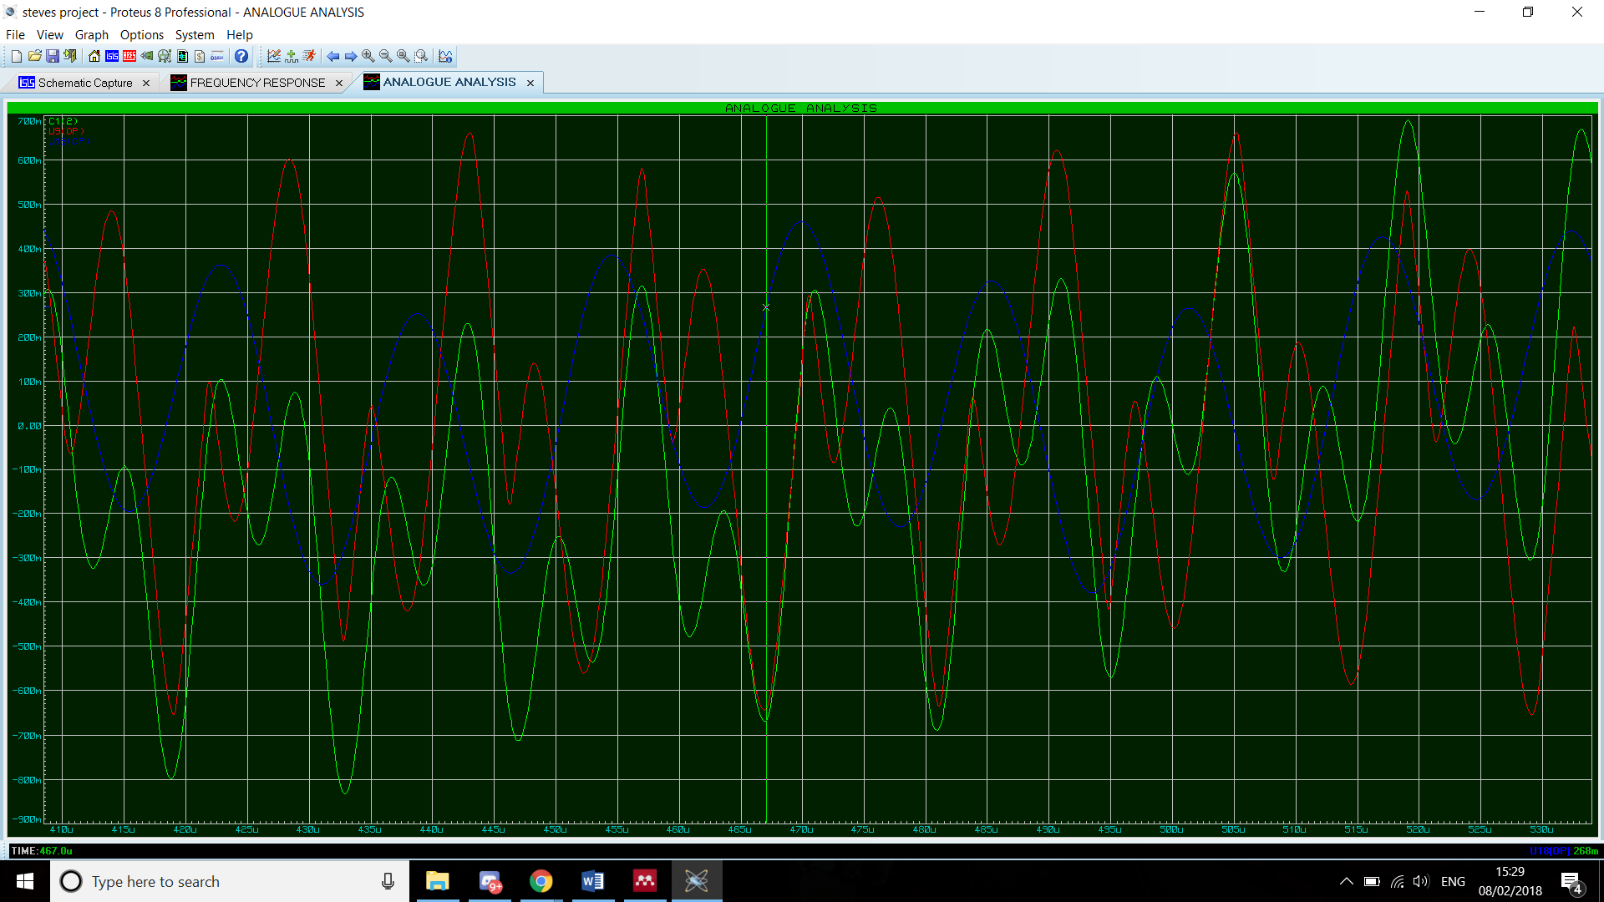
Finally as the filter design is complete the circuits analogue response is tested to demonstrate the filter effectively working in action. This filter manages to eliminate most of the noise but alas does not return an identical signal to the source therefor it doesn’t fulfil the task expected of it. This can be seen in the screenshot below as the blue line (the output) seems to rest at three frequencies although not to the same extent as the green input signal (plus noise). This shows that the filter is in effective as it is still picking up some noise a the end of the circuit. This can be attributed to a high Q factor that was not taken into account earlier in the project and can be solved by using two cutoff frequencies a little closer to the source signal and (the more expensive alternative) adding further orders to the filter.

5 Conclusion
In conclusion this project has successfully outlined the properties and benefits of active Sallen-key filters of various topologies and created a (not optimal) filter design. Active filters are an effective method of creating tuned filters although the closer to perfection the filter achieves the more expensive it gets in terms of design and in parts and sometimes it can be better to use a passive filter. The project failed to demonstrate an effective filter meeting the requirements of the assignment but with more research and better preparation this could be improved if undertaken again. This could be achieved by altering the cut on and cut off frequencies used and moving them closer to the source frequency as this will create a lower Q factor in order to make sure as much noise as is possible is removed from this circuit.

6 Bibliography
6.1 References
[1] H. Akagi, “Modern active filters and traditional passive filters,” Bull. Polish Acad. Sci. Tech. Sci., vol. 54, no. 3, pp. 255–269, 2006.
[2] K. Lacanette, “A Basic Introduction to Filters - Active, Passive, and Switched-Capacitor,” Appl. Note, pp. 1–22, 2010.
[3] Electronic Tutorials, “High Pass Filter - Passive RC Filter Tutorial.” 2016.
[4] Hyper Physics, “Filter Circuits with Capacitors.” 2017.
[5] AspenCore Inc, “Butterworth Filter Design with a Low Pass Butterworth.” 2016.
[6] “https://www.electronics-notes.com/articles/electronic_components/resistors/standard-resistor-values-e-series-e3-e6-e12-e24-e48-e96.php”, 2018.
6.2 Research
http://www.d.umn.edu/~htang/ece3235_doc_F10/Active_Filter_Summary.pdf
http://hyperphysics.phy-astr.gsu.edu/hbase/electric/filcap.html
R. Hayes and R. Chapter, “Band,” no. Chapter 6, pp. 11–25, 2002.
“Gadolinium - Questions and Answers ​in MRI.” . 2018.
T. T. Function, “Laboratory 6 : Design the Sallen-Key Low-Pass Filter,” no. 1, pp. 1–4.
R. G. Lyons, “Digital Filter Terminology,” Understanding Digital Signal Processing, vol. 1. 1997. S. K. L. Filter, “Second-Order Sallen-Key Filters Properties of Sallen-Key Filters” pp. 3–5.

6.3 Appendix


