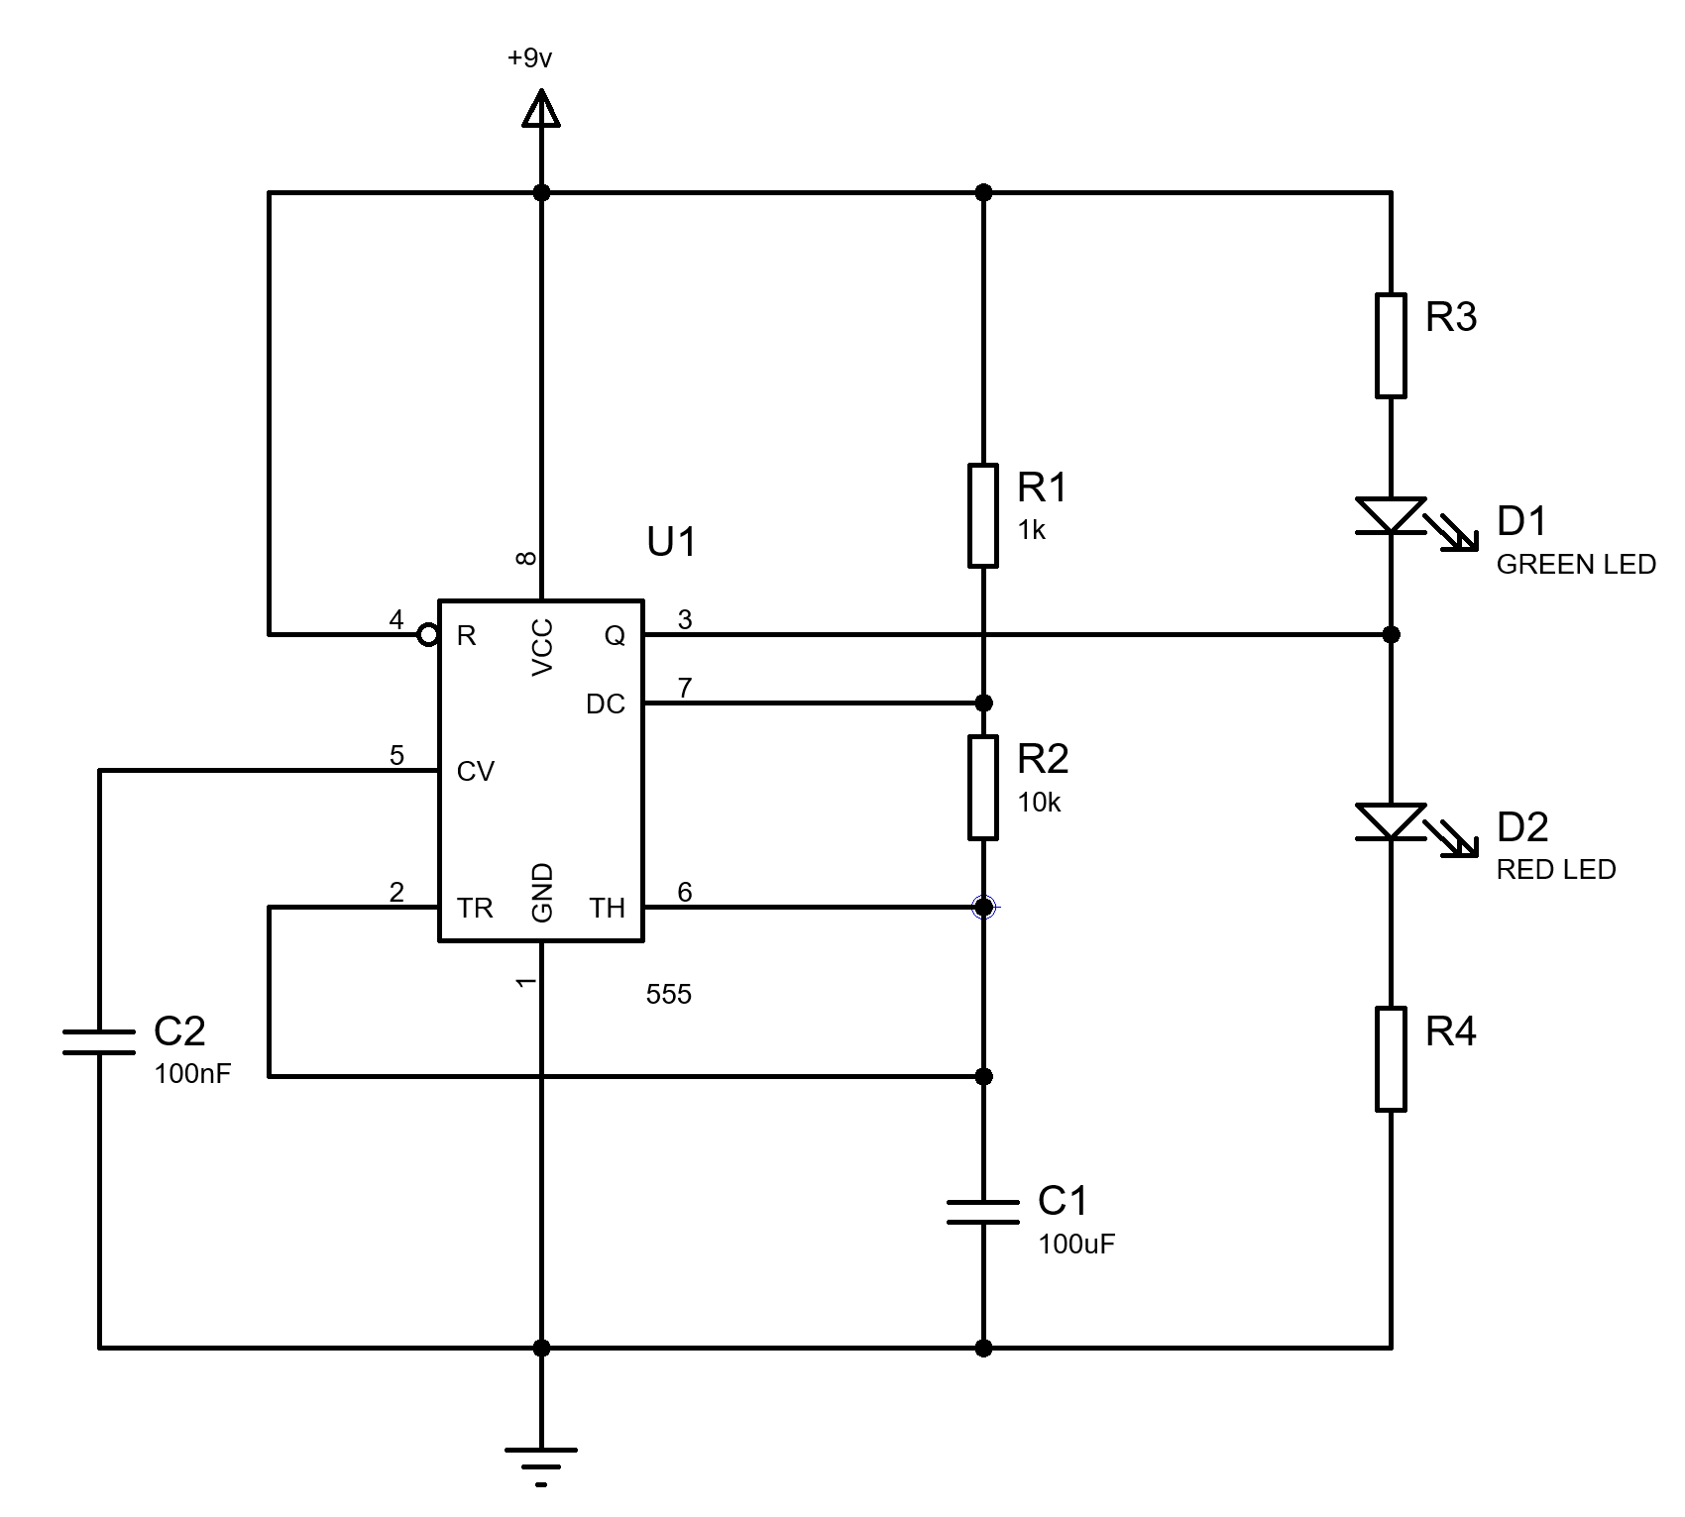
Belton Christopher | ACDA40118 | Fundamentals of Electrical and Electronic Systems

Circuit Build

Figure 1- Assignment Brief Schematic [1]

Contents
Introduction 2
Circuit description and operation 2
Simulated circuit in Proteus and schematic 3
Design Calculations 3
Resistance of R3 and R4 3
On time, off time 4
Period 4
Frequency 4
Proteus timing measurement tables and C1 capacitor graph 5
555 timer circuit build and Testing 6
Conclusion 7
Figures 8
References 8

Introduction
This report covers the build using breadboard and simulation using Proteus software of the 555 timer. Focusing on how the circuit operates, the simulated circuit in Proteus, a number of calculations on the design, tables and graphs from Proteus and how further analysis of the results and data gathered in the future.

Circuit description and operation
The 555 timer is one of the most proliferated circuit components currently produced and has been largely unchanged since it’s initial design. It is thought that “about 1 billion devices a year. These are mostly made in Korea now, Samsung. The electronics industry is big now.” [2]
The configuration of the chip dictates how the chip will operate. One configuration is monstable which is a very simple on/off function after a set period of time. Another configuration is called astable which oscillates on and off like a metronome. The astable configuration is more commonly used. The final configuration is bistable, this “flip-flops” between two stable states, either high or low.
Figure 2- Assignment Brief Schematic
The 555 timer has 8 terminals listed below;
- Terminal 1- Ground. This grounds the chip.
- Terminal 2- Trigger. This is how the 555 timer starts. This is triggered by a drop in voltage.
- Terminal 3- Output. This outputs a digital signal which is either high or low. The signal will never be higher than the supply voltage and on the low output it will be 0V.
- Terminal 4- Reset. This pin is used to reset the timer.
- Terminal 5- Control voltage. This controls the voltage to ensure minimal fluctuations in the signal. This is often achieved by using a small capacitor.
- Terminal 6- Threshold. This pin monitors the voltage that’s discharged when the 2/3 of the supply voltage is reached.
- Terminal 7- Discharge. This pin discharges the external capacitor used to control the timing of the timer. This can be combined with a resistor.
- Terminal 8- Power supply. This is connected to the DC positive power supply with a maximum voltage of 15V and a minimum voltage of 4.5V.
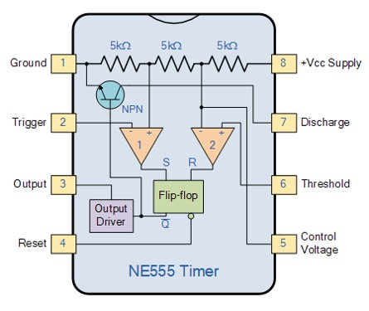
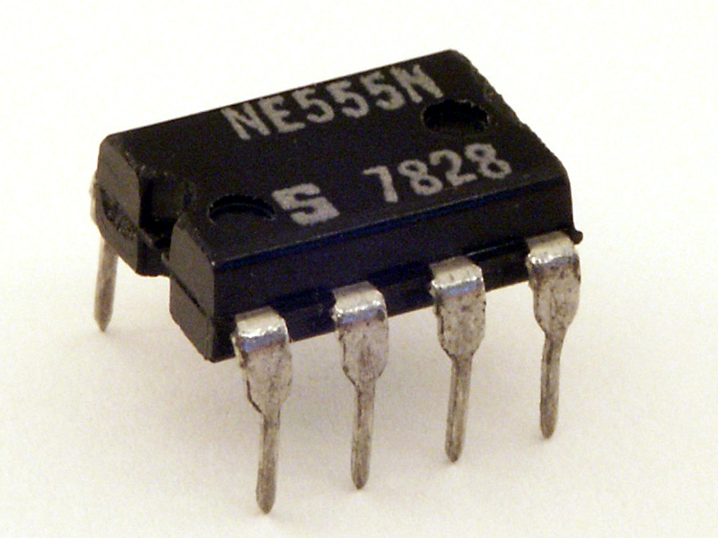
Figure 3- NE555N Timer [6]
The configuration we discuss and build in this report is the astable 555 timer. Due to the astable 555 timer having no stable state it is constantly toggling back and forth over a set length and frequency.

Figure 4- 555 Timer Schematic [3]

Simulated circuit in Proteus and schematic
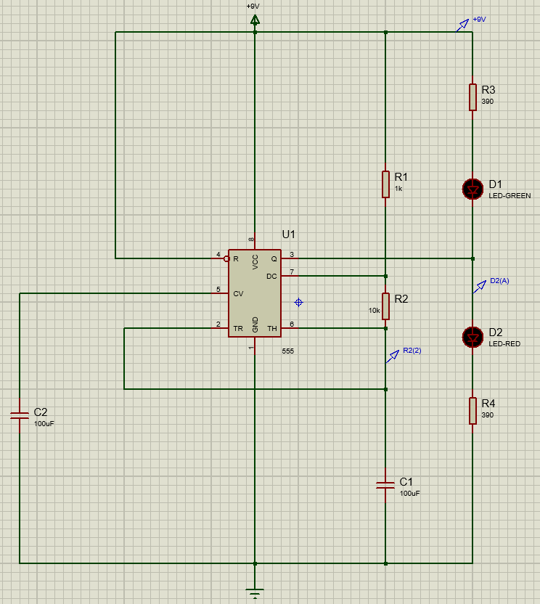
The values for all components needed to be calculated in order to find the correct component and component figures on Proteus for accurate simulation. The capacitor value was provided as C1= 100uF and C2= 100nF. This was important for the circuit to function as intended. The capacitor C2 reduces the noise in the circuit and the C1 affects the timing of LEDs flashing. Incorrect capacitor could either make the LED flash too slowly or not at all.
Figure 5- Proteus Circuit Schematic
The resistor R3 and R4 was calculated using Ohms law described in the design calculation section below.
Firstly the components were added to the Proteus work plane in approximately the correct area from the component list. These components then got moved to ensure they lined up to enable them to be connected with straight wires where possible. Three probes were added to the circuit to allow for voltage measurements to be taken across the various locations.
Inserting a graph allowed for a graphical representation of the on/ off times to be shown. This was done by dragging the two probes required onto the graph and starting the simulation. It is important on the graph to choose an appropriate duration.

Design Calculations

Resistance of R3 and R4
To calculate the resistance of R3 and R4 you must use Ohms Law “Ohm’s law, description of the relationship between current, voltage, and resistance. The amount of steady current through a large number of materials is directly proportional to the potential difference, or voltage, across the materials. Thus, if the voltage V (in units of volts) between two ends of a wire made from one of these materials is tripled, the current I (amperes) also triples; and the quotient V/I remains constant. Ohm’s law may be expressed mathematically as V/I = R” [4]
R3 Calculation= V/I = R 7V/ 0.02A= 350Ω
R4 Calculation= V/I= R 7V/ 0.02A= 350Ω
The manufacturer specifies an approx. Voltage drop across the LED of 2v therefor this must be taken into account when calculating resistor values hence the 7V voltage.

On time, off time
This is the time in seconds that the output is ‘high’ and then ‘low’.
Time calculation the output is high: $Ln(2)$ (1KΩ+10KΩ) x 100uF = 0.76246s
Ln(2)1000Ω+10000Ωx0.0001F= 0.76246s
Time calculation the output is low: Ln(2)10KΩ) x 100uF= 0.69315s
Ln(2)(10000)x0.0001F= 0.69315s
High= 0.76246s Low= 0.69315s

Period
The definition of period time of output on plus time output off in seconds.
On time= 0.76246s Off time= 0.69315s
0.76246s + 0.69315s = 1.46s
Period= 1.46s

Frequency
The definition of frequency is the “rate at which current changes direction per second. It is measured in hertz (Hz), an international unit of measure where 1 hertz is equal to 1 cycle per second” [5]
Frequency= 1/ Period
1/1.46= 0.68Hz
Figure 6- 3Hz Waveform [3]

Proteus timing measurement tables and C1 capacitor graph
This table allows the comparison of the on/ off time and compare it to the previous design calculations. As evident from the table the figures differ to the calculated results. This is likely due to the fact that the calculations do not take into account any external factors. The Proteus software is able to do this and will change the results as appropriate.
Table showing on/ off times over a 10 sec period from figure 7.
State | Time Elapsed (s) | Time In Current State (S)
Start | 0 | 0
On | 1.06 | 1.06
Off | 1.79 | 0.73
On | 2.5 | 0.71
Off | 3.22 | 0.72
On | 3.94 | 0.72
Off | 4.65 | 0.71
On | 5.37 | 0.71
Off | 6.08 | 0.72
On | 6.80 | 0.71
Off | 7.51 | 0.71
On | 8.25 | 0.74
Off | 8.95 | 0.70
On | 9.68 | 0.73
Off | … | …
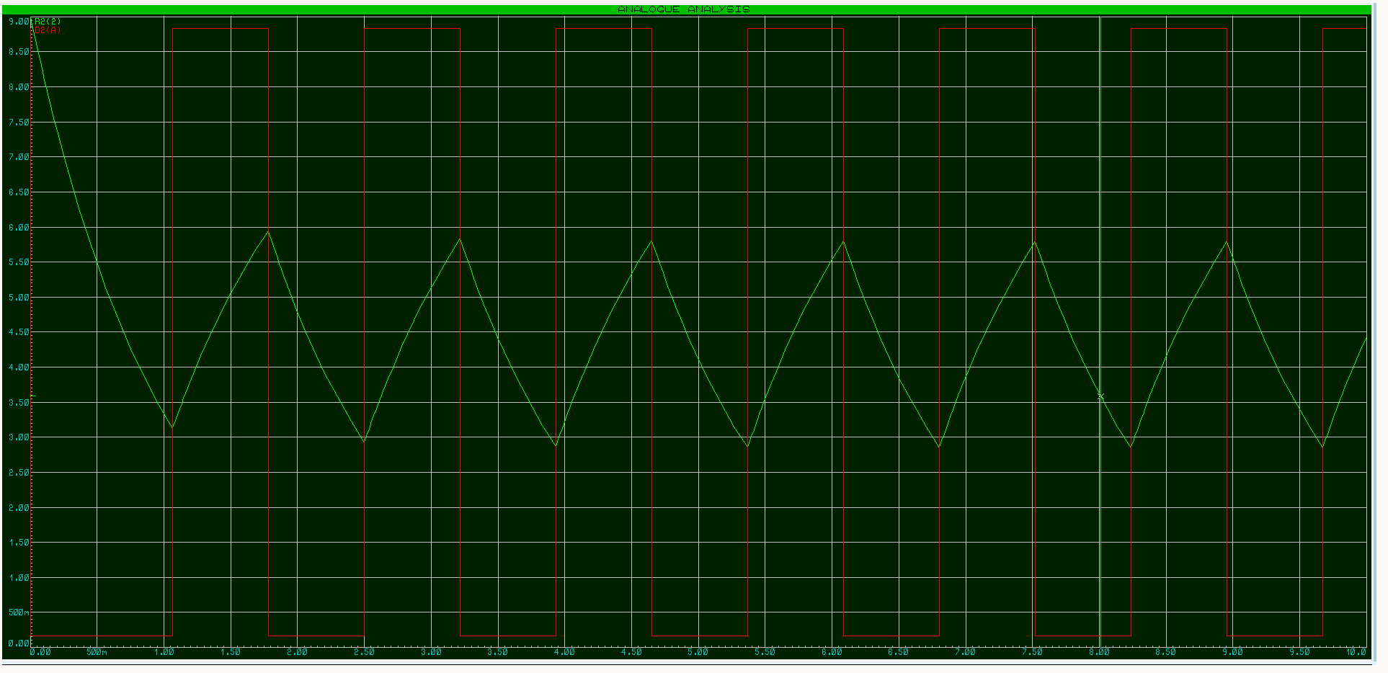
Figure 7- 555 Timer Output voltage/ Capacitor Output Voltage
- Green- Capacitor voltage
- Red- Output Voltage
The red line on this graph shows the 555 timer chip output voltage. This would be from pin 3 which is the output. The green line shows the 555 timer chip capacitor output voltage. This will be from pin 2 and 6 which is the trigger and threshold. When capacitor voltage is 2/3 of supply voltage output voltage goes high. Once capacitor 1/3 supply voltage turns low. The chip then oscillates between 1/3rd and 2/3rd until the power is removed or turned off to the circuit. This was over a 10 second period.

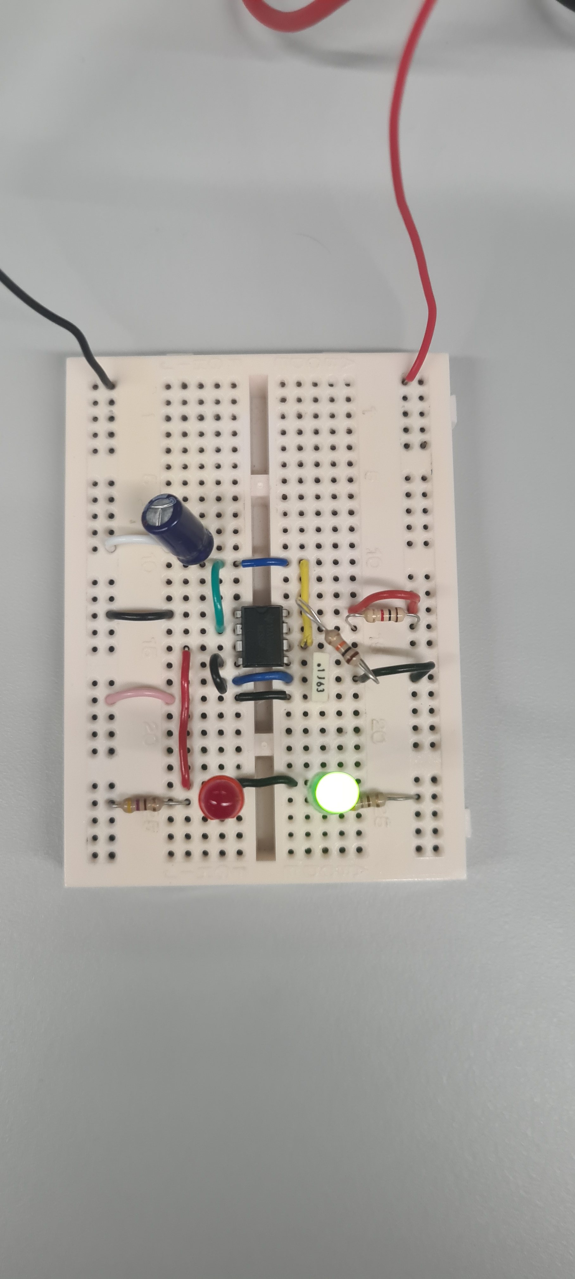
555 timer circuit build and Testing
Figure 8- Breadboard Circuit (Green)
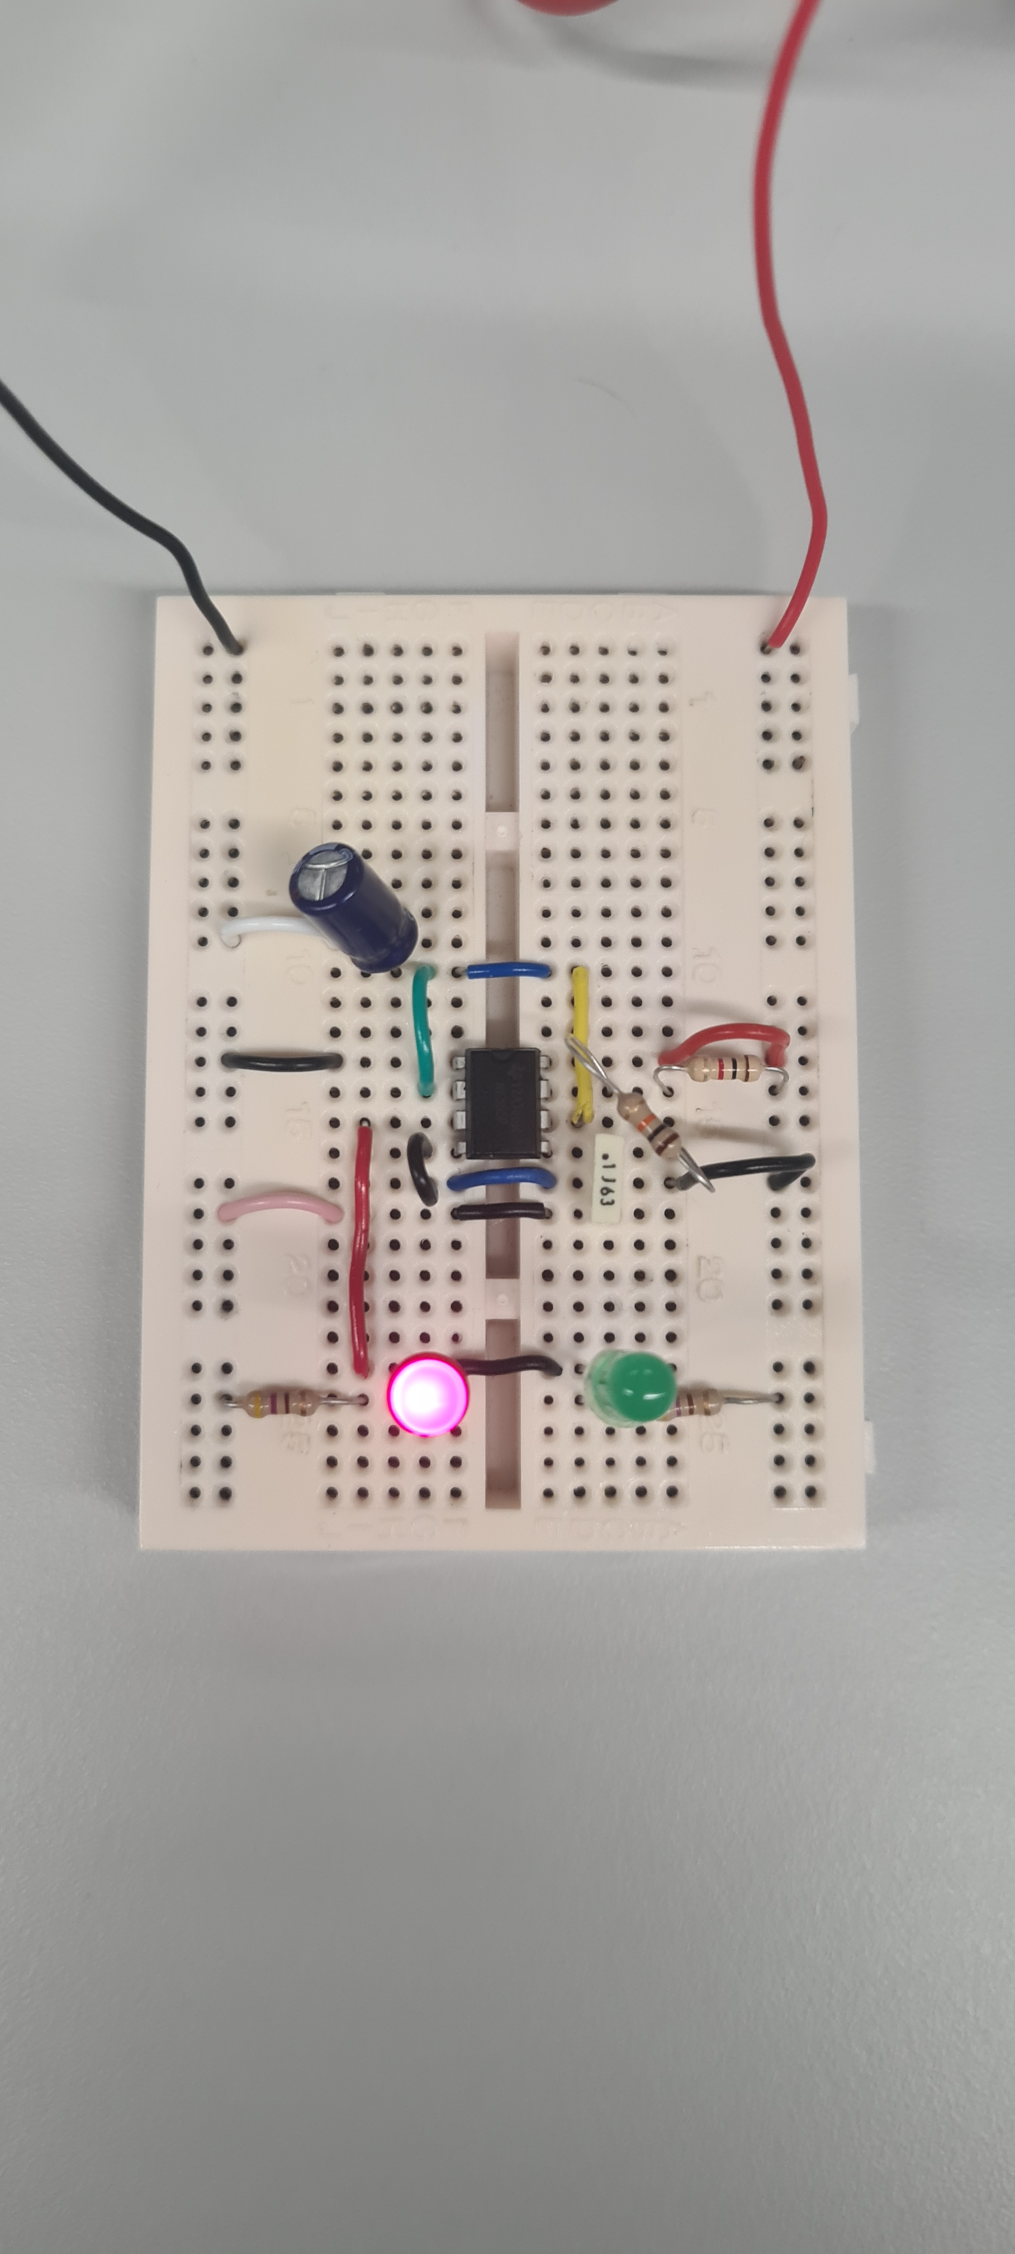
Figure 9- Breadboard Circuit (Red)
Breadboard is an easy way to temporarily connect electrical components together for testing and prototyping. The breadboard is used before mass producing a printed circuit board. Most breadboards work in the same way, you must connect the components and wires in the correct place to make the circuit work. This is normally done by pushing down the bare metal of the component or the wire into the specified hole on the board. Jumper wires are sometimes used if you can’t fit the component in the space you have available. Prior planning on paper of where the components and wires go is vital to increase efficiency and reduce wastage.
This astable 555 timer circuit consisted of one 555 Timer, four resistors, two capacitors and two LED’s and wire. With the Black and Red wire leaving the board to the power source. The circuit was built in an electronics lab with all the required components and tooling available. Using the paper breadboard schematic it made component placement much easier than it otherwise would have been. The first component to go down was the 555 timer as all other components revolved around this. It was then the other major components in the following order; Resistors, capacitors, LED’s. To make the circuit small bits of wire were used to connect the various components and pins together in the correct hole in the breadboard. Two final longer stripped wires were used to enable the breadboard to be connected to an external power supply.
This breadboard circuit was tested using a power supply connected to the longer stripped wires. The power supply was set at 9v with 0.2 Amps. Both the green and red LED flashed independently of each other as expected based on the Proteus software simulation.
In future if time allowed timing measurements from the breadboard should be taken to allow comparison to the Proteus software package. It is also possible to export graphs and data from oscilloscope to give you information on the output voltage against time. This will allow side by side comparison to Proteus. At this point refinements to the circuit can be made to improve the circuit and ensure the specification is met. Tolerances also need to be taken into account as some can be up to 5%. This would be detailed in the data sheet.

Conclusion
In conclusion, the 555 timer is an extremely popular electronic component due to cost and its relative versatility. This is just one application of when a 555 timer can be used but you will find these chips even in space.
Each component in the circuit has a desired function. This must be accurately added to Proteus to enable accurate simulation of the circuit. Calculations will need to be completed so that the values of the resistors and capacitors can be simulated. Proteus allows for probes to be placed to enable data to be extracted from the circuit and plotted on a graph.
The manual calculations completed can also be verified on Proteus, the figures given on the software will likely be different to those calculated. The data sheet with each component will need to be reviewed to ensure the component is being used within its parameters. The data gathered using the Proteus simulation software allows comparison between circuits to ensure you’re getting the most out of the circuit. It is a lot cheaper and easier to test and adjust early on in the design process rather than when something has been manufactured.
The 555 timer circuit was built on breadboard and consisted of one 555 Timer, four resistors, two capacitors and two LED’s. This breadboard was then tested whilst connected to a power supply and compared to the Proteus simulation. In future further comparison between the results from the breadboard and Proteus should be completed.

Figures
Figure 1- Assignment Brief Schematic [1] 0
Figure 2- Assignment Brief Schematic 2
Figure 3- NE555N Timer [6] 3
Figure 4- 555 Timer Schematic [3] 3
Figure 5- Proteus Circuit Schematic 3
Figure 6- 3Hz Waveform [3] 4
Figure 7- 555 Timer Output voltage/ Capacitor Output Voltage 5
Figure 8- Breadboard Circuit (Green) 6
Figure 9- Breadboard Circuit (Red) 6

References

[1] | S. Mosey, Circuit Build- Fundamentals of Electrical and Electronic Systems, UWTSD, 2022.
[2] | H. Camenzind, Interviewee, THE 555 TIMER IC, An interview with Hans Camenzind. [Interview]. June 2004.
[3] | Microcontrollerslab, "In-Depth 555 timer IC complete guide," [Online]. Available: https://microcontrollerslab.com/555-timer-modes-circuit-diagram/. [Accessed January 2023].
[4] | The Editors of Encyclopaedia Britannica, "Ohm's Law," 21 Nov 2022. [Online]. Available: https://www.britannica.com/science/Ohms-law. [Accessed January 2023].
[5] | FLUKE, "What is frequency?," [Online]. Available: https://www.fluke.com/en-gb/learn/blog/electrical/what-is-frequency#:~:text=Frequency%20is%20the%20rate%20at,to%201%20cycle%20per%20second.. [Accessed January 2023].
[6] | Stefan506, "Signetics NE555N," [Online]. Available: https://commons.wikimedia.org/wiki/File:Signetics_NE555N.JPG. [Accessed January 2023].

