Assessment 1

Marketing Fundamentals
MODULE CODE: LCBB4004

Blogging to Communicate
Waitrose & Partners

University of Wales Trinity Saint David

Name of Student: Maria Hagiu
Student’s ID: 2024157
January 2022
Table of Contents
Introduction 3
Analysis and Discussion 4
Developing blog post to ensure communication with the target audience 4
STP analysis 6
SWOT analysis 7
Recommendations 9
Conclusion 10
Reference 11

Introduction
Marketing is the way to develop the relationship with the customers that helps to enhance the value to the customers as well. Communication becomes more effective through the marketing that catches each and every customers and their position. This report is prepared to develop the communication with the customers through the blog post. The Waitrose is taken to prepare the report which is incorporated in the supermarket in UK.

Analysis and Discussion

Developing blog post to ensure communication with the target audience
Executive Summary
The blog has been created in order to attract the target audience of the Waitrose, is based on the supermarket. This blog is used to do marketing that generally intensify the growth of the business (Padmanabhan and Png, 2004). This is kind of written statement that helps to share the thoughts that bears the depth explanation of anything that wants to express by which clients and the business both are got benefited. Here, the Waitrose does blog regarding their fresh organic food market, has a unique brand named Waitrose Duchy Organic, to catch the large market. The motive of Waitrose Duchy Organic is to introduce its chain value in the market by the essential products that will make the organisation less risky as well.
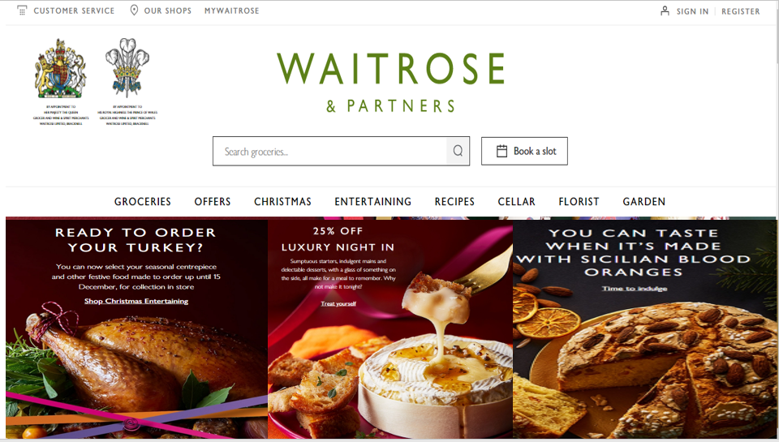
Figure: Website of Waitrose regarding the Waitrose Duchy Organic
‘The blog post’
‘Come to the Waitrose and weight your food according to your best choice would make you healthy and price sensitive. Grabbing the opportunities would make you feel better in your purchase that could have been less in others. Go and Run!’
Marketing Mix of Waitrose
Influential factors are considering that makes the differences while targeting the audience and encourage them to place the order. Below is the illustration of the marketing mix on the Waitrose that would help the company to grab more opportunities and customers.
Product: Products of Waitrose are always good due to focusing on the competitor’s steps that make them updated which sometimes varies due to the taste of the customers (Harutyunyan and Jiang, 2019). In the meantime, supply chain of Waitrose plays an important role that puts the food organic. They focus on the extremely short maturity that helps the customers feel that their products are fresh and organic.
Price: Identical prices are followed at the Waitrose that makes the prices fixed considering the competitors (Suveg, 2019). But their prices sometimes vary considering the size and position of the stores. But, in the case of the Waitrose Duchy Organic, Waitrose follows the discount pricing in order to enhance the product availability. More customers will be attracted because of the discount pricing. In addition, the customers who are from the middle class would be under the coverage of the Waitrose as the product’s price is in their availability. The preference of the customers would be high that will maximise the profitability tremendously.
Promotion: Taking the promotional activities by Waitrose for enhancing the customer base increases their sales well (Akhter et al., 2014). Waitrose generally considers the social media in order to promote their products as it has wide range and large number of customers. The wide range of audience is the main target of the promotion that also helps to beat the competitors and increase the reach of the brand. Moreover, Waitrose takes variation in their promotional activities to stimulate the customers switching to own brand. Customers who know the products and their benefits generally get attracted with the products in order to purchase.
Place: Central places are focused by the Waitrose that because of having the competitive advantages in shopping facilities (Harutyunyan and Jiang, 2017). Their products are prices vary according to the size and region of the stores that make the differences as well. But, their shop sizes are usually small as they focus on the central area where the demand is too high. For that reason, they have planned to build the stores out of the town in order to expand their business as well as make their stores large to increase the capacity by which they can meet the large number of demand up.

STP analysis
The Waitrose can examine the products that they are offering to their specific customers and communicate the advantage of these to the customers by the STP analysis. The analysis of STP is stated below-
Market Segmentation
Needs of the products vary according to the need of the people that are generally done with some common characteristics (Jang and Lee, 2018). That why organisation uses to the STP analysis to communicate with their customers which easy as they can segment their customers considering the demand and other variables. Some approaches are followed to segment the customers that helps the organisation to do the communication process effectively, are illustrated below-
Demographic: Waitrose’s Organic food isn’t good for all types of customers that because of having some complexities in age, gender, education and occupation differences. The food allows only for the people who belong to the 18-35 ages. The people who are from there will be able to purchase the products are required to communicate by the Waitrose company.
Geographic: Waitrose Organic food is only for the people of UK as their motive is to provide the fresh food to the people (O’Dowd, 2013). Informing the people would be more beneficial as the customers always demand the fresh food that will impressed them to purchase the products.
Psychologist: As the products of Waitrose are food and premium so the people who are from good personality and have high values in the society would need to be communicated.
Behavioural: Waitrose must inform the benefits of the organic food to the customers through communicating them that will help to make impressed with the organisation to purchase the products.
Targeting
The segmented customers would need to target which has been done in the targeting section that helps the organisation to make any legal and important decision regarding the operations (Moffat, Collins and Carson, 2017). This targeting can be done by Waitrose where there have some criteria are the profitability, size and growth. The Waitrose must focus on the size of the market and the potentiality of the growth of the market. In that case, Waitrose has a benefit regarding the market as the organic food market is growing among the people of 18-35. The organisation must focus on the targeted aged people and gets connected with them so that the organisation can identify the demand and take necessary steps to meet the demand up. Moreover, the organisation should also consider the aged people that because of having concern regarding their health would be benefited by taking organic food will make the market growing.
Positioning
Identifying the demand of the targeted group, the Waitrose must take position so that they can make the customer valuable in their organisation (Morisada, Miwa and Dahana, 2019). Waitrose must make reason so that the customers get impressed regarding their products. Taking good position and unique selling proposition must be considered by the Waitrose in order to take competitive advantage over the competitors. Taking the position according to the segmentation can be done through effective communication and positioning map make the communication activities efficient. This communication reduces the problems as well related to the products by which value proposition has been done so easily. These all help to make the products of Waitrose competitive over the competitors of the market.

SWOT analysis
The effectiveness of the plan would be analysed through the SWOT that also helps to analyse the business environment. The analysis of SWOT based on the Waitrose is illustrated below-
Strengths: Waitrose has good brand value in the market that helps to get connected with the customers by which communication stays strong (BOZOKLU, 2018). Advertising strategy of Waitrose is strong enough among the people that builds the communication strong. Moreover, sponsoring the English Cricket Team by Waitrose builds the identify across the world that is good for communication activities as well.
Weaknesses: Intense competition regarding the prices demolishes the position of the Waitrose that also reduces the margin of the company. The capital of the company reduces which creates hindrance in developing the plan. Backlash of article which is published in the social media demolishes the reputation as the advertising is mostly done in the social media.
Opportunities: Organic food is demanded mostly in nowadays due to the Covid-19. In the meantime, ‘community matters’ campaign launched by the Waitrose increases the publicity of the company by which their market is growing.
Threats: Due to high competition, position of the company is decreasing that becomes the burden for the company to establish the plan (Crane, 2005). Moreover, Covid-19 makes the economy poor that hurts the business of Waitrose.

Recommendations
In order to make the operations and communication effective, the following steps should be considered by the Waitrose.
- The quality of the products should be high as the people are demanding for good food due to the Covid-19.
- The price of the products must be competitive so that the Waitrose can take advantage over the competitors (Camillo and Di Pietro, 2014).
- The placing of the order should be easy and convenient so that the customers get helped while placing orders from the websites.
- The targeted customers should be considered effectively so that they always create a bonding with the organisation which will build the communication long-lasting.
- The article in the social media should be eye-catching so that the customers get impressed which will enforce them to purchase the products.
- Overall the organisation should have good promotional activities because these help to build a good communication with the customers and get connected with them.

Conclusion
To conclude the report, it can be said that the promotional activities should be good in order to build a communication which is also helped by the blog post as the customers get impressed through the blog post. Enthusiastic writing and convenient approach should be implemented by the Waitrose so that the customers get connected with the organisation which will activate the communication.

Reference
Akhter, S., Rizwan, M., Shujaat, S. and Durrani, Z. (2014). The impact of retail shoes sales promotional activities on ladies’ purchase intentions. Journal of Public Administration and Governance, 4(2), p.166.
BOZOKLU, Ç.P. (2018). EMPLOYER BRAND IMAGE DEPENDING ON STAKEHOLDERS’ MATERIAL VALUE TENDENCY: COMMUNICATION MARKET IN TURKEY. Business & Management Studies: An International Journal, 6(3).
Camillo, A.A. and Di Pietro, L. (2014). Creating Competitive Advantage for Calabrian-Made Products: The Influences of Culture and Price Perception. Journal of Food Products Marketing, 21(1), pp.44–67.
Crane, A. (2005). In the company of spies: When competitive intelligence gathering becomes industrial espionage. Business Horizons, 48(3), pp.233–240.
Harutyunyan, M. and Jiang, B. (2017). Strategic Implications of Keeping Product Value Secret from Competitor’s Customers. Journal of Retailing, 93(3), pp.382–399.
Jang, J. and Lee, Y. (2018). An Analysis of Empowerment Perception and Needs According to Individual Characteristics of Forest Interpreters. Journal of People, Plants, and Environment, 21(2), pp.167–183.
Madhani, P.M. (2020). Customer-focused supply chain strategy: developing 4Rs framework for enhancing competitive advantages. International Journal of Services and Operations Management, 36(4), p.505.
Moffat, D., Collins, D. and Carson, H.J. (2017). Target Versus Ball Focused Aiming When Putting: What Has Been Done and What Has Been Missed. International Journal of Golf Science, 6(1), pp.35–55.
Morisada, M., Miwa, Y. and Dahana, W.D. (2019). Identifying valuable customer segments in online fashion markets: An implication for customer tier programs. Electronic Commerce Research and Applications, 33, p.100822.
O’Dowd, A. (2013). Half a million people using food banks in UK as food poverty grows. BMJ, 346(may31 4), pp.f3578–f3578.
Padmanabhan, V. and Png, I.P.L. (2004). Reply to “Do Returns Policies Intensify Retail Competition?” Marketing Science, 23(4), pp.614–618.
Suveg, M. (2019). Does the Number of Competitors Affect Producer Prices? Firm-Exit and Inflation During the Crisis. SSRN Electronic Journal.

