Business Plan of SI Accounting
Mst. Shalma Pervin
Prepared for: Melanie Squire
Date: 25/11/2021

Table of Contents
Business summary 2
Mission statement 2
Aim and objectives 2
Services offered 2
Business location 3
Human resource 3
Market analysis 4
Market segmentation 4
Marketing strategy 5
Financial resources 6
SWOT analysis 6
Forecasted cash flow 7
References 10

Business summary
SI Accounting is a completely new firm in the accounting industry. It will be a sole-proprietor firm, accounting and tax preparation service business run by Ms. ShalmaPervin in Cardiff, UK. ShalmaParvin will be the founder of SI Accounting and 100% ownership will be with her.
A sole proprietor firm is the one having only one owner. The reason for choosing this type of business is that it is easy to form, inexpensive to start, the owner has complete freedom to take his own decisions and there is no liability to any other individual such that in the partnership firm. Moreover, the profit also belongs entirely to one individual and the business activities in sole proprietorship helps in establishing the status of the firm (Tomo, Mangia&Canonico, 2021). Since SI Accounting will be a small business, hence sole proprietor is the most appropriate option for the business.

Mission statement
We intend to provide a complete financial package and accounting services while maintaining professionalism and integrity at the most affordable price

Aim and objectives
SI Accounting aims to launch the accounting line of services for small businesses, and new struggling businesses and assist them in bookkeeping, accounting reviews and compilations.
SI Accounting firm has set the following objectives:
- To help the small and medium sized businesses grow without having to worry about the legal assistance
- To enter into the training business within 6 months of existence
- To achieve a net profit of £ 50000 in 3 years
- To provide high quality services at the most competitive market price
- To create a team of highly concerned people

Services offered
The idea is to provide accounting services in Cardiff at highly competitive prices. The services that would be offered by the organisation includes reviews and compilations of the following:
Tax related services:
- Preparing the taxes
- Tax planning
- Addressing problems such as audit representations, payroll problems, and bankruptcy
Accounting services:
- Assisting the businesses for their Audit plans
- Conducting detailed cost and margin analysis
- Assisting the firms for financial projection
- Establishing credit card processing
Book keeping services:
- Account payable and receivable services
- Payroll processing
- Bank reconciliations
- Processing sales tax
- Inventory management
- Preparing the financial statements
- All types of other financial reporting
Training small businesses
- Financial trainings
- Technological skills training
- Leadership and soft skills training
- Negotiation

Business location
Accounting would operate on a small rented office at Cardiff City Centre which would have an enough room for a total of 3 to 4 employees. The premises of SI Accounting will not be used for any of the client’s meeting. Any meeting or discussion will be held at the client’s office. There will be limited resources required such as furniture, computer and other accessories. The office would be located at Mill Lane at Cardiff city centre. The minimum office rent is £2400 per annum. It is a very popular place with a lot of foot fall. The location is near to Cardiff Central Rail and is also close to bus station. For the start-up, this location is very ideal.
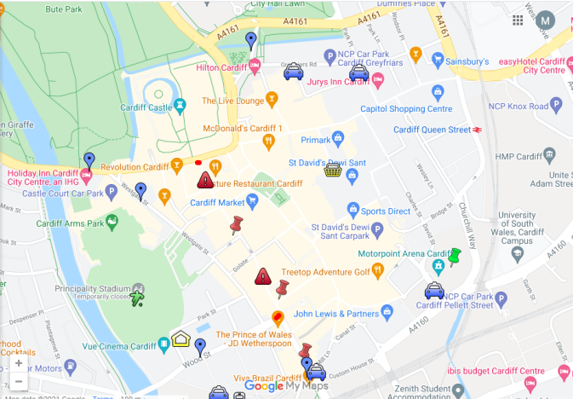

Human resource
SI Accounting will employee 3 employees in total. There will be an in-house book keeper who would be completely responsible for the client’s book keeping, oversight and management and would also be responsible for trainings in the relevant field. Each client will have a consistent book keeper who would be trained by ShalmaPervinwith proper techniques. Since the business will be newly established, the employees would be the students majoring in accounting and will be hired based on one professional and one educational recommendation.
In addition, there will also be a manager, who will supervise the audit and other services, will provide and assure quality, review all the clients, and the reports created by the book keepers so that they can assure that there is no mistake and everything is prepared correctly.
Both of these employees would be employed from university portal and the wage rate would be £ 9 / hour and it will be 5 days a week. Apart from the basic wage, the employees would be provided with bonuses as the project completes.
The third employee would be Ms. Shalma herself who would overlook the office, deal with the clients, generate sales and develop strategies.

Market analysis
SI Accounting is operating in the market of Cardiff, targeting small businesses and newly established firms. As the business grows, there is a need to seek help from the professionals with respect to tax-preparations, additional bookkeeping and also for all sorts of accounting services (Duff, 2018). Small businesses tend to outsource these services by hiring book keepers to manage their business (Ferry & Ahrens, 2021).
The market related to accounting services include firms providing expertise such as corporate accounting and auditing firms, the accounting for small businesses and then personal accounting. The market has many firms offering such services but there is skill a space to enter this industry and provide services (Huerta & Jensen, 2017).

Market segmentation
With the increase in the population of private sector businesses, Cardiff is the centre of the financial and business services accounting for more than 50000 jobs in the city. Cardiff is well known for the companies offering financial services and have contributed significantly to the economic growth, having a competitive business model and highly skilled workforce. The business by SI Accounting is divided into three groups/markets:
- Non-employer firms: having no employees, these non-employer firms do not face any such concerns such that of the larger businesses. however, the owners of these firms tend to be highly vigilant in protecting their own tax liability while sorting out all the personal and the tax return of the business. With the growth in their business, they clearly need professionals for their quick book services as well as tax preparation services (Boso et al., 2017).
- Very small businesses: The very small businesses are designed in a way that they tend to stay small and when they go through a growing phase, they require accounting services such as payroll and book keeping services as well as tax preparation services. These businesses are highly concerned about losing their control over the business. However, they are generally convinced to outsource their accounting and book keeping services along with cost analysis. With the high rate of stakes, these very small businesses could effectively use services related to management accounting, considering that they cannot afford a dedicated CFO. These businesses are such that they do not require a full-time book keeper and could possibly work with the part-time help (Gonçalves &Gaio, 2021).
- Other small businesses: these small businesses do have some financial management as well as book keeping help in their businesses. However, they do not core about what their business seeks to do, hence, they prefer to save money of in-house accountant and outsource these services to professionals. These small businesses might be comfortable with their situation as they generate business and produce cash for the owners and have the intention of growing and positioning themselves for higher sales (Gonçalves &Gaio, 2021).
The focus of SI Accounting Firm is to provide services to both the small and medium sized enterprises as well as fresh businesses into the market for its bookkeeping services. The primary target market is based on the three areas: established businesses at a small scale under 50 employees, existing businesses of more than 50 employees to 150 employees in any area of the industry and companies that have just launched their business and are looking for legal assistance in all segments of their businesses.

Marketing strategy
SI Accounting; a newly formed accounting business in Cardiff would implement several marketing tactics to be able to reach their target market of small and very small businesses. The marketing strategies would include:
- Social media and Website marketing
- Development of the brochure
- Periodic advertisement with the small business publication of Cardiff which would be tracked and determined in yielding clients and inquiries.
The first and most important type of marketing strategy implemented by SI Accounting would be social media and website marketing. This would supplement the business and reach the target audience within the region. Platforms such as Facebook, and LinkedIn would be used for social media marketing. On the other hand, the company will make a website and maintain their current tactics. There will be a focus on Google Adwords with a budget allocated per month to book keeping related keywords in Cardiff market online. In addition to that, the business will be listed on several databases and websites related to small business services and the book keeping and training services in Cardiff.
SI Accounting will hire marketing services firm to carry out the marketing services for the company as the company itself will not have proper expertise and time to execute these activities. These marketing messages of the company will focus more on the economic reasons of the decisions to outsource their book keepers from SI Accounting while providing all the advantages of the services with the experience of the owner.
Furthermore, one of the most important marketing tactics would encompass when the company will search for student book keepers. Whenever the job will be posted on different platforms such as local universities, it would create awareness about the business and would attract concerned people. This will also help the company to recruit the best possible student book keepers and the cost associated with the recruitment would be only one time.
The following is the business card and brochure made for the company.
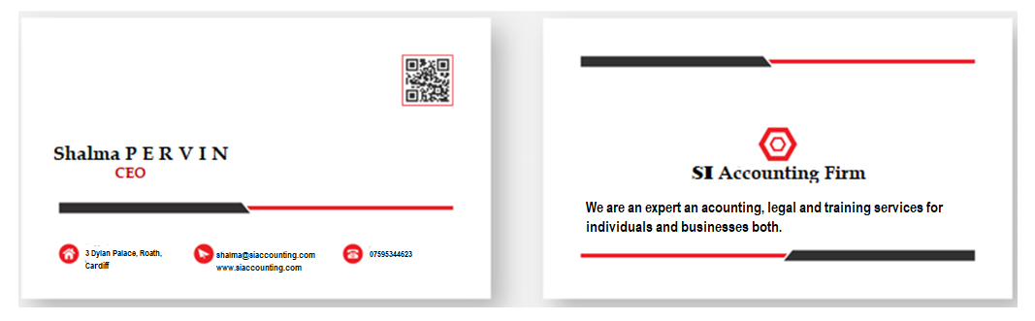

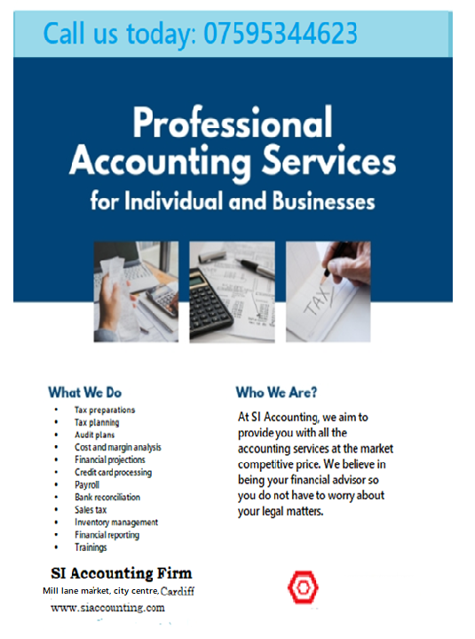

Financial resources
As SI Accounting is sole proprietor, the initial investment will be done by the owner Ms. Shalma Parvin. There is no need of any outside investment as the new business is not capital intensive. There will be a fixed cost incurred in the business which will be covered within the few months of start-up. It is expected that the company will receive at least 5 clients in the first month of business for their book keeping services. There will be initial investment of £ 5000 which would cover the office expenses and marketing expenses.

SWOT analysis
Every business has certain strengths, weaknesses, opportunities and costs. These aspects affect the overall performance and outcome of the business. Similarly, SI Accounting also has strengths, weaknesses, opportunities and threats which are detailed below:
Strengths
The changing economy and the government laws have affected all the businesses in the economy especially the small business owners. In such situations, these businesses tend to need advice and expertise to prepare their taxes and their financial statements. This reflects increasing demand of the financial services which is the biggest strength of this business. Secondly, the owner of SI Accounting has a great experience in this industry. The business is targeting small and newly established business at a very competitive price which is another strength of the business. The diversified options of services would prove to be a great source of revenue for the company. In addition, the cost of starting this business is relatively low which is yet another strength of the business.
Weaknesses
The biggest weakness is the substantial competitive threats to the business. Since the start-up cost is low, more people tend to do this business and provide accounting services to the people. However, since this company is focusing on a different segment, and have highly competitive prices, this could be avoided considering that the firms have enrolled book keepers who have complete knowledge and are working at competitive prices.
Opportunities
There are several opportunities for SI Accounting as they start this business. Firstly, the company will be able to generate higher sources of revenues by providing extensive services at a lower price. The sale of audit services including audit insurance in the near future would prove to be a great opportunity for them to cater this niche. Having the aim of entering the training industry would allow them to capture a different segment which would prove to be highly profitable. In he near future, the company can also expand to other cities and can also expand via acquisition of other firms in the same industry.
Threats
The threats of accounting firm are minimal. However, the threats occur in case of any mistake by the employees due to the complexity of law. However, an expert would make sure there are no errors and this is one of the reason this industry is high in demand. In addition to that, it can be expected that the regulatory environment does not change frequently and hence there is less complexity. The only threat that SI Accounting will face will be from the other firms operating in the same capacity.
Strengths  - High demand  - Price penetration  - Low start-up cost  - Diversified services | Weaknesses  - Competitive threats  - Low start-up cost
Opportunities  - Sale of audit insurance services  - Expansion to other cities  - Training industry | Threats  - Mistake of employees  - Sudden change in regulatory environment  - Firms operating in the same capacity

Forecasted cash flow
The business start up will be taken from the initial investment of the owner in current cash reserves. The business needs to pay for the set-up cost and the marketing expenses for the services to be provided. It would also incur the cost of recruitment and the other expenses to be paid initially. It is expected that the business will return to a positive cash flow during the second quarter of the year. The book keepers who would be hired would be positioned on paying jobs and this would further lower the risk of the new business with respect to the cost related to book keeping manager and marketing. It is also expected that the company will be able to have good cash reserves in the future years. The following represents the projected cash flow of SI Accounting for the year 2022.

Pro forma cash flow | 2022
Pro forma cash flow | Amount in £
 | January | February | March | April | May | June | July | Aug | September | October | November | December
Cash invested/ received | 5000
Balance b/f |  | 1000 | 23000 | 37000 | 47000 | 60000 | 61000 | 57000 | 48000 | 52000 | 74000 | 90000
Cash from operations
Cash sales | 50000 | 52000 | 50000 | 48000 | 60000 | 40000 | 35000 | 30000 | 50000 | 70000 | 65000 | 60000
Cash from receivables | 0 | 0 | 0 | 0 | 0 | 0 | 0 | 0 | 0 | 0 | 0 | 0
Total cash from operation | 50000 | 52000 | 50000 | 48000 | 60000 | 40000 | 35000 | 30000 | 50000 | 70000 | 65000 | 60000
cash spending | -10000 | -11000 | -13000 | -14000 | -18000 | -15000 | -15000 | -15000 | -20000 | -22000 | -22000 | -22000
Rent | -1000 | 1000 | -1000 | -1000 | -1000 | -1000 | -1000 | -1000 | -1000 | -1000 | -1000 | -1000
Bills and wages | -20000 | -20000 | -22000 | -23000 | -28000 | -25000 | -23000 | -23000 | -25000 | -25000 | -26000 | -26000
Net cash from operations | 20000 | 21000 | 14000 | 10000 | 13000 | 1000 | -4000 | -9000 | 4000 | 22000 | 16000 | 11000
Cash flow from investment
Cash received from sale of property or equipment | 0 | 0 | 0 | 0 | 0 | 0 | 0 | 0 | 0 | 0 | 0 | 0
Cash paid to purchase additional equipment | 5000 | 0 | 0 | 0 | 0 | 0 | 0 | 0 | 0 | 0 | 0 | 0
Net cash flow from investment | 15000 | 21000 | 14000 | 10000 | 13000 | 1000 | -4000 | -9000 | 4000 | 22000 | 16000 | 11000
Cash flow from financing | 5000 | 0 | 0 | 0 | 0 | 0 | 0 | 0 | 0 | 0 | 0 | 0
Purchase of assets | 0 | 0 | 0 | 0 | 0 | 0 | 0 | 0 | 0 | 0 | 0 | 0
Dividends | 0 | 0 | 0 | 0 | 0 | 0 | 0 | 0 | 0 | 0 | 0 | 0
Long term liabilities | 0 | 0 | 0 | 0 | 0 | 0 | 0 | 0 | 0 | 0 | 0 | 0
Net cash flow | 20000 | 21000 | 14000 | 10000 | 13000 | 1000 | -4000 | -9000 | 4000 | 22000 | 16000 | 11000
Cash balance | 1000 | 23000 | 37000 | 47000 | 60000 | 61000 | 57000 | 48000 | 52000 | 74000 | 90000 | 101000

References
Boso, N., Donbesuur, F., Bendega, T., Annan, J. and Adeola, O., 2017. Does organizational creativity always drive market performance?. Psychology & Marketing, 34(11), pp.1004-1015.
Duff, A., 2018. Intellectual capital disclosure: evidence from UK accounting firms. Journal of Intellectual Capital.
Ferry, L. and Ahrens, T., 2021. The future of the regulatory space in local government audit: A comparative study of the four countries of the United Kingdom. Financial Accountability & Management.
Gill, L., McCarthy, V. and Grimmett, D., 2019. Voice of the customer: Creating client centered cultures in accounting firms for retaining clients and increasing profitability. Journal of Accounting, Business and Management, 26(2), pp.46-58.
Gonçalves, T. and Gaio, C., 2021. The role of management accounting systems in global value strategies. Journal of Business Research, 124, pp.603-609.
Huerta, E. and Jensen, S., 2017. An accounting information systems perspective on data analytics and Big Data. Journal of information systems, 31(3), pp.101-114.
Ishaque, M., 2021. Managing conflict of interests in professional accounting firms: a research synthesis. Journal of Business Ethics, 169(3), pp.537-555.
Lagat, C. and Frankwick, G.L., 2017. Marketing capability, marketing strategy implementation and performance in small firms. Journal for Global Business Advancement, 10(3), pp.327-345.
Tomo, A., Mangia, G. and Canonico, P., 2021. Innovating processes and processing innovation: strategic approach to innovation in accounting firms. Journal of Economic and Administrative Sciences.

