My digital portfolio.
By Jayden Nicholas

Here are some of the tasks I have completed while on my digital skills journey.

I was awarded a digital helper badge by my lecturer. This meant it was my duty to help my classmates if they were struggling to understand the task. I also helped show them easier ways to navigate through their digital devices.
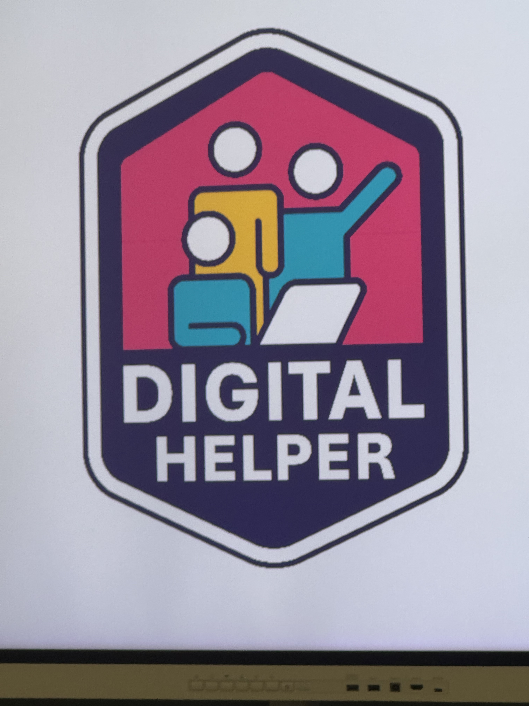
I used the Canva tool to help me with my second assignment. The task was to create a digital artefact for a business and I found this task very easy. I used ai to generate an image of students smiling the pasted that onto a blank canvas. I then changed the colour of the canvas background and added large shapes and relevant text.
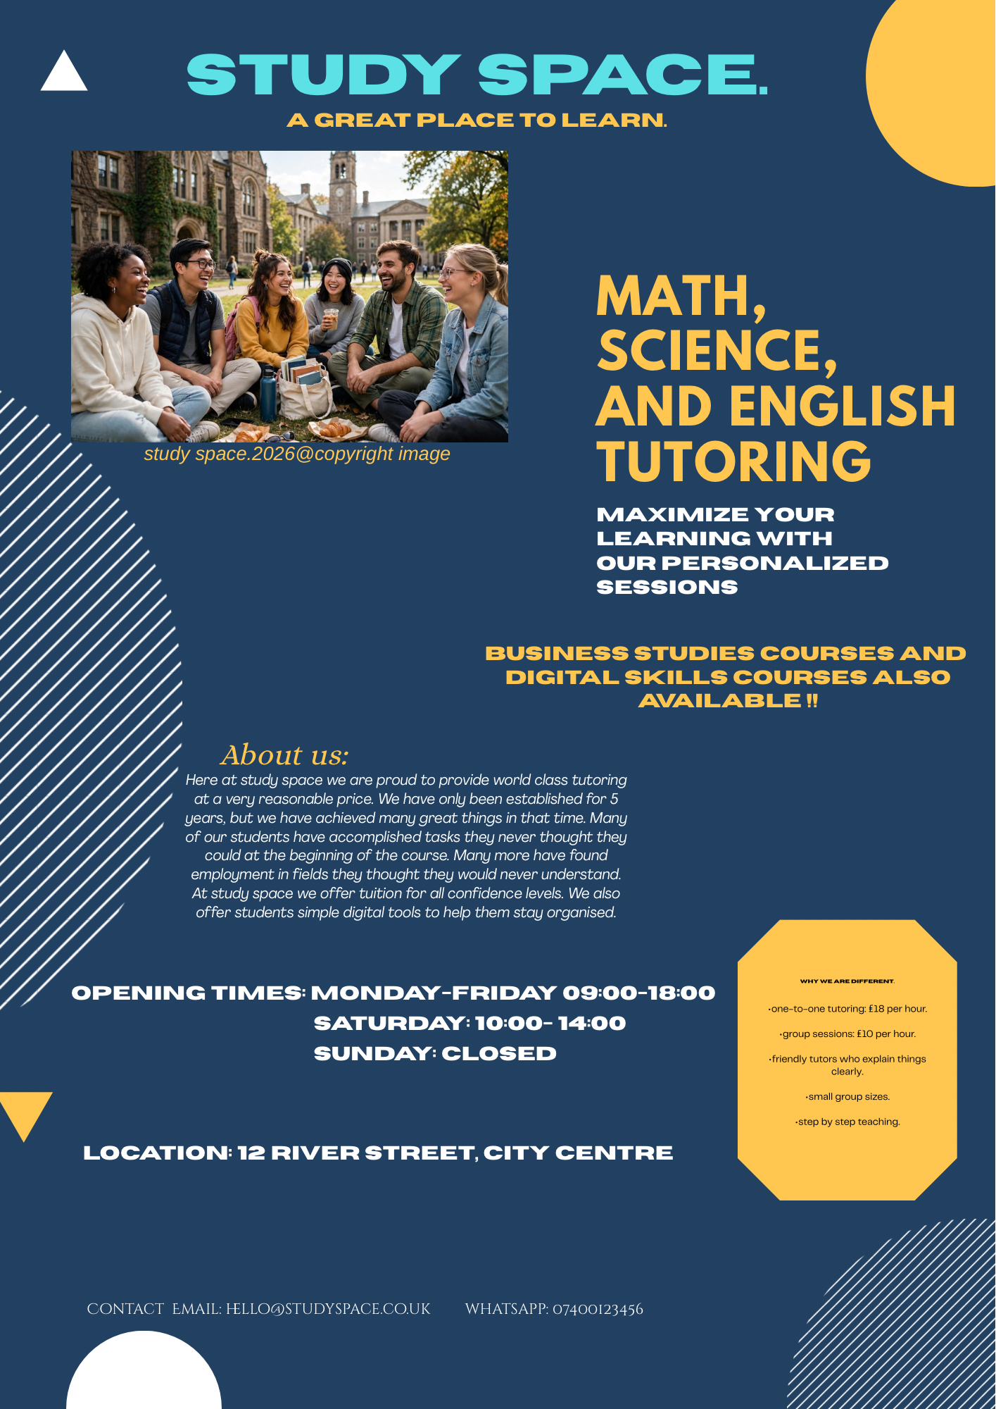
My last skill I would like to share is the skill of being able to navigate moodle efficiently (library, modules etc.)and complete all these tasks on my phone. I have also taught myself new techniques because of this course. Finally, Reviewing text and writing comments helped me massively when I was writing my assignment logs.
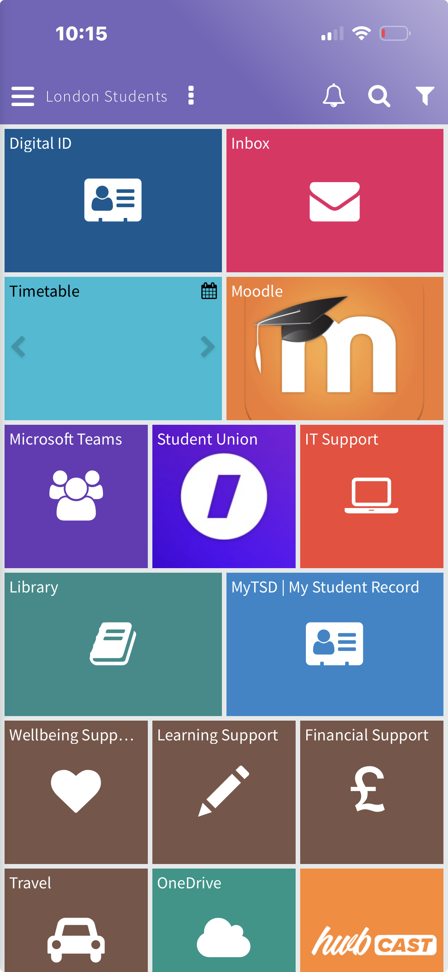
A screenshot of the moodle homepage and the apps I have learned to use because of this module.

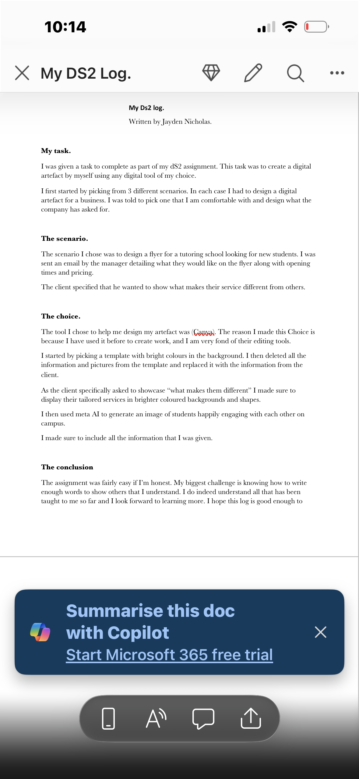
A screenshot of my finished dS2 assignment where I used my newly learned skills.

