

Programme: Master of Business Administration
Module: Strategic Management
Module Code: LCMB7003

Lifebuoy in India: A Strategic Management Assessment of
Hindustan Unilever's Personal Wash Business

Student Name: Jainil Kanubhai Patel
Student ID: 2519957
Group: 3

Lecturer: Amare Desta & Ghulam Mujtaba

Table of Contents
Table of Contents 1
Section 1: Strategic Analysis of Lifebuoy (Hindustan Unilever) in India 1
1. Organisational Context and Overview 1
2. External and Internal Analysis 1
2.1 PESTEL Analysis 1
2.2 VRIO Analysis 1
2.3 SWOT Synthesis 1
3. Comprehensive and Holistic View of the Organisation 1
3.1 CSR Strategy and Its Alignment with Business Objectives 1
3.2 Balanced Scorecard 1
4. Strategic Choices and Implementation 1
4.1 Business-Level Strategic Choice 1
4.2 Validating the Choice: Porter's Five Forces 1
4.3 Recommended Strategy 1
4.4 Implementation Challenges and Mitigation 1
Section 2: Reflective Account 1
Description 1
Feelings 1
Evaluation 1
Analysis 1
Conclusion 1
Action Plan 1
References 1

Section 1: Strategic Analysis of Lifebuoy (Hindustan Unilever) in India
This section provides a strategic analysis of Lifebuoy in India, a developing nation.

1. Organisational Context and Overview
Hindustan Unilever Limited (HUL) is the largest fast-moving consumer goods (FMCG) company in India, and is a subsidiary of the British company Unilever plc. HUL has a portfolio of over 50 brands across 16 categories, with 19 individual brands recording a turnover of over ₹1,000 crore annually, and a consolidated revenue of ₹66,052 crore against a profit of ₹14,971 crore (Screener.in, 2026).
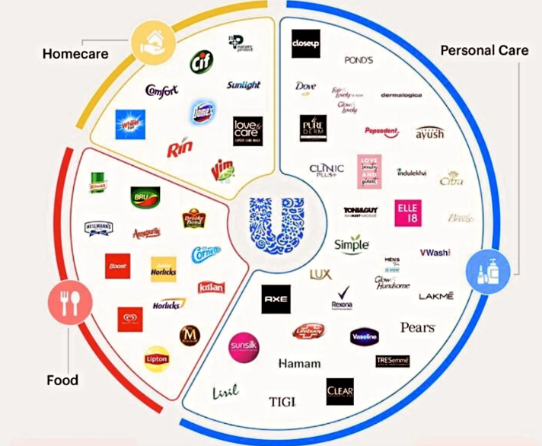
Figure 1 Brand Owned by HUL
This report is limited to only Lifebuoy, the HUL personal-wash brand, with a focus on the 'germ protection' segment.
Lifebuoy was introduced in the United Kingdom in 1894 as a carbolic soap and entered the Indian market in the 1930s. In 2002, the brand was significantly repositioned on a health and hygiene proposition, taking it away from its former carbolic legacy and shifting it to an active "germ protection" platform (Indpaedia, n.d.). The report focuses on India, the brand's founding market and Lifebuoy's largest, rather than the 40+ countries in which Lifebuoy is active, for two reasons. India was Lifebuoy's first and biggest market, and its rural handwashing behaviour-change programme (Section 3, examined critically) is the most strategically distinctive activity undertaken by the brand; it is not replicable at a comparable scale in other countries and so cannot be meaningfully assessed at a global level.
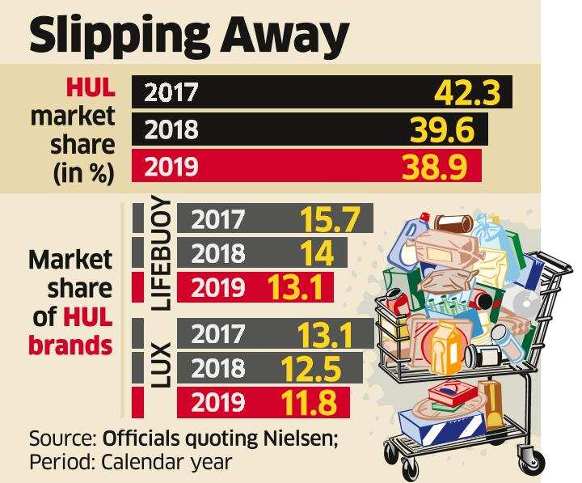
Figure 2 Lifebuoy Dominance
HUL's business is defined as a high-volume, distribution-intensive FMCG business, where the overwhelming part of profitability is attributed to reach of routes as compared to per-unit margin. The Beauty & Personal Care segment (which includes Lifebuoy) accounted for 36% of group revenue during H1 FY25 and increased by 15% on a volume-led basis during FY22–24 (HUL segment data, 2025). The most recent evidence of HUL's regional portfolio differentiation strategy comes from its deliberate "restaging" of its hygiene business in FY2024–25, which included the reformulation of both Lux and Lifebuoy with new "Stratos" technology, suggesting that the company considers Lifebuoy's competitive position to call for active intervention more than passive defence.
The Indian soap industry is extremely competitive and volatile. HUL/Lifebuoy has typically enjoyed a strong market share in toilet soap, but this has declined precipitously (Indianmirror, n.d.). Other key competitors include Santoor by Wipro Consumer Care, Dettol by Reckitt, Cinthol by Godrej, and Patanjali in the natural/herbal segment (Expert Market Research, 2024). According to Nielsen survey data for January–March 2019, Lifebuoy held 13.7% value share in comparison to Lux (12%) and Santoor (9.3%) (Indpaedia, n.d.). As of early 2026, however, industry sources indicated this was shifting: Lifebuoy was reported to be at 12.1%, as opposed to Lux at 12.2%, with Wipro claiming that Santoor had generated ₹2,850 crore in revenue in 2025, overtaking Lifebuoy to become India's largest soap brand by value a claim that HUL contests on methodological grounds, arguing that it uses multiple data sources (India.com, 2026). This is a live, competition-driven market-share battle, and it is the strategic issue that this report addresses.

2. External and Internal Analysis

2.1 PESTEL Analysis

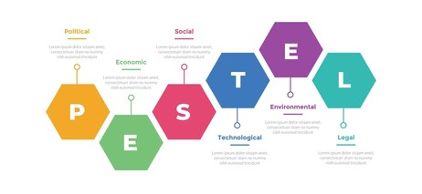
Figure: 3 PESTEL Analysis

PESTEL Element | Critical Analysis
Political | Lifebuoy's hygiene mission is clearly linked to government policy; HUL's former CEO, Sanjiv Mehta, stated that more than 90% of Indian households use an HUL product (India Education Diary, 2017). This is a real opportunity, but it also poses a risk of political dependency: proximity to a government campaign that could be funded differently or reprioritised implies that some of Lifebuoy's health-position legitimacy is borrowed rather than independently earned.
Economic | Economic development and India's large rural population are driving category growth. According to one industry analysis, by 2025 the Indian rural market will be worth in excess of USD 100 billion (Academia.edu, 2022), and more than 40% of consumption in some categories, such as personal care, is expected to occur in rural areas (Worldwide Journals, 2013). This is a clear opportunity, but growth in the rural market has also helped value-oriented competitors like Santoor and Patanjali to grow quickly in this case, the economic tailwind is on their side.
Social | India faces a significant public-health problem with the burden of hygiene-related disease more than 296,000 children under five years of age died due to diarrhoea and pneumonia in India in 2015 (India Education Diary, 2017). This social need is a key element of Lifebuoy's positioning and CSR programme; however, increased health literacy and hygiene awareness following the pandemic have reduced Lifebuoy's differentiation.
Technological | In addition to the digitisation of HUL's traditional rural distribution network, quick commerce (Blinkit, Zepto, Instamart-type platforms) is changing the landscape of FMCG distribution. This is an opportunity for HUL, given its resources, but a threat to Lifebuoy specifically, as digitally native, direct-to-consumer challenger brands can sidestep HUL's general-trade advantage.
Environmental | Unilever has made progress toward deforestation-free sourcing, a 50% virgin-plastic-reduction target by 2025 (Unilever plc, n.d.), and a commitment to collect and process more plastic than it sells by 2025 (Unilever plc, 2025). These commitments will enhance Lifebuoy's sustainability credentials, but will also increase operating costs and put the brand at risk if these targets are missed publicly.
Legal | Given Lifebuoy's explicit health claim of 'germ protection', the following are relevant: Bureau of Indian Standards (BIS) product norms, Legal Metrology labelling rules, and Advertising Standards Council of India (ASCI) rules on health claims. The prevalence of counterfeit soap in unorganised rural retail is another legal/enforcement challenge unique to Lifebuoy's mass-market, low-unit-price positioning.
Table 1: PESTEL analysis of Lifebuoy's market in India. Data compiled by the author from sources cited in the table.
Lifebuoy's strategic relevance is highest for the Economic and Social forces of the six PESTEL forces, as they enable category growth while also legitimising low-cost competitors. This is an important distinction from a purely descriptive PESTEL: the same macro-environmental trends that HUL reports as opportunities are present for Santoor and Patanjali too, at lower price points, so Lifebuoy cannot rely on macro-environmental tailwinds alone to defend share, as the VRIO analysis below will show.
The Political factor also requires a more critical reading than a superficial parallel allows. HUL's own framing of its hygiene mission as support for a national government campaign is strategically opportune, but it also leaves HUL with a degree of reputational dependency. Part of Lifebuoy's public-health legitimacy rests on the credibility of a political mission it is not responsible for, rather than on its own independent evidence; should the government's campaign be cut, delayed, or reshaped, the perceived authenticity of Lifebuoy's positioning is exposed. This is a materially different risk profile from a purely commercial hygiene claim that HUL could defend on its own evidence.
The same rural-growth thesis works in HUL's favour at group level, with Beauty & Personal Care, which includes Lifebuoy, accounting for 36% of HUL's revenue in H1 FY25 (HUL, 2025), while it also explains the rapid growth of value-tier competitors. Santoor's claimed share gains are most plausible during a period of input-cost inflation, since price-sensitive rural households are typically the first to "down-trade" to cheaper alternatives behaviour that is built explicitly into Santoor's positioning, rather than any claim of premium efficacy.
On the Environmental dimension, Unilever's group sustainability commitments are directly relevant to soap production, which uses significant water and packaging. Group data indicates that Unilever operates 21 water-stewardship programmes in water-stressed areas, and its Scope 1 and 2 greenhouse-gas emissions have fallen 72% against a 2015 baseline (Unilever plc, 2025). These commitments give Lifebuoy an opportunity to stake a claim to the natural/sustainability ground that Patanjali already occupies, but they also impose a cost burden that a price-led competitor does not carry reinforcing the "stuck in the middle" risk discussed critically in Section 4.

2.2 VRIO Analysis
Resource / Capability | V | R | I | O | Implication
Brand equity ("germ protection" positioning) | Yes | Yes | Weakening | Yes | Temporary not sustained advantage: see critical discussion below
Rural distribution network (general trade + Project Shakti) | Yes | Yes | Yes | Yes | Sustained competitive advantage
Core soap formulation / R&D (e.g. Stratos technology) | Yes | No | No | Yes | Competitive parity competitors can match the antibacterial claims
CSR / behaviour-change infrastructure (handwashing programmes) | Yes | Yes | Moderate | Yes | Moderate advantage increasingly imitated by competitors' own hygiene-education programmes
Parent-company (Unilever) scale, sourcing and sustainability infrastructure | Yes | Moderate | Yes | Yes | Sustained advantage at group level
Table 2: VRIO analysis of Lifebuoy's key resources, applying the framework developed by Barney (1991).
The biggest conclusion from the VRIO analysis is that Lifebuoy's brand equity, which previously satisfied Barney's (1991) full value–rarity–inimitability–organisation test, is now losing its strength on the inimitability dimension specifically. A resource generates sustained competitive advantage only when it is sufficiently costly for competitors to match overcoming the causal ambiguity or social complexity that the firm has built to the point that it is genuinely difficult to offer consumers the same value (Barney, 1991); as reported, that is precisely what has happened here, with the brand reportedly overtaken by a rival in value share in India (India.com, 2026). This is a more meaningful conclusion than simply labelling brand equity "rare and valuable": it shows that VRIO status is not a static resource but an attribute that must be continually maintained, and that in HUL's case, the company's organisational response (the "O" in VRIO) when and how to reformulate, price-pack architecture, and distribution intensity has likely been lagging the threat, not the underlying resource itself.
The distribution network resource is a more solid example of sustained advantage, and is worth quantifying rather than merely asserting: HUL's network of women micro-entrepreneurs (Project Shakti) is reported to serve some 3.3 million outlets nationally (academic case-study data on Project Shakti). This scale is, for all intents and purposes, difficult to duplicate in the short-to-medium term because it depends on relationship capital developed village-by-village over nearly 20 years precisely the type of resource Barney (1991) describes as hardest for a competitor to replicate. The benefit, however, is only realised when the resource is well organised the fourth VRIO criterion and HUL's under-investment in digitising this network, relative to its financial ambitions, suggests that the rarity and inimitability of this resource are not yet translating into the market-share protection the Balanced Scorecard in Section 3.2 would predict.
Barney's (1991) original formulation also highlights non-substitutability alongside value, rarity and inimitability: a resource offers no advantage if a strategically equivalent resource is accessible another way. The first-mover advantage that Lifebuoy built since launching Help a Child Reach 5 in 2010–2013 (see Section 3.1) has eroded over time, since other FMCG players such as Reckitt, Lifebuoy's competitor, through Dettol's own hygiene-education initiatives have launched broadly substitutable community health programmes.

2.3 SWOT Synthesis
STRENGTHS | WEAKNESSES
• Deep brand trust and a rural distribution network (general trade plus Project Shakti) that remains genuinely hard to replicate quickly.  • The R&D and sustainability scale of the parent company, Unilever, which is large-scale and difficult for competitors to replicate rapidly.  • A long-standing, CSR-linked reputation for hygiene credibility (Help a Child Reach 5, since 2013). | • A formulation and antibacterial claim now largely matched by competitors, leaving it indistinguishable from rivals.  • A high price point compared with competitors such as Santoor, increasingly difficult to justify to price-sensitive rural consumers.  • A slower organisational response to competitive threats than should be expected of an organised incumbent, per the VRIO analysis above.
OPPORTUNITIES | THREATS
• Continued rural market growth, projected to reach USD 100 billion by 2025 (Academia.edu, 2022).  • Premiumisation and category extension into liquid handwash and sanitiser.  • Quick-commerce as a new distribution channel. | • The aggressive value-for-money approach of Santoor and Patanjali.  • Counterfeit products in unorganised rural retail.  • Input-cost inflation squeezing margin at a time when price competitiveness is already under pressure.
Table: SWOT matrix for Lifebuoy in India.
These four quadrants can be read individually as a checklist; the more important exercise, in keeping with the module's focus on synthesis rather than description, is to cross-reference them. The most important Strength–Threat interaction is that HUL's distribution advantage (Strength) is currently necessary but not sufficient to out-compete Santoor for rural households (Threat): superior distribution strength will not translate into superior share if the product delivered through that network is priced above what rural households can currently pay for a comparable germ-protection claim. Similarly, the clearest Weakness–Opportunity tension is that Lifebuoy's price premium (Weakness) sits awkwardly against the fastest-growing part of the market rural India, projected to be worth USD 100 billion (Academia.edu, 2025) because that is precisely the price-sensitive segment least able to absorb the premium HUL is asking it to pay. This SWOT synthesis thus leads to the same conclusion as the VRIO analysis: Lifebuoy's strategic issue in 2025–26 is not that it lacks resources, but that it is misaligned with the segment driving most of the category's growth.

3. Comprehensive and Holistic View of the Organisation

3.1 CSR Strategy and Its Alignment with Business Objectives
Lifebuoy's principal CSR programme is 'Help a Child Reach 5', which started in 2013 in the village of Thesgora, Madhya Pradesh, where the incidence of child diarrhoea was one of the highest ever recorded in India. An evaluation of the intervention by Nielsen, commissioned by the project, showed that the incidence of diarrhoea in the village dropped from 36% to about 5% (CSRWire, n.d.). The programme expanded to 17 countries (Sustainable Brands, 2013), and by early 2014 it was reported to have impacted 183 million people across 14 countries (CSRWire, n.d.). This is a textbook example of "reconceiving products and markets" (Porter and Kramer, 2011): HUL is not simply giving money to a cause it is not directly responsible for, but making a direct investment in the behaviour handwashing that its core product exists to enable, strengthening Lifebuoy's brand equity around germ protection while genuinely helping to reduce the risk of child death.
In 2017, the programme was extended through a partnership with the World Association of Girl Guides and Girl Scouts, reported to have trained young women as "handwashing heroes" who reached over four million people (India Education Diary, 2017). Help a Child Reach 5 fits best into this first pillar alone reconceiving products and markets since it is essentially a demand-generation and trust-building exercise for an existing product, rather than a redesign of HUL's value chain or an investment in an industry cluster surrounding HUL. This is a more precise and critical description of the programme than simply calling it "good CSR", since it addresses the question of whether soap should be used at all which supports category growth generally but not the more specific question of why a customer should choose Lifebuoy over a competitor once already in the market.
A critical reading, however, should go further than accepting this alignment at face value. The headline impact statistics the 36%-to-5% diarrhoea reduction are not the result of an independently peer-reviewed public-health study, but are instead provided by Unilever itself, distributed through a press-release service (CSRWire, n.d.), and should be understood as brand-validated rather than externally audited evidence a distinction the report itself should make, rather than asserting the number as an independent fact. Second, and more significantly for a strategic analysis, the CSR programme has been in place since 2010–2013, yet Lifebuoy's market position has deteriorated over almost exactly the same period, culminating in Santoor's reported overtaking of Lifebuoy by value in 2025–26 (India.com, 2026). This timeline is a genuinely critical finding: it suggests that CSR investment, however socially valuable, has not been sufficient on its own to defend commercial market share against price-focused rivals. CSR appears to have sustained brand trust without preventing brand switching on price a significant distinction for the Board to understand, rather than assuming that CSR automatically translates into commercial protection. The strategic implication is that the Board should treat CSR as a category-growth and reputational investment, rather than a substitute for competitive pricing or distribution execution the two levers identified as decisive in Section 4.

3.2 Balanced Scorecard
Table 3 sets out an illustrative Balanced Scorecard for Lifebuoy India across the four perspectives developed by Kaplan and Norton (1992).
Perspective | Objective | KPI | Illustrative Target | Initiative
Financial | Achieve financial category leadership and margin protection | Revenue growth %; gross margin % | Achieve #1 position by value in the soap category | Price-pack architecture spanning sachets to premium SKUs; portfolio premiumisation
Customer | Rebuild customer trust in the brand and rural market penetration | Household penetration %; brand-trust/NPS score | Arrest the penetration decline suggested by the 2019–2026 share data | Stratos reformulation messaging; renewed hygiene-education campaigns
Internal Business Process | Improve distribution speed and efficiency | Outlet coverage count; order-to-delivery time | Digitise and strengthen the Project Shakti network | Direct-to-retailer digital ordering; route optimisation
Learning & Growth | Build innovation and premium-category capability | New SKU launches per year; R&D cycle time | Extend Lifebuoy into liquid handwash/sanitiser on a timeline comparable to the Minimalist acquisition | R&D investment; partnerships with health NGOs and government bodies
Table 3: Balanced Scorecard for Lifebuoy India, based on the four-perspective method of Kaplan and Norton (1992). These are suggested targets; use the actual figures from the most recent HUL Annual Report when submitting.
The Balanced Scorecard is used as a diagnostic rather than descriptive tool making it more familiar to understand the order in which the problem that Lifebuoy is currently experiencing occurs. Read this way, the financial loss to Santoor is not isolated financial loss but a delayed consequence of a failure earlier on, at Customer-perspective level – namely price-value perception erosion among the rural households, an issue for which HUL also now recognises a lag – namely a slower response to reformulation and distribution, as the WiMI/Stratos initiative seems to suggest. For the Board, this means that the key performance indicators that should be shifted first, instead of revenue, are rural household penetration and brand-trust scores – the most influential indicators the revenue numbers will follow.
A truly critical use of the Balanced Scorecard should also reveal the conflict of viewpoints, not presume that they are mutually reinforcing. HUL's Beauty & Personal Care segment is also investing in premium brands like Minimalist (Unilever plc, 2025) that claim the same capital and manpower as the Internal-Process objective of digitising Project Shakti and the Learning & Growth objective of expanding Lifebuoy's product portfolio. The Board should therefore not only consider the four perspectives as a list of investment options that should be funded in parallel, but should rather prioritise on the evidence presented in this report: Given that the immediate threat is share erosion in the existing category, rather than a lack of adjacent growth options, the investment-sequencing decision should be made to fund Customer-perspective and Internal-Process-perspective investment before funding any more Learning & Growth investment.

4. Strategic Choices and Implementation

4.1 Business-Level Strategic Choice
Porter (1980) enumerates three generic strategies that companies can use at the business-unit level: cost leadership, differentiation, and focus; he warns of companies becoming "stuck in the middle" if they do not choose one of the three. That's Lifebuoy's exposure right now—the premium pricing, while it has some edge over competition of its own antibacterial efficacy, that edge has been matched by other players around, making it difficult for price sensitive rural consumers to justify paying a premium for Lifebuoy. The real strategic challenge for HUL is not if it can differentiate or compete on cost but how rapidly it can establish a defensible basis for differentiation (health credibility, reformulation, CSR supported trust) that retains its edge over the cost advantage the value segment is gaining.
The only suggestion is that a cost-leadership response, at the same price as Santoor and Patanjali is not recommended. HUL's sustainability commitments are part of the group level; a leaner regional challenger has lower embedded service costs in its distribution model; competing on price alone would jeopardize the margin that provides the resources identified in Section 2.2. The path which makes more sense is a targeted differentiation strategy (Porter's 1980 definition) specifically geared towards the health-conscious rural household segment where the strength of HUL's CSR-branded trust and distribution is still an authentic and hard-to-replicate advantage, not one that it can defend share across the entire price spectrum of the market.

4.2 Validating the Choice: Porter's Five Forces
Force | Intensity | Critical Analysis
Threat of new entrants | Low–Medium | Capital and distribution barriers are high, but new entrants have succeeded at the value end (as with Patanjali), and quick-commerce further lowers the distribution barrier.
Bargaining power of suppliers | Low | HUL sources commodity oil/fat inputs from a wide supplier base, and its group-level sourcing scale gives it additional leverage; supplier power is not currently a major constraint on Lifebuoy's strategy.
Bargaining power of buyers | High | The Indian mass-market soap consumer is highly price-sensitive, has wide brand choice, and faces low switching costs this is the decisive force, directly evidenced by the share shift toward Santoor described in Section 1.
Threat of substitutes | Medium | Liquid handwash, body wash, and antiseptic liquids (Dettol, Savlon) substitute for bar soap, particularly in premium and urban segments, limiting Lifebuoy's ability to raise price without losing volume.
Competitive rivalry | High | In early 2026, Wipro claimed Santoor had overtaken Lifebuoy as India's top soap brand by value a claim HUL disputes on the grounds of the data source used (India.com, 2026).
Table 4: Porter's Five Forces analysis of the personal-wash/soap category in India (Porter, 1979; 2008).
The Five Forces analysis confirms that buyer power and competitive rivalry are the two forces that matter most to Lifebuoy's strategic choice, both pointing to the same conclusion as the generic-strategy analysis above: Lifebuoy cannot defend its position through distribution or supplier leverage alone, because the threat comes directly from consumer price sensitivity and a named competitor's value proposition.

4.3 Recommended Strategy
This report recommends a hybrid approach of renewed differentiation and disciplined market penetration, validated using Ansoff's (1957) growth matrix. On the product side, HUL should accelerate the ongoing Stratos reformulation into a visible, communicable point of difference, and extend Lifebuoy into the liquid handwash and sanitiser space consistent with the premiumisation logic already shown at group level through the acquisition of Minimalist, a premium beauty brand (Unilever plc, 2025), in January 2025. On the market axis, HUL should pursue deeper market penetration in rural India by digitising the Project Shakti distribution network, reducing order-to-delivery time and outlet stock-outs, which the Balanced Scorecard in Section 3 suggests HUL has under-invested in relative to its financial ambitions. This combination directly targets the two forces identified as most intense in Section 4.2 buyer power (through renewed, communicable differentiation) and rivalry (through faster distribution execution than Santoor can match at comparable scale).
It is also important to state which Ansoff (1957) quadrants are not recommended, and why. Market development selling Lifebuoy in new international markets with the current formulation is not recommended in the near term, since the evidence in Section 1 shows HUL has not yet secured its founding, largest market; exporting the current value proposition elsewhere before resolving the domestic share loss would compound rather than solve the underlying competitive problem. Diversification (entering an unrelated category) is rejected using the same VRIO logic as in Section 2.2, because the one attribute most clearly shown to remain sustainable is trust and distribution reach within personal hygiene specifically expanding into an unrelated category would dilute rather than leverage that advantage.

4.4 Implementation Challenges and Mitigation
There are three implementation risks of note. First, even though aggressive pricing from Santoor and Patanjali might lead to a margin erosion price response not structurally suited to HUL, the way to mitigate this is by not simply reducing prices but developing a tiered price-pack architecture (sachets to premium SKUs), which is recommended in Section 4.1. Second, in unorganised retail in rural areas, counterfeits pose a problem to revenue, trust and CSR positioning as a genuine germ protection counterfeit directly undermines the entire claim of the brand; tight authentication of Shakti network, packaging security features and continued legal action with local authorities will be essential to mitigate the risks. Third, input-cost inflation may limit the resources available for both reformulation and distribution-digitisation initiatives to run concurrently, as both require capital investment - a phased regional sequencing of these initiatives, prioritising the states with the highest share loss from Nielsen reported sales to Santoor (as reported to be concentrated in Andhra Pradesh, Telangana, Karnataka, Maharashtra and Gujarat (India.com, 2026) would help here.

Section 2: Reflective Account
Gibbs' (1988) six-stage reflective cycle description, feelings, evaluation, analysis, conclusion, and action plan is used to reflect on the research, analysis and preparation process for writing Section 1 of this report.
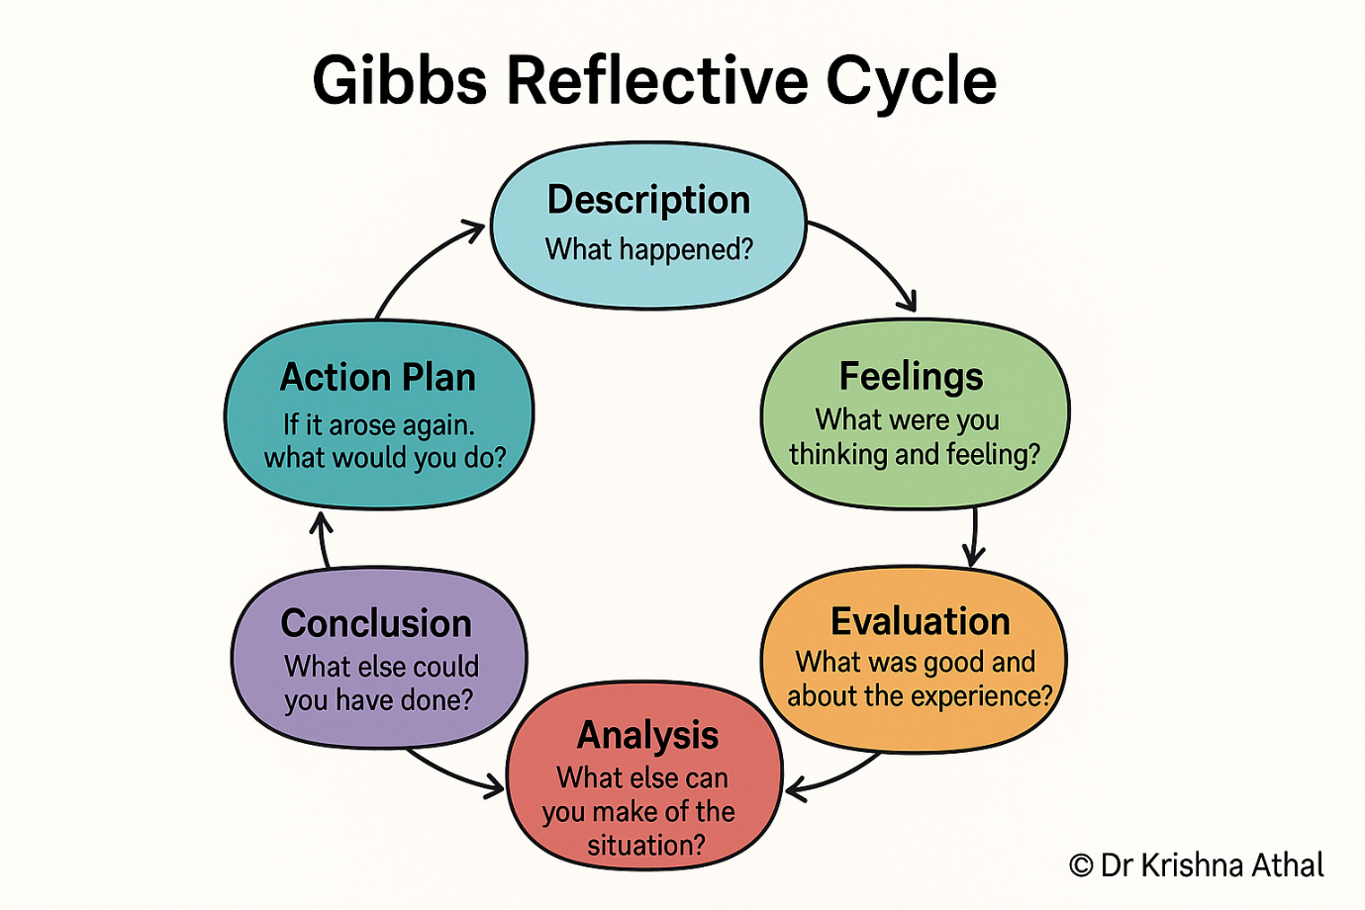
Figure 4: Gibbs Reflective Cycle

Description
The challenge was to select a real organisation and reduce it down to one product and one market, and then use PESTEL, VRIO, SWOT, CSR – Balanced Scorecard, Five Forces and Ansoff frameworks to come up with Board-level recommendations for strategic actions. I picked Lifebuoy for this, because I felt it was a rich, dynamic strategic resource, and there was genuine contestation to it – most significantly the 2025–26 issue of whether Lifebuoy had now become India's top soap brand, or Santoor. I started by finding primary sources (HUL's and Unilever's own reporting), then secondary sources (current market-share sources from industry and news sources) and finally tertiary sources (theories themselves).

Feelings
I was really at ease at the outset as Lifebuoy is a proven name and has a very long track record of CSR. It was only when I found the market-share tussle between Santoor in the year 2025–26 that the confidence turned into a more productive discomfort; a less glowing picture for HUL's recent health than I was originally set to present. This proved to be productive not problematic: it maintained the analysis in the direction of critical evaluation, rather than description.

Evaluation
What worked well was using several dated data points (2014, 2019, and 2025–26) to illustrate a trend in the market-share data, rather than relying on a single snapshot, and triangulating this against HUL's own recent strategic language the WiMI strategy and Stratos reformulation to produce an evidence-based discussion rather than a textbook application of the frameworks. It was also helpful to apply the same underlying evidence across more than one framework deliberately for instance, using the Santoor share-shift data in both the VRIO analysis and the Five Forces analysis since the resulting recommendations were more internally consistent than if each section had been researched and written in isolation. What worked less well was relying on some secondary/aggregator sources (for example, industry summary sites) for market-share figures from earlier periods, where the underlying primary Nielsen data was not directly accessible; this is a genuine limitation that a professional consulting engagement would resolve through a paid syndicated-data subscription.

Analysis
The central analytical insight that Lifebuoy's CSR investment appears to have sustained brand trust without preventing commercial share loss to a cheaper rival was only discovered because I did not treat each of the frameworks (PESTEL, VRIO, CSR, BSC) as a self-contained checklist, but instead looked for the same underlying signal rural, price-sensitive consumer behaviour recurring across all of them. This reflects Gibbs' (1988) emphasis on analysis as the stage at which description is transformed into understanding: each framework applied individually would have produced a plausible but generic description of "a strong FMCG brand facing competition", whereas combining them produced a specific, falsifiable account of why that competition is currently winning. Looking back on it, I also identify a risk that I took in my analysis: that I am focused on the Santoor story and in the last part, not wanting to miss out on a more balanced interpretation of the available market data, which HUL itself challenges (one, perhaps highly contested, data point, which I was drawn to, to the detriment of the other, perhaps more prevalent, data point) but is directly related to the module's focus on cognitive and intellectual skills: the ability to make sound judgements in the presence of contested or incomplete information.

Conclusion
In this task, I believe that the best strategic analysis was not to be done by asserting a position but by actively looking for disconfirming evidence – that is, the evidence that Lifebuoy might be losing rather than simply holding on to the position. The report would have been less accurate if it had only included older, more positive market-share figures, that would have lessened the strategic urgency of HUL's Board. I also think that there's more to transparency in the sense of stating sources of limitations (flagging brand-commissioned CSR impact data, or dated statistics) than there is about it being a weakness to be covered up.

Action Plan
For future strategic analysis assignments, I will take the following actions:
No. | Action
1 | Consciously look for the latest, most controversial, or negative evidence before finalising a narrative, rather than settling for the most coherent story the data first suggests.
2 | Explicitly flag where impact data originates from the organisation being studied itself, so that any resulting argument accounts for that potential bias.
3 | Plan cross-framework connections (as here, between CSR and the Balanced Scorecard) deliberately at the planning stage, rather than treating each part of a report as an isolated exercise.

References
Ansoff, H.I. (1957) 'Strategies for diversification', Harvard Business Review, 35(5), pp. 113–124.
Barney, J.B. (1991) 'Firm resources and sustained competitive advantage', Journal of Management, 17(1), pp. 99–120.
CSRWire (n.d.) Unilever Lifebuoy campaign reduces diarrhoea from 36% to 5%. Available at: https://www.csrwire.com/press_releases/36887-unilever-lifebuoy-campaign-reduces-diarrhoea-from-36-to-5- (Accessed: 1 August 2026).
Elks, J. (2013) 'Unilever expands "Help a Child Reach 5" campaign to mark Global Handwashing Day', Sustainable Brands. Available at: https://sustainablebrands.com/read/unilever-expands-help-a-child-reach-5-campaign-to-mark-global-handwashing-day (Accessed: 1 August 2026).
Expert Market Research (2024) India Soap Market Size, Share and Growth Report. Available at: https://www.expertmarketresearch.com/reports/india-soap-market (Accessed: 1 August 2026).
Gibbs, G. (1988) Learning by Doing: A Guide to Teaching and Learning Methods. Oxford: Further Education Unit, Oxford Polytechnic.
Hindustan Unilever Limited (2025) Personal Care [performance highlights, FY 2024–25]. Available at: https://hul-performance-highlights.hul.co.in/performance-highlights-fy-2024-2025/personal-care.html (Accessed: 1 August 2026).
Hindustan Unilever Limited (n.d.) Annual Reports and Performance Highlights. Available at: https://www.hul.co.in/investors/annual-reports-and-performance-highlights/annual-reports/ (Accessed: 1 August 2026).
Hindustan Unilever Limited (n.d.) Unilever Compass Strategy. Available at: https://hul-performance-highlights.hul.co.in/performance-highlights-fy-2020-21/unilever-compass.html (Accessed: 1 August 2026).
India Education Diary (2017) Lifebuoy's Help a Child Reach 5 campaign and Kajol announce young handwashing heroes. Available at: https://indiaeducationdiary.in/lifebuoys-help-child-reach-5-campaign-kajol-announce-young-handwashing-heroes/ (Accessed: 1 August 2026).
India.com (2026) 'Lifebuoy is no longer India's no. 1 soap; which brand has overtaken it, and who is at number 3?', India.com, 3 February. Available at: https://www.india.com/business/lifebuoy-is-no-longer-indias-no-1-soap-which-brand-has-overtaken-it-and-who-is-at-number-3-fmcg-sector-hindustan-unilever-wipro-santoor-lux-ac-nielsen-data-andhra-pradesh-telangana-karnataka-8292091/ (Accessed: 1 August 2026).
Indianmirror (n.d.) Indian Soap Industry. Available at: https://www.indianmirror.com/indian-industries/soap.html (Accessed: 1 August 2026).
Indpaedia (n.d.) Soap industry: India. Available at: http://www.indpaedia.com/ind/index.php/Soap_industry:_India (Accessed: 1 August 2026).
Kaplan, R.S. and Norton, D.P. (1992) 'The balanced scorecard: measures that drive performance', Harvard Business Review, 70(1), pp. 71–79.
Lifebuoy India (2023) Lifebuoy Helps More Children Reach Their 5th Birthday. Available at: https://www.lifebuoy.in/health/infection-and-prevention/health-and-lifestyles/lifebuoy-helps-more-children-reach-their-5th-birthday.html (Accessed: 1 August 2026).
Porter, M.E. (1979) 'How competitive forces shape strategy', Harvard Business Review, 57(2), pp. 137–145.
Porter, M.E. (1980) Competitive Strategy: Techniques for Analyzing Industries and Competitors. New York: Free Press.
Porter, M.E. (2008) 'The five competitive forces that shape strategy', Harvard Business Review, 86(1), pp. 78–93.
Porter, M.E. and Kramer, M.R. (2011) 'Creating shared value', Harvard Business Review, 89(1/2), pp. 62–77.
Screener.in (2026) Hindustan Unilever Ltd Share Price and Company Overview. Available at: https://www.screener.in/company/HINDUNILVR/consolidated/ (Accessed: 1 August 2026).
Sustainable Brands see Elks, J. (2013).
Unilever plc (2025) Unilever Sees Signs of Progress Towards Sustainability Goals. Available at: https://www.unilever.com/news/news-search/2025/unilever-sees-early-signs-of-progress-on-sustainability-goals/ (Accessed: 1 August 2026).
Unilever plc (n.d.) The Unilever Compass for Sustainable Growth. Available at: https://www.unilever.com/files/8f9a3825-2101-411f-9a31-7e6f176393a4/the-unilever-compass.pdf (Accessed: 1 August 2026).
Warc (n.d.) Lifebuoy: Help a Child Reach 5 [case study]. Available at: https://www.warc.com/content/article/lifebuoy-help-a-child-reach-5/en-gb/102862 (Accessed: 1 August 2026).
Figure 3: https://www.google.com/search?q=pestel+analysis+diagram&rlz=1C1CHBF_enIN974IN974&oq=pestel+&gs_lcrp=EgZjaHJvbWUqCAgAEEUYJxg7MggIABBFGCcYOzIGCAEQRRg5MgoIAhAAGLEDGIAEMgcIAxAAGIAEMgcIBBAAGIAEMgcIBRAAGIAEMgcIBhAAGIAEMgcIBxAAGIAEMgcICBAAGIAEMgkICRAAGAoYgATSAQk1MDQzajBqMTWoAgiwAgHxBbMzVg78z7Bs&sourceid=chrome&source=chrome.rb&ie=UTF-8#sv=CAMSZxowKg53MTRIamlXZE44SFhqTTIOdzE0SGppV2ROOEhYak06DnlHRUpvU0VlNC1vQ05NIAQqLwobXzhDMThhdGlNQWV2RGhiSVBrb1RXeVFrXzQ4Eg53MTRIamlXZE44SFhqTRgAMAEYByCIl9zhD0oIEAEYASABKAE

Figure 4:

