I acknowledge the use of Grammarly on 12/11/2024 to check my work for readability, grammar and syntax.
I confirm that I have not presented any AI-generated text as my own work. I confirm I have copies of my drafts, notes, and other resources I used before and after using AI tools, which I may be asked to provide in evidence.
Module: Financial Management for the Hotel Industry
Module code: BMIH5007
Lecturer: Tristan Hawkins
Student: Beatrice -Elia Gherasim
Student ID: 2241871
Wordcount: 1846

Report Case study: the city hotel

Executive summary
This report examines the financial challenges faced by The City Hotel, focusing on the factors contributing to its recent decline in revenue, customer satisfaction, and occupancy rates. Analysing its income statements and balance sheets over the past three years, the hotel’s struggles with high operational costs, poor asset utilisation, and elevated debt levels can be observed. Increased expenses, ineffective supplier relations, and outdated marketing strategies have contributed to its declining profitability and financial instability, especially post-COVID. The report presents a comprehensive turnaround strategy that includes streamlining operations, improving funding processes, and investing in digitalisation. These measures aim to enhance operational efficiency, reduce costs, and boost revenue by addressing the hotel’s core financial and competitive challenges.

Table of Contents
Introduction 2
Financial Analysis of The City Hotel’s Performance 3
Income statement 3
Balance Sheet 4
Identifying Core Issues Behind Financial Decline 6
Comprehensive Turnaround Strategy 8
Streamline Business Operations and Enhance Efficiency 8
Improving Funding Process 8
Investment in Digitalisation and Modern Marketing 8
Conclusion 9
References 9

Introduction

The purpose of this report is to analyse the financial performance of The City Hotel, an urban-based restaurant, bar, and event operator. Financial performance analysis provides proper transparency in maintaining organisational profitability, liquidity, and solvency over time (Hamsyah et al, 2023). This allows financial analysts and investors to make informed decisions that can aid in maintaining financial stability. The City Hotel has experienced a decline in revenue generation, customer satisfaction, and occupancy rates in recent years—key areas impacting its financial performance. This report identifies the core reasons behind these declines and offers a comprehensive turnaround strategy to improve financial health and restore the hotel’s business reputation.

Financial Analysis of The City Hotel’s Performance

Income statement

A financial analyst can understand organisational financial performance in maintaining profitability over a financial period. An income statement represents transparency in revenue, expenses, and income information, reflecting organisational efficiency in managing costs to improve financial health (Zadorozhnyi et al, 2021). In the current context, the income statement for three financial years is used to analyse the organisational profitability and cost management efficiency of The City Hotel. Based on that, effective decisions will be made to improve the business's overall financial capability and strength in the upcoming situation by implementing relevant strategies.
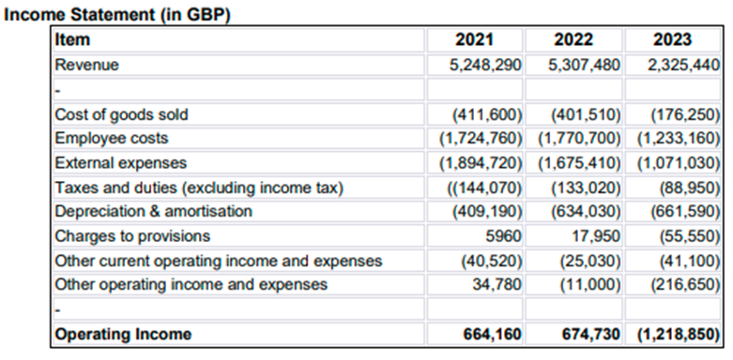
Figure 1: Income Statement
(Source: Self-developed)

The above figure shows that The City Hotel improved its total revenue to £5,307,480 in 2022 from £5,248,290 in 2021. In this case, the organisation also improved its financial efficiency in managing the total cost of business operations, which helped the company increase its operating income from £664,160 to £674,730 in 2022. The financial outcome reflects a positive financial performance over the period, which is excellent for maintaining long-term financial stability in the marketplace. On the contrary, high market competition and poor market demand influenced lower revenue and high operational investment, which declined the total business revenue to £2,325,440 in the financial period 2023. Contrasting with the industry trends, the hotel market in the UK has maintained revenue growth as the industry's market size was valued at 24.7 billion British pounds in 2023 (Statista, 2024). Due to high external expenses, the organisation also faced a huge financial loss of £1,218,850 in 2023, which is a negative financial performance. In this case, it is recognised that investment in business operations for better financial performance increased overall operating spending compared to its total revenue, resulting in an operating profit margin of -52.4% from 12.86% in 2022, indicating a substantial need for cost management improvements.

Balance Sheet
A balance sheet helps to understand organisational financial efficiency in its asset management system that meets its financial obligation and represents organisational financial strength to meet further financial requirements (Shi, 2021). In this present case, a balance sheet of The City Hotel for three consecutive years, including 2021, 2022 and 2023, is represented below to analyse its financial efficiency, liquidity management and solvency position in recent years.
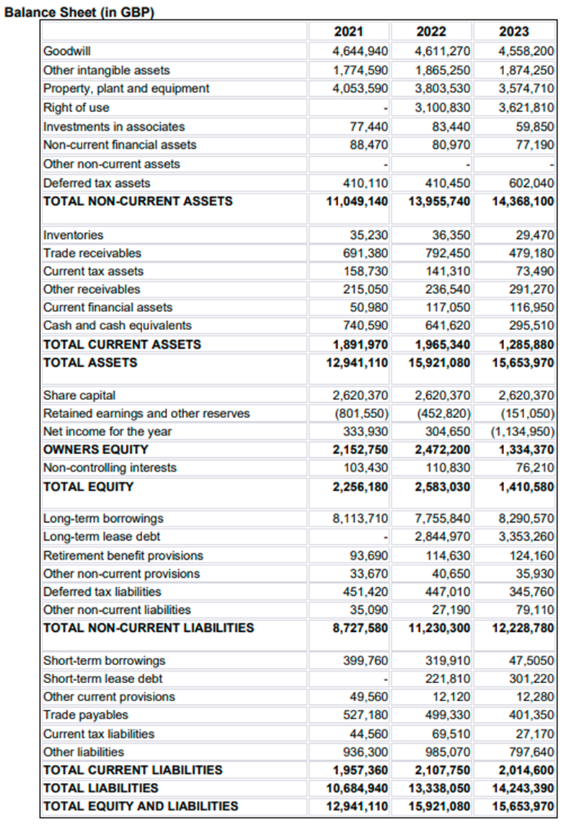
Figure 2: Balance Sheet
(Source: Self-developed)
Based on the above financial report, the liquidity ratio of The City Hotel is determined as below:
Current ratio = “Current assets / Current liabilities”
For 2021: £12,941,110 / £1,957,360 = 6.61
For 2022: £15,921,080 / £2,107,750 = 7.55
For 2023: £15,653,970 / £2,014,600 = 7.77
The qualitative outcome shows that the hotel organisation increased its current ratio from 6.61 in 2021 to 7.77 in 2023, which depicts too many assets in the company compared to its current liability. As per industry trends, the current ratio between 1.5 and 2 is considered a healthy financial condition. On the contrary, the City Hotel increased its current ratio. In this case, the financial outcome reflects that the hotel’s current assets are not being used effectively to meet its business obligations. Comparing the financial performance of the Premier Inn, it is found that the organisation maintained a current ratio of 1.33 over a recent period, which is close to industry trends and acceptable (Wsj, 2024). In the present case, due to high operational expenses and external business expenses, the company increased its total non-current liabilities from £8,727,580 in 2021 to £12,228,780, which affected the overall solvency position of the business. The solvency ratio is determined below by the financial data of the business's total debt and equity.
Debt/Equity Ratio = “Total Debt / Total Equity”
For 2021: £8,113,710 / £2,256,180 = 3.6
For 2022: (£7,755,840 + £2,844,970) / £2,583,030 = 4.1
For 2023: (£8,290,570 + £3,353,260) / £1,410,580 = 8.3
The qualitative outcome depicts that the organisation increased its debt/equity ratio from 3.6 to 8.3 in 2023. In this case, it is recognised that the organisation increased its total debt compared to its total equity in the financial year 2023, which affected the overall solvency position of the business. Consequently, the firm faced a decline in its solvency position in the year 2023 compared to its preceding years, which is not significant enough to represent better creditworthiness. Comparing these results to the industry average would underscore the need to manage debt levels more effectively.

Identifying Core Issues Behind Financial Decline
Concerning the financial performance analysis, it was found that the firm faced a decline in maintaining its profitability and solvency position in the recent year. The core reason behind the key context is that the firm spends high expenses on its business operations, which affects its net earnings. Poor supplier relations and inadequate supply chain management may lead to significant disruptions and cost increases that directly cut into the organisational profitability (Katsaliaki et al, 2022). A further major reason behind its poor financial performance is that The City Hotel also has an ineffective pricing strategy, which affects the overall cost management system and reduces net earnings per consumer. Comparing these findings with the market trends, it is also found that the hotel faces low market demand due to seasonal changes, which is constrained to implement a strategic business plan to boost its sales performance effectively. Ultimately, the firm faces substantial financial loss at the end of 2023.
Regarding the balance sheet, it is noted that the company raised its total debt during the same financial period, impacting the business's overall solvency. High business debt decreased its creditworthiness as the debt-equity ratio reflected higher in 2023 than in the preceding years. In this case, it also has been found that the company prioritises the debt financing system as a favourable source of funds instead of using debt financing. Consequently, the firm faces high financial risk in maintaining sustainability in the highly competitive marketplace and getting strong financial support from external sources. A further primary reason behind its declining financial performance is poor technological advancement. The firm mainly focuses on maintaining its traditional marketing and business processes to run its business in even the current competitive business era. On the contrary, adopting a digitalisation system is one of the significant contemporary changes in the current business world that significantly impacts overall business growth and sustainability in the competitive business field (Agrawal et al, 2022). As per the research, it is found that instalment of advanced technology requires a high budget in the first period. However, due to poor creditworthiness, the firm faces a crisis in raising funds, which is constrained to meeting financial requirements when adopting advanced technologies. Consequently, the firm faces issues in improving its business performance and threats to maintaining long-term sustainability in the hotel industry.
Concerning real-work events, it is recognised that COVID-19 is one of the most significant real-world events that has negatively impacted the overall hospital industry. In the post-COVID era, pre-caution maintenance increased the total operational costs of organisations in the hospitality industry (Baum et al, 2020). Being a part of the industry, The City Hotel also faced issues that increased its expenses compared to total revenue in recent years. The shifting of consumer preferences in the digitalisation system or e-booking process also affected the total number of sales in the competitive era. However, once the firm focuses on improving its assets management system, it will be able to overcome the core challenging aspects in the future.

Comprehensive Turnaround Strategy
Streamline Business Operations and Enhance Efficiency.
A detailed analysis of The City Hotel’s financial challenges shows that high operating costs and inefficient processes affect profitability. To address this, the hotel should implement a comprehensive cost-reduction strategy focused on streamlining operations and improving contract terms with suppliers. Specific steps include assessing workflow processes to eliminate inefficiencies, optimising labour allocation to reduce excess staffing costs, and negotiating better rates for supplies and services with vendors. Additionally, resource management software can track and minimise waste, lowering costs. Through these initiatives, The City Hotel can improve its operational efficiency, lower expenses, and position itself to generate more substantial profits and financial stability in the coming years.

Improving Funding Process
Raising funds is one of the significant concepts in financial management practices that help to meet all the financial requirements of a business and enhance its financial efficiency. At this point, applying an appropriate source of funds is crucial to get more substantial financial support from an external source. Equity financing plays a significant role in organisational fundraising, helping raise funds at low cost and avoiding financial threats (Investopedia, 2023). On the contrary, applying for debt financing may raise the threat of facing financial losses as it requires debt repayment at high interest rates (Investopedia, 2021). Therefore, the City Hotel needs to improve its debt financing system instead of prioritising debt financing. In this case, a further strategic solution would be the application of crowdfunding, which helps raise capital through social media platforms (Investopedia, 2023a). Consequently, the firm can enhance its online presence and reach a broader range of investors efficiently within a conscious period.

Investment in Digitalisation and Modern Marketing
Digital transformation is one of the most significant contemporary changes that positively impact organisational growth and financial success. Investment in modern digital technologies is the most effective strategic solution in the current era, and it increases automation in business operations. In this case, once the City Hotel focuses on adopting advanced technologies, it will also reduce its total operational cost and increase the overall profit margin of the business. Consequently, the business will be able to revitalise its financial health and recover all the financial loss within a conscious period. Social media platforms, including Facebook, Instagram, Pinterest and more, will help reach a broader range of customers (Hootsuite, 2023). At this point, it can enhance its online presence and maintain market competitiveness efficiently without raising operations costs. Digital presence and e-marketing strategies will enable The City Hotel to respond to modern consumer preferences, strengthening its market position.

Conclusion
In summary, The City Hotel’s financial health is affected by high expenses, outdated practices, and a lack of investment in modernisation. The hotel can improve profitability and competitiveness by focusing on operational efficiency, pursuing alternative funding methods like equity financing and crowdfunding, and investing in digital transformation. Embracing digital marketing and automation will enable The City Hotel to reach a broader audience and streamline operations, positioning it for financial recovery and sustainable growth in a competitive post-COVID hospitality market.

References

Agrawal, R., Wankhede, V.A., Kumar, A., Upadhyay, A. & Garza-Reyes, J.A. (2022). Nexus of circular economy and sustainable business performance in the era of digitalization. International Journal of Productivity and Performance Management, 71(3), pp.748-774. Available at: https://cris.brighton.ac.uk/ws/portalfiles/portal/22859605/Revised_Manuscript.pdf (Accessed: 1 November 2024).
Baum, T., Mooney, S., Robinson, R., & Solnet, D. (2020). COVID-19's impact on the hospitality workforce - new crisis or amplification of the norm?, International Journal of Contemporary Hospitality Management, 32(9), pp. 2813-2829. Available at: https://doi.org/10.1108/IJCHM-04-2020-0314 (Accessed: 3 November 2024).
Hamsyah, H., Latif, I.N. and Dewi, C.K. (2023). Cooperative Financial Performance Analysis of Liquidity, Solvency, Profitability, and Activity Ratios. Indonesian Journal of Sustainability Policy and Technology, 1(1), pp.30-45. Available at: https://dhsjournal.id/index.php/ijospat/article/view/119. (Accessed: 1 November 2024).
Hootsuite (2023). Social Media Advertising. Available at: https://blog.hootsuite.com/social-media-advertising/ (Accessed: 11 November 2024).
Investopedia (2023). Equity Financing. Available at: https://www.investopedia.com/terms/e/equityfinancing.asp (Accessed: 6 November 2024).
Investopedia (2021). Why is debt cheaper than equity? Available at: https://www.investopedia.com/ask/answers/05/debtcheaperthanequity.asp (Accessed: 11 November 2024).
Investopedia (2023a). Crowdfunding. Available at: https://www.investopedia.com/terms/c/crowdfunding.asp (Accessed: 6 November 2024).
Katsaliaki, K., Galetsi, P. and Kumar, S. (2022). Supply chain disruptions and resilience: A major review and future research agenda. Annals of Operations Research, pp.1-38. Available at: https://link.springer.com/article/10.1007/s10479-020-03912-1 (Accessed: 2 November 2024).
Shi, W. (2021). Analyzing enterprise asset structure and profitability using cloud computing and strategic management accounting. PLOS ONE, 16(9), p.e0257826. Available at: https://doi.org/10.1371/journal.pone.0257826. (Accessed: 2 November 2024).
Statista (2024). UK Hotel Industry market size. Available at: https://www.statista.com/statistics/1364712/hotel-industry-market-size-uk/#:~:text=The%20United%20Kingdom's%20hotel%20market,of%2016.42%20billion%20British%20pounds. (Accessed: 9 November 2024).
Wsj (2024). Financial report of Premier Inn. Available at: https://www.wsj.com/market-data/quotes/ZA/XJSE/PMR/financials (Accessed: 9 November 2024).
Zadorozhnyi, Z.M., Ometsinska, I. and Muravskyi, V. (2021). Determinants of firm's innovation: increasing the transparency of financial statements. Marketing i menedžment innovacij, (2), pp.74-86. Available at: https://essuir.sumdu.edu.ua/handle/123456789/84326. (Accessed: 1 November 2024).

