
CertHE Computing Skills for Workplace
Analysing and Solving Problems | ACCA4019
MediCare Plus
Appointment Management System
Problem Solving, Pseudocode and Reflection

STUDENT NAME | Pedro Pereira
STUDENT ID | 2536022
COURSE | CertHE Computing Skills for Workplace
MODULE NAME | Analysing and Solving Problems
MODULE CODE | ACCA4019
LECTURER | Abdullah Usman
SUBMISSION DATE | 22 /10/2026

Contents
Section 1: Problem Deconstruction 3
1. Problem Statement/Introduction 3
2. Breakdown of the Problem 3
3. Requirements Analysis using MoSCoW 4
4. Requirements 5
Functional Requirements 5
Non-functional requirements 5
5. Constraints 5
6. Variables 6
7. Supporting Evidence 6
Section 2: Proposed Solution 7
Step 1: Create a Flowchart 7
Step 2: Write Pseudocode 8
Pseudocode design process 9
Step 3: Explain the Solution 9
1. How it works 9
2. What each step does 9
3. Why the student made these decisions 10
4. How it reduces waiting times 11
5. How it uses doctors efficiently 11
Section 3: Reflection and Justification 11
How did the student break the problem down? 11
How did abstract thinking help? 12
Why did the student choose the solution? 12
What are the strengths of the solution? 12
What are the weaknesses? 12
Conclusion: 13
References 14

Section 1: Problem Deconstruction

1. Problem Statement/Introduction
The Hospital has a problem with its appointment system. Patients often wait a long time to see a doctor, when some doctors have empty gaps in their day and others have too many patients. This means the hospital does not use its doctors well, and patients have a bad experience.
The hospital wants a solution with three main goals: to give patients appointment slots in an efficient way, to keep waiting times as short as possible, and to make sure no patient waits more than 30 minutes after their scheduled time.

2. Breakdown of the Problem
To understand the problem better, it can be divided into smaller parts:
- Giving each patient a doctor and a time slot
- Choosing a doctor with the right specialty
- Checking and reducing waiting times
- Using doctors' working hours more effectively
- Dealing with problems such as cancellations, missed appointments, emergencies and long consultations
In short, this is a problem of limited doctors and time slots. The system must share them fairly so that waiting is short, doctors are well used, and the 30-minute limit is never broken.

3. Requirements Analysis using MoSCoW

Must Have | Should Have | Could have | Won't have
Reduce waiting time | Prioritise urgent cases over routine ones | Delay alerts by SMS or email | Connecting the system with billing, insurance, or complete medical records.
Allocate each patient to one doctor and one time slot | Make sure all doctors have a similar amount of work | Live queue dashboard | Multi-hospital scheduling
Prevent double-booking | Handle consultations that take longer than planned | Online booking | Telemedicine (video consultations)
No patient waits more than 30 minutes | SMS or email reminders and delay alerts | Mobile application
Match patients to the right Doctors | Handle emergencies
Book appointments (by reception or phone) | Handle cancellations and no-shows
Use doctors’ time well (reduce empty slots) | Give free slots (after cancellations) to other patients
Respect doctors’ working hours and breaks
Record actual start times

4. Requirements
The system must assign each patient to one suitable doctor and one time slot, prevent double-booking, respect working hours, and record actual start times. It must keep waiting under 30 minutes, use doctors’ time well, and share work fairly between doctors.

Functional Requirements
- The system must give each patient one doctor and one time slot.
- The system must match the patient to a doctor with the right specialty.
- The system must prevent double-booking (one doctor, one patient, one slot).
- The system must only use slots inside the doctor’s working hours and outside breaks.
- The system must record the actual start time of each appointment.
- The system must calculate waiting time (actual start − scheduled start).
- The system must fill empty slots (for example, after cancellations) to reduce idle doctor time.
- The system must prioritise urgent cases and handle emergencies.

Non-functional requirements
- No patient waits more than 30 minutes after the scheduled time.
- Waiting times must be as short as possible on average.
- Doctor utilisation must be high (few empty gaps).
- Workload must be fair between doctors.
- The system must be easy to use for reception staff.
- Patient data must be kept private and safe.

5. Constraints
Constraints are limits that the solution cannot change. They are different from requirements: a requirement is what is wanted, a constraint is what stops or limits the solution. Examples:
- Limited number of doctors
- Limited appointment slots per doctor per day
- Budget restrictions
- Limited reception staff
- One doctor can see only one patient at a time
- Fixed working hours and breaks for doctors
- Maximum delay of 30 minutes after the scheduled time
- Consultations have different lengths
- Patient data privacy (laws and hospital rules)
- Specialty requirements
- Emergencies can arrive without warning

6. Variables
The system uses demand variables (number of patients, specialty needed, urgency), capacity variables (number of doctors, working hours, breaks, slots), time variables (scheduled start, actual start, waiting time), and performance variables (doctor utilisation, empty slots, workload). Together they show if the hospital has enough capacity for the demand and if waiting stays under 30 minutes.

Variable | Why Important
Number of Patients | Determines demand
Patient specialty need | Decides which doctors can see the patient
Urgency level (routine / urgent / emergency) | Decides who must be seen first
Expected consultation time | Helps to plan how long each slot must be
Number of cancellations and no-shows | Creates empty slots that can be filled
Number of doctors | Determines capacity
Doctor specialty | Decides which patients each doctor can see
Doctor break times | Slots cannot be placed in these times

7. Supporting Evidence

The variables in this system describe demand and capacity. Good scheduling aims to match demand with capacity, so that resources are used well and patient waiting times stay low [1]. Capacity planning must also make sure that resources match the needs for care [3]. Consultation times differ between patients, and this service time variability affects how well an appointment system performs [2]. Many factors, including patient and provider preferences, also influence performance [2]. For this reason, the system measures patients, doctors, and consultation time.

Section 2: Proposed Solution

Step 1: Create a Flowchart
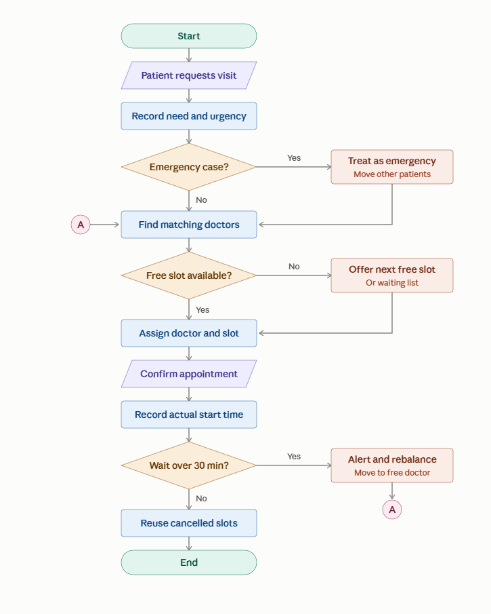

Step 2: Write Pseudocode
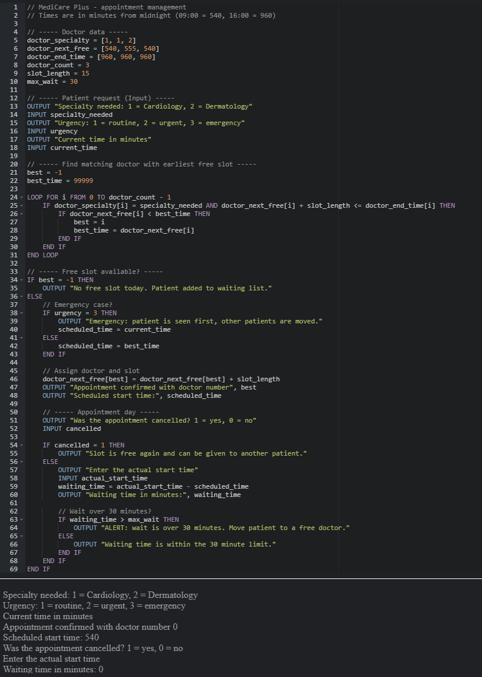

Pseudocode design process
Pseudocode plans a program in plain language using sequence, decision and repetition [5]. It breaks a problem into clear steps that are easy to read and test [6]. The student listed the data, wrote the steps, and corrected them until they worked.

Step 3: Explain the Solution

1. How it works
The solution is a scheduling system with one simple idea: give each patient the best free slot with the right doctor, then watch the waiting time. Good scheduling systems try to match demand with capacity, so that doctors are used well and patient waiting is as short as possible [1].
The system works in 3 stages:
- Before the visit: it takes the patient’s request, finds a doctor and gives a slot.
- On the day: it records the actual start time.
- After the visit: it checks the waiting time and reuses free slots.

2. What each step does
Step | What it does
Input | The system asks for the specialty needed, the urgency level, and the current time.
Find matching doctors | A loop checks every doctor. It keeps only doctors with the right specialty who still have time before the end of their working day.
Choose the earliest slot | Among the matching doctors, it picks the one who is free soonest.
Free slot? | If no doctor is available, the patient goes on a waiting list. This stops the system from giving an impossible appointment.
Emergency? | If urgency is 3, the patient is seen first and other patients are moved.
Assign doctor and slot | The system gives one doctor and one slot, then moves that doctor’s next free time forward by one slot length. This is what prevents double-booking.
Cancelled? | If the patient cancels, the slot is released for someone else.
Record actual start time | The system saves when the visit really began.
Calculate waiting time | Waiting time = actual start time − scheduled start time.
Wait over 30 minutes? | If yes, the system sends an alert to move the patient to a free doctor. If no, the process ends normally.

3. Why the student made these decisions
Decision | Reason
Match by specialty first | A patient can only be treated by a doctor with the right skills. This is a constraint from Step 5, so it is checked before anything else.
Pick the earliest free doctor | This gives the patient the shortest possible wait for an appointment.
Check working hours | No appointment can be placed after a doctor’s day ends or outside their time.
Push the next free time forward | One doctor can see only one patient at a time, so each slot can be given only once.
Emergencies go first | An emergency cannot wait. The system accepts that other patients will move, because emergencies are a known source of disruption.
Waiting list instead of overbooking | If there are no slots, adding extra patients to a full day would create long delays.
Record actual start time | Only what is measured can be managed. Real data shows whether the system keeps the 30-minute promise.
Fixed limit (30 minutes) | It is a Must have in the MoSCoW table. A clear number is easy to test.

Another reason for the 30-minute check is that real consultations do not always take the planned time, and this kind of variability affects how well an appointment system performs [2]. The system cannot remove variability, but it can detect it quickly and react.

4. How it reduces waiting times
- Earliest slot: patients get the nearest free appointment, so the time before the visit is shorter.
- No double-booking: two patients are never promised the same doctor at the same time, which is a common cause of delay.
- Right doctor the first time: no time is lost sending a patient to the wrong doctor.
- Alert at 30 minutes: a long wait is caught and the patient is moved to a free doctor, so the limit is enforced and not only hoped for.
- Waiting list and reused slots: When a patient cancels, the slot does not stay empty. A waiting patient can take it, so the queue gets shorter.
The system also records waiting times. Little’s law (L = λW) shows that waiting depends on how many patients are in the system and how fast they arrive [4]. If many patients are waiting, demand is higher than capacity, so the hospital can add slots or doctors.

5. How it uses doctors efficiently
- Balanced work: because the system always picks the doctor who is free soonest, work moves to doctors with free time and not only to the same busy doctor.
- Fewer empty slots: cancelled slots are given to other patients, so doctors have fewer idle gaps.
- Working hours respected: the system uses all available time inside the doctor’s day, but never goes beyond it.
- Good use of capacity: capacity should match the needs for care [3], and the system does this by sharing patients between doctors with the same specialty.
- Data for improvement: start times and waiting times let the hospital measure doctor utilisation and see if work is shared fairly.

Section 3: Reflection and Justification
How did the student break the problem down?
The student split the problem into smaller parts: how patients book appointments and how doctors’ time is divided into slots, what happens when a patient cancels, how to manage waiting patients, and how to measure waiting times. Each part was easier to solve alone, and then the student connected them into one system.
How did abstract thinking help?
Abstract thinking helped the student ignore details that do not matter, such as the patient’s name, illness, or the doctor’s room. The student kept only the important ideas: a patient, a slot, a queue, and time. This made the problem a general queue problem, so the student could use Little’s law (L = λW) to understand waiting times.
Why did the student choose the solution?
The student chose a waiting list with reused slots because empty slots waste doctors’ time and long queues are bad for patients. When a patient cancels, the slot goes to the next waiting patient, which is simple and fair. The student also recorded waiting times, so the hospital can see when demand is higher than capacity and add slots or doctors.

What are the strengths of the solution?
- It is simple and easy to understand.
- It reduces wasted slots and shortens the queue.
- It is fair, because patients are served in order.
- It uses data (waiting times), so decisions are based on facts.
- It can grow: more slots or doctors can be added without changing the main design.

What are the weaknesses?
- Little’s law gives only average values. It does not show very long waits for single patients.
- Patients who get a freed slot may have very little time to prepare, and some may not accept it. This means a slot can still be lost.
- The system depends on good data. If waiting times are recorded wrongly, the hospital may make wrong decisions.
- Adding more doctors costs money, so the hospital cannot always solve the problem this way.

Conclusion:
The MediCare Plus hospital had long patient waiting times and doctors with empty time slots. The student divided the problem into smaller parts, used the MoSCoW method to choose the key requirements, and designed a solution with a flowchart and pseudocode. The solution gives each patient the earliest free slot with a doctor of the right specialty, prevents double-booking, prioritises emergencies, reuses cancelled slots, and sends an alert if a patient waits more than 30 minutes. It is simple and fair, but it uses average values and depends on correct data. Future improvements include SMS reminders and a better priority system.

References
[1] T. Cayirli and E. Veral, “Outpatient scheduling in health care: A review of literature,” Prod. Oper. Manag., vol. 12, no. 4, pp. 519–549, Dec. 2003.
[2] D. Gupta and B. Denton, “Appointment scheduling in health care: Challenges and opportunities,” IIE Trans., vol. 40, no. 9, pp. 800–819, Sep. 2008.
[3] R. Hall, Ed., Handbook of Healthcare System Scheduling (Int. Series in Operations Research & Management Science, vol. 168). New York, NY, USA: Springer, 2012.
[4] J. D. C. Little, “A proof for the queuing formula: L = λW,” Oper. Res., vol. 9, no. 3, pp. 383–387, Jun. 1961, doi: 10.1287/opre.9.3.383.
[5] T. Gaddis, Starting Out with Programming Logic and Design, 6th ed. Hoboken, NJ, USA: Pearson, 2023, ISBN 978-0-13-760214-8.
[6] J. Farrell, Programming Logic and Design, 10th ed. Boston, MA, USA: Cengage Learning, 2023, ISBN 978-0-357-88087-6.

