Change makers: Building your Personal Brand for Sustainable Employment

Student id: 2232370
Student name : Valentina Micu

Table of Contents
Introduction 3
Job Advertisement 4
Job Role Employability Skills 7
Evaluation of Own Skills 9
Existing Qualifications and Experience 9
Personal Skills and Strengths 9
Professional Support for Skill Development 10
Academic Guide 10
Registered Nurse 11
Peer Support Guide 11
Action Plan and Timeline 11
Building Personal Brand 14
Value Integration 14
Digital Profile Infrastructure 14
Professional Content Management 15
Promoting Professional Identity 15
Building a Network for Successful Employment 16
Conclusion 16
References 18
Appendix 20
Professional Curriculum Vitae (CV) 20
Professional Cover Letter 21

Introduction
Building a personal brand fora sustainable, change-making employee is considered a crucial aspect of analysing core skills with values, aligned with the consumer needs in the market (Hwang and Han, 2026).
A Healthcare Assistant (HCA) is a critical role in the social and healthcare sector that incorporates the dimension of monitoring personal hygiene and maintaining human dignity among the patients. This entry-level positon is directed to handle the operational structures that bridge the gap between vulnerable individuals and the medical team (Alharbi, et al. 2024).
My primary motivation for perusing this career role is that it will provide me hands-on-experience to deal with clinical expertise without procuring a medical degree at first.

Job Advertisement
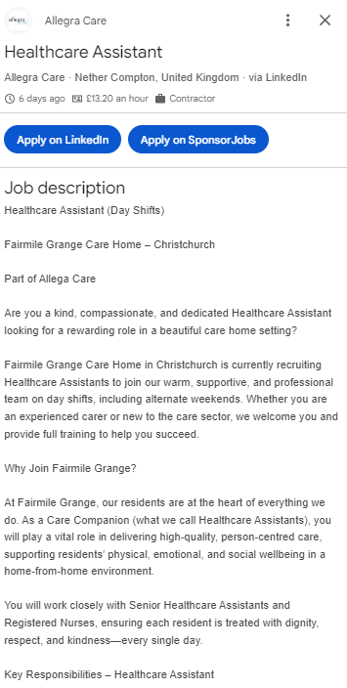
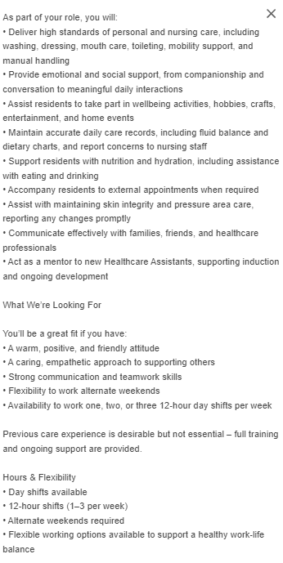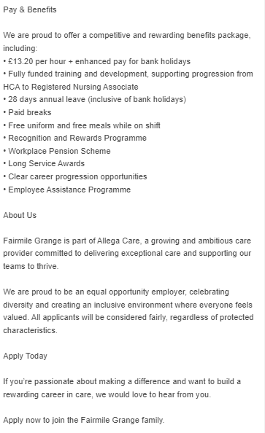
Figure 1: Job Advertisement
Source: (Allegra Care, 2026)

Job Role Employability Skills
Key Employability Skills | Execution Process of HCA Position | Managing Effective Job Performance
Proficient Communication | - Optimising behavioral tone to target patients suffering from mental illness such as dementia  - Managing accurate medical charts  - Formulating fact-based data sets to maintain shift-to-shift handovers | - Mitigate medical issues by providing accurate data to medical team  - Building extensive credibility among vulnerable individuals  - Ensuring legal compliance of patient to handle with personal care (Ezzerouali, et al. 2024)
Multi-disciplinary Teamwork | - Performing extensive collaborations with mentors such as senior nurses and doctors  - Responding to emergency request with safety to handle complex situations  - Maintaining rules and regulations with instructions by listening to assigned line managers | - Maximising utmost efficiency and operational safety  - Limits incurrence of stress and burnout by enabling to share workload  - Guarantee of promoting care to align therapy plans
Clinical Problem-Solving | - Identification of initial changes to analyse baseline mobility  - Handling minor conflicts between distressed family members  - Implementing localised spill-management to maintain environment hygiene (Nyambura, 2025) | - Operates as an initial developer to implicate warnings at times of critical conditions of patients  - Overcoming low-end issues before turning critical  - Maintaining future safety by analysing core possibilities of ward oriented crises
Efficient Time-Management | - Prioritising laundry schedules with handling meal assistance of elderly patients  - Incorporating punctual to manage shift ends  - Completing documentation accurately before shift ending | - Reduction in delays to handle high-dependable patients  - Mitigation of rushed and chaotic practice oriented medical habits  - Safeguarding professional and personal boundaries by achieving task completion by deadline
Technical Medical Literacy | - Maintaining Digital Electronic Patient Record (EPR) tools  - Implementing manual hosts and digital scaling  - Operating automation to blood pressure and pulse supervision | - Assurance of legal compliance by regulating digital notes  - Reducing patient and staff injury by maintaining efficient risk preventing measures  - Deliver core accuracy of goals to maintain physical metrics among physicians

Evaluation of Own Skills
In terms of becoming an efficient Healthcare Assistant (HCA), it is highly vital to focus on analysing personal self-assessment. It provides me the ability to reflect on the personal core capabilities and enhance the overall building of professional network support.

Existing Qualifications and Experience
Academic Qualifications: I have significantly procured a ‘5 GCSE’s’ in English and Mathematics during Grade 5. Currently, I am working on completing my level 2 certificate in Health and Social Care.
Practical Experience: I have completed voluntary work for 6 months at a local community center in UK. It covered my role and duties of managing social communicating and coordinating meal programs for the elderly people to help their cognitive impairments.
Relevant Certifications: I have procured community verified certifications related to Emergency First-Aid and Food Safety Catering to foster developed training procedures.

Personal Skills and Strengths
Self-assessment factor | Current strengths and USP | Areas for Improvement
Skills and Competencies | - Efficient communication and active listening capability  - High-end fluency in handling digital software  - Alignment of relationship-building with issue-free technical data logging system | - Establishment of zero practical training  - Inefficient experience in handling diagnosis aligned with implicating medical jargon  - Minimal exposure in fast-paced clinical ward environment
Practical Evidence | - Maintaining and modifying structured body language to utilise validation strategies | - Unfamiliar with NHS orientation of Electronic Patient Record (EPR) software platforms to handle tracking system
Operational value to practice | - Promoting trust and credibility by promoting safety among anxious patients  - Limiting ward oriented admin burdens (Smiseth, 2022)  - Reduction in formatting and typographical errors to promote electronic care notes | - Unable to perform clinical wards independently  - Requires extensive clinical monitoring with coherent physical checks  - Enhancing initial induction during training time for the hiring manager

Professional Support for Skill Development
Professional Supporter | Specific Role and Capability | Actionable Development Strategy
College Mentors | Academic Guide | - Reviewing my course progress with on-time completion  - Establishment of personal statements and CV formatting
Clinical Placement Manager | Registered Nurse | - I will ask for practical skills and manual handling of tasks  - Seeking real-tome feedback during shifts
Senior Clinical Ward HCA | Peer Support Guide | - Learning effective time-management framework (Yadav, et al. 2023)  - Observing documentation to configure work efficiency

Action Plan and Timeline
Based on the analysis of personal development, I am inclined to utilise the approach of resources and certain evidence to bridge the potential gap, in order to secure the metrics of professional promotion.
Strategic Objective based Milestone | Strategic Actions | Potential Development with resource and support | Verification and Evidence
Short Term (Months 1-6): Foundational Entry | - I will complete al final modules with Level 2 certificate  - Creating a professional LinkedIn profile to implicate care values | - I will utilise feedbacks procured from mentors to learn CV formatting tools  - Conduct effective tracking of NHS uploaded job vacancies | - Level 2 certification transcription  - Submitted application logs
Short Term (Months 7-12): Primary Onboarding | - I will submit applications through NHS job portal  - Completing 15 core module of NHS Care Certificate | - Attaining proficient trust building during induction  - Work inclusion of clinical mentors with utmost monitoring | - Officially signed Care Certificates  - Incorporation of my personal records based on Electronic Staff Record (ESR)
Medium Term (Year 2-3): Clinical Role Expansion | - Enrolling in a Level 3 clinical support oriented diploma  - Implementing supervised training program to access the system of ECG Goals | - Application of employer oriented training funding  - Participating in RCN support forums for development | - Inclusion of Level 3 Diploma-driven qualification system  - Signed aspect of clinical competency management for portfolio records
Long-Term (Years 4-5): Career Promotion | - Application for band 3 senior HCA position  - I will conduct effective research on researched nurse degree apprenticeship | - Requesting reference programs from ward managers  - Attending trustworthy interview workshops | - Formal Band 3 of promotional letter  - Application of approved metrics procured from RNDA accepted documentation

Building Personal Brand
The process of building a personal brand is considered to be highly vital to maintain a professional identity within the working environment (Frimpong, 2025). Demonstrating of my future goal of being an efficient Healthcare Assistant (HCA), I am strategically inclined to showcase my competency and commitment to handle health and social care dynamics. As an enthusiastic Healthcare Assistant, I want to work on my personal skills and capabilities to deal with the patients through safe and clinical practice. By incorporating the structure of value-driven standards, I can strategically enable my professional experience to align with the workforce criteria that is required by the National Health and relative care providing institutions.

Value Integration
This aspect is significantly regulated by the dynamics guided by the National Health Service (NHS) '6Cs' framework, which enables me to focus on value-oriented professional structure that systematically manages care, compassion, competence, communication, courage and commitment to encourage the overall level of interaction. I can successfully manage these 6 values with personal evaluation to focus on immediate functioning of healthcare employees. This relatively provides me the accessibility to implicate digital signature block with execution of current qualification and certifications.

Digital Profile Infrastructure
This approach fits perfectly with establishing a clear and optimised structure by utilising the core aspects of tools like LinkedIn. This can enable me to build a strategic professional profile and a digital resume that aligns with my capabilities and core skills. This aspect drives high-end quality that provides me the accessibility to generate a headshot photograph with a neutral corporate or clinical background that helps in attracting the employers. I can also add a proficient headline on my profile’s bio to reflect my personal attributes and traits. For example, Aspiring Healthcare Assistant I Level 2 Health and social care student.
With the application of this approach, I will be able to focus on procuring extensive healthcare digital badges by uploading my verified certifications gained from training institutes such as Emergency First Aid and Food Safety Catering to foster long-term professional promotions.

Professional Content Management
In order to build my personal brand and professional identity, I will proactively focus on implicating health and social care dynamics that are related to clinical guidelines and policies published such as Skills for Care and The Royal College of Nursing (RCN). These certainly enable me to focus on writing and publishing core digital posts that can be associated with the latest healthcare trends to promote maintaining human dignity with the patients. This will enhance the overall understanding of dealing with the comprehensive structure of visually showcasing my personal commitment toward the approach of Continuous Professional Development (CPD) to promote digital footprint among the employers to foster long-term learning consideration.

Promoting Professional Identity
In terms of strategical analysis, I can extensively consider the application of certain skills to enhance my professional identity among the prospective employers. This can be specifically targeted within the communication tools and channels to foster long-term viability and maximising my core opportunities of getting hired as a Healthcare Assistant (HCA).
Tailored CV and Cover letter: My personal CV can be comprehensively inbuilt with certain use of keywords related to my clinical profile. This can help me in aligning my core competencies gained during the execution of placement hours. It can be also systematically implicated with the structure of NHS Band 2 Job description that is highly inclined to be passed by the applicant targeting system imposed by the institution.
Optimised professional presence: I can relatively connect my professional experience on LinkedIn profile by specifically targeting healthcare recruitment teams and institutions. This can leverage me to target the dynamics of NHS trust and enable me to encourage engaging more with promoting healthcare campaigns to foster organisational values.
Digital Portfolio: This approach complies with managing a digital folder that is hosted with inclusion of First Aid and Food Safety Certification to demonstrate the dynamic of reflective logs (Clark, 2025). I will certainly utilise the strategy of Gibbs’s Reflective cycle to visually enhance professional growth within the hiring managers.

Building a Network for Successful Employment
In order to build a proficient network to enhance my professional relationship with the appropriate set of strategies. Implementation of this strategy can certainly provide me the accessibility to focus on identification of core opportunities that will relatively increase my overall dynamics of professional network.
Professional Association Membership: I can register myself as an HCA member in inclusion of the Royal College of Nursing (RCN). This will enable me to focus on actively participating with the online forum of staying updated and handling core clinical policies.
Workplace mentorship: This will provide me the accessibility to formally ask my seniors for mentorship and their feedback to evaluate my personal bottlenecks. I will extensively implicate month based reflection assessment sessions to acknowledge the consideration of discussing clinical developmental gaps.
Recruitment open days: With this approach, I can comprehensively apply the dynamics of NHS trust fairs and career open days to attend. This will strategically enhance my overall measure of face-to-face alignment to safeguard immediate banking vacancies.

Conclusion
This report analysed Healthcare Assistance (HCA) as the selected career role in the social and healthcare sector that incorporates the dimension of monitoring personal hygiene and maintaining human dignity among the patients. It focused on the relative job advertisement to implicate employability skills, in order to enhance proficient communication and multi-disciplinary teamwork with focusing on managing effective job performance. This report evaluated the individual’s own skills in terms of existing qualifications and experience to promote action plan and timeline of being an efficient Healthcare Assistant. This final roadmap provided the accessibility to promote professional identity by earning Level 3 Diploma in NHS Care Certificate.

References
Books and Journals
Alharbi, S.T.M., et al. (2024). The Role of Health Assistance in Enhancing Patient Care. Journal of International Crisis and Risk Communication Research, 7(S12), p.402.
Clark, C.H., (2025). Mobile-First eLearning for Food Safety: Usability, Knowledge Acquisition, and Performance in Fast-Casual Settings (Master's thesis, Western Governors University).
Ezzerouali, S., et al. (2024). Legal challenges in hospital management and their impact on the quality of healthcare. Journal of Ecohumanism, 3(8), pp.6210-6220.
Frimpong, R., (2025). Personal Support Workers/Health Care Assistants' Perceptions of Work Effectiveness: A Relationship Marketing and Intercultural Communication Competence Lens into Senior Care in Victoria, CMA, BC (Doctoral dissertation, Royal Roads University (Canada)).
Hwang, P.C. and Han, M.C., (2026). Career crafting for personal brand equity: optimizing sustainability and prosocial behaviors with development i-deals. Career Development International, pp.1-22.
Nyambura, M., (2025). Sanitation and hygiene interventions in low-resource communities: A comprehensive review of community health nursing approaches. J. Hyg. Community Heal. Nurs, 2(1), pp.01-07.
Smiseth, O.A., (2022). Reduce the Administrative Burden. In Managing a Hospital: How to Succeed as a Clinical Leader in the Post-Pandemic Age (pp. 23-39). Cham: Springer International Publishing.
Yadav, N., et al. (2023). Dynamic self-regulation: A key to effective time management. International Journal of Novel Research and Development, 8(11), pp.d854-d876.
Online
Allegra Care, (2026). Google, [Online], accessed through: < https://share.google/dUSCr4dxlzAdR8HAW>, accessed on: 16th July, 2026.

Appendix

Professional Curriculum Vitae (CV)
ABC I XXX I ABC@gmail.com I ABC@LinkedIn.com
Professional Summary
An Aspiring Level 2 Health and Social Care student that extensively incorporates the strategy of NHS 6Cs. I am inclined to comprise of high-end skills related to digital literacy and practical empathy to become a proficient Band 2 Healthcare Assistant.
Core Skills
Highly Patient, fostering human dignity, vital signs charting, active listening, efficient team-worker and safety complied
Education
- Level 2 Certificate in Volunteer (6 Months)
- Assisted vulnerable elderly residents with meals and provided companionship to promote professional strategies
Certifications
- Emergency First Aid at professional work dynamics
- Food Safety Level 2

Professional Cover Letter
Dear Hiring Manager,
I am writing this to apply for Advertised Band 2 Healthcare Assistant role. I currently completed my Level 2 Certificate in health and social care sector. I am very enthusiastic regarding my role as I hold the proficient traits aligned with NHS 6Cs that incorporates compassion and competence.
I have also done 6 months of volunteering at the elderly residents that provides me the accessibility to develop core active listening skills and emotional intelligence that I specifically requires to handle patients. I am eager to complete my NHS Care Certificate that can also enable me to enhance value of your ward team.
Yours Sincerely,
ABC

