NAME: YEDUKONDALU VADLAMUDI
STUDENT ID : 2127061
MODULE: LCMB7003_STM_A1 - OCT 22
PROFESSOR: CHARLES OHAM
COURSE: MASTERS IN BUSINESS ADMINISTRATION
SUBMISSION DATE: 13.01.2023
TITLE: Strategic management
FILE NAME: 2127061-YEDUKONDALU VADLAMUDI-Strategic Management- LCMB7003

STRATEGIC MANAGEMENT (TESLA - AUTOMOTIVE SECTOR)

Executive summary
This case study report has been focused on the strategic analysis of the chosen company. In this context, an evaluation of organisation's strategic dimensions have been conducted through different theoretical frameworks and models. Tesla is a disruptive automotive company that has significant influence on the industry because of the innovative technologies that are present in the product as well as the ones that are implemented in the production process. Tesla's entry into the US EV market was speculative in the beginning because the company did not have the production power to compete with the likes of GM and Ford. Still, the transformation of Tesla has been successfully brought about by the investment in innovation capabilities which have resulted in inventions such as Gigafactory. The diffusion of innovation theory, impacts of industrial revolution, and organisational change theory have been utilised to address the changes that had taken place in Tesla from 2008 when Elon Musk took over as CEO, and 2018 when Tesla's stocks hit $335 per share. Tesla's key advantage was that the company was willing to invest huge amounts of money in integrating the supply chain for EVs and also introducing new technologies, which helped to ensure that the production efficiency was high. The efficiency ratios of Tesla show that the company is performing at high efficiency. Furthermore, Tesla also has high profitability. In terms of efficiency and profitability, Tesla is the best in the industry. Tesla has great track record for introducing new innovations to the automotive industry. As a result, it will be possible for the company to make the most of their initiatives in developing technology for connected cars, shared mobility solutions, and autonomous driving. Thus, the strategic analysis has shed light on the core strategic areas of the automobile company, its strengths and limitations based on which recommendations for vertical integration, continuous innovation and working on potential profitability scope have been developed.

Table of Contents
Introduction 4
Background of the case 4
Analysis and evaluation of current and future positions 5
Theories and models 5
Schumpeter’s theory of constructive destruction 5
Diffusion of innovation 7
Industrial revolutions 9
Types of organisational change 11
Burke Litwin model 13
Implications of theoretical frameworks on case study organisation 13
Purpose and vision 14
Strategy formulation 15
Strategy implementation pestle analysis 16
strategic swot analyses…………………………………………………………………..17
Connected mobility 18
Shared mobility 18
Autopilot 19
Reference List 22
Appendices 26
Appendix 1: Burke Littwin model 26
Appendix 2: Strategic management framework 27
Appendix 3: Teslas business model canvas 28

Introduction
The introduction of electric vehicles (EVs) to the US market has been a challenging journey. In large countries such as the United States, changing the habits of the population can be challenging. The adoption of new technology is dependent on several factors. In this case study report, the case of Tesla has been analysed with the relevant theoretical models to assess whether the company has made the right decisions or choices that have led them on its journey towards market leadership status in the EV market. Tesco was founded in the year 2003, and Elon Musk became the first and the most dedicated investor in the company. Tesla's board comprises eight or nine members, most of whom are associated with other companies that are owned by Elon Musk (Sull and Reavis, 2019). Elon Musk took over the position of CEO in 2008 after investing over US$ 55 million into the company (Sull and Reavis, 2019). Things have not been smooth sailing for the company as the introduction of EV has coincided with other important changes to the automotive industry, such as the introduction of driver assistance systems, auto-pilot, and shared mobility. The manufacturing processes are also transforming due to the introduction of autonomous Industry 4.0 technology such as IoT, cyber-physical systems, and big data technologies (Fragapane et al. 2020). Artificial intelligence is finding an increasing role to play in both manufacturing operations and inside vehicles (Fragapane et al. 2020). Furthermore, the transition from an internal combustion engine to an electric motor requires a revamp of the traditional manufacturing processes and solving the riddle of production/recycling of lithium-ion batteries. Therefore, it has taken the exceptional innovation and entrepreneurial skills of Elon Musk to convert Tesla from facing bankruptcy and developing into a company that can produce 50000 cars per week (Sull and Reavis, 2019). Objectives of this case study is to analyse the strategic direction of Tesla, its core strategic elements and strategic performance. Further recommendations will be developed for improvement of strategic performance of the company.

Background of the case
The case study of Tesla highlights that organisations in the automotive industry can not be averse to taking risks. Innovation is embedded into the automotive industry at a very fundamental level. In the United States, the automotive industry has not seen the emergence of new companies since the 1920s (Sull and Reavis, 2019). It was in 2003 that Tesla changed that statistic and went on to become the most disruptive automotive company not only in the United States but in the world. Tesla's owners had the entrepreneurial qualities required to bring a revolutionary new product that is the EV, to the US market. However, Tesla lacked in times of the production power that the leading automaker that is General Motors, Ford, and Chrysler, possessed (Sull and Reavis, 2019).
Tesla's journey to increase its production capacity is just as historic as its new product offering. Elon Musk's plan was for the beginning to accelerate the transition of human society from fossil fuel to renewable energy and, in doing so, accelerate the adoption of electric vehicles (Gayathri and Kumari, 2019). Traditional practices of manufacturing in the automotive industry provided significant barriers to the introduction of innovations. Therefore, Tesla had to take vertical integration approaches to ensure that more than 80% of the components of the EV were made within the manufacturing processes of the organisation (Sull and Reavis, 2019). This increased the quality of the manufacturing process and reduced the cost of the product. Innovations in the manufacturing process of the lithium-ion battery and an integrated battery production and EV assembly plant called the Gigafatory are all inventions that tesla has introduced along the way (Lin et al. 2022, March). The development of auto-pilot systems and technologies to support connect/shared mobility are also developed by Tesla in-house. None of the other automakers goes through the pain of integrating the production process so that the main parts of the car are manufactured inside the company. Although Tesla does not have the advantage of receiving the expertise of OEMs such as Bosch in the major areas of operations, they collaborate with EV OEMs to develop the parts of the production process that involve tasks in which the OEM expertise is higher (Sull and Reavis, 2019). Therefore, while traditional players in the automotive industry are held back by the bureaucratic procedures in practice in the industry, Tesla is independent of the influence of bureaucracy and developing a completely new automotive production process that will lift the company out of "production hell" as described by CEO Elon Musk (Sull and Reavis, 2019).

Analysis and evaluation of current and future positions

Theories and models
The theories and models that have been discussed in this section have to do with innovation, challenges with technological transformation, and the adoption of technology in an organisation. They correspond to the challenges that Tesla has faced during the growth of the company.

Schumpeter’s theory of constructive destruction
The impact of Tesla on the automotive industry has been considered to be disruptive (Sandefur, 2022). The company had been able to crack the code of EV production systems years before companies like Mercedes Benz and Volkswagen launched their first EV models. Even companies such as Chevrolet and Toyota could come up with their first EV model no earlier than 2017 (Sull and Reavis, 2019). Therefore, in terms of the EV market, Tesla is the first car company that could deliver a production EV to consumers in the market. Joseph Schumpeter, who proposed his famous theory of creative destruction, suggests that innovation is the process by which the long-term arrangements in an industry are rendered obsolete, leading to the freeing up of resources and allowing them to be used in other places increasing the economic efficiency (Chen et al. 2020). The basis of the Schumpeterian theory of economics is that economic growth is caused by the processes of innovation in organisations which leads to the development of new products, processes, and technology. The term innovation has a lot of positive connotations associated with American culture (Sandefur, 2022). The word has been used in conjunction with all human activities and usually carries the meaning of added cost or benefits to people from different walks of life, such as political philosophers, economists, and artists. Innovation can lead to different outcomes in an organisation, like the replacement of manual labourers with machines. In this case, organisational efficiency is improved, as robots are less likely to make mistakes compared to human labourers (Chen et al. 2020). Machines consume fewer resources, and resource efficiency also increases. Thus, the quality of operations, as well as the sustainability of the operations, takes a positive boost from the introduction of robots.
Joseph Schumpeter's theory suggests that the process of innovation can be considered to be composed of three parts, invention (where a new idea is conceived), innovation (where the new ideas are put into practice through economic investment), and diffusion (where people adopt the discovery is forced to imitate it) (Malerba and McKelvey, 2020). There can be reasons for supporting as well as opposing innovations. Support for innovation is considered by many to be essential since innovation is the key to solving social and personal challenges. Therefore, support for innovation often comes because of the long-term benefits that the innovation is likely to deliver. From a short-term perspective, innovation can lead to disruption that will hurt society. An example of this is illustrated by the loss of jobs that is caused by the introduction of new labour-saving technology (Malerba and McKelvey, 2020). The fulfilment of economic demand is one of the foremost reasons for which innovation is required. The process of innovation requires an investment to be made by the entrepreneur. Thus innovation is a risk-taking venture which is why many researchers are opposed to innovation (Keklik, 2018). Entrepreneurship is crucial to investing in innovative ventures because entrepreneurship combines the presence of capital in mobile form with the willingness to invest and the ability to identify lucrative innovation opportunities (Keklik, 2018). The thought that the economic return from innovation activities will be higher than the cost of the activities is why entrepreneurs take risks in innovative ventures. However, an entrepreneur must also assess the risk in the innovation in terms of the diffusion of innovation which will lead to the next theoretical model.

Diffusion of innovation
The Diffusion of Innovation (DOI) theory has particular significance to the automotive industry because significant new technological systems are being implemented in the industry that has a positive impact on the quality of processes (Corporatefinanceinstitute.com, 2022). The DOI theory is also applicable to the acceptance of new technology within the automotive market. The organisation that developed the innovation is called the innovator. The EV is a product that competes directly with the internal combustion engine automobile. The EV is technologically advanced because the autopilot technologies are not developed to be able to run on combustion engine cars. This limitation itself puts the combustion engine car at a relatively disadvantageous position and is likely to be completely replaced by the EV shortly. The DOI theory applies to any social system or population (Corporatefinanceinstitute.com, 2022). Apart from the innovators, there are four other adopter categories, five in total. The innovators are the entrepreneurs who are likely to possess the ability, capital, and willingness to take risks in developing a new idea (Dearing and Cox, 2018). The incentive of earning high returns from investment decisions is the only one that is necessary for innovators to engage in entrepreneurial activity. These people or organisations adopt the new idea at the earliest stage in the development cycle of the idea, and therefore, there is little appeal or promise in the idea at this stage (Dearing and Cox, 2018). This is the reason why innovators are known as risk-takers. After developing the idea, the innovators get to the task of promoting the idea to the other adopter categories. As different adopter categories have different demands and characteristics, it is also customary for the innovators to be using different promotional techniques to make the idea appealing to the different adopter categories (Dearing and Cox, 2018).
The early adopters are those individuals who are willing to accept new ideas and thoughts. They take up leadership positions, and they are open to change. They require a minimum amount of information to change (Bharadwaj and Deka, 2021). They are self-motivated, and it is usually sufficient to provide them with a training manual for ensuring that they adopt the new idea (Bharadwaj and Deka, 2021). The early adopters rarely require convincing to change as they can use the minimum information that is provided to them to accept the new idea.
The key difference between the early adopter and the early majority is that the early adopters are leaders, but the early majority are rarely so (Bharadwaj and Deka, 2021). Another clear point of distinction is that the early majority is much larger as compared to the early adopter category (Bharadwaj and Deka, 2021). The early majority are not as ready to change as the early adopters. Therefore, they need to be convinced that the new idea is successful, which provides them with proof of success. Once convinced of the effectiveness of the new idea, the early majority is ready to adopt the new idea.
The sceptics belong to the category of the early majority. The early majority is only convinced about the usefulness of an innovative idea once they have been provided with information about how other people have benefited from using the new idea (Kagenaar et al., 2022). The late majority tends to wait for a majority of people to adopt the new idea and then learn from the experiences that have been gained by the early majority in using the new idea (Kagenaar et al. 2022). The success of the early majority in adopting a new idea is crucial for the late majority to feel like they have a chance to benefit (Kagenaar et al., 2022). This shows considerable resistance to the adoption of new ideas, and thus the promotion strategies for this adopter category include customer testimonies.
The final group of adopters is called the laggards. The laggards are the most resistant to the adoption of new ideas. The laggards are heels back by tradition and conservative beliefs, which significantly reduce their willingness to change (Marak et al. 2019). Fear is an important stimulus to promote the adoption of a new idea in this group (Marak et al. 2019). It is also necessary to provide statistical proof and pressurise these laggards through the community or other people to ensure that they see the change from a bright perspective.
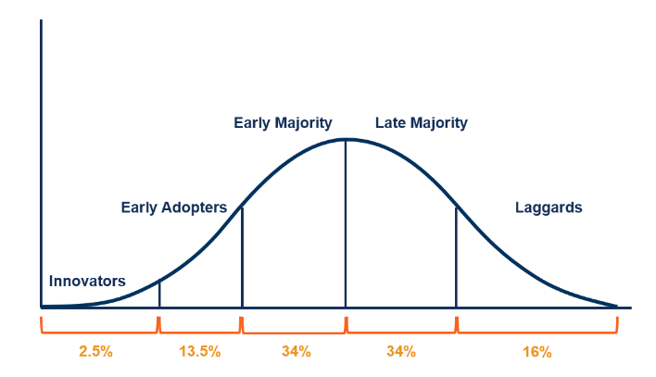
Figure 1: Diffusion of innovation theory
(Source: Corporatefinanceinstitute.com, 2022)
The distribution of the percentage of the population that can be expected to fall into each category is not the only challenge that the DOI theory can solve. The DOI theory also proposes that there are five factors which influence the adoption of a new idea (Marak et al. 2019). Therefore, in assessing the feasibility of investing in an idea, entrepreneurs must also assess the diffusibility of the new idea.
- Relative advantage: This factor determines how much a new idea can replace a previously existing idea; the term can also be extended to processes and products.
- Complexity: This factor represents the degree of difficulty that adopters are likely to face when adopting a new idea (Corporatefinanceinstitute.com, 2022).
- Compatibility: Compatibility is a term that represents the degree of alignment of the new idea with the needs, ideals, and experiences of the adopter.
- Observability: This term represents the ability of a new idea to provide tangible results.
- Trialability: This factor assesses how much a new idea can be experimented on or tested before the decision to adopt it is made (Corporatefinanceinstitute.com, 2022).
The views presented in the DOI theory might not be completely true because the DOI theory does not consider the social support systems or a participatory approach to the adoption of new ideas (Corporatefinanceinstitute.com, 2022). The DOI theory also seems to work better for the adoption of new behaviours rather than the prevention of behaviour.

Industrial revolutions
Industrial revolutions have taken place since the early industrial activity, and each time an industrial revolution takes place, the process in the industry undergoes significant changes. There are a total of four industrial revolutions that have taken place until today.
The first industrial revolution took place in 1765 when the discovery of coal led to a change in the economy of human civilisation (Sustainability-success.com, 2022). With the introduction of coal, human beings were able to generate power or electricity. The generation of power or electricity is the first step in the mass extraction of energy, and it led to the development of industrial activity in the steel sector. The steam engine was a product of the discovery of coal, and other machinery were being introduced as a result, such as looms and spinning machines (Sustainability-success.com, 2022). These developments led to a drastic change in the way that the human population considered changing and moving goods around. Therefore, thermal power was the cause of the first industrial revolution.
In contrast, the second industrial revolution took place because of the discovery of electricity, oil and gas. The first and the second industrial revolutions were a century apart, with the second industrial revolution coming in 1870 (Sustainability-success.com, 2022). With the introduction of new fuels, the transportation sector boomed, and there was a possibility of mechanised transportation in the air and on the land (Pardi et al. 2020). The discovery of the car and the plane offered new ways of moving goods from one place to another. Chemical and steel products boomed in the market (Sustainability-success.com, 2022). The second industrial revolution also saw the mechanisation of the production or assembly line leading to the discovery of mass production.
Another hundred years apart, in 1969, the third industrial revolution took place, and it was led by the discovery of nuclear power (Sustainability-success.com, 2022). The introduction of the integrated circuit mimicking a fundamental block of the computer was a great invention that also took place in this period and increased the possibility of robots that could perform work that would previously require labour (Pardi et al. 2020). The nuclear arms race between the superpowers of Europe, the United States and Russia were the main reason for conflict in world politics. Automation was seen everywhere, from production lines to robots replacing labour in repetitive tasks.
With the third industrial revolution, the room was open for further development in technology, and eventually, it came in the year 2000 (Pardi et al. 2020). During this time, renewable sources of energy were also discovered, leading to an increase in the adoption of alternative energy and digital systems for communication. Real-time connectivity was enabled by the technology of the internet of things (IoT), artificial intelligence and cloud technology. Organisation increasingly relies on data today, which are collected by IoT systems. In addition, the data can be monitored and analysed with the help of artificial intelligence to make real-time predictions (Pardi et al., 2020). The cyber-physical systems allow for intelligent systems and robots to be deployed in the organisational workplace, removing human monopoly over complex jobs (Pardi et al. 2020). As the technology is refined, more autonomous agents are deployed to remove human labour from complex jobs in the workplace. Big data systems provide information about the patterns of data that managers and leaders use to make operational or corporate decisions, respectively. Organisations are becoming intelligent because of Industry 4.0 technologies (Pardi et al. 2020).
The overview of the industrial revolution provides a glimpse of the positive and negative aspects of the industrial revolution. Whenever an evolution in technology comes along, such as the internet, there are widespread changes to the process capabilities of an organisation. The advancement of technology, resource efficiency, dependency on human labour and reduction of environmental impact have all been observed to have been an effect of the fourth industrial revolution (Pardi et al. 2020).

Types of organisational change
Organisational change arises from the need for an organisation to adapt to the changing internal and external environment of an organisation. The reason why organisational changes are relevant in modern businesses is because of the significant threats that the external environment poses to a business's profitability. Organisational change can be studied from an organisational process perspective or an individual perspective. Like in the DOI theory, organisational change theories also adopt crucial principles of psychology to determine the path that organisations should take to deliver organisational change successfully (Alhezzani, 2020). Managing change is crucial because often, more than one external factor might be affecting the organisation. Therefore it is necessary to identify the causes of the organisational change and address them through strategic realignment, change in processes, or the adoption of new technology (Alhezzani, 2020). Organisational change can be of different types.
Organisational change is principal of four types, incremental or radical and anticipatory or reactive. The four types of organisational change are known as tuning, reorientation, adaptation, and recreation (Alhezzani, 2020).
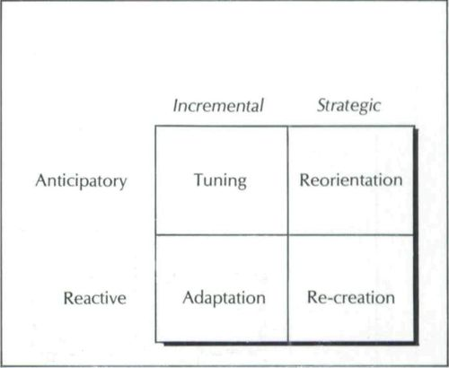
Figure 2: Types of organisational change
(Source: Alhezzani, 2020)
The anticipatory and incremental change type is called tuning. Tuning refers to the organisational change that is common during periods of low uncertainty (Akingbola et al. 2019). Organisations can monitor a few variables that affect the business and anticipate adverse changes. By doing so, organisations can deliver change in a planned manner with small incremental steps to ensure that the impact of change on the workforce is minimised. Tuning is the ideal way to change an organisation, but it can not always be relevant (Akingbola et al. 2019). In the contemporary world, incremental change is finding very low relevance because of the large number of external factors that are affecting businesses. Incremental change is slow, and it has a long-term effect on the organisation. Business leaders of today are more inclined to suggest transformational or radical change over incremental change because the organisation needs to make sure that the organisational change has an immediate impact on the organisation. The question of ethics arises in transformational change because the impact that it has on the workforce can lead to damage to the internal organisational environment (Tamunomiebi and Akpan, 2021). Since organisational change leads to the introduction of new and disruptive technology or change in processes or ideas, the work environment is altered drastically in transformational change. If organisational change is anticipatory, then there is a possibility that the workforce in the organisation will be able to control the change in a way that can smoothen the delivery process of the change (Obina and Adenike, 2022). However, if the organisational change is reactive, then there might not be a significant time for the organisation to plan a strategy and implementation/action plan to guide the organisational change process (Obina and Adenike, 2022). As a result, the impact of the organisational change is much higher in the case of unplanned change as opposed to planned change.
Depending on the parts of the organisation that is affected by the change, there can be strategic, people-centric, structural or technological change (Sklyar et al. 2019). The strategic change in the organisational or corporate strategy affects the organisation from a very high point of view. Structural or people-centric changes are two types of change that affect the organisational power structure or managerial structure and the behaviours and abilities of the workforce, respectively (Sklyar et al. 2019). Finally, there is a technological change which has to do with the changes to the technological tools and infrastructure that are present in the organisation. The problem with this classification is that although it has relevance to understanding the influence of change in the organisation, it does not classify change as in the previous model (Sklyar et al. 2019). In most cases, organisational change will likely influence more than one of these areas, people strategy or technology, as they are connected in an organisation.
Organisational change can be described as a developmental, transitional or transformational change. This classification is based on the general purpose of the change and how it will affect the organisation. In developmental change, the change is directed towards the development of capabilities or resources of the organisation to ensure that the organisation can overcome barriers to productivity or profitability (Waddell et al. 2019). Transitional change is characterised by the organisation moving from one state to a different state (Waddell et al. 2019). Transitional change is said to take place when an organisation takes small change initiatives to reach a predetermined final state. The final state of the organisation is defined by the strategic direction and objectives of the company. Transformational change is a type of organisational change which is conducted when the organisation needs to change their course or strategic direction of the organisation (Waddell et al. 2019). With the change in the strategic direction, the organisation undergoes renewal and can assume a different identity that is appropriate for addressing the external factors in the business environment.

Burke Litwin model
The Burke-Litwin model of organisational change is an important change management model which indicates the relationship between the different internal, external and personal factors in the process of organisational change. The Burke-Litwin model identified the crucial factors which influence the organisational change process and the outcomes of the initiatives taken to deliver and institute organisational change in a business (French et al. 2022). Organisational change can hurt the organisation if it is not controlled by connected factors in the organisation. The Burke-Litwin model shows that the external environment factors (political, social, ethical, economic, technological and others) and transformational factors (leadership, strategy, and organisational structure), which in turn, are connected with transactional factors (structures, practices, and systems), and these are connected with internal environment or culture; and thus affects the personal factors (motivation, needs, and job requirements) (Olivier, 2018). The inter-relationship and connectedness of the different factors provide a glimpse of how an organisation can implement change. If the personal behaviours and outcomes for the workforce are to be controlled due to changes in the external environment, then it might be relevant to consider changes to different transformational, transactional, cultural and personal factors to reach a target behaviour in an organisational workforce (Olivier, 2018). [Referred to appendix 1]

Implications of theoretical frameworks on case study organisation

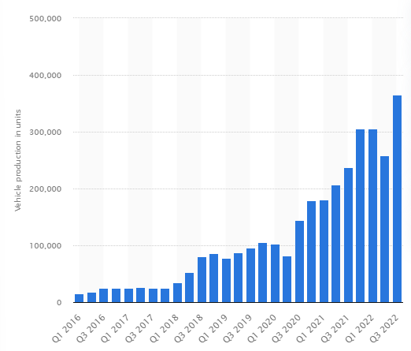
Figure 3: Output in vehicle production for the production lines at Tesla
(Source: Statsta.com, 2022)
The production volume of tesla has increased in recent years due to the introduction of new production facilities and global expansion of the company. The interesting fact in Tesla's journey is that the company's technology is valued very highly by the market. In owning as much as 80% of the supply chain, Tesla's market capitalisation exceeds that of Daimler, Volkswagen, and Toyota (Sull and Reavis, 2019). The strategic management framework consists of three broad processes: purpose and vision, strategy formulation, and strategy implementation (Fuertes et al., 2020). The business model of Tesla shows that the company relies on key partners such as Daimler, Toyota, Panasonic, and Nvidea to produce their vehicles. Innovation is among the key activities of Tesla and this increases the R&D cost of Tesla (Liu, 2023). [Referred to appendix 2 and 3]

Purpose and vision
The development of purpose and mission of the organisation in Tesla is something that Elon Musk (Tesla's CEO) has been largely engaged with. In the Masterplan, Elon Musk states that it is high vision to use Tesla to accelerate electrification in the automotive industry, adoption of renewable energy solutions in general, and help in the process of developing a sustainable economy or society.

Strategy formulation
The formulation of the strategy begins with an analysis of the external and internal environment. The PESTLE and SWOT analysis with respect to the global automotive industry and Tesla's position within the industry has been presented below.

Figure 4: PESTLE analysis of global automotive industry
(Source: Debnath et al. 2021)

Figure 5: SWOT analysis of Tesla
(Source: Debnath et al. 2021)
The key strategies that Tesla follows are:
- Increasing the production efficiency of the manufacturing operations of Tesla.
- Attracting new customers to the electric mobility segment through sustainable and social marketing initiatives.
- Developing new technology in-house through investment in a bid to become the first entrant to new and niche segments in the automotive industry (Debnath et al. 2021).

Strategy implementation

Impoving production proceses with technology
Tesla is a disruptive automotive company, and to prove that, it is only necessary to look at the company's production process. Tesla's production process does not employ human beings. The lack of human capital in the production process seems to be a radically new concept, but it is something that Tesla are exploring (Okanga, 2022). Industry 4.0 technologies allow robots to function intelligently. Cyber-physical systems are the next generation of technologies after automated robots that carry out production and assembly (Okanga, 2022). The cyber-physical systems provide the link between the automated robots and fulfil tasks that require intelligence, such as navigation, detection of faults and relaying communication if a mistake is encountered (Okanga, 2022). Tesla's industry 4.0 technologies are at the cutting edge of the automotive industry. Tesla is taking all the help that it can get in terms of the efficiency gains offered by the introduction of industry 4.0. Technological transformation has been at the heart of Tesla's strategy to bring capabilities across the value chain under the organisational umbrella and ensure that the maximum value can be delivered to the customer at the minimum cost (Rimmer, 2018).

Exploring new markets and applications
The predictive maintenance system offers significant advantages to Tesla because it allows the company to reduce the breakdown of machinery. Predictive systems are a feature of industry 4.0, and to implement these technologies, Tesla had to develop capabilities for developing their technology (Vazquez et al. 2018). This helped the company not only deploy CPS and predictive intelligence to the manufacturing plant but also extend the use of the technology to the car. One of the key features of Tesla's product is that it is rich in technological innovation. From smart driver assistance systems to remote calling and auto-pilot/connected mobility, Tesla offers the full range of automation services that could be offered by the contemporary technology in the automotive vehicle (Vazquez et al. 2018). Therefore, Tesla is not one to take a back-row seat, but the company is meant to lead the automotive industry towards electrification, autonomous driving, and shared mobility. In fact, in Elon Musk's Master Plan, part Deux, it was his vision that Tela should one day make an EV that is not just self-driving, but it is available to use by other customers when the car is not in use (Sull and Reavis, 2019). Elon Musk's long-term vision for Tesla is to provide shared mobility services through which it will be possible for customers to gain access to the services of mobility without having to take ownership of the vehicle (Sull and Reavis, 2019).

Continuous organisational change
The different types of organisational change have been identified. In Tesla, organisational change has a crucial role to play in the development of organisational capabilities. Tesla is continuously innovating in their product and production process, and the company does not intend on stopping until it reaches the target of product cost that Elon Musk has set for the company (Lang et al. 2021). Therefore, Tesla is continuously undergoing planned, anticipatory and incremental change in the organisation. The costs of innovation and change have affected Tesla for almost half a decade since Elon Musk took over as the CEO of the company. It was not until 2013 that the company posted its first profitable quarter. Tesla's stocks skyrocketed in the following year when the company was trading at $335 per share (Sull and Reavis, 2019). Compared with the $17 per share that the company had started with, Tesla's share price had multiplied by over 20 times (Sull and Reavis, 2019). People have doubted the company's stock for being overpriced. However, Elon Musk's visionary leadership and innovative operational processes have allowed it to grow from strength to strength. (Lang et al. 2021) Tesla's strategy and organisational structure have not changed too much. Still, the company has been able to innovate in technology which has allowed the company to become a significant power in the automotive industry.
Alternative options
Tesla embodies the concept of constructive deconstruction, which is necessary for the company to break free from the shackles of bureaucratic procedures in the automotive industry. The future that Tesla is trying to build in the automotive industry is going to lead the way for other companies in the industry.

Connected mobility
Connected mobility is an important area of automotive application that Tesla is exploring. Tesla's strategic resources put the company in an advantageous position about developing mobility solutions which can eliminate contact collisions between vehicles by connecting all vehicles to a single network that relays messages for the car to the central server and vice versa (Giust et al., 2018). Elimination of the collision between vehicles plays a significant role in the reduction of casualties and leads to an improvement in the safety of the automotive vehicle (Goggin, 2019). Connected mobility is, therefore, a crucial market that Tesla is going to explore in the future and given that the company has a head start against the key rivals with in-house software systems being developed by Tesla, Tesla will likely be revolutionising this market as well.

Shared mobility
Shared mobility solutions are being explored by many automakers as the distribution chain of the automotive industry is looking like it is going to be cut short shortly. Shared mobility is necessary for ensuring that customers can share mobility resources without actually owning a vehicle (Becker et al. 2020). While this reduces the cost of mobility, it also increases e resource utilisation efficiency. As a result, from the perspective of sustainability, shared mobility is a crucial target that the automotive industry is looking to pursue (Qi et al., 2018). However, to completely implement shared mobility, Tesla needs to change their business model and how they allow customers to access their vehicles. Therefore, it remains to be seen whether Tesla will adopt the shared mobility platform to offer shared mobility to all customers or if the company will form a partnership with suitable companies who are offering customers shared mobility services.

Autopilot
The introduction of autopilot in the vehicle is one of the bold moves that Tesla has taken in the automotive industry. The autopilot can have different levels of automation. The first stage of automation is called the hands-on scenario (Lutin, 2018). The hands-on scenario is characterised by smart or intelligent driver assistance systems which assist the driver in the task of driving the vehicle. The second stage of automation in the autopilot leads to a hands-off scenario (Lutin, 2018). The hands-off scenario is one where the driver can completely take their hands off the steering wheel but is ready to take over as soon as the system prompts. The third level of automation is the eyes-off scenario. In this scenario, the driver is capable of taking their eyes off the road completely (Lutin, 2018). However, they must be prepared for complex cases where they might have to intervene. The fourth level of automation in an autopilot is the mind-off scenario. Here, the driver completely switches off and may not have any knowledge or awareness of the road (Nees, 2019). The car is capable of both manual and automation capabilities depending on the needs of the driver. The fifth and highest form of automation is also the full automation scenario which is characterised by the absence of the steering wheel completely (Nees, 2019). In this scenario, the autopilot is fully capable of steering the car as well as any human ever could. It is Elon Musk's vision that Tesla will one day produce cars that have full automation capability.
Conclusion and recommendations
Tesla is one of the most innovative companies in the world, and they have a strong culture of innovation, due to which they are engaged in the task of developing the production or manufacturing processes in keeping with the objective of cost reduction. Tesla is an inspiration to many disruptive technology companies whose sole purpose is to create conditions in the industry that facilitates the transition or transformation of the industry. Tesla is taking the case of automation of mobility services with a great deal of seriousness, and the company has developed the capabilities of producing automation technology to be used in the vehicle. Thus Tesla's strategic path is clear, and it is to explore the possibilities of electric vehicles and accelerate the adoption of electric vehicles along with concepts such as autopilot, shared mobility, and connected vehicles. The adoption of these technologies by the customer is a challenge for Tesla. To accelerate adoption, Tesla has introduced innovations in the production process that can reduce cost and will continue to innovate and vertically integrate the production process to ensure that most parts manufactured in the house are of high quality and minimum cost to the company. The financial results of Tesla suggest that the company has solid profitability and is a good choice for investment. Tesla's position in the market as the automotive manufacturer with the highest market capitalisation is an enviable position for the auto manufacturer to be in, and it also allows the company to attract a significant amount of investment which is a positive sign for the company.
The financial performance of Tesla reveals that the company was operating at a level that is far higher than the standard that is expected from the players in the automotive business. Tesla's profitability ratios are higher than the best in the industry. At almost 25%, Tesla's profitability is almost twice that of Daimler. However, the operating margin of Tesla is again at par with industry leader Daimler at 12%. In terms of efficiency, Tesla's financial performance is just as feasible for long-term profitability as the best in the industry that is Toyota (Okanga, 2022). Toyota's inventory turnover ratio is as high as 8.4, and in comparison, Tesla comes up with 8.2 (Okanga, 2022). Therefore the company can go through a full inventory within 44 days or one and a half months. The most important part of Tesla's financial record is the company's ability to attract investment. According to financial reports, Tesla's debt ratio is less than 50% which is not that good compared to other companies such as Daimler or General Motors (Okanga, 2022). Tesla's debt-to-equity ratio is close to 1, which is not considered to be healthy because equity dilutes the owner's stake in the company. Tesla should be looking to take this value up and close to 1.5, which is considered to be a healthier debt-to-equity ratio (Okanga, 2022). The current ratio of Tesla is just short of that which is considered to be healthy. The cash ratio of Tesla is 0.92, which is in the good range.
The recommendations that can be proposed for Tesla after considering the financial performance of the company are:
- Tesla should invest less in technology and innovation since the company's ability to pay off debt with current assets is not the finest. Moreover, the debt-to-equity ratio of Tesla is too small and therefore, the company needs to look towards investment options sourced from the debt market (Okanga, 2022).
- Tesla’s strategy encapsulates what an automotive startup in the 21st century would be looking to achieve. With many fingers in different pies, Tesla is still in a primer position to enter the niche market of shared mobility, connected mobility and autopilot (Lutin, 2018). Therefore, Tesla must continue to explore the possibilities of attaining profitability from operating in these niche market segments.
- Elon Musk's vision is the key driving force behind Tesla. Therefore vertical integration and continuous incremental change in the organisation are necessary to ensure that the cost reduction strategy can achieve the targeted cost of the EV (Lang et al. 2021).

Reference List
Akingbola, K., Rogers, S.E. and Baluch, A., (2019). Organizational Change. In Change Management in Nonprofit Organisations (pp. 1-35). Palgrave Macmillan: Cham.
Alhezzani, Y.M.R., (2020). Change recipients' resistance and salience to organisational re-creation: the effects of participation and coercion strategies on change derailment. Organization Management Journal. 18(2), ppp.1-18.
Becker, H., Balac, M., Ciari, F. and Axhausen, K.W., (2020). Assessing the welfare impacts of Shared Mobility and Mobility as a Service (MaaS). Transportation Research Part A: Policy and Practice, 131, pp.228-243.
Bharadwaj, S. and Deka, S., (2021, December). Behavioural intention towards investment in cryptocurrency: an integration of Rogers’ diffusion of innovation theory and the technology acceptance model. In Forum Scientiae Oeconomia, 9(4), pp. 137-159.
Chen, J., Han, L. and Qu, G., (2020). Citizen innovation: Exploring the responsibility governance and cooperative mode of a “post-schumpeter” paradigm. Journal of Open Innovation: Technology, Market, and Complexity, 6(4), p.172.
Corporatefinanceinstitute.com, (2022). Diffusion of innovation. Available at https://corporatefinanceinstitute.com/resources/economics/diffusion-of-innovation/, [Accessed 30.12.2022].
Dearing, J.W. and Cox, J.G., (2018). Diffusion of innovations theory, principles, and practice. Health affairs, 37(2), pp.183-190.
Debnath, R., Bardhan, R., Reiner, D.M. and Miller, J.R., (2021). Political, economic, social, technological, legal and environmental dimensions of electric vehicle adoption in the United States: A social-media interaction analysis. Renewable and Sustainable Energy Reviews, 152, p.111707.
Fragapane, G., Ivanov, D., Peron, M., Sgarbossa, F. and Strandhagen, J.O., (2020). Increasing flexibility and productivity in Industry 4.0 production networks with autonomous mobile robots and smart intralogistics. Annals of operations research, pp.1-19.
French, R., Mahat, M., Kvan, T. and Imms, W., (2022). Viewing the transition to innovative learning environments through the lens of the burke-litwin model for organisational performance and change. Journal of Educational Change, 23(1), pp.115-130.
Fuertes, G., Alfaro, M., Vargas, M., Gutierrez, S., Ternero, R. and Sabattin, J., (2020). Conceptual framework for the strategic management: a literature review—descriptive. Journal of Engineering, pp.1-21.
Gayathri, S. and Kumari, D.A., (2019). Electric Vehicles-An Introduction of the Tesla for Strategy and Leadership. International Journal of Recent Technology and Engineering, 8, pp.1522-1524.
Giust, F., Sciancalepore, V., Sabella, D., Filippou, M.C., Mangiante, S., Featherstone, W. and Munaretto, D., (2018). Multi-access edge computing: The driver behind the wheel of 5G-connected cars. IEEE Communications Standards Magazine, 2(3), pp.66-73.
Goggin, G., (2019). Cars and Contemporary Communication| Disability, Connected Cars, and Communication. International Journal of Communication, 13, p.26.
Kagenaar, E., Van Hemelrijck, W.M.J., Kunst, A.E. and Janssen, F., (2022). Long-term trends in obesity prevalence by socio-economic group in five European countries and the USA: The relevance of the diffusion of innovations theory. Obesity Facts, 15(6), pp.753-761.
Keklik, M., (2018). Schumpeter, Innovation and Growth: Long-cycle dynamics in the post-WWII American manufacturing industries. Routledge: UK.
Lang, J.W., Reber, B. and Aldori, H., (2021). How Tesla created advantages in the ev automotive paradigm, through an integrated business model of value capture and value creation. Business & Management Studies: An International Journal, 9(1), pp.385-404.
Lin, P., Lu, Y. and Xu, Z., (2022, March). Tesla’s Dilemma and Future Development Trends. In 2022 7th International Conference on Financial Innovation and Economic Development (ICFIED 2022) (pp. 2174-2180). Atlantis Press.
Liu, J., (2022, December). Research on the Tesla's Business Model Analysis. In 2022 4th International Conference on Economic Management and Cultural Industry (ICEMCI 2022), pp. 828-835. Atlantis Press: UK.
Lutin, J.M., (2018). Not if, but when: Autonomous driving and the future of transit. Journal of Public Transportation, 21(1), pp.10-26.
Malerba, F. and McKelvey, M., (2020). Knowledge-intensive innovative entrepreneurship integrating Schumpeter, evolutionary economics, and innovation systems. Small Business Economics, 54(2), pp.503-522.
Marak, Z.R., Tiwari, A. and Tiwari, S., (2019). Adoption of 3D printing technology: an innovation diffusion theory perspective. International Journal of Innovation, 7(1), pp.87-103.
Nees, M.A., (2019). Safer than the average human driver (who is less safe than me)? Examining a popular safety benchmark for self-driving cars. Journal of safety research, 69, pp.61-68.
Obina, F. and Adenike, S., (2022). Managing Employee Resistance during Organizational Change: Causes and Solutions Available. American Journal of Business and Strategic Management, 1(1), pp.1-14.
Okanga, B., (2022). Radical and Incremental Innovations as Critical Leveragers of a Firm's Financial Performance: Best Practices from Tesla and Toyota. Universal Journal of Financial Economics, 1(1), pp.2-22.
Olivier, B., (2018). Psychometric validation of an Organisational Performance Questionnaire (OPQ) based on the Burke-Litwin model. Journal of Psychology in Africa, 28(1), pp.46-51.
Pardi, T., Krzywdzinski, M. and Lüthje, B., (2020). Digital manufacturing revolutions as political projects and hypes: evidences from the auto sector. Available at https://www.econstor.eu/bitstream/10419/228481/1/Full-text-paper-Pardi-et-al-Digital-manufacturing-revolutions.pdf, [Accessed 30.12.2022].
Qi, W., Li, L., Liu, S. and Shen, Z.J.M., (2018). Shared mobility for last-mile delivery: Design, operational prescriptions, and environmental impact. Manufacturing & Service Operations Management, 20(4), pp.737-751.
Rimmer, M., (2018). Elon musk’s open innovation: Tesla, intellectual property, and climate change. In Intellectual Property and Clean Energy, pp. 515-555. Springe: Singapore.
Sandefur, T., (2022). Innovation. Available at https://www.econlib.org/library/Enc/Innovation.html#:~:text=According%20to%20Schumpeter%2C%20the%20process,discovery%20adopt%20or%20imitate%20it)., [Accessed 29.12.2022].
Sklyar, A., Kowalkowski, C., Tronvoll, B. and Sörhammar, D., (2019). Organising for digital servitisation: A service ecosystem perspective. Journal of Business Research, 104, pp.450-460.
Statista.com, (2022). Number of Tesla vehicles produced worldwide from 1st quarter 2016 to 3rd quarter 2022. Available at https://www.statista.com/statistics/715421/tesla-quarterly-vehicle-production/, [Accessed 31.12.2022].
Sull, D., and Reavis, C., (2019). Tesla’s entry into the US Auto Industry. MIT Management: SLOAN Schoool, 18(5), pp.1-28.
Sustainability-success.com, (2022). Industry 1.0 to 4.0 – Brief history of the Industrial Revolution. Available at https://sustainability-success.com/industry-1-0-to-4-0-2-3-revolution/, [Accessed 29.12.2022].
Tamunomiebi, M. and Akpan, E., (2021). Organizational Change and the Imperatives of Managing Employee Resistance: A Conceptual Review. Journal of Strategic Management, 6(1), pp.18-32.
Vazquez, M., Hallack, M. and Perez, Y., (2018). The dynamics of institutional and organisational change in emergent industries: the case of electric vehicles. International Journal of Automotive Technology and Management, 18(3), pp.187-208.
Waddell, D., Creed, A., Cummings, T.G. and Worley, C.G., (2019). Organisational change: Development and transformation. Cengage AU.

Appendices

Appendix 1: Burke Littwin model
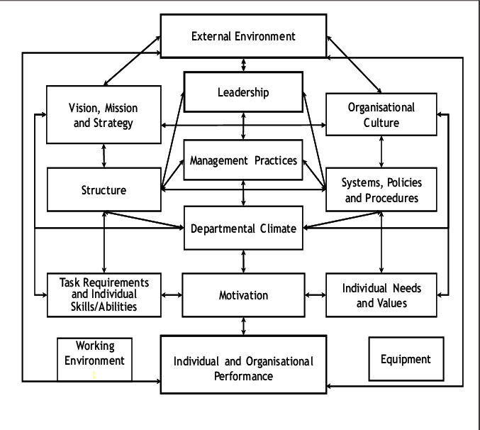
(Source: Olivier, 2018)

Appendix 2: Stratgic management framework
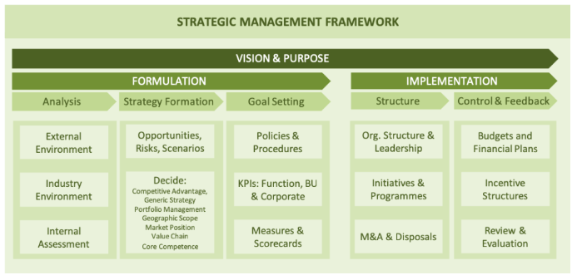
(Source: Fuertes et al. 2020)

Appendix 3: Teslas business model canvas
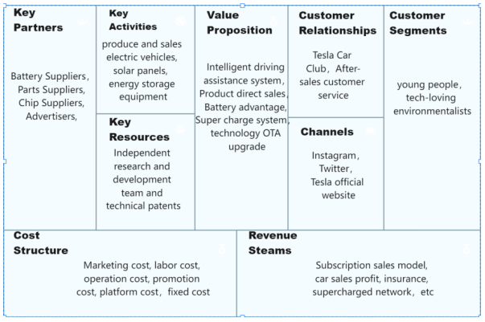
(Source: Liu, 2023)

