Brussels Package Tour

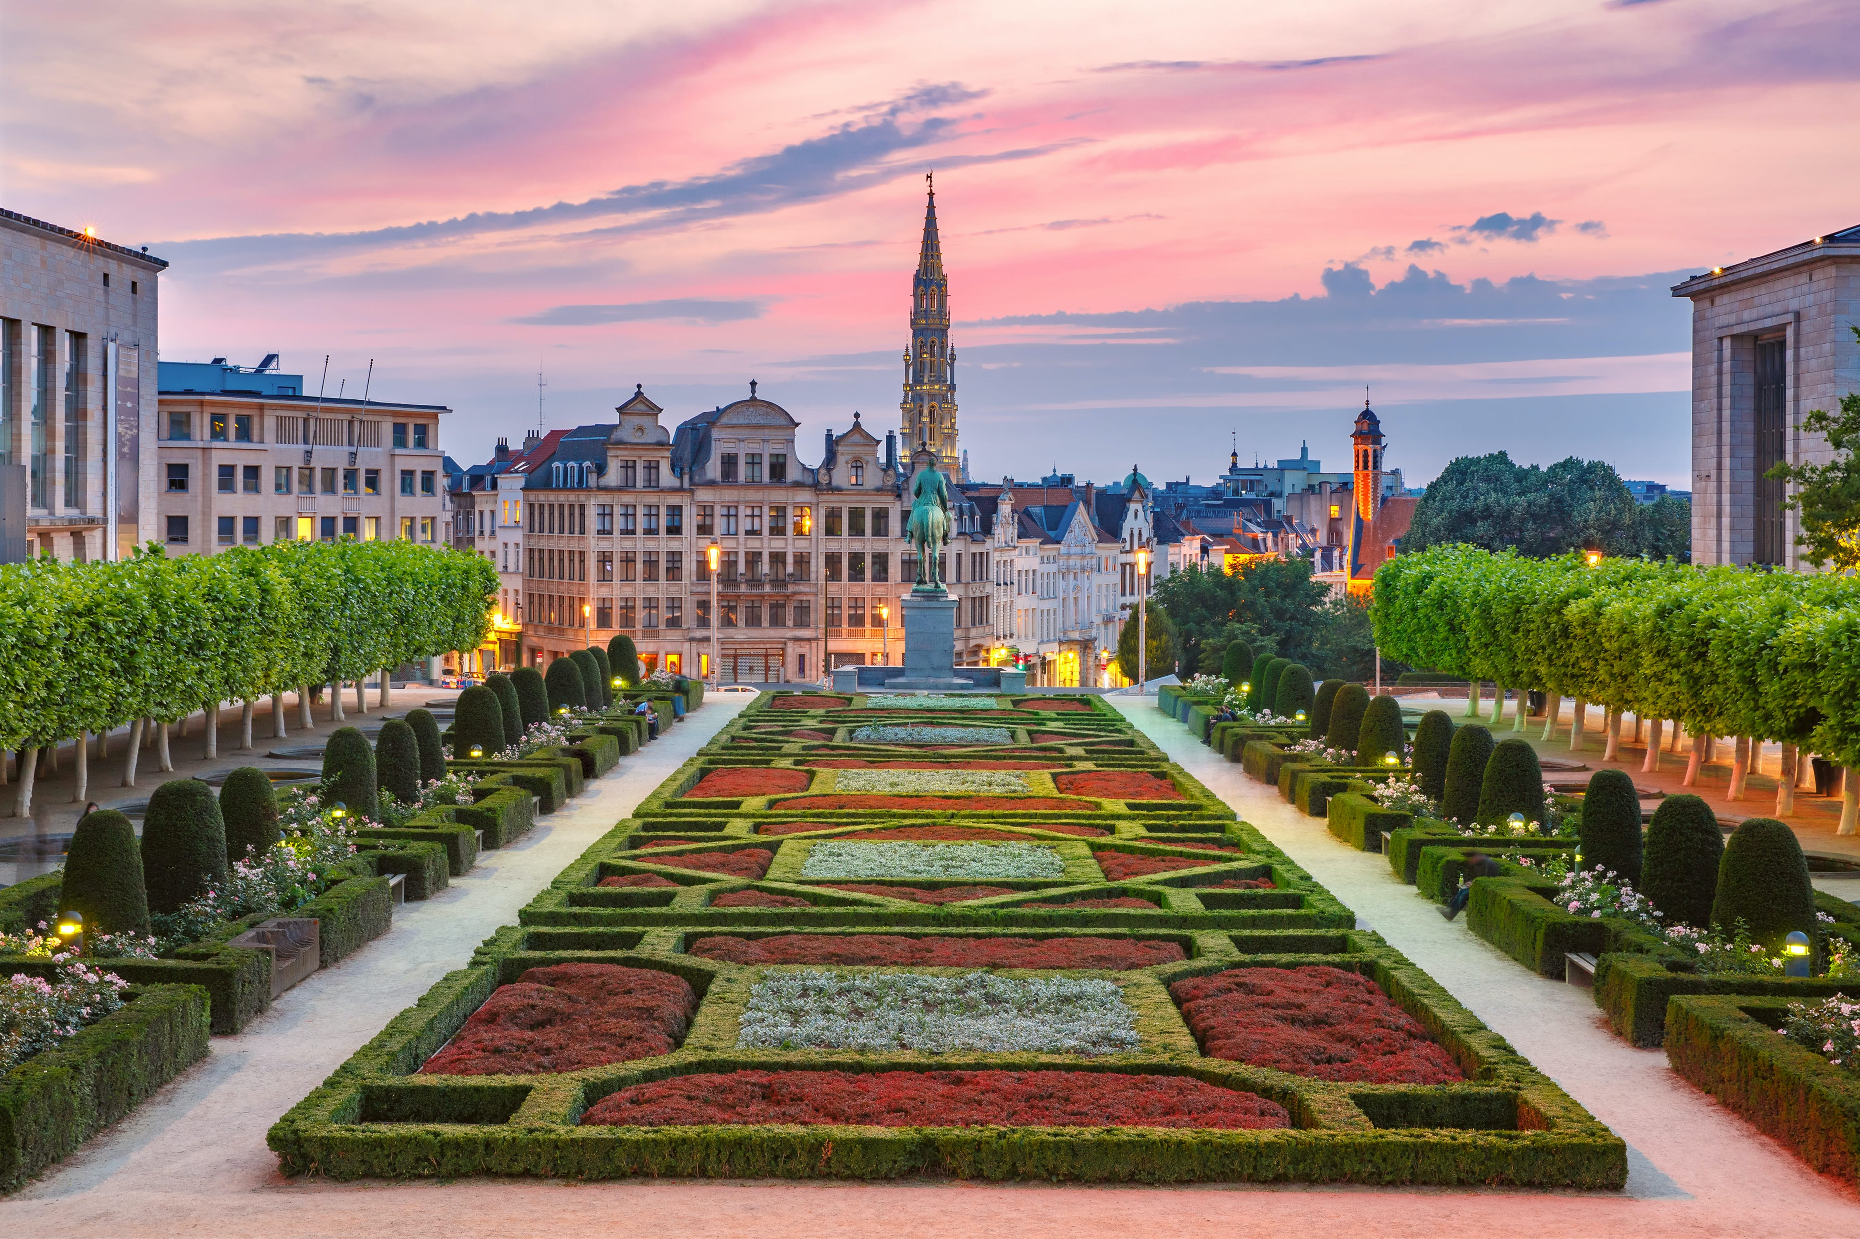
https://www.lonelyplanet.com/amp/articles/best-time-to-visit-brussels

Contents

Aims and Objectives…………………………………………………………………………………1
Pricing……….…………………………………………………………………………………………….2
Data Protection………………………………………………………………………………………2
Insurance……………………………………………………………………………………………….2
ABTA………………………………………………………………………………………………………3
Risk Guidance…..…………………………………………………………………………………….3
Target Market……………………………………………………………………………………..4-5
Itinerary………………………………………………………………………………………………6-7
Terms and Conditions……………………………………………………………………………..8
Screenshots.………………………………………………………………………………………9-16
References………………………………………………………………………………………17-18

Brussels trip – 17th to 20th January

Aims and Objectives
The aims of this package tour are to create a specialised and unique trip for twelve art and design students and three lectures from the Gower College Swansea.

This trip is intended to show students the different aspects of art in Brussels and the importance on how it can influence their studies and future careers. It has been shown that museums and tours can help to develop a student’s learning experience and gain a different perspective for their studies (Griffin J., 2004). To achieve this aim, the tour will include an Art Nouveau walking tour which will show students only a few out of the thousands of houses that were built in Art Nouveau style throughout Brussels in the late 19th century.

Another aim of this trip is to educate students about the history of Brussels as it is a very diverse city, with Dutch speakers in the north and French speakers in the south (De Vries, A., 2003). As Brussels is in the middle, it is full of different people and is a multi-cultural city, so is vital that the students learn about the history.

Pricing
Excursions - £37 per person
Train (return) - £201 per person
Hotel (3 nights) - £150 per student/ £380 per teacher
Insurance - £21 per person
Total - £369 per person

Customers are required to pay 40% of the total price as a deposit when booking, e.g., £2214 for this booking. Then the company will request the rest of the money to be paid a week before the trip e.g., £3321. If customers wish to book over the phone, the company will take debit and credit card payments (including American Express, Visa and Mastercard cards) and if you book in store, the company will also accept cheques.

Data protection
World travellers is a registered data controller; therefore, the company may keep personally identifiable information from each customer relating to you, e.g., your name, address, telephone number. You can agree to them using such personal information as necessary when booking. Your information may then be used to send you marketing and informational material on our different products and services that is relevant to you.

Insurance
Quote - £21 per person
Included –
- Emergency Medical and Repatriation Expenses (Not Private Health).
- Cancellation (due to illness e.g., Covid).
- Hazardous Activities Category A (Fell walking/any sports, not including extreme sports).
- Terrorism (Covers prepaid transport, accommodation, and prepaid excursions if act of terrorism occurs within a 40-mile radius of the accommodation).

ABTA
ABTA is a trade association for travel agency’s, tour operators and for the broad travel industry. They provide businesses and traveller with support and guidance. They provide protection financially if a member of ABTA goes out of business. As described by ABTA ‘Together with our members, we help you Travel with confidence’ (ABTA 2022).

Risk Guidance
To ensure that students stay safe throughout their stay in Brussels, the company provides a guidance that staff can follow in terms of Covid-19.
- Only private excursions are arranged.
- Scheduled time at each excursion and indoors.
- Making sure all students and staff attending, take a Covid-19 test before they leave.
- The Belgian government have eased their Covid-19 restrictions.
- Demonstrations often take place in Brussels around transport hubs, so it is very important that you move away quickly if there are signs of disorder.
- Crime rate is fairly low is Brussels but it is recommended that all travellers take sensible precautions to protect themselves.

Target Market
For this trip, it is aimed towards college students and tutors with around 12 students booked on and 3 tutors attending as supervisors. It is for art and design students to get more knowledge and understanding about the art district of Brussels and get to know about their culture and heritage.

Students attending this trip will be aged between 16 to 18 years old, meaning that although some may be legal to drink alcohol, we have not organised any excursions or activities that include the serving of alcohol as there are under 18s also attending. There will be 9 female students, 3 male students attending with all 3 staff being female. This trip is aimed at this age group as there will be activities such as art tours, chocolate tours and activities for under 18s to enjoy.

This trip has assumed there will be 3 tutors attending as supervisors, to ensure the under 18s are not travelling/booking alone as they are forbidden to. The leading name will also be the one who we will contact, and they are permitted to inform everyone else travelling the information provided.

The trip is exclusively for the art and design department at the Gower College in Swansea. As the travel agency is based in Swansea, they are easily accessible to visit the store and chat with the agents. Similarly, the travel agents at the store are more than happy to visit the college and set up a talk with students, tutors, and parents about the trip and what it will entail.

This educational trip will be marketed in brochures which will be placed in the travel agency store, in public libraries and high traffic locations like in local parks as well as in colleges, specifically Gower College as this is who we want to market towards.

As many know, marketing is a very important step in promoting and selling a business or holiday, so having the knowledge on how to market to a select group, in this instance a college, is vital. One of the more popular strategies is Kotler (2012) ‘winning marketing practices’ that is made up of nine different strategies including a very important one being ‘Win through adaptation and customisation’. This essentially means that choosing a specific group to market to and customising the trip to fit their needs will make the consumer keener to book with that company. As well as this, McQueen J. & Miller K.E. (1985) suggest there are three criteria’s to help evaluate the attractiveness on the market, Accessibility meaning how easy is it to find the brochure, phone number, address etc., variability meaning is there anything different about this trip that other companies do not promote and profitability which in this case does not apply as the college trip is a non-profit trip and is for educational purposes only.

Itinerary

Day 1 – Travelling
Swansea to London Paddington (10:23am – 13:12 £60 return pp)
London Paddington to London St Pancras (tube)
London St Pancras to Brussels (15:04 – 18:05 EU time £104 return pp)
Walk from train station to Best Western City Centre Hotel (£150 per student)
Best Western City Centre – Walking distance to city centre
3.5 stars
3 x Family Room
1 x Triple Room
Free Cancellation/ Free WIFI
Metro – 1 minute walk away
Free to look around area of hotel in small groups

Day 2 – Sightseeing
Art Nouveau walking tour (2 hours 30 minutes)
Meet outside hotel at 9:15am
Metro to city centre
Meet tour guide outside City Hall at the Grand Place of Brussels at 9:45am
Guide will be recognisable with their white umbrella with Bravo Discovery logo
Tour will end outside former home/workshop of Victor Horta (Horta Museum)
£15 a ticket pp
Free to get lunch in small groups
Meet back up outside City Hall at 2pm
Walk to Grand Place to meet tour guide for chocolate tasting tour
Duration of tour, 2 hours
Get to know about the home of chocolate
Free to look around city centre at 4pm
Meet back up at 6:15pm outside Le Bistro – Porte de Hal Restaurant
Reservation for 6:30pm for 15 people
Metro to Hotel 9pm

Day 3 – Sightseeing
Mini-Europe and Atomuim tour (2hours)
£22 a ticket pp
Meet outside hotel at 9am
Walk to metro station and get off at Heizel station (23 minutes)
Walk to Mini-Europe for tour at 10am
Then over to Atomium (Design Museum) for tour
Finish tour at 12:30pm
Free to get lunch in small groups
Meet back up at Town hall for 2pm
Walk around Town Hall and Grand Place as a group
Walk over to St Michael and St Gudula Cathedral to look around
Table booked at Scott’s Bar & Kitchen for 6pm
Day 4 – Travelling
Meet outside hotel after checking out at 11am
Brunch at Le Pain Quotidien for 11:30am
Metro to Brussels train station
Brussels to London St Pancras (14:52 – 15:57 GMT)
London St Pancras to London Paddington (tube)
London Paddington to Swansea (16:48 – 19:32)
Arrive back at Swansea station at 19:30

Brussels Package Trip Contract

Terms and Conditions –

When booking the trip, the company will only deal with the lead traveller who must be 18 or older. Anyone under the age of 18 must always be accompanied by an adult and are not able to book under their name.

All information must be correct, and pax must pass on any information given to everyone travelling. All pax must obey all passport and visa requirements e.g., passport must be in good condition and travel documents must be correct and kept safe. The lead pax is required to say if anyone attending the trip is not self-reliant and/or has reduced mobility at least 48 hours before the trip.

As this is a pre-planned trip, there cannot be any changes made to the excursions or hotel; however, if any pax would like to make changes to the room there will be a fee and therefore will have to pay the difference. If any pax would like to change the dates, there will also be an additional fee from the train providers that will have to be confirmed when booking. If someone does not attend, the price per person may go up a certain amount. Some of the excursions may not be refundable. If the pax cancel or change the booking less than 14 days before the trip, there will be a 100% fee of the holidays price.
The company is unable to serve anyone alcohol under the age of 18 (this includes on excursions and at the hotel).

Signature ……………………………………. Date …………………….
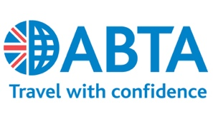

Screenshots

Options that were not chosen and why –

These train times were not selected as they were inconsiderate times for all PAX to arrive to the station for as well as being too expensive at £90 instead of the cheaper option of £60 return.

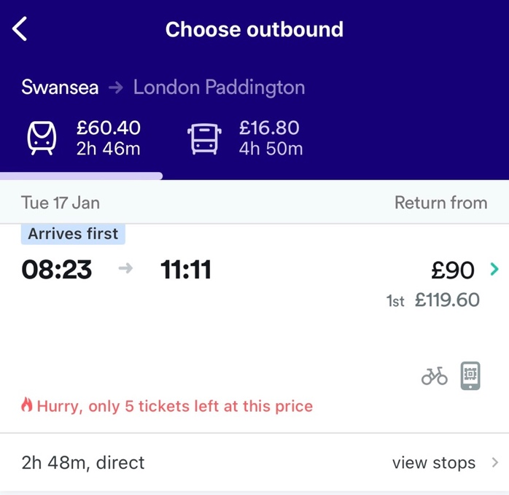

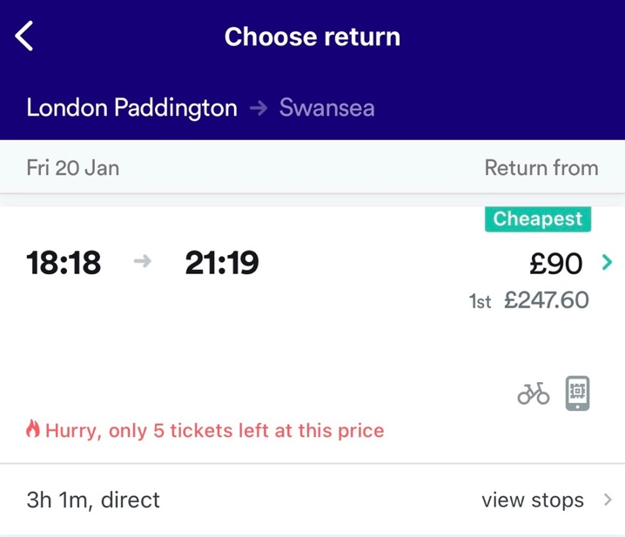

These other train times were not chosen as it would mean the PAX would have to wait 2 hours before getting on their connecting train from London St Pancras to Brussels. As well as this, the times returning from Brussels to London St Pancras were unreasonable as it would mean they arrive home at 9:30pm.

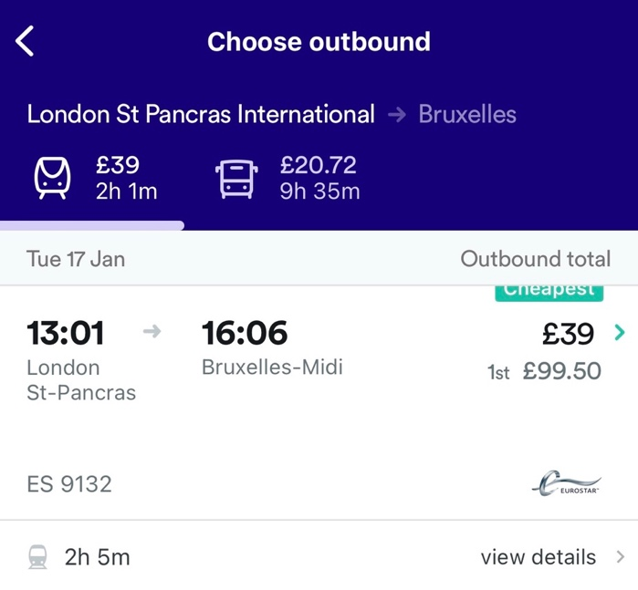

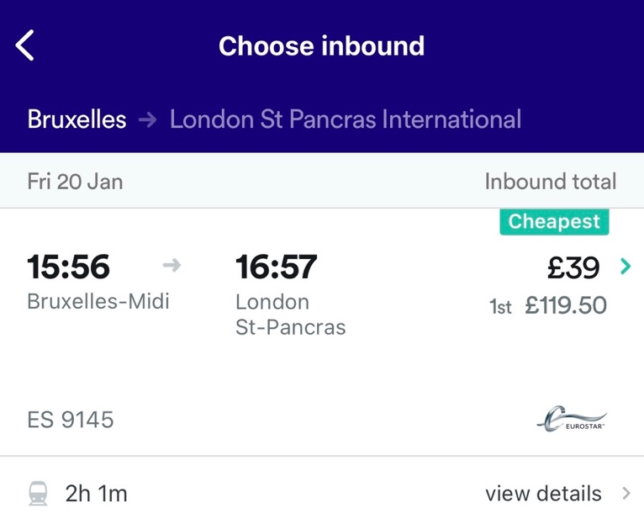

This hotel was not chosen as they do not cater towards larger groups/schools, so would be very hard to book multiple rooms under the same name. They were a cheaper option but because they do not accept large groups, it was not selected.

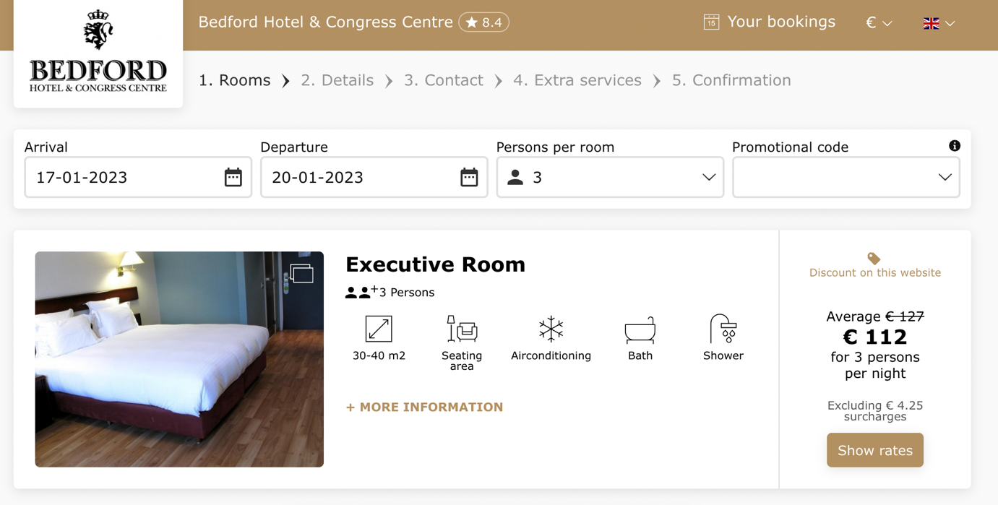

Options that were chosen -

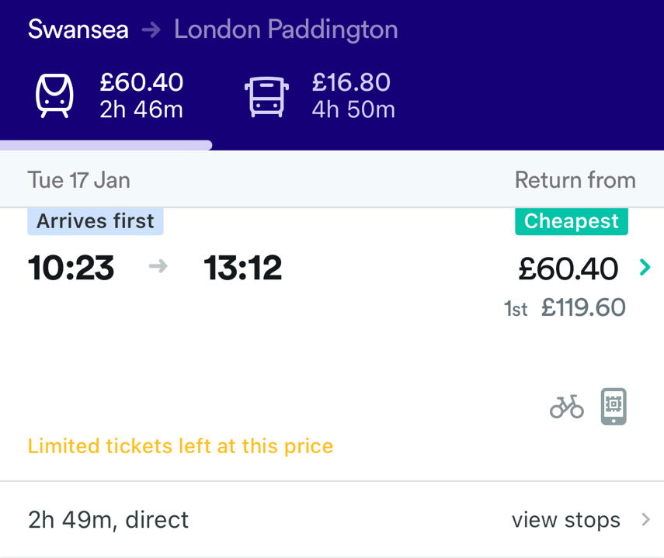

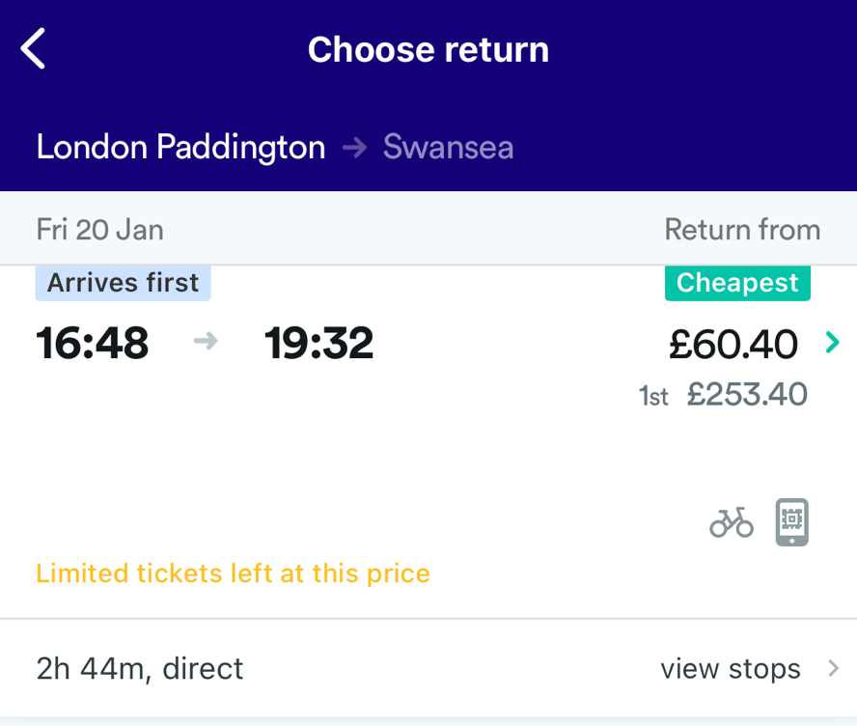
These train times were chosen as they were the cheapest at £60.40 return and are reasonable times for everyone travelling without it being too early outbound and not too late on the return.

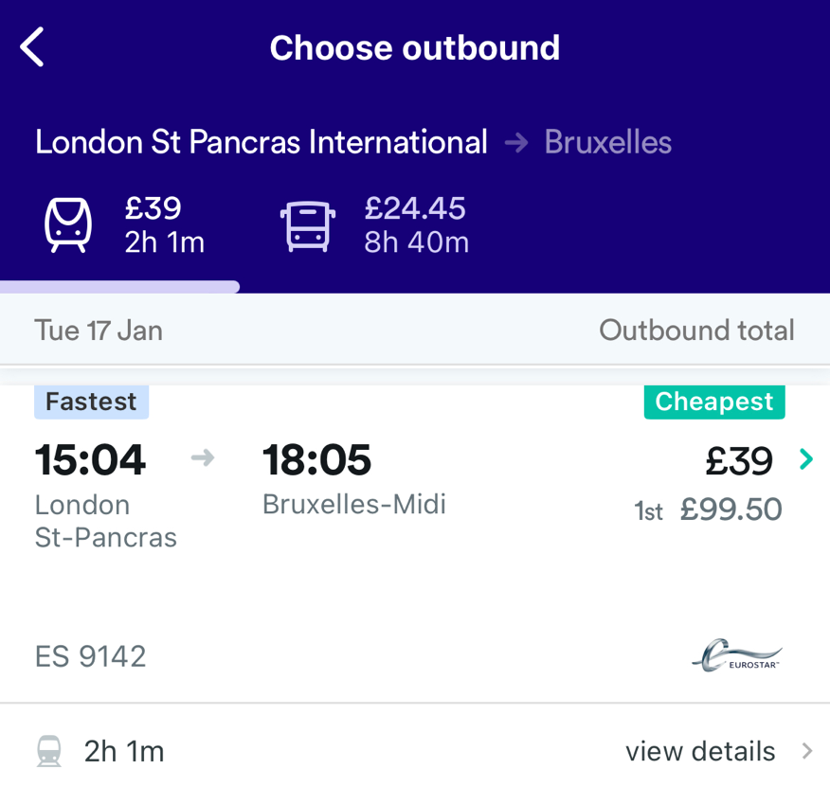

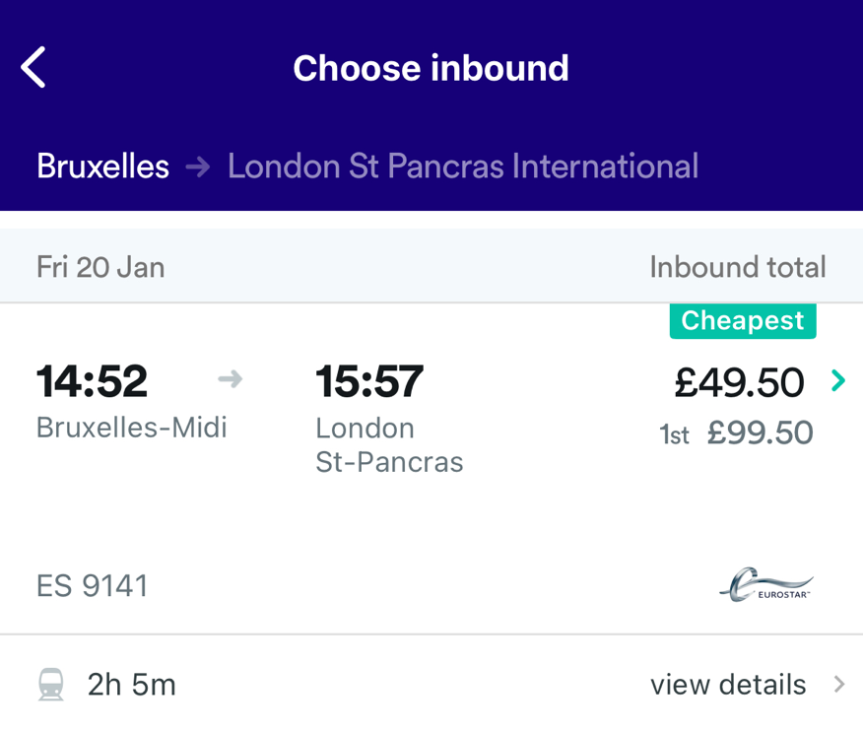
These train times were chosen as they were the cheapest and fastest direct trains outbound and inbound. The outbound train time was chosen because it was the only next available train that would match up with the train time to London Paddington. The inbound train was chosen as it would give the students and tutor time to change stations before heading back to Swansea.

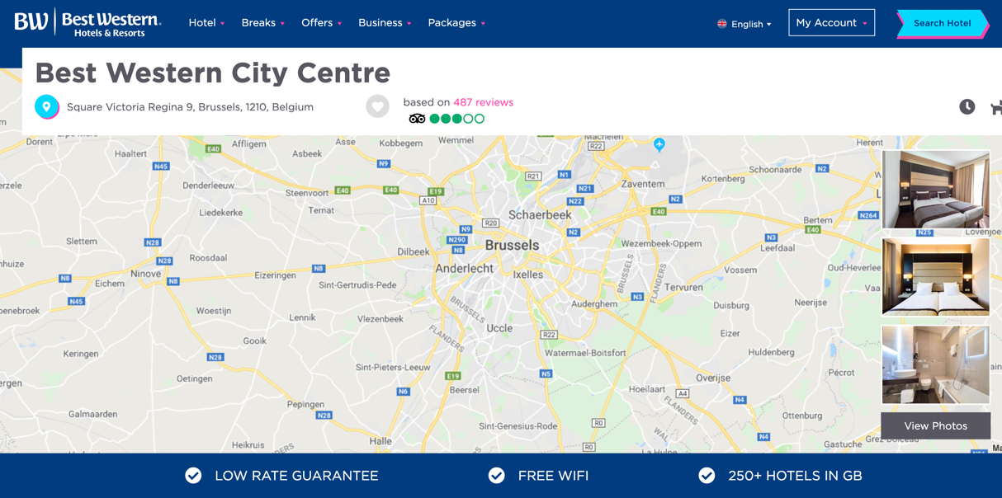
This hotel was chosen as it is very near the city centre, with a 1-minute walk to the metro station, has free cancellation, free WI-FI and can accommodate to 15 people with a rate of £110 per person for 3 nights.

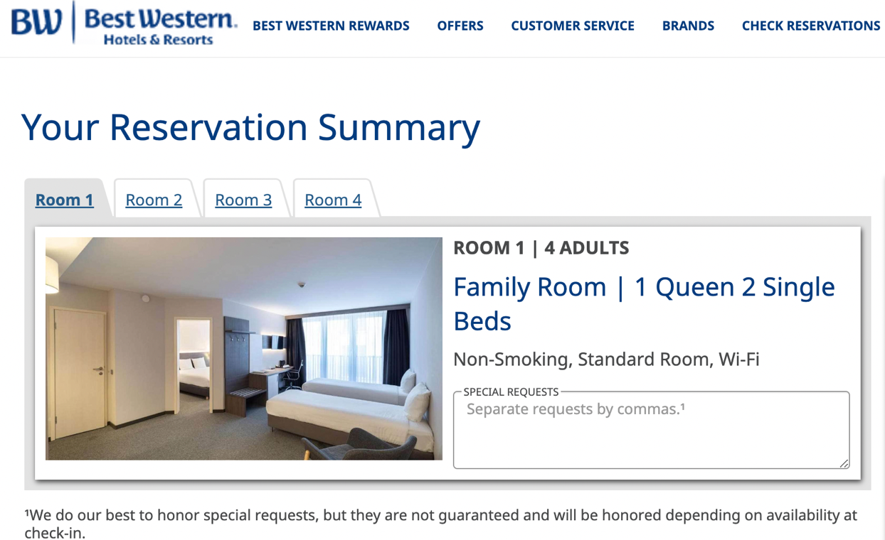

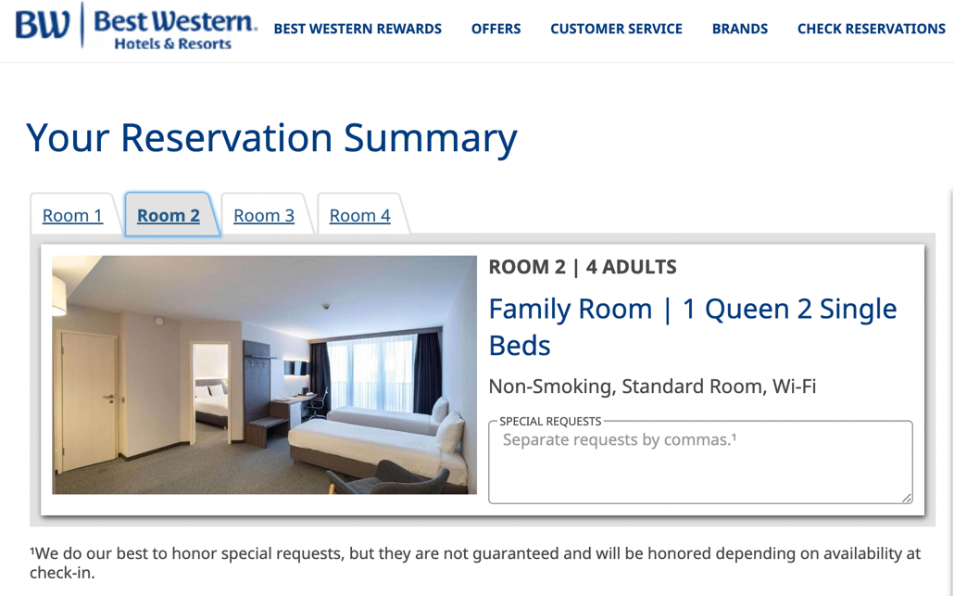

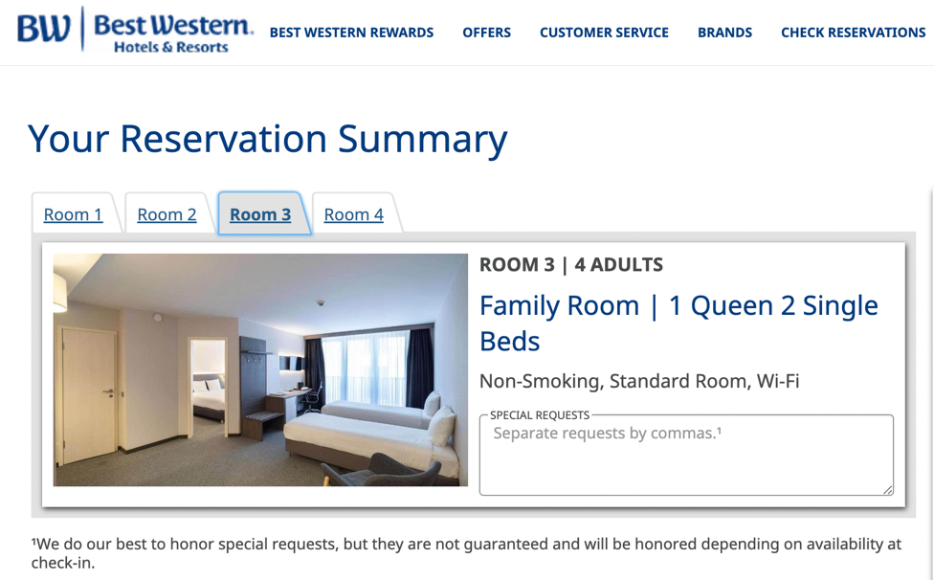
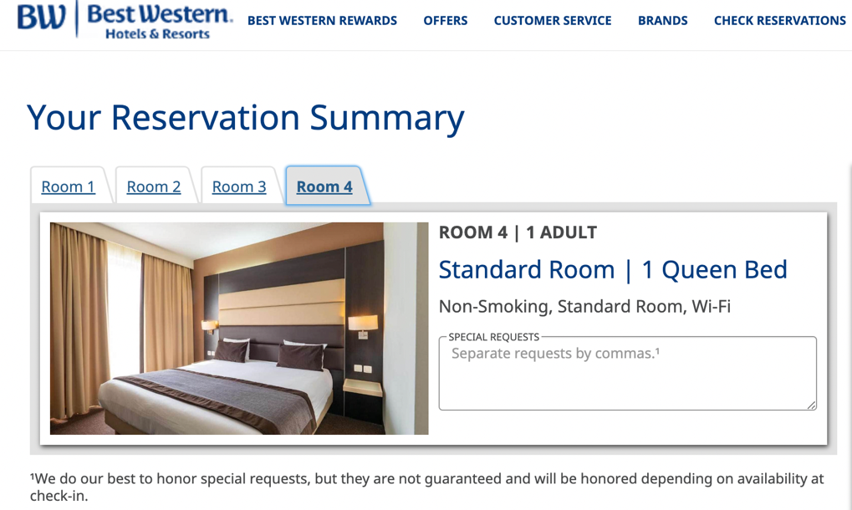

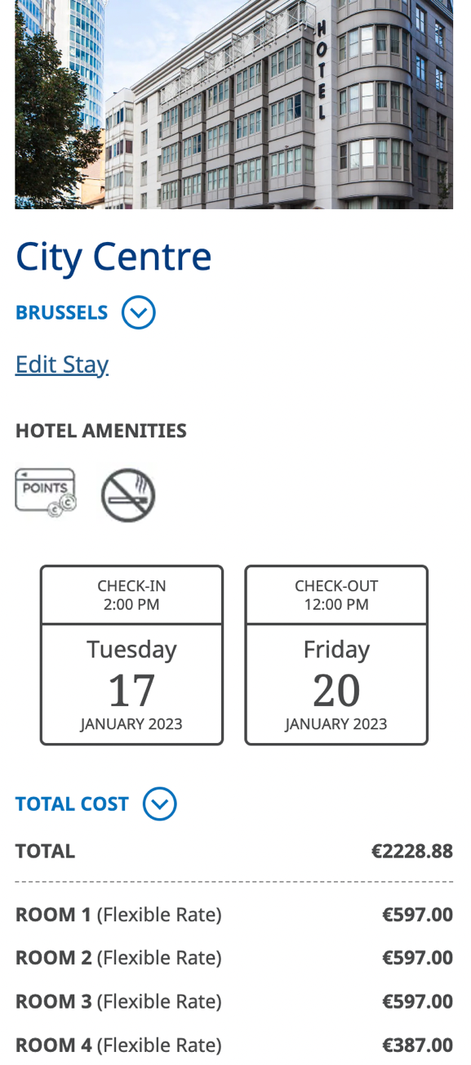

References

ABTA.com (2022) https://www.abta.com/

ABTA (2022) ABTA events booking terms and conditions. Available from: https://www.abta.com/events/abta-events-booking-terms-and-conditions [Accessed on 26th November 2022].

Bedford Hotel & Congress Centre. Available from: https://engines.hoteliers.com/en/1461/booking/getdata/arrival/17-01-2023/departure/20-01-2023/persons/3/ [Accessed on: 6th December 2022].

Best Western Hotels & Resorts (2022) Best Western City Centre, Brussels, Belgium. Available from: https://www.bestwestern.com/en_US/book/brussels/hotel-rooms/best-western-city-centre/propertyCode.92933.html [Accessed on: 14 November 2022].

De Vries, A., (2003) Brussels: A cultural and Literary History. Signal Books.

GOV.UK (2022) Foreign Travel Advice, Belgium. Available from: https://www.gov.uk/foreign-travel-advice/belgium/safety-and-security [Accessed on 1st December 2022].

Griffin J. (2004) research on student and museums: Looking more closely at the students in school groups. Science Education, 88, S59-S70.

Just Travel Cover (2022) School trip cover. Available from: https://www.schooltripcover.com/quote [Accessed on 25th November 2022].

Kotler P. (2012) Kotler on Marketing. Simon and Schuster.

McQueen J. & Miller K.E. (1985) Target Market selection of Tourists: A Comparison of Approaches. Journal of Travel research 24(1):2-6.

Musement (2022) Small-group Art Nouveau walking tour in Brussels. Available from: https://www.bestwestern.com/en_US/book/brussels/hotel-rooms/best-western-city-centre/propertyCode.92933.html [Accessed on: 14th November 2022].
PGL (2022) COVID Safe and Secure for groups. Available from: https://www.pgl.co.uk/en-gb/group-residentials/leader-guide/covid-safe-and-secure [Accessed on 1st December 2022].

Tapped Out Travellers (2022) Mini-Europe Miniature Park In Brussels, Belgium. Available from: https://tappedouttravellers.com/belgium-archive/mini-europe/ [Accessed on: 23rd November 2022].

The Brussels Times (2016) the eight most stunning Art Nouveau buildings in Brussels. Available from: https://www.brusselstimes.com/38851/the-eight-most-stunning-art-nouveau-buildings-in-brussels [Accessed on 23rd November 2022].

Trip Advisor (2022) Brussels Chocolate Tasting Tour. Available from: https://www.tripadvisor.co.uk/AttractionProductReview-g188644-d14916890-Brussels_Chocolate_Tasting_Tour-Brussels.html [Accessed on: 14th November 2022].

Trip Advisor (2022) Best Western City Centre. Available from: https://www.tripadvisor.co.uk/Hotel_Review-g1891930-d1467851-Reviews-Best_Western_City_Centre-Saint_Josse_ten_Noode_Brussels.html [Accessed on: 23rd November 2022].

TUI (2022) Our Agreement. Our Agreement for Package Holidays. Available from: https://www.tui.co.uk/destinations/booking/tandc?ptype=PDP [Accessed on 26th November 2022].

Visit Brussels (2022) Visit Atomium – Mini – Europe – Design Museum Brussels. Available from: https://ticket.visit.brussels/fr/544250/visite-atomium-mini-europe-design-museum-brussels/shop/6b578dbc-ec49-487f-bb05-3d60e28c3373/client [Accessed on: 14th November 2022].

Wikipedia (2022) Old England (department store). Available from: https://en.wikipedia.org/wiki/Old_England_%28department_store%29 [Accessed on 23rd November 2022].

