CV & COVER LETTER.
Mock Interview.
Student Name: Chene Davis
Student Number: 1914509
Module Code: BMSW4005
Lecturer: Charles Nimoh
Assignment Title: Portfolio of Work
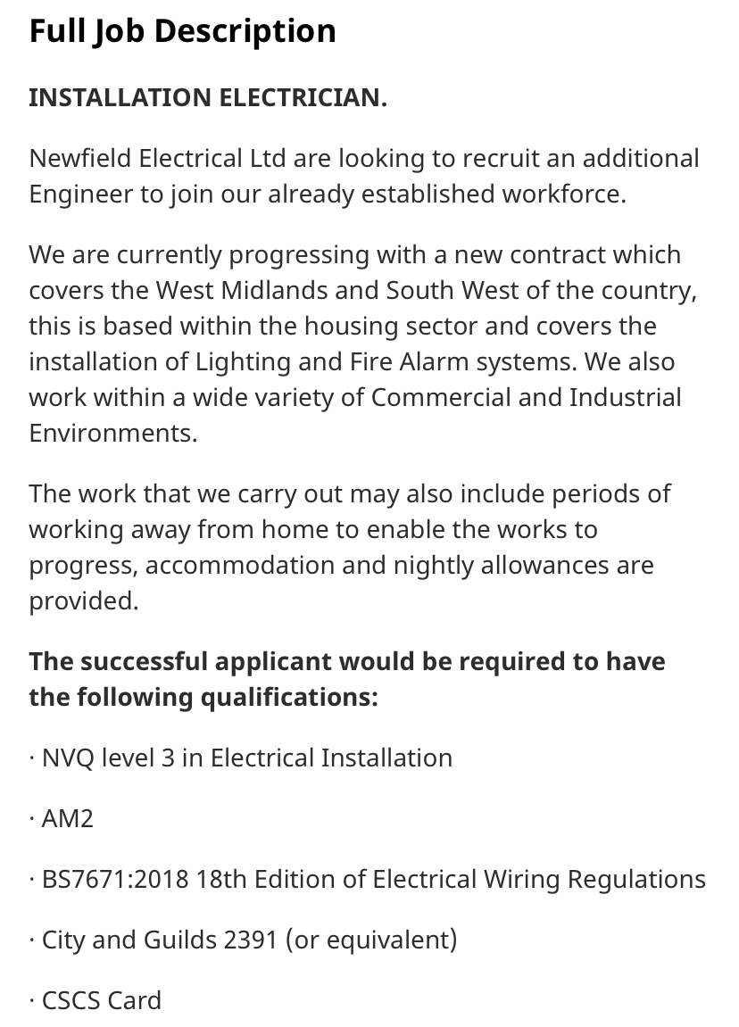
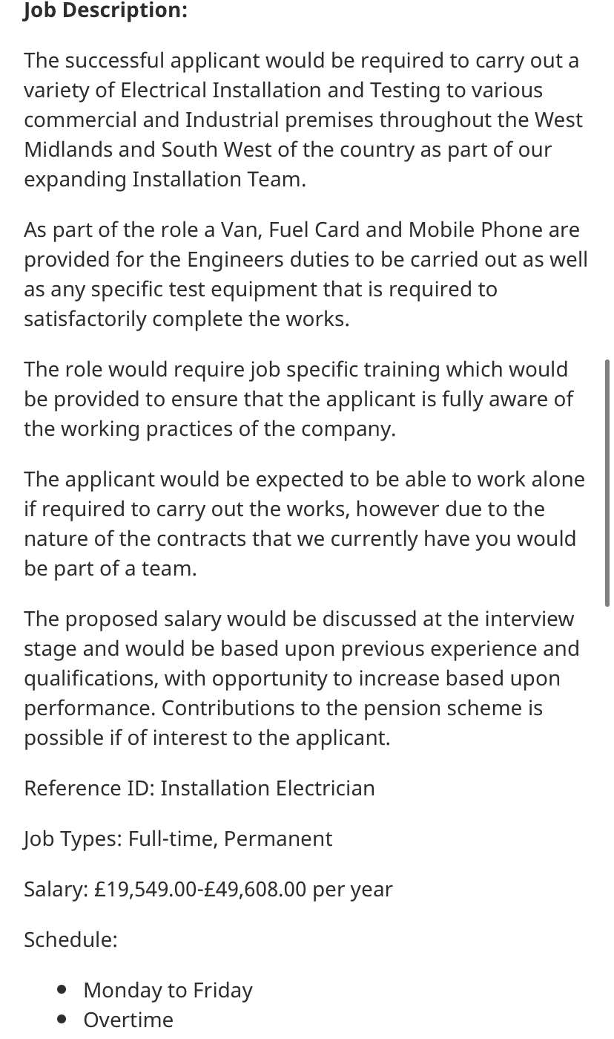
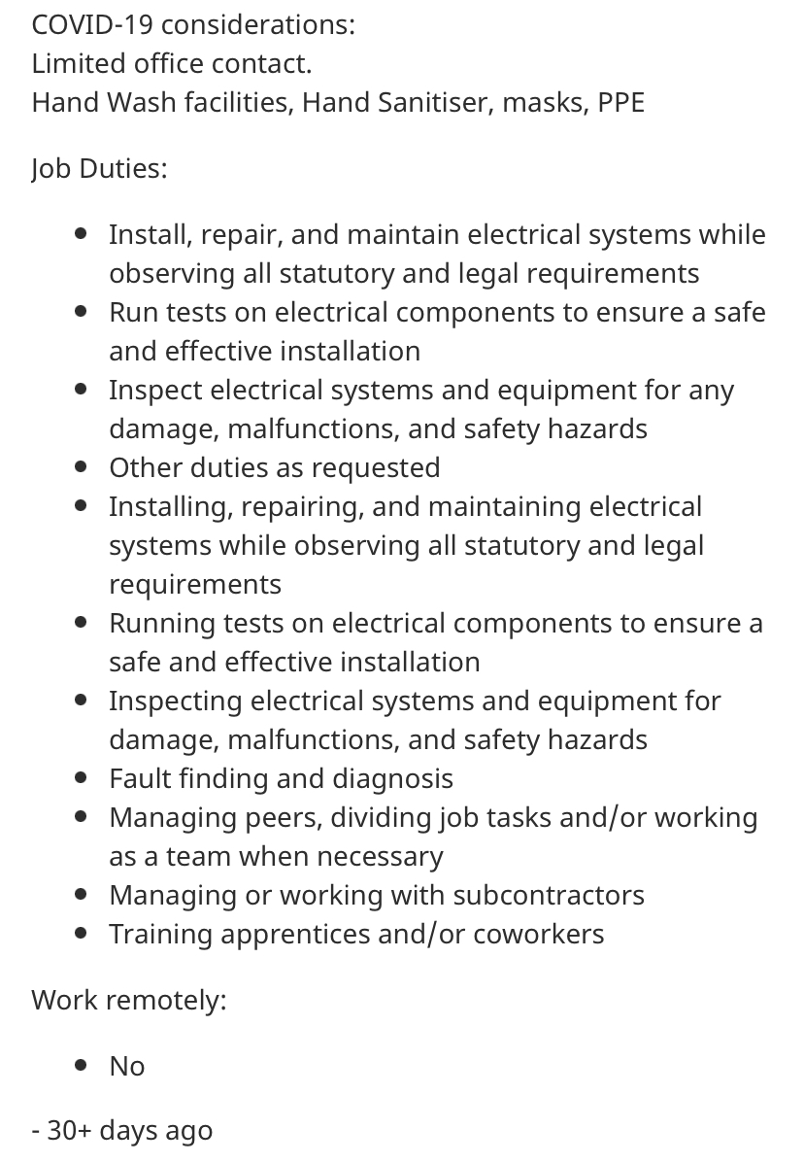
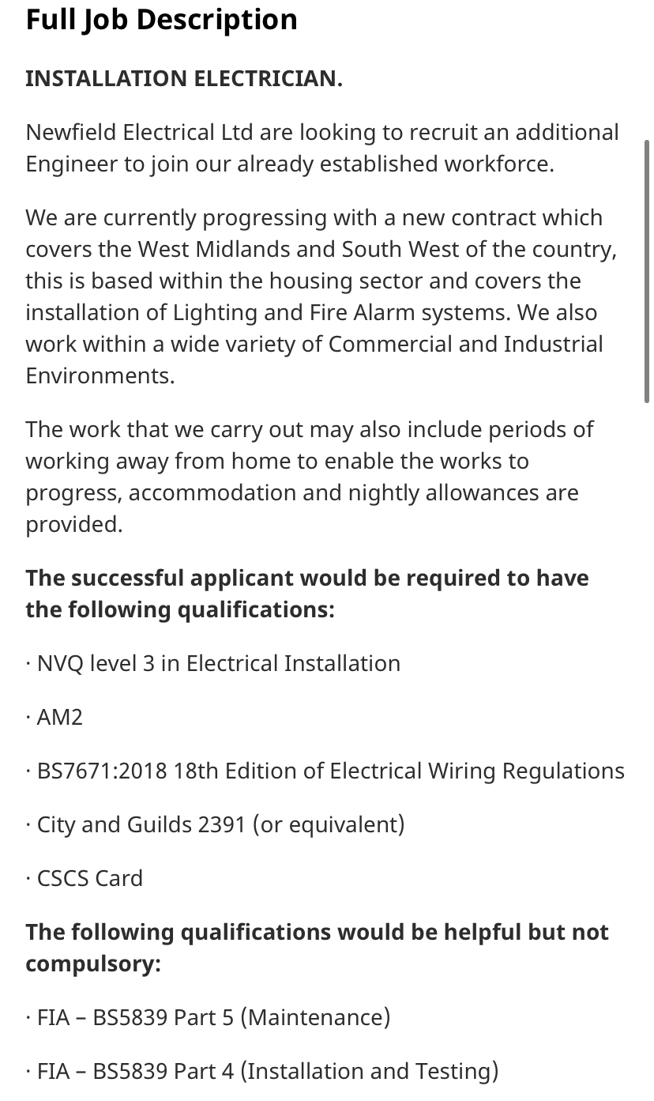

COVER PAGE
13/10/2020
Dear, Whom Concern
I am sending you this cover letter and CV regarding the position advertised on indeed. Having read the advert, I would be obliged to go forward and apply for the position of the Electrician.
As a Skilled Electrician I read your job post for a new Electrician with interest. My experience aligns well with the qualifications you are seeking at Newfield Electrical Ltd in particular my role as Electrician with JAS Electrical and I am highly certain I would make a valuable asset to your organisation and would love to bring all my skills to help Newfield Electrical Ltd.
With more than 3 experience as an Electrician I am adept in installations planning and equipment repair. While my on-the-job experience has been a delight to achieve and do. I have a well-rounded skill set including first-rate organisational and time management abilities I excel at:
- Connected wires to circuit breakers and transformers.
- Installed conduit, wire and motor controls.
- Evaluated electrical systems, equipment and components to identify and resolve defects and safety risks.
- Testing electrical equipment for performance levels and safety concerns.
- Collaborating with diverse teams of architects and engineers.
- Tracing and diagnosing malfunctions to correct issues.
- Maintaining high safety levels on all jobs.
- I am capable of installing new lighting and sockets, as well as swift diagnosis and resolution of issues. I would really appreciate the chance to share my skills and enthusiasm with you.
Due to the addition to my experience and personal qualities I have a solid educational foundation and a strong passion for quality construction. I am extremely enthusiastic about Newfield Electrical Ltd. I focus on new commercial construction and would welcome the opportunity to contribute to your continued growth and success of your business.
Please review my attached cv for additional details regarding my expertise and career achievements.
Thank you for your time and consideration.
Sincerely
Chene Chyanne Davis

CHENE CHYANNE DAVIS
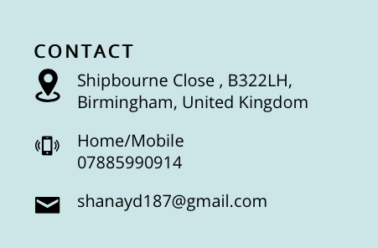
2+ years of experience. Skilled with diagnosis, repair, and installation in both residential and commercial environments. Meticulous Electrician, excellent at juggling multiple tasks and working under pressure. Broad industry experience includes Healthcare, Finance and Legal. Electrician bringing a solid understanding of mechanical troubleshooting and electrical installation techniques. Veteran Electrician with a wide-range of experience in electrical wiring and installation of electrical panels and switch boards for buildings and industrial-level projects. Electrician with wide-range of experience in electrical wiring and installation of electrical panels and switch boards for buildings and industrial-level projects. Safety-focused Electrician highly effective at testing electrical equipment and predicting possible electrical malfunctions. Electrician with extensive experience in new home construction and major commercial projects. Licenced Electrician equipped with strong hand-eye coordination and knowledge of complex wiring systems. 2+ years accurately troubleshooting systems such as EMCS and variable frequency drives. Offers unfailing direction on all electrical plans and specifications.

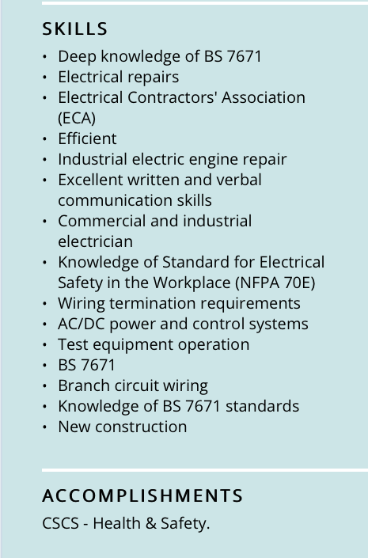

EXPERIENCE.

January 2018 – January 2019
Electrician JAS, Birmingham, United Kingdom

- Effectively worked with the team providing wiring installation, maintenance and equipment testing.
- Drafted wiring layouts and developed plans for installation, selecting equipment and fixtures according to code and project specifications.
- Identified and addressed hazards, defects and repair requirements through inspection of electrical equipment.
- Performed electrical utility services for industrial-based and new building projects.
- Traced and diagnosed malfunctions with hand tools and test equipment such as multi-meters.
- Examined and created solutions for high-voltage electrical system issues.
- Troubleshot 220-480 volt equipment.
- Reported improper conduct and events that were potentially dangerous or harmful to the supervisor.
- Worked on projects, which provided value to the department, the company, and the client base.
- Connected wires to circuit breakers and transformers.
- Installed conduit, wire and motor controls.
- Evaluated electrical systems, equipment and components to identify and resolve defects and safety risks.

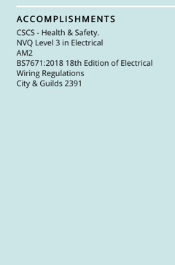

January 2019 – July 2019
Data Cabler, Birmingham, United Kingdom

- Analysed and tracked data to prepare forecasts and identify trends.
- Created reports detailing findings and recommendations.
- Designed and implemented key measurement reports for conveying metrics to customers, monitoring service levels and attainments, identifying trends and performing root cause analysis.
- Study specifications in blueprints sketches or building plans to prepare project layouts and determine dimensions and materials
- Assemble and fasten materials to make framework or props using hand tools, screws, nails, dowel pins, tie raps or glue
- Arrange for subcontractors to deal with special areas, such as DATA POINTS CCTV, Wi-Fi or electrical wiring work.
- Work with or remove hazardous materials.


January 2016 to April 2017
Caterer Bubblicious Desserts, Birmingham, United Kingdom
- Finalised banqueting arrangements by conducting thorough inspections with clients prior to event start.
- Coordinated food service stations and venue accommodation, including setup and tear-down of furniture and equipment per customer guidelines.
- Removed soiled linen, serving utensils and trays from dining areas to maintain cleanliness and organisation throughout events.
- Delivered customer service excellence by promptly filling guests' orders, communicating food requests to kitchen personnel and offering assistance ahead of requests.
- Served guest tables by transporting meals and beverages from kitchen and bar areas.
- Ensured safe and appropriate food temperatures and sanitary conditions of banqueting and food service areas.
- Thoroughly cleaned and sanitised kitchen utensils, cookware, dishes and cutlery used in food preparation and serving.
- Trained and assisted new kitchen staff members.
- Received food orders from cashiers and cooked items quickly to complete entire order together and serve hot.
- Restocked inventory and ingredients to maintain optimal kitchen efficiency.
April 2017 to January 2018
Web Designer Rank Business, Birmingham, United Kingdom
- Maintained excellent standards of service through impeccable attention to detail.
- Supported Rank Business in negotiations with suppliers.
- Managed employees, overseeing the hiring, training, and professional growth of employees.
- Delivered exceptional, friendly and fast service.
- Monitored multiple databases to keep track of all company inventory.
- Delivered high-calibre staff induction and training.
- Delivered an exceptional level of service to each customer by listening to concerns and answering questions.
January 2017 to April 2017
Receptionist CES Education, Birmingham, United Kingdom
- Maintained excellent standards of service through impeccable attention to detail.
- Coordinated with staff to ensure the effective implementation of care
- Delivered exceptional, friendly and fast service
- Carried out essential tasks to improve day-to-day operations.
- Reduced customer waiting time
- Monitored multiple databases to keep track of all company inventory.
- Delivered high-calibre staff induction and training.
- Delivered an exceptional level of service to each customer by listening to concerns and answering questions.
November 2019 to December 2019
Bar/Waitress The Boat Inn, Birmingham, United Kingdom
- Maintained neat personal appearance.
- Monitored glassware and stemware inventory.
- Stocked beer and wine coolers.
- Delivered quality food and beverage service to guests quickly.
- Cleaned and filled ice bins.
- Ensured alcohol was consumed in designated areas only.
- Opened and closed bar tabs and transferred tabs to dining area.
- Prepared coffee and espresso drinks.
- Served each guest with sincere, positive, pleasant and enthusiastic attitude.
- Managed bar area, including cocktail design and menu, inventory, regulation compliance and customer relationships.

EDUCATION

2014 GCSE Maths Shenley Academy, Birmingham
2014 GCSE Science Shenley Academy, Birmingham
2014 GCSE English Shenley Academy, Birmingham
2014 BTEC Information Technology Shenley Academy, Birmingham
2014 BTEC Art & Design Shenley Academy, Birmingham
2019 NVQ Level 4 Fencing & Dry Lining FACTS, Birmingham
2016 NVQ Level 4 Electrical Health & Safety Trades Gateway, Wolverhampton

