Professional Career Development

  - Task 2 – Report

Student: Ivelina Draganova
Student number: 2007926
Tutor: Husam Helmi

Contents
I. Introduction 3
II. Reflection of the role play 4
Interviewer: 4
Interviewee: 5
III. Self-evaluation review 5
IV. Personal development planning: SMART objectives, SWOT analyse 6
SMART objective. Specific – Measurable – Achievable – Relevant – Timely 6
SWOT Analysis 8
V. Review of understanding and expectations of the world of employment 8
VI. Career ambitions 9
VII. Personal Development Plan 10
VIII. Conclusion 11
IX. References: 12
X. Appendix 13

Introduction

Table 1: Table of high/low points in life.
Age range | High points | Low points
20s | - Started my first job as a sales assistant.  - Moved to London.  - Started university. | - Needed to find new place for living.  - Struggled to find new job.  - Had difficulties to speak English.
30s | - Concentrate on creating a family.  - Start building my own business. | - To balance between work and family
40s | - Career peak.  - More experience and new opportunities to grow. | - Health problems, related to normal body processes
50s | - Dedicate the business and control it from distance.  - Have more time for my family. | - Period in which loss of loved ones starts.

My history related to the working world starts from my high school years. I was attending classes in the economic high school so I can prepare for the future endeavours. There were a lot of interesting classes related to business, economics, and ways how to handle easier our day-to-day life either in business perspective or in human’s one.
After my graduation there I have moved to Sofia where I started my first job- Sales advisor. For sure I am accepting this job as a big plus for me, because I am still growing in this same area and it is making me happy to continue develop my learning and skills in it. Two more important things happened in this decade until now- I’ve moved to London and started my university which is important for me. Of course, with the moving to the new country I had my low peaks faced – difficulties in finding a place to live, in speaking the language and with finding a new job. For my luck after a lot of efforts I was able to overcome all of them and got where I’m now- living my best life.
For my 30s I will be aiming to concentrate on expansion of my family and to start my own business. My biggest concern which may transfer to low peak is to balance correctly between the two, without burning out, as both are important for me.
My wish for now for my 40s is to reach peak in my business which means that from then on, I will be just getting my incomes and I will be thinking for new busines opportunities, to grow in different spheres and gain more experience. The low peak that I can oversee from now would be some health issues related with the normal processes in my body.
For my 50s I will leave the part with the dedication of my business to trusted people whom I will be controlling by distance from some pleasure holiday place along with my family. My fears in these years will be related with the loss of older loved people.

Reflection of the role play
In the second point of my Personal Career Development work, we are touching the reflection on my role play as interviewer and candidate for a job.

Interviewer:
Role playing is a social activity. We interact within the scenarios, which encourages us to come together to find solutions and to get to know how our colleagues think. It helps us to see how our colleagues perform and we can steal tips and tricks from them. If I am the first interviewer, I will be feeling good because my colleagues will be able to learn some tips from me and if I am interviewing later, I will be able to see how they are acting so I can adopt some of their actions. Another advantage is that role playing prepares us for real life scenarios. It allows us to receive a feedback from the colleagues which feedback will be useful in the real life as well. We think that it is easier to be in the interviewers’ role, but it has it owns challenges, so this feedback will help to identify the challenges easier and helps to improve them. Besides the challenges it also helps to outline the skills that I have as an interviewer and the gaps in them.
If we are talking about the challenges in playing as an interviewer in the role play, I think that the biggest one is that the scenario may not be taken seriously from the candidate which will drive some non-realistic answers or unexpected questions. Also, there is a risk that the role play can turn into entertainment instead of serious exercise.

Interviewee:
As an interviewee I think that the best plus is that we can learn about the subject from the inside. It makes us feel the intensity of the situation by enacting it. We already mentioned in the interviewer paragraph that it prepares us for real life scenarios, but this is applicable here as well in the candidate side. When we are playing the scenario there are good questions and answers that we can use in the real life. Being a candidate in a role play situation will improve our well-being in the real situation as we answered already some of the questions in the testing environment which will minimalize the stress form the unexpected.
Another positive side is that we can act out the situation not only verbally but also non-verbally, and then in fact our mentors can tell us whether our non-verbal expression is good or needs to be improved.
For the challenges as a candidate, I can tell that the most difficult one is to act as this is in real life. I think that it is hard to have the same feelings in the testing environment as we know that at the end of the exercise, we will be assessed from the academic mentors and not from the employer. The answers we are giving are calmer due to the lack of real tension.

Self-evaluation review
- Strengths
  - As a supervisor I’m always working with people that’s why I’m always positive, because the first sign impression is important, and this approach is always winning. This is my self-motivation as I love when I meet positive people around me, so I want to be positive as well.
  - One of the most established strengths of mine is the multitasking. As a supervisor I need to do my assigned job, train employees, service customers and be the connection between the management and the personnel which is related with answering on many questions.
- Weaknesses
  - One of my weaknesses is sporadic distraction. When I aim to do a lot of things in a short period of time, it happens that for a moment I get distracted or rather my body and my brain give themselves a break in a busy moment. Since I have realized this weakness, I am working to solve this problem by giving short breaks more often to help me gather my thoughts and have my body rest from the intensive push.
  - The above mentioned is drilled because I often do not delegate any of my work. I’m aiming to complete everything, and I do not ask for some help.
- Accomplishments
  - I’m proud that in the last year when working on this position I didn’t miss a deadline.
  - I’ve taken more work in a hard moment for the company so the team can work effectively, and we can meet our targets.
- Goals
  - To have even more better communication to help my staff understand me better and trust me more so we can hit easier our targets.
  - Regarding the professional growth, I aspire to enter a managerial role.

Personal development planning: SMART objectives, SWOT analyse

SMART objective. Specific – Measurable – Achievable – Relevant – Timely
For my SMART I will be using the goal from the previous point- My team to hit their targets easier.

Specific
The outcome we are looking for in this goal is: Better communication with the team to hit more targets.
Meetings will be scheduled, and a time plan crated. The team will be asked to point and analyze what are their challenges, stoppers, and motivations. Brainstorming and similar techniques will be used so the personnel can relax their mind to create more open and creative thoughts. Important thing will be the shared feedback from both staff and management. In this way people will be motivated to determine the right decisions for improvement of the target’s deadlines. Worker’s time need to be set correctly so there can also be a room for a rest and not only work.

Measurable
My goal is measurable. At the end of the period, the fulfilled targets will be measured.

Achievable
The actions will be carried from the employees. The supervisor will need to mentor them, control the implementation and support wherever there is a need. They will be working with available resources. An extra motivation is that if the targets are met the personnel will get bonus.

Relevant
As the targets are related with the day to day work the employees will be well prepared to meet them as they already pass a training related to their work. They have the understanding and gained the skills for the task’s achievement. Even in times of pandemic the store is working online so there is still possibility for success.

Timely
The targets have their own period for completion. When setting the deadlines, if there are any external ones, the managers should put them at least 2-3 days before the real deadline so there can be a room for eventual failure, workaround, and rest.

SWOT Analysis
Table 2: SWOT analyse
Strengths | Weaknesses | Opportunities | Threats
- Years of experience in sales advisory  - Multitasking  - Economics\business education  - Positive attitude | - Distracts fast  - Not able to dedicate work  - A bit poor at handling stress | - A lot of connections in the store consulting area  - New positions are opened because of the pandemic  - Pending participation in more educational classes  - Covering colleagues may help me gain new experience | - My language needs improvement/ colleagues are stronger speakers  - The pandemic may cause closure of some positions/can delay the educational courses  - Burn out from not dedicating work is possible

Review of understanding and expectations of the world of employment
My understanding of the work world boils down to a few related points. Personal understanding or one that I have acquired from my family. Understanding built from the stages of my academic learning. Some from my experience and last ones are the ones understood and gained by the media and the world around me. From them follow my expectations.
Personal understanding is the first I have received from my family and is built on over the years by the other types that follow. It has been related to the fact that in a patriarchal family, the father is the one who has to go to work to make money for the family. He has a boss who guides him and gives him his salary. When I started going to school, the concept of work was expanded by the fact that there are different areas of work, levels in the hierarchy. More developed opinions were also mentioned at the university, supported by many examples and much more in-depth explanations, providing details and even an opportunity to get to the real work. My understandings from the media opened doors for areas farther from me, and conversations with friends gave me the opportunity to find out about their feelings related to work. When I signed my first contract myself, I could already see what it was like to be in the working world, to make your money and support yourself with it. Until then, I had completely different expectations from the current ones after I had already gained experience. My expectations then were related to the demands of the job itself - what will make me do, how many hours will I work, will I make friends there, what will happen if I am sick or if I want to leave the workplace. As I worked, they changed. Now my expectations are about how I can contribute to improving the work environment, how I can improve myself and my discipline so that I can be an example to others, because their expectations are probably different.

Career ambitions
Fortunately, in the world of store advising there is huge room for self and professional development. I started as a store advisor, and the highest goal I'm looking at right now is a country manager. To get there, I have to take a few steps that have become my ambitions in the work environment and are backed by strong aspirations. In this academic work earlier, I developed SMART objectives related to one of my goals set in the self-evaluation, namely achieving more frequent targets by the team I lead. This is the first aim on my path to the realization of my ambitions. In addition, I have set points such as building the trust of my team, deal with unstable customer situations calmly and politely, provide first aid help, consistently meet, and exceed sales goals. In order to reach the highest level- country manager, I must first go through the assistant manager level. In this environment there is always something new to learn and the experience gained helps not only the good work, but also good mood and motivation, so after 5 years I see myself as a general manager who has already begun to take the first steps towards development to country manager.

Personal Development Plan
My PDP is related to my ambitious to grow and become country manager.
Table 3: PDP
Goal | Priority of the actions | Period for achieving | Obstacles | How can I improve my actions for easier achievement
1. Build the trust of my team. | 1. Communicate more with the team.  2. Try to understand deeper their problems at work.  3. Try to understand if they have problems outside the work that are effecting their work behavior.  4. Be friendly with them so they can trust me more. | This will be the first step from my working development path so I want it to happen in the next 6 months. | Rumors for me that are not real.  The character of the people. | With being consistent in my goals related to it.
2. Deal with unstable customer situations calmly and politely. | 1. Talk more calmly with customers without worrying.  2. Have enough product and relations knowleadge so I can answer on their questions with high quality.  3. Have more patience. | As this is also important for the next step from my development it will be good if happen in the next 6-8 months. | Incidents in the store that may be impacting more than needed the customer's good mood. | Proactively go to the customers and talk with them in my free fro other duties tme.
3. Learn more about the management world. | 1. Shadow the work of the managers.  2. Read some managers articles.  3. Read more about the specific manager position. | In one year form now. | Limited time at work to shadow the managers.  Limited time to read more information. | Organize better my time.

Conclusion
What I want to emphasize in my study is that management skills are very important and necessary in the daily work of the supervisor and in general. The learning of these skills and the development of the human factor in the work environment is necessary so that the personnel who come out can be of a high-quality level. In my academic work I have used various techniques set by my mentors, with the help of which I have developed a plan to achieve these skills and more. Following it step by step, analysing the details further, improving it, I will be more committed to the set goals in the long run so I can achieve my development plans.

References:
- Adam Uzialko. (Mar 19, 2021). Self-Assessment: 5 Tips for Writing Your Performance Evaluation. Available: https://www.businessnewsdaily.com/5379-writing-self-assessment.html
- Louis Pasteur. (). Personal SWOT Analysis Making the Most of Your Talents and Opportunities. Available: https://www.mindtools.com/pages/article/newTMC_05_1.htm
- Chartedet Management Institute . (November 2014). Setting SMART Objectives Checklist 231. Available: https://www.managers.org.uk/wp-content/uploads/2020/03/CHK-231-Setting_Smart_Objectives.pdf

- https://www.highspeedtraining.co.uk/hub/wp-content/uploads/2016/08/personal_development_plan_template.pdf

Appendix

Appendix 1 Job interview – Store supervisor
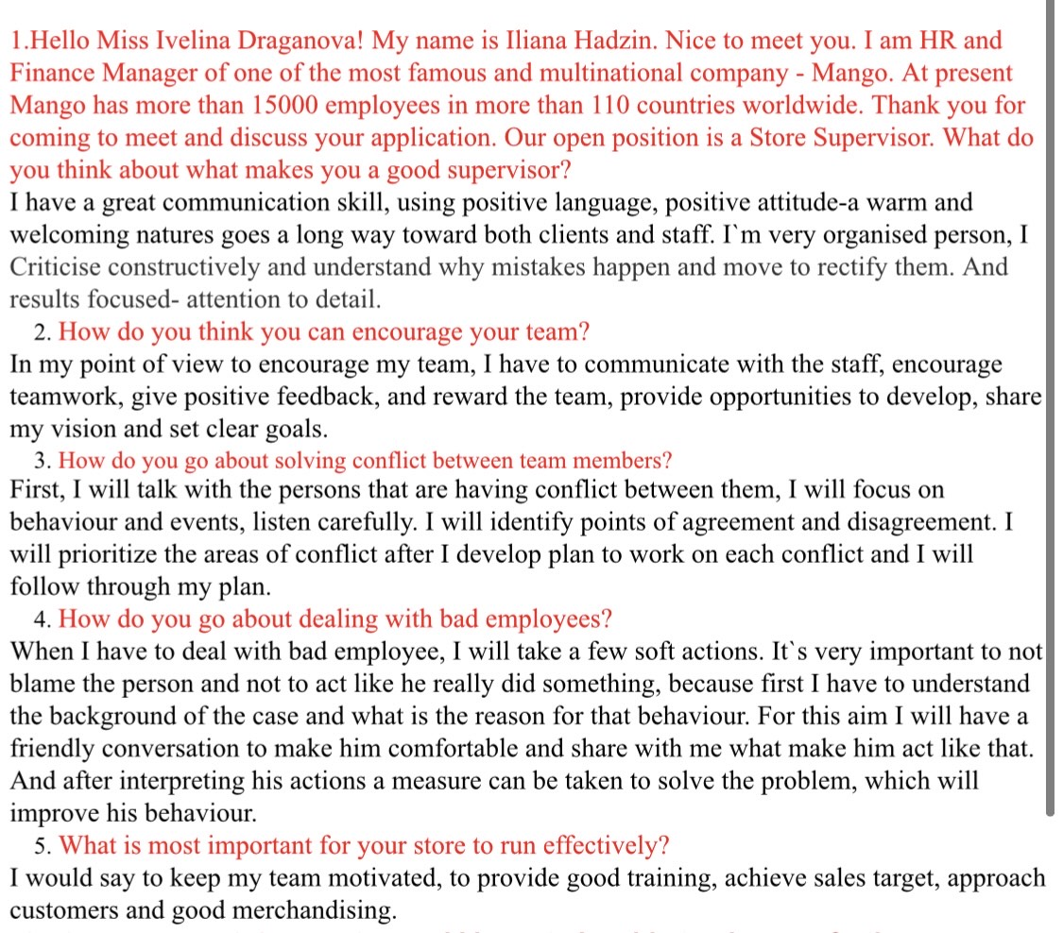
Appendix 2 Job description
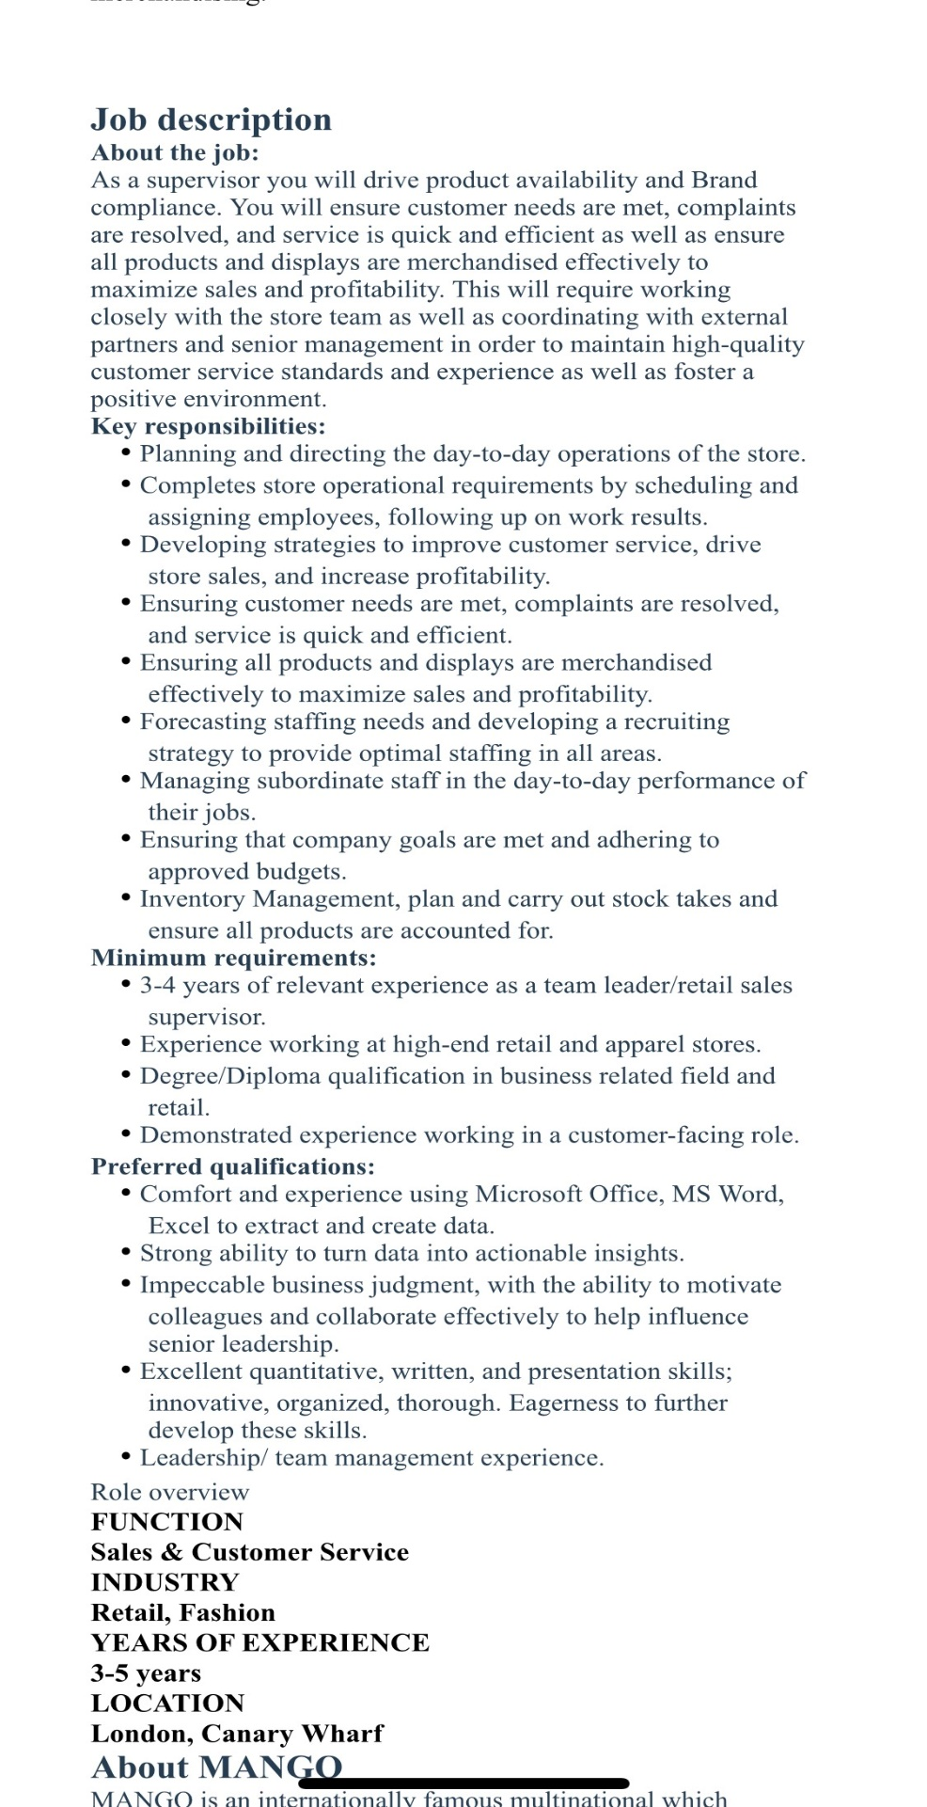
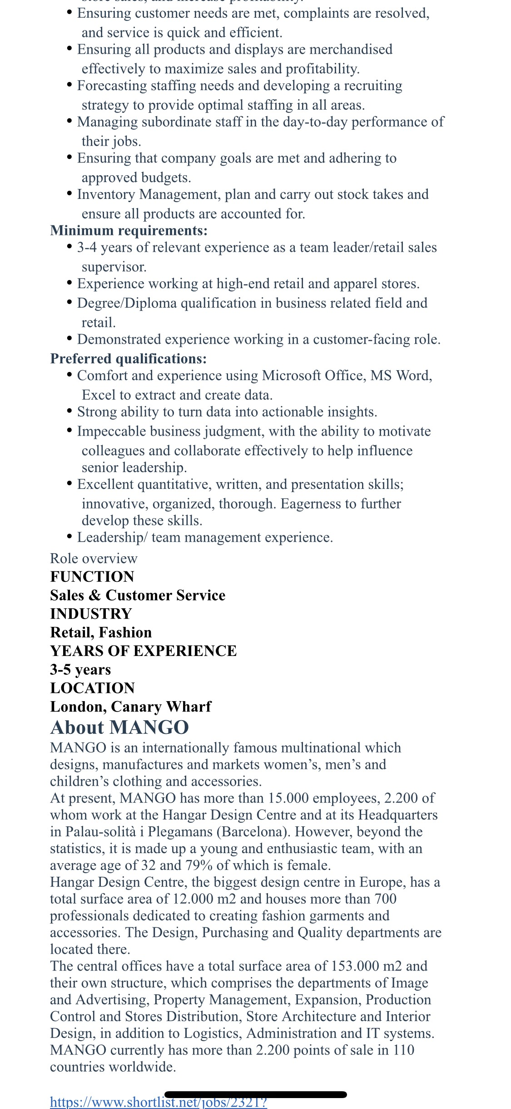
Appendix 3 Application form


