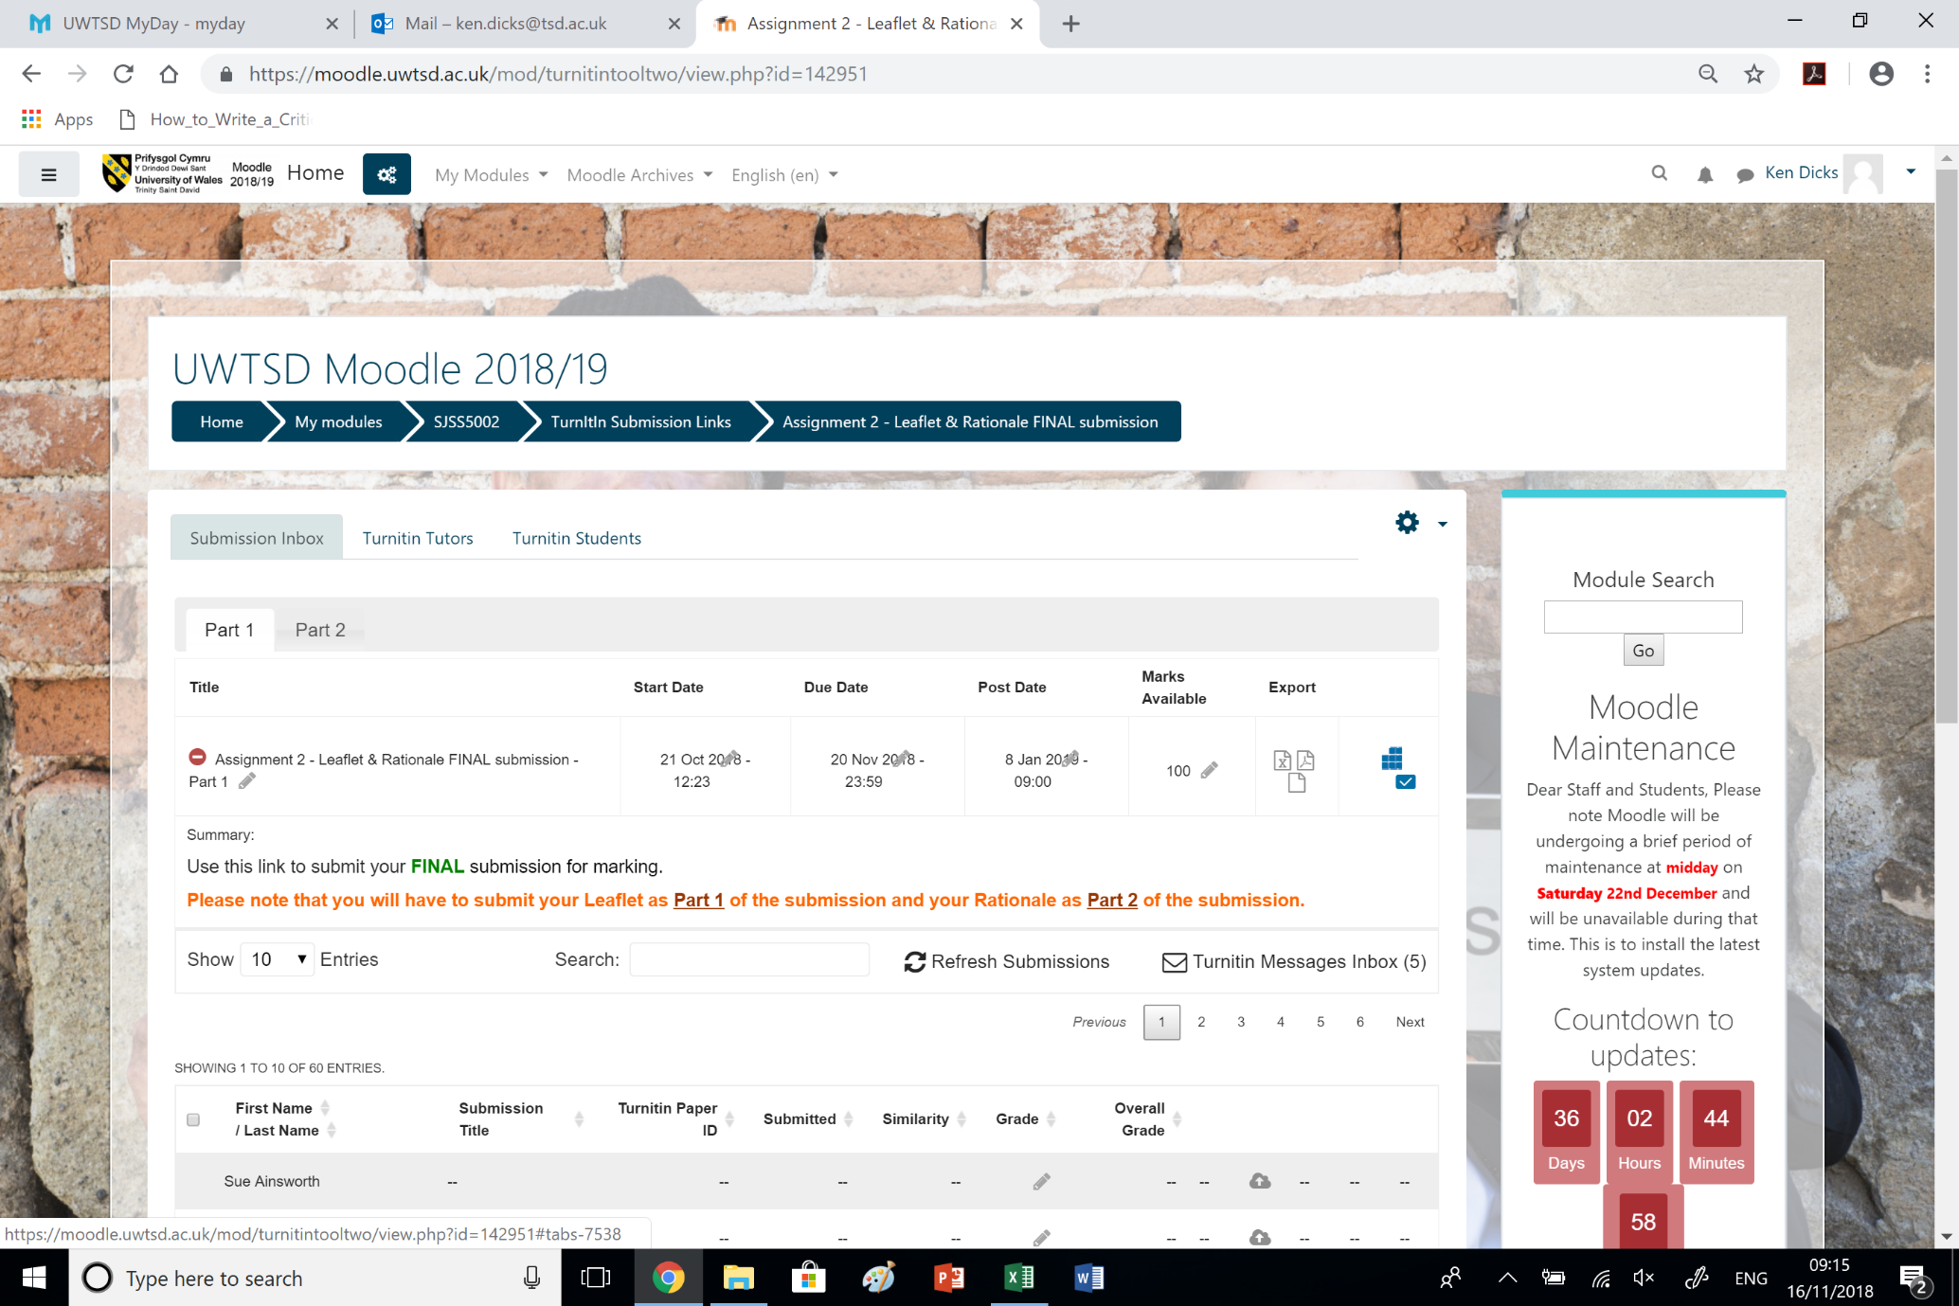
You need to submit your RATIONALE in Part 2 of the Submission page.
You need to submit your LEAFLET in Part 1 of the Submission page.

