Program: BA – International Hotel Management

Module: Financial Management for the Hotel Industry

Student Name: Romarick Ange Mondesire Steve Yai
Student ID: 2016134

Task -1 3
Introduction 3
Financial performance analysis 4
Determining appropriate ratios, discussing trends, and drawing inferences from analysis. 4
Determination of appropriate ratios 4
Liquidity Ratio of Marriott 5
Gearing Ratio of Marriott 6
Activity Ratio of Marriott 7
Profitability Ratios of Marriott 8
Examining the Fundamentals of Ratio Understanding and Their Variations for Hotel Management 9
Limitation of Ratio Analysis 10
Understanding of Ratios and Their Importance for Decision Making for Hotel Management 11
Conclusions 12
References 13

Task -1

Introduction
A valuable method for assessing a company's financial performance over time and contrasting it with industry benchmarks is financial ratio analysis. To find trends and make inferences about the company's financial performance and health, we will examine Marriott International's financial statistics from 2020 to 2021. By understanding the fluctuations in these ratios, hotel management can gain valuable insights into the strengths and weaknesses of the company and make informed decisions about its future operations. However, it is important to keep in mind the limitations of ratio analysis, such as the impact of non-recurring events and differences in accounting methods, as these can skew the results. This analysis will consider these limitations and provide a comprehensive interpretation of Marriott's 2020 and 2021 financial ratio performance.

Financial performance analysis
Financial performance analysis, also called ratio analysis, is a way to figure out how well a company is doing financially by looking at its financial statements and comparing its key financial ratios to industry benchmarks (Chakravarti, 2018). The ratios tell stakeholders about a company's liquidity, solvency, efficiency, gearing, and profitability, so they can make decisions about the company's future that are based on accurate information.
Liquidity ratios: show how well a company can meet its short-term obligations, like paying its bills and getting back the money it borrowed. The current ratio, which compares a company's current assets to its current liabilities, is an example of a liquidity ratio.
Gearing ratios: show how a company's finances are leveraged and how much debt it uses to run its business. The debt-to-equity ratio is an example of a gearing ratio. This ratio shows how much debt a company has compared to how much equity it has.
Activity Ratios: These ratios show how well a company uses its assets to make money. The asset turnover ratio is an example of an activity ratio (Crowther, 2019). This ratio measures how well a company uses its assets to make sales.
Profitability ratios: show how well a business is able to make money from its operations. One example of a profitability ratio is the profit margin, which shows how much a company makes compared to how much it sells.

Determining appropriate ratios, discussing trends, and drawing inferences from analysis.

Determination of appropriate ratios
Marriott
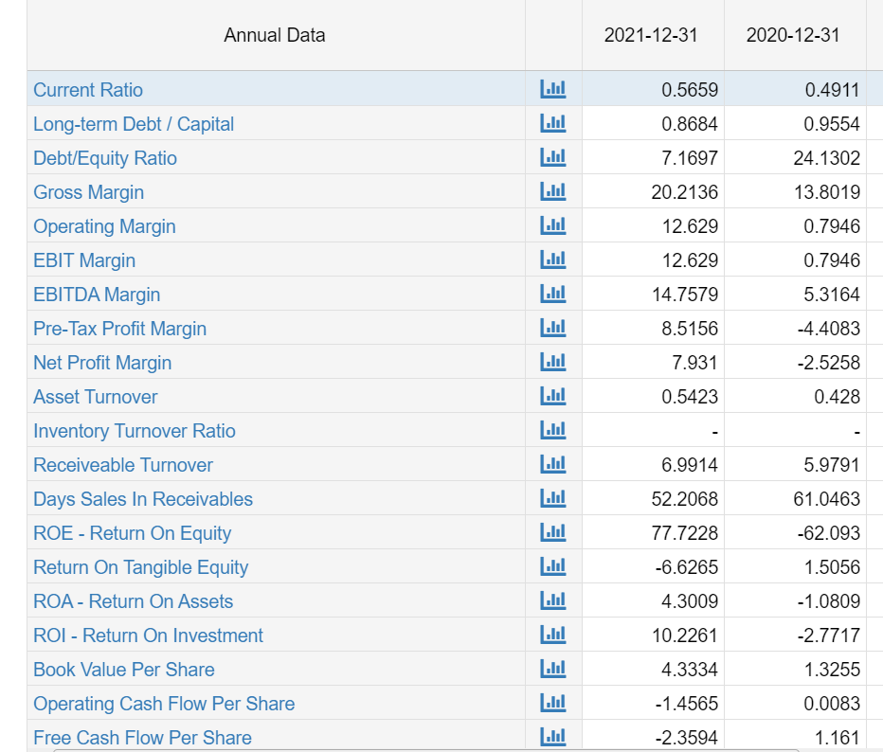
Financial Ratio Statements of Marriott

Liquidity Ratio of Marriott
The current ratio for 2021 is 0.5659, and the current ratio for 2020 is 0.4911. This shows that the company's liquidity has improved over the last two years (Du, 2017). The current ratio shows how well a company can pay its short-term debts, and a ratio of 1.0 or higher is usually a good sign.
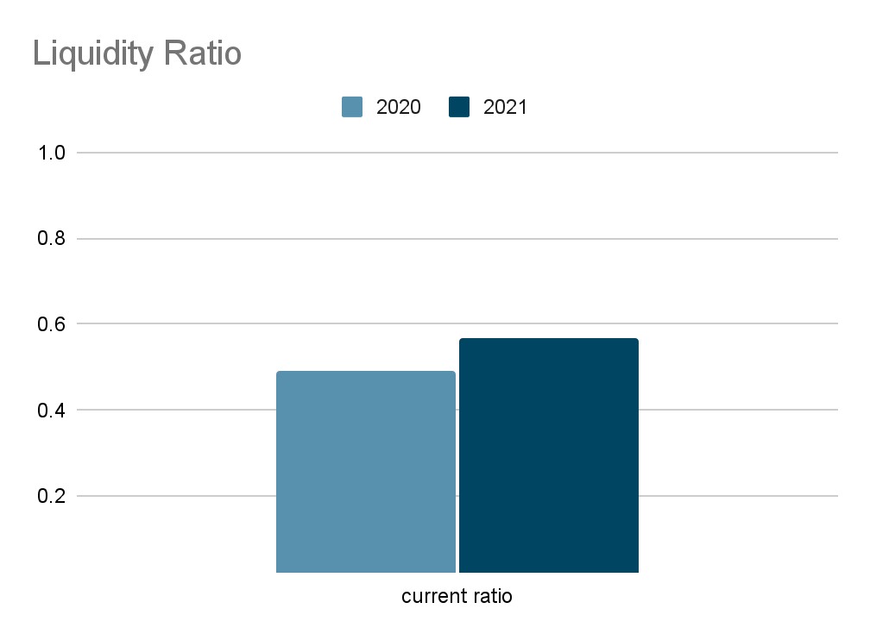
Drawn conclusion: The fact that the current ratio went up a little bit from 2020 to 2021 shows that the company has more current assets than current liabilities, which is usually a good sign. But it's important to remember that a high current ratio could mean that the company isn't making good use of its assets, while a low current ratio could mean that the company is having trouble meeting its short-term obligations (Gowthorpe, 2018). The improvement in the current ratio from 2020 to 2021 is a positive sign.

Gearing Ratio of Marriott
A trend analysis of the debt-to-equity ratio, which was 24.1302 in 2020 and 7.1697 in 2021, shows that the company's finances have gotten much better over the two years. The debt-to-equity ratio shows how much of a company's financing comes from debt compared to equity. It is a key indicator of how much a company is using debt to get money.
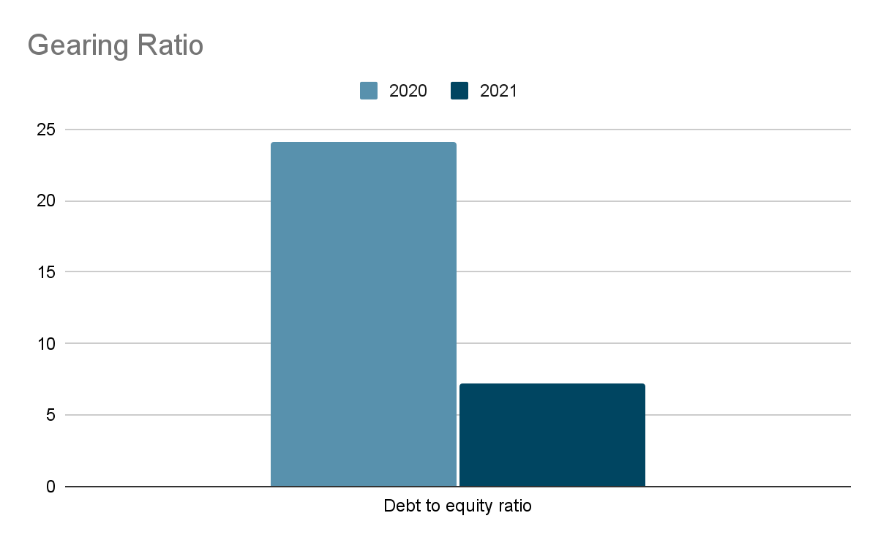
Drawn conclusion: The significant decrease in the debt-to-equity ratio from 2020 to 2021 indicates that the company has reduced its dependence on debt financing and has increased its equity financing (Iqbal, 2020). This is generally a positive sign as it reduces the company's financial risk and improves its ability to weather economic downturns.

Activity Ratio of Marriott
The trend analysis of the asset turnover ratio, which was 0.5423 in 2021 and 0.428 in 2020, shows that the company has gotten better at turning its assets into money (Jinjarak, 2020). The asset turnover ratio shows how well a business is using its assets to bring in money.
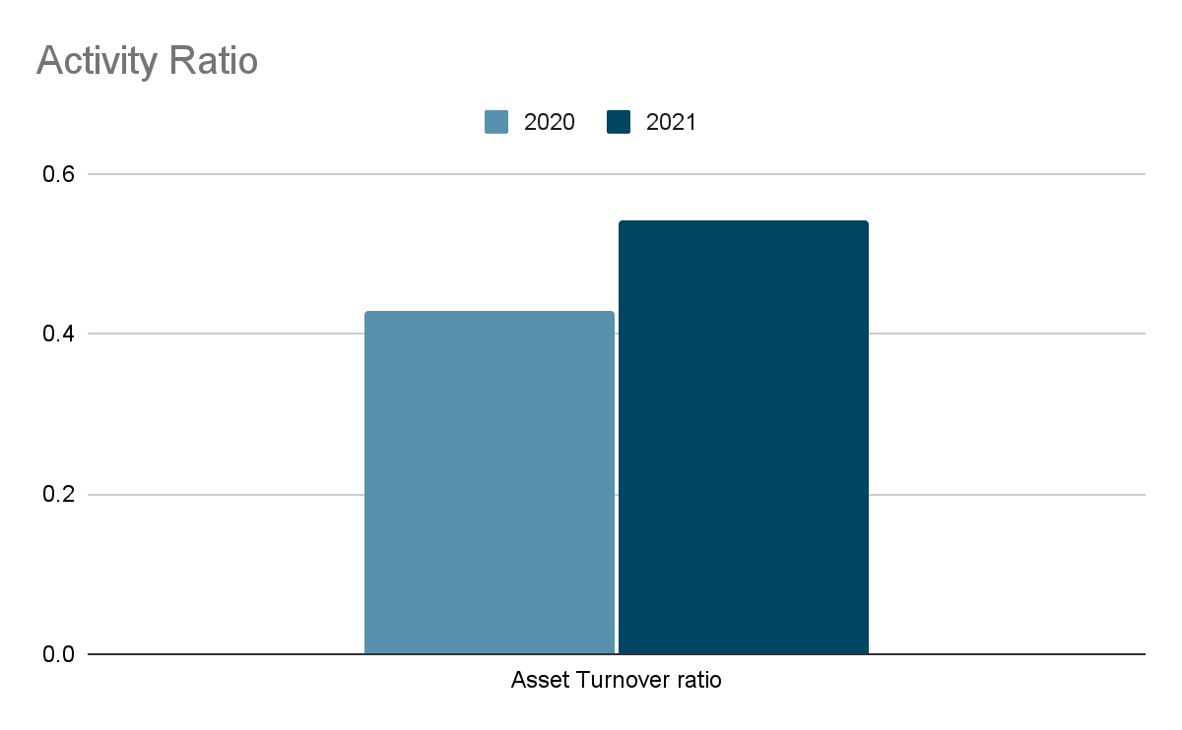

Drawn conclusion: By utilizing its assets more effectively to produce revenue, the corporation has grown its asset turnover ratio from 2020 to 2021. This can result from various factors, such as improvements in operations or a shift in the company's business mix towards higher-margin products or services (luke, 2020). The trend analysis of the asset turnover ratio gives important information about how well the company is using its assets to make money.

Profitability Ratios of Marriott
The trend analysis of the profit margin ratio, where the profit margin ratio in 2020 was -2.5258 and in 2021 was 7.931, shows a significant improvement in the company's profitability over the two years. The profit margin ratio shows how much of a company's income is kept as profit.

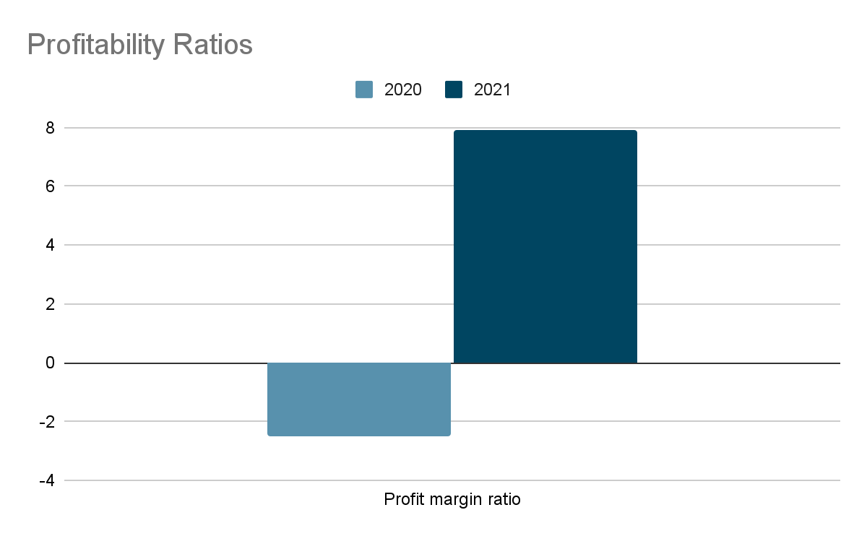

Drawn conclusion: The significant increase in the profit margin ratio from 2020 to 2021 indicates that the company has improved its ability to generate profit from its revenue (Polymenis, 2019). This can be a result of a variety of factors, such as improvements in operations, cost-cutting measures, or a shift in the company's business mix towards higher-margin products or services.

Examining the Fundamentals of Ratio Understanding and Their Variations for Hotel Management
Hotel management needs to know how liquidity ratios, activity ratios, gearing ratios, and profitability ratios change in order to analyze their financial statements. These ratios give helpful information about different parts of a hotel's financial performance and can be used to find problems and ways to make things better.
Liquidity ratios show how well a hotel can pay its short-term bills. The current ratio is the most common liquidity ratio. It shows how well a hotel can pay off its current debts with its current assets (Shykina and Lisetskaya, 2020). If a hotel's current ratio is low, it could have trouble meeting its short-term obligations and may need to get more money or sell assets to do so.
Activity ratios show how well a hotel makes use of its assets to make money. The asset turnover ratio is the most common activity ratio. It shows how much money is made for every dollar of assets (Stoutenburg, 2021). If a hotel's asset turnover ratio is low, it could mean that the hotel is not using its assets to make money as well as it could. The hotel may need to improve its operations or change its business mix to include more high-margin products or services.
Gearing ratios show how much debt a hotel has compared to how much money it has in the bank. The debt-to-equity ratio is the most common gearing ratio. It shows how much debt a company has compared to how much equity it has. If a hotel's debt-to-equity ratio is high, it could mean that the hotel is taking on too much debt compared to how much equity it has. This could mean that the hotel is more likely to run into financial trouble.
Profitability ratios show how well a hotel can turn its income into profit. The profit margin ratio is the most common measure of profitability (Burns, 2018). It shows what percentage of revenue is kept as profit. If a hotel's profit margin ratio is low, it may mean that the hotel isn't making enough money from its sales and needs to improve its operations or change how it prices its rooms.

Limitation of Ratio Analysis
Ratio analysis is a great way to figure out how well a company is doing financially, but it also has a few flaws that you need to be aware of (Boháčková and Svatošová, 2018). Some of the main limitations of ratio analysis are:

Historical data: Ratio analysis is based on past information and doesn't take into account future events or changes in the market that could affect a company's finances.

Industry benchmarks: Ratios can vary significantly across different industries and it is important to consider industry benchmarks when evaluating a company's financial performance.

Accounting policies: When assessing a company's financial performance, it is critical to be aware of the accounting policies that are being followed because they can have a substantial impact on the company's financial ratios.

Size of the company: The size of a company can significantly impact its financial ratios, so it is important to consider the size of a company when evaluating its financial performance.

Simplification: Ratio analysis can simplify complex financial information but may not provide a complete picture of a company's financial performance.

Limited scope: Ratio analysis does not offer a thorough examination of a company's financial status; rather, it offers a snapshot of its financial performance at a certain point in time.

Misuse: Ratio analysis can be easily misused or misinterpreted if the person conducting the analysis does not have a thorough understanding of financial accounting principles and ratios.

Understanding of Ratios and Their Importance for Decision Making for Hotel Management
Ratios are a valuable tool for hotel management to understand and analyze their financial performance and make informed decisions (Beidleman, 2018). Hotel management needs to know about ratios and how they change so they can look at the information in their financial statements. Here are the key reasons why ratios are important for decision-making in the hotel industry:

Financial performance evaluation: Ratios provide a quick and easy way for hotel management to evaluate the financial performance of the business and compare it with industry benchmarks and previous periods.

Benchmarking: Ratios allow hotel management to compare their performance with competitors and industry benchmarks, helping them to identify areas for improvement and make informed decisions about future strategies.

Liquidity management: Liquidity ratios, such as the current ratio, help hotel management assess their ability to meet short-term obligations and make decisions about managing cash flow and working capital.

Solvency assessment: Solvency ratios, such as the debt-to-equity ratio, help hotel management assess their ability to repay long-term debt and make decisions about leveraging and financing strategies.

Activity analysis: Activity ratios, such as asset turnover and accounts receivable turnover, help hotel management assess the efficiency and effectiveness of their operations and make decisions about improving operational performance.

Gearing analysis: Gearing ratios, such as the debt-to-equity ratio, help hotel management assess their financial leverage and make decisions about financing and debt management strategies.

Profitability analysis: Profitability ratios, such as profit margin and return on equity, help hotel management assess the profitability of the business and make decisions about pricing, cost management, and resource allocation.

Conclusions
Marriott's financial performance improved from 2020 to 2021 as reflected in its key financial ratios. The current ratio and asset turnover ratio increased, while the debt-to-equity ratio and profit margin ratio showed significant improvement. These results suggest that Marriott has effectively managed its liquidity, solvency, activity, gearing, and profitability. However, it is important to consider other factors such as economic conditions, competition, and industry trends in making decisions about the company's financial performance. As a recommendation, Marriott should continue to monitor its financial ratios and regularly assess its financial position to ensure long-term financial stability and success.

References
Beidleman, C.R. (2018). Limitations of Price-Earnings Ratio. Financial Analysts Journal, 27(5), pp.86–91. doi:10.2469/faj.v27.n5.86.
Boháčková, I. and Svatošová, L. (2018). Profitability and risk ratio of financial portfolio. Agricultural Economics (Zemědělská ekonomika), 48(No. 3), pp.117–120. doi:10.17221/5458-agricecon.
Burns, J.M. (2018). Errata: Financial Institutions and Markets. The Journal of Financial and Quantitative Analysis, 6(1). doi:10.2307/2330124.
Chakravarti, B.K. (2018). Hotel management. New Delhi: A.P.H. Pub. Corp.
Crowther, T. (2019). The Perception of Activity. Ratio, 27(4), pp.439–461. doi:10.1111/rati.12080.
Du, B. (2017). How Useful Is Basel III’s Liquidity Coverage Ratio? Evidence From US Bank Holding Companies. European Financial Management, 23(5), pp.902–919. doi:10.1111/eufm.12116.
Gowthorpe, C. (2018). Financial analysis. Oxford: Cima.
Iqbal, U. (2020). Financial Performance in Daily Hotel and Business Management. Journal of Hotel & Business Management, 05(02). doi:10.4172/2169-0286.1000e113.
Jinjarak, Y. (2020). Equity prices and financial globalization. International Review of Financial Analysis, 33(12), pp.49–57. doi:10.1016/j.irfa.2013.08.009.
luke, J. (2020). Worm gearing with variable transmission ratio. Wear, 16(1-2), p.159. doi:10.1016/0043-1648(70)90328-5.
Polymenis, A. (2019). A combined likelihood ratio/information ratio bootstrap technique for estimating the number of components in finite mixtures. Computational Statistics & Data Analysis, 71(14), pp.107–115. doi:10.1016/j.csda.2013.01.028.
Shykina, O. and Lisetskaya, K. (2020). TREND ANALYSIS OF THE INTERNATIONAL HOTEL INDUSTRY. Market Infrastructure, 12(39). doi:10.32843/infrastruct39-9.
Stoutenburg, G. (2021). Vicious Regresses, Conceptual Analysis, and Strong Awareness Internalism. Ratio, 29(2), pp.115–129. doi:10.1111/rati.12087.

