Assignment
SOFTWARE SOLUTIONS FOR BUSINESS
4/27/2026
UNIVERSITY OF WALES TRINITY SAINT DAVID LONDON CAMPUS
Module name: SOFTWARE SOLUTIONS FOR BUSINESS
Module code: ACCA4026_LON
Student Name: Rumyana Bicheva
Student ID: 2527182
Group: 2

Lecturer`s Name: Anum Paracha
Contents
INTRODACTION 2
Task 1 - E-Commerce Website Builders- Wix vs Weebly 2
1a. WIX 2
1b. Weebly 6
Task 2. Mind-map of contemporary software applications 7
Task 2a. Mind mapping and explain the benefits of using Mind mapping in business 7
Task 2b. Mind map of contemporary software applications 9
Task 3 Office Applications 10
Task 3a. Software solutions for business operations 10
Task 3b 28
VLOOKUP 28
PIVOT 33
Task 4 Communication and Collaboration applications 38
Task 4a 38
Communication application - Google Gmail 38
Collaboration application - Microsoft Teams 40
Task 4b 46
CONCLUSION 52
REFERENCES 53

INTRODACTION
Organizations, regardless of the field in which they operate, have their structures. On the one hand, this is business structure, i.e. how the different roles and responsibilities are distributed, and on the other hand, this is its functional structure - how the relationships between the different departments and units are carried out in order to achieve the goals of the organization. [1]
Business software solutions are a set of different applications and tools that are developed to help business in each area of its functioning – accounting, marketing, customer relationship management CMR, supply chain management and human resources. [2]
Implementing software solutions increases efficiency and accuracy through automation, improves process and financial management, and enables faster communication between suppliers, manufacturers, and consumers. They help with information storage and its analysis but also help the business to protect information and prevent the risk of cyber-attacks. [3]

Task 1 - E-Commerce Website Builders- Wix vs Weebly
Two widely used contemporary e-commerce website builders are Wix and Weebly. Both platforms allow users to design and manage websites without requiring advanced technical/coding skills.

1a. WIX
Wix is ​​an online platform for creating websites with ready-made templates for portfolio, resume/CVs or personal. Wix is known for its high-level creativity and customization control. It uses a drag and drop editor, which allows users to design their website freely. The platform offers built-in hosting as well as the ability to pay online and marketing analysis. It also includes AI tools that can completely create the desired format by entering text. [4]
With a wide range of templates and built in e-commerce features such as product listings and marketing tools, it is useful for businesses that want a unique and visually appealing online presence. [5]
However, it may be more complex and expensive for beginners as it offers a wide range of features. Also, it can’t swap the chosen templates, if the website is already live. [5]
In addition, Wix supports business growth through its scalability and integration options. It has App Market, which allows adding features such as booking systems, live chat, and customer relationship management (CRM) tools. This makes Wix suitable not only for small businesses, but also for those planning to expand their operations over time. Furthermore, Wix provides built-in analytics and reporting tools, enabling users to monitor website performance and make informed business decisions [5]

- From templates for business, I created website for fashion designer Fig.1.
Figure 1 Main page Wix site


- Navigation bar is easy. On the home page I added “portfolio” and “blog” button, Fig2.
Figure 2 Adding the buttons in navigation bar


- In page of Portfolio, I dded my bridal collection Fig.3
Figure 3 Portfolio page

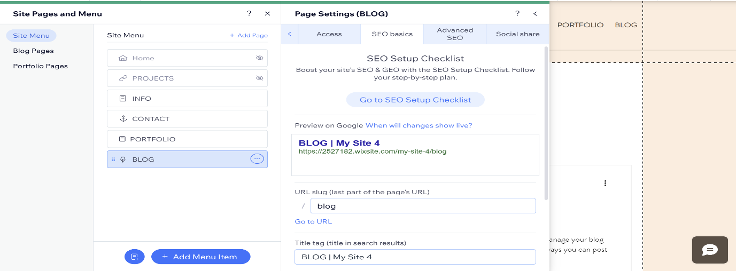
- My “Blog” button is set up with SEO Fig.4 and Fig.5
Figure 4 Setting Blog with SEO


Figure 5 SEO Setup

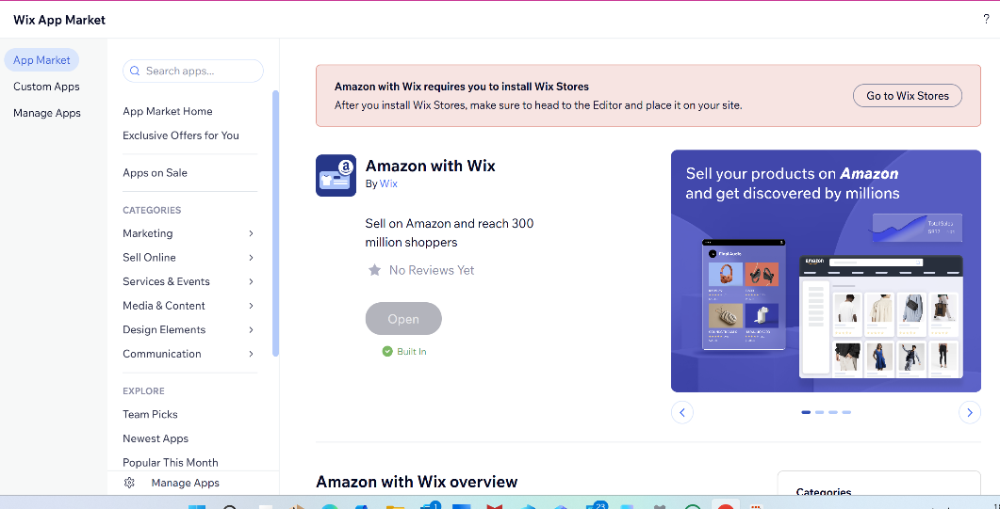
- If I want to develop online shop, many apps are available and “Amazon with Wix” is bult in, Fig.6
Figure 6 Bult in Amazon app

1b. Weebly
Weebly is simpler and easier to use. It also has a drag-and-drop editor, but with a more structured layout that is better for beginners. [6]
It is suitable for small businesses or individuals who want to create a website quickly. Weebly includes essential e-commerce tools, such as inventory management, payment processing and among others. [7]
However, despite its ease of use, Weebly has some limitations compared to Wix. The platform offers fewer design options and less flexibility when customizing websites, which may restrict creativity. In addition, its SEO and marketing tools are more basic, which could make it more difficult for businesses to improve their online visibility. [5]
A key advantage of Weebly is affordability, as it offers lower-cost plans and free options and it has no limit in website pages. However, it has fewer templates and limited customation to Wix and fewer advanced features which can limit business growth.[7]
In addition, in their free plan Wix offers more than 800 free apps, Weebly has limited.[8]
Conclusion
Wix and Weebly are effective e-commerce website builders. They are suited to different user needs. Wix is more appropriate for businesses seeking advanced features and flexibility, Weebly is ideal for beginners and small businesses, it is easier to use and low cost.[7]

Task 2. Mind-map of contemporary software applications

Task 2a. Mind mapping and explain the benefits of using Mind mapping in business
The concept of mind mapping was developed and popularized by Tony Buzan in the 1970s. According to him, it is a natural way for the brain to work - not linearly, but through associations. It is a method of visually organizing information around a central idea, in which related thoughts are presented as branches. By visualizing the thought process, faster generation of ideas and an increase in creativity is achieved, as well as easy to remember. [9]
A mind map is a diagram for structuring and organizing information, in which the main idea is placed at the centre and related concepts branch out radially. This approach allows information to be presented in a hierarchical and associative way that facilitates understanding, memorization and analysis. The technique uses keywords, colours, symbols, and images to aid cognitive processing and reduce the complexity of information The key features of mind maps include simplifying complex information by deriving key concepts, structuring knowledge in a hierarchical form, and visualizing the relationships between different elements. This leads to a clearer understanding of the overall topic and easier recall of information. [10]
The application of mind mapping is widespread in education to take notes, summarize learning material and prepare for exams. In business, it is applied in:
- Project development
- Strategic thinking and development
- Brainstorming and idea generation
- Meeting management and decision-making
- Business Process Analysis
- Software planning and knowledge management
By visualizing ideas and connections between them, mind maps facilitate strategic planning, project management, and business process analysis. When complex goals are divided into smaller and manageable components, it improves the decision-making process and reduces cognitive load. In an organizational context, they contribute to more effective communication between teams and better knowledge management by making information more accessible and understandable. In a business context, mind maps are used in brainstorming sessions, where they stimulate the generation of ideas and support creative thinking. They are used as tool of improving productivity and clarity when working with complex tasks, supporting both individual and team work. [11]
In the diagram below Fig.7, MIND MAP for starting a small business has been developed - IT support for small and medium business. The main branches show which clients will be our target and how exactly will provide support for their business as software solution, website service, IT support as well as cyber security.
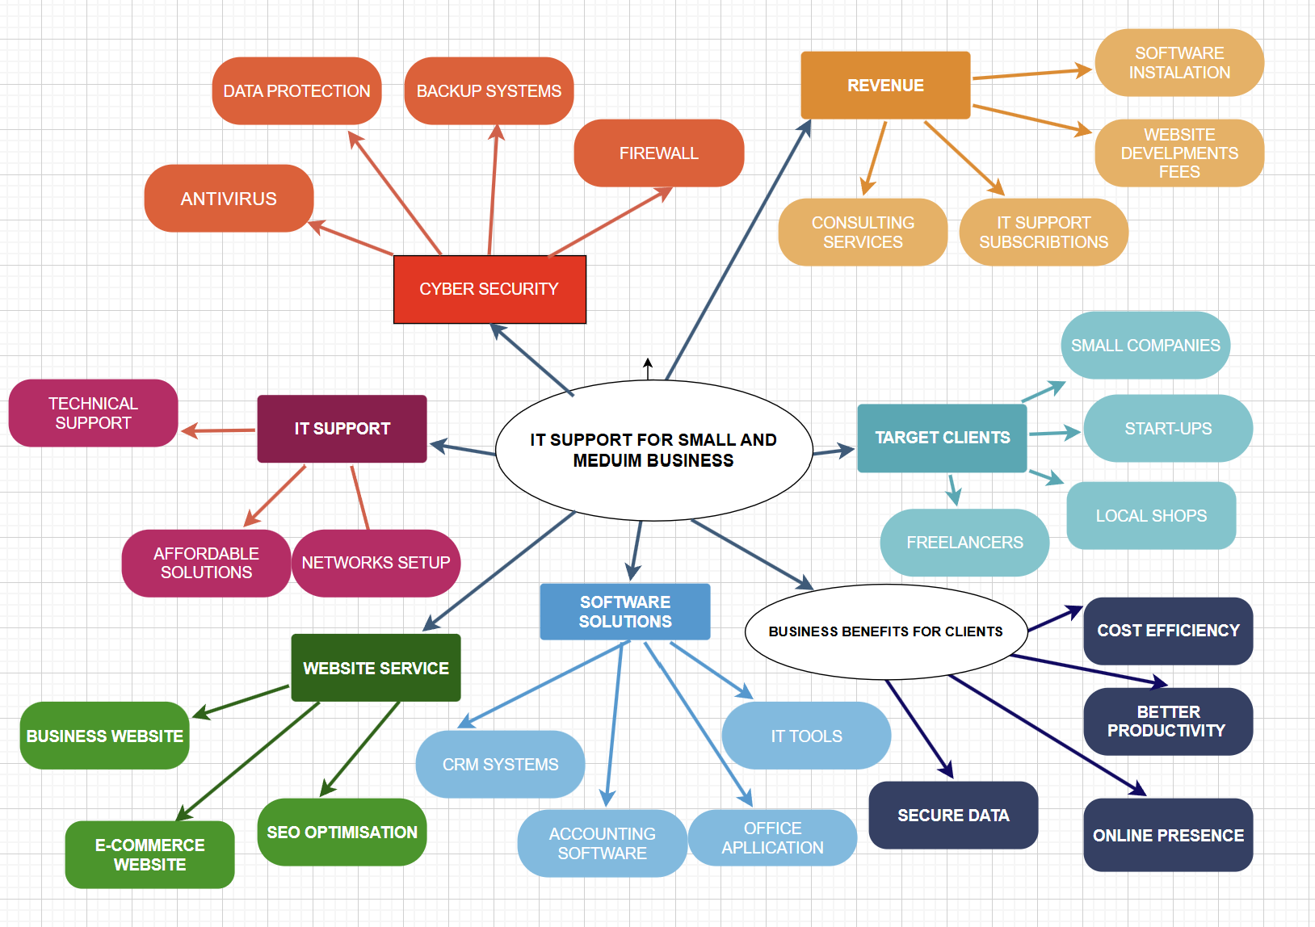
Figure 7 Mind map in Business idea development

The idea of ​​customer benefits is taken out in a separate section. In the revenue section is suggestion for income components of this business : software solutions, consulting service, etc. The method clearly simplifies the main idea of this business and highlights the development directions with possibilities to brainstorm more ideas.
This supports the conclusion, that Mind Map is an effective visual thinking tool for businesses in various areas – from strategic planning to operational management by improving the clarity of information, speed up decision-making, and increase teamwork efficiency.

Task 2b. Mind map of contemporary software applications
The Mine Map structure created below outlines the main applications for modern business Fig.8.
Figure 8 Mind map for contemporary business applications
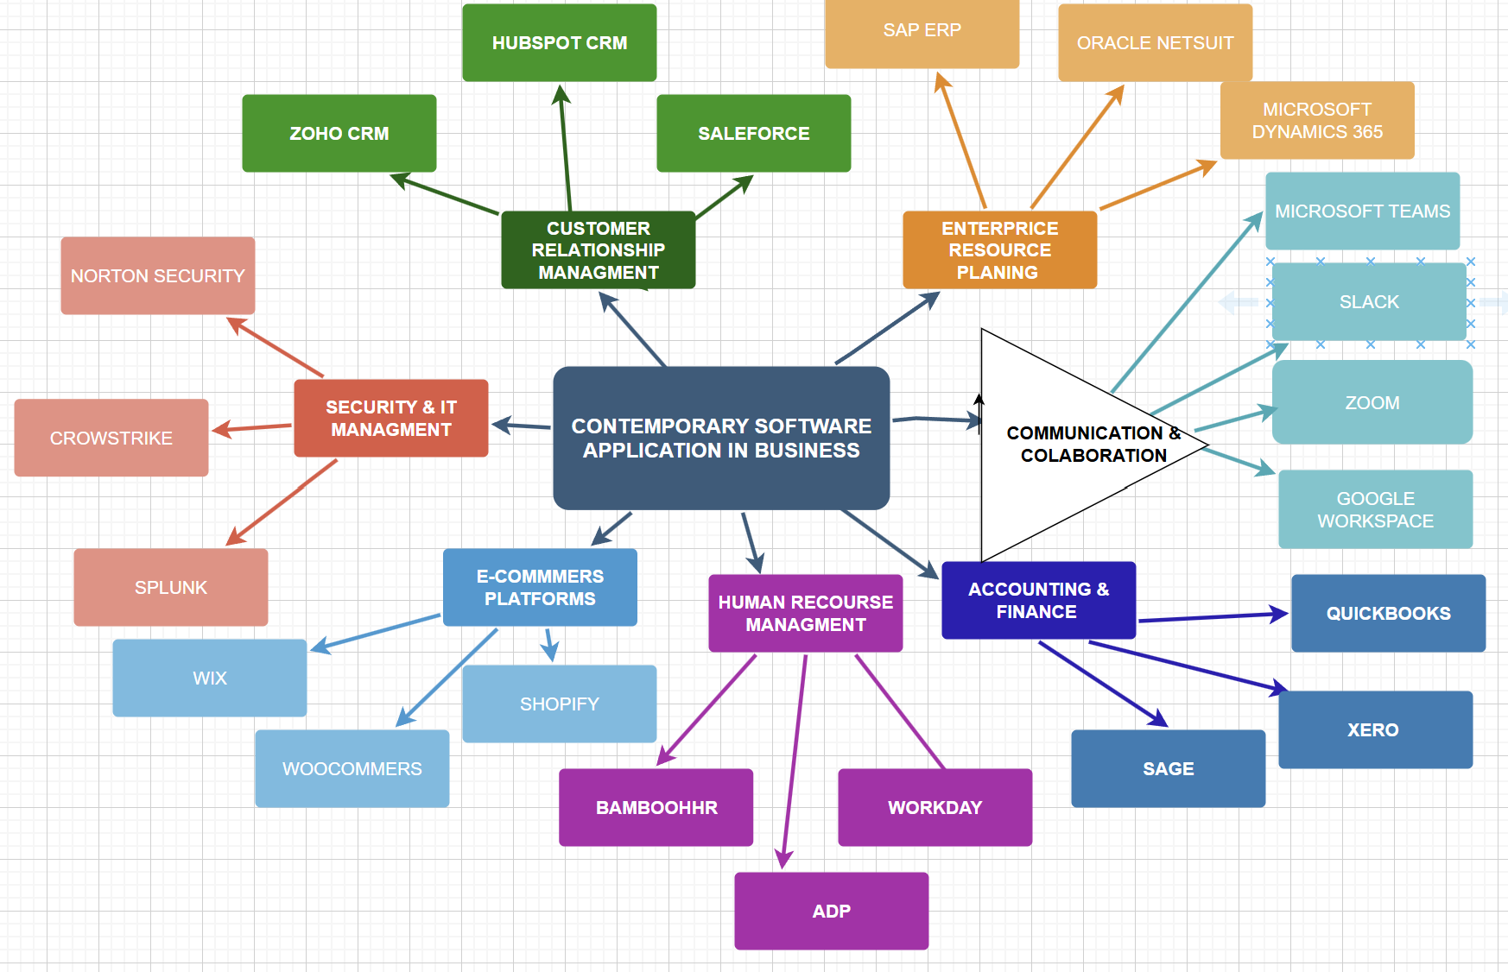
To build this diagram, I proceeded from the functional structure of a well-developed company. But since the organizational structure of each business is also extremely important, I put the communication and collaboration apps in a separated triangle. In addition to the diagram, the place of Microsoft Office 365 should be recognized as it supports core business operations by enabling document creation, communication, data processing, and team collaboration, acting as a fundamental base across all organisational processes.

Task 3 Office Applications

Task 3a. Software solutions for business operations

Microsoft Access
The Microsoft application used for creating, working with, and managing databases is called Access. It allows users to create, store, and manage data in a structured format using built-in tools, making it easy to use without requiring advanced technical knowledge. [12]
Key Functions
Tools in Access are in the "Create" menu, Fig.9.
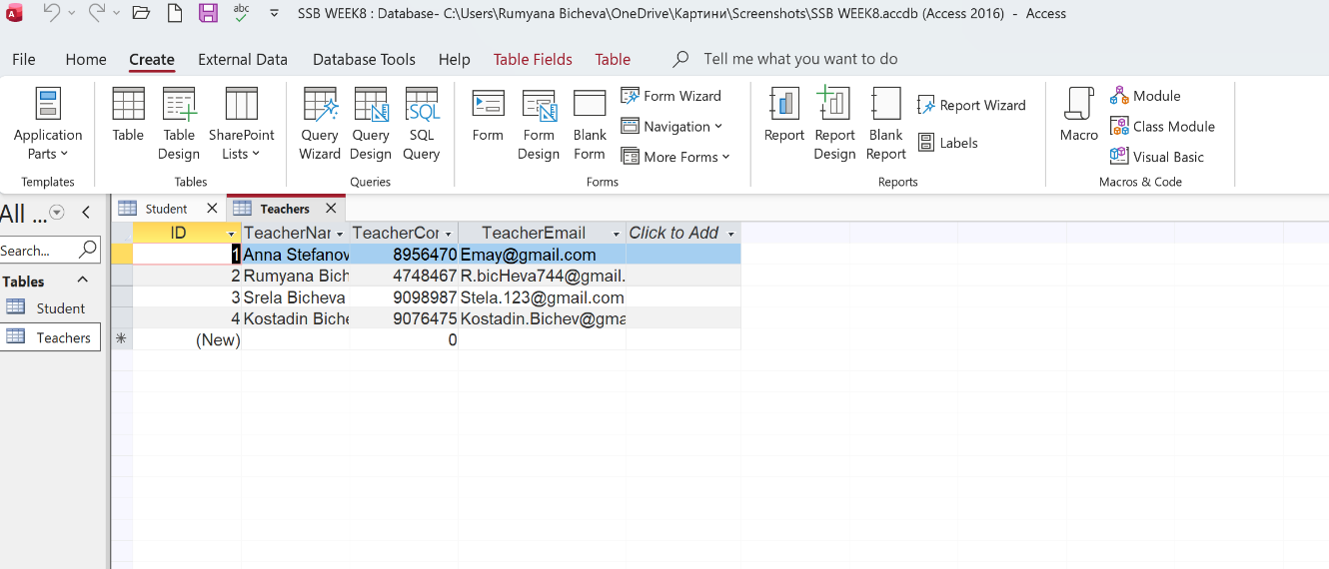
Figure 9 Components of "Create" menu

The main tools are tables. They are the primary structure used to organize and store data, arranged in rows (records) and columns (fields). Each row has an ID, which is a unique identifier for that record. It cannot be empty and ensures that every row in the table is uniquely identifiable within the system. The ID, also known as the Primary key, is generated automatically and is used to create relationships between tables. [12]
On the other hand, an ERD (Entity-Relationship Diagram) visualizes how information is structured and connected within a system, where the relationships are defined in four types: one-to-one (1:1), one-to-many (1:M), many-to-one (M:1), and many-to-many (M:N).
Columns are added to tables by "click to add" button. Right click on it defines different types of input data and sets the rules for validating columns, Fig.10.
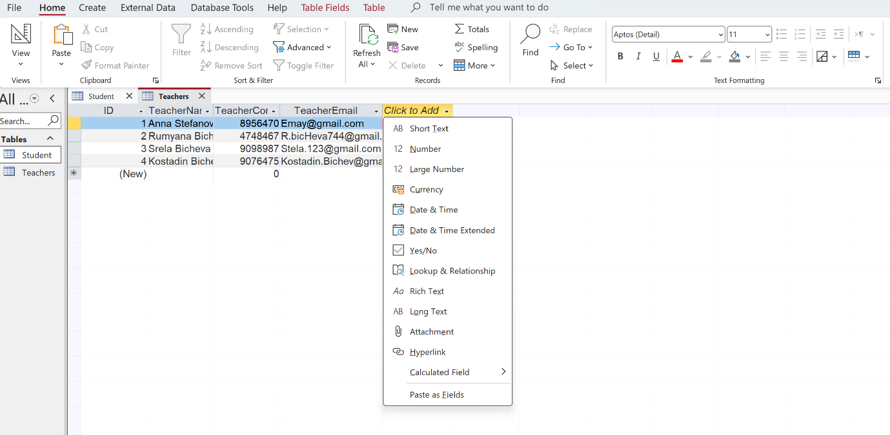
Figure 10 Types of different data format

From the “Create” menu, another main tool is Queries. They are used to search, filter, and summarize data. Queries can also be used to update or delete records. In addition, users can sort results and perform calculations. Access provides both - a visual tool for creating queries and SQL (Structured Query Language), which is the programming language used in Microsoft Access. The main SQL commands include SELECT, INSERT, UPDATE, and DELETE.[12]
Example of SELECT, find the records from Student table who live in London and show the ID of students from London, Fig.11,12,13,14.
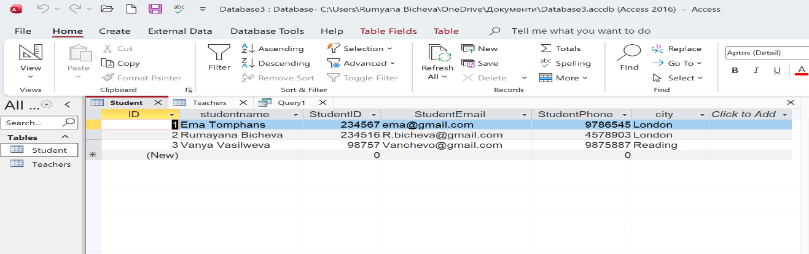
Figure 11 Table with recorded information

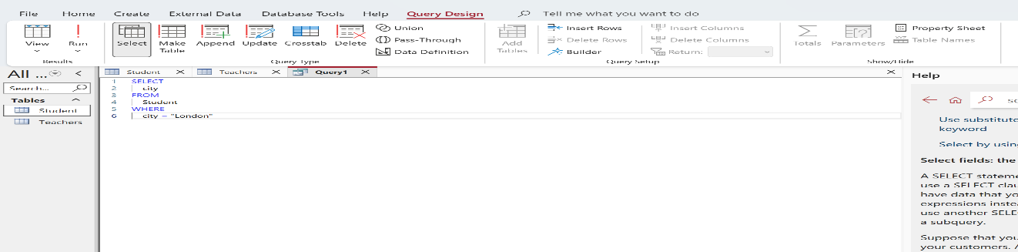
Figure 12 Using SQL

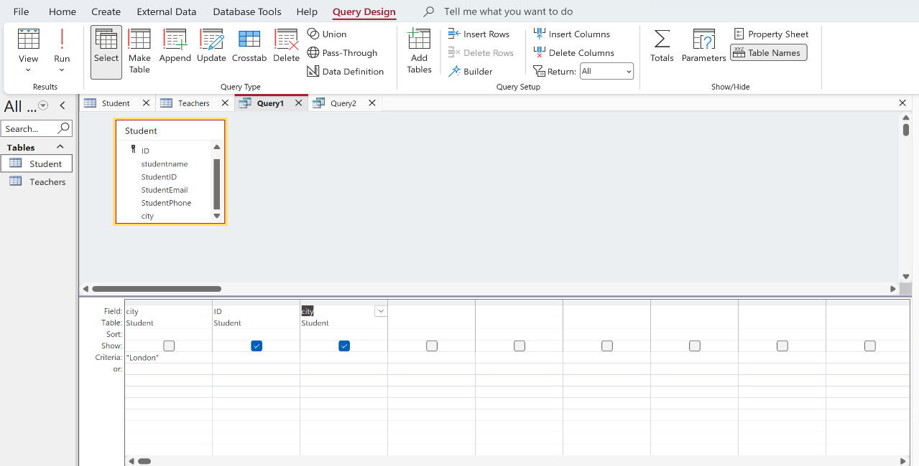
Figure 13 Design view of Query

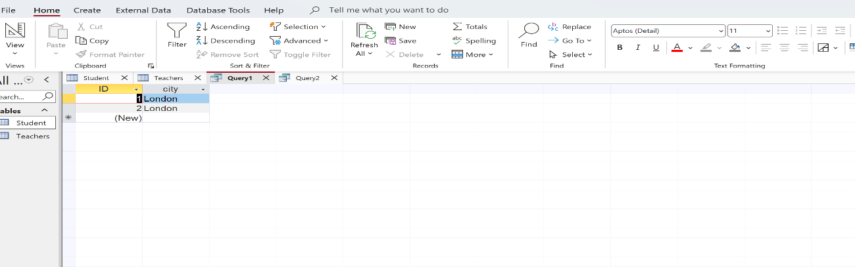
Figure 14 Result of Query

Forms are another tool, they represent interface that displays data from tables in a clear and organized way, making it easier to enter, edit, and view information. It helps reduce the likelihood of errors and improve efficiency. They do not store data themselves and are not a database as only provide a way to interact with the underlying data, Fig15. [12]
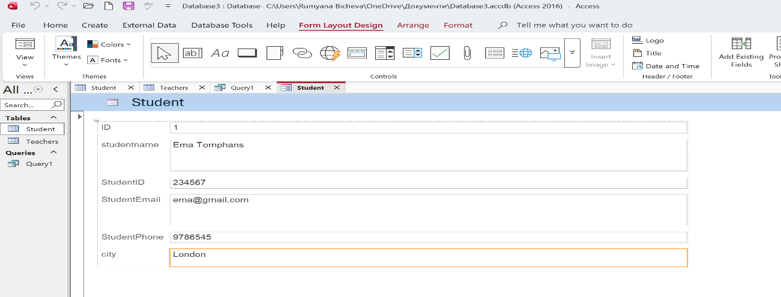
Figure 15 Example of Form in Access
Reports generate structured documents for analysis and printing using existing table and query data without data editing or modification. They extract and format information into a clear, readable layout for analysis. It can also combine information from one or multiple related tables, when the foreign key is created. Queries often act as an intermediate layer between tables and reports, where data is processed before being presented. [12]
For repetitive tasks, the program supports macros, which reduce errors while saving time. Also, it allows the import and export of data from other programs, such as Excel. Through this integration, Access provides structured data management, while Excel offers powerful tools for data analysis and visualization.
Disadvantages - Mainly limitations related to its performance for huge volumes of data and many users. It is not designed for complex corporate systems, where reliability and security in processing are priority. [12]
Conclusion, Microsoft Access is an easy and cost-effective database management software for small projects.

PowerPoint
Microsoft PowerPoint is powerful software developed by Microsoft, widely used tools for business and academic presentations. It uses a slide-based structure to create, edit, and present information in a clear and organized way. Content can be displayed using text, images, charts, diagrams, and multimedia elements such as audio and video. This visual approach makes information easier to understand and more engaging.[13]

Key functions

Slide Creation and Design
Users can create presentations using ready-made templates, themes, and customizable layouts. This allows fast development of visually consistent and professional slides without advanced design skills. [13]
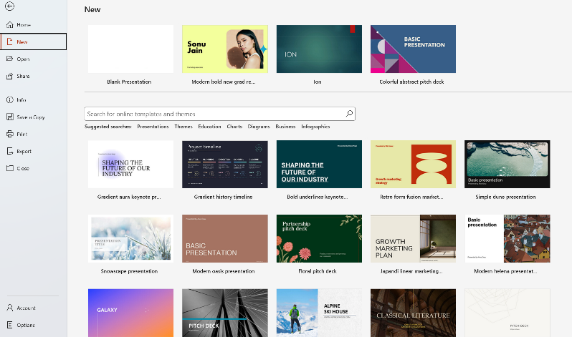
Button “File” open gallery with ready to use themes for different type of presentation. The main functions here are share your document, save a copy, print and export. Fig.16
Figure 16 Screen of different Theme options and main functions in "File" menu

Export allows you to make a video on your presentation or change the type of your file. Fig17
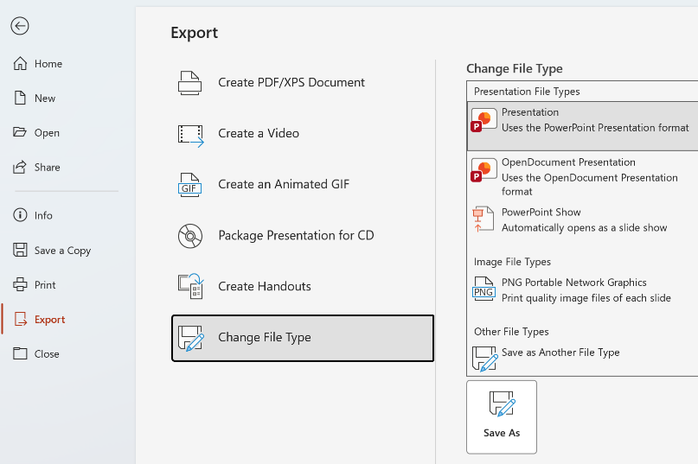
Figure 17 Main functions in Export button

Multimedia Integration
Microsoft PowerPoint allows users to add multimedia content such as images, videos, audio files, charts/ graphs, links and tables to enhance understanding and engagement. [13]

Insert tab in the top menu (Ribbon) is the main place where all visual and interactive elements are added to a slide. I inserted picture, Fig18.
Figure 18 Inserted picture in presentation

I inserted table and hyper link, Fig19
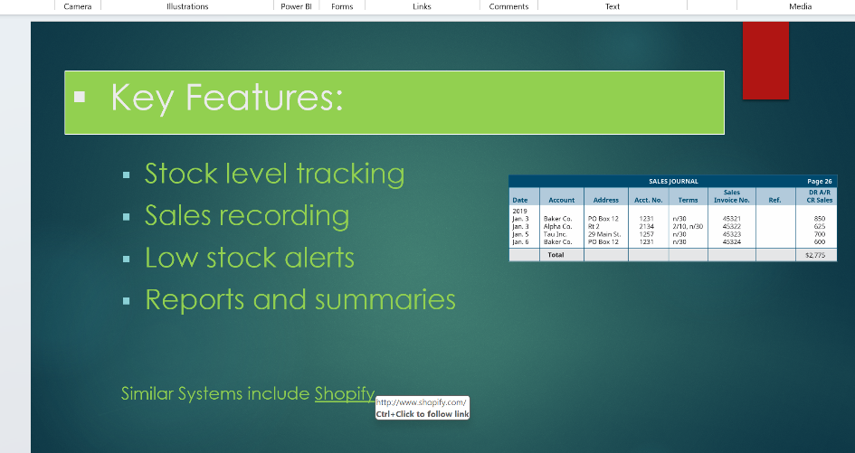
Figure 19 Inserted Table and hyperlink
After inserting elements, they can be resized, moved, formatted, and animated to fit the slide design, making complex information clearer and easier to understand.

Animations and Transitions
Users can apply animations to text and objects, as well as transitions between slides. These features improve visual flow and make presentations more dynamic and interactive. [13]
Animation and Transitions tabs are in Ribbon menu.

Collaboration tools
Through cloud integration with Microsoft services such as OneDrive and SharePoint, multiple users can work on the same presentation simultaneously. This improves teamwork, version control, and productivity. [13]

Presentation Tools
Presenter View - This feature allows the presenter to see notes, upcoming slides, and a timer on their screen, while the audience only see the current slide, Fig.20.
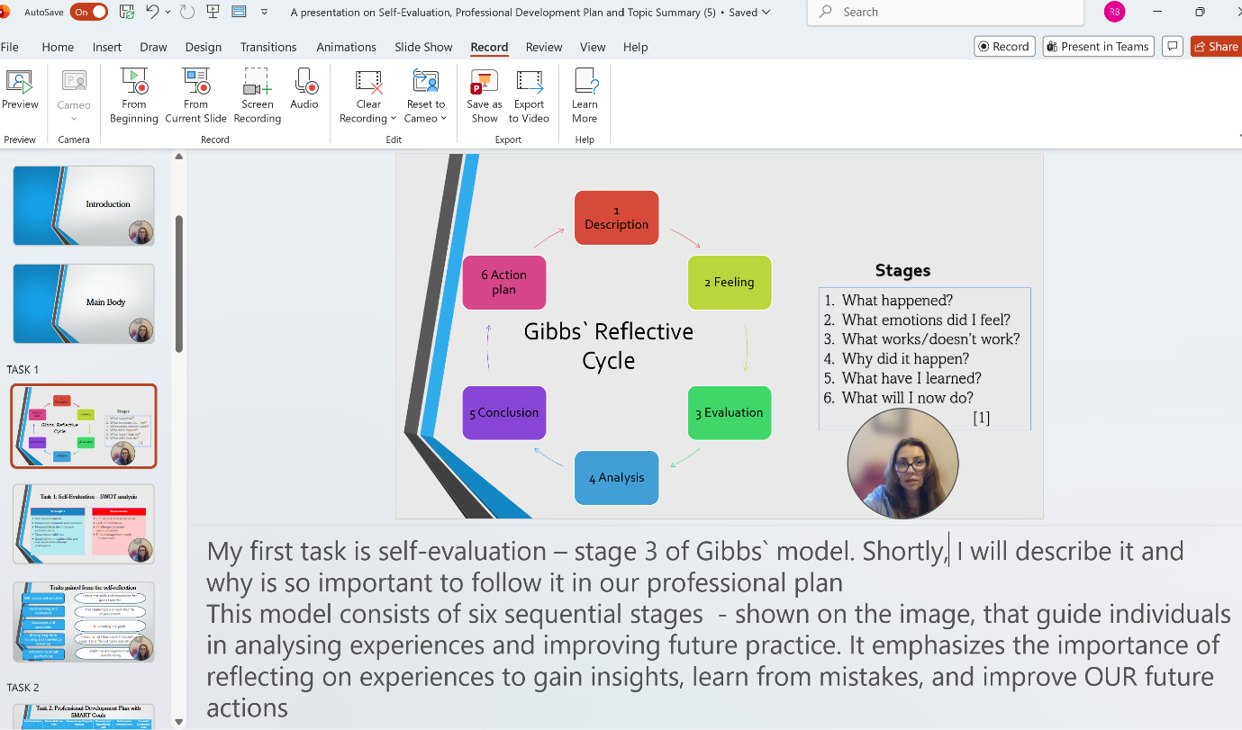
Figure 20 Note added for presentation and video record

Slide Show Set up - PowerPoint includes manually or automatically tools to start, pause, navigate, or end a presentation easily. Slide timing allows presentation to run automatically from slide to slide. During presentation, virtual laser pointer can highlight or draw on slides to emphasize key points. Recording a video and share options; present in Teams are also available and Speaker Coach helps in improve speaking.
Disadvantage, Presentations are often overloaded with text and unnecessary elements, which contradicts the basic purpose of a clear and effective presentation.
Conclusion
Thanks to its design features, animations, collaboration, and presentation tools, PowerPoint remains one of the powerful software for presentation.

Excel
Microsoft Excel is a spreadsheet software, designed to help users organize, calculate, and analyse data in a structured manner. It operates through worksheets composed of rows and columns, where their intersections form cells. Each cell can contain text, numbers, formulas, or functions and is identified by a unique address based on its column ( named A, B ……AA, AB and etc.) and row position (named 1,2 …… to infinity) for example, A1. Cells represent the fundamental building blocks of a worksheet, enabling efficient data entry, processing, and analysis. By integrating this table-based structure with powerful built-in data processing and calculation features, Excel facilitates automated calculations and advanced data analysis, making it an essential tool widely used in business, education, and scientific fields.[14]

Key functions
One of the most important features of Microsoft Excel is its built-in calculation system based on formulas and functions. Formulas are the main mechanism for performing calculations and data processing. They enable dynamic interaction with data, as results are automatically updated whenever input values change. In addition, formulas can be copied across large ranges without the need to rewrite them, since Excel uses cell references to retrieve values from different parts of the worksheet. Furthermore, cell references whether relative, absolute (e.g., $A$1), or mixed provide flexibility in how formulas behave when copied. This functionality is particularly important when building models that operate over extensive data.[15]
Formulas in Excel are often related to functions, Fig21.
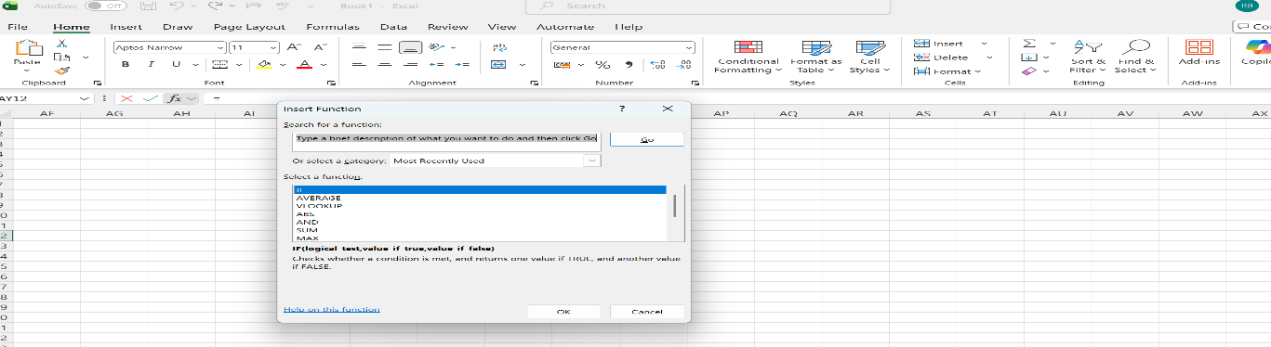
Figure 21 Functions

Through functions such as SUM, AVERAGE, MIN, MAX, IF, VLOOKUP and many others, Excel automates information processing and eliminates the need for manual calculations. Through them, users perform both elementary arithmetic operations and complex logical and statistical calculations.[15]
The examples for Sum and Average Fig22 and Fig23.
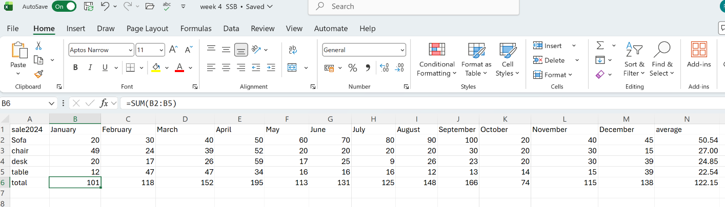
Figure 22 Example for SUM function

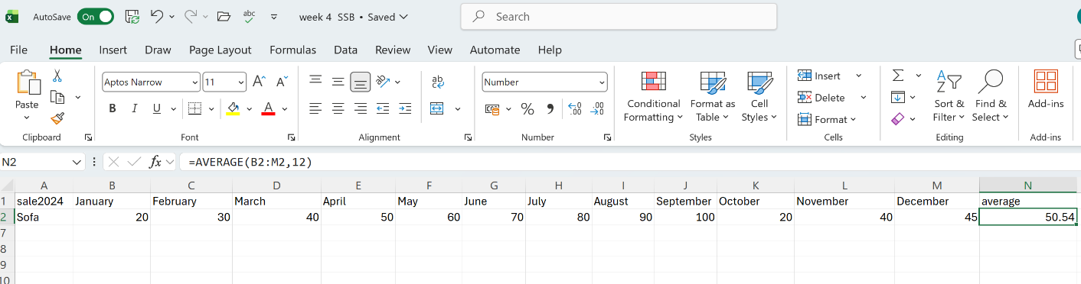
Figure 23 Example for Average function

Another important function is related to the organization and structured storage of data. The program provides tools for sorting, filtering and grouping information, which greatly facilitate the management and analysis of large volumes of data. [14]
Data visualization - Through charts and graphs (bar charts, pie charts, line graphs), users can easily present trends and relationships. The styling options here are countless. This is particularly valuable in decision-making processes, as visual representations of data are generally interpreted more quickly and intuitively than raw numerical values, enabling faster and more informed decisions.Fig24[14]
Figure 24 Bar chart
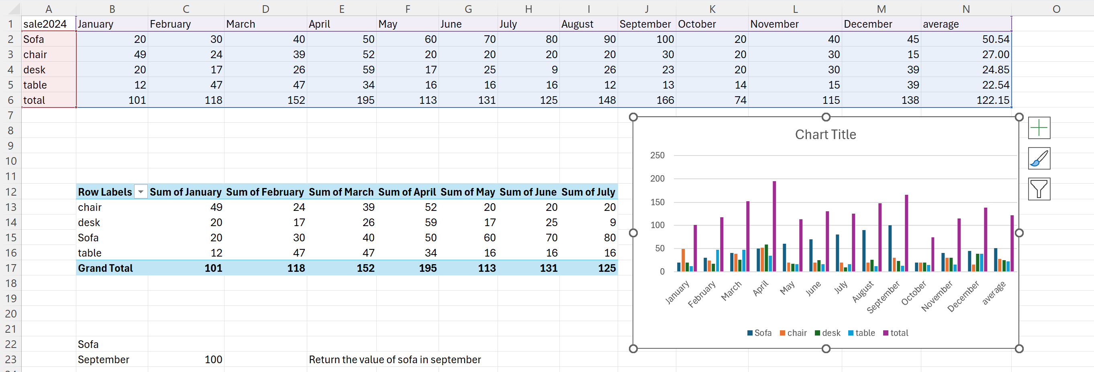
Automation through macros - Users can automate repetitive tasks. This expands the functionality of the software and improves accuracy when processing large volumes of data.[14]
Pivot Tables - It is one of the most powerful analytical tools in Excel. Pivot Tables are a key feature of Microsoft Excel that enable efficient analysis of large datasets. They provide the ability to summarize, group, and aggregate information based on selected criteria without the need to use complex formulas. In this way, users can quickly extract meaningful indicators, trends, and relationships.[14]
In addition, Excel allows text to be entered and formatted within cells, enabling users to change the font, size, colour, alignment, and style of the content. This improves the readability of tables. And function freeze for rows and columns adds more facilities working with tables.
Excel limits are related to the maximum number of rows, columns, and worksheets, but in practice they are rarely reached and do not represent a significant limitation in standard data work. A significant limitation is the size of the file and parameters such as the RAM memory and processor performance on the device used for processing.
Conclusion
Excel improves efficiency and accuracy in the workplace by providing automation, formulas, and analytical tools that support better business decisions.

Word
Microsoft Word is a word processing tool included in Microsoft 365. It offers tools for creating, editing, and formatting text, making it suitable for both simple and complex documents. [16]

Key Functions

Creating and formatting documents
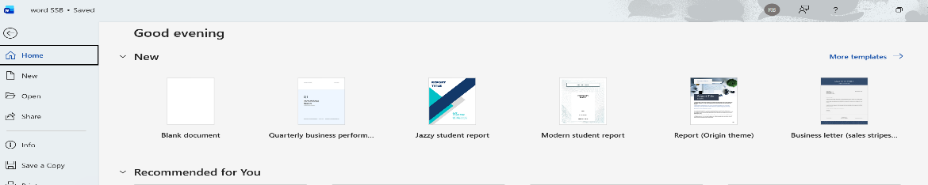
Microsoft Word includes built-in templates and cover page options, Fig.25 Fig.26. It saves files in .docx format, with the option to export in other formats, including the older .doc format Fig.27.[16]
Figure 25 Templates

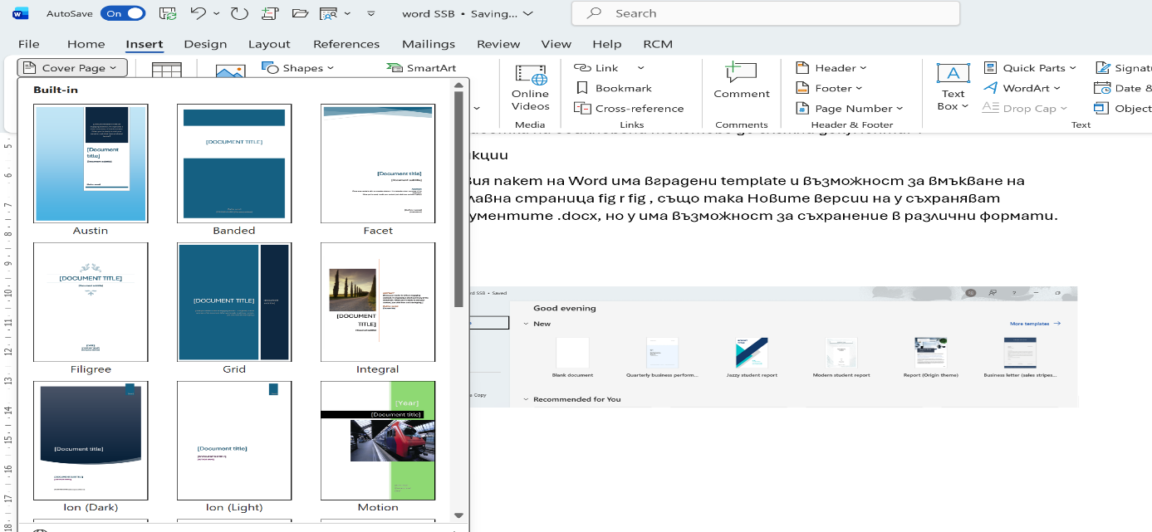
Figure 26 Cover Pages
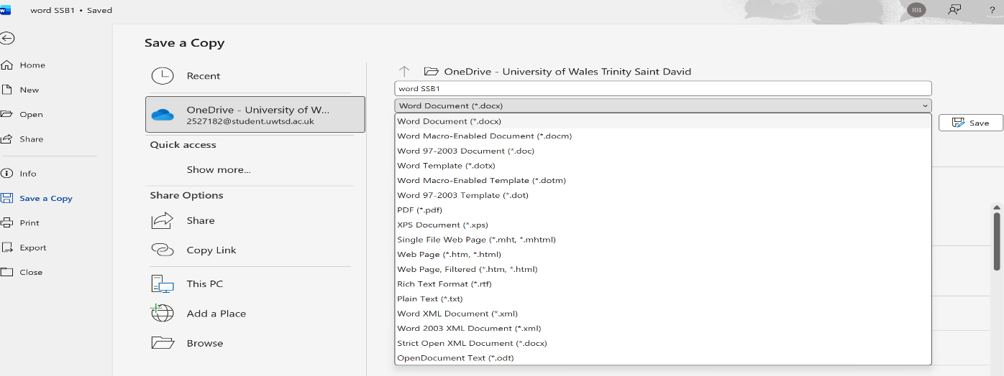
Figure 27 Saving format
For the creation and editing of text is using various copy, crop and paste tools. Available are different fonts, sizes, colours and line spacing, as well as different ways of formatting paragraphs, Fig28. [16]
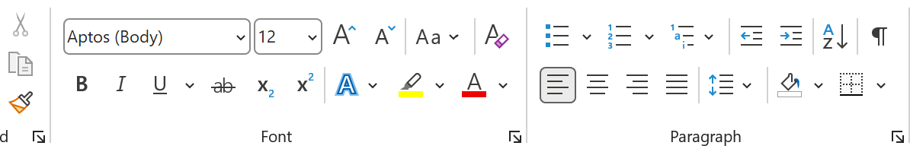
Figure 28 Formatting text, paragraph

It has built-in header elements styles fig.29, which allows us to use different themes for the whole document fig.30.
Figure 29 Heading
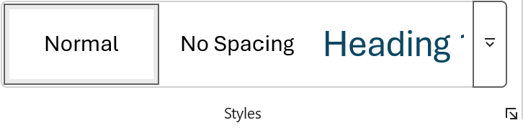
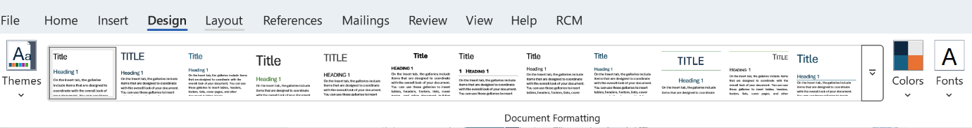
Figure 30 Design Format

Formatting the document in this way allows you to create Table of Content, which is located in the References - Ribbon menu Fig.31. This provides convenience when working with large documents, users can automatically navigate to the desired section by using CTRL+Click.
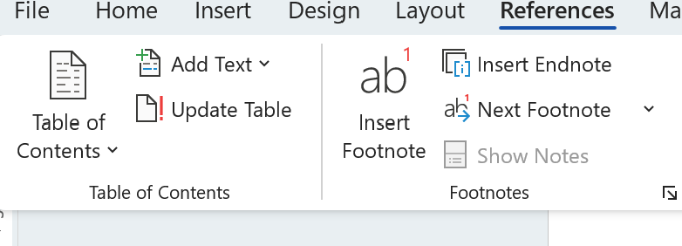
Figure 31 Table of Contents

Inserting Elements

Excel tables, images, graphs, and hyperlinks. When inserting an image, various sources can be used, own resource or online stock, Fig.32.[16]
Figure 32 Inserting Image

Images can be processed with different styles and effects, Fig.33.

Figure 33 Image Effects
The tools are located by clicking on the picture, the Picture format button appears in the MAIN MENU, Fig34.
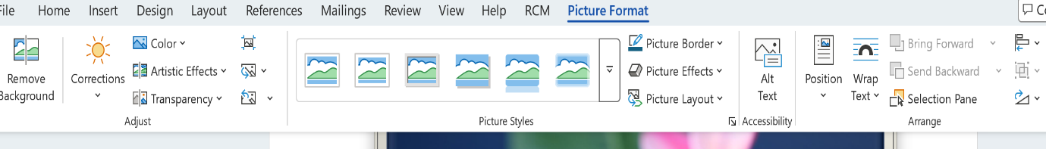
Figure 34 Picture format menu

The positioning of the picture is in Fig.35.
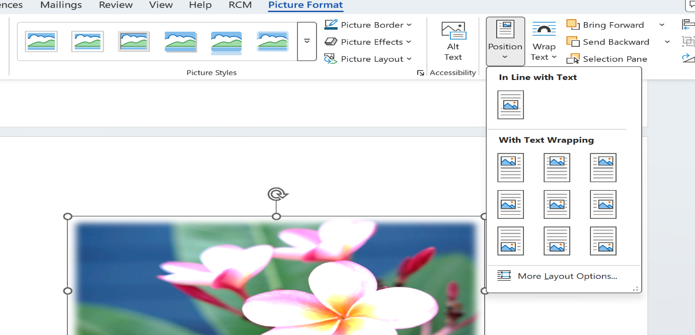
Figure 35 Picture position features

With Text wrapping, relative Picture to the text, Fig.36.

Figure 36 With text wrapping

The labelling of figures is done using Insert Caption from the References menu, and here Table of figures is also generated, Fig.37.
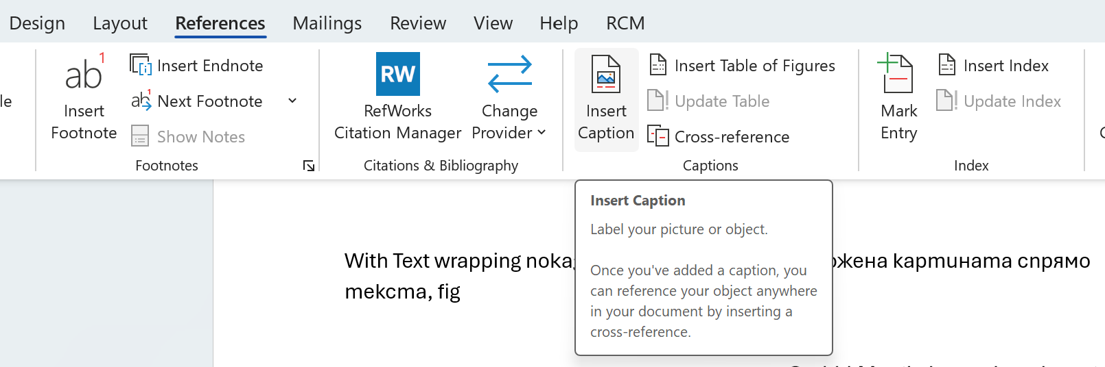
Figure 37 Labelling Figure

Microsoft Word allows inserting graphics, videos, and hyperlinks homework SSB, making visually present documents for information and trends, Fig.38.[16]
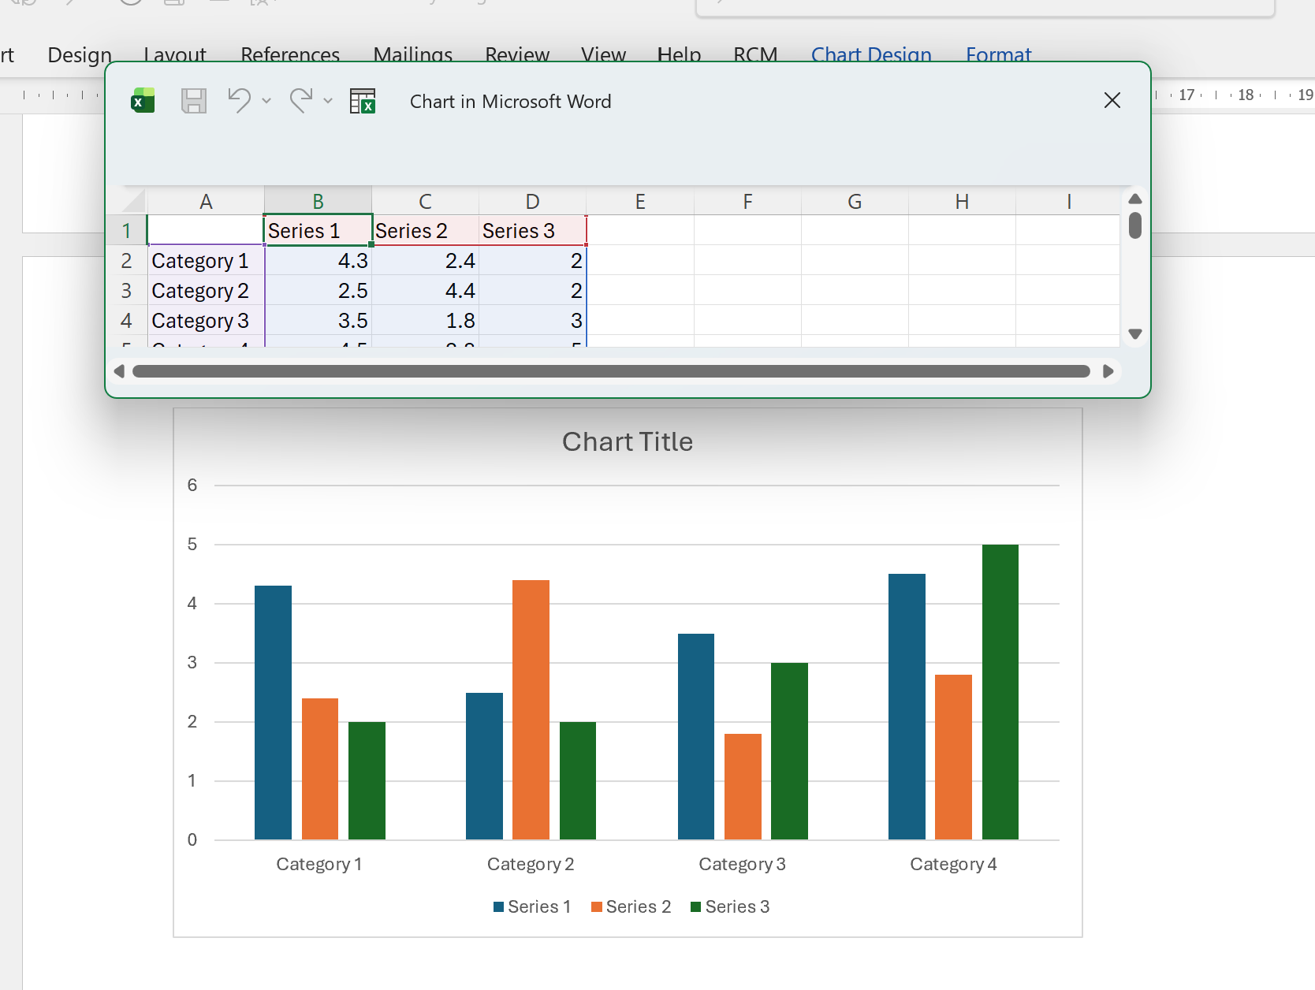
Figure 38 Bar chart

Adding header and footer, automatically repeated on each page of the document, as well as the page number feature.

Spell and grammar checkers
In REVIEW menu, Fig.39 Built-in spell and grammar checkers improve text quality, while the Translator and Dictation add convenience.

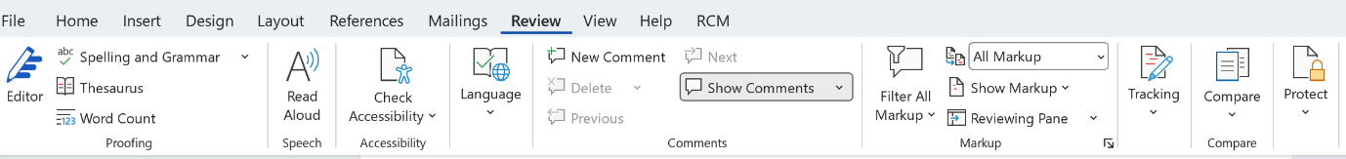
Figure 39 Review menu

Cloud services
Through integration with cloud services, the program allows easy storage, sharing via link or sharing options, and real-time collaboration between multiple users. Tracking feature allows users to monitor, accept, or reject document changes, which is useful for collaboration. [16]

Citation manager
An important feature is the ability to insert references using built-in tools in Microsoft Word, as well as support for external reference management providers. Word citation manager has different styles and allows to create bibliography. This function is directly linked to academic integrity, as it helps prevent plagiarism by properly citing sources and ensuring that all used information is clearly referenced.[17]
Mail Merge Function for personalized letter and bulk e-mails
Mail Merge creates multiple personalized documents automatically by combining a template with data such as names and addresses. This function is important because it saves time, reduces manual errors, and improves efficiency when sending letters, emails, labels, invoices to many recipients. It is especially valuable in business communication where speed, accuracy, and personalization are essential. It is supported by Wizard. [16]
As a disadvantage, Microsoft Word may become slow or unstable when handling large documents or when sharing documents between different versions, and its wide range of features can be confusing for beginners. Despite this, Microsoft Word remains a powerful and versatile word processing tool and one of the most widely used software products in the world. [16]

Task 3b

VLOOKUP
Fig.40,41,42,43,44,45 present my knowledge for using it.
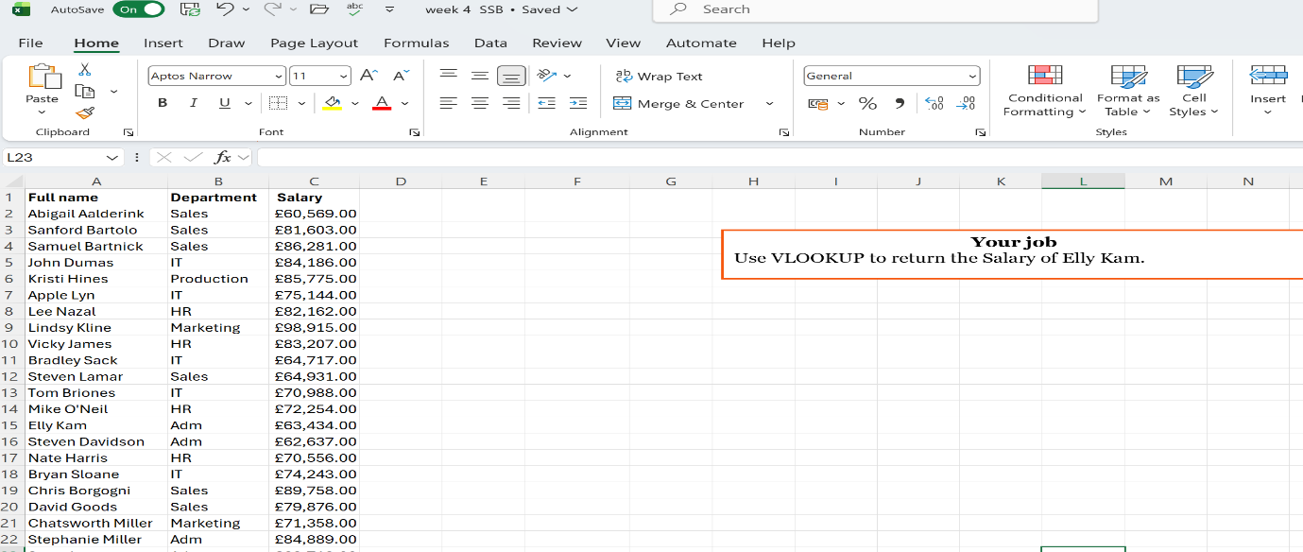
Figure 40 Task

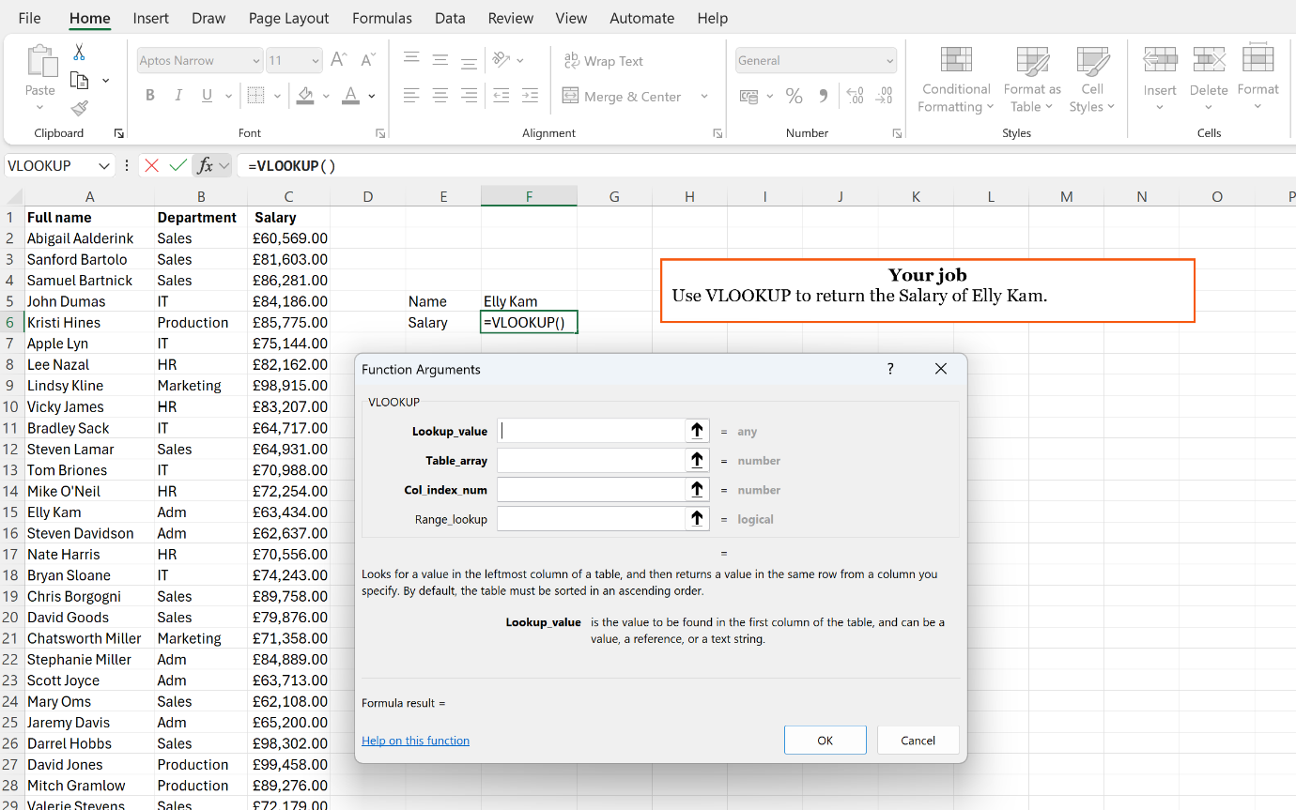
Figure 41 VLOOKUP in functions

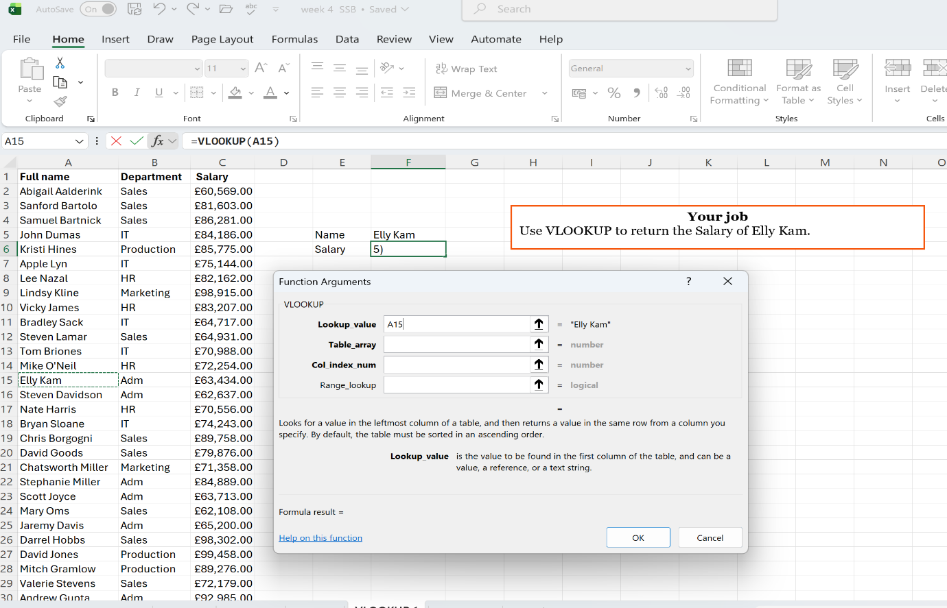
Figure 42 Criteria

Figure 43 Range
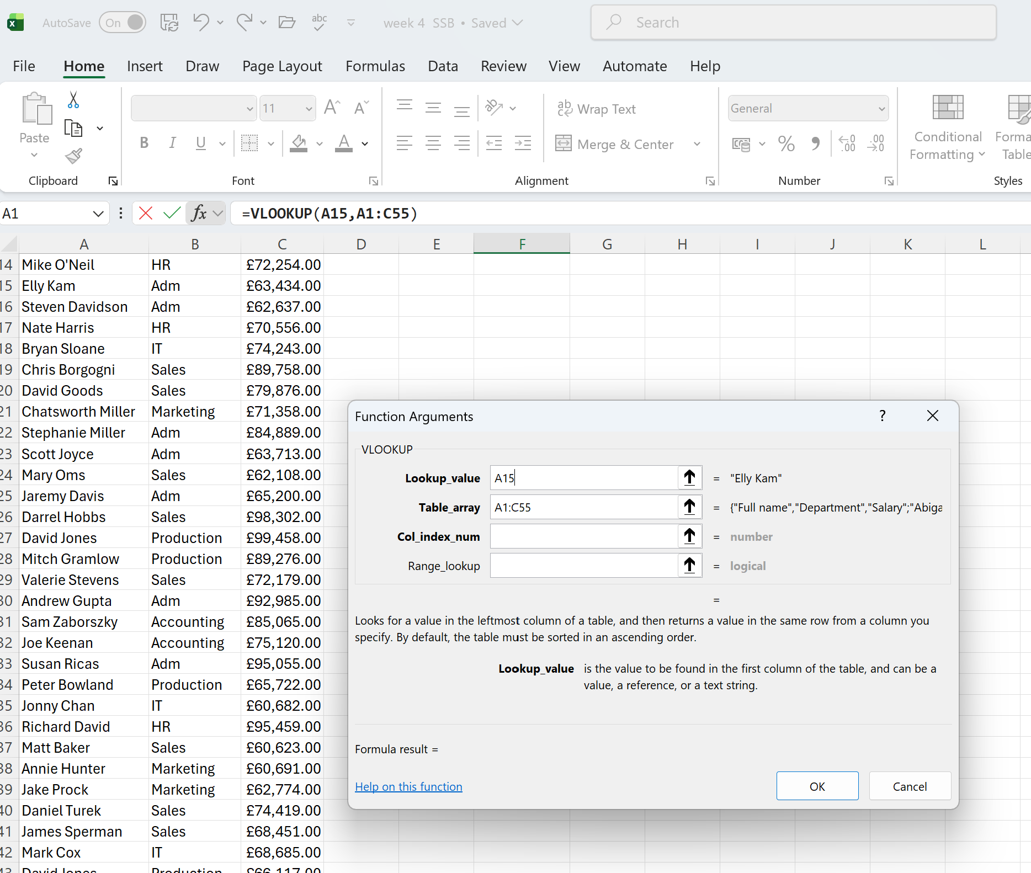
Figure 44 For which column and False for finding exact much
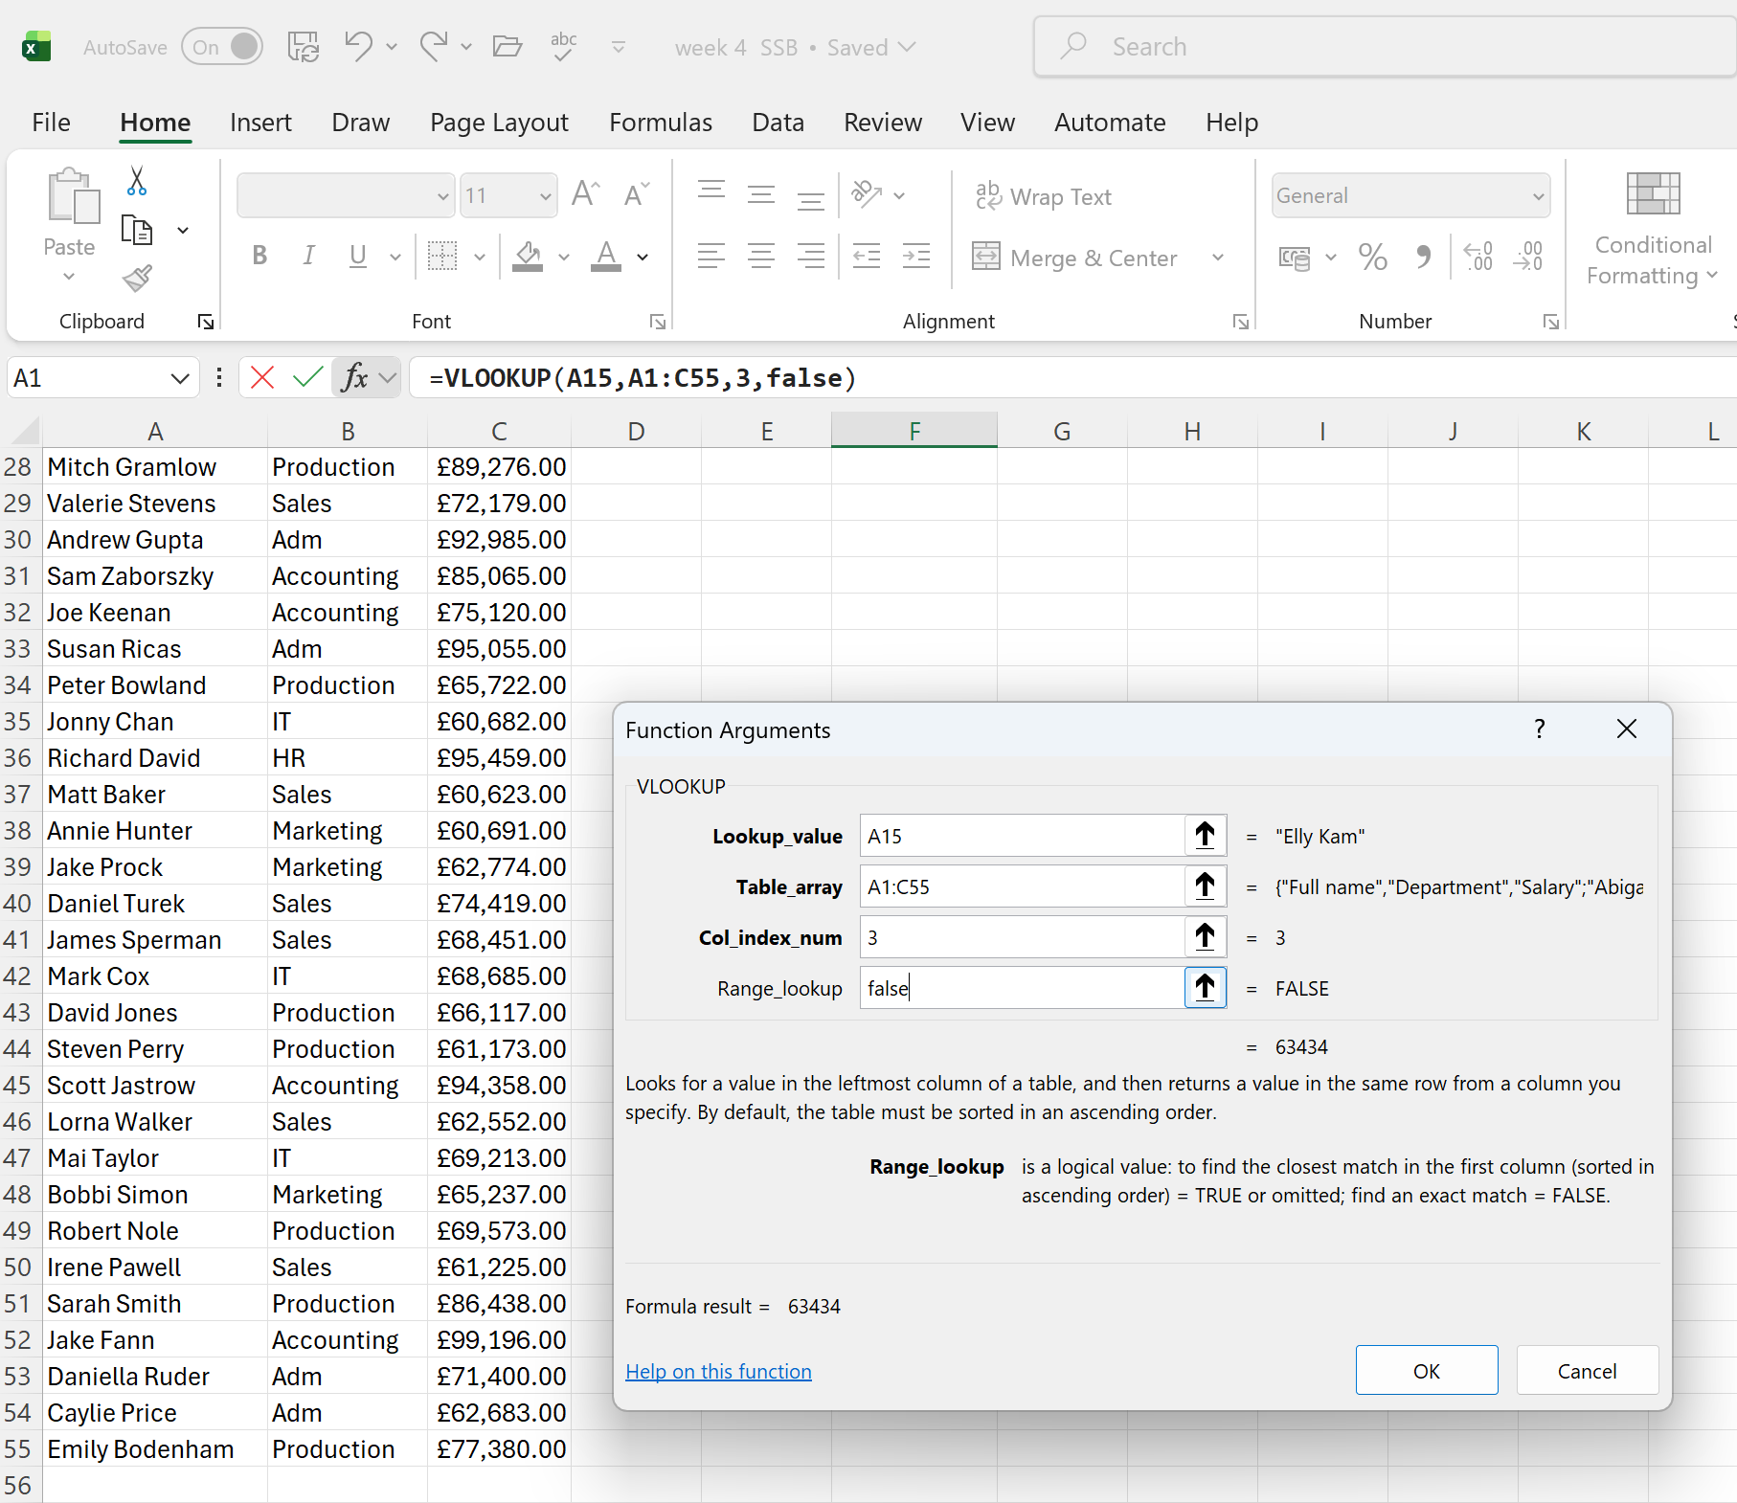
Figure 45 Result
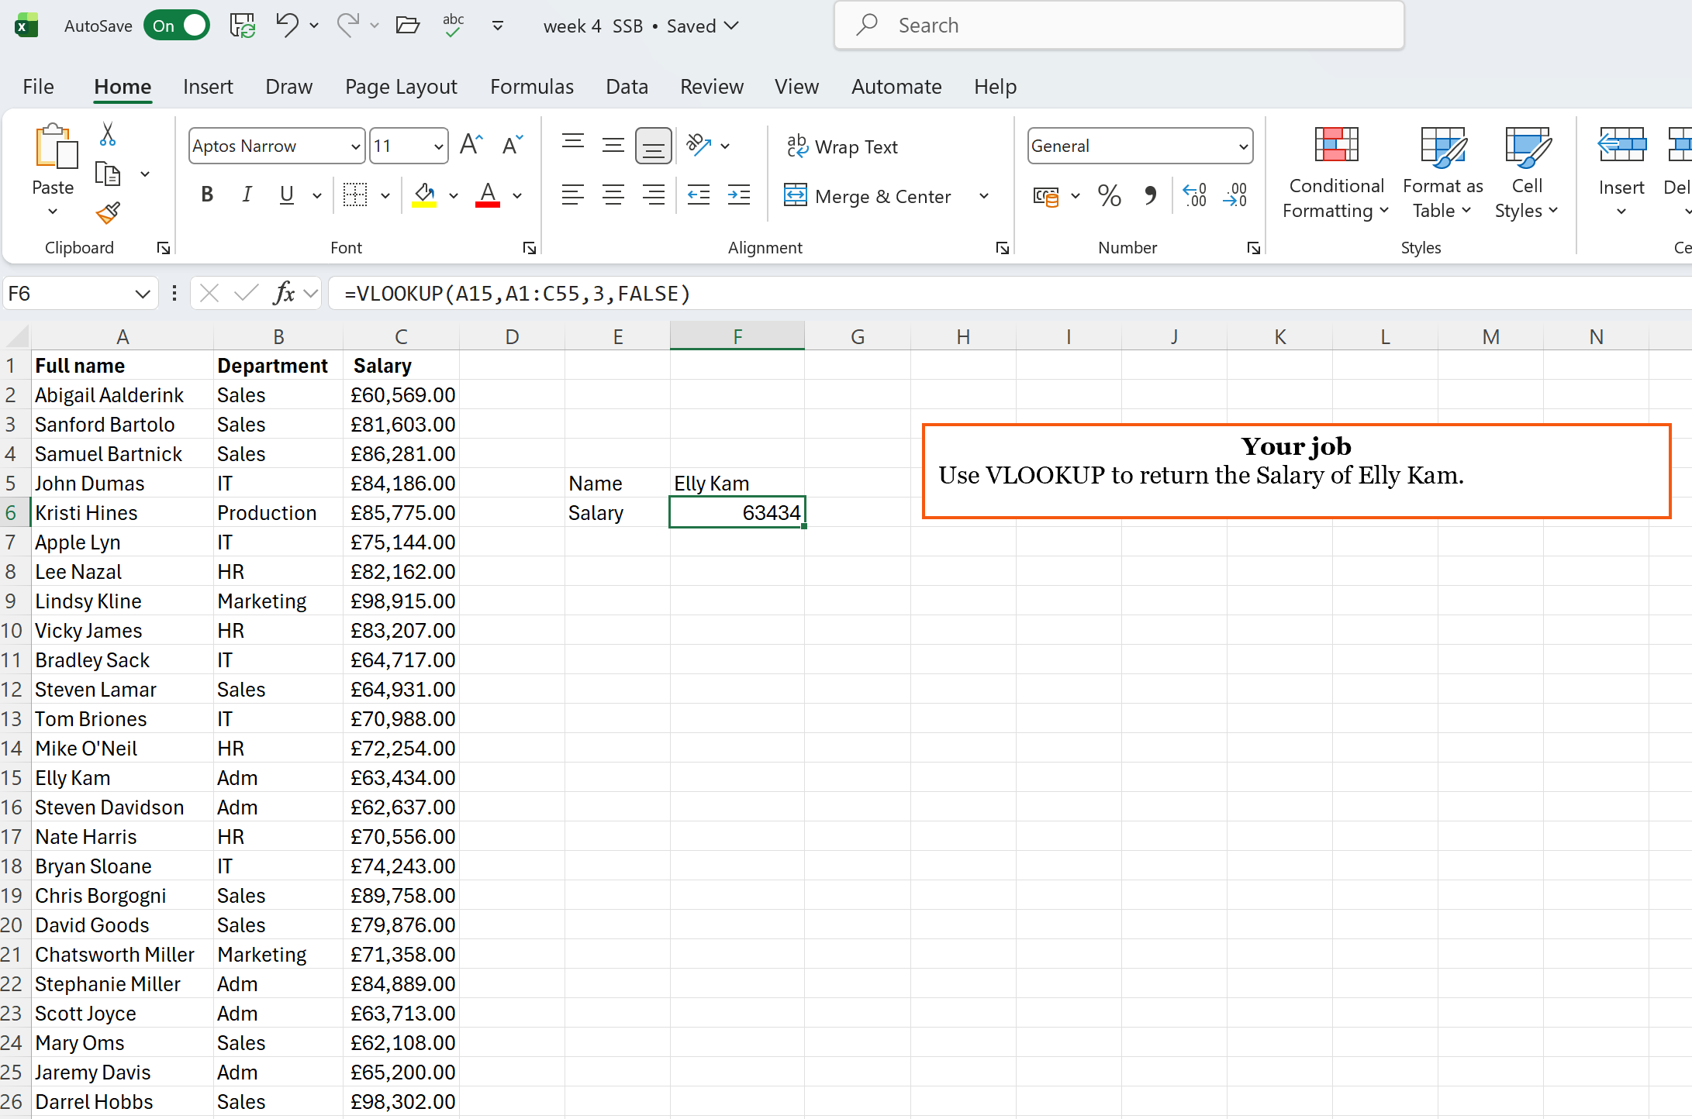

PIVOT
Fig.46,47,48,49,50,51,52,53,54 present my example.
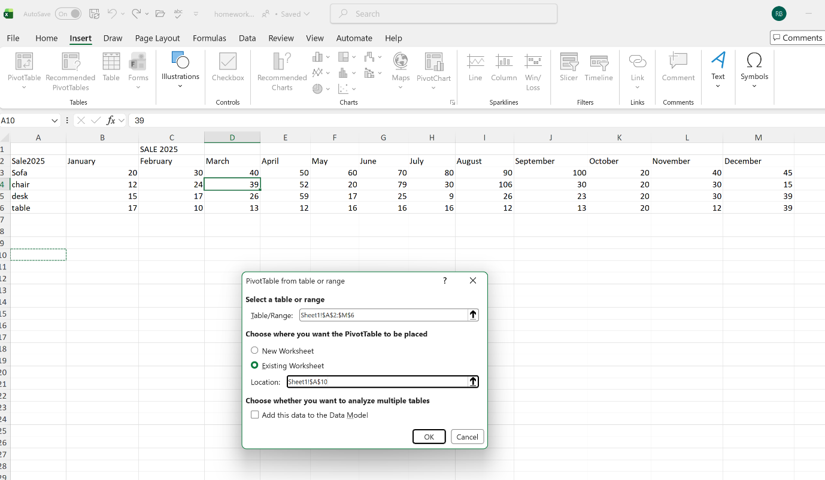
Figure 46 Select table for Pivot and where pivot will be placed

Figure 47 Empty Pivot is done
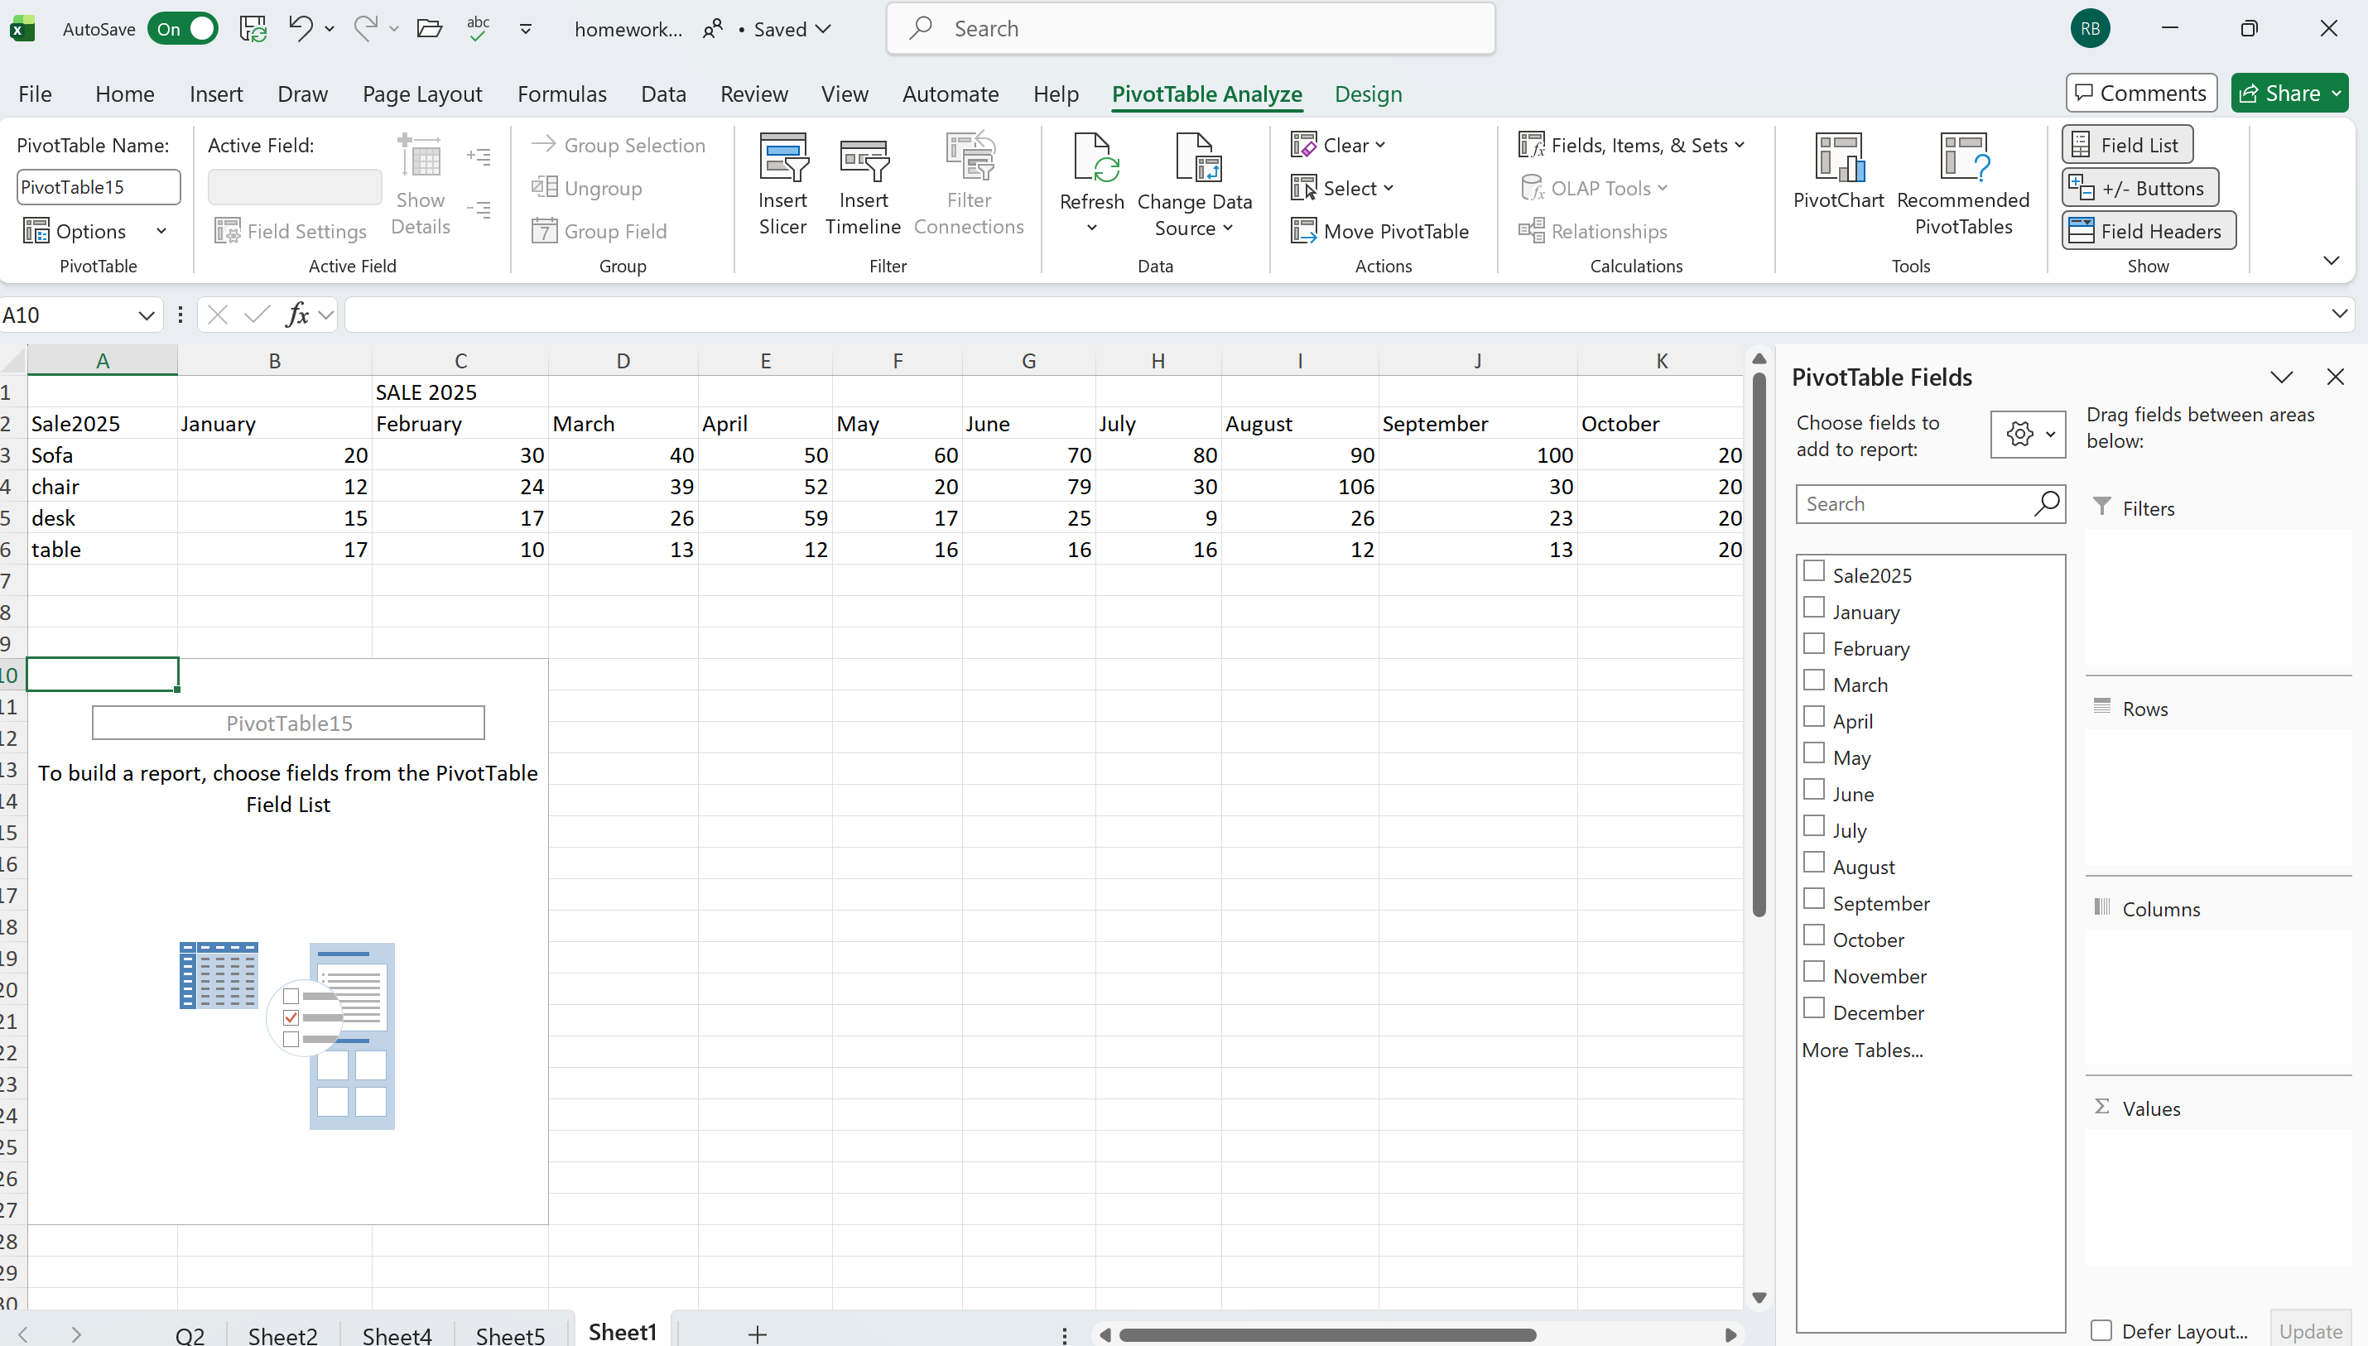
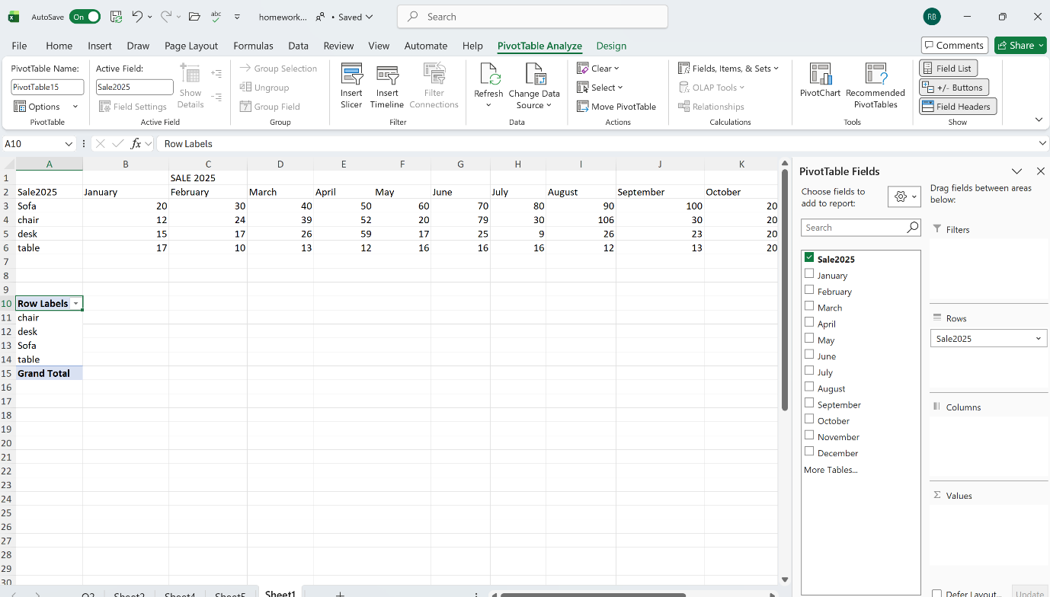
Figure 48 Select what rows and columns will consist, Filters and Values
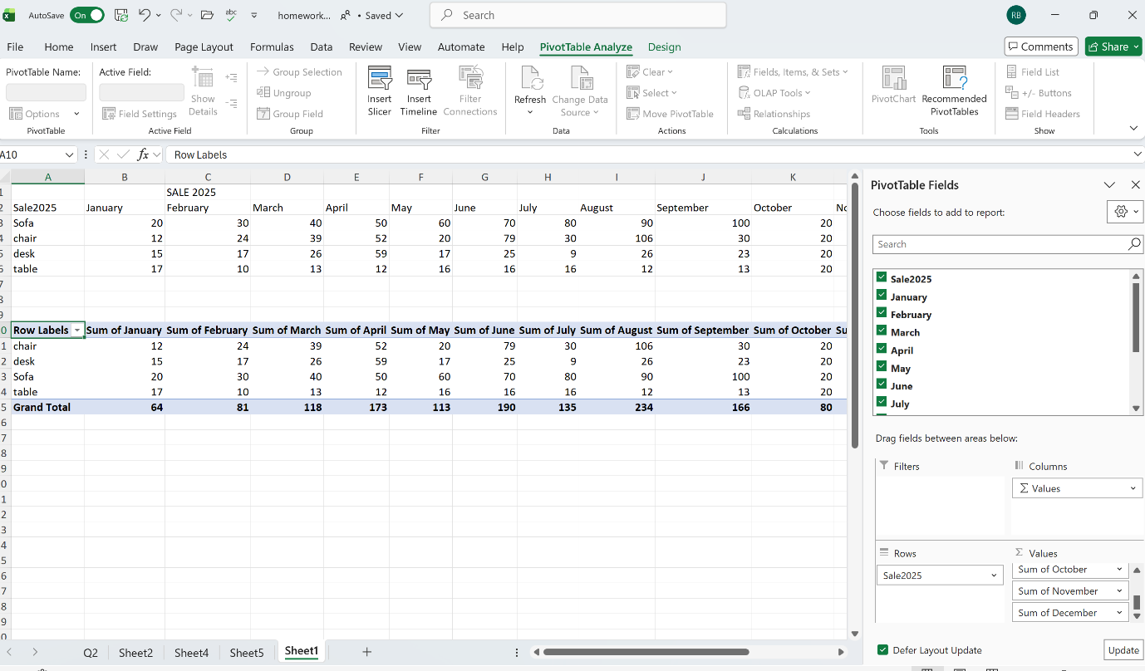
Figure 49 Pivot is done

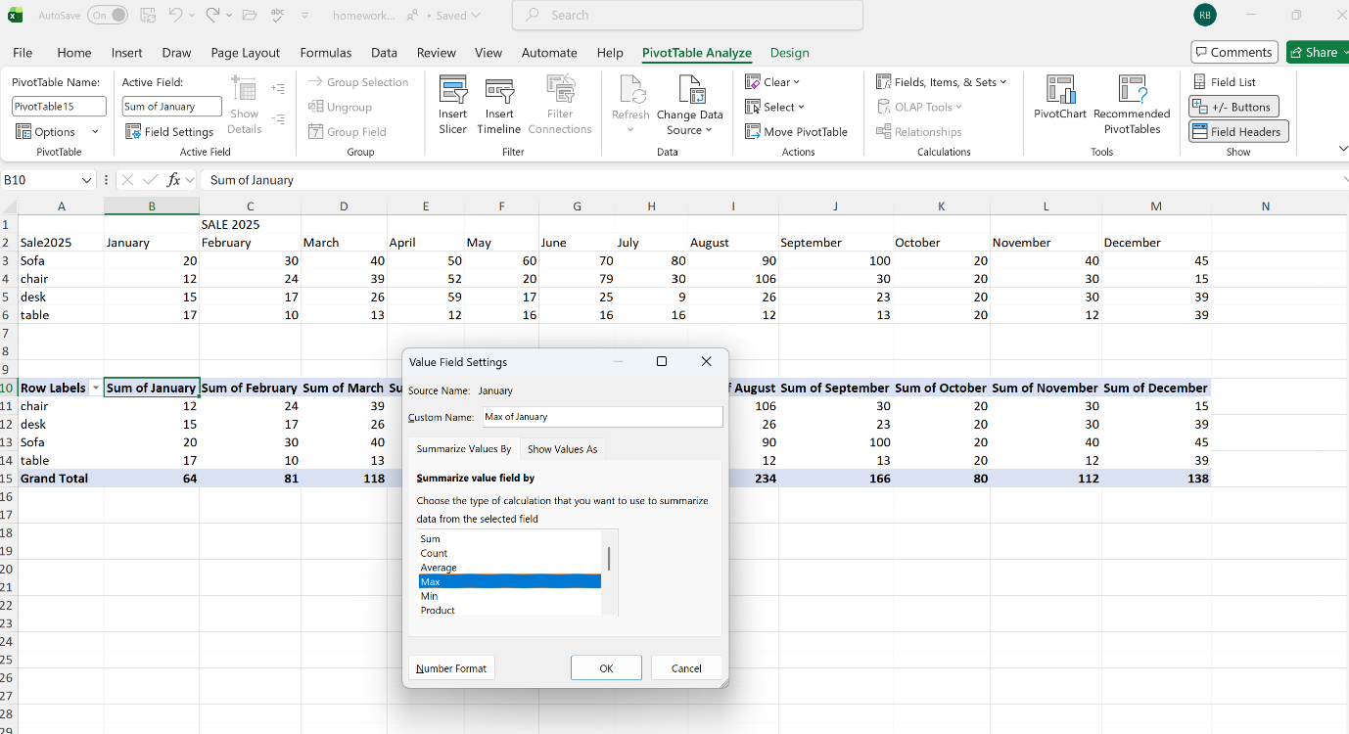
Figure 50 Can select different type of calculation

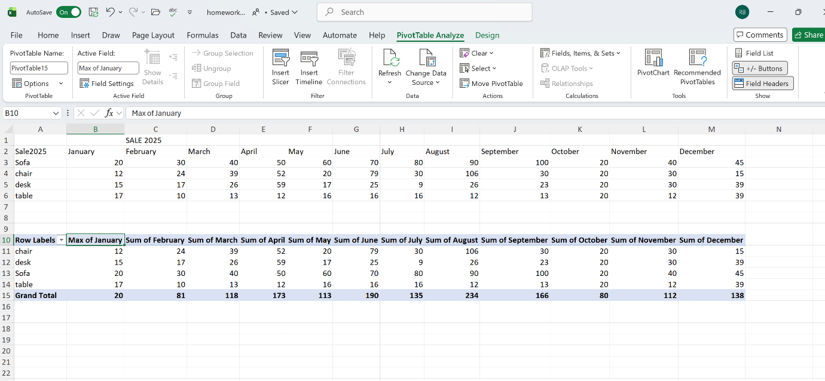
Figure 51 January is changed to show max. sales

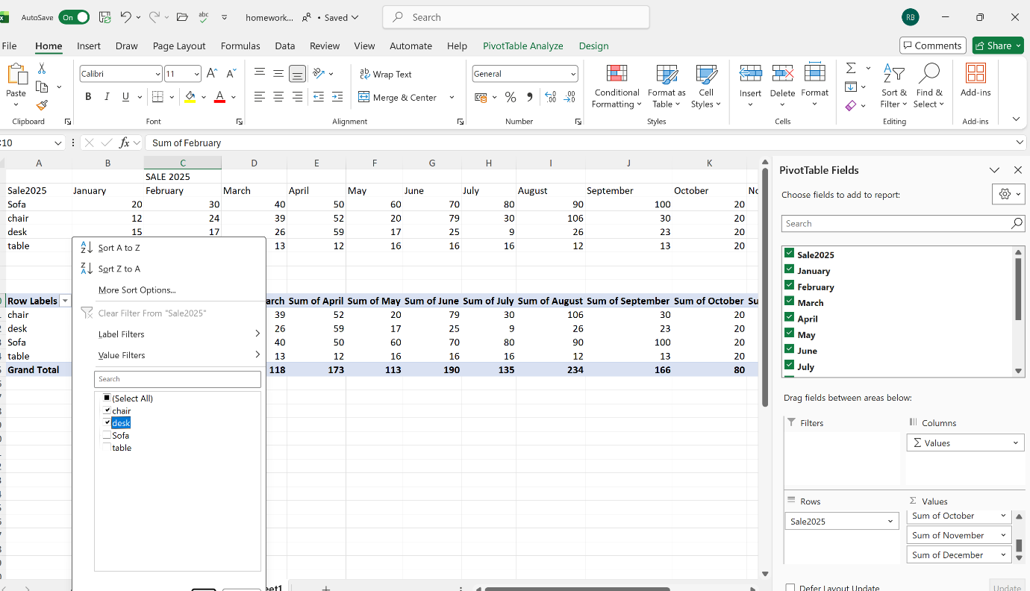
Figure 52 Can do filter and chart with the new filter

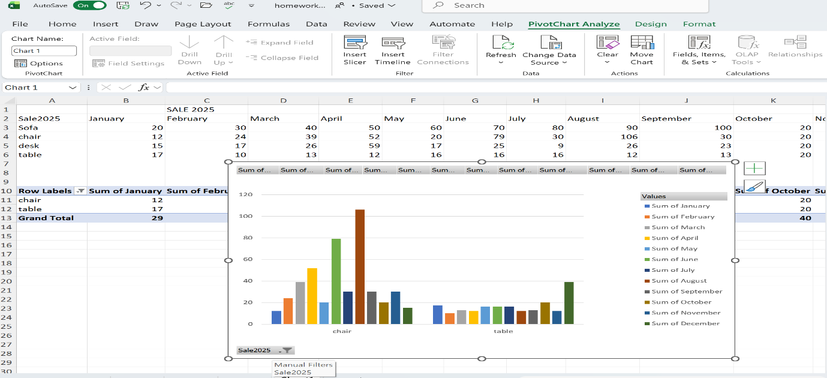
Figure 53 Bar chart with applied filter
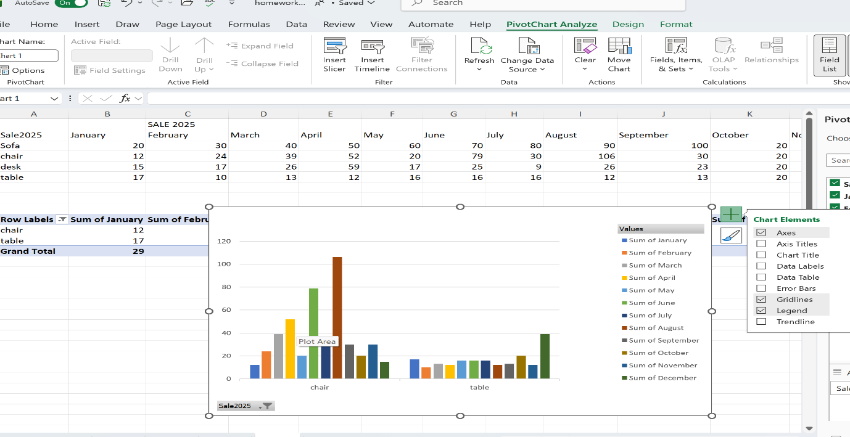
Figure 54 Removing elements that are not needed

Task 4 Communication and Collaboration applications

Task 4a

Communication application - Google Gmail
Gmail is a free web-based email service developed by Google and part of Google Workspace. Emails and files are stored on Google’s servers and can be accessed from different devices via a web browser or mobile application. It offers large storage, spam protection, high reliability, and a user-friendly interface for organizing messages. [18][19]

Key Functions

Email management
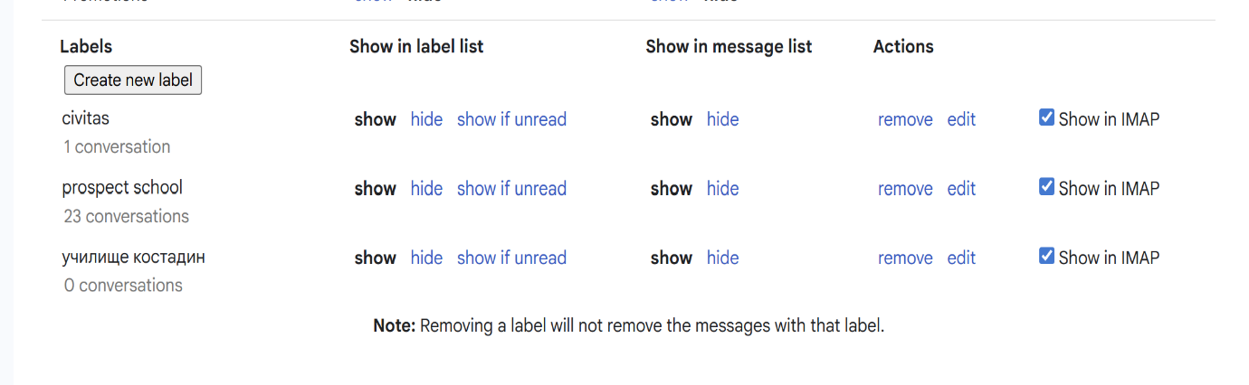
Users can send and receive messages, attach files, and use folders and labels for better organization, Fig.55. Gmail also provides intelligent filters that automatically sort emails into categories such as Primary, Social, and Promotions, Fig.56. [20]
Figure 55 Created e-mail labels
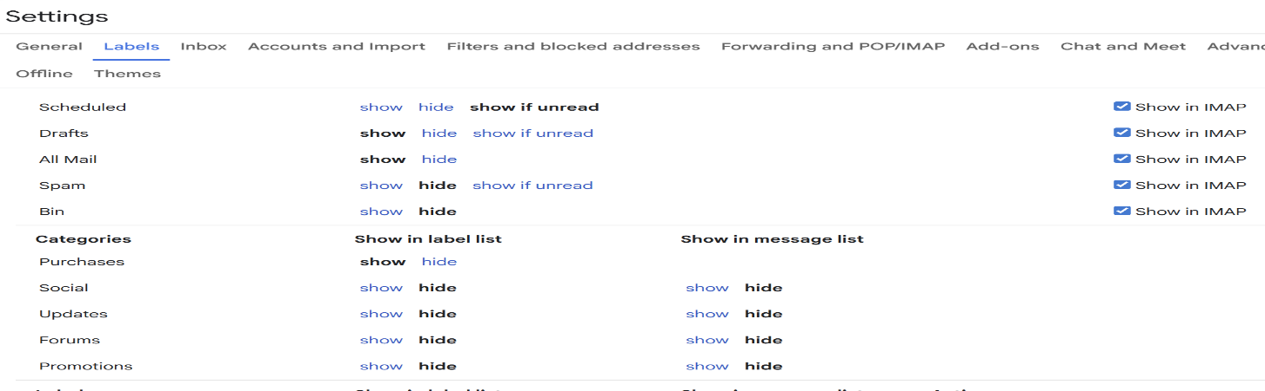
Figure 56 Intelligent labels

Gmail supports CC and BCC fields to manage multiple recipients, Fig.57. CC sends a visible copy of an email to additional recipients, while BCC sends a hidden copy without revealing recipients’ addresses, improving privacy and communication control.[20]
Subject line is very important; this is the theme of the message.
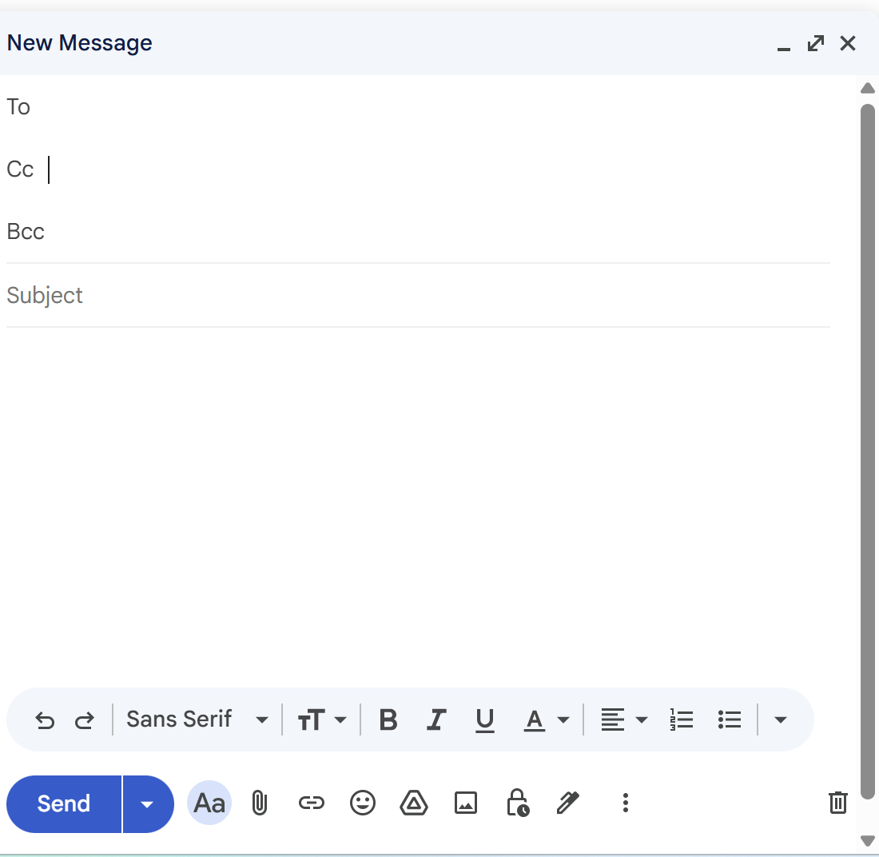
Figure 57 Different type of recipients

Intelligent searching
Built-in search engine, based on Google technology, allows users to quickly find specific messages using keywords. [20]

Protection and Security
Gmail provides protection against spam, phishing, and malware through integrated security systems. This makes the platform secure and convenient for everyday use. [21]

Integration with Other Services
Gmail works together with services such as Google Drive, Google Calendar, and Google Meet for better productivity. It also offers 15 GB of shared cloud storage. From the Google Workspace Marketplace, users can integrate many applications, add notifications to Calendar, and manage notes or tasks, Fig.58.[20]

Figure 58 Adding email to calendar
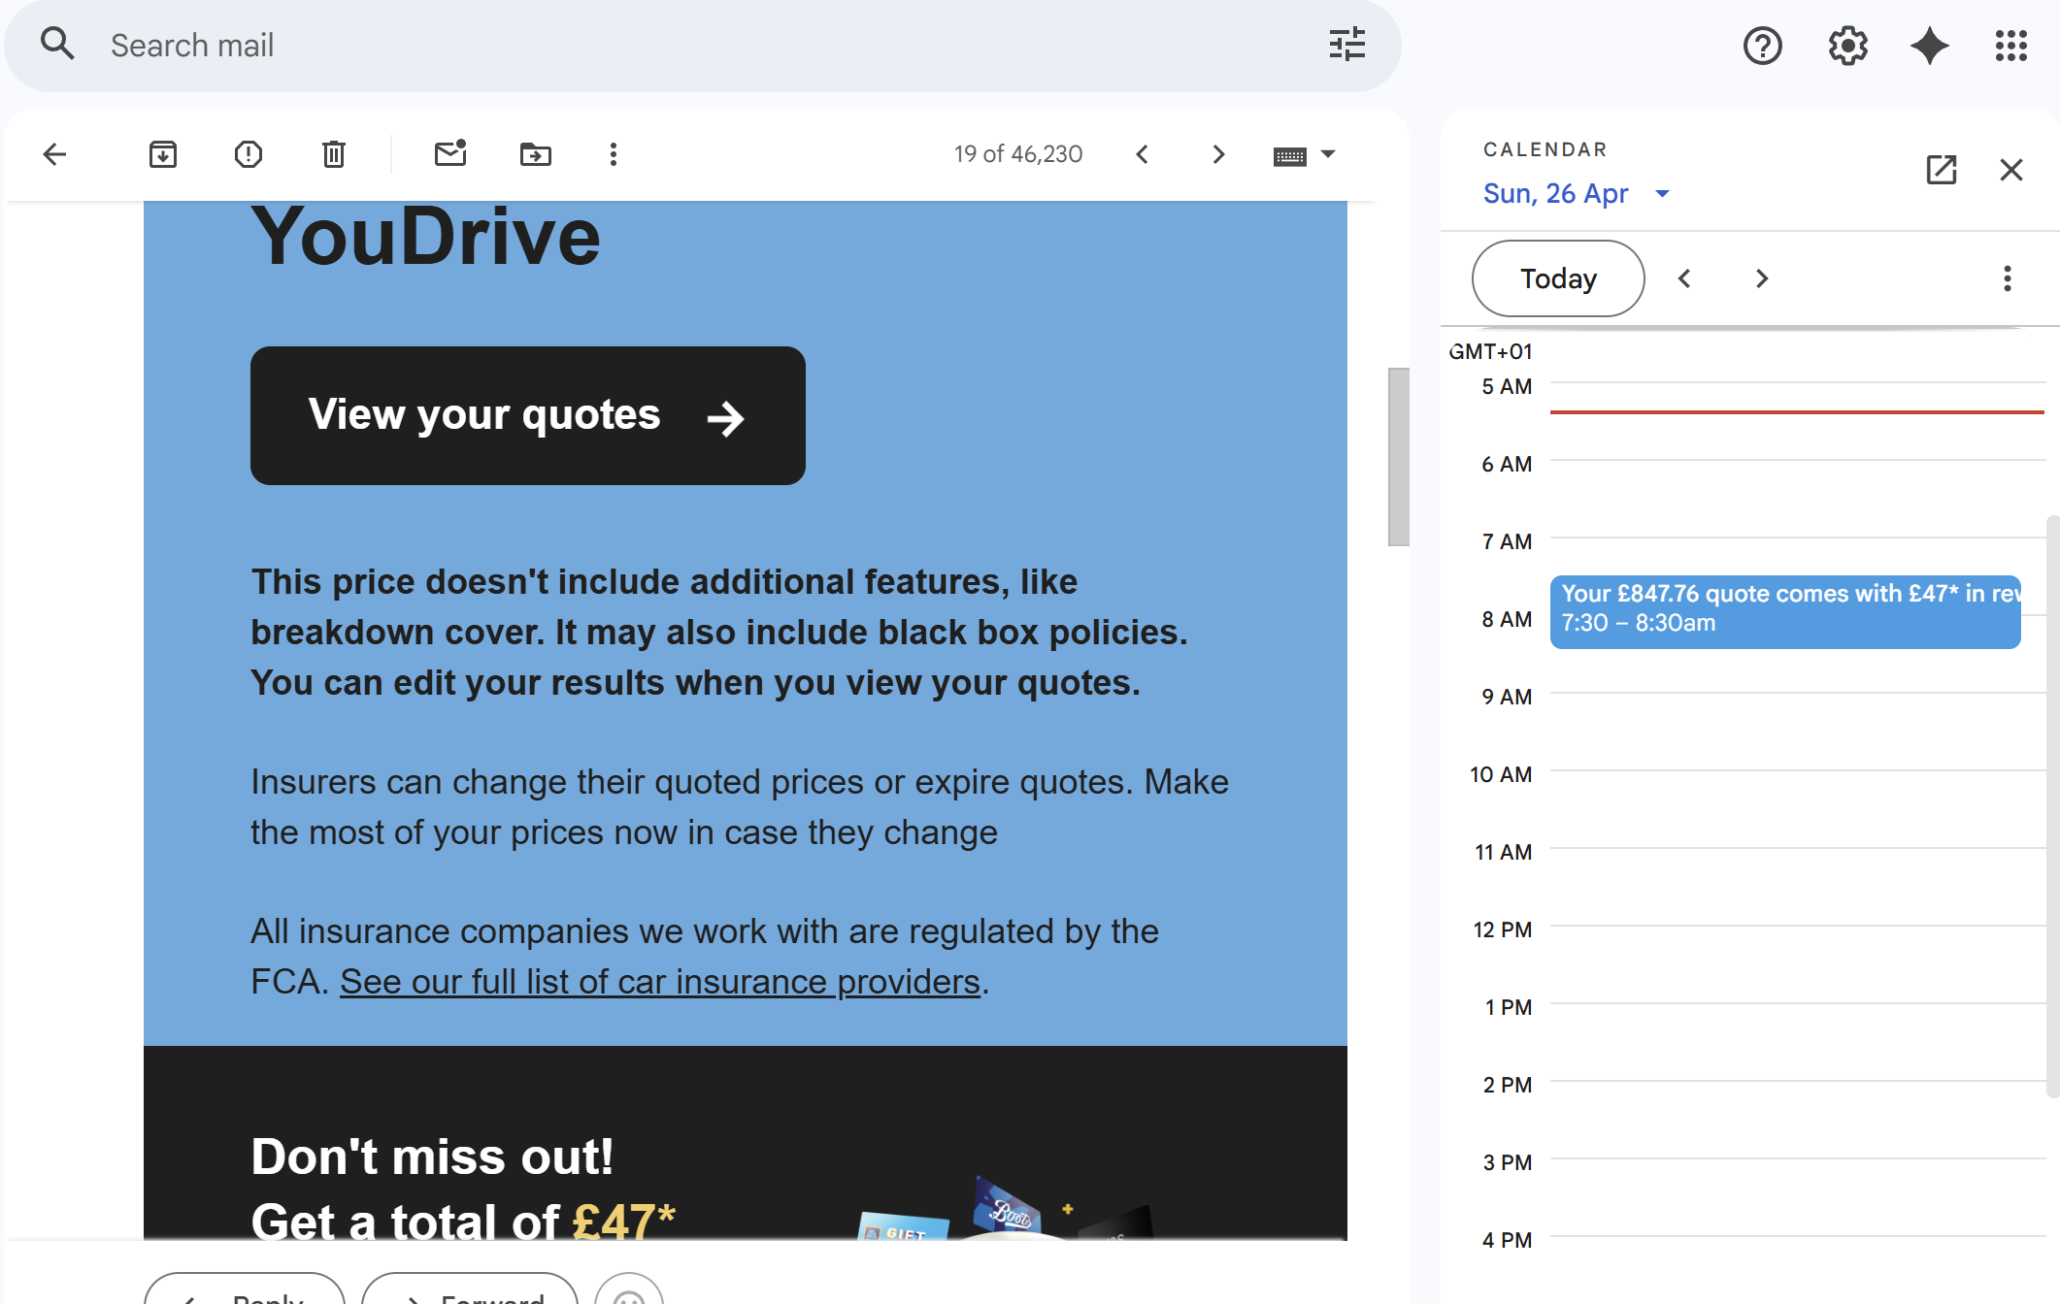

Gmail limitations - requires an internet connection and the free version offers limited storage. Some users are concerned about privacy and personalised advertisement . Managing large amounts of emails can also be difficult without proper organisation.[20]
Thanks to its reliability, user-friendly interface, and easy access, Gmail is one of the most widely used application for communication in the world.

Collaboration application - Microsoft Teams
Microsoft Teams is developed by Microsoft. It is designed to support teamwork between people and combines chat, video calls, file sharing, and task management, providing all the essential tools for collaborative work in a single place. This makes it especially useful for remote and team working. [22]

Key Functions

Chat
Users can send individual or group messages in real time, share files, and use emojis, reactions, and search tools in conversations. This improves daily communication and reduces the need for email for quick questions and responses.[22]

Channel
A channel in Microsoft Teams is used to organize communication and work on a specific topic, project, or department within a team. It allows focused discussions, file sharing, and collaboration between members. Multiple users can work simultaneously on the same file (Word, Excel, or PowerPoint) and changes are saved automatically. This helps create better structure, clearer communication, and more efficient teamwork. [22]
Steps in creating channel, Fig.59,60,61,62,63,64,65.

Figure 59 Create team
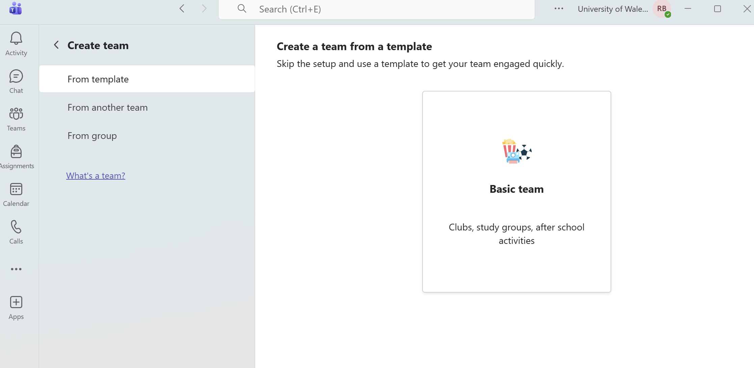

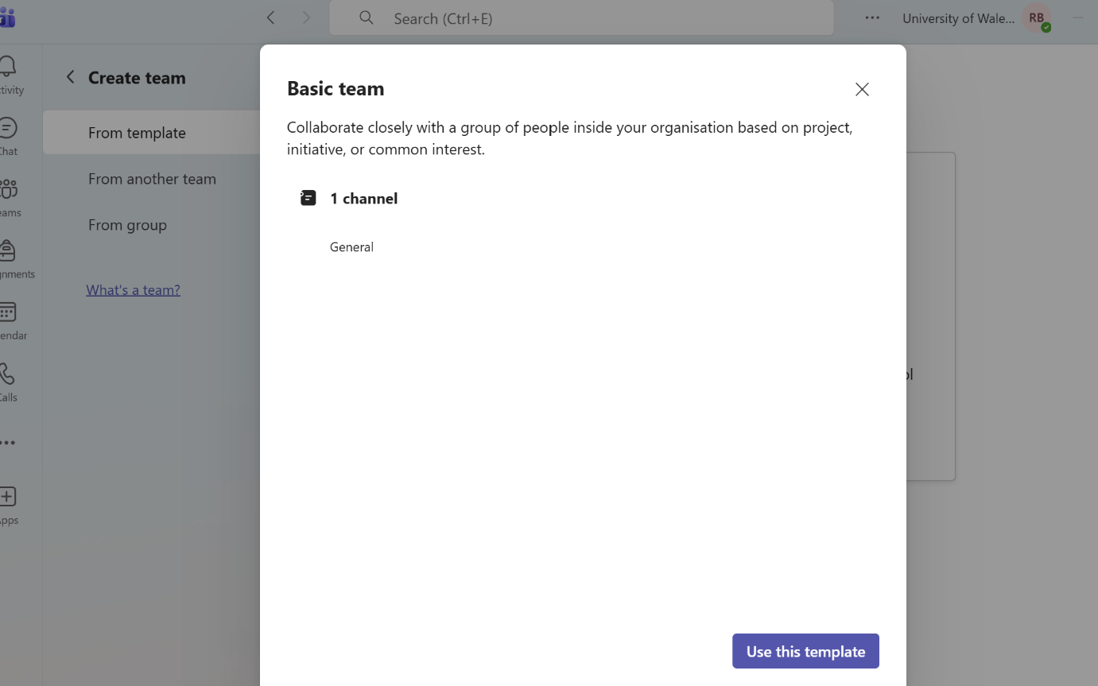
Figure 60 Choose template

Figure 61 Privacy
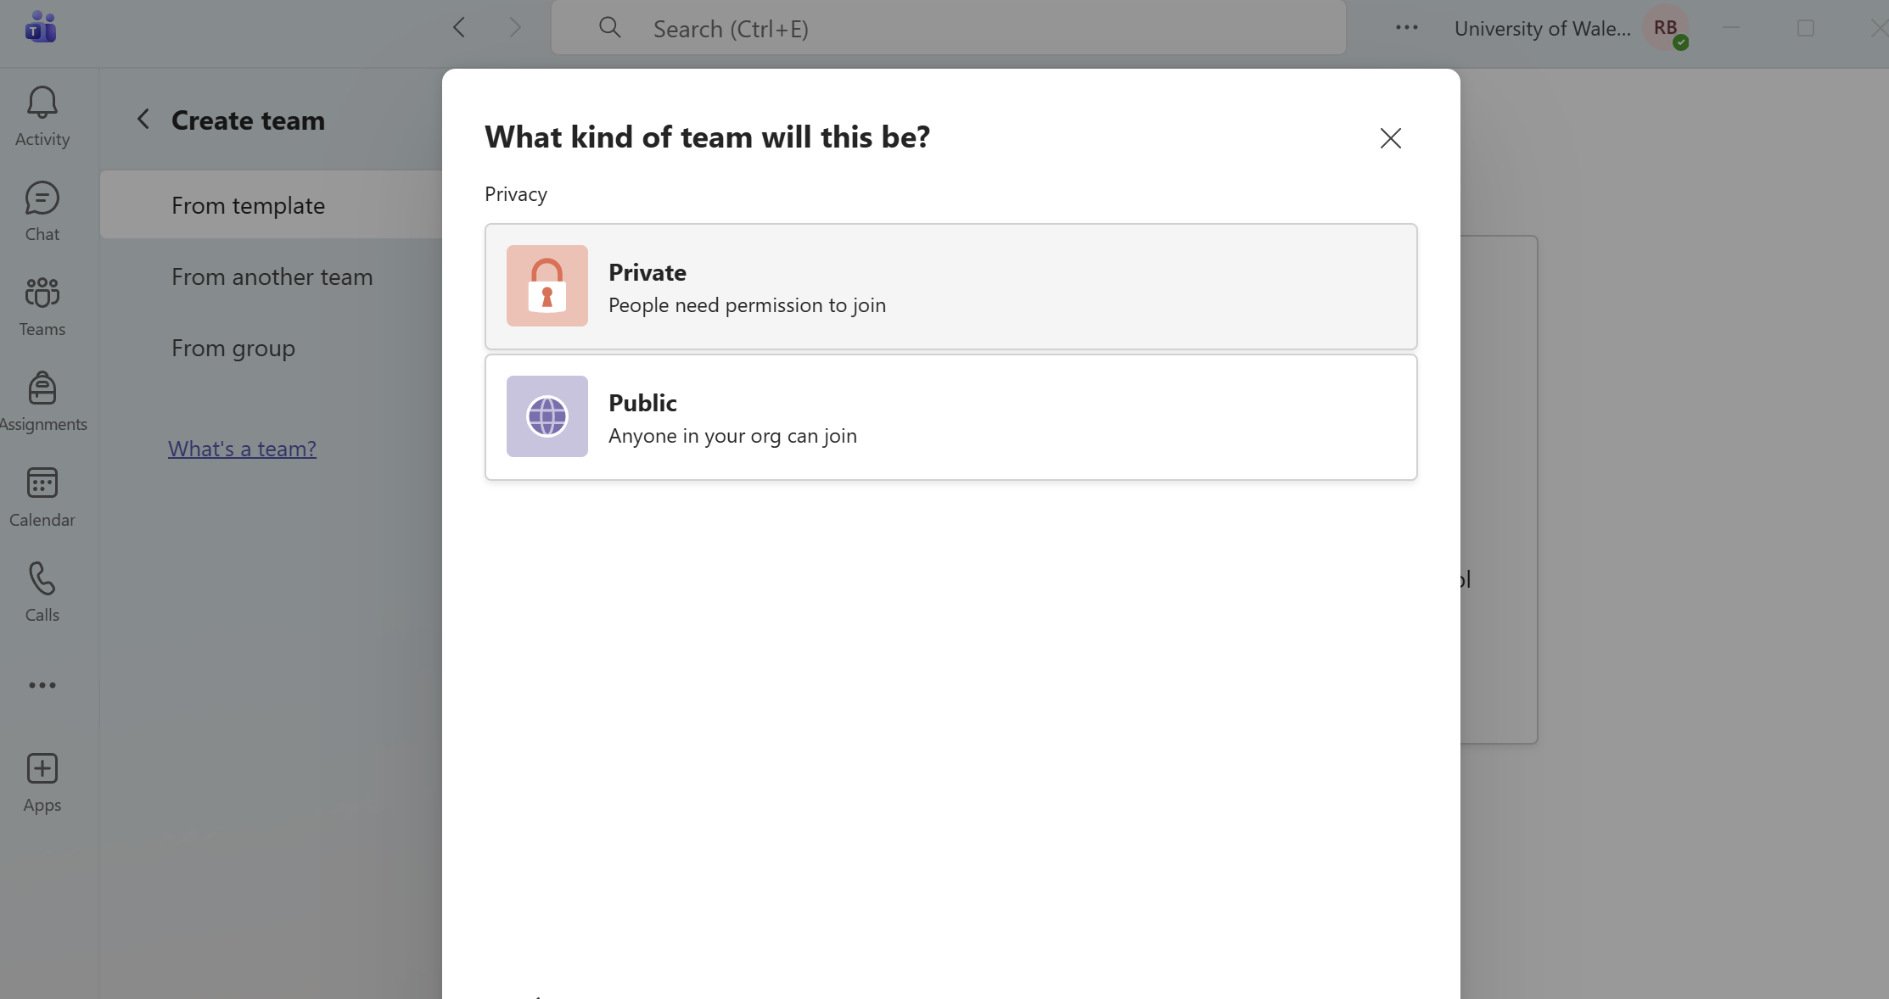

Figure 62 Description of Channel
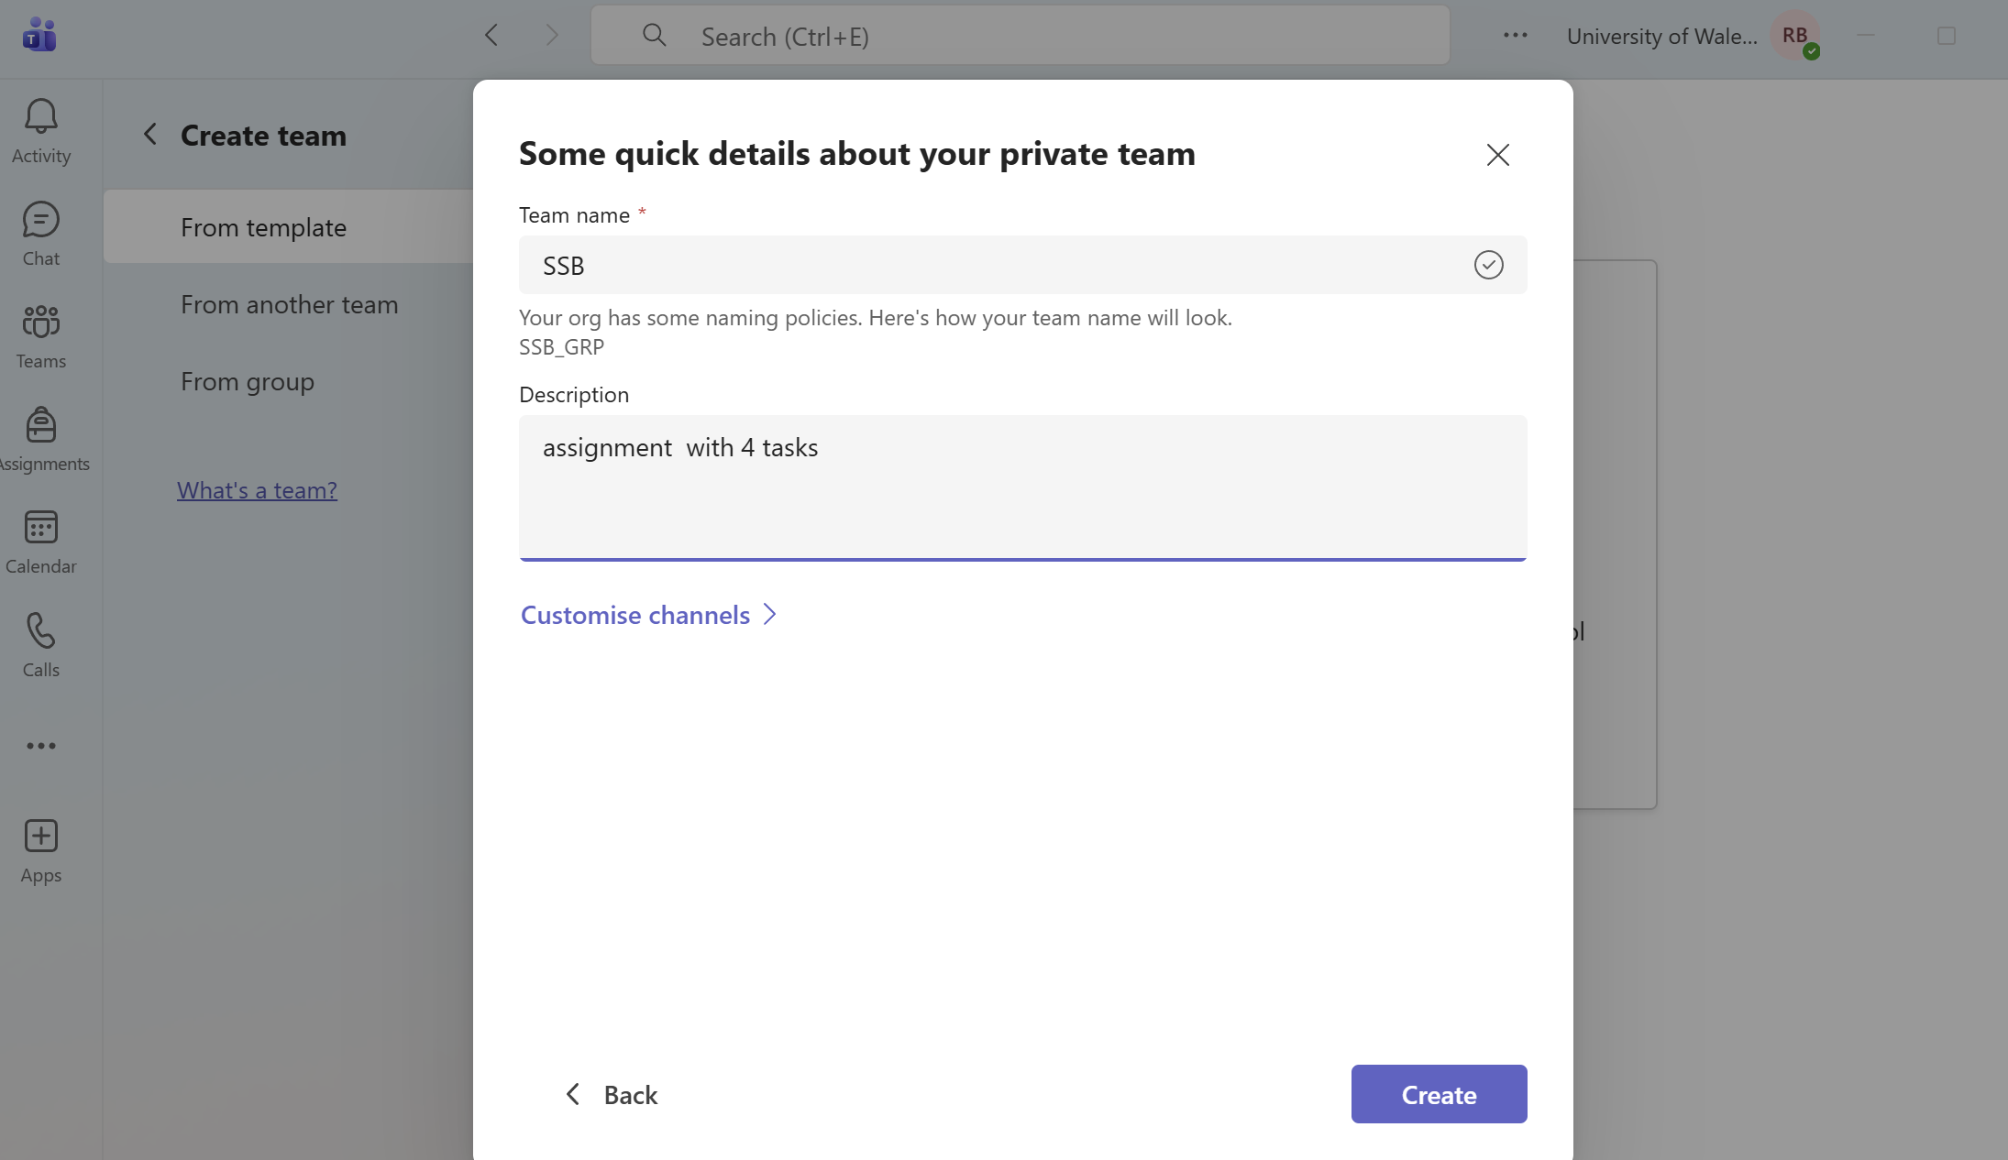

Figure 63 Adding members
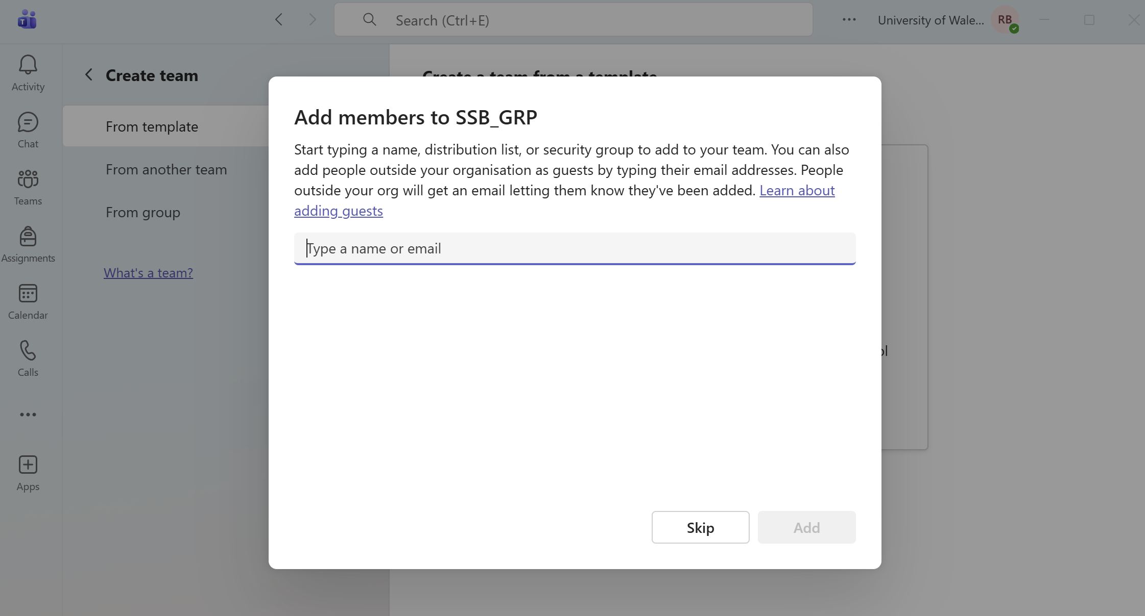

Figure 64 Channel is done
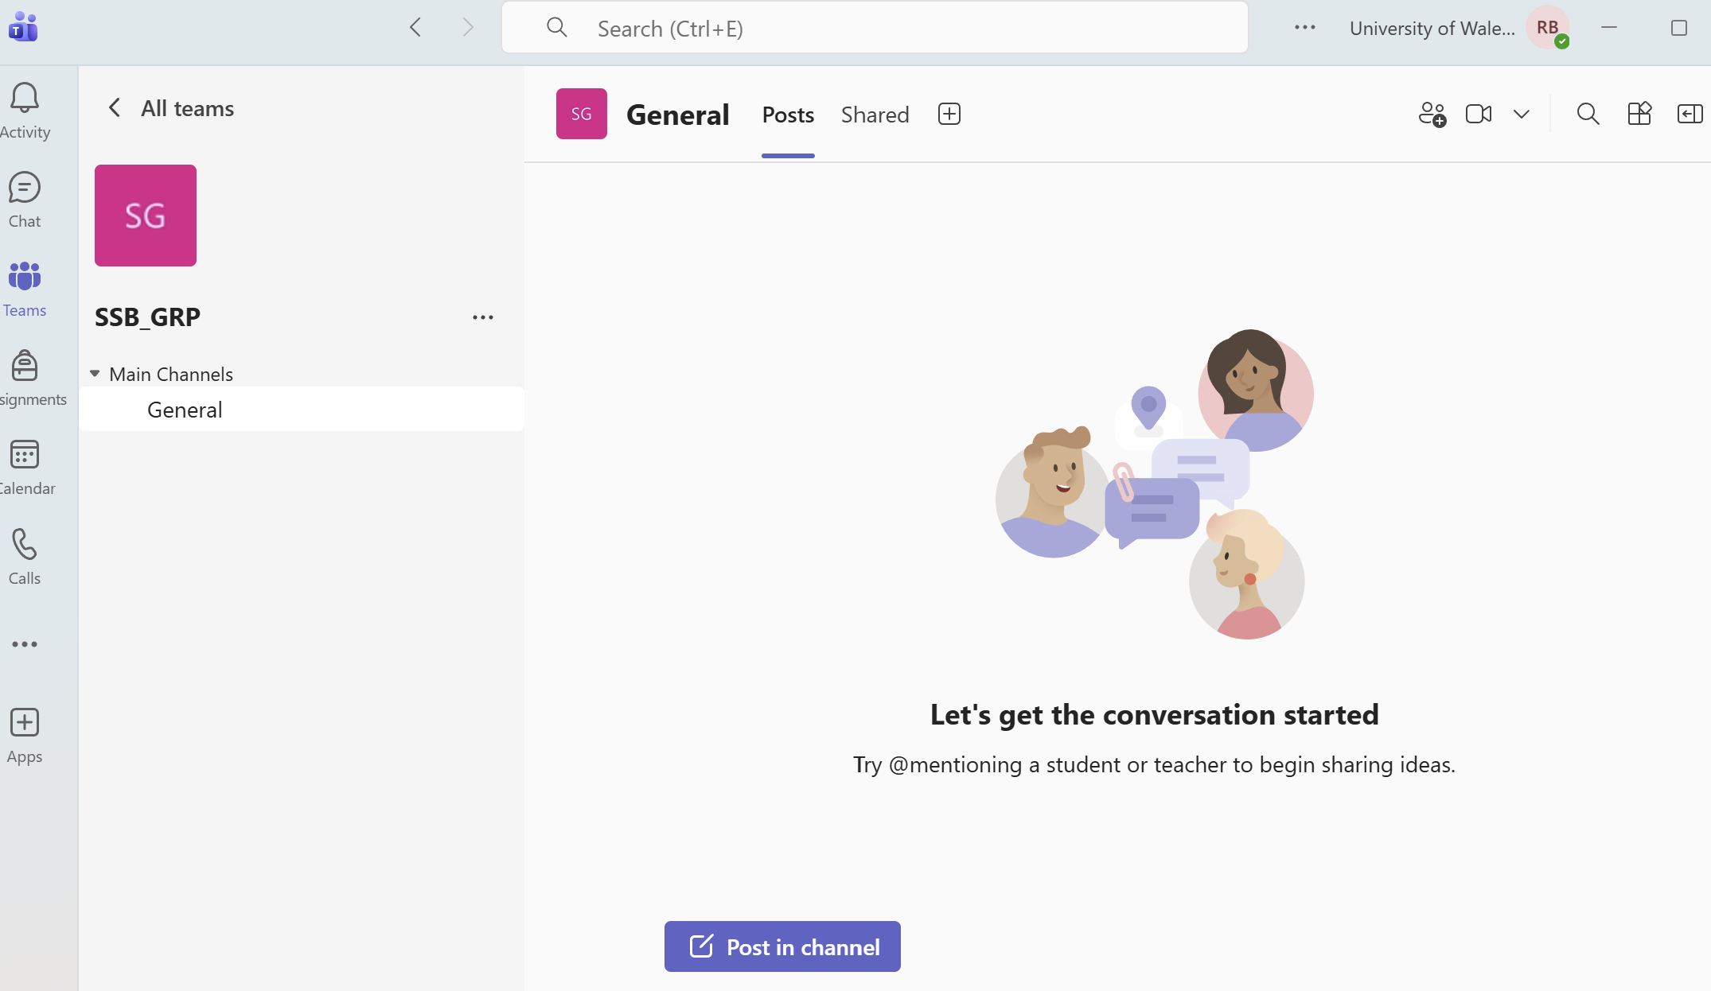

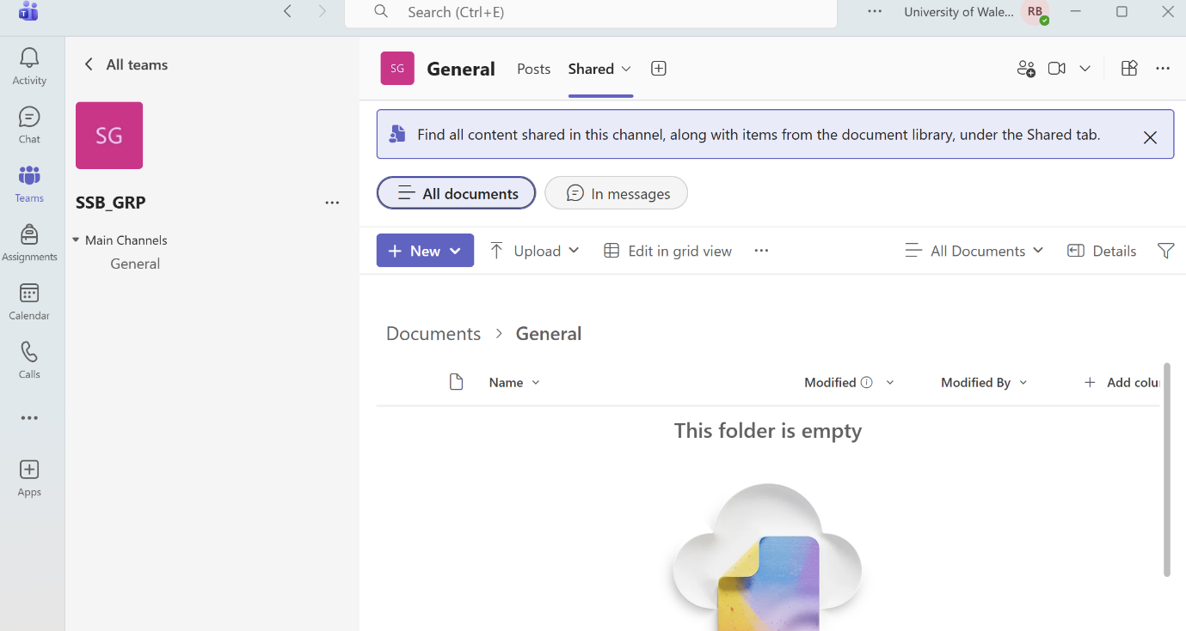
Figure 65 Option "share" to upload files
Whiteboard in Microsoft Teams is a digital interactive board that often is used during online meetings or in the channel to write, draw, and share ideas in real time, supporting collaborative thinking and teamwork, Fig.66.

Figure 66 Adding White board app in Channel
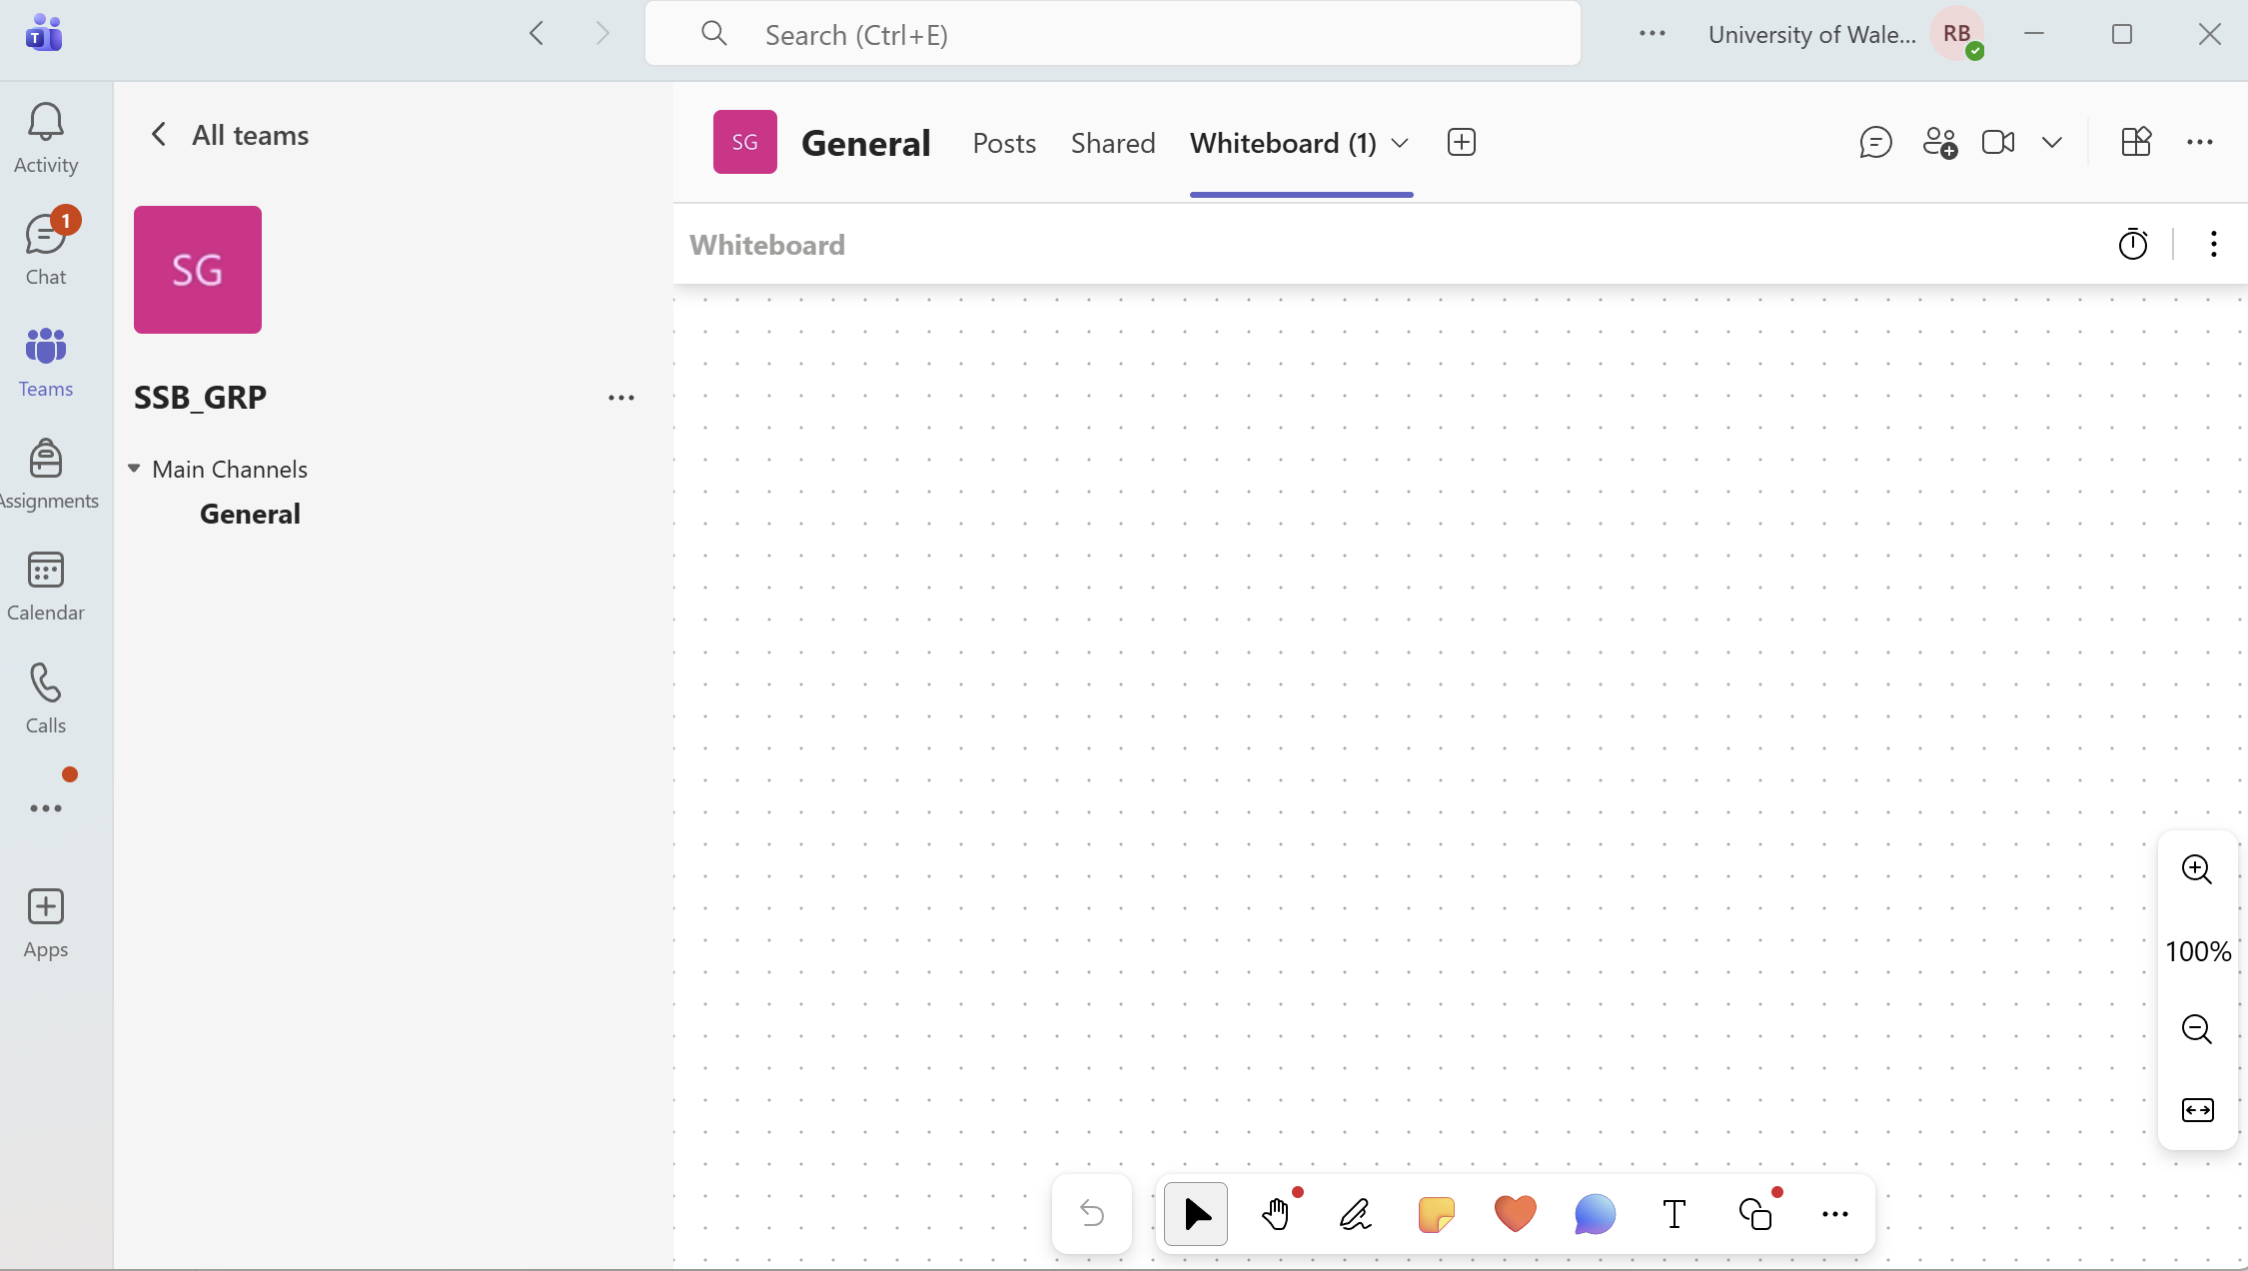

Online meeting and video calls
The platform enables users to organize virtual meetings using audio and video, share their screen, record sessions, and use virtual backgrounds. It supports real-time communication and effectively collaboration.[22]
A key advantage is that Microsoft Teams is connected with other Microsoft services such as Outlook, OneDrive and SharePoint. This allows users to check their calendar, access files and work with team documents all in one place, without switching between different applications.[22]
Disadvantage - interface appears crowded and complex, especially at first use. From a performance point of view, it can also be demanding in terms of RAM and CPU, which may lead to slower system performance during operation.
Despite its limitations, Microsoft Teams remains one of the most widely used solutions for digital collaboration in today’s working environment.

Task 4b

Gmail and Integration with Google Meet example - There are two main ways of sending a link by email or using the Calander, Fig.67,68,69,70,71,72,73
Figure 67 From main menu choose "Meet"
Figure 68 Generate Link and share by email
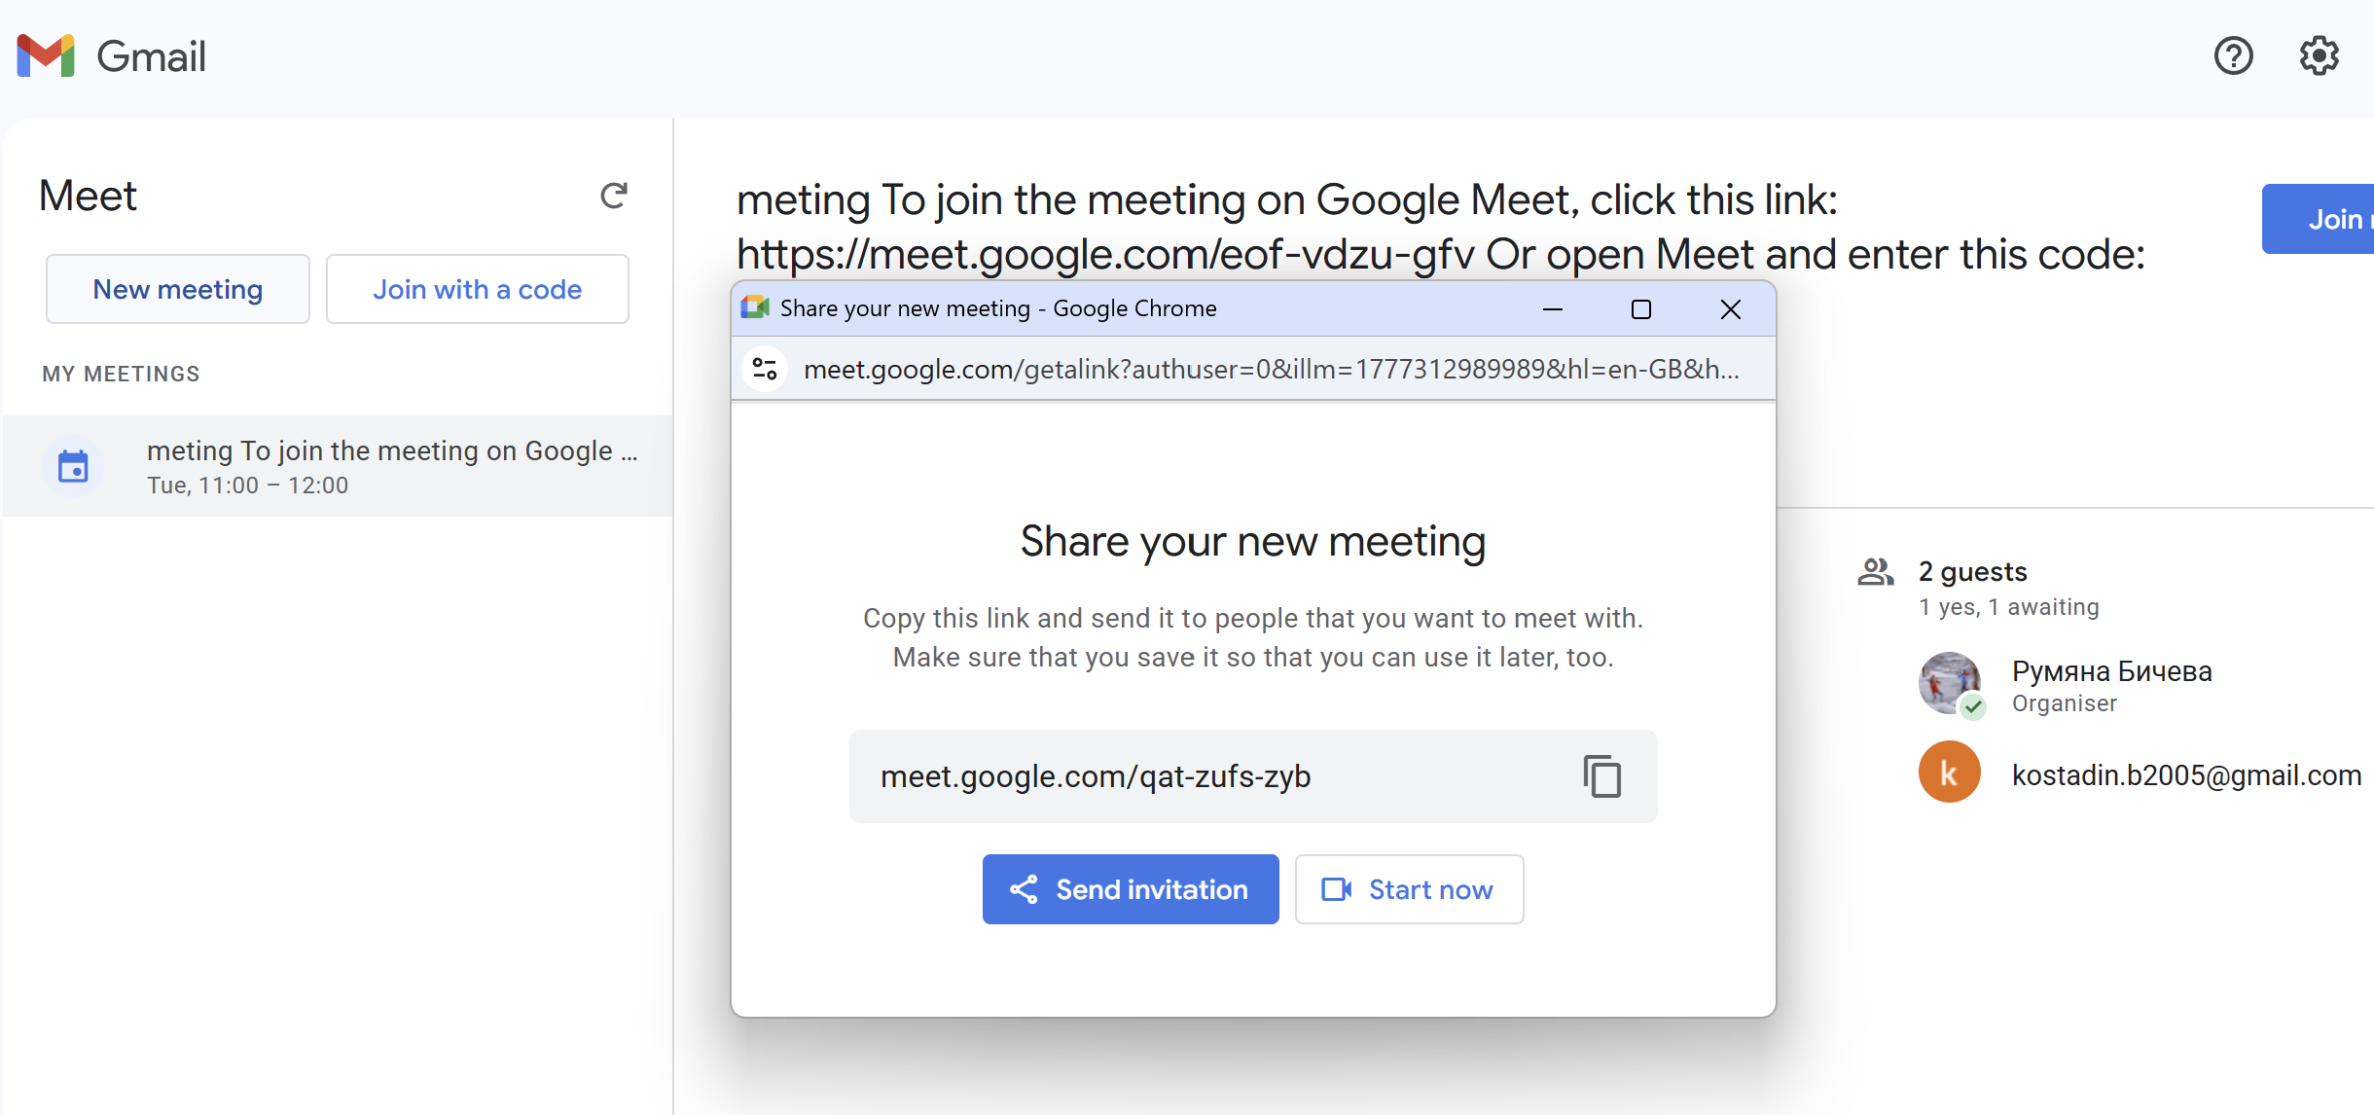
Figure 69 Open Calendar and set up day and time
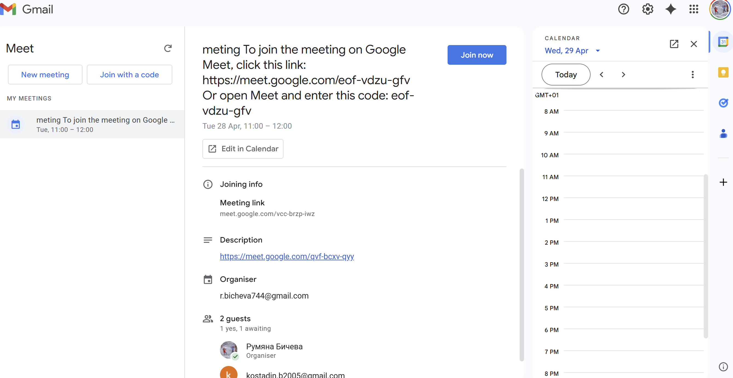

Figure 70 Add Guests
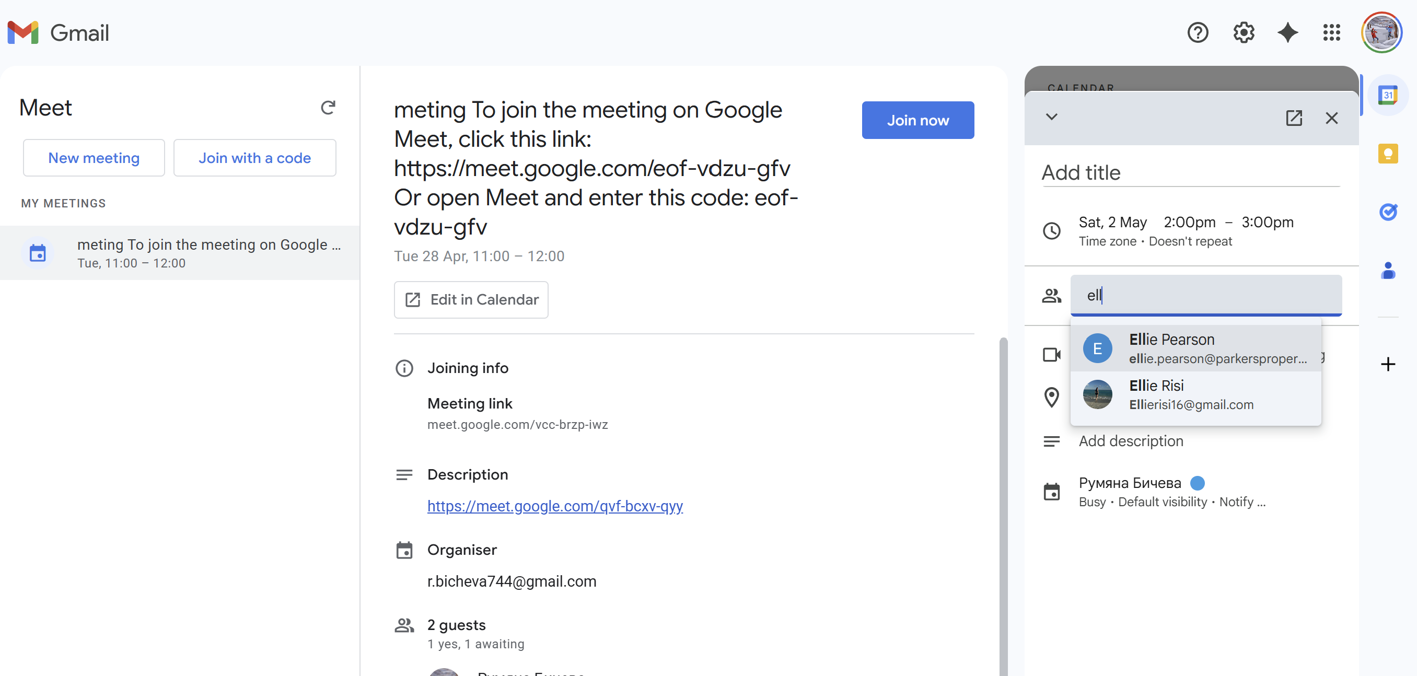
Figure 71 Write invitation emails
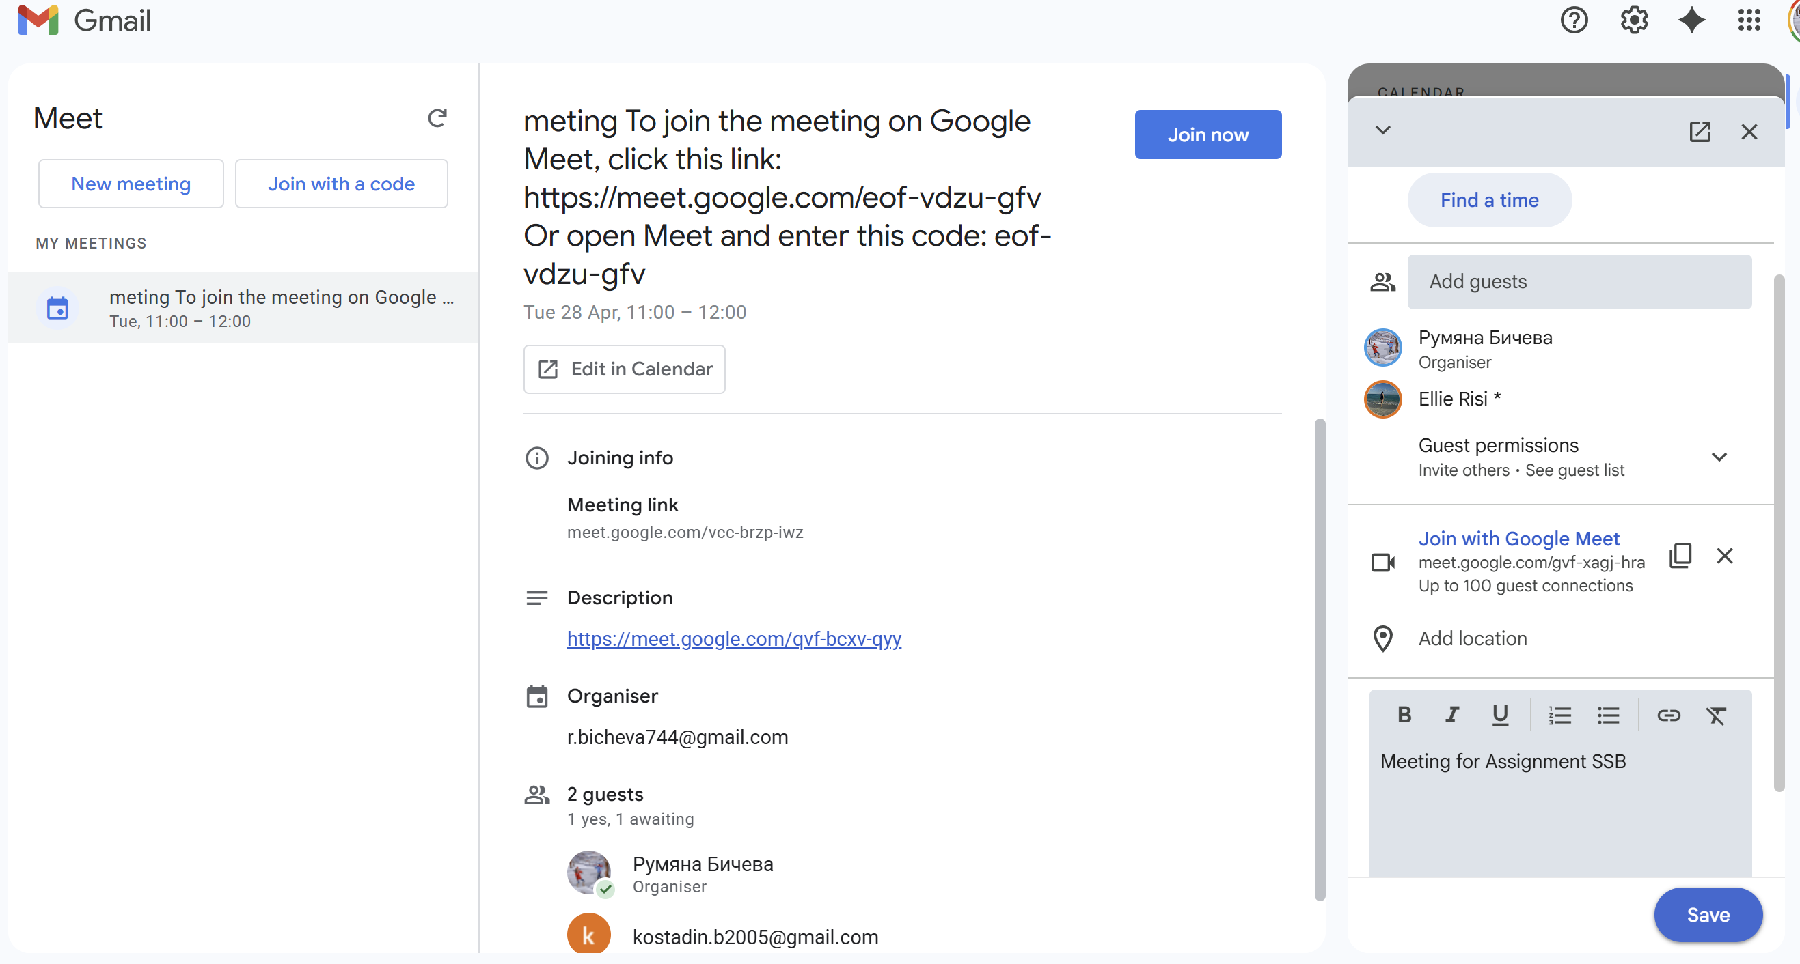

Figure 72 If I want to suggest my guests to add the meeting in their calendars


Figure 73 Meating is created
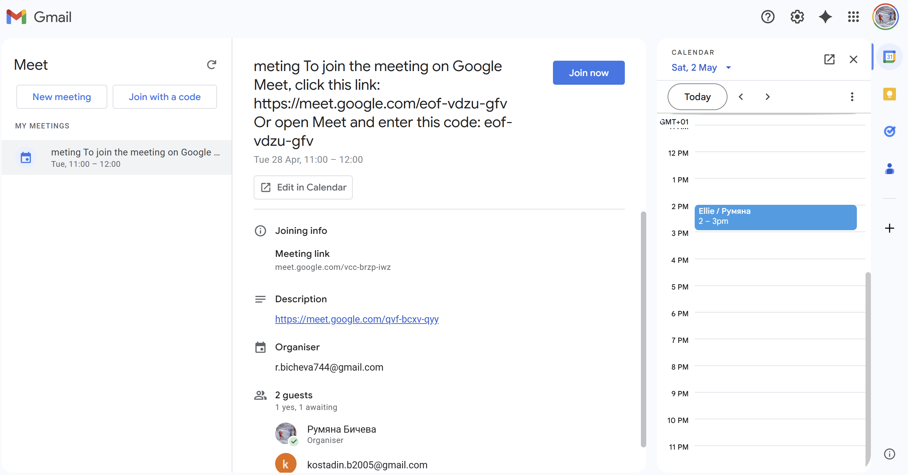

Creating Teams Meating, Fig.74,75,76,77,78
Figure 74 Open Teams Calendar
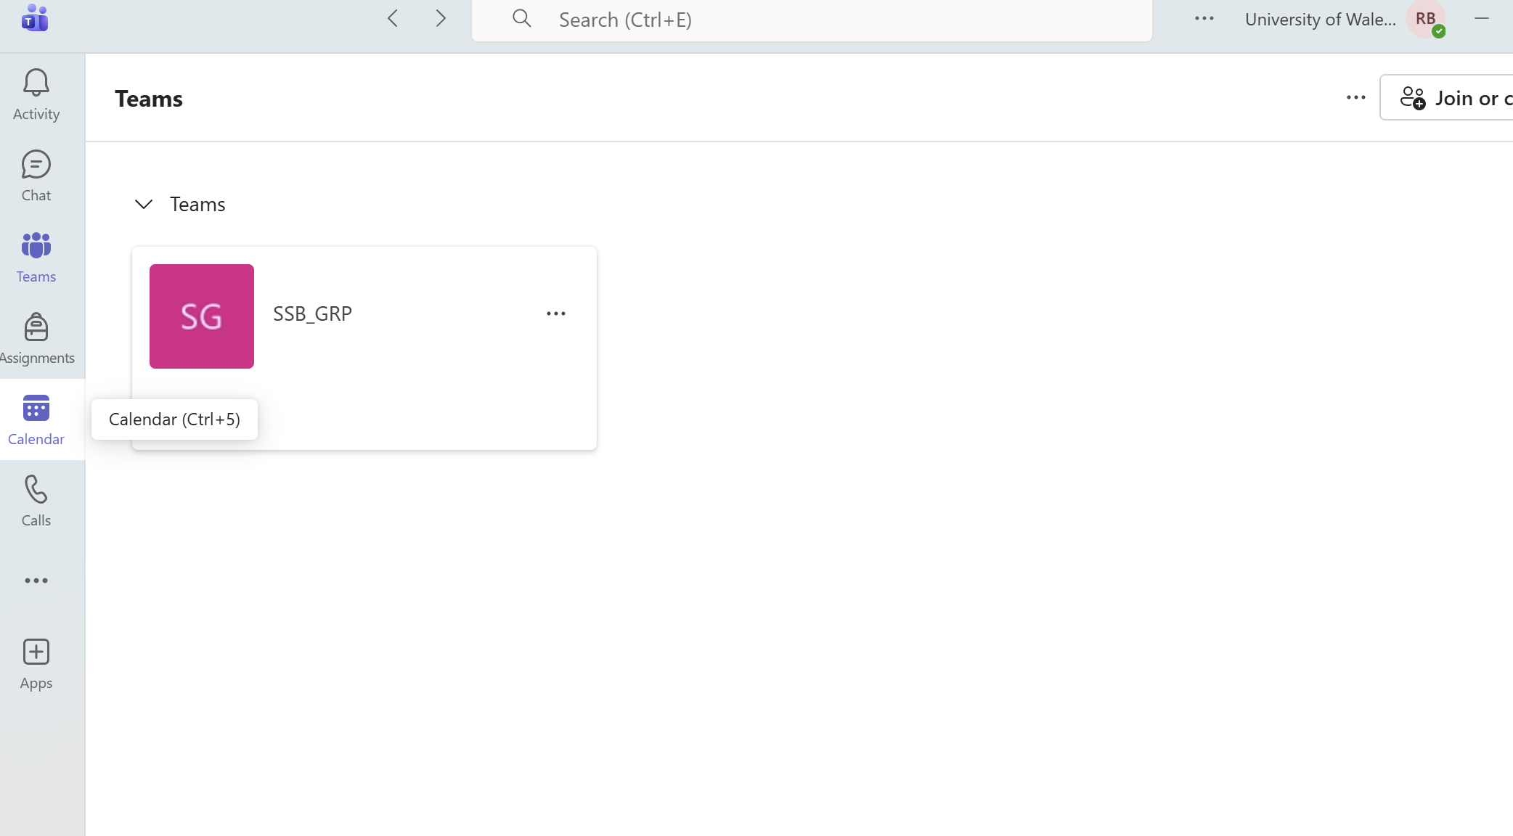

Figure 75 Create new event
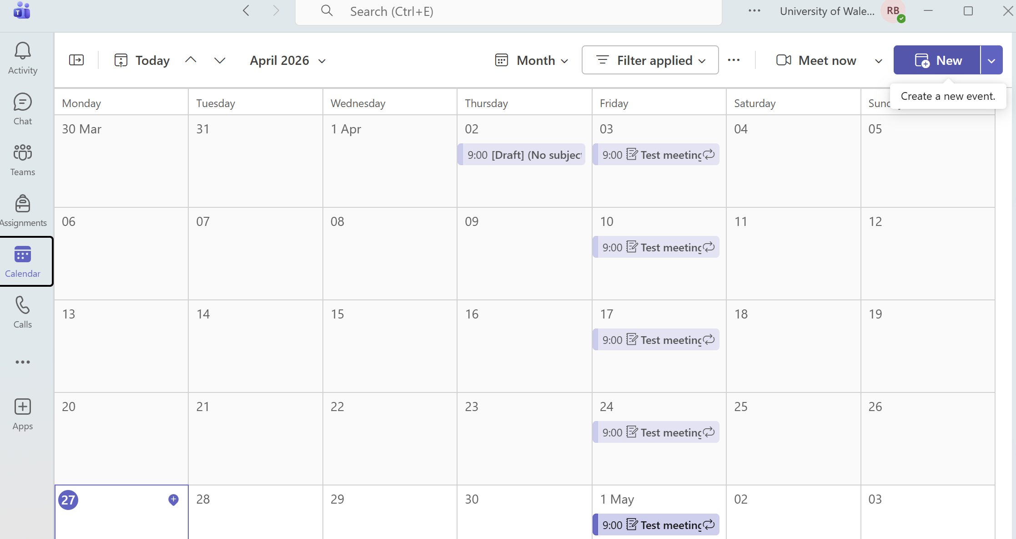

Figure 76 Invite percipients and fix date and time
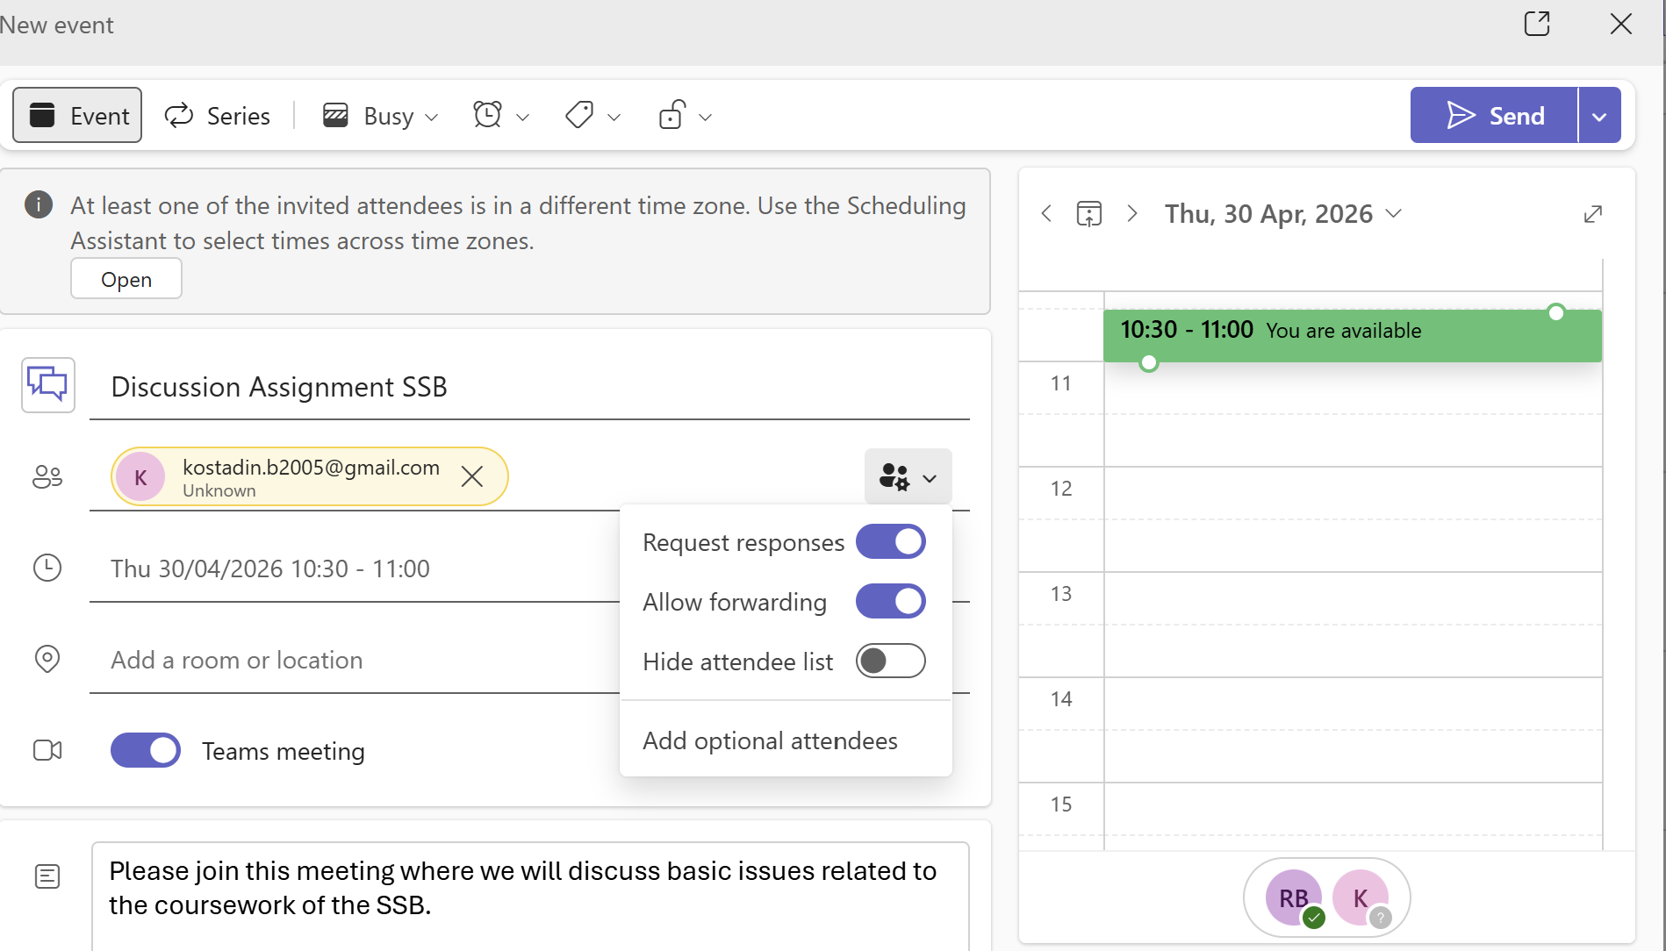

Figure 77 Click on SEND button and event is created
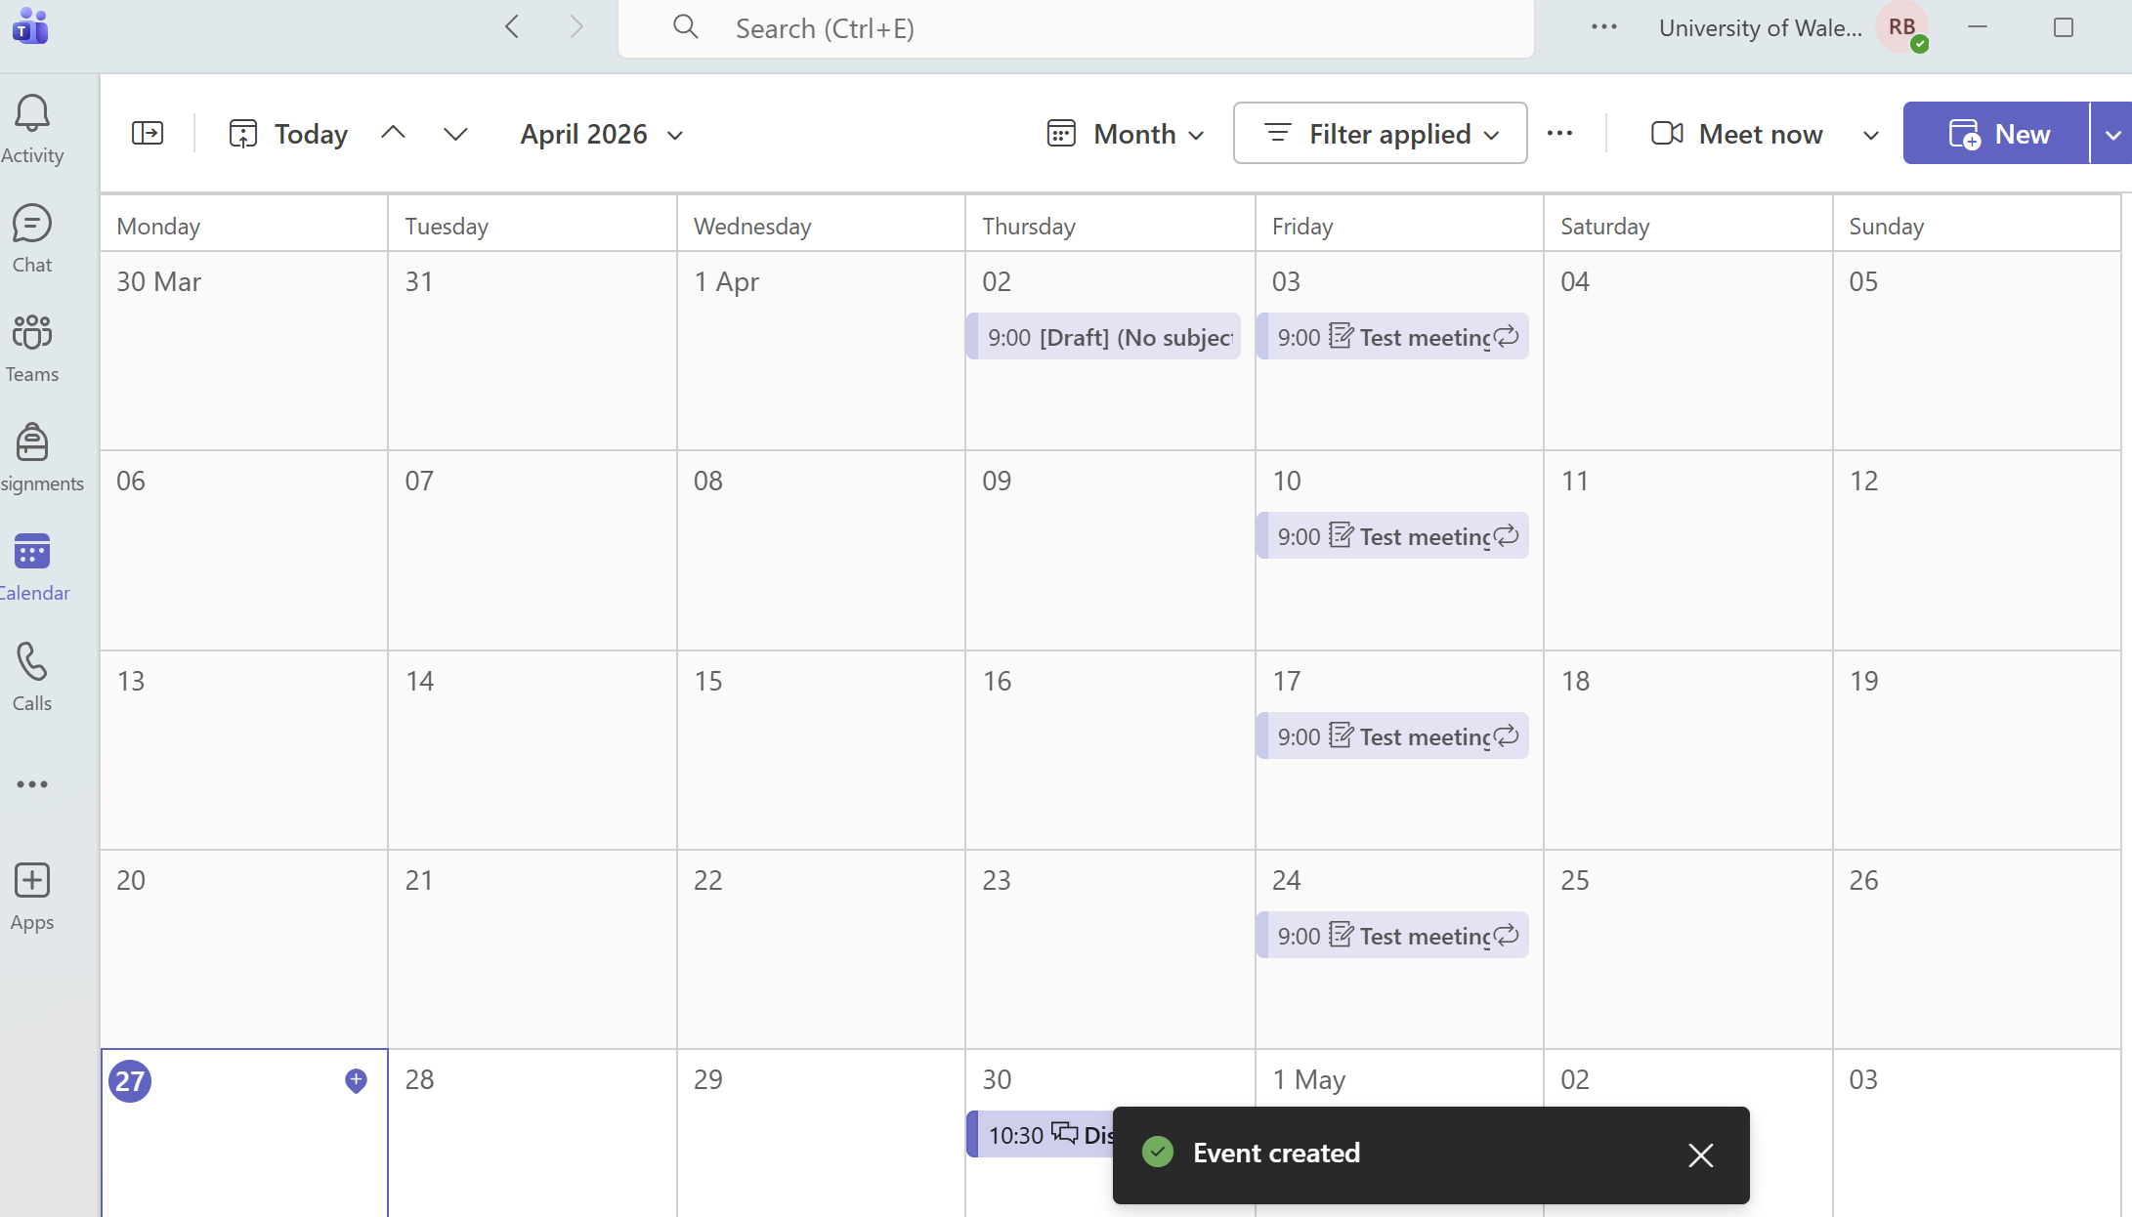

Figure 78 Meeting is shown in my calendar
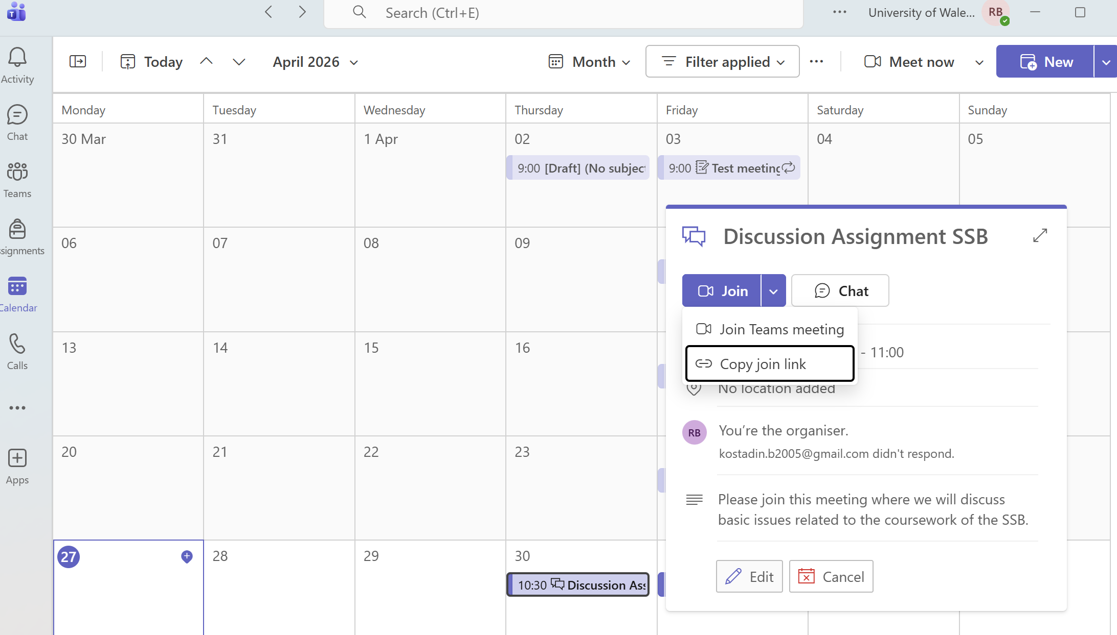

CONCLUSION
The coursework demonstrated the importance of modern software applications for business, while also showing my knowledge of their purpose and practical use. These tools support content creation, data analysis, communication, teamwork, and information management, which significantly improve efficiency, organisation, and productivity in the workplace, making them essential in the modern business world.

REFERENCES

[1] Gareth R. Jones, "The Organization and Its Environment," in Organizational Theory, Design, and Change, Seventh Edition, Ed., Pearson Education, pp. 30.
[2] "What Are Business Software Systems? A Comprehensive Overview." [Online]. Available: https://www.iplum.com/blog/what-are-business-software-systems-a-comprehensive-overview?srsltid=AfmBOoqO_ALeHCXG-xJFB8IlEjw8I9GgVYA6ft-DGziW5pRpt4-oAY9W
[3] "Top Benefits of Software Solutions & How to Choose the Perfect One for Your Business." https://cbslgroup.in/. [Online]. Available: https://cbslgroup.in/blogs/top-benefits-of-software-solutions-how-to-choose-the-perfect-one-for-your-business
[4] S. Hafuta. "Wix vs. Weebly: which website builder is right for you?" Accessed: Apr 5, 2026. [Online]. Available: https://www.wix.com/blog/wix-vs-weebly
[5] "Best 5 Website Builders for 2026: My Tried & Tested Picks" Website Builder Expert. Accessed: Apr 5, 20262026, [Blog]. Available at: https://www.websitebuilderexpert.com/website-builders/
[6] "Create a Website with Weebly's Powerful Website Builder." Accessed: Apr 5, 2026. [Online]. Available: https://www.weebly.com/websites
[7] J. Novak. "Weebly Vs. Wix Comparison." Accessed: Apr 5, 2026. [Online]. Available: https://www.forbes.com/advisor/business/software/weebly-vs-wix/
[8] "Weebly vs Wix: Which offers a better free plan?" Accessed: Apr 5, 2026. [Online]. Available: https://www.techradar.com/pro/website-building/weebly-vs-wix-which-offers-a-better-free-plan
[9] T. Buzan, B. Buzan and J. Harrison, "The mind map book: Unlock your creativity, boost your memory, change your life," 2010,
[10] "What is Mind Mapping? What Are Its Uses?" Mindmaps.com. Accessed: Apr 9, 20262026, [Blog]. Available at: https://www.mindmaps.com/what-is-mind-mapping/
[11] T. Buzan and C. Griffiths, Mind Maps for Business: Using the ultimate thinking tool to revolutionise how you work, Pearson UK, 2013.
[12] "Access help & learning," Accessed: Apr 17, 2026. Available at: https://support.microsoft.com/en-gb/access.
[13] "PowerPoint help & learning," Accessed: Apr 17, 2026. Available at: https://support.microsoft.com/en-us/powerpoint.
[14] "What is Excel? - Microsoft Support," Accessed: Apr 25, 2026. Available at: https://support.microsoft.com/en-gb/office/what-is-excel-94b00f50-5896-479c-b0c5-ff74603b35a3.
[15] "Overview of formulas in Excel - Microsoft Support," Accessed: Apr 25, 2026. Available at: https://support.microsoft.com/n-gb/office/overview-of-formulas-in-excel-ecfdc708-9162-49e8-b993-c311f47ca173.
[16] "Word help & learning," Accessed: Apr 26, 2026. Available at: https://support.microsoft.com/en-gb/word.
[17] "Add citations in a Word document - Microsoft Support," Accessed: Apr 26, 2026. Available at: https://support.microsoft.com/en-gb/office/add-citations-in-a-word-document-ab9322bb-a8d3-47f4-80c8-63c06779f127?utm_source=.
[18] P. Darbyshire and A. Darbyshire, "Gmail," in Getting StartED with Google Apps, Springer, 2010, pp. 45–107.
[19] "About Gmail - Email. Chat. Video. Phone. - Google," Accessed: Apr 27, 2026. Available at: https://www.gmail.com/mail/help/intl/en-US/about.html?__shortid__=1wZ9.
[20] "Gmail Help," Accessed: Apr 27, 2026. Available at: https://support.google.com/mail?sjid=10899677983729948698-EU#topic=7065107.
[21] "Gmail security tips - Computer - Gmail Help," Accessed: Apr 27, 2026. Available at: https://support.google.com/mail/answer/7036019.
[22] "Microsoft Teams help & learning," Accessed: Apr 27, 2026. Available at: https://support.microsoft.com/en-us/teams.

