Abstract
Overview of the ethnic minority community in Haringey Borough’s main characteristics, with a different approach to promoting better community development in line with campaigns, awareness, theories, policies, and action plans.
Table of Contents
INTRODUCTION 1
Discussion 3
Conclusion/Recommendations 9
References 10

COMMUNITY CARE & DEVELOPMENT Assessment 2
Erkan Paca 2010132
Lecturer Layla Sorani
Approaches & Initiatives for Addressing Health & Social Needs of Ethnic Minority Community in Haringey Borough


Introduction
It's interesting to learn that the population of Haringey has increased by 3.6% from 2011 to 2021, bringing the total number of residents up to 264,200. Haringey currently ranks 18th out of the 33 London boroughs in population. However, it's worth mentioning that this increase is lower than the overall increase in London and England, which were 7.7% and 7%, respectively. Compared to ONS 2021 projection figures, Haringey's change of -3.1% is similar to the average change/reduction across London (-3.2%). As of 2021, Haringey's population density is 89.24 persons per hectare of land, making it London's 12th most densely populated local authority area. In contrast, London has a population density of 55.98 persons per hectare, and England's population density is 4.34 persons per hectare. (Haringey Census, 2021).
Haringey is also an incredibly diverse borough with a vibrant cultural mix. Boasting over 180 languages spoken, it's truly a melting pot of cultures. While facing challenges regarding deprivation, particularly in the northeast, the community is dynamic and ever-evolving. Although notable gaps in GCSE attainment require attention, improvements have been made. (Haringey, Gov, UK, 2023).

Over the past decade, the "Other" category in Haringey, which includes "Arab" and "Any other ethnic group", has seen a significant increase from 4.7% to almost 10%. Meanwhile, the percentage of people who identified as "White" and "Black, Black British, Black Welsh, Caribbean or African" slightly decreased. In contrast, the percentage of people who identified as "Asian, Asian British or Asian Welsh" decreased somewhat. Experts suggest that ageing, fertility, mortality, and migration patterns may contribute to these demographic changes. (ONS, 2022)
The demographics of Haringey have undergone significant changes since 2011. The number of children under 15 has decreased by 8%, while adults aged 15 to 64 have increased by 4%. Those aged 65 and over have seen a significant increase of 24%. It is fascinating to observe how these age groups have shifted over time. Moreover, among the 264,200 residents in Haringey, 51.9% were women, and 48.1% were men. (Haringey Census, 2021).
Also fascinating to know that, Evidently, in Haringey, there has been a slight increase in the proportion of households with couples but no children. At the same time, the percentage has decreased across England as a whole. Moreover, the rate of employed individuals in Haringey has risen over the same period, while it has declined throughout England overall. However, the regional percentage has increased across the board. (Haringey Census, 2021).

As of 2022, there are 27,700 individuals over the age of 65 residing in Haringey. This age group is projected to experience significant growth of 40% over the next ten years, totalling 40,000 residents by 2031. It is crucial to ensure that sufficient resources and support are readily available for our ageing population in the years to come. (Haringey, Gov, UK, 2023).

In Haringey, cancer, cardiovascular disease, and lung disease are the main contributors to premature death (deaths before age 75). Regrettably, unhealthy eating, smoking, and high blood pressure are the most prevalent habits linked to chronic illnesses, poor well-being, and early mortality in the region. Therefore, it is crucial to prioritise our health and make constructive lifestyle choices to mitigate these dangers. (Haringey, Gov, UK, 2023).
As a result, It's startling to discover that one in every five Haringey adults has high blood pressure. Furthermore, a third of the population needs to get more physical activity. It's crucial to prioritise our health and remain active while monitoring our blood pressure levels. Adding more physical activity to your daily routine, even minor alterations, can significantly impact your overall health and well-being. (Haringey, Gov, UK, 2023).
Discussion
Knowing that Haringey's Health and Wellbeing Board actively promotes a healthier community is comforting. The board was established in April 2013 by the Health and Social Care Act 2012. The statutory partnership is doing an excellent job, and it's commendable to see local leaders taking a proactive stance on health and well-being. (Haringey, Gov, UK, 2022).

Hence, It is essential to acknowledge that enhancing our borough's health and well-being is not a task that can be accomplished by a few organisations alone. This is a shared responsibility that must be taken seriously. By collaborating and offering support to one another, we can establish a healthier and more contented community for everyone. (Haringey, Gov, UK, 2022).

In line with this, The Health and Wellbeing Strategy 2020-2024 has been released with collaborative principles that are community centred approach with a long-term effect and well-informed to people needing monitoring and considering the perspectives of Haringey residents, health and social care professionals, and the voluntary and community sector. This will also incorporate insights from our Joint Strategic Needs Assessment to shape our priorities. The strategy is centred around three main goals and is essential to enhancing well-being in Haringey: decreasing obesity, promoting healthy life expectancy, and improving mental health and well-being. Dedicated to partnering with our allies to make meaningful strides in these areas, we are confident that together we can make a genuine impact on the quality of life for Haringey locals. (Haringey, Gov, UK, 2022).

Our top priority is to improve our patients' and clients' health and well-being. We will use the Department of Health's outcomes frameworks for the NHS, Public Health, and Adult Social Care to accomplish this. These frameworks are crucial for tracking progress in healthcare and social care. Using them, we are confident we can deliver the best possible outcomes for the people we help. We are committed to using these frameworks to ensure we provide the highest quality care and support to those who most need it. (Haringey, Gov, UK, 2022).
Hence, In 2021, The North Central London Integrated Care Board recently selected the Bridge Renewal Trust and Public Voice to assess the needs of our community from a broader health perspective. They will work closely with four grassroots organisations, including 4U2, DALMAR, ROJ, and MEWSO, to address the specific needs of ethnic minority groups. Additionally, Haringey Let's Talk, and Nafsiyat have successfully reduced waiting times for IAPT or Talking Therapy. The Somali Mental Health Project is also actively working to improve mental health within our community. Mind in Haringey has organised workshops to train 42 organisations and VCS staff and offer bereavement counselling. Finally, the BEHMHT has helped people to become more active, promoting a healthy and active lifestyle. The initiative targeted women from Somali, other Black African/Caribbean, Turkish, Kurdish, and Middle Eastern communities to understand their unique perspectives better. (Health Watch Haringey, 2021).
Respectively, some approaches can be applied to connect communities effectively. One of them is a top-down attitude which is passive and lower empowerment; a cooperative system enables community with moderate participation; and a bottom-up route, which is full empowerment and participation. (Abbott, 1996).
These approaches can easily be achievable for the community via online consultations and have made communicating easier for patients and GPs in North Central London. Care homes have also adopted digital technology to improve patient care. A single Directory of Services makes it easier for patients to access social prescribing schemes. Patient outcomes have improved with shared data and the NHS App. (NHS, 2021).
Healthwatch Haringey is digital support that enables people to access online NHS appointments. As well as third-party referrals. (Healthwatch Haringey, 2023).
Digital champions allow people to manage their housing, benefit and other domestic issues online. Connected care service for 24 hrs of supportive care for older, disabled, discharged patients and individuals who wish to live independently. (Haringey Council, 2023).
Moreover, The Bridge Renewal Trust provides community engagement supported by The Laurels Healthy Living Centre, Chestnuts Community Centre, and Bridge Community Hut, offering a unique opportunity and exceptional facilities to engage and empower members. Individuals warmly welcome from diverse backgrounds to participate in empowering programs promoting healthy living, cooking daily activity classes, and mental health support. (Bridge Renewal Trust, 2023).
One of the approaches to prevent cardiovascular disease was creating an action plan called ‘Primary Care Intelligence Packs, June 2017, Version 1 NHS Haringey CCG’, which aimed and improved the prevention and management of cardiovascular disease. This could involve building clinical leadership through communities of practice, conducting local audits to identify gaps in care and outcomes, and creating new models of care that affect the wider primary care team to alleviate the burden on general practice. By taking these steps, we work towards improving the health and well-being of people across the country. (PHE, 2017).
Therefore, healthcare professionals can find this valuable resource in determining the prevalence, variation and treatment of cardiovascular conditions in their local area. This information can be utilised to plan, commission and improve local services. The pack contains GP practice data on the prevention, detection and management of various cardiovascular conditions, including high cardiovascular, hypertension, stroke, atrial fibrillation, diabetes, kidney disease, coronary heart disease and heart failure. (PHE, 2017).
Early detection and treatment are essential to prevent the prevalence of cardiovascular disease; Haringey and Islington were united in 2018 to tackle the issue by concentrating on the management and identifying hypertension and irregular heartbeats, which can directly impact the ailment. (Haringey. GOV.UK, 2023).
A similar focus was introduced under the 10-Year Cardiovascular Disease Ambition of Public Health England. This initiative aims to decrease the occurrence, fatality, and health disparities linked to cardiovascular disease in England by 2030. This comprehensive plan focuses on improving the prevention, detection, and treatment of cardiovascular disease and lowering risk factors like smoking, unhealthy diets, and physical inactivity. (Public Health England, 2019).
It is a clear sign that non-communicable diseases like heart disease, stroke, Type 2 diabetes, and liver disease are prevalent due to obesity, physical inactivity, and smoking. Therefore, high-risk conditions like atrial fibrillation, high blood pressure, diabetes, and high CVD risk score need preventive treatments. Consequently, population-level primary care interventions must align with social prescribing, well-being hubs, and NHS Health Check to support behaviour change and early detection. Specifically, assessing the effectiveness of follow-up management of clinical risk factors in primary care is crucial. (PHE, 2017).
To promote this, Maslow (1943) states that one must meet physiological and safety requirements to achieve emotional and mental wellness. Without a sense of security and stability, we cannot strive for our utmost potential or pursue higher needs, such as love, esteem, and self-actualisation, as outlined by Maslow's theory. Therefore, we must prioritise these basic needs to reach our full potential.
The pyramid below is designed to show how social factors affect health. It's similar to Maslow's pyramid. Both start with basic needs like food and shelter and end with higher needs like community and self-actualisation. It's essential to consider social factors in healthcare. (Catawba Valley Healthcare, 2021).

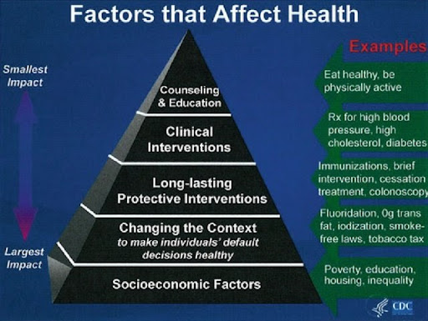

Align with MASLOW theory, Bronfenbrenner's ecological systems theory also explains a similar need that every child's growth is influenced by their environment, including family, school, culture, laws, and customs. We must analyse the child's immediate and broader environment to understand their development. The microsystem, including family and school, is the most influential. (Simple Psychology, 2023).
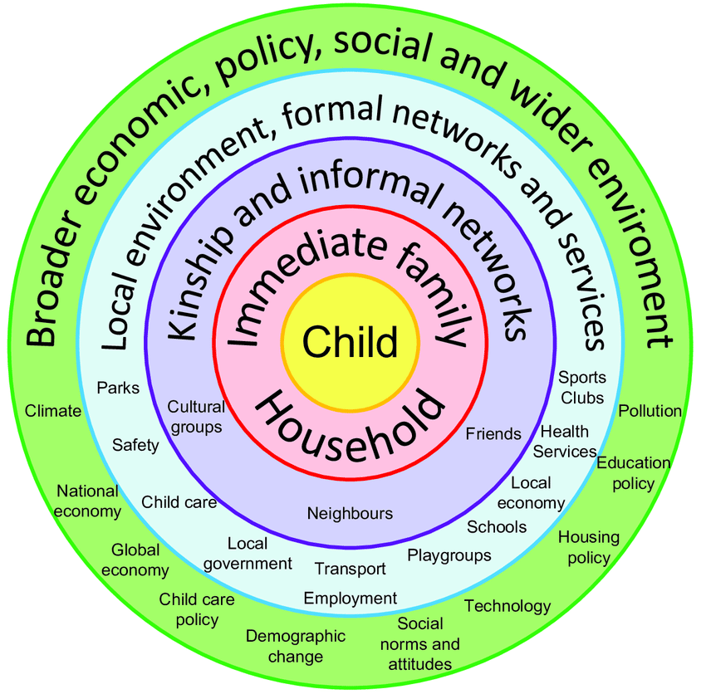

In line with mentioned theories, according to Albert Bandura's (1977) social learning theory, people can learn effectively by observing and modelling others. The idea highlights that individuals can acquire new skills and behaviours by watching others perform the same actions. Additionally, Bandura's approach underscores the importance of personal agency and self-efficacy in learning. Essentially, the theory suggests that people are more likely to engage in a behaviour if they believe they have the necessary skills to perform it successfully. Overall, Bandura's social learning theory has significantly impacted the field of psychology by providing invaluable insights into how people learn and adopt new behaviours. (Bandura, 1977)
To provide ethical and practical community engagement, organisations must act according to Human Rights Act 1998, respecting dignity and being kept safe from harm. (Equality and Human Rights Commission, 2019).
Privacy and Confidentiality (Data Protection Act, 1998), guarding service users in case of harm or exposure of important information causing a vulnerability.
The Safeguarding Vulnerable Groups Act 2006 deals mainly with the ones working with individuals and children.
Care Act 2014, the duty of care within the community; empowerment, prevention, proportionality, protection, partnership, and accountability.
Working Together to Safeguard Children 2018, working collaboratively to ensure children, families, and young people are safe from abuse. (GOV.UK, 2021).
Recommendations/Conclusions
High-quality primary care is fundamental to boost outcomes in CVD because primary care is where much prevention is needed so that most diagnoses and treatments are delivered accordingly. (Public Health England, 2023). Also, Late diagnosis and treatment can cost mortality and thousands of pounds for the NHS. (Public Health England, 2023).
Therefore, to tackle these issues, organisations should work collaboratively to manage and reduce the lateness of the treatment. Detection and management are crucial. (Public Health England, 2023).

REFERENCES
Abbott, J. (1996) Sharing the City. Participation in Urban Management. European Journal of Science, Volume 11. Number 1. London (2009).
Bridge Renewal Trust (2023) About us. (online) Available at: https://www.bridgerenewaltrust.org.uk/Pages/FAQs/Category/about-us. (Accessed:31/07/20213).
Catawba Valley Healthcare (2021) How Social Determinants of Health Align with Maslow’s Hierarchy of Needs. (Online). Available at: https://www.cvhnc.org/how-social-determinants-of-health-align-with-maslows-hierarchy. (Accessed: 04/08/2023).
Equality Act (2010). Guidance. (online). Available at: https://www.legislation.gov.uk/ukpga/2010/15/part/2/chapter/1 (Accessed: 16/07/2023).
Equality and Human Rights Commission (2019) Diversity (online). Available at: https://www.equalityhumanrights.com/en/secondary-education-resources/lesson-plan-ideas/lesson-4-diversity. (Accessed: 16/07/2023).
GOV.UK (2021) Discrimination: your rights (online). Available at: https://www.gov.uk/discrimination-your-rights/discrimination-at-work (Accessed: 16/07/2023)
Haringey Council (2023) Connected Care Service: Available at: https://www.haringey.gov.uk/social-care-and-health/health/accident-prevention-and-safety/safe-and-sound-community-alarms. (Accessed, 14/07/2023).
Haringey, GOV, UK (2023) State of the borough. (Online) Available at: https://www.haringey.gov.uk/sites/haringeygovuk/files/state_of_the_borough_final_master_version.pdf. (Accessed:31/07/2023)
Haringey, GOV, UK (2022) Health and Wellbeing Board. (Online) Available at: https://www.haringey.gov.uk/local-democracy/working-partnership/health-and-wellbeing-board. (Accessed:30/07/2023).
Haringey. GOV.UK (2023) Haringey and Islington Prevention Scale: Cardiovascular disease prevention focusing on blood pressure and atrial fibrillation. (Online). Available at: https://www.minutes.haringey.gov.uk/documents/s99087/prevention. (Accessed:03/08/2023).
Healthwatch Haringey (2021) Engaging with ethnic minority women in Haringey about local services you said we did. (online) Available at:: https://www.healthwatchharingey.org.uk/files/pdf. (Accessed:30/07/2023)
Healthwatch Haringey (2023) Digital Support Service. Refer a patient. Available at: https://www.healthwatchharingey.org.uk/digital-support-service-refer-patient. (Accessed:15/07/2023).
Maslow, A. H. (1943). A theory of human motivation. Psychological Review, 50(4), 370–396. (Online) Available at: https://doi.org/10.1037/h0054346. (Accessed:04/08/2023).
NHS (2021) JHOSC: General practice update. (online). Available at: https://www.minutes.haringey.gov.uk/documents/s121025/Digital%20Inclusion.pdf. (Accessed:16/07/2023).

Office for National Statistics (2022) How life has changed in Haringey: Census 2021. (Online) Available at: https://www.ons.gov.uk/visualisations/censusareachanges/E09000014/. (Accessed:31/07/2023).
Public Health England (2017) CVD: Primary Care Intelligence Packs June 2017 Version 1. NHS Haringey CCG. (Online.) Available at: https://assets.publishing.service.gov.uk/government/uploads/system/uploads/attachment_data/file/623641/NHS_Haringey_CCG_CVD_intelligence_pack.pdf. (Accessed: 03/08/2023).
Public Health England (2019) Health matters: preventing cardiovascular disease. (Online) Available at: https://www.gov.uk/government/publications/health-matters-preventing-cardiovascular-disease/health-matters-preventing-cardiovascular-disease. (Accessed: 02/08/2023).
Public Health England (2023) Guidance. Health matters: preventing cardiovascular disease Available at: https://www.gov.uk/government/publications/health-matters-preventing-cardiovascular-dise.ase/health-matters-preventing-cardiovascular-disease. (Accessed:1918/07/2023).
Simple Psychology (2023) Bronfenbrenner’s Ecological Systems Theory. (Online). Available at: https://www.simplypsychology.org/bronfenbrenner.html. (Accessed:04/08/2023).
Very Well Mind (2022) How Social Learning Theory Works. (Online). Available at: https://www.verywellmind.com/social-learning-theory. (Accessed: 04/08/2023).

