UNIVERSITY OF WALES:  TRINITY SAINT DAVID |  |  | PRIFYSGOL CYMRU:  Y DRINDOD DEWI SANT
LOCATION: LAMPETER |  | LLEOLIAD: LLAMBED
LEVEL 6 |  | LEFEL 6
November 2019 |  | Tachwedd 2019

HPAH6037
Murder, Mayhem and Megalomania: The Life and Times of the Emperor Nero

QUIZ 2

Write your name here:
Write your Student number here:

TIME: 20 minutes

ATTEMPT TO ANSWER ALL OF THE FOLLOWING 20 QUESTIONS:

In the case of multiple-choice questions indicate your answer by circling either A, B, C or D (as you think is correct). Giving more than one answer to a question will result in a zero mark (if you wish to change your answer make this clear). For other questions write your answer.

1) What is the name of Nero’s second wife?
. .

2) In what year did Nero divorce Octavia?
. .

3) Who is the author of the following passage?
“After the conclusion of the games Poppaea died from a casual outburst of rage in her husband, who knock her down with a kick when she was pregnant.”
. .

4) Gaius Ofonius Tigellinus was one of Nero Praetorian Prefects from 62 CE. Who was his colleague (up until 65 CE, when said colleague got caught up in a conspiracy)?
. .

5) Which Neronian era literary author is said to have mockingly quoted a line of Nero’s poetry – “You might suppose it thundered 'neath the earth” – as he unleashed his bowls in a public toilet?
. .

6) Who is the biographer who reported the incident mentioned in the previous question (the insulting quoting of Nero’s poetry while in a public toilet)?
A – Plutarch
B – Suetonius
C – Philostratus
D – Diogenes Laërtius

7) Who was Nero’s elegantiae arbiter according to Tacitus?
. .

8) Who is the author of the following (translated) passage?
“…always having his hair arranged in tiers of curls, and during the trip to Greece also letting it grow long and hang down behind…”
. .

9)
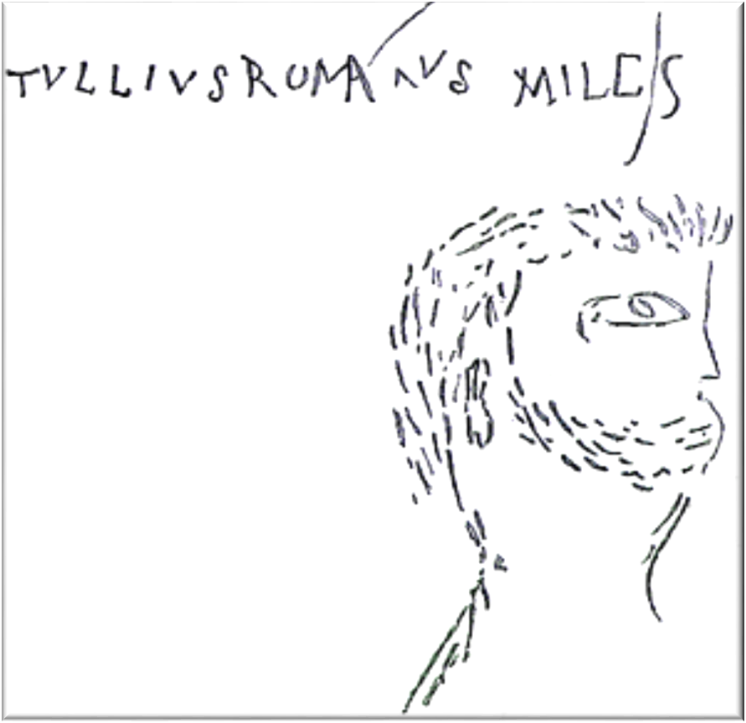
In the substructures of which building in Rome was this caricature of Nero found?
. .

10) Which of these coins is latest in date?
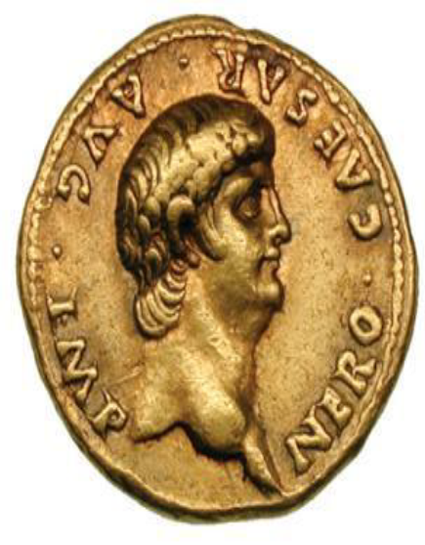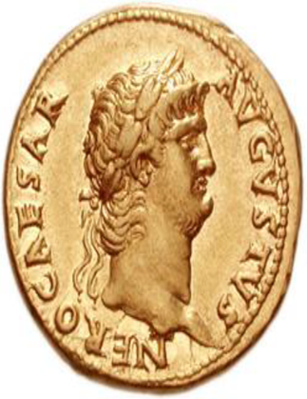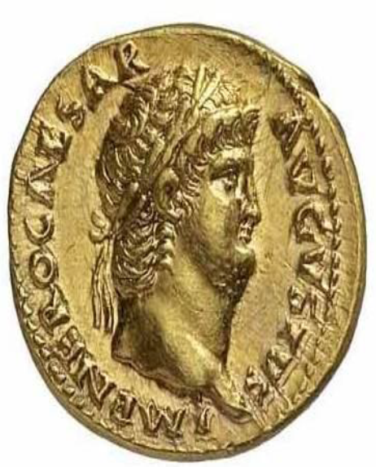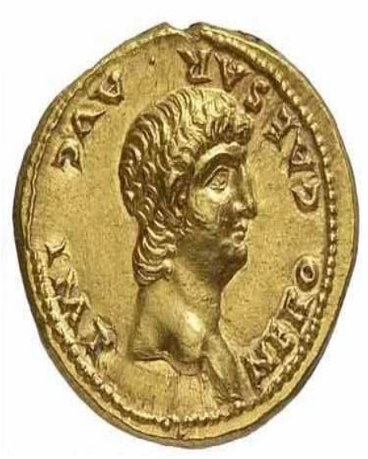
A B C D

11) Name the author of this passage?
“Nero was of fairly average height, with a pustular and malodorous body and blondish hair; his face was pretty rather than handsome, his eyes blue-grey and rather weak; he had a squat neck, a protuberant belly, and spindly legs… He was utterly shameless in the care of his person and in his dress, always having his hair arranged in tiers of curls, and during the trip to Greece also letting it grow long and hang down behind; and he often appeared in public in a dining-robe, with a handkerchief bound about his neck, ungirt and unshod.”
. .

12) What is the name of the brother of King Vologeses of Parthia, whom the later attempted to install on the throne of Armenia during the Neronian period?
. .

12) What is being represented at the centre of this image?
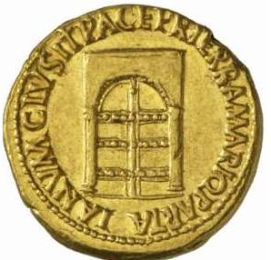
.

13) What is the name of the king being referred to in this passage of Suetonius?
“As the king approached along a sloping platform, the emperor at first let him fall at his feet, but raised him with his right hand and kissed him. Then, while the king made supplication, Nero took the turban from his head and replaced it with a diadem, while a man of praetorian rank translated the words of the suppliant and proclaimed them to the throng.”
. .

14) In what year did Augustus formally establish the Cohortes Vigilum?
. .

15) In what year did the Great Fire of Rome take place?
. .

16) What is the work of Tacitus from which this (translated passage) comes from?
“… Didius Gallus, the next governor, merely held what this predecessors had won, establishing a few forts in more advanced positions, so that he could claim the credit of having made some annexations. Veranius succeeded Didius only to die within the year. After him Suetonius Paulinus enjoyed two years of success, conquering fresh tribes and strengthening the forts.”
. .

17) Who is the author of this passage?
“Nero felt no ambition to extend the Roman Empire; he even considered withdrawing his forces from Britain, yet kept them there because such a decisions might have reflected on the glory won by his adopted father Claudius. The sole additions made during his reign to the list of provinces were the kingdom of Pontus (NE Turkey), ceded to him by Polemon, and that of the Cottian Alps (SW Alps) on the death of Cottius.”
A – Suetonius
B – Tacitus
C – Cassius Dio
D – Josephus

18) Of the fourteen regions of Rome, how many were left undamaged by the fire according to Tacitus?
. .

19) What does the term scalae mean?
A – A force pump
B – little bucket fellows
C – ladders
D – siege engines

20) Who is the author of this (translated) passage?
. .

